Screenshots-Payroll Management System

1. INSERT Operation

Fig 1.1: Home Page for employee table – Click on “Add Employee”Graphical user interface

Description automatically generated with medium confidence

Fig 1.2: Employee Add Page – Enter in Employee details

Fig 1.3: Click on “Save Employee”

Fig 1.4: Home Page – Inserted successfully

1. DELETE Operation

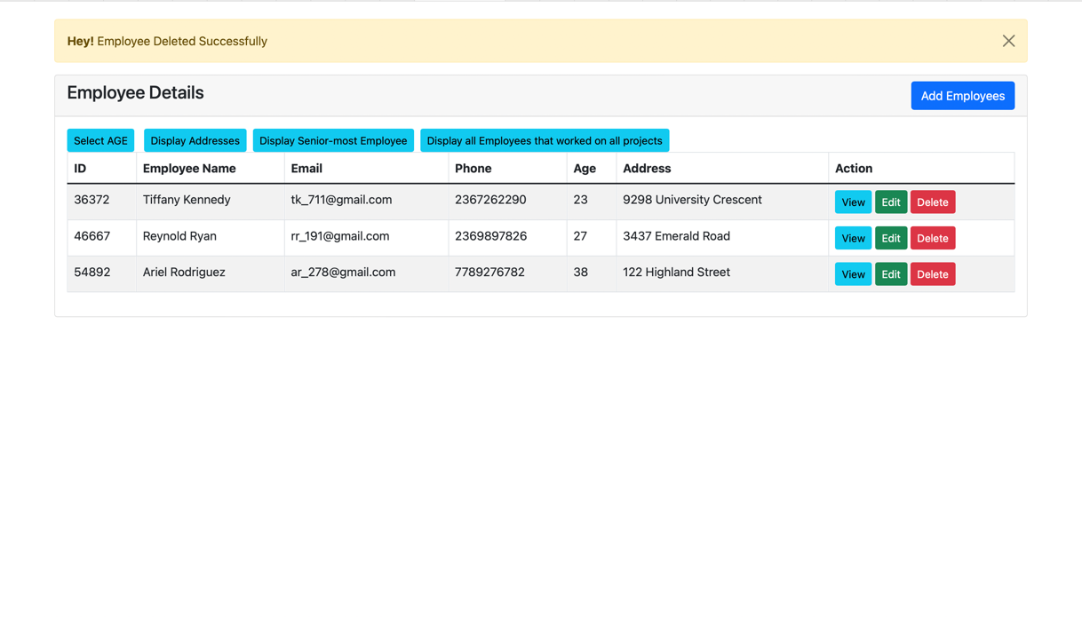

Fig 2.1: Click on “Delete” button, deletion successful

1. UPDATE Operation

Fig 3.1: Home Page – Click on “Edit” button

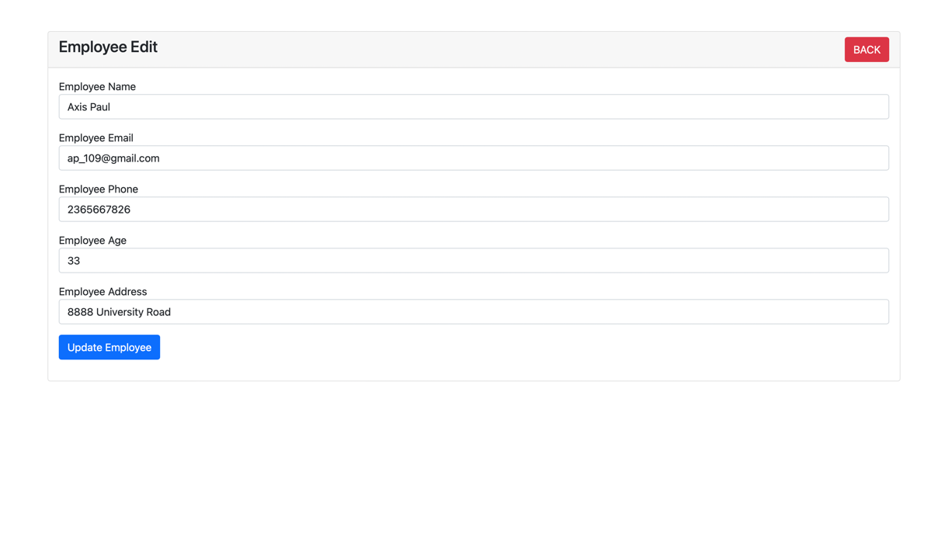

Fig 3.2: Update Employee details – Click on “Update Employee”

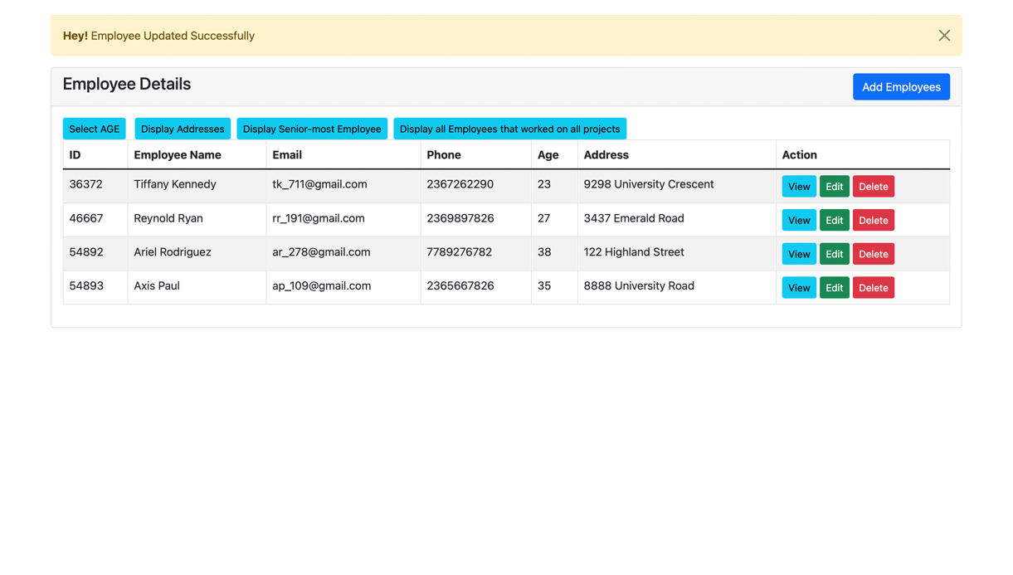

Fig 3.3: Home Page - Updated Successfully

1. SELECTION

Fig 4.1: Click on “Select AGE” – All employees displayed whose AGE >= 25

1. PROJECTION

Fig 5.1: Click on “Display Addresses” – All addresses displayed

1. JOIN Query

Fig 6.1: Home Page for project_works_on table

Fig 6.2: Click on “Display Projects under employees” – joins employee table and project_works_on table through id

1. AGGREGATION Query

Fig 7.1: Click on “Display Senior-most Employee” – Max query on age

1. Nested Aggregation with GROUP-BY

Fig 8.1: Click on “Display # by status” – Grouped by Active status (3 non active projects, 1 active project)

1. DIVISION Query

Fig 9.1: Click on “Display all Employees that worked on all projects” – no records found