Part A
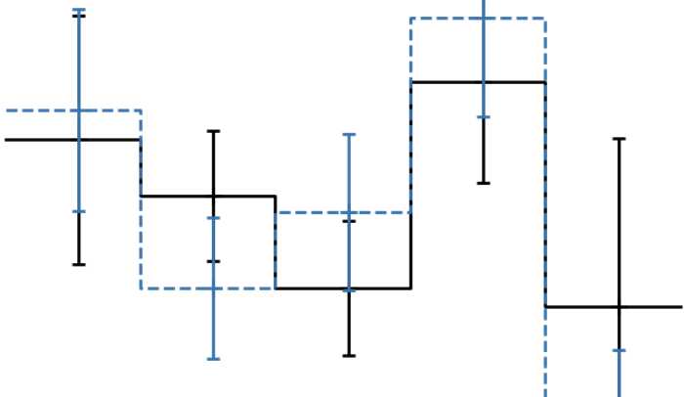
age [Gyr]
metallicity [Fe/H]
initial radius (kpc)
occurance rate, Γ

this work

Fig 1. Stars and their planet system migrate many kiloparsecs over their lifetimes, carrying with them the chemical fingerprints of their birthplaces and ages; however, it remains unclear how processes driving radial migration influence planet outcomes. The upcoming telescope PLATO (PLAnetary Transits and Oscillations of Stars) will detect terrestrial exoplanets in the habitable zones of solar-type stars making this project not only timely but highly feasible. Work has been done to investigate how the age and metallicity of a star impacts planet occurrence rate but these variables alone do not tell us much. The blue lines and error bars on the left and middle plots represent the inconclusive relationships between age and metallicity versus planet occurrence rate (Sayeed+2025). On the right plot we discuss this work, which aims to investigate dynamics while holding the age and metallicity constant to help us determine whether the birthplace of the star and planet system is linked to planet occurrence. This program will build tracer particle simulations to make predictions about the dynamical histories of stars and then investigate how these histories correlate with planet outcomes in the PLATO field.

Part B

Constraining Planet Occurrence in the Milky Way: The Missing Role of Dynamics

We find that young, slow, and metal-rich stars, associated mainly with the thin disc, host on average more planets than the old, fast, and metal-poor thick disc stars. Stars and their planetary systems migrate many kiloparsecs over their lifetimes, carrying with them the chemical fingerprints of their birthplaces and age, suggesting that where a star was born and how it migrated may be key to locating Earth-like planets. However, it remains unclear how the dynamical processes driving radial migration influence planet outcomes. Previous work has examined how stellar age and metallicity relate to planet occurrence rates, but these results remain inconclusive, indicating that these properties alone are insufficient to constrain planet occurrence. We now have access to high-resolution observational data and high-precision simulations that make it possible to measure ages, metallicity, and dynamical histories for large samples of stars. The upcoming telescope PLATO (PLAnetary Transits and Oscillations of Stars) will detect terrestrial exoplanets in the habitable zones of solar-type stars making this project not only timely, but highly feasible. In this talk, I will discuss how tracer particle simulations can be used to predict the dynamical histories of stars and how these histories correlate with planet outcomes in the PLATO field. Understanding the impact of radial migration of stars and their planet systems is the missing key to finding exoplanets in our search for habitability.

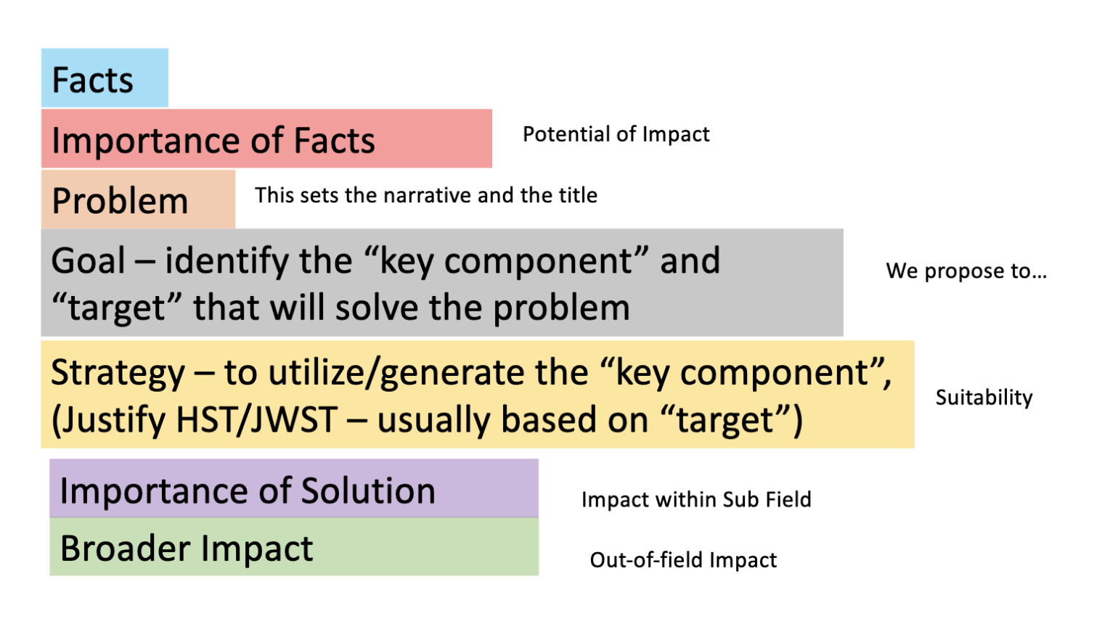



Bashi, Dolev, and Shay Zucker. “Exoplanets in the Galactic Context: Planet Occurrence Rates in the Thin Disc, Thick Disc, and Stellar Halo of Kepler Stars.” Monthly Notices of the Royal Astronomical Society 510, no. 3 (2022): 3449–59. https://doi.org/10.1093/mnras/stab3596.

Sayeed, Maryum, Ruth Angus, Travis Berger, et al. “Exoplanet Occurrence Rate with Age for FGK Stars in Kepler.” The Astronomical Journal 169, no. 2 (2025): 112. https://doi.org/10.3847/1538-3881/ada8a1.

Using only stars with both isochrone and gyrochronology ages (2658 stars), we find no significant trend with occurrence rate and stellar ages. We tested the effect of mass and metallicity on age trends, and found a slight, decreasing trend (< 2σ) for lowmass, metal–rich stars. We urge caution in overinterpreting our results given the large uncertainties in both isochrone and gyrochronology ages, as well as our small sample size (235 planets and 2658 stars). We attempted to disentangle the effects of mass and metallicity (see Figure 5), but evaluating the occurrence rate along three axes – mass, metallicity, and age significantly reduced our sample size, especially for older stars (5.3 − 8 Gyr). Accurate ages for planet hosts are needed to effectively derive the relationship between planet occurrence rate and age.

