Part A: Figure and Caption
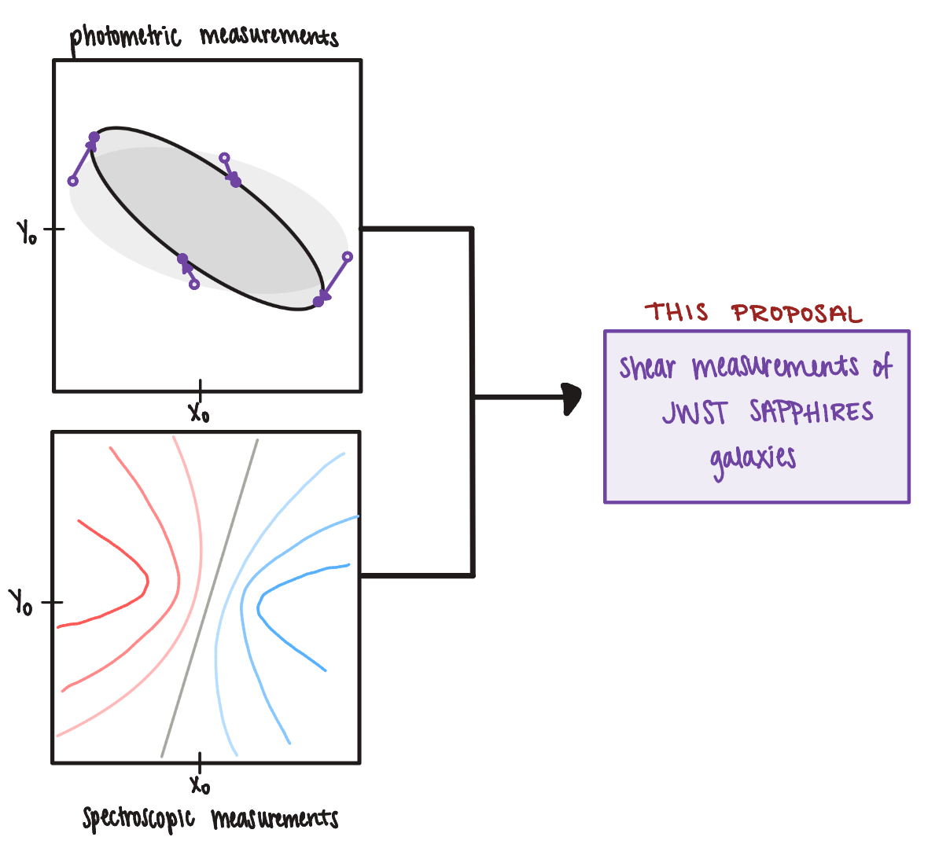
a)
Kinematic lensing will significantly reduce shape noise and allow for precise shear measurements, thus improving our ability to map the matter distribution of the universe. The left hand of the figure shows the two separate measurements necessary for kinematic lensing. a) shows how shear manifests in photometric samples, depicting a galaxy shape changing due to lensing. b) depicts the spectroscopic measurements as a line-of-sight velocity map, showing the redshift and blueshift of the galaxies. The right hand shows that the combination of these measurements will result in shear measurements of the JWST SAPPHIRES spiral galaxies. Weak lensing is currently one of the best tools to constrain cosmic evolution and dark energy, however, it is severely limited by shape noise due to the inability to distinguish the difference between intrinsic ellipticities and those produced by cosmic shear. We propose to apply the novel method of kinematic lensing to the JWST SAPPHIRES spiral galaxies to reduce shape noise by an order of a magnitude, enabling tight constraints on cosmic evolution and dark energy models.
b)

Part B: Talk Abstract
Talk Title: “Constraining Dark Energy: Reducing Shape Noise of Shear Measurements with Kinematic Lensing”

Abstract:
Weak gravitational lensing (WL) is a leading method of mapping the large-scale structure of the universe and its matter distribution. Precise measurements of galaxy shear enables tight constraints of the growth of cosmic structure and thus the ability to determine the cause of the accelerated expansion of the universe. However, WL shear is significantly small compared to the intrinsic ellipticities of galaxies, resulting in the inability to differentiate the signals, referred to as “shape noise,” and a need for large survey samples to achieve precise measurements with small statistical errors. In this talk, I will discuss an alternative method of shear measurement called kinematic lensing, designed to reduce shape noise by combining photometric and spectroscopic measurements of individual galaxies, and its application to JWST’s SAPPHIRES spiral galaxies. With the upcoming Nancy Grace Roman Telescope (Roman) later this year, it is crucial that kinematic lensing is tested thoroughly using JWST’s grism to refine and improve the method for future Roman grism measurements. An empirically tested model of kinematic lensing will allow for its application to many current and future surveys, enabling the most precise constraints on cosmic evolution and dark energy yet.

Proposal will be a pilot test of kinematic lensing (key) using JWST data (target)
Problem: weak lensing faces shape noise due to the random-orientation of galaxy ellipticies
Solution: introduce new method of combining photometric and spectroscopic imaging to get direct measurements on galaxy orientations to minimize shape noise when measuring shear
Facts: measuring shear shares information about the underlying dark matter and thus cosmic evolution of matter

