Assignment 2

Part A:
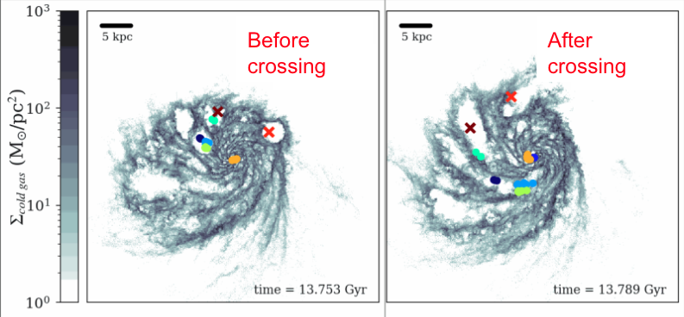
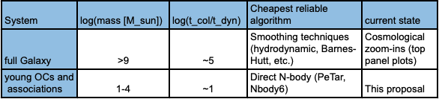
Figure 1: Although computationally challenging, direct N-body integration of low mass clusters within a realistic galactic potential will allow us to quantify the role played by the environment in cluster disruption and evolution. Top: gas distribution (grey colormap) and star particle members (colored points and crosses) of 8 identified massive young star associations identified within a Milky Way-like galaxy from the FIRE project shown at different times. Clusters are sheared along gaseous spiral arms when they cross the boundary between empty feedback bubbles and gas regions. Bottom: total mass, ratio between collisional and dynamical times, best N-body algorithms and state of simulations state of the art for different systems. Due to the high number of particles and the necessity of direct N-body techniques, simulations of low-mass clusters within a galactic potential remain a critical challenge to this date to understand the evolution of these clusters within a realistic environment. Understanding the evolution of young star associations within their host galaxies is crucial to model the structure and physical properties of both resolved and unresolved galaxies.

Part B:
An important number of stars in spiral galaxies are believed to be formed within dense embedded clusters covering a mass range of ${10}^{2}-{10}^{6}$ solar masses. The masses of these clusters as well as their disruption and evolution under the influence of their gaseous environment and galactic potential are crucial components to understand the structure and physical properties of both resolved and most importantly unresolved spiral galaxies. Although cosmological zoom-in simulations as well as HST and JWST observations of spiral galaxies suggest that gradients in the gas density play an important role in disrupting massive clusters ($>{10}^{4}$ solar masses), little is known about low-mass clusters due to resolution limitations. In this talk, I will explain how we can quantify the impact of surrounding gas in destroying low mass clusters by combining direct N-body simulations using PeTar with snapshots of realistic spiral galaxies simulations from the FIRE project. In this era of high computational power, the study of the evolution of low-mass clusters within a galactic context is not only crucial but most importantly possible for the first time! Such study is fundamental to more accurately model the formation, evolution, structure, and physical properties of both resolved and unresolved spiral galaxies within HST/JWST images. We will also be able to better understand the formation process of low-mass co-moving groups such as the ones observed in the solar neighborhood, a crucial step to understand the physical properties of their star members as well as their potential exo-planets.

Total number of characters in abstract:
1597

Colormap:
- facts
- importance of facts
- problem
- goal/target
- urgency
- importance to subfield

