ASTR 578
Mucha Assignment 4 Parts A & B

Part A: Figure and Caption

Modeling Vent Pipe Structures within Pitted Terrains on Mars: Insights from COMSOL Finite Element Modeling
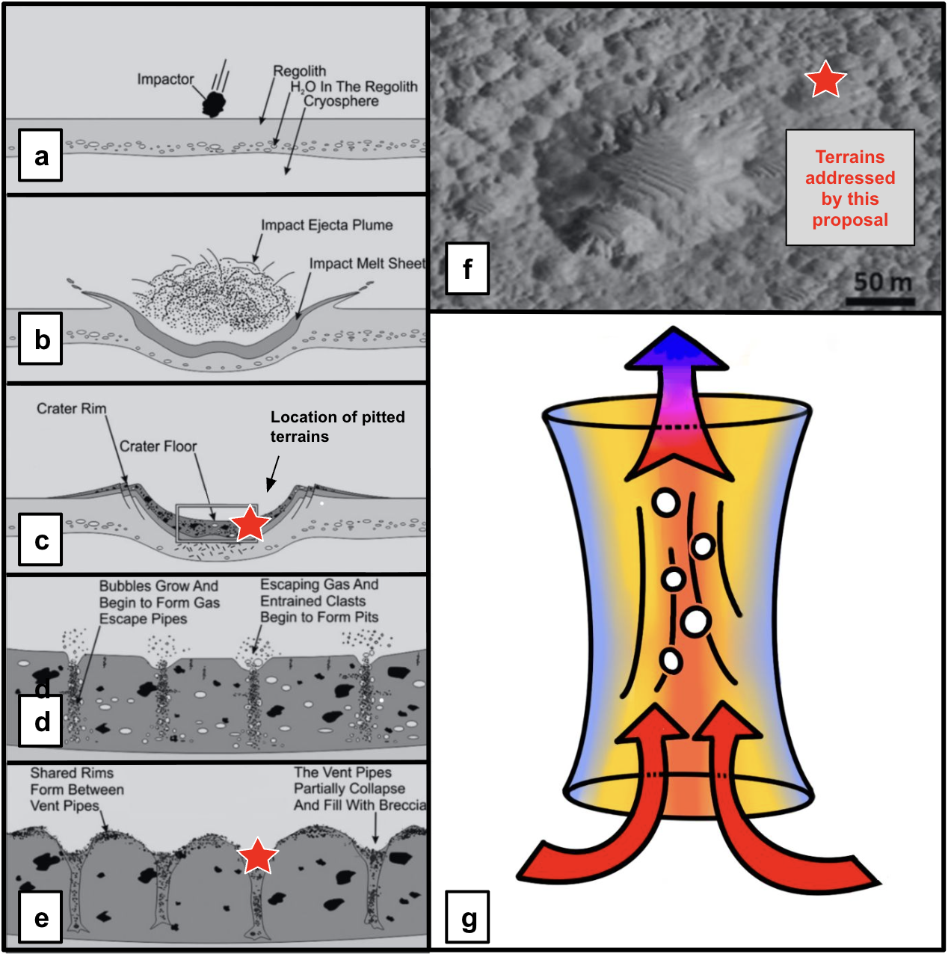

Constraining the dynamics of heat flow within Martian impact-generated hydrothermal systems will offer insights into the microbial habitability of these terrains. Panels a though f, modified from Boyce et al., 2012, describe the formation of vent pipes within impact melt deposits, and panel f is a portion of HiRISE image PSP_007406_2035 depicting varying sizes of pitted terrains on the floor of Tooting Crater on Mars, with red stars denoting areas where pitted terrains can be observed. Panel g is a schematic illustration of an isolated vent pipe structure, to be modeled by this proposal, with arrows indicating the direction of flow through the conduit. Vent pipe structures, theorized to form pitted terrains within impact craters, have not been studied with modern finite element modeling approaches, indicating our understanding of the dynamics of these systems is incomplete. We propose to model volatile escape through vent pipe structures using the finite element modeling software COMSOL Multiphysics, which will constrain the dynamics of fluid flow following impact events on the Martian surface, allowing us to ascertain the duration of post-impact habitable temperatures and water volumes, informing future mission directions and sampling strategies.

Part B: Talk Abstract

Constraining the Habitability of Martian Impact Crater Hydrothermal Systems: Insights from COMSOL Multiphysics Finite Element Modeling of Vent Pipe Structures

Recent high resolution images of the Martian surface collected by the High Resolution Imaging Science Experiment (HiRISE) have revealed detailed information about enigmatic pitted structures within impact craters, interpreted to be the remnants of post-impact hydrothermal systems. These hydrothermal systems are theorized to be transiently habitable systems on the surface of Mars, an otherwise cold and nutrient-depleted planet, indicating they may be unique high-priority targets in the search for extinct and extant life. However, uncertainties regarding the dynamics of hydrothermal circulation, starting with constraining fluid flow and heat dissipation within vent pipe structures, makes it challenging to define habitable regions on Mars. In this talk, I will discuss the formation of impact-generated hydrothermal systems, and introduce the finite element modeling software COMSOL Multiphysics as a strategy by which to model and understand vent pipe structures within pitted terrains. The advanced capabilities in modeling heat transfer, fluid flow, and structural mechanics offered by COMSOL Multiphysics have not been applied to the study of Martian impact crater hydrothermal systems, indicating our understanding of these structures and their implications for habitability is incomplete. The results of this work are critical to ongoing research on the Martian surface, including informing future sampling missions and selecting intriguing targets for astrobiological exploration.

Abstract Color Code:
Facts
Importance of Facts
Problem
Goal – identify the “key component” and “target” that will solve the problem
Urgency/Importance to Subfield
Broader Impact to Field

