Constraining Stellar Mass-Halo Mass Relation From Stacked Lensing of Dwarf Galaxies
P.I. Chen-Yu Chuang
Scientific Writing Assignment 4 Part A&B
Empirical scaling relations have enabled estimates of the stellar–to–halo mass relation (SHMR) across a broad range of galaxy masses. The SHMR at the dwarf scale is especially powerful because it links galaxy formation to small-scale dark-matter structure, where different dark-matter models can diverge most strongly. At the low-mass end, many SHMR constraints rely on indirect halo-mass inference, leaving systematic uncertainties from selection, baryonic physics, and environment largely uncalibrated by an independent mass probe. In this talk I will demonstrate a strategy to independently calibrate dwarf halo masses ($M_{h}∼{10}^{10}-{10}^{12} M_{⊙}$) by stacking lensing signals around large samples of $z∼0.2-0.8$ dwarfs in Roman WFI deep-field data and transferring that calibration to shallower wide-field samples. Roman’s High-Latitude Survey is designed for weak lensing and will deliver uniform, space-based imaging with rapid public release, enabling timely, community-wide low-mass halo-mass calibration during the first survey data products. Establishing an independent low-mass halo-mass scale will sharpen tests of dark-matter physics and clarify how star formation proceeds in the smallest halos, strengthening the foundation for interpreting the next generation of wide-field galaxy and lensing surveys.

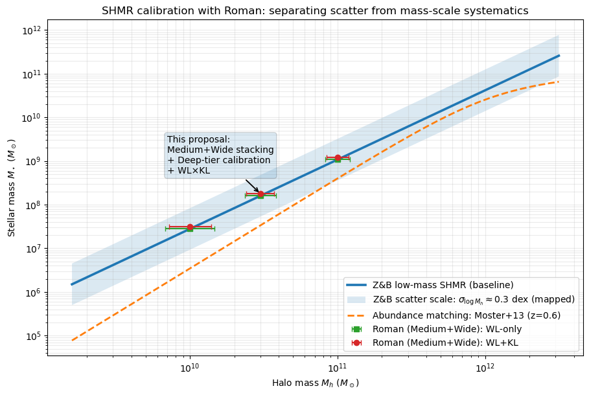
Broader Impact: Roman will deliver an independent calibration of dwarf halo masses that anchors the low-mass stellar–halo mass relation and strengthens small-scale tests of dark-matter physics.
This figure shows the low-mass SHMR baseline from Zaritsky & Behroozi (2023) with an indicated scatter scale and a comparison abundance-matching relation (Moster et al. 2013). The Roman forecast points illustrate the expected uncertainty on the mean halo mass in bins using Medium+Wide-tier stacking and an improved weak lensing (WL)+kinematic lensing (KL) combination, enabled by the HLWAS’s >5000 deg² total Medium+Wide area and weak-lensing–optimized survey design. The key problem is that low-mass SHMR inferences can be limited by mass-scale systematics tied to modeling assumptions rather than by statistical errors alone, motivating an independent calibration. We propose to use Roman Medium+Wide-tier stacked weak lensing, calibrated by the Deep tier and strengthened by WL×KL, to constrain the dwarf-halo mass scale and thereby improve the reliability of low-mass SHMR constraints central to galaxy–halo connection and dark-matter tests.

