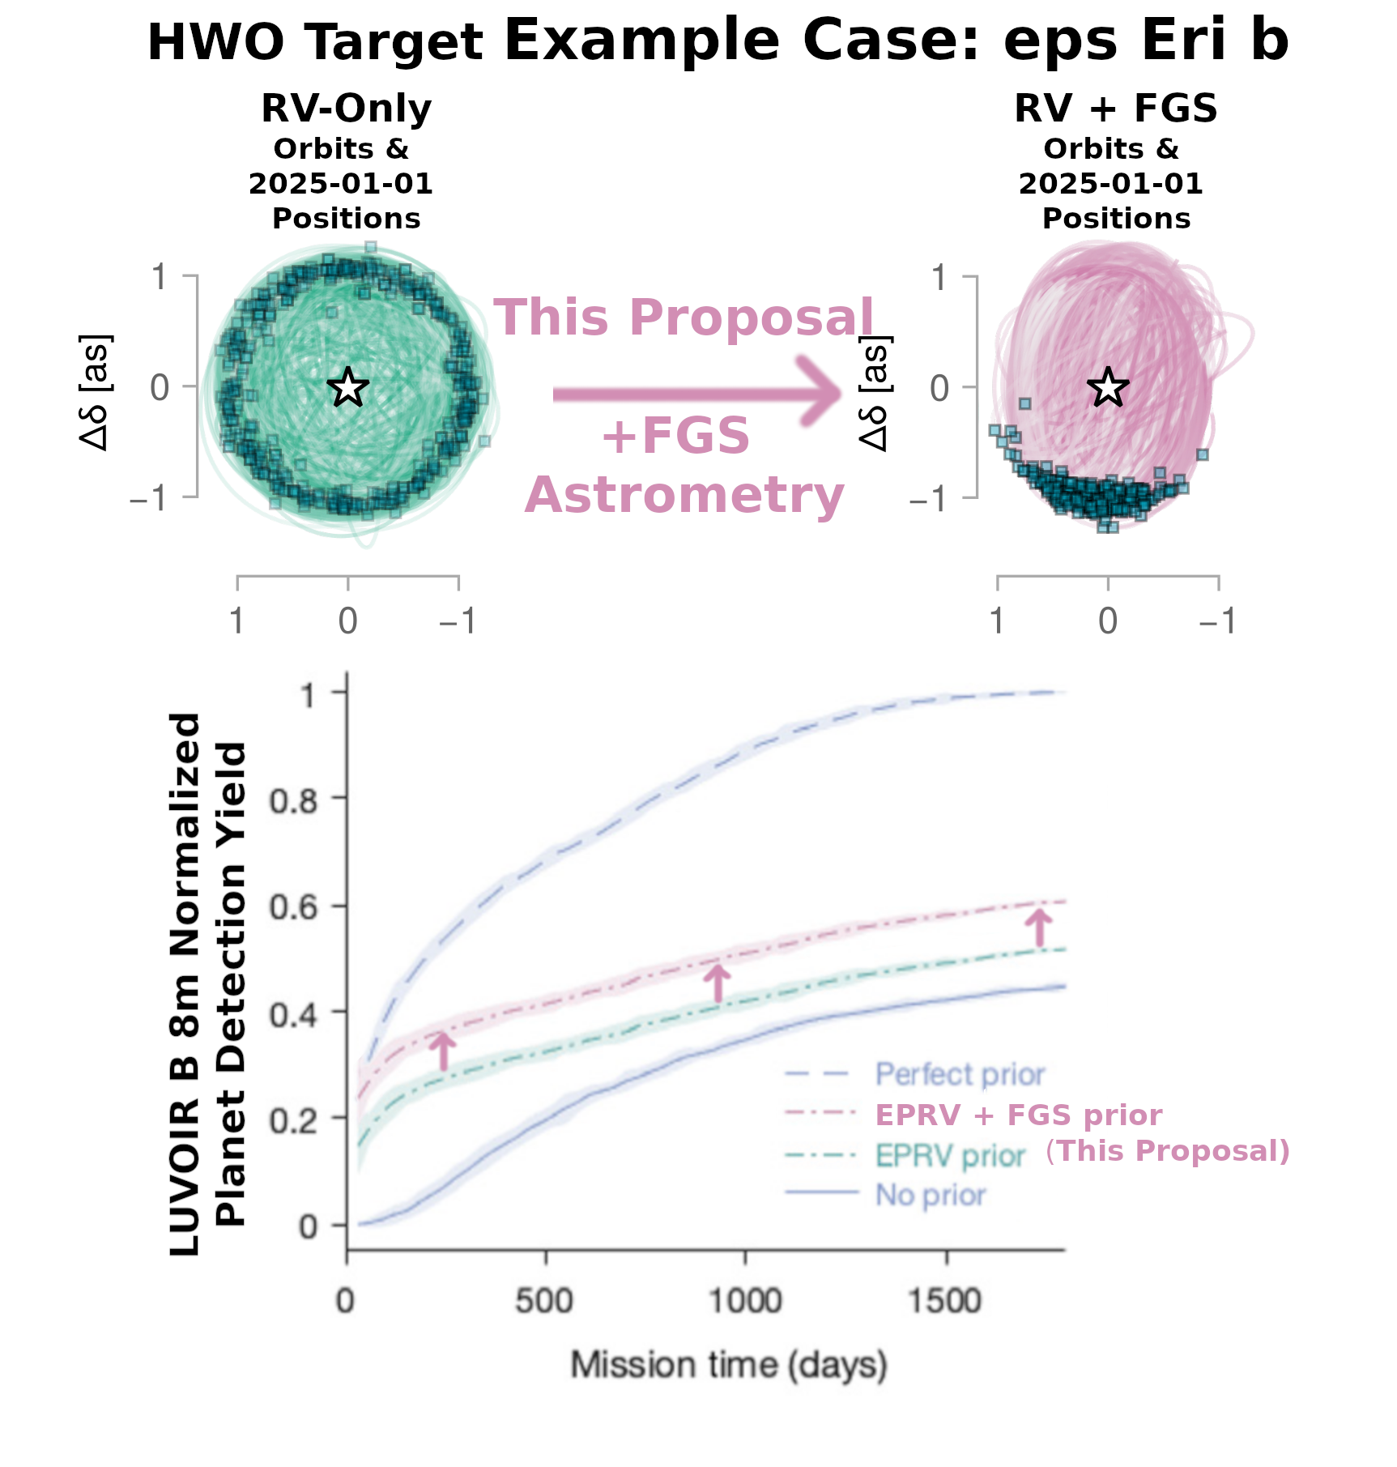
Absolute astrometry measurements of Habitable Worlds Observatory (HWO) target stars with the HST Fine Guidance Sensors (FGS) will increase HWO planet detection yield and characterization science return by decreasing planet position uncertainty. Top: Orbits (traced) and predicted locations for eps Eri b on 2025-01-01 (square points) sampled from orbit fit posteriors derived from RV data (Left) and RV data + HST/FGS astrometry (Right) (adapted from Thompson et al. 2025). Bottom: LUVOIR B 8m planet detection yields as a function of mission elapsed time based on different cases for planet orbit prior knowledge. All yields are normalized to the yields from perfect orbital priors. EPRV + FGS curve is illustrative only (adapted from Morgan et al. 2021). Orbital fits for exoplanets like eps Eri b are largely based only on radial velocity measurements. Orbital constraints from only RVs leave the orbital inclination, planet mass, and longitude of ascending node ambiguous, resulting in large uncertainties in planet position at any given epoch. These uncertainties are greatly mitigated by the inclusion of host star astrometric measurements. This program will perform dedicated HST/FGS astrometry for HWO target stars to place tighter orbital constraints on their Jovian-mass planets, thereby decreasing position uncertainties at future epochs and accelerating detection by exoplanet direct imaging missions like HWO.

Filling the Exoplanet Astrometry Gap: Refining orbits of HWO target planets with astrometric measurements from the HST Fine Guidance Sensors

Directly observing exoplanets around nearby stars based on prior knowledge of their orbits is one of the core missions of the Habitable Worlds Observatory (HWO) and its pathfinder mission, the Nancy Grace Roman Space Telescope Coronagraph Instrument (CGI). For a large part, these exoplanet orbital priors are based solely on radial velocity measurements which leave ambiguities in the orbital inclination, planet mass, and longitude of the ascending node. However, for direct imaging missions like HWO & CGI, these ambiguities are detrimental to the estimation of exoplanet observability windows. In this talk, I will demonstrate how a dedicated campaign to perform precision astrometric measurements on HWO target stars with the HST Fine Guidance Sensors (FGS) will resolve these ambiguities for Jovian-mass exoplanets. Astrometric measurements like this are most valuable when performed over long temporal baselines sufficient to cover at least one planet orbit - to perform these measurements in time for HWO, this campaign needs to begin now. This HST/FGS astrometry will enable higher efficiency observations with HWO and lead directly to more scientific output with increased numbers and confidence of exoplanet detections, improved dynamical constraints integral to contextualizing characterization observations, and allow for more time to be spent on the other scientifically fruitful observations possible only with HWO.

References

Morgan, R., Savransky, D., Turmon, M., Mennesson, B., Dula, W., Keithly, D., et al. (2021) Faster Exo-Earth yield for HabEx and LUVOIR via extreme precision radial velocity prior knowledge Journal of Astronomical Telescopes, Instruments, and Systems, 7, 021220. https://doi.org/10.1117/1.JATIS.7.2.021220
Thompson, W., Nielsen, E. L., Ruffio, J.-B., Blunt, S., & Marois, C. (2025) Revised Mass and Orbit of ∊ Eridani b: A 1 M_{Jup} Planet on a Near-circular Orbit The Astronomical Journal, 170(6), 301, IOP. https://doi.org/10.3847/1538-3881/ae0cbd

