PTYS578 Assignment 4: A&B
Lily Robinthal

A:

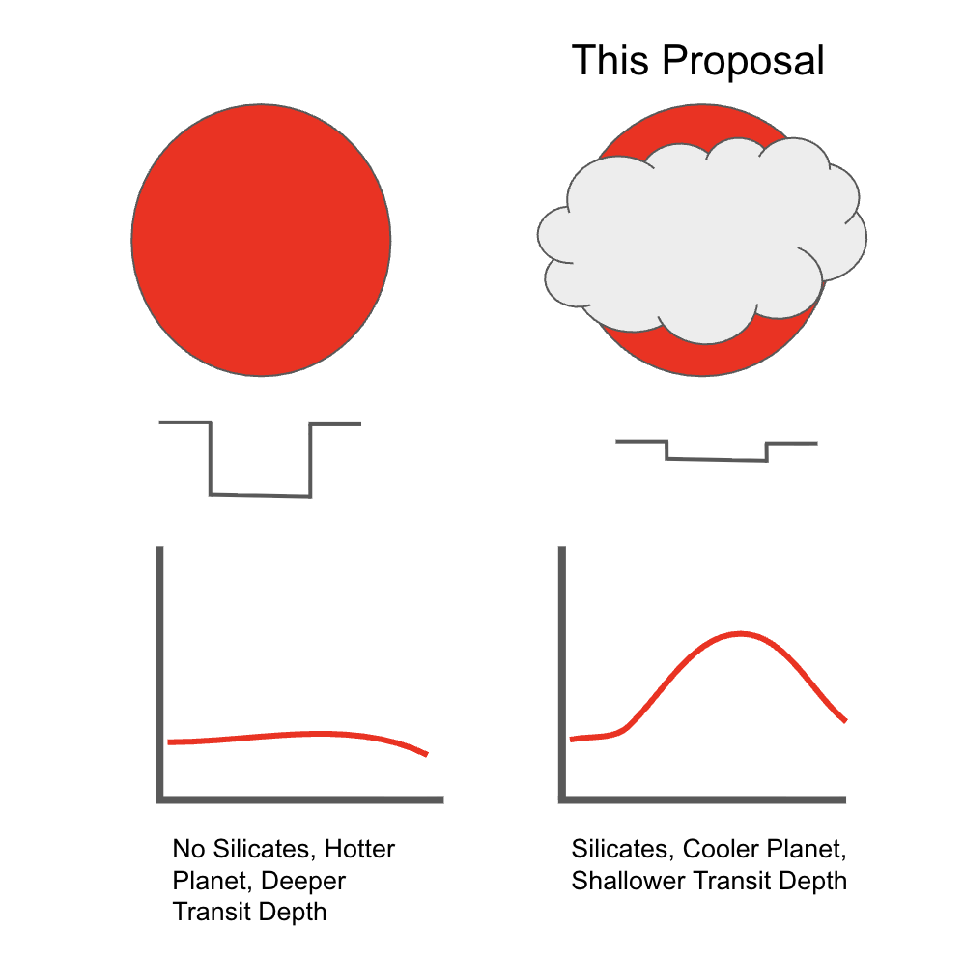

Figure 1: Observations of silicate features in the atmosphere of hot super-earth 55 Cancri e would support a cloud feedback mechanism as an explanation for observed variations in secondary eclipse occultation depth. On the left is a cloud-free planet with a hotter surface due to a lack of clouds blocking incoming radiation, which would result in a deeper secondary eclipse depth. On the right is a planet with silicate clouds in its atmosphere, which would result in a cooler planet and therefore a shallower secondary eclipse transit depth. We have not yet had the opportunity to confirm the existence of the silicate clouds that would drive this mechanism. We propose to perform simultaneous JWST MIRI and NIRSpec observations to probe the wavelengths at which such silicate features would appear, which will allow us to constrain 55 Cancri e’s atmospheric composition, explain its puzzling discrepancies in transit depth, and give us insight into an as-yet unexplored mechanism for driving climate on close-in rocky exoplanets.

B:
Solving the Mysteries of Close-in Super Earths: Observations to Constrain the Presence of Silicates in the Atmosphere of 55 Cancri e

55 Cancri e represents a type of planet for which there is no counterpart in the solar system: the Super Earth. Understanding this enigmatic variety of planet is essential if we are to obtain a full picture of planetary formation, evolution, and composition. However, 55 Cancri e has thus far provided us with far more questions than answers; one of these is its strong variation in secondary eclipse transit depth over the course of multiple observations. In this talk, I will discuss the JWST observations that could constrain a possible mechanism to explain this strange quality that hinges on the presence of silicates in 55 Cancri e’s atmosphere. JWST is the only instrument with the capability to perform the necessary multi-wavelength observations, and it is crucial that we take this opportunity to do so, as it will determine what follow-up observations of this planet might be necessary. If we can solve the mystery of 55 Cancri e’s variable transit depths, it will give us entirely new insight into a mysterious type of planet that will inform everything we know about planetary formation and climate going forward.

Fact, importance of fact, problem, goal, urgency, broader impact

References:
Loftus, K., Luo, Y., Fan, B., & Kite, E. S. (2025). Extreme weather variability on hot rocky exoplanet 55 Cancri e explained by magma temperature–cloud feedback. Proceedings of the National Academy of Sciences, 122(17), e2423473122.

