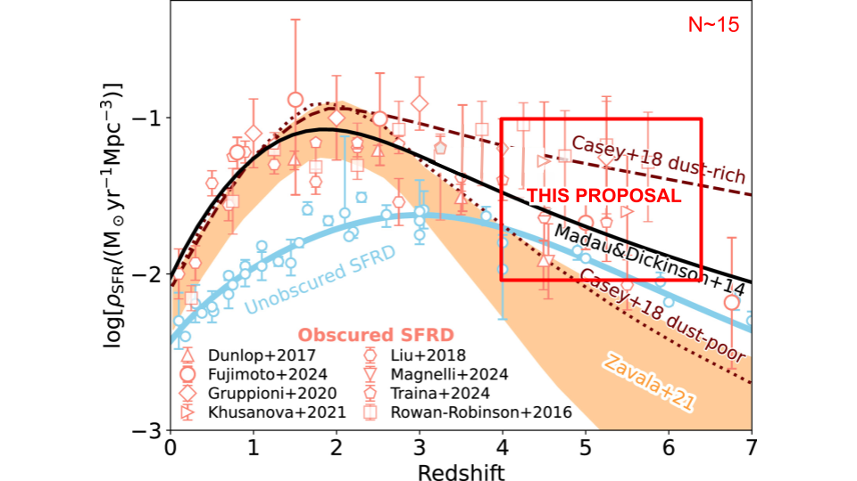

Spectroscopic follow-up of dusty star forming galaxies in the Epoch of Reionization is integral to constrain models of dust production and massive galaxy formation. Existing measurements of the obscured star-formation rate density are shown in open salmon symbols and unobscured measurements are shown in light blue (Sun et al. 2025). Models of a dust-rich and dust-poor early universe are shown by maroon lines while an inferred obscured SFRD from a backwards evolution model is shown in orange. The parameter space that will be probed by this proposal is outlined in red. Existing measurements of the obscured SFRD at z>4 are both sparse and highly uncertain, largely due to spectroscopic uncertainty. This proposal will observe ~15 DSFGs at z>4 with NIRSpec to constrain the obscured star-formation history with unprecedented accuracy and resolve the long debate between a dust-poor and dust-rich early Universe.

When Did It Get So Dusty: A Spectroscopic Census of High-z Dusty Star-Forming Galaxies

Dust obscuration hides a substantial fraction of star formation at early cosmic times. Observations of dusty star-forming galaxies (DSFGs) are integral for determining the precise obscured fraction of the cosmic star-formation rate density (SFRD) and testing models of early massive galaxy growth. However, while JWST has pushed extragalactic science to higher and higher redshifts, the abundance of DSFGs at z>4 is poorly constrained due to their relative rarity, faintness, and uncertainties in photometric analyses. In this talk, I will present NIRSpec observations of ALMA 2mm selected DSFGs from z=4-7 used to constrain the obscured star-formation history with unprecedented accuracy. Recent JWST observations of early, massive quiescent galaxies challenge existing models of high-z galaxy evolution and dust production, implying the early Universe may be dustier than previously thought. The results of this work are vital to constraining the onset of cosmic star formation and settling the long debate between a dust-poor and dust-rich early Universe.

