Part A: Figure and Caption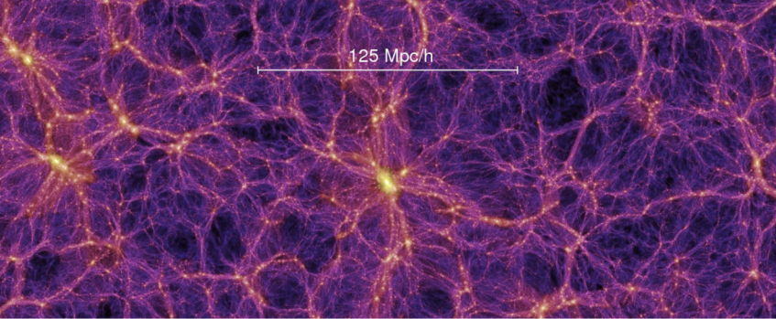

20 Mpc h⁻¹
Linear Regime
Non-linear Regime

Two-Point Statistics: 2PCF, Power Spectrum
Beyond Two-Point Statistics: Density-split clustering, Voids, etc.
This Proposal: greedy algorithm combination
Figure 1: We will achieve tighter and more robust cosmological constraints by recovering information contained in both linear and non-linear regimes of large-scale structure. The figure illustrates the Gaussian, perturbative large-scale density field and the complex, non-Gaussian small-scale structure separated by the approximate boundary 20 Mpc h⁻¹, as well as the statistics used to probe these regimes. Standard analyses rely primarily on linear statistics and therefore miss much of the cosmological information encoded in non-linear structure, while naively combining many non-linear statistics leads to large, highly covariant data vectors. We propose to use a greedy algorithm to identify and combine the most informative bins from both linear and non-linear statistics into a single and optimized data vector. This approach will enable efficient recovery of non-Gaussian information while retaining the robustness of linear probes, leading to significantly improved cosmological constraints.

Part B: Talk Abstract about the Figure
Title: Optimizing Cosmological Constraints: Two-Point Statistics and Beyond
Abstract:
On large scales, the matter density field of the Universe is well described by a Gaussian random field, while on small scales non-linear gravitational evolution generates non-Gaussian structure. This non-Gaussian regime contains a substantive amount of the cosmological information available in galaxy surveys. However, most standard analyses rely solely on summary statistics designed for Gaussian fields, and no robust framework yet exists to model them jointly with beyond–two-point statistics. In this talk, I will discuss a strategy to combine information from two-point and alternative summary statistics using a Fisher-information greedy algorithm that identifies the most informative measurements across all statistics. With large surveys like DESI questioning the ΛCDM framework, it is critical to efficiently exploit the full wealth of information from both Gaussian and beyond two-point statistics. Combining large- and small-scale information is crucial for fully realizing the potential of large-scale structure as a probe of fundamental cosmology, while also providing new insights into galaxy evolution and the galaxy–halo connection.

Fact
Importance of Fact
Problem
Goal
Urgency/Importance
Future Outlook/Broader Impact

Character count: 1149

