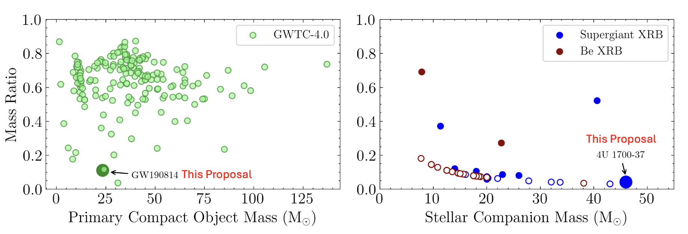
Unraveling the Origin of The Most Extreme Gravitational Wave Events and X-ray Binaries. Left panel: The mass of the primary (heavier) compact object and the mass–ratio of the system for all the confident GW events in the cumulative GWTC 4.0 catalog ( The LIGO Scientific Collaboration et al. 2025c). Right panel: The mass of the companion star and the mass–ratio of the system for all the HMXBs in the catalog of F. Fortin et al. (2023). Blue circles denote Supergiant XRBs, while red circles represent Be XRBs. GW190814 and 4U 1700-37, highlighted with larger circles in both panels, are clear outliers in their respective populations. GW190814 has one of the lowest mass–ratios among GW events, while the XRB 4U 1700-37 has the most massive companion star among known XRBs. Both host at least one compact object whose BH or NS nature remains unknown. The origin of outlier events such as GW190814 remains a puzzle, and with a rapidly growing GW catalog, the number of outliers is bound to increase, posing a challenge for GW population analyses. XRBs are a potential intermediate step towards a GW source, and provide key insights into their formation. We propose to develop detailed binary evolution models to reveal the formation history of both GW190814 and XRB 4U 1700-37, thus providing a unified framework to bridge the most extreme XRB with its GW counterpart.

(I imagine these acronyms will be introduced somewhere earlier in a proposal)
XRB = X-ray Binary
GW = Gravitational Wave
BH = Black Hole
NS = Neutron Star

A Step Towards the Extremes: Understanding the Origin of Highly Asymmetric Mass–Ratio Gravitational Wave Events and Galactic X-ray Binaries

The catalog of Gravitational Wave (GW) events is rapidly growing, and is poised to exceed thousands soon. GW observations have provided key insights into the evolution of massive binaries and compact object formation. However, one of the challenges is to explain the origin of outlier events such as GW190814, among the most asymmetric mass–ratio mergers to date. In this talk, I will discuss how we can leverage local observations of the most extreme Galactic X-ray binary 4U 1700-37 to develop detailed binary evolution models that can reveal the formation of both systems in a unified framework. GW observations will soon reveal numerous outlier events that may pose a challenge to population studies and various formation channels. At the same time, a variety of electromagnetic surveys will rapidly expand the population of massive binaries in various evolutionary stages. My work will provide a benchmark on how to jointly utilize diverse observations and detailed theoretical models to understand the origin of the most extreme GW sources and X-ray binaries. Moreover, this study will highlight the critical role of finding and characterizing local analogs in different evolutionary phases, and using them as a bridge to understand the origin of GW sources.

