Sophie Clark
ASTR 578
Assignment 4: Part A & B
Part A: Figure and Caption
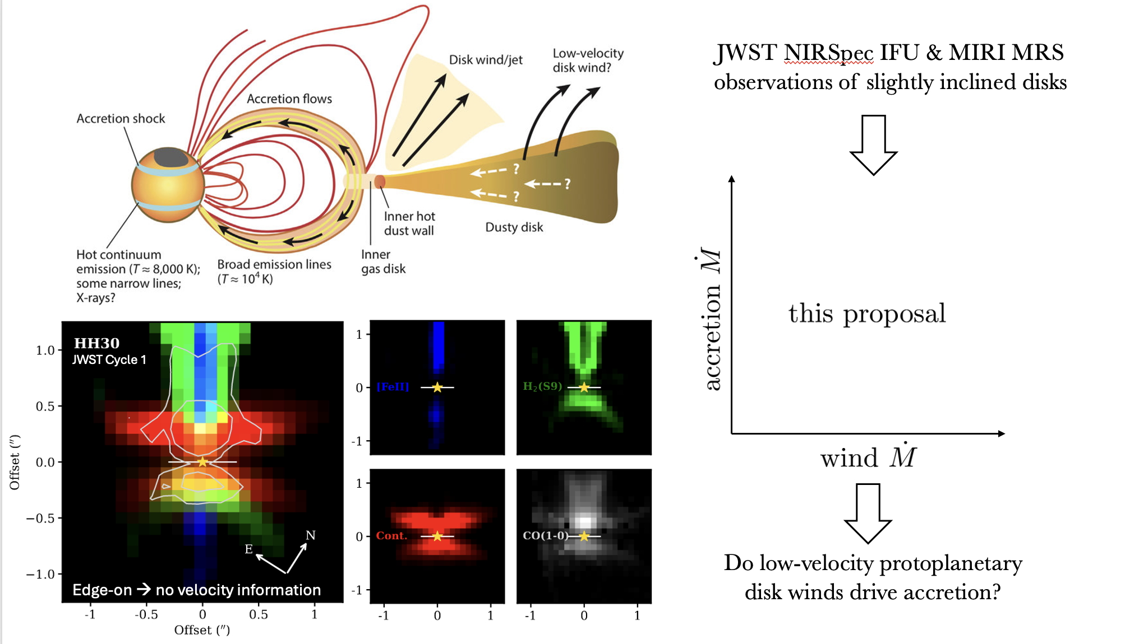
Figure 1: JWST Observations of Slightly Inclined Disks (JOSID) will investigate the extent to which mass removal via radially extended magnetohydrodynamic (MHD) protoplanetary disk winds enables accretion, thus progressing disk evolution and setting the stage for planet formation. (Upper left) A schematic detailing the morphology of disk accretion and high-velocity and low-velocity wind components from Hartmann et al. (2016). (Lower left) JWST NIRSpec & ALMA observations of edge-on disks from Pascucci et al. (2025), revealing the nested chemical morphology of disk outflows. (Right) The basic goals of this proposal. Since Pascucci et al. (2025) only surveyed edge-on disks, these observations are lacking velocity information, preventing a robust estimation of the wind mass loss rate. We propose for JWST NIRSpec IFU and MIRI MRS observations of four slightly inclined (i ~ 45°) protoplanetary disks so that we may produce robust estimates of the mass loss rate for each wind component, enabling an investigation of whether MHD winds are indeed responsible for protoplanetary disk evolution.
Part B: Talk Abstract About Figure
The James Webb Space Telescope (JWST) has provided stunning observations of young stars in the process of creating solar systems like our own. For the first time, we have a glimpse into the evolution of these systems, from the formation of the protoplanetary disk to its dispersion. However, even with these observations, the mechanism driving this evolution is poorly understood and remains a topic of debate between astronomers. In this talk I will discuss our efforts to identify the driving mechanism using spatially resolved JWST observations of slightly inclined disks, which allow us to measure the rate at which mass is lost via outflows from the disk surface and determine if magnetohydrodynamic (MHD) protoplanetary disk winds are the cause. We currently do not have observational evidence of radially extended MHD winds driving stellar accretion, and only JWST has the spatial and spectral resolution capable of probing this issue. Theory has shown that MHD winds will have dramatic effects on the process of planet formation and migration, and thus determining whether they are the responsible mechanism is crucial to our understanding of solar system formation.

References
Hartmann, L., Herczeg, G., & Calvet, N. (2016). Accretion onto Pre-Main-Sequence Stars. Annual Review of Astronomy and Astrophysics, 54, 135–180. https://doi.org/10.1146/annurev-astro-081915-023347
Pascucci, I., Beck, T. L., Cabrit, S., Bajaj, N. S., Edwards, S., Louvet, F., Najita, J. R., Skinner, B. N., Gorti, U., Salyk, C., Brittain, S. D., Krijt, S., Muzerolle Page, J., Ruaud, M., Schwarz, K., Semenov, D., Duchêne, G., & Villenave, M. (2025). The nested morphology of disk winds from young stars revealed by JWST/NIRSpec observations. Nature Astronomy, 9, 81–89. https://doi.org/10.1038/s41550-024-02385-7

