Part A:
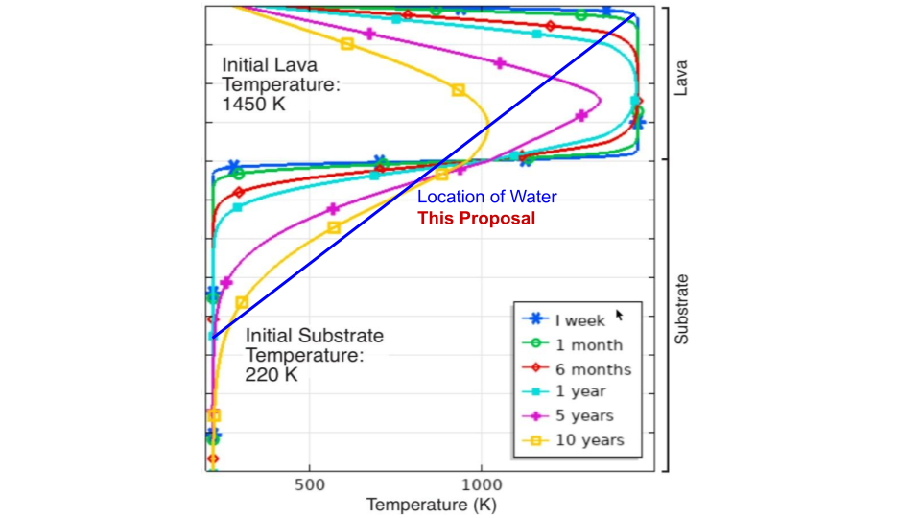
Figure 1: Understanding 2D transport of steam in the Martian subsurface, the process that creates volcanic rootless cones (VRCs) will inform estimates of lava-induced hydrothermal systems and their implications for habitability (Duhamel et al., 2022). Displayed is an example of implementation of a 1D conductive heat transfer model in COMSOL Multiphysics for a lava flow emplaced on a dry sedimentary substrate. In addition, the figure shows the movement of water through the substrate to burst through the lava, as this proposal will investigate through 2D models. Previous 1D models (e.g., Hamilton et al., 2011) assume water does not advect heat laterally, making 2D models of subsurface fluid flow critical for assessing hydrothermal system longevity. We propose to model volatile migration in the context of lava-induced substrate heating to determine how lateral transport of water affects thermal advection and hydrothermal system longevity, to enable surface observations (i.e. VRCs) to be used to infer subsurface thermal environments and the duration of ephemeral hydrothermal activity at the time of emplacement.

Part B:
On Earth, volcanic rootless cones (VRCs) form when lava vaporizes substrate water, generating steam explosions (Thorarinsson, 1951); on Mars, VRCs within the <5 Ma Athabasca Valles Flood Lava (AVFL; Jaeger et al., 2007) indicate ephemeral hydrothermal systems existed beneath these young lava flows. Quantifying the longevity of these lava-induced hydrothermal systems is critical for assessing habitability and microbial life potential on Mars and elsewhere (Duhamel et al., 2022). Previous 1D models (e.g., Hamilton et al., 2011) assume water does not advect heat laterally, but VRC concentrations along buried crater rims in the AVFL contradict this, as their concentration above buried topographic features implies later transport of water, steam, and heat toward thinner parts of the flow. In this talk, I will demonstrate that 2D models can better model heat and steam flow that form VRCs. These modeling results will enable surface observations (i.e. VRCs) to be used to infer subsurface thermal environments and the duration of ephemeral hydrothermal activity at the time of emplacement, which is desperately needed as the Mars 2020 rover searches for evidence of past life on Mars. Understanding 2D transport of steam in the Martian subsurface will inform estimates of lava-induced hydrothermal systems and their implications for habitability (Duhamel et al., 2022).

Sources Cited:
Duhamel, S., Hamilton, C. W., Pálsson, S., & Björnsdóttir, S. H. (2022). Microbial response to increased temperatures within a lava-induced hydrothermal system in Iceland: an analogue for the habitability of volcanic terrains on Mars. Astrobiology, 22(10), 1176-1198.
Hamilton, C. W., Fagents, S. A., & Thordarson, T. (2011). Lava–ground ice interactions in Elysium Planitia, Mars: Geomorphological and geospatial analysis of the Tartarus Colles cone groups. Journal of Geophysical Research: Planets, 116(E3).
Jaeger, W. L., Keszthelyi, L. P., McEwen, A. S., Dundas, C. M., & Russell, P. S. (2007). Athabasca Valles, Mars: A lava-draped channel system. Science, 317(5845), 1709-1711.
Thorarinsson, S. (1951). Notes on patterned ground in Iceland, with particular reference to the Icelandic “flás”. Geografiska Annaler, 33(3-4), 144-156.

