Part A – Figure and Caption
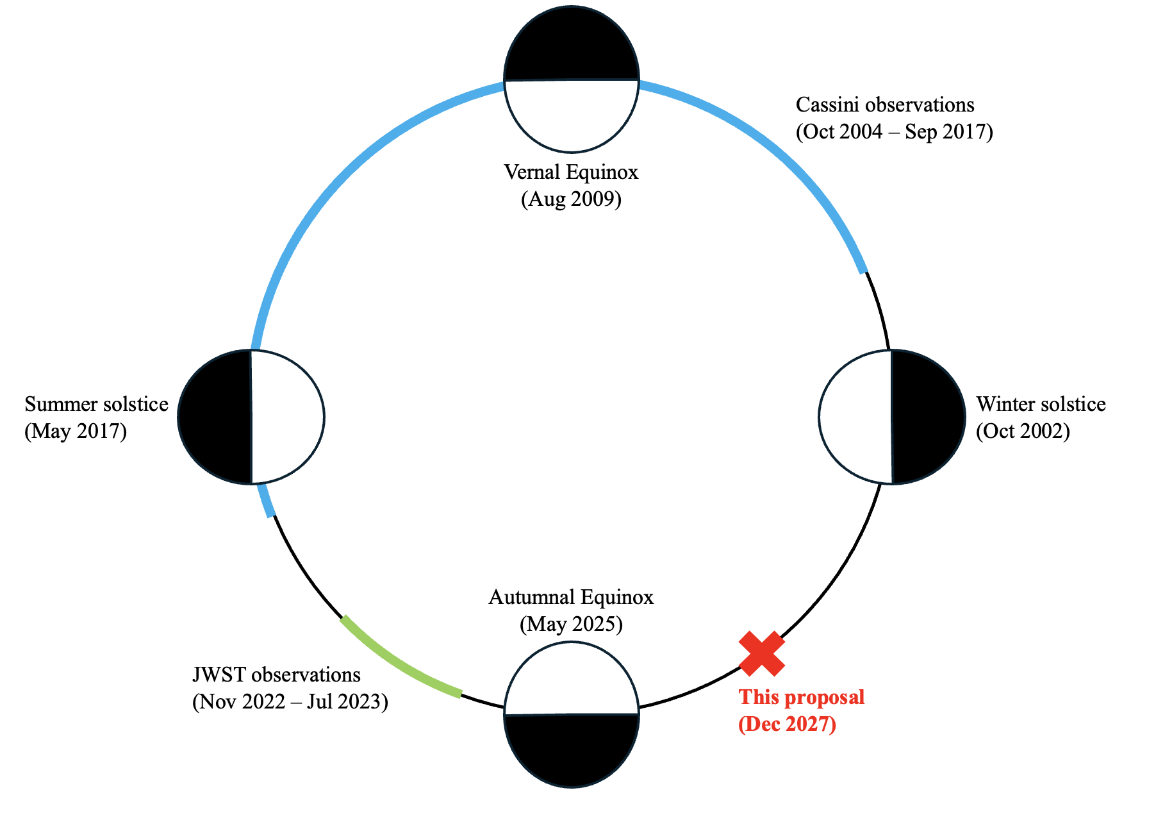
Figure 1: Our JWST observations will complete analyses of Titan’s seasonally evolving atmosphere. Cassini-Huygens observations occurred during northern winter and spring (figure adapted from Lorenz et. al., 2010), while previous JWST observations occurred during northern summer. In contrast, Titan’s atmosphere has been sparsely studied during northern fall. This program will robustly constrain Titan’s atmospheric composition and temperature profiles through JWST/FGS observations of the December 12, 2027 stellar occultation. These observations will inform efforts to accurately model Titan’s climate and photochemistry throughout Titan’s entire seasonal cycle.

Reference: Lorenz, R. D., Brown, M. E., Flasar, F. M., 2010, in Titan from Cassini-Huygens, ed. R. H. Brown, J.-P. Lebreton, Waite, J. H., doi: 10.1007/978-1-4020-9215-2 14

Part B – Talk Abstract

Monitoring Titan’s Seasonal Evolution: JWST/FGS Observations of a Stellar Occultation
Titan’s atmosphere experiences significant seasonal variations in composition and temperature. These variations impact Titan’s methane-based hydrocarbon cycle, distribution of photochemically-generated organic haze, and atmospheric structure. Titan’s seasonal variations were extensively observed during northern winter and spring. However, they were scarcely observed during northern summer and fall, preventing a complete understanding of Titan’s seasonal cycle. In this talk, I will describe a JWST/FGS Titan stellar occultation campaign scheduled for December 12, 2027, aimed at monitoring Titan’s seasonal evolution. This survey will exploit a rare, transient stellar alignment to provide robust constraints on Titan’s atmospheric composition and temperature profiles during northern fall. Because significant seasonal changes are anticipated during Titan’s northern fall, our measurements will assist in modeling Titan’s evolving climate and photochemistry throughout Titan’s entire seasonal cycle.

Key:
- Facts
- Importance of Facts
- Problem
- Goal/Strategy
- Urgency/Importance to Subfield
- Future Outlook/Broader Impact

