Part A
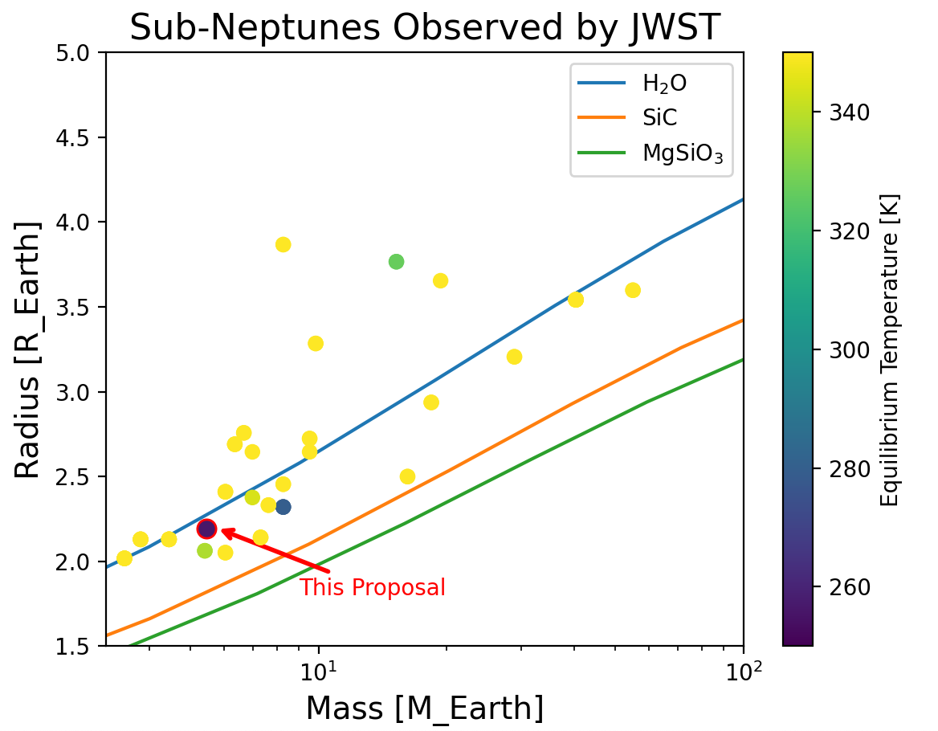
Figure 1. Observations of TOI-2257 b would characterize the sub-Neptune with the lowest equilibrium temperature yet observed by JWST. Plotted are all planets with radii between 2-4 Earth radii (sub-Neptune sized) that have been observed by JWST, color-coded by equilibrium temperature, with mass vs. radius curves for compounds that are often important elements of planetary composition also shown. TOI-2257 b, outlined in red, is also plotted. These sub-Neptune sized planets do not as a group follow the trend of any one consistent mass vs. radius curve, which is why these JWST observations are necessary to investigate the nature and diversity of sub-Neptune composition and internal structure. However, most of the sub-Neptunes observed by JWST thus far have equilibrium temperatures above 350 K. By observing TOI-2257 b (with an equilibrium temperature of 256 K), this program will use atmospheric properties to probe the interior structure of the sub-Neptune with the lowest equilibrium temperature yet observed by JWST, which will illuminate how the interior structures of cooler sub-Neptunes compare to those of the hotter sub-Neptunes that have already been observed.

Part B
Title: What Cool Sub-Neptunes Can Tell Us About Planet Formation: Transmission Spectra of the Lowest Equilibrium Temperature Sub-Neptune Yet Observed by JWST
JWST has now observed the atmospheres of almost 30 sub-Neptune-sized exoplanets. These observations are a key step toward understanding the nature and diversity of the interiors of sub-Neptunes, which are a class of planets that provide one border of the “radius valley”—the dearth of planets between approximately 1.5 and 2 Earth radii. However, the majority of sub-Neptunes observed so far have high equilibrium temperatures, above 350 K; and the lowest equilibrium temperature of a sub-Neptune observed with JWST so far is 280 K. Thus, we lack information about colder sub-Neptunes and whether and how they may differ in structure from hotter sub-Neptunes. In this talk, I will discuss transit spectroscopy observations of the sub-Neptune TOI-2257 b, which has an equilibrium temperature of 256 K and thus occupies a parameter space that has not been observed by JWST before. In order to fully understand the radius valley and its consequences for planet formation, we must observe a diverse range of planets, which we can now accomplish with JWST. This program will place constraints on the structures of cooler sub-Neptune exoplanets, which, due to their proximity to the radius valley, are a necessary piece of understanding planet formation.
Characters: 1248
Big picture fact
Importance of fact
Problem
Goal
Urgency/importance
Broader impact

