Ruby Fulford
PTYS 578
Assignment 4
February 11, 2026

Part A: Figure and Caption
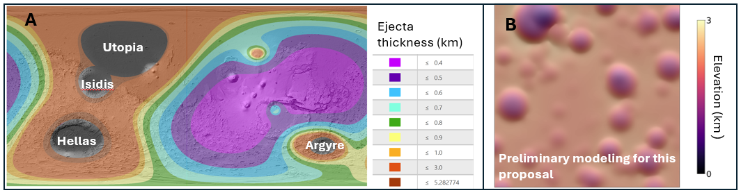
The ejecta generated by Mars’s four giant Noachian impacts--Hellas, Utopia, Argyre, and Isidis—blanket the southern highlands and obscure the pre-Noachian geologic record. Panel A shows estimated thickness of the combined ejecta from these four impacts. The thinnest region is ~400 m thick. Panel B shows results from a simple airfall model used to emplace 400 m of debris on a heavily cratered model landscape. The craters are altered but still visible, contradicting the widely-held assumption that giant basin ejecta fully erased the pre-Noachian geologic record. Because giant basin ejecta is so widespread, we must form a detailed understanding of how it interacts with pre-existing topography. We propose to use a debris flow model to simulate the effects of an ejecta layer of various thickness on a heavily cratered landscape. Results will enable us to determine whether any pre-Noachian topography still exists on Mars, offering new insight into a little-understood period of Martian history.

Part B: Talk Abstract

Title: Unburying Martian History: constraining the extent to which giant impact ejecta altered the pre-Noachian geologic record.

The four giant Noachian impacts–Hellas, Utopia, Argyre, and Isidis–undoubtedly generated a massive amount of ejecta that blankets the Martian surface. Because the oldest terrain on Mars only crater-dates as far back as the early Noachian, it is often assumed that the ejecta from these giant impacts completely destroyed any evidence of pre-Noachian craters and topography. However, the thickness distribution of the ejecta layer and its interaction with the pre-existing topography is not well constrained, and therefore it is unclear whether impact ejecta alone would have fully erased the pre-Noachian geologic record. In this talk, I will demonstrate how we can use a debris flow model to simulate the effects of an ejecta layer of various thickness on a heavily cratered pre-Noachian landscape, which will show us whether other processes like flood volcanism or fluvial erosion are required to alter the pre-Noachian topography to the observed degree, and whether subtle remnants of pre-Noachian topography remain on Mars’s surface. As new data from rovers and orbiters offers us increasingly detailed views of Mars’s surface, it is imperative that we understand exactly how the giant impact layer shaped the landscape so that we can correctly interpret the geologic record. Investigating how giant impact ejecta shapes a landscape also has important implications for the surface geology of other bodies that have experienced giant impacts, such as Mercury, Callisto, and Earth’s Moon.

Color Code:
Fact
Importance of fact
Problem
Goal+strategy
Importance to subfield
Broader impact

