Assignment 4

Part A:

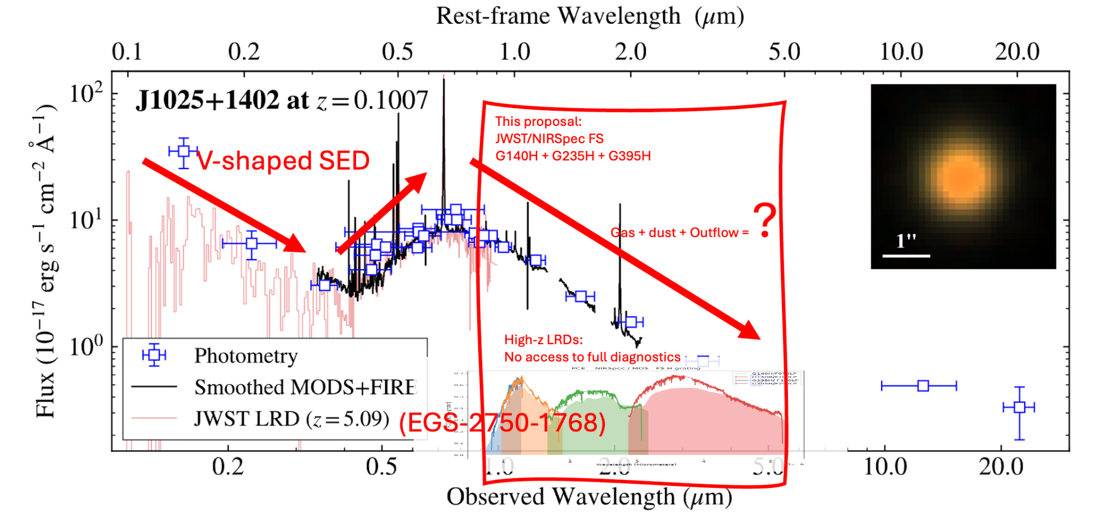
JWST/NIRSpec will provide the first full rest-frame near-infrared diagnostics to uncover the physical nature of little red dots (LRDs).The spectra compare the SED of the local LRD analog “The Egg” (black curve with blue photometric points) to that of a representative high-redshift JWST LRD (red), highlighting the wavelength regime inaccessible for distant sources (Lin, X. et al. 2026).
This program will obtain high-resolution near-infrared spectroscopy of “The Egg” to enable precise BPT diagnostics, molecular and forbidden line analysis, and hot-dust continuum characterization, establishing a physical template for interpreting LRDs across cosmic time.

Part B:

Talk title: Early Black Hole Growth: Unlocking the Missing Diagnostics of Little Red Dots

Talk abstract:
Little red dots (LRDs) represent a newly discovered population of compact, red AGN-like sources in the high-redshift universe, residing in the high-redshift universe. Their V-shaped spectral energy distributions challenge conventional models of black hole accretion and early galaxy evolution. However, because of their high-redshift nature, critical rest-frame optical and near-infrared diagnostics are inaccessible, preventing robust measurements of gas density, metallicity, excitation mechanisms, and absorption features needed to distinguish between competing physical explanations. In this talk I will demonstrate a strategy to solve this problem by using JWST/NIRSpec to obtain high-resolution rest-frame near-infrared spectroscopy of a newly identified local LRD analog at z≈0.1, known as “The Egg.” By accessing spectral diagnostics unavailable in distant sources, we will perform precise BPT measurements, molecular and forbidden line analysis, and hot-dust continuum characterization. This low-redshift and relatively bright source (r = 19.003) enables high signal-to-noise spectroscopy within modest exposure times and allows us to probe redder rest-frame diagnostics that are inaccessible for distant LRDs using current facilities. Establishing the physical nature of LRDs through a calibrated local analog will provide a benchmark for interpreting compact AGN in the early universe. Ultimately, solving this problem will refine models of black hole growth, accretion atmospheres, and feedback in dense environments, advancing our understanding of faint AGN across cosmic time.

