ASTR/PTYS 578: Assignment 4 Part A,B & C

Part A& B DUE : Feb 11th 2026 by NOON
FORMAT: Word doc
FILENAME: LastName_Assignment4_PartAB

Part A: Figure and Caption

Construct a figure and caption that outlines a strategy for a solution to a problem that you will
use HST/JWST/Theoretical Model to solve.

i.e. the figure and caption convey: Target + Strategy = Solution.

Figure Details:

- The figure can be a diagram or sketch – you can design it by hand/power point etc. It does not have to be the final polished version that you will use in the proposal.
- You can modify a figure from a published paper – make sure to cite the paper.
- The figure can have multiple panels.
- Somewhere in the figure itself should be the words: “This proposal” to highlight the
- strategy being proposed.

Figure caption must follow the following format:

- First sentence: bold faced takeaway that highlights the broader impact of the program. Effectively states the outcome of the program.
- Second(+) sentence(s): Description of what is plotted
- Following the description is a statement of the problem related to the target, which will be solved by the plot.
- Last sentence(s) is the Goal. Must include : “This program will” … or “We propose to” AND the importance of the solution to the subfield. Underline the goal.

Part B: Talk Abstract about the Figure

Create a talk abstract centered on your figure. Include this in the doc after the Part A.

- Determine a talk title that is connected to “the problem” that is solved by your figure from Part A. Follow the “[Big Picture]: [Direct Problem]” format.
- Construct a talk abstract as follows:
  - One sentence : one big picture Fact
  - One sentence : Importance of the Fact.
  - One sentence: Problem – this is set up by the first two sentences.
  - One Sentence: Goal: “In this talk I will discuss/demonstrate a *strategy* to solve *the problem”. [ This maps on to “we propose” ]
    - If you don’t know the solution yet, that’s ok. you can write one idea down for now and we can build from there in class.
    - These Sites can help you figure out what you want to propose for:
      - JWST: https://webb.nasa.gov/content/science/index.html
      - HST: https://www.stsci.edu/hst/about/key-science-themes
  - One Sentence: Urgency/Importance to subfield. Why now? Why this facility/funding call?
  - One Sentence: Future Outlook/Broader Impact. End with a sentence about the importance of solving “the Problem” broadly to the field.
- Highlight each of the above components in your abstract in a different color.
- Abstract must be no longer than 20 lines of 85 characters of text (including spaces). In other words max 1700 characters including white spaces.

Part C: Presentation

Create a presentation slide deck based on your figure and abstract, and present the slides in a
short (7 min) talk to the class. The grade is based on the slide quality and presentation.
FORMAT: Oral presentation on schedule below & Upload a PDF of your presentation slides.
Format for Upload: “LastName_Assignment4PartC.pdf”
Deadlines:
- Upload your slides by March 5th at 5 PM on D2L.
- Presentation Schedule:
Feb 19th: Nick S., Carter M., Kayla S., Kylie H., Rafa B.
Feb 24nd: Maddy C., Ruby F., Devin H., Lily R., Tyler R.,
March 3rd: Aaron G, Alena C., Emily M, Madi V., Yichen L
March 5th: Lipika C., Cole M., Neev S., Chen-Yu C., Sophie C.
Duration: 7 minutes + 3 min discussion
Format/Instructions: Turn your abstract into a 7 slide presentation (with relevant images):
Slide 1) Title Slide – spend 1 minute setting the stage!
Include: title, your name, one picture that is evocative
Slide 2) (1-2 slides max) Fact – this should correspond to the first sentences of your abstract.
Set the background needed to understand the context for the problem
Slide 3) Importance of fact. (WHY does the topic MATTER – why should the audience care?)
Slide 4) The Target – what are you proposing to study/model?
Slide 5) The Problem – convey urgency in solving this *now*
Slide 6) Proposed Solution & Importance/Urgency (This will turn into the “we propose” e.g.
Target + Proposed Data = Solution). This is where the Figure you created in Part A should be
presented.
Slide 7) Broader Impacts/Future Outlooks: What future observatories/programs will benefit
from your proposal?
• Each slide must have a heading that states the *takeaway* point for the slide.
• You must explain the axes for each figure.
• When asked questions, you must repeat the question back to the asker.Grading Criteria for the entirety of Assignment 4: (20% of final grade)
- Part A: Follow the Structure Outlined Above for the Figure and Caption (/10)
- Part B: Follow the Structure Outlined Above for the Abstract (/10)
- Part C: (/20)
o Follow the Structure Outlined Above for the Presentation (/10)
o Quality of Presentation – clarity of slides & oral presentation (/10)
Participation (asking at least 3 questions to others)

Part A Figure and Caption

Panel 1)
Range of Archival X-Ray spectra Exposure Times vs. TDE Redshift
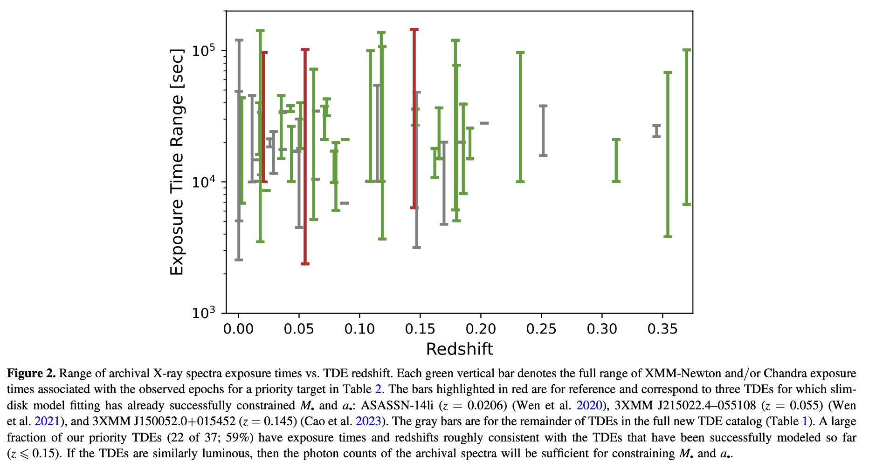
Citation: Goldtooth, A., Zabludoff, A. I., Wen, S., et al. 2023, PASP, 135, 034101

Panel 2)
Mass-Spin Constraints of SMBH TDEs: Early + Late Epoch Effects
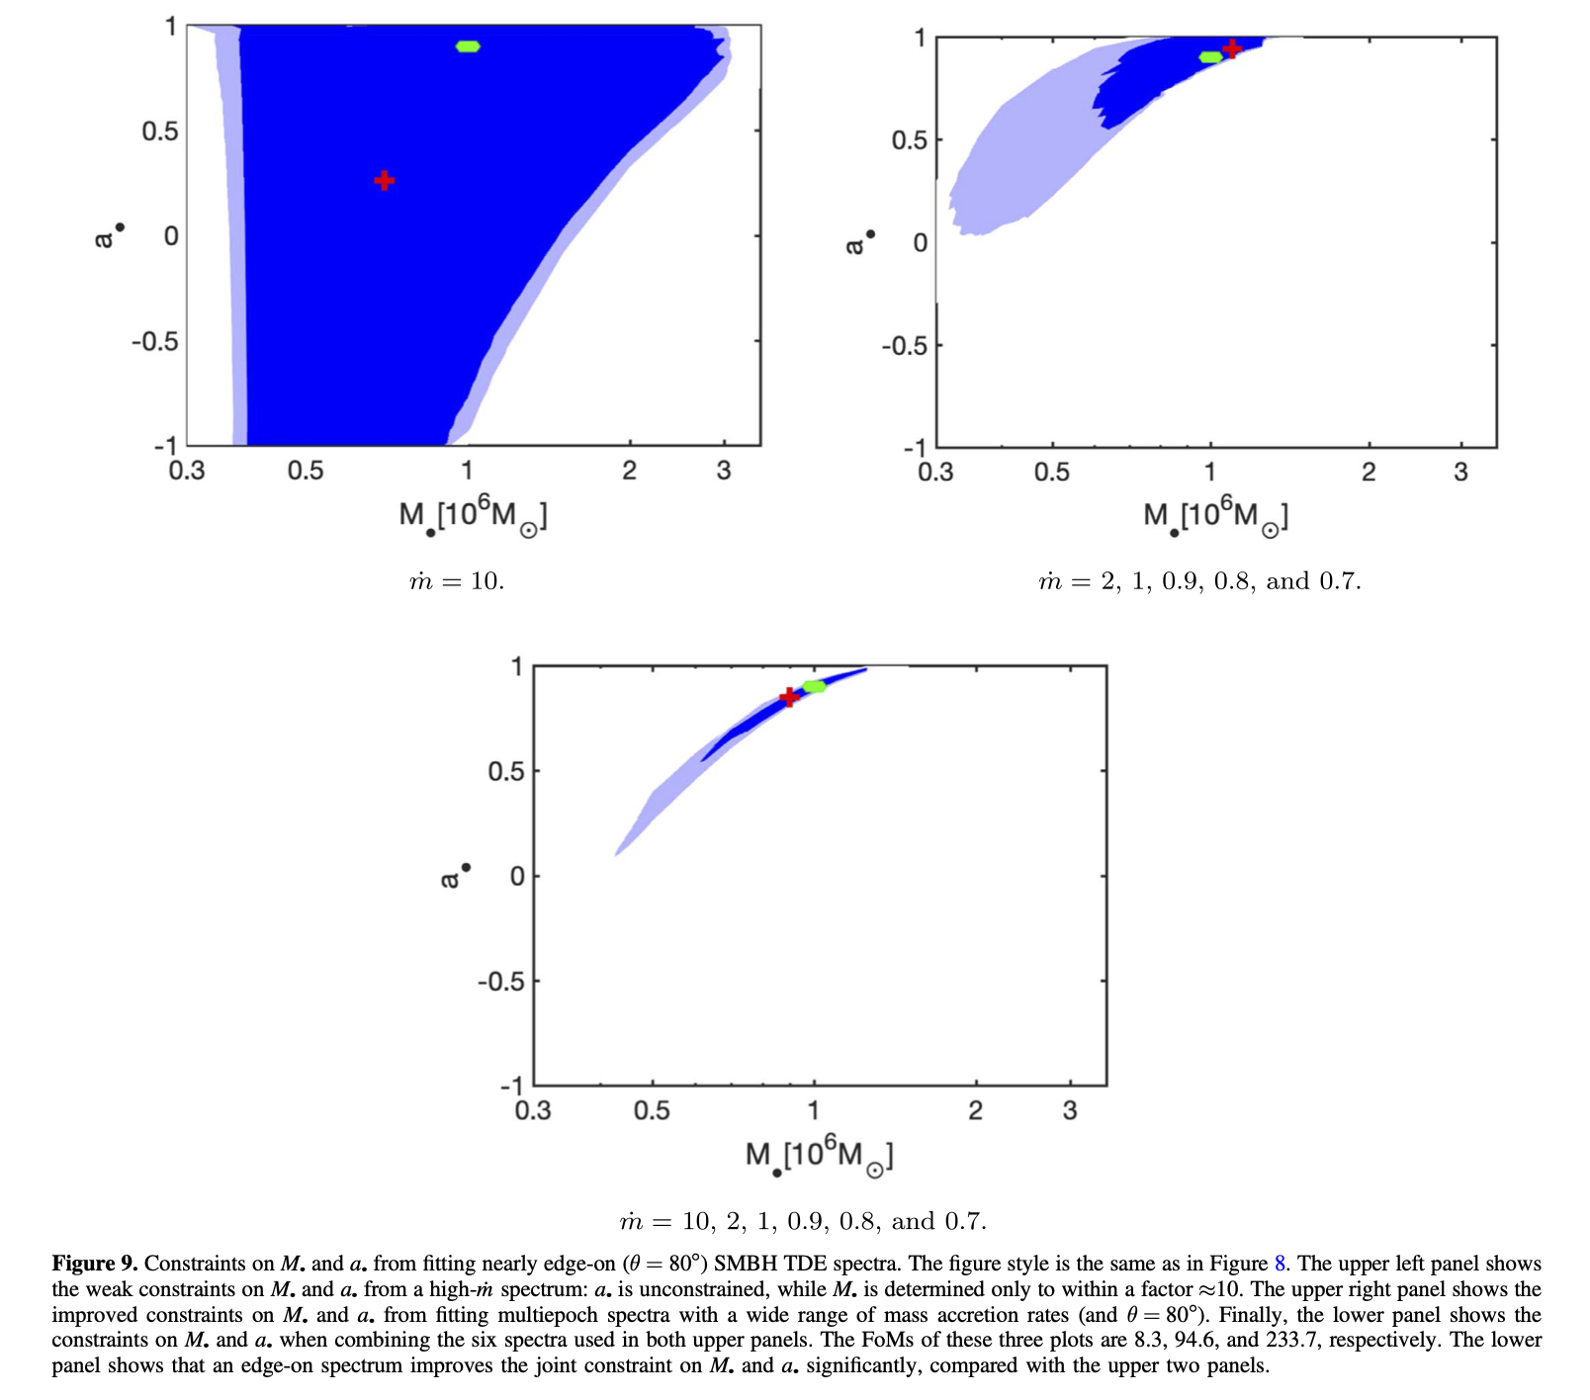

Citation: Wen, S., Jonker, G., Stone, N. C., Zabludoff, A. I., & Cao, Z. 2022b, ApJ, 933, 31

Panel 3)
Population-Level Constraints of SMBH mass-spin

[
Figure Description: Image here will be akin to panel 2 but with improved contours due to more robust modeling of systematics and calibration from modeling the available priority TDEs in Figure 1). Legend will show “This proposal” contours.
]

Overall Figure Caption:

Population-level calibration of supermassive black hole mass and spin enables well-tested, precision characterization of future TDE discoveries in the era of all-sky, time-domain observations. Panel 1): Current archival X-ray spectral data for TDEs showing epochs with deep X-ray data (>1000 s integration time) plotted against redshift. TDE epoch ranges are color-coded; red=successfully modeled targets (3), green=priority targets (34), and grey=all other TDEs (~100). Red and green targets share similar time coverage and depth at similar redshifts, indicating sufficient flux for successful fitting. Panel 2): The posterior constraints of SMBH mass and spin for synthetic spectra of a nearly edge-on SMBH (M=1e6 M_sun) accretion disk (theta=80 degrees) depend on the number, timing, and accretion rate of observed epochs. Epochs with higher, super-Eddington accretion along with sub-Eddington accretion yield the tightest constraints in mass and spin of their host SMBH (2c), than either case alone (2a or 2b). Panel 3): Population-level posteriors before and after calibration illustrate the reduction of systematic mass-spin degeneracies from calibrating the general-relativistic slim-disk accretion models for TDEs across larger population constraints. Currently, only three TDEs have been systematically fitted to a general-relativistic slim-disk accretion model, limiting systematic calibration of mass-spin degeneracies and preventing population-level inference. We propose to fit the remaining 34 priority TDEs and calibrate the slim-disk model for systematic effects including improved estimates of mass and spin for the host SMBHs, thereby enabling population-level constraints on black hole growth in the time-domain era.

Talk Abstract:

Title of Talk:
Preparing for the Time-Domain Era: Breaking Mass-Spin Degeneracies in TDE Slim-Disk Accretion Models

Abstract:

The mass and spin of supermassive black holes (SMBHs) are encoded in transient accretion events of tidally disrupted stars (Tidal Disruption Events, TDEs). Black hole (BH) mass and spin regulate the accretion efficiency and relativistic feedback of the accretion disk produced by the TDE. Current general-relativistic slim disk accretion models rely on constraints on only three well-modeled TDEs, leaving mass-spin degeneracies poorly calibrated. In this talk I will discuss a strategy to systematically model the remaining 34 priority TDEs with early, deep, multi-epoch X-ray data to break degeneracies in mass-spin space. Imminent all-sky, time-domain surveys such as LSST will increase TDE discovery rates by orders of magnitude, requiring calibrated models now. Establishing population-level constraints on BH mass and spin will advance accretion physics, tests of strong gravity, and further constrain BH growth scenarios.

Character count: 929

