Proposal Outline: DUE March 27th at Midnight
(LastName_Assignment6.doc on D2L)

Revise Title
- Revise abstract.
Adhere to word limit: The abstract must be written in standard ASCII and should be no longer than 20 lines of 85 characters of text. Use the HST/JWST Templates.
The Diverse Fates of Massive Stars in the Pair-Instability Regime: Impact of Binary Interactions
Very massive stars (≳$100M_{⊙})$ encounter the pair-instability limit during their evolution, which triggers their collapse and thermonuclear explosion(s) before they run out of nuclear fuel. Such stars are the progenitors of theorized (pulsational) pair-instability supernovae (P)PISN that lack unambiguous observational confirmation, and their remnants (if any) directly impact the black hole mass function actively being probed through gravitational wave observations. However, most massive stars have a companion with which they interact, dramatically altering the evolutionary pathway and final fate of both stars in the binary. Yet, the impact of such interactions on pair-instability evolution is largely unexplored. We propose to develop the first suite of detailed, publicly available models of massive interacting binaries, where the stars encounter the pair-instability limit during their evolution. For the first time, we will robustly demonstrate the influence of binary interactions on the evolution and fate of P(PISN) progenitors. We will use these novel models to address diverse science cases, including a rigorous determination of the remnant mass distribution of (pulsational) pair-instability supernovae, and the impact of binary interactions on the signatures of associated electromagnetic transients. Our proposed program is thus timely and critical for several ongoing efforts such as: 1) accurately measuring the upper mass-gap in the black hole mass distribution through gravitational wave observations; 2) identifying transients associated with (P)PISN through various time-domain surveys like LSST; and 3) used as initial conditions for 3D simulations of (P)PISN.
Science Justification will need to be 3 pages in total. This includes 1 figure, but not the bibliography.

Science Justification Outline
3) Provide an outline for your proposal (BULLETED POINTS that answer each of the below)
Section 1: Facts, Problem & Summary paragraph (3/4 of a page)
  - What is the descriptive heading? It must be a statement
The Need to Account for Binary Interactions in Models for (P)PISN Progenitors
  - 1 fact-based paragraph:
    - State the fact leading the paragraph (the conclusion) – this should follow from the abstract.
Very massive stars encounter a disruptive instability in the late stages of their evolution
    - What would be supporting facts (1-3)? Provide at least one paper citation per supporting fact.
1) Before running out of viable nuclear fuel, the low-density cores of these radiation-pressure dominated stars are hot enough to trigger the so called pair-instability, where radiation energy density is converted to electron-positron pairs. (Rakavy & Shaviv 1967)
2) The loss of radiation pressure robs the core of its pressure support, triggering its collapse, resulting in a thermonuclear explosion that leads to diverse fates depending on the mass of the star. (Woosley+2017)
    - What is the nuanced conclusion for the paragraph? This is the importance of the fact that should set the stage for the problem (should follow from abstract)
Such stars end their lives in the long theorized (pulsational) pair-instability supernovae. In the era of large sky surveys like LSST, it is an active effort to search for an unambiguous confirmation of the associated transients, and the remnants (if any) that they leave behind directly impact the black hole mass function that is only now being probed with gravitational wave observations.
  - Problem paragraph:
- What is “the problem” statement?
Most massive stars are found to be in interacting binaries, which affects the structure and evolution of both stars.
- What references are needed to support the problem?
Sana+25, Sana+12, Laplace+21, Renzo+23
- Why is the problem critical to answer now? (nuanced conclusion)
The effects of binary interactions have not yet been accounted for in existing models of (P)PISN progenitors, most of which only model the evolution of single, bare helium cores, neglecting the impact of previous binary interactions. Given that most massive stars are in binaries, this effect cannot be neglected.
  - Synopsis paragraph:
- What is the proposal? (identify key component) “We propose”
We propose to create the much needed detailed stellar evolution models of massive interacting binaries in the pair-instability regime.
- Why the facility? This can be related to the funding call.
NASA FINESST Proposal: This proposed research is directly relevant to the SMD Division “Astrophysics Research Program” to “explore the origin and evolution of the galaxies, stars and planets that make up our universe”
This proposal is directly relevant to several key areas identified in the 2020Astro Decadal Survey (mentioned in Broader Impacts section)
- What is the broader impact ? Community deliverables?
Our publicly available models will be released to the community, providing necessary tools to interpret the black hole mass function inferred through gravitational wave observations, predict signatures of transients associated with (P)PISN, and to be used as initial conditions for 3D simulations of (P)PISN explosions.
Broader impact: Our models are critical for:
1) interpreting gravitational wave observations of the black hole mass function;
2) predict and interpret signatures of (P)PISN-associated transients, directly informing the ongoing searches through various time-domain surveys and observations of the high redshift Universe.
3) To be used as initial conditions for 3D simulations of (P)PISN explosions.
Community deliverable: The first detailed stellar evolution models of massive binaries in the pair-instability regime that will be fully public.

Section 2: The Problem & Motivation/Narrative of the proposal
- Identify a descriptive heading that states the problem
Binary Interactions Will Impact the Evolution of (P)PISN Progenitors
- What fact do you need to start with to set up the problem?
1) Binary interactions are expected to dominate the evolution of massive stars, including the mass-range relevant for (P)PISN progenitors
2) Binary interactions significantly alter the internal structure of both stars in the binary.
3) The stripped donor stars in a binary have been shown to have systematically different density structures and composition profiles, both of which are essential components to determine the outcome of pair-instability evolution, and are known to impact their “explodability”
4) The mass-gaining accretor star, which can also enter the pair-instability regime is also impacted during the interaction phase. Studies have shown that the core of the accretor can grow (get “rejuvenated”) due to gaining mass, modifying the structure of its core-envelope boundary.
- What references support the problem?
Offner+23, Sana+25, Laplace+21, Renzo+23, Wagg+24
- State why solving this problem advances the subfield.
Although the density structure and mass of a star are known to determine the outcome of the pair-instability phase, the differences caused by binary interactions are not captured when only modeling single star (P)PISN progenitors. Given that (P)PISN progenitors will be in binaries, we need to include binarity to understand their evolution and explosions.
- Identify the “key component” missing to solve the problem.
Presently lacking detailed binary evolution models of (P)PISN progenitors.
- State that this program will generate the “key component” to solve the problem
Effects of binary interactions cannot be captured without computing the detailed binary evolution models of (P)PISN progenitors, such as those proposed here.
Section 3: The Strategy: HST/JWST + Target Solves the Problem (Generate the “Key Component”)
- Create a descriptive heading that states the strategy 🡪 “This Proposal: Observe/Model This Thing”
This Proposal: New Detailed Models for Massive Interacting Binaries in the Pair-Instability Regime
- What are you targeting ? (imaging/spectra/archival data of what astronomical object, or what physical mechanism/ simulations/data set )
Progenitors of (Pulsational) Pair-Instability Supernovae
- Why this facility? (Why HST/JWST? )
NASA FINESST: Key goal of SMD Division “Astrophysics Research Program” to “explore the origin and evolution of the galaxies, stars and planets that make up our universe”
- Outline (bullets) the strategy to generate the key component
- For GO: describe the proposed observations *briefly/succinctly*
  - For AR/Theory: describe *briefly* the analysis method/proposed usage of simulations/codes and relation to existing/future HST/JWST data sets.
  - You must explain how the figure will be used to support the strategy

  - We will use the open-source stellar evolution code MESA to compute a grid of detailed binary evolution models spanning the parameter space relevant for (P)PISN progenitors.
  - We will self consistently evolve through phases of interaction, and will be able to quantify the change in structure of both stars, and measure its impact on evolution and outcome during the pair-instability phase.
  - In Fig.1 we show that our proposal will compute detailed binary evolution of models of (P)PISN progenitors, which has not been done before.
- Outline the products of the program (tangible outcomes)
Publicly available grid of detailed evolution models of massive interacting binaries consisting of (P)PISN progenitors
Quantification of the impact of binary interactions on remnant mass distribution of (P)PISN

Progenitor models that can be used as initial conditions for 3D simulations of (P)PISN
- How do these products solve the problem?
These models will be the first to include the effects of binary interactions on (P)PISN progenitors, which has mostly been unexplored, even though theoretical and observational works show that it is expected to significantly impact the evolution of massive stars, including the (P)PISN progenitors.
Binary progenitor models are also important for interpreting the GW observations of systems that form through binary evolution.
Include a Figure that explains the strategy/target/solution

Add here your (revised) Figure from Assignment 4 (or you must create a new one if your proposal is different)
Figure and caption instructions are in Assignment 4.

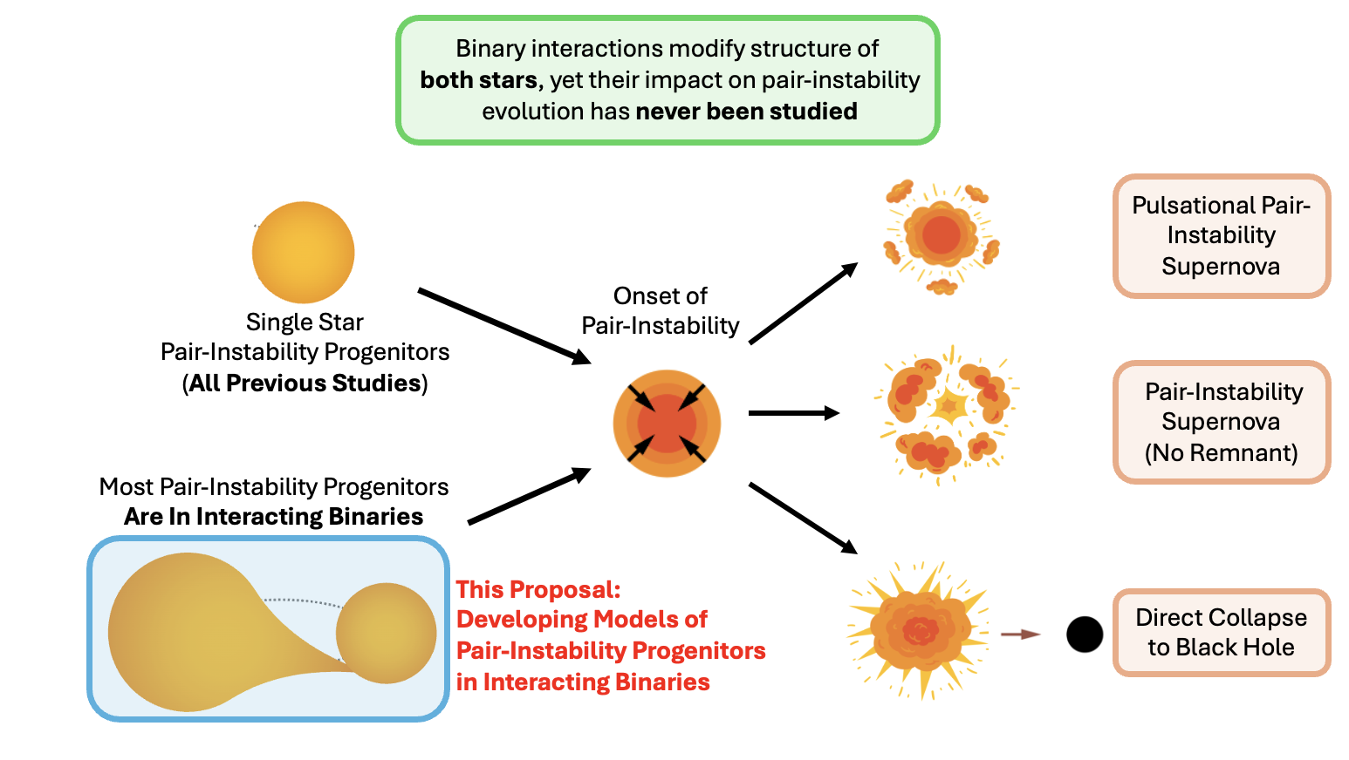

Figure Caption: New Detailed Binary Evolution Models for Progenitors of (Pulsational) Pair Instability Supernovae. The above schematic shows the different outcomes of very massive stars that go through pair-instability evolution: 1) Pulsational Pair-Instability Supernova; 2) Pair-Instability Supernova; 3) Direct collapse to a Black Hole. However, as highlighted in the schematic, all previous studies have focused on modeling the evolution of single star pair-instability progenitors, despite observational evidence that most massive stars are in interacting binaries that can significantly alter the internal structure and evolution of both stars. This program will develop the first detailed models of pair-instability progenitors in interacting binaries, allowing us to quantify the impact of binary interactions that are important for interpreting gravitational wave observations as well as electromagnetic transients associated to (pulsational) pair-instability supernovae. (Illustration Credits: Farag+22, Tom Wagg, Ebraheem Farag, Frank Timmes)

Section 4: Importance and Broader Implications
- Create a heading that states the broader impact/importance of the solution.
Binarity: The Next Big Leap in Deepening Our Understanding of (Pulsational) Pair-Instability Supernovae
- What is the high level importance of the proposed products of your study to your subfield ? How will your study advance the subfield? (this is a like a summary statement)
This work will provide the first detailed models of (P)PISN progenitors in a binary. Since this a dominating factor affecting the evolution of (P)PISN progenitors, our models will help interpret several observations, both through gravitational waves, and EM transients.
- Repeat Suitability:
  - Why now?
(P)PISN influences the black hole mass distribution, and GW observations are only now starting to measure the black hole mass function at higher masses.
Several EM surveys like LSST are going to be actively searching for the EM transients associated with (P)PISN.
To interpret and understand all these observations, we need detailed models for the evolution of the progenitors of (P)PISN. Given that most progenitors will be in binaries, we cannot ignore the impact of binarity in developing such models.
  - How does this program relate to the funding call?
Which key science goals of HST/JWST does your proposal connect to ?
    - JWST: https://webb.nasa.gov/content/science/index.html
    - HST: https://www.stsci.edu/hst/about/key-science-themes [ if applicable -> Observational] Repeat Why this facility?
HST Science Theme: Stars and their Environments
Application for NASA FINESST:
This proposed research is directly relevant to the SMD Division “Astrophysics Research Program” to “explore the origin and evolution of the galaxies, stars and planets that make up our universe”
This proposal is directly relevant to several key areas identified in the 2020Astro Decadal Survey:
2020Astro Decadal Survey
[B-Q1a] highlights how the theory of pair-instability SNe predicts the existence of a gap in the BH mass distribution that may be observed with GW observations.
[B-Q2d] highlights how pair-instability are among the class of theoretically expected astrophysical transients that still lack an uncontroversial observational example. It emphasizes questions such as: Which theoretical models will find observational confirmation? What is the role of other sources of energy to power astrophysical transients? How do the explosions of the first stars appear? To interpret observations and answer questions like these, we need to have realistic, and detailed models of the stars that undergo such explosions, as proposed here.
[D-Q1c] Properties of the First Stars, Galaxies, and Black Holes highlights how the elusive Pop III stars may be observed indirectly via pair-instability supernovae (PISN), emphasizing the importance of understanding the first stars and their explosions.

- How does this study increase the legacy value of the facility/agency?
- What other subfields are advanced by these observations (GO) or data analysis/code/simulations (AR) ? [ Broader Impact]
And/OR
- Do the products of your proposal serve the community at large?
Our publicly available models will be available to the community, providing necessary tools to interpret the black hole mass function inferred through gravitational wave observations, observations of transients associated with (P)PISN. Our models will also serve as initial conditions for 3D simulations of (P)PISN explosions.

