New Constraints on the Stellar Mass-Halo Mass Relation: Stacked Lensing of Dwarf Galaxies
P.I. Chen-Yu Chuang
Scientific Writing Assignment 6
The stellar-to-halo mass relation (SHMR) is a powerful tool for estimating the dark matter content of a galaxy from its observed stellar mass. The SHMR at the dwarf galaxy scale (halo mass,$M_{h}={10}^{10}-{10}^{11}M_{⊙}$) is particularly informative because it links galaxy formation to small-scale dark-matter structure, where different galaxy evolution models can diverge most strongly. However, at the low-mass end, many SHMR constraints rely on indirect halo-mass inference, leaving systematic uncertainties from selection effects, baryonic physics, and environment that are not calibrated by an independent mass probe. We propose to independently calibrate the dark matter halo masses of dwarf galaxies at low redshift ($z∼0.2-0.8$) by stacking lensing shear around large samples of dwarfs ($∼{10}^{5}$ ) in the cutting-edge Roman High-Latitude Survey data to boost the signal-to-noise ratio. This program will produce the first statistically significant sample of dwarf galaxies with well-defined halo masses, which is critically needed to reduce the scatter in the low-mass SHMR by $50-70\%$ . Establishing an independent halo-mass scale for low-mass galaxies will shed new light on the galaxy–halo connection and help us better understand how galaxies’ stellar masses and their dark matter halos grow over cosmic time.

Section 1
- The Dwarf-Galaxy SHMR Links Galaxy Formation Physics to Small-Scale Dark Matter Structure
- 1 fact based paragraph
  - The SHMR at the dwarf galaxy scale (halo mass,$M_{h}={10}^{10}-{10}^{11}M_{⊙}$) is particularly informative because it links galaxy formation to small-scale dark-matter structure, where different galaxy evolution models can diverge most strongly.
  - Supporting facts
    - Constraining the SHMR at $M_{h}∼{10}^{10}M_{⊙}$ can discriminate among competing galaxy formation models, because the SHMR at sub-galactic scales remains poorly (Wang et al. 2026)
    - Different quenching prescriptions within empirical galaxy evolution models cause dwarf galaxies to reside in halos of different masses. For example, time of quenching could produce up to a 0.15 dex offset in typical halo mass at the lowest stellar mass bin (O’Leary et al. 2023)
    - Merger history of dwarf galaxies (number of major merger and minor merger) can affect the stellar mass of dwarf galaxies, and therefore affect the SHMR (Deason et al. 2022)
  - Accurately measuring the SHMR of dwarf galaxies is therefore essential to constrain the physics of galaxy evolution (e.g. quenching and merger histories) and to test the galaxy–halo connection in a regime where models diverge and observational data remain sparse.
- Problem paragraph
  - However, at the low-mass end, many SHMR constraints rely on indirect halo-mass inference, leaving systematic uncertainties from selection effects, baryonic physics, and environment that are not calibrated by an independent mass probe.
  - References needed:
    - Indirect methods (abundance matching [AM] and HI kinematics) are the dominant tools for halo mass inference but face fundamental limitations: AM is hampered by stellar mass function incompleteness at the faint end, while dynamical methods are restricted to nearby, gas-rich dwarfs Wang et al. 2026
    - selection effects, baryonic physics, and environment affects the halo mass estimation: Fahttahi et al. 2018, Chan et al. 2015, Read et al. 2017
  - Next-generation surveys (Roman, Euclid, Rubin) will soon deliver unprecedented weak-lensing and photometric datasets covering large amount of dwarf galaxies. Without an independently calibrated halo-mass scale at the low-mass end, the community will propagate existing systematic biases into these new analyses. The Roman High-Latitude Survey, in particular, offers the first opportunity to perform stacked weak lensing around statistically large dwarf samples to constrain the biases, making this the right moment to establish the calibration.
- Synopsis paragraph:
  - We propose to independently calibrate the dark matter halo masses of dwarf galaxies at low redshift ($z∼0.2-0.8$) by stacking lensing shear around $∼{10}^{5}$ of dwarfs in the cutting-edge Roman High-Latitude Survey data, boosting the signal-to-noise ratio sufficiently to directly constrain the SHMR at $M_{h}={10}^{10}-{10}^{11}M_{⊙}$.
  - Roman’s primary science driver is weak-lensing cosmology. Its wide-field infrared imager ($0.28 \deg^{2}$ FoV) provides the combination of survey area ($∼2000 \deg^{2}$), depth ($J∼26.7$), and shape-measurement quality needed to detect the lensing signal around dwarf lenses. This is a measurement infeasible with current ground-based surveys
  - This program will deliver:
    - A public catalog of $∼{10}^{5}$dwarf galaxies with stacked weak-lensing halo masses
    - The first independent calibration of the low-mass SHMR with 50–70% reduced scatter
    - A stacked-lensing pipeline applicable to other halo-mass measurements across different systems.
    - These products serve cosmology (halo mass function), galaxy evolution (dwarf quenching, assembly history constraints), and dark matter physics (small-scale structure tests).
Section 2
- Indirect Halo-Mass Inference Leaves the Dwarf SHMR Uncalibrated Against Independent Mass Measurements
- Tidal stripping could remove dark matter, making us over estimate the halo mass. Stellar feedback reshaping the inner dark-matter profile. Low surface brightness dwarfs could be missing in the sample.
- Fahttahi et al. 2018, Chan et al. 2015, Read et al. 2017
- An independently calibrated dwarf SHMR would break the current degeneracy between competing galaxy evolution models (which diverge most strongly at and below dwarf galaxy mass scale), provide a ground truth for validating abundance matching and kinematic methods.
- We’re missing a direct, model-independent halo-mass measurement for a statistically large sample of dwarf galaxies
- This program will produce the first statistically significant sample of $∼{10}^{5}$ dwarf galaxies with well-defined halo masses, which is critically needed to reduce the scatter in the low-mass SHMR by $50-70\%$ .
Section 3
- This Proposal: Stacked Weak Lensing of $∼{10}^{5}$ Dwarf Galaxies in the Roman High-Latitude Survey
- Weak-lensing shear profiles stacked around $∼{10}^{5}$ photometrically selected dwarf galaxies ($M_{⋆}∼{10}^{7}-{10}^{9} M_{⊙}$) at $z∼0.2-0.8$ in the Roman High-Latitude Wide-Area Survey.
- Roman’s Wide-Field Instrument provides the unique combination of wide area ($∼2000 \deg^{2}$), infrared depth ($J∼26.7$), and space-based PSF stability required for precision shape measurements around faint, low-mass lens galaxies. No current ground-based survey achieves the simultaneous area, depth, and shape-measurement quality needed for this measurement.
- Strategy: Identify $∼{10}^{5}$ dwarf galaxies via photometric stellar masses from Roman multi-band imaging + photometric redshifts, then measure weak-lensing shapes of background source galaxies using Roman WFI broad-band imaging, exploiting the stable space-based PSF for high-fidelity shape calibration. We also use slitless grism spectroscopy for a kinematic-lensing cross-check where available. Stack the tangential shear signal in bins of lens stellar mass to achieve S/N sufficient for halo-mass constraints.
- (1) A public catalog of $∼{10}^{5}$ dwarf galaxies with stacked weak-lensing halo-mass estimates. (2) The first independently calibrated SHMR at dwarf galaxy mass scale with 50–70% reduced scatter compared to current indirect constraints. (3) A reusable stacked-lensing pipeline for Roman data applicable to other halo-mass measurements.
Figure 1
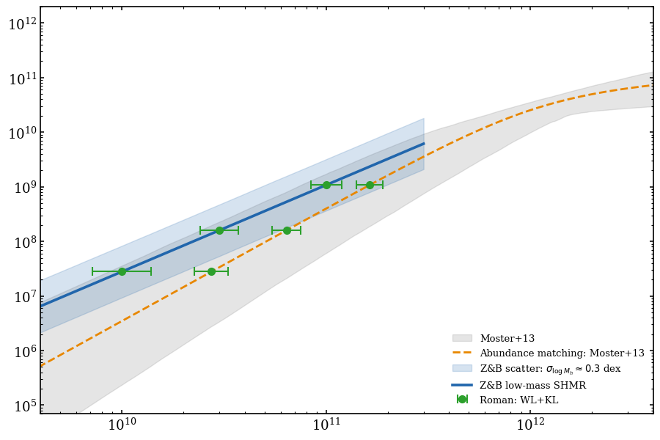
$$({M_{h}}/{M_{⊙}})$$
$$({M_{⋆}}/{M_{⊙}})$$
This proposal:
- Reduce uncertainty by 50-70%
- Distinguish the SHMR model
Figure 1. The low-mass stellar-to-halo mass relation (SHMR) and the discriminating power of Roman stacked lensing. The blue solid line shows the low-mass SHMR from Zaritsky & Behroozi (2023, Z&B), who infer halo masses photometrically from galaxy structural parameters (i.e. effective radii, surface brightness) calibrated against dynamical mass estimates assuming NFW profiles. This approach is independent of abundance matching but still relies on assumed dark-matter profile shapes and mass-to-light scaling relations. The blue shaded region indicates the $∼0.3$ dex (or $3σ$) scatter in halo mass at fixed stellar mass. The orange dashed line and grey band show the abundance-matched SHMR from Moster et al. (2013) and the $3σ$ scatter of the SHMR. The two relations diverge below $M_{h}∼{10}^{11} M_{⊙}$, illustrating the regime where model assumptions matter most. Green points show the forecast Roman WL+KL constraints on the mean halo mass in stellar-mass bins, using $∼{10}^{5}$ dwarf galaxies identidied in High-Latitude Wide-Area Survey (HLWAS). Because weak lensing measures the total mass directly without assuming a dark-matter profile shape or a stellar-mass-to-halo-mass mapping, it provides a genuinely independent mass scale. If the Z&B relation is approximately correct in its mean, the Roman data will tighten the scatter; if the indirect methods carry systematic biases, the Roman data will reveal the discrepancy. Either outcome advances the field. This program will reduce mass-scale systematics and deliver a more robust low-mass SHMR that is central to our understanding of the galaxy–halo connection and to small-scale dark-matter tests of structure formation.
Section 4
- An independent dwarf halo-mass scale anchors the galaxy–halo connection across cosmic time
- Importance
  - The independently calibrated low-mass SHMR produced by this program provides the empirical anchor needed to distinguish among galaxy formation models that currently diverge at the dwarf scale. This advances the subfield by testing whether abundance-matching and kinematic SHMR estimates carry systematic biases; and providing the halo-mass ground truth required for other purposes (such as testing the small scale challenges in CDM).
- Suitability
  - The Roman High-Latitude Survey will deliver the first dataset with the simultaneous area, depth, and shape-measurement quality required for this measurement. As the community prepares to use Roman, Euclid, and Rubin data to constrain cosmology and galaxy evolution, an independent halo-mass calibration at the dwarf scale is urgently needed to prevent propagation of systematic biases from indirect methods into next-generation analyses.
  - This proposal directly addresses two of Roman’s key science themes: “Dark Matter” (constraining halo masses and small-scale structure) and “Cosmic Evolution” (understanding how galaxies and halos co-evolve). It leverages Roman’s core weak-lensing capability for a science case that is only achievable from space.
- Lagacy value:
  - Cross-subfield impact: The deep imaging of dwarf galaxies at z = 0.2–0.8 produced by this program also serves galaxy evolution studies (dwarf morphology, quenching, and satellite populations), while the background source catalog and shear measurements contribute directly to Roman’s cosmological weak-lensing program. The spectra of the background source can also be used to investigate high redshift galaxies.
  - Community deliverables: The public dwarf halo-mass catalog and the stacked-lensing pipeline are reusable resources. The catalog provides calibration data for any empirical model of the galaxy–halo connection. The pipeline we used can be applied to measure halo masses of other galaxy populations (e.g., ultra-diffuse galaxies, green-valley galaxies) in the same Roman dataset, increasing the legacy value of the survey.

