Proposal Outline: DUE March 27th at Midnight
(LastName_Assignment6.doc on D2L)

1) Revise Title
2) Revise abstract.
Adhere to word limit: The abstract must be written in standard ASCII and should be no longer than 20 lines of 85 characters of text. Use the HST/JWST Templates.

Science Justification will need to be 3 pages in total. This includes 1 figure, but not the bibliography.

Science Justification Outline

3) Provide an outline for your proposal (BULLETED POINTS that answer each of the below)

Section 1: Facts, Problem & Summary paragraph (3/4 of a page)

- What is the descriptive heading? It must be a statement
- 1 fact-based paragraph:
  - State the fact leading the paragraph (the conclusion) – this should follow from the Abstract.
  - What would be supporting facts (1-3)? Provide at least one paper citation per supporting fact.
  - What is the nuanced conclusion for the paragraph? This is the importance of the fact that should set the stage for the problem (should follow from abstract)
- Problem paragraph:
  - What is “the problem” statement?
  - What references are needed to support the problem?
  - Why is the problem critical to answer now? (nuanced conclusion)
- Synopsis paragraph:
  - What is the proposal? (identify key component) “We propose”
  - Why the facility? This can be related to the funding call.
  - What is the broader impact ? Community deliverables?

Section 2: The Problem & Motivation/Narrative of the proposal
- Identify a descriptive heading that states the problem
- What fact do you need to start with to set up the problem?
- What references support the problem?
- State why solving this problem advances the subfield.
- Identify the “key component” missing to solve the problem.
- State that this program will generate the “key component” to solve the problem.

Section 3: The Strategy: HST/JWST + Target Solves the Problem (Generate the “Key Component”)
- Create a descriptive heading that states the strategy → “This Proposal: Observe/Model This Thing”
- What are you targeting ? (imaging/spectra/archival data of what astronomical object, or what physical mechanism/ simulations/data set )
- Why this facility? (Why HST/JWST? )
- Outline (bullets) the strategy to generate the key component
  - For GO: describe the proposed observations *briefly/succinctly*
  - For AR/Theory: describe *briefly* the analysis method/proposed usage of simulations/codes and relation to existing/future HST/JWST data sets.
  - You must explain how the figure will be used to support the strategy
- Outline the products of the program (tangible outcomes)
- How do these products solve the problem?

Include a Figure that explains the strategy/target/solution
Add here your (revised) Figure from Assignment 4 (or you must create a new one if your proposal is different)
Figure and caption instructions are in Assignment 4.

Section 4: Importance and Broader Implications
- Create a heading that states the broader impact/importance of the solution.
- What is the high level importance of the proposed products of your study to your subfield ? How will your study advance the subfield? (this is a like a summary statement)
- Repeat Suitability:
  - Why now?
  - How does this program relate to the funding call?
    - Which key science goals of HST/JWST does your proposal connect to ?
    - JWST: https://webb.nasa.gov/content/science/index.html
    - HST: https://www.stsci.edu/hst/about/key-science-themes
    - [ if applicable -> Observational] Repeat Why this facility?
- How does this study increase the legacy value of the facility/agency?
  - What other subfields are advanced by these observations (GO) or data analysis/code/simulations (AR) ? [ Broader Impact]
  - And/OR
  - Do the products of your proposal serve the community at large?

Goldtooth JWST Proposal

1) Revised Title

Resolving the Hubble Tension: Constraining the Cepheid PLZ relation with JWST NIRCam

2) Revised abstract

The Hubble constant (H₀) is a fundamental parameter in modern cosmology, its value determining the age, size, and expansion history of the Universe. Precise determination of H₀ is critical to constraining cosmological models, including the nature of dark matter, dark energy, and the curvature of the Universe. However, a significant 5σ tension has emerged between H₀ measurements derived from the early and late universe. The origin of this tension remains undetermined and may be attributable to systematics or requiring new physics beyond ΛCDM. We propose to obtain cutting-edge JWST NIRCam light curves of Gaia-calibrated Cepheids in the Milky Way and nearby galaxies to rigorously constrain the Cepheid Period-Luminosity-Metallicity (PLZ) relation. NIR photometry from NIRCam uniquely reduces dust extinction and metallicity sensitivity, yielding a first-ever robust NIR PLZ calibration that supersedes prior optical and UV datasets. This program will establish a new, precise measurement of H_{o} and advance distance ladder cosmology, directly addressing whether the Hubble tension is the product of systematic errors or a new signature of cosmological physics beyond the standard model. Beyond cosmology, a rigorously calibrated Cepheid PLZ relation will benefit all research areas that rely on precise, independent extragalactic distance measurements, such as stellar astrophysics and galaxy evolution.

Character count: 1408
- Legend:
  - Fact
  - Importance of fact
  - Problem
  - Goal
  - Solution
  - Importance of solution
  - Broader Impact

Science Justification Outline

3) Provide an outline for your proposal (BULLETED POINTS that answer each of the below)

Section 1: Facts, Problem & Summary paragraph (3/4 of a page)

- What is the descriptive heading? It must be a statement
The Hubble Tension: Systematics or New Physics?
- 1 fact-based paragraph:
  - State the fact leading the paragraph (the conclusion) – this should follow from the Abstract.
Unaccounted systematic effects in late-time measurements of the Universe could be driving the Hubble constant to higher values than early-time measurements, causing the Hubble Tension.
  - What would be supporting facts (1-3)? Provide at least one paper citation per supporting fact.
    - Fact: Planck 2018 collaboration measure H₀=67.4 km/s/Mpc at 1% uncertainty using CMB data under ΛCDM.
      - Source: https://www.aanda.org/10.1051/0004-6361/201833910
    - Fact: SH0ES collaboration (Riess et. al (2022))measure H₀ = ~73 km/s/Mpc at ~1.5% uncertainty using SNe data under ΛCDM.
      - Source: https://ui.adsabs.harvard.edu/abs/2022ApJ...934L...7R
    - Fact: Cai et al. (2022) investigate late-Universe modifications to ΛCDM as potential solutions to the Hubble tension, analyzing how constraints from BAO, Type Ia supernovae, and cosmic chronometers limit such models. They find that most late-time modifications are strongly constrained, leaving only a narrow parameter space consistent with current expansion and growth-of-structure data, including fσ8​, for resolving the tension outside of systematics.
      - Source: https://link.aps.org/doi/10.1103/PhysRevD.105.L021301

  - What is the nuanced conclusion for the paragraph? This is the importance of the fact that should set the stage for the problem (should follow from abstract)
The hubble tension is real and reconciling early- with late-universe measurements requires careful consideration and management of all known and unknown systematics. Identifying the full effects of systematics is crucial in informing whether new physics is required to explain any remaining tension.

- Problem paragraph:
  - What is “the problem” statement?
The current best late-time measurement of H₀ using SNe distance ladder cosmology is now at the precision (~1.5%) where systematics effects are of the size of statistical uncertainties. Unresolved systematics have the potential to bias H₀ about 1-2 km/s/Mpc, not enough to fully resolve the Hubble Tension. The largest systematics come from Cepheid calibration and SN light curve standardization.
  - What references are needed to support the problem?
Reiss et al (2022) has a table of error budgets, improvements over time, and what systematics were/weren’t modeled, and the potential impact of certain systematics on biasing H₀.
  - Why is the problem critical to answer now? (nuanced conclusion)
JWST is the newest telescope and is positioned to explore a lesser explored data-space and has the potential provide a lasting legacy dataset in the NIR that has the potential to minimize systematic effects and reveal the extent of bias relating to cepheid calibration (e.g. blending, metallicity, color/reddening)
- Synopsis paragraph:
  - What is the proposal? (identify key component) “We propose”
We propose to obtain NIR photometry and NIRSpec spectroscopy of cepheid variables in the milky way with Gaia parallax data as well as extragalactic cepheids with Supernova hosts.
  - Why the facility? This can be related to the funding call.
JWST has unprecedented resolving power in the NIR as well as the potential for high resolution NIR spectra to be obtained. Current NIR data for cepheids is sparse. NIR cepheid photometry and spectra are less affected by dust/extinction effects producing less scatter in its period-luminosity relation than comparable data in the Optical and UV. JWST can push the cepheid calibrating samples of SNe host to greater distances than previous facilities (e.g. HST).
  - What is the broader impact ? Community deliverables?
Photometry of cepheids benefits studies of stellar structure, galactic structure and populations. Spectra for cepheids informs metallicity gradients within the milk way and cepheid hosted galaxies.

Section 2: The Problem & Motivation/Narrative of the proposal
- Identify a descriptive heading that states the problem
Unresolved Systematics Beget an Uniformed Hubble Tension
- What fact do you need to start with to set up the problem?
The current best late-time measurement of H₀ using SNe distance ladder cosmology is now at the precision (~1.5%) where systematics effects are of the size of statistical uncertainties. Unresolved systematics have the potential to bias H₀ about 1-2 km/s/Mpc, not enough to fully resolve the Hubble Tension. The largest systematics come from Cepheid calibration and SN light curve standardization.

- What references support the problem?
Reiss et al (2022) has a table of error budgets, improvements over time, and what systematics were/weren’t modeled, and the potential impact of certain systematics on biasing H₀.

- State why solving this problem advances the subfield.
Ensuring proper accounting of systematic biases and uncertainties can minimize or eliminated the need for new physics, especially more exotic variants of cosmology. Careful consideration of systematics can inform where new physics might be necessary, if needed.
- Identify the “key component” missing to solve the problem.
Currently, late-universe methods for determining the hubble constant use optical data to constrain systematic effects. NIR data is less sensitive to these systematics and can both reduce uncertainties as well as inform the extent of impact from other systematics (e.g. extinction)
- State that this program will generate the “key component” to solve the problem.
This program will generate NIR photometry and spectroscopy of calibrator cepheids in the Milky way and anchor galaxies that are vital in constraining SNe properties vital in breaking degeneracies in H₀ determination.

Section 3: The Strategy: HST/JWST + Target Solves the Problem (Generate the “Key Component”)
- Create a descriptive heading that states the strategy → “This Proposal: Observe/Model This Thing”
This Proposal: Observe Cepheid Stars in NIR
- What are you targeting ? (imaging/spectra/archival data of what astronomical object, or what physical mechanism/ simulations/data set )
calibrator cepheids in the Milky way and anchor galaxies
- Why this facility? (Why HST/JWST? )
JWST is equipped with both a NIR photometer as well as a NIR spectrograph. NIR photometry and spectroscopy is less sensitive to the effects of reddening from dust, minimizing the impacts of such systematics on hubble constant inference.
- Outline (bullets) the strategy to generate the key component
  - For GO: describe the proposed observations *briefly/succinctly*
  - For AR/Theory: describe *briefly* the analysis method/proposed usage of simulations/codes and relation to existing/future HST/JWST data sets.
  - You must explain how the figure will be used to support the strategy
Cepheid stars for observation will be chosen based on prior independent distance determination (parallax, water maser, eclipsing binaries). Observations for cepheids require multi-epoch observation to obtain lightcurve data. The appropriate cadence will be suggested based on prior periodicity data for local sources and using a simplified period-luminosity relation-informed cadence for extragalactic sources based on their independently derived distances. Nyquist sampling requires sampling to be at least <= P_min/2. Regular sampling is also critical for reducing systematics related to period sampling. Recommended cadences are between 1-7 days depending on period (range 5 days < Period < 50 days).
Figure will show error budgets of systematics related to distance ladder. Will show dominant systematics and effects on hubble constant.
- Outline the products of the program (tangible outcomes)
    - NIR cepheid photometry in the milky way and anchor galaxies
    - NIR cepheid spectra in the milky way and anchor galaxies
- How do these products solve the problem?
These products reduce the impacts of the largest systematic contributors.

Include a Figure that explains the strategy/target/solution
Add here your (revised) Figure from Assignment 4 (or you must create a new one if your proposal is different)
Figure and caption instructions are in Assignment 4.
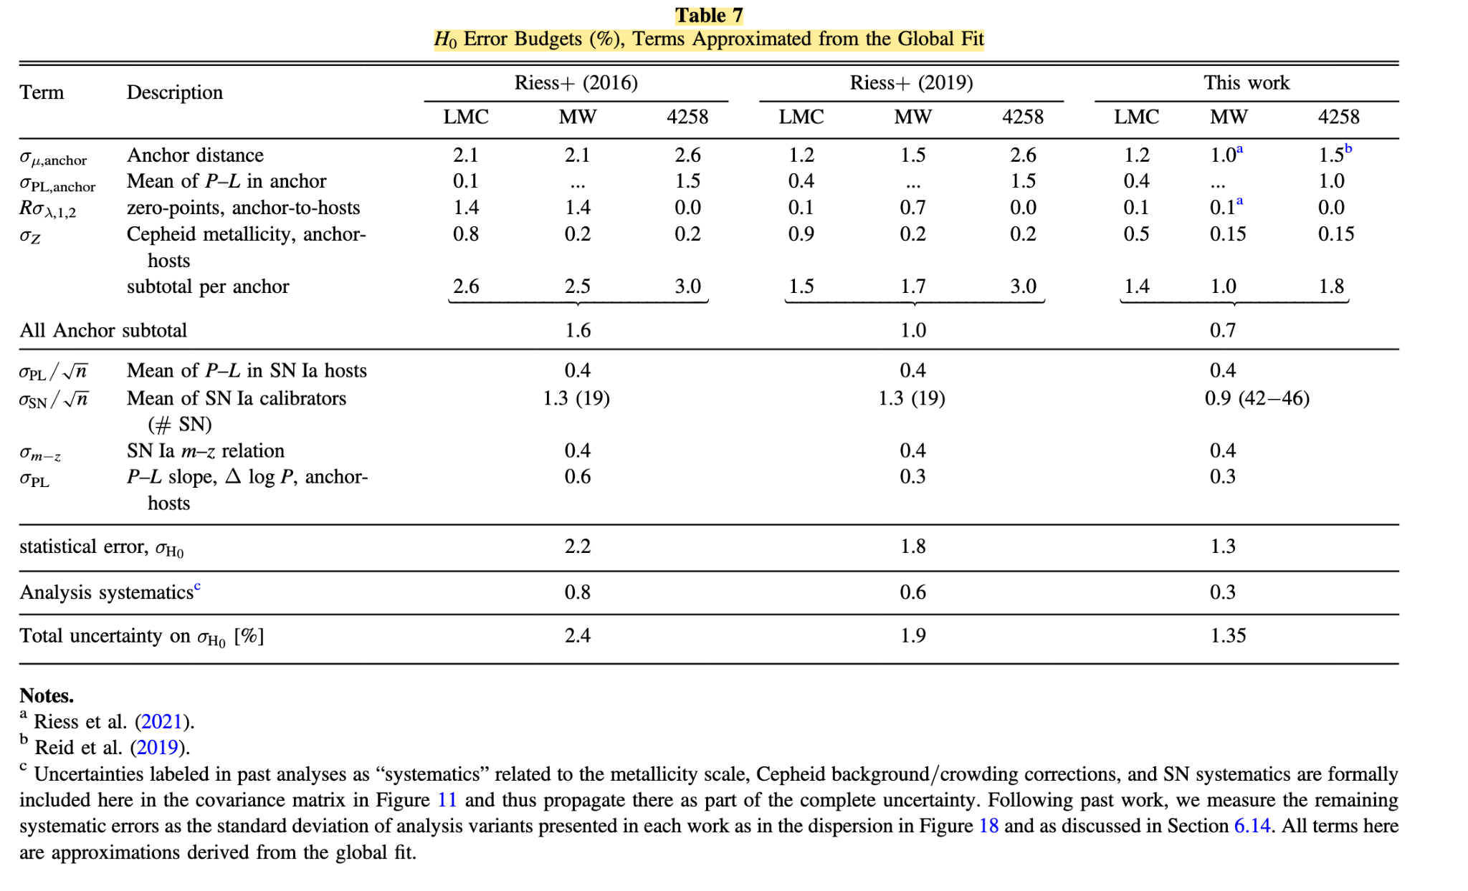
Source: Reiss et al. 2022

(Couldn’t easily figure out how to get a “this proposal” arrow but it will point to the cepheid systematics and the contribution to the SN tier of distance ladder cosmology)

Section 4: Importance and Broader Implications
- Create a heading that states the broader impact/importance of the solution.
A Local and Extragalactic Legacy Dataset of NIR Photometry and Spectra for Cepheid Variable Stars
- What is the high level importance of the proposed products of your study to your subfield ? How will your study advance the subfield? (this is a like a summary statement)
This dataset will minimize systematic effects of extinction, blending, and metallicity. THis will further inform biases in cross-calibration datasets as well as shed light on where new physics must take over in addressing the hubble tension (if needed).
- Repeat Suitability:
  - Why now?
JWST observations are in their early years. Starting now would provide years of critical data on cepheid variables both within our galaxy and outside. Our current flagship cosmological analysis for late-time rides on the cepheid tier of the distance ladder. We have many SNe data points currently but many do not have the prerequisite cepheid data within those SNe hosts to further anchor the distance ladder. Pushing the cepheid distance scale increases the number of usable SNe in our cosmological analyses. As it stands, we have pushed the limits of our current legacy datasets and require major advances such JWST to push even further.
  - How does this program relate to the funding call?
Which key science goals of HST/JWST does your proposal connect to ?
    - JWST: https://webb.nasa.gov/content/science/index.html
    - HST: https://www.stsci.edu/hst/about/key-science-themes
[ if applicable -> Observational] Repeat Why this facility?

This program directly addresses the following JWST science goals:
- Early Universe
  - Determining Cosmology/informing Hubble tension
- Galaxies Over time
  - Cepheids trace star-forming regions. Extragalactic cepheids inform formation history and galaxy evolution
- Star life cycles
  - Cepheid physics is well-known, expanding the cepheid datasets to NIR will help control systematics in stellar evolution.

- How does this study increase the legacy value of the facility/agency?
  - What other subfields are advanced by these observations (GO) or data analysis/code/simulations (AR) ? [ Broader Impact]
And/OR
  - Do the products of your proposal serve the community at large?

Photometry of cepheids benefits studies of stellar structure, galactic structure and populations. Spectra for cepheids informs metallicity gradients within the milk way and cepheid hosted galaxies.
JWST is the newest telescope and is positioned to explore a lesser explored data-space and has the potential to provide a lasting legacy dataset in the NIR that has the potential to minimize systematic effects and reveal the extent of biases.

