- Radiation Effects from Energetic Heavy Ions: Studying Acceleration by Interplanetary Shocks via Test Particle Simulations
- Ions are accelerated to high energies (>MeV) by shocks associated with coronal mass ejections. Single Event Effects from these high mass Solar Energetic Particles present unique challenges to spacecraft electronics. However, energetic ions are relatively diffuse and do not strongly influence the bulk flow of the plasma. As such, it is inefficient temporally and computationally to model the behavior of SEPs via conventional methods such as Particle-In-Cell or Hybrid codes – new, cutting-edge methods are needed. We propose a new simulation suite to predict heavy ion SEP fluxes using kinetic models coupled to a deterministic radiation transport code. The proposed simulations will generate differential intensities for heavy ions up to Z = 26 and use the data for rapid forecasts of Single Event Effect failure rates. Our suite will be constrained four observation-based parameters: Solar Wind speed, shock speed, plasma beta, and Solar Wind magnetic field strength. A minimized set of inputs will allow for an optimized, yet rigorous simulation suite. The proposed program will provide critical data streams for operational use of space assets exposed to the natural space radiation environment. Completion of this project will result in simultaneous reduction design risk and cost for future deployments.
Science Justification Outline
3) Provide an outline for your proposal (BULLETED POINTS that answer each of the below)
Section 1:
a) Ionizing Radiation from Solar induces malfunctions in space-based electronics
b) 1 fact-based paragraph:
i) Ionizing radiation induces malfunctions into space-based electronics
ii) What would be supporting facts (1-3)? Provide at least one paper citation per
supporting fact.
- Describe Rad-Effects on Electronics (Petersen 1991 Textbook)
- Describe modeling inputs for predicting rad effects (Zac Robinson’s MSSREM paper)
- Most hazardous rad environment is from SEPs (Liu et al 2026)
iii) Radiation effects degrade mission performance, can cause loss of asset or mission failure
c) Problem paragraph:
iv) Modeling/Predicting the most intense portion of the radiation environment is computationally challenging
v) References: Decker 1988: Test Particles Modeling , Giacalone Sp. Sci. Rev. Large Gradual SEP events, & Heliophysics decadal
vi) Space Economy increasing in size / scope. “Space Weather can generate hazardous radiation that harms aircraft and space-based crew and disrupts critical systems including satellites, communications networks, aviation, and the [electrical] grid. Knowing more about space weather will be of paramount importance as we increase our reliance on space-based assets and venture beyond LEO”- Heliophysics Decadal
d) Synopsis paragraph:
vii) We propose a new simulation suite to predict heavy ion SEP fluxes using kinetic models coupled to a deterministic radiation transport code.
viii) NASA funding calls for radiation-hardened designs
ix) More accurate modeling which translate the rad environment to rad effects allows for reduced risk in design – lowers costs.
Section 2: Modeling Heavy Ion acceleration computational challenging
b) Ions are accelerated to high energies (> MeV) by shocks associated with coronal mass ejections, producing Solar Energetic Particles that can cause Single Event Effects in spacecraft electronics.
c) References: Liu et al 2026 – SOFIE Suite as example of computational challenge
Giacalone 2017 for methodology
Reese 2026 (pre-print) for heavy ion use case
d) accurate prediction SEP fluxes and associated radiation effects will improve the reliability of spacecraft, reduce cost for future missions
e) Computationally efficient models for SEP fluxes
f) New simulation suite that couples kinetic models with deterministic radiation transport to efficiently and rigorously predict heavy-ion SEP fluxes and SEEs
Section 3: “This Proposal: Coupled Simulation Framework for SEP Flux and SEE Forecasting
a) Coupled radiation transport and radiation environment models in one simulation
b) Outline (bullets) the strategy to generate the key component
- Kinetic models for heavy ion fluxes
- Tied to observables
- Coupled to deterministic failure rate calculator
c) Kinetic model for heavy ion flux grounded by observable parameters: shock speed, plasma beta, and Solar Wind magnetic field strength, density
f) Predict fluxes and energy spectra
Figure and caption
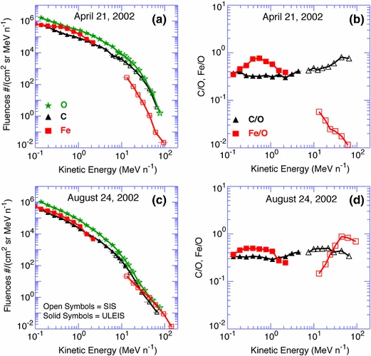
Figure 1: Spectrally realized fluences of different heavy ions(O+, C+, Fe+) from two different SEP events. We see in the right hand side that the relative abundance of high-Z ions can vary energetically. This behavior can be studied and predicted via kinetic modeling of test particles. The governing parameters of the shock define the acceleration efficiency. Our proposed toolset will deliver real-time simulated energy spectra and fluxes of shock acceleration heavy ions such as those shown above.
Section 4: Simulation and Prediction reduce risk posture
b) To protect assets on Earth / in space, we need to be able to predict the radiation environment from the Sun
c) Repeat Suitability:
Variability in the space environment impacts all technology in space.
The proposed program will provide critical data streams for operational use of space assets exposed to the natural space radiation environment. Completion of this project will result in simultaneous reduction design risk and cost for future deployments.
d) Radiation environment is global, simulation suite can be used to study any space asset in orbit.

