A Benchmark for Planetary Atmospheric Dynamics: New Constraints on Titan’s Atmospheric Seasonal Variability
Abstract:
Titan’s atmosphere exhibits seasonal variations due to changes in its circulation. These variations impact Titan’s methane-based hydrocarbon cycle, organic haze distribution, and atmospheric temperature structure. Previously, the Cassini and JWST conducted detailed observations of Titan’s atmosphere during northern winter, spring, and summer. However, Titan’s atmosphere was scarcely observed during northern fall, preventing a complete understanding of Titan’s seasonal cycles. We propose a JWST/FGS stellar occultation campaign for December 12, 2027, which will provide robust constraints on Titan’s atmosphere during northern fall. Using precision astrometry, FGS will capture high-resolution images within the 1-5 μm spectral range, encompassing absorption and emission bands from a multitude of species in Titan’s atmosphere. We will develop a sophisticated radiative transfer model to retrieve atmospheric number density and temperature profiles for these species. By exploiting a rare, transient stellar alignment, this program will analyze Titan’s atmosphere at higher vertical resolution than other techniques. This program’s results will advance models of Titan’s climate and photochemistry throughout Titan’s entire seasonal cycle. The similarities between Titan’s atmosphere and those of other planets, particularly early Earth’s atmosphere, enable the results of this program to broadly inform the seasonal evolution of Titan-like atmospheres within and beyond the solar system.

Section 1: Facts, Problem, and Summary
- What is the descriptive heading (must be a statement)?
  - Titan’s Atmosphere Experiences Significant Seasonal Variations
- 1 fact-based paragraph:
  - State the fact leading the paragraph (the conclusion) – this should follow from the abstract
    - Cassini observations reveal that Titan’s atmosphere experiences significant seasonal variations over cycles of 29.45 Earth years
  - What would be supporting facts (1-3)? Provide at least one paper citation per supporting fact.
    - Measurements by Cassini/CIRS instrument indicated a strong temperature decrease and compositional enhancement above Titan’s southern polar latitudes during Titan’s southern autumn (Vinatier et. al., 2015; Mathé et. al, 2020; Coustenis et. al., 2020)
    - Titan’s lower stratospheric temperatures above the south pole decreased by 19 K between summer (January 2007) and late autumn (June 2016) (Sylvestre et. al., 2020)
    - Although 2010 CIRS observations were compatible with the coexistence of two circulation cells upwelling at Titan’s mid-latitudes and downwelling at the poles, one year later, global circulation appeared to reverse (Vinatier et. al., 2015)
    - Upper atmosphere density profiles vary by ~1 order of magnitude above 1000 km altitude; temperature profiles inferred from Cassini INMS-measured N₂ densities show a variability of +/- 30 K (Müller-Wodarg and Koskinen, 2025)
  - What is the nuanced conclusion for the paragraph?
    - Because these variations impact the composition and energy balance in Titan’s atmosphere, they influence the evolution of Titan’s methane-based hydrocarbon cycle, organic haze distribution, and atmospheric escape
- Problem paragraph:
  - What is the problem statement?
    - Although detailed observations of Titan’s atmosphere are available for Titan’s northern winter, spring, and late northern summer, Titan’s atmosphere lacks comparably detailed observations during northern fall
  - What references are needed to support the problem?
    - Nixon et. al. (2024) – JWST observations during Titan’s late northern summer
    - Karkoschka (2022) – HST observations of Titan between 2017-2019 (northern summer)
    - Lorenz et. al. (2008) – describes early Cassini observations during Titan’s northern winter, basis for the figure in this proposal
    - Nixon et. al. (2019) – describes Cassini/CIRS observations throughout entire mission
    - Titan After Cassini-Huygens review papers – Cassini mission overview
  - Why is the problem critical to answer now (nuanced conclusion)?
    - Titan is currently in northern fall, offering an opportunity to complete observations of Titan’s seasonal cycles
- Synopsis paragraph:
  - What is the proposal (identify key component)?
    - We propose a JWST/FGS Titan stellar occultation campaign for December 12, 2027, aimed at retrieving robust constraints on Titan’s number density and temperature profiles during northern fall
  - Why the facility (can be related to the funding call)?
    - FGS provides precision astrometry – only FGS will be capable of observing the stellar occultation
    - JWST will provide higher spectral and spatial resolution than HST or ground-based facilities
    - Although the occultation should be visible to ground-based observatories around the Indian Ocean, JWST will not be impacted by light pollution, atmospheric turbulence, or inclement weather
  - What is the broader impact (community deliverables)?
    - This project will aim to obtain temperature and composition profiles for Titan’s lower and middle atmosphere that can be incorporated into future climate and photochemistry models
    - Because Titan’s atmosphere is similar to other planetary atmospheres, particularly early Earth’s atmosphere, the results of this program can be used to compare the seasonal evolution of planetary atmospheres
    - The density and temperature profiles obtained from this program can be utilized in models of Titan-like exoplanet atmospheres

Section 2: Problem and Motivation/Narrative
- Identify a descriptive heading that states the problem
  - Lack of Detailed Observations During Titan’s Northern Fall
- What fact do you need to start with to set up the problem?
  - Prior Cassini, JWST, and ground-based measurements provided robust constraints on Titan’s atmosphere during northern winter, spring, and summer
- What references support the problem?
  - Nixon et. al. (2024) – JWST observations during Titan’s late northern summer
  - Karkoschka (2022) – HST observations of Titan between 2017-2019 (northern summer)
  - Lorenz et. al. (2008) – describes early Cassini observations during Titan’s northern winter
  - Nixon et. al. (2019) – describes Cassini/CIRS observations throughout entire mission
  - Titan After Cassini-Huygens papers – Cassini mission overview
- State why solving this problem advances the subfield
  - Periodic, detailed observations are critical for creating and interpreting Global Circulation Models (GCMs) and photochemical models of Titan’s atmosphere, which can help to characterize atmospheric circulation and organic haze production
- Identify the “key component” missing to solve the problem
  - Currently, the planetary science community lacks observations of Titan’s atmosphere during northern fall on the same level of detail as Cassini or JWST
- State that this program will generate the “key component” to solve the problem
  - By conducting detailed observations of Titan’s atmosphere during northern fall, this program will help to understand the evolution of Titan’s atmosphere throughout its entire seasonal cycle

Section 3: Strategy: HST + Target Solves Problem
- Create a descriptive heading that solves the problem
  - This Proposal: JWST/FGS Titan Stellar Occultation Campaign
- What are you targeting?
  - Targeting Titan’s lower and middle atmosphere during northern fall
- Why this facility?
  - By providing precision astrometry, FGS will be the only JWST instrument capable of observing this occultation
  - JWST has higher spatial/spectral resolution than other space-based observatories
  - Because emissions from these species have already been identified in JWST spectra (Nixon et. al., 2024), it is possible to design a robust density retrieval algorithm
  - While this occultation is expected to be visible to ground-based facilities around the Indian Ocean, these observations could be plagued by atmospheric turbulence, high cloud cover, or light pollution; JWST will not suffer from these problems
- Outline (bullets) the strategy to generate the key component
  - FGS will track the occulted star during the occultation, capturing 2.3’x2.3’ images as the star passes behind both sides of Titan’s limb
  - Using these images, we will obtain spectra from different tangent heights in Titan’s atmosphere (with vertical resolution ~10 km)
  - Using NEMESIS radiative transfer model, we will retrieve density profiles
- Outline of the products of the program (tangible outcomes)
  - Evenly-spaced occulated spectra with a ~10 km vertical resolution
  - Density/temperature profiles for leading and trailing limbs with ~10 km vertical resolution
- How do these products solve the problem?
  - This project will provide the most robust constraints on Titan’s atmosphere during Titan’s northern fall
  - Comparing these results with density and temperature profiles inferred from prior observations, we will create the most detailed, global picture of Titan’s seasonally evolving atmosphere

Include a figure that explains the strategy/target/solution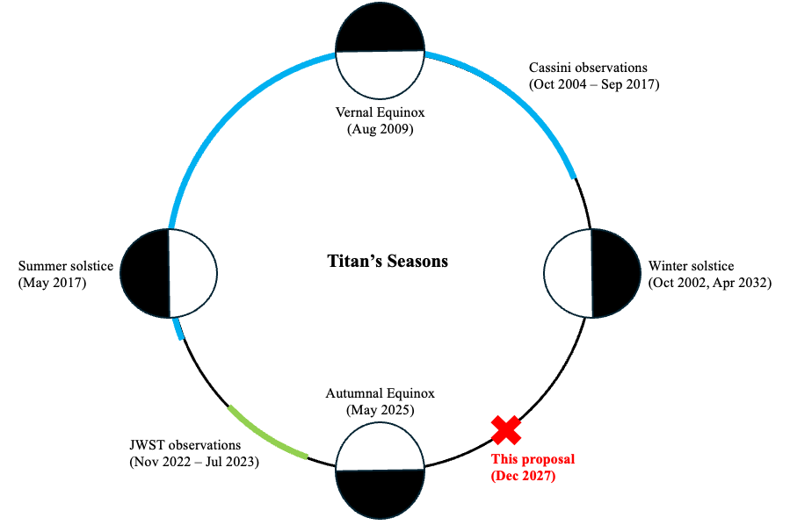
Figure 1: The proposed JWST measurements will occur during the final phase of Titan’s orbit lacking in-depth observations, facilitating detailed analyses of Titan’s seasonally evolving atmosphere. The four circles represent Titan at the beginning of each season, and the light and dark areas represent Titan’s dayside and nightside. The blue arc represents Cassini-Huygens observations that occurred during northern winter and spring (figure adapted from Lorenz et. al., 2010), while the green arc represents prior JWST observations during northern summer. In contrast, Titan’s atmosphere has been sparsely studied during northern fall. This program will robustly constrain Titan’s atmospheric and temperature profiles through JWST/FGS observations of the December 12, 2027 stellar occultation (indicated by the red “X” in the figure), during Titan’s northern fall. These observations are critical to enable accurate models of Titan’s climate and photochemistry throughout Titan’s entire seasonal cycle.

Section 4: Importance and Broader Applications
- Create a heading that states the broader impact/importance of the solution
  - New Constraints on Titan’s Seasonal Variability: Implications for Early Earth’s Atmosphere
- What is the high level importance of the proposed products of your study to your subfield? How will your study advance the subfield?
  - New density and temperature profiles will contextualize seasonal variability in Titan’s atmosphere
  - These density and temperature profiles can be used in future Titan global circulation and photochemical models
  - These profiles can also assist in contextualizing Titan’s lower atmosphere prior to the arrival of Dragonfly
- Repeat suitability:
  - Why now?
    - Titan is currently in northern fall, presenting an opportunity to conduct detailed observations of a Titan during a poorly-observed phase of Titan’s orbit
  - Which key science goals of HST/JWST does your proposal connect to?
    - Other Worlds – “Measure the physical and chemical properties of planetary systems, including our own solar system, and investigate the potential for life in those systems”
    - Relevant to JWST key science theme “Planetary Systems and the Origins of Life”
    - Understanding Titan’s atmosphere can help to contextualize “Titan-like” exoplanets
    - Within Titan’s atmosphere, aerosols within photochemically-generated organic haze descend to Titan’s surface, potentially engaging in prebiotic chemistry with materials from those environments; because the species in our density retrieval are precursors to the organic haze, this project will constrain the availability of biologically relevant molecules
- How does this study increase the legacy value of the facility/agency?
  - What other subfields are advanced by the observations (GO) or data analysis/code/simulations (AR)?/ Do the products of your proposal serve the community at large?
    - Since early Earth’s atmosphere and Titan’s atmosphere have similar compositions, these observations will inform our understanding of early Earth’s climate
    - In the figure, JWST data can be re-analyzed with more sophisticated statistical and radiative transfer schemes (AR)
    - While not the focus of this proposal, JWST data can also constrain energy balance in Titan’s lower and middle atmosphere

