1) Revise Title
The Origin of Early Cosmic Structure and Ionizing Radiation: Quantifying the Role of Quasars via [O III] Emitters at z∼7.5

2) Revise abstract
Cosmic reionization transformed the intergalactic medium (IGM) from neutral to ionized at z~6–20, coinciding with the emergence of the first supermassive black holes (SMBHs). A key unresolved question is how SMBHs were able to grow rapidly in this early epoch, and whether this growth is linked to overdense environments or rare accretion pathways. However, the relative roles of quasars and their surrounding environments in driving reionization and enabling early SMBH growth remain poorly constrained. Traditional tracers of ionizing sources, such as Lyα emission, are severely attenuated by the neutral IGM, limiting our ability to probe the surrounding galaxy population. We propose to conduct a systematic search for [O III] emitters around the z=7.5 quasar J1007+2115 using JWST NIRCam imaging and grism spectroscopy. [O III] emission provides a robust and minimally attenuated tracer of ionized gas, enabling direct identification of ionizing sources in the reionization epoch. By identifying [O III] emitters through line excess in the F444W band, we will measure their spatial distribution and line fluxes. This characterization of [O III] emitters enables a quantitative mapping of the galaxy overdensity and the ionization structure of the quasar environment. These measurements directly test whether early SMBH growth is associated with overdense regions or occurs in more typical environments and assess the role of quasars in shaping the local reionization topology. This program establishes a direct observational link between SMBH growth and the reionization environment.

Word Count: 1588 characters, 237 words

3) Science Justification Outline
Section 1: Facts, Problem & Summary paragraph (3/4 of a page)
a) What is the descriptive heading? It must be a statement
The environments of z>7 quasars hold the key to understanding early SMBH growth during reionization.
b) 1 fact-based paragraph:
i) State the fact leading the paragraph (the conclusion) – this should follow from the abstract.
The rapid growth of supermassive black holes (SMBHs) at z>7 remains one of the central challenges in early structure formation.
ii) What would be supporting facts (1-3)? Provide at least one paper citation per supporting fact.
Luminous quasars at z>7 host SMBHs with M_BH >10^9 M within <1 Gyr:
Mortlock+2011; Bañados+2018; Wang+2021
Standard Eddington-limited growth from stellar-mass seeds is insufficient:
Volonteri 2012; Inayoshi+2020
Observations suggest diversity in quasar environments (overdense vs typical):
Decarli+2017; Overzier 2016
iii) What is the nuanced conclusion for the paragraph? This is the importance of the fact that should set the stage for the problem (should follow from abstract)
These results suggest that environmental conditions may play a critical role in enabling rapid SMBH growth, but current observations provide conflicting constraints on whether high-redshift quasars reside in overdense regions.
c) Problem paragraph:
iv) What is “the problem” statement?
A key limitation is the lack of a robust census (probe?) of galaxies in the immediate environments of z>7 quasars.
v) What references are needed to support the problem?
rapidly declining Lyα emitter fraction over 6 < z < 8 (Stark+2017); The transmission on the blue part of the Lyα line is typically very low (Matthee+2018)
Lyα interpretation is complicated / model-dependent (Mason+2018)
vi) Why is the problem critical to answer now? (nuanced conclusion)
Without an unbiased tracer of galaxies in the reionization epoch, it remains impossible to determine whether early SMBH growth is driven by overdense environments or rare accretion pathways.
d) Synopsis paragraph:
vii) What is the proposal? (identify key component) “We propose”
We propose to identify [O III] emitters around the z=7.5 quasar J1007+2115 to construct the first spatially complete census of galaxies in its environment.
viii) Why the facility? This can be related to the funding call.
JWST/NIRCam uniquely enables this measurement by combining wide-field imaging, grism spectroscopy, and access to rest-frame optical emission lines that are not attenuated by the neutral IGM.
ix) What is the broader impact ? Community deliverables?
This program will provide a benchmark dataset for quasar environments at z>7, enabling direct comparisons with theoretical models of SMBH growth and informing future JWST and Roman surveys of the reionization epoch.

Section 2: The Problem & Motivation/Narrative of the proposal
a) Identify a descriptive heading that states the problem
Current observations cannot robustly determine whether z>7 quasars reside in overdense environments.
b) What fact do you need to start with to set up the problem?
Observational studies of high-redshift quasar fields have yielded conflicting results, with some indicating overdensities and others consistent with field-like environments.
c) What references support the problem?
No Overdensity of Lyman-Alpha Emitting Galaxies around a Quasar at z ∼ 5.7 (Mazzucchelli+2017)
Rapidly star-forming galaxies adjacent to quasars at redshifts exceeding 6 (Decarli+2017)
(Maybe add some more theoretical papers introducing the competing models)
d) State why solving this problem advances the subfield.
Resolving this discrepancy is essential for distinguishing between competing models of SMBH formation, including environment-driven growth versus stochastic accretion scenarios.
e) Identify the “key component” missing to solve the problem.
The missing component is a spatially complete and unbiased tracer of galaxies in quasar environments at z>7. (Since the launch of JWST, some quasars e.g. J0313-1806 have detected such tracers. Should I specify the key component to this proposal, J1007+2115?)
f) State that this program will generate the “key component” to solve the problem.
This program will generate this key component by identifying [O III] emitters that are minimally affected by IGM attenuation.

Section 3: The Strategy: HST/JWST + Target Solves the Problem (Generate the “Key Component”)
g) Create a descriptive heading that states the strategy -> “This Proposal: Observe/Model This Thing”
This Proposal: Mapping [O III] Emitters Around a z=7.5 Quasar with JWST/NIRCam
a) What are you targeting ? (imaging/spectra/archival data of what astronomical object, or what physical mechanism/ simulations/data set )
We target the z=7.5 quasar J1007+2115 and its surrounding galaxy population using NIRCam imaging and grism spectroscopy.
b) Why this facility? (Why HST/JWST? )
JWST/NIRCam uniquely enables this program: the SW channel identifies Lyα break via dropout selection (photo-z), while the LW channel provides slitless grism spectroscopy to detect [O III] emitters in a single, self-consistent setup.
c) Outline (bullets) the strategy to generate the key component
- For GO: describe the proposed observations *briefly/succinctly*
- For AR/Theory: describe *briefly* the analysis method/proposed usage of simulations/codes and relation to existing/future HST/JWST data sets.
- NIRCam imaging with F090W/F115W -> Lyα dropout selection
- NIRCam LW (F356W, F430M, or maybe just F444W grism spectroscopy) -> [O III] line excess selection
- Dither pattern -> fill detector gaps, achieve continuous spatial coverage (and also quasar imaging)
- Grism spectroscopy -> confirm line identification and redshift
(Maybe also add some new successful paper using similar methods, e.g., Pudoka+25)
- You must explain how the figure will be used to support the strategy
The proposed dither pattern (Fig. 1 left) ensures uniform spatial sampling around the quasar, while the filter configuration enables efficient identification of [O III] emitters.
d) Outline the products of the program (tangible outcomes)
- Catalog of [O III] emitters
- Spatial overdensity map
- Line flux (and profile, depending on the quality) measurements
e) How do these products solve the problem?
These products enable a direct measurement of the galaxy overdensity around the quasar, providing a decisive test of whether early SMBH growth is linked to dense environments.

Include a Figure that explains the strategy/target/solution
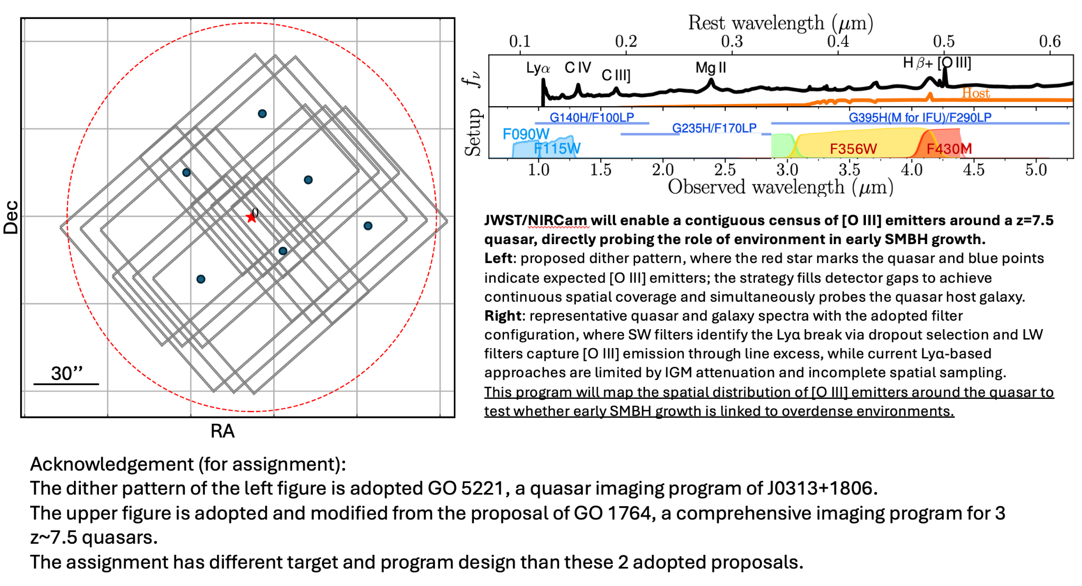
I created a new figure since the proposal is different.

Section 4: Importance and Broader Implications
a) Create a heading that states the broader impact/importance of the solution.
This program establishes a direct observational link between SMBH growth and the reionization environment.
b) What is the high level importance of the proposed products of your study to your subfield? How will your study advance the subfield? (this is a like a summary statement)
By providing the first spatially complete census of [O III] emitters around a z>7 quasar, this program will directly determine whether early SMBH growth is associated with overdense environments or occurs in typical regions. This result addresses a central uncertainty in models of SMBH formation and connects quasar growth to the topology of cosmic reionization.
c) Repeat Suitability:
i) Why now?
JWST has recently enabled the discovery of z>7 quasars and the first detections of rest-frame optical emission lines at these redshifts, making it possible for the first time to probe galaxy environments using tracers that are not attenuated by the neutral IGM.
ii) How does this program relate to the funding call? Which key science goals of HST/JWST does your proposal connect to ?
o JWST: https://webb.nasa.gov/content/science/index.html
o HST: https://www.stsci.edu/hst/about/key-science-themes
[ if applicable -> Observational] Repeat Why this facility?
This program directly addresses JWST key science goals of understanding the first galaxies, the sources of reionization, and the growth of supermassive black holes in the early universe.
d) How does this study increase the legacy value of the facility/agency?
- What other subfields are advanced by these observations (GO) or data analysis/code/simulations (AR) ? [ Broader Impact]
Legacy value: The resulting catalog of [O III] emitters and their spatial distribution will serve as a benchmark dataset for high-redshift quasar environments, enabling direct comparisons with simulations of SMBH growth and large-scale structure formation.
Other Subfield: These data will also provide valuable targets for future JWST spectroscopy and Roman surveys, and can be used to study galaxy clustering, ionization structure, and feedback in the reionization epoch.
And/OR
- Do the products of your proposal serve the community at large?
Community value: These data products will serve the community as a reference sample for high-redshift galaxy studies and as targets for follow-up JWST/Roman spectroscopy, supporting studies of clustering, ionization structure, and reionization-era galaxy populations. This program will define a new observational framework for linking SMBH growth to environmental conditions at cosmic dawn, providing a critical reference for interpreting future high-redshift surveys.

