Establishing the Onset of Obscuration: A JWST Spectroscopic Census of High-z Dusty Star-Forming Galaxies

The total cosmic star formation rate density (SFRD) of the Universe is a critical metric of galactic growth over time. Dust obscuration hides a substantial fraction of star formation at early cosmic times, making observations of dusty star-forming galaxies (DSFGs) integral for determining the obscured contribution to the SFRD. The obscured fraction of the SFRD is key to distinguishing between competing models of a dust-rich vs dust-poor early Universe. However, the abundance of DSFGs at z>4 is poorly constrained due to their relative rarity, faintness, and uncertainties in photometric analyses. As a result, the obscured SFRD during the reionization era remains highly uncertain. We propose JWST NIRSpec/MSA spectroscopic follow-up of 15 ALMA 2mm-selected DSFGs at z=4-7 across 8 massive galaxy clusters to constrain the obscured star-formation history at the Epoch of Reionization with unprecedented accuracy. NIRSpec spectroscopy will secure redshifts via rest-frame optical emission lines, breaking photometric degeneracies and enabling robust characterization of the internal structure and dust content of these rare galaxies. This program will provide the largest spectroscopically confirmed sample of DSFGs at z>4 to date. We will precisely measure the obscured SFRD and resolve the long-standing debate between a dust-rich vs dust-poor early Universe. This program will further establish the epoch at which obscured star formation dominates the SFRD, enabling new tests of the timeline for massive galaxy formation and growth in the early Universe.

Science Justification Outline

Section 1: Facts, Problem & Summary paragraph (3/4 of a page)
a) What is the descriptive heading? It must be a statement
- The Missing Census of Dust-Obscured Star Formation in the Early Universe
b) 1 fact-based paragraph:
i) State the fact leading the paragraph (the conclusion) – this should follow from the abstract.
- The evolution of galaxies over cosmic time can be characterized by the star formation rate density (SFRD) of the Universe.
ii) What would be supporting facts (1-3)? Provide at least one paper citation per
supporting fact.
- SFRD is composed of both obscured and unobscured star-formation. It has been known for decades that dust hides a large fraction of star-formation at high-z (Hauser et al. 1998)
  - Obscured fraction of the SFRD is measured with the infrared luminosities of dusty star forming galaxies (DSFGs) (Casey et al. 2014)
- The high-z SFRD tells us if early star formation is dominated by rare starbursts or by more numerous UV bright galaxies with lower star formation rates (Casey et al. 2018).
iii) What is the nuanced conclusion for the paragraph? This is the importance of the fact that should set the stage for the problem (should follow from abstract)
- The obscured fraction of the SFRD is key to distinguishing between competing models of a dust-rich vs dust-poor early Universe.

c) Problem paragraph:
iv) What is “the problem” statement?
- The obscured SFRD at z>4 is highly uncertain due to the poorly constrained abundance of DSFGs at these redshifts.
v) What references are needed to support the problem?
- Sun et al. 2025, Fujimoto et al. 2023, Zavala et al. 2021
vi) Why is the problem critical to answer now? (nuanced conclusion)
- Recent measurements of the obscured SFRD made possible with JWST are significantly higher than previous estimates based on UV and optical measurements. This suggests that the total SFRD in the EoR has been historically underestimated and our understanding of the dust content of the early universe is incomplete.

d) Synopsis paragraph:
vii) What is the proposal? (identify key component) “We propose”
- We propose JWST NIRSpec/MSA spectroscopic follow-up of 15 ALMA 2mm-selected DSFGs at z=4-7 across 8 massive galaxy clusters
viii) Why the facility? This can be related to the funding call.
- JWST NIRSpec is the only instrument capable of efficiently obtaining spectroscopic redshifts of high-z DSFGs. Large mm interferometers (such as ALMA) are capable of detecting these galaxies but would require prohibitively long on-source integration times to measure spectroscopic redshifts. (Casey et al. 2019, Sun et al. 2024)
ix) What is the broader impact ? Community deliverables?
- We will deliver the most accurate constraint on the obscured SFRD at z>4 to date and settle the long debate between a dust-poor vs dust-rich early Universe. These observations will not only provide valuable test-beds for models of DSFG formation but for massive galaxy formation as a whole across cosmic time.

Section 2: The Problem & Motivation/Narrative of the proposal
a) Identify a descriptive heading that states the problem
- Uncertain abundance of high-z DSFGs
b) What fact do you need to start with to set up the problem?
- The number density of DSFGs is poorly understood at z>4.
  - These galaxies are rare and difficult to find in blind-searches. Additionally, there are large uncertainties in photometric redshifts due to degeneracies between dust attenuation, stellar age, and redshift.
c) What references support the problem?
- Jin et al. 2024, Long et al. 2024, Sun et al. 2025
d) State why solving this problem advances the subfield.
- Accurate number densities of DSFGs and thus reliable measurements of the obscured SFRD would constrain the dust content of the early universe, an important factor in testing models of massive galaxy formation.
e) Identify the “key component” missing to solve the problem.
- We are missing a spectroscopically secure, cosmic variance-resistant sample of DSFGs
f) State that this program will generate the “key component” to solve the problem
- We have selected a sample of DSFGs from an ALMA 2mm survey of 60 massive lensing clusters.
  - Our 60 sight-line search reduces cosmic variance
- We will follow-up the 15 most-promising high-z DSFG candidates with JWST NIRSpec/MSA to obtain the largest spectroscopically secure sample of high-z DSFGs to date.

Section 3: The Strategy: HST/JWST + Target Solves the Problem (Generate the “Key Component”)
Create a descriptive heading that states the strategy -> “This Proposal: Observe/Model This Thing”
- This Proposal: Spectroscopic Follow-Up of Dusty Star-Forming Galaxies in the EoR
- What are you targeting ? (imaging/spectra/archival data of what astronomical object, or what physical mechanism/ simulations/data set )
- NIRSpec/MSA follow-up of 15 high-z DSFGs
  - These targets were selected as the most-promising high-z DSFG candidates from an ALMA 2mm survey of 60 massive lensing clusters.
  - A sample of 15 doubles the previous largest spectroscopically secure sample of DSFGs at these redshifts (8)
- Why this facility? (Why HST/JWST? )
- Ground-based interferometers capable of observing IR-bright sources require prohibitively long on-source integration times to obtain redshifts via molecular line scans. JWST is the only other instrument with the wavelength-range and spatial resolution necessary to observe these sources.
- Obtaining JWST NIRSpec data is vital for robust characterization of dust content and obscured fraction of the target galaxies
c) Outline (bullets) the strategy to generate the key component
- For GO: describe the proposed observations *briefly/succinctly*
- NIRSpec will secure redshifts via rest-frame optical emission lines
  - We expect H-alpha and O[III]
- Spectroscopic redshifts will enable accurate SED fitting of our DSFG targets to measure their IR luminosity
  - We will fit the SED with our ALMA 2mm data and existing NIRCam photometry from the Cycle 4 VENUS program
- You must explain how the figure will be used to support the strategy
- Spectroscopic redshifts of DSFGs will decrease existing uncertainties in the obscured SFRD at z>4 (see Figure 1).
d) Outline the products of the program (tangible outcomes)
- We will obtain spectroscopic redshifts for our DSFG sample
- We will generate an IR luminosity function (IRLF) from our sample and derive the obscured SFRD
- We will also measure the dust attenuation, gas metallicity, and kinematics of our DSFG sample
e) How do these products solve the problem?
- By reducing the redshift uncertainty of DSFGs at z>4 we greatly reduce the uncertainty on the obscured SFRD

Include a Figure that explains the strategy/target/solution
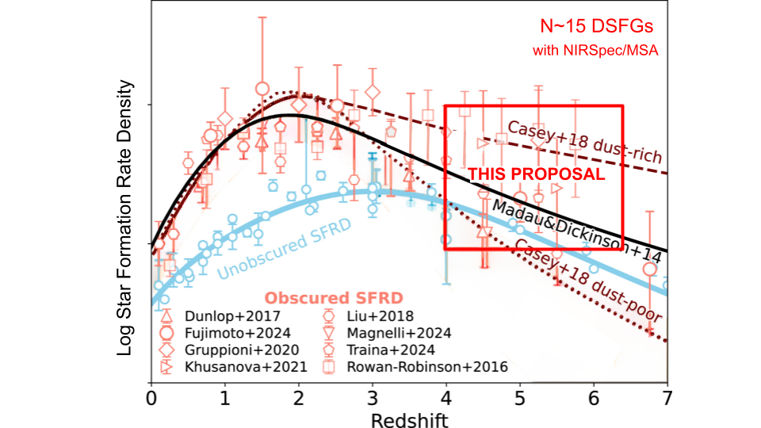

Figure 1. Spectroscopic follow-up of dusty star forming galaxies (DSFGs) in the Epoch of Reionization (EoR) is essential to constrain models of dust production and massive galaxy formation. Existing measurements of the obscured star-formation rate density (SFRD) are shown in open salmon symbols and unobscured measurements are shown in light blue (Sun et al. 2025). Predictions for dust-rich and dust-poor early-Universe scenarios are indicated by the maroon lines and the best-fit total SFRD from Madau & Dickinson (2014) is shown by the solid black line. The parameter space probed by this program is outlined in red. Previous measurements of the obscured SFRD at these redshifts have been comparable to the Madau & Dickinson line, suggesting that the total SFRD during the EoR may be underestimated. However, high-z measurements of the obscured SFRD are both sparse and highly uncertain, primarily due to limited spectroscopic confirmation of DSFGs. This program will obtain NIRSpec/MSA spectroscopy for ~15 newly ALMA-identified DSFGs at z>4, delivering the most precise constraints to date on the obscured star-formation history and resolving the long-standing debate between a dust-poor and dust-rich early Universe.

Section 4: Importance and Broader Implications
a) Create a heading that states the broader impact/importance of the solution.
What is the high level importance of the proposed products of your study to your subfield ?
- Understanding massive galaxy evolution in the early universe
b) How will your study advance the subfield? (this is a like a summary statement)
- The results of this work are vital to constraining the dust content of the early-Universe and testing models of massive galaxy formation.
c) Repeat Suitability:
i) Why now?
- There have been substantial efforts to map the evolution of star formation rate density across time for decades
- Recent measurements of the obscured SFRD with JWST imply that dust-obscured star formation may have been historically underestimated
- Surprising observations of JWST “blue monsters” and z>3 massive quiescent galaxies indicate that star formation may have started earlier than previously suggested (Ferrara et al. 2025). The obscured SFRD is vital to understanding how these massive galaxies emerged and evolved
ii) How does this program relate to the funding call?
Which key science goals of HST/JWST does your proposal connect to ?
- JWST: https://webb.nasa.gov/content/science/index.html
Repeat Why this facility?
- This program directly relates to JWST’s science goal “Galaxies Over Time” by addressing the questions “how do the oldest galaxies differ” and “how did the first galaxies form?”
- JWST is the only instrument capable of efficiently securing redshifts of these extremely dusty, IR luminous galaxies

d) How does this study increase the legacy value of the facility/agency?
- What other subfields are advanced by these observations (GO)?
- Studies of massive high-z galaxies: These observations will enable robust physical characterization of the most rapidly star forming galaxies at the EoR
- DSFGs have been proposed as an evolutionary link between the z>10 blue monsters and the z>3 quiescent galaxies. This program will enable further studies on the possible link between JWST’s most surprising extragalactic discoveries.
- Do the products of your proposal serve the community at large?
- This work will settle the long debate between the dust-poor vs. dust-rich early galaxy model. This is a vital parameter to understand the evolution of star formation, dust mass assembly, reionization, and galaxies as a whole at early cosmic times.

