PTYS578 Assignment 6: Proposal Outline
Lily Robinthal

The Mysterious Transit Depths of 55 Cancri e: JWST Observations to Constrain the Presence of Atmospheric Silicates

55 Cancri e represents the most common type of exoplanet, one for which there is no counterpart in the Solar System: the Super Earth. Establishing the presence and constraining the composition of an atmosphere on Super Earths is essential to advance our understanding of planetary formation, evolution and composition. However, 55 Cancri e has demonstrated a puzzling property that cannot be explained by our current data: a significant variation in secondary eclipse transit depths over the course of multiple observations. We propose to perform simultaneous JWST MIRI and NIRSpec observations to constrain the presence of silicates in 55 Cancri e’s atmosphere. Observations of silicates would support a possible cloud feedback mechanism that would explain the discrepancies in transit depths. Even if silicates are not observed, this program will still be an opportunity to robustly confirm and characterize the first ever rocky exoplanet atmosphere. The proposed observations will establish 55 Cancri as a gold-standard benchmark that will enable interpretation of future observations of Super Earths, and will give us entirely new insight into planetary formation and climate as a field.

Science Justification Outline
3) Provide an outline for your proposal (BULLETED POINTS that answer each of the below)
Section 1: Facts, Problem & Summary paragraph (3/4 of a page)
- What is the descriptive heading? It must be a statement
- Understanding the nature of 55 Cancri e is essential as we advance our knowledge of Super Earth exoplanets.

- 1 fact-based paragraph:
  - State the fact leading the paragraph (the conclusion) – this should follow from the abstract.
- 55 Cancri e represents the most common type of exoplanet, one for which there is no counterpart in the Solar System: the Super Earth
  - What would be supporting facts (1-3)? Provide at least one paper citation per supporting fact.
- 55 Cancri e orbits extremely close to its host star, so it is an ideal observational candidate for multiple observations (Hu, R., Bello-Arufe, A., Zhang, M., Paragas, K., Zilinskas, M., van Buchem, C., ... & Demory, B. O. (2024). A secondary atmosphere on the rocky exoplanet 55 Cancri e. Nature, 630(8017), 609-612.)
- It has been observed extensively and the presence of an atmosphere is heavily implied, but has not been robustly confirmed. (Zilinskas, M., van Buchem, C. P. A., Zieba, S., Miguel, Y., Sandford, E., Hu, R., ... & Zhang, M. (2025). Characterising the atmosphere of 55 Cancri e-1D forward model grid for current and future JWST observations. Astronomy & Astrophysics, 697, A34.)
- 55 Cancri e has shown extensive variability in many of its observed properties (Patel, J. A., Brandeker, A., Kitzmann, D., dit de la Roche, D. P., Bello-Arufe, A., Heng, K., ... & Hooton, M. J. (2024). JWST reveals the rapid and strong day-side variability of 55 Cancri e. Astronomy & Astrophysics, 690, A159.)
  - What is the nuanced conclusion for the paragraph? This is the importance of the fact that should set the stage for the problem (should follow from abstract)
- Establishing the presence and constraining the composition of an atmosphere on Super Earths is essential to advance our understanding of planetary formation, evolution, and composition.

- Problem paragraph:
  - What is “the problem” statement?
- However, 55 Cancri e has demonstrated a puzzling property that cannot be explained by our current hypotheses about the state of its atmosphere: a significant variation in secondary eclipse transit depths over the course of multiple observations.

  - What references are needed to support the problem?
- Loftus, K., Luo, Y., Fan, B., & Kite, E. S. (2025). Extreme weather variability on hot rocky exoplanet 55 Cancri e explained by magma temperature–cloud feedback. Proceedings of the National Academy of Sciences, 122(17), e2423473122.

  - Why is the problem critical to answer now? (nuanced conclusion)
- Constraining the presence of an atmosphere on a rocky planet is a decadal priority, and the launch of JWST has finally made this possible

- Synopsis paragraph:
  - What is the proposal? (identify key component) “We propose”
- We propose to perform simultaneous JWST MIRI and NIRSpec observations to constrain the presence of silicates in 55 Cancri e’s atmosphere.
  - Why the facility? This can be related to the funding call.
- JWST is the only facility with the wavelength range to detect silicates

  - What is the broader impact ? Community deliverables?
- The proposed observations will establish 55 Cancri as a gold-standard benchmark that will enable interpretation of future observations of Super Earths, and will give us entirely new insight into planetary formation and climate as a field.

Section 2: The Problem & Motivation/Narrative of the proposal
- Identify a descriptive heading that states the problem
- Variations in 55 Cancri e’s secondary eclipse transit depths remain unexplained

- What fact do you need to start with to set up the problem?
- 55 Cancri e shows a significant variation in secondary eclipse transit depths over the course of multiple observations.

- What references support the problem?
- Loftus, K., Luo, Y., Fan, B., & Kite, E. S. (2025). Extreme weather variability on hot rocky exoplanet 55 Cancri e explained by magma temperature–cloud feedback. Proceedings of the National Academy of Sciences, 122(17), e2423473122.

- State why solving this problem advances the subfield.
- The proposed observations will establish 55 Cancri as a gold-standard benchmark that will enable interpretation of future observations of Super Earths, and will give us entirely new insight into planetary formation and climate as a field.

- Identify the “key component” missing to solve the problem.
- JWST transit observations in the wavelength range to detect silicates

- State that this program will generate the “key component” to solve the problem.
- This program will take transit observations that can detect silicates in the atmosphere

Section 3: The Strategy: HST/JWST + Target Solves the Problem (Generate the “Key Component”)
- Create a descriptive heading that states the strategy: “This Proposal: Observe/Model This Thing”
- This proposal: Constrain the atmospheric composition of 55 Cancri e through JWST transit spectroscopy
- What are you targeting ? (imaging/spectra/archival data of what astronomical object, or what physical mechanism/ simulations/data set )
- Transit observations of 55 Cancri e
- Why this facility? (Why HST/JWST? )
- JWST is the only facility with the wavelength range to detect silicates

- Outline (bullets) the strategy to generate the key component
  - For GO: describe the proposed observations *briefly/succinctly*
- JWST Transit observations of 55 Cancri e in the wavelength range to detect silicates
  - You must explain how the figure will be used to support the strategy
- The figure shows the direct connection between the transit detections of silicates and the variations in secondary eclipse transit depth
- Outline the products of the program (tangible outcomes)
- Transit spectra that confirm or deny a. The presence of an atmosphere and b. The presence of silicates in the atmosphere
- How do these products solve the problem?
- If there are silicates in the atmosphere, this would point towards a cloud feedback mechanism to explain the variations in transit depths

Include a Figure that explains the strategy/target/solution
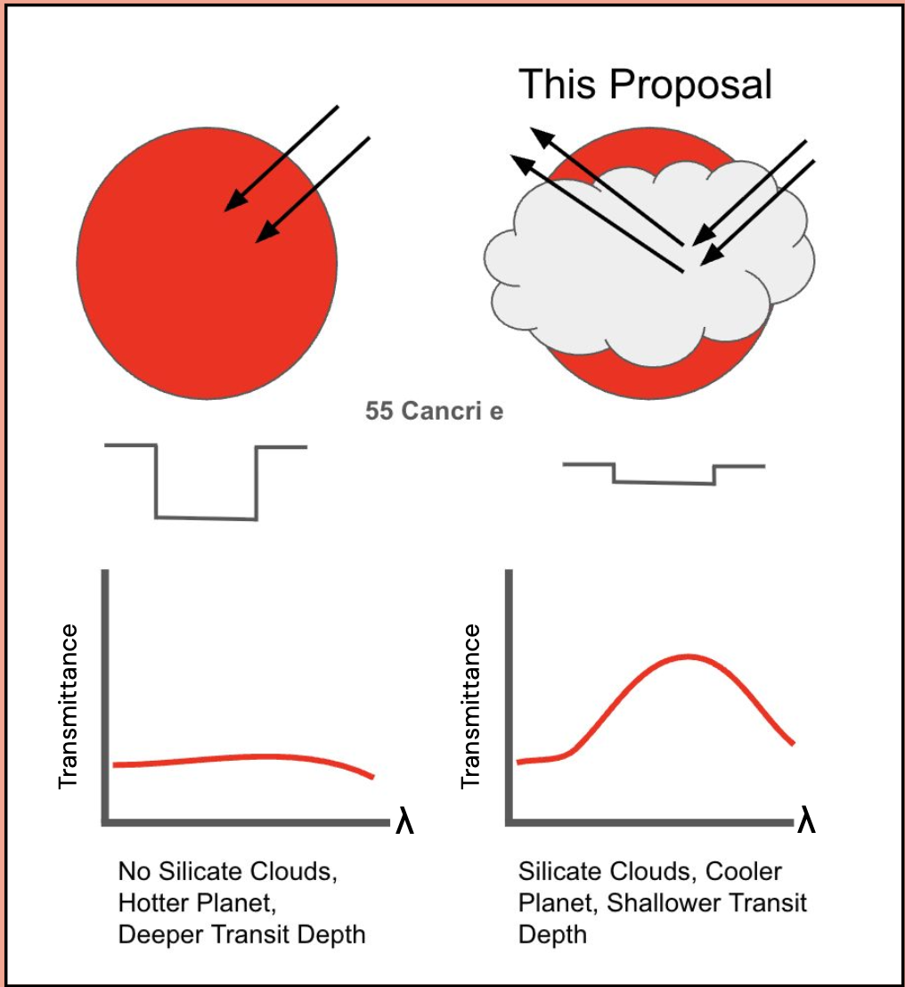
Figure 1: The confirmation of silicate features in the atmosphere of hot super-earth 55 Cancri e would support the existence of a cloud feedback mechanism that can explain the observed variations in secondary eclipse occultation depth. On the left is a cloud-free planet with a hotter surface due to a lack of clouds blocking incoming radiation, which would result in a deeper secondary eclipse depth. On the right is a planet with silicate clouds in its atmosphere, which would result in a cooler planet and therefore a shallower secondary eclipse transit depth. However, there is insufficient data to confirm or refute the existence of the silicate clouds that would drive this mechanism. We propose to perform simultaneous JWST MIRI and NIRSpec observations to probe the wavelengths at which such silicate features would appear. These observations will allow us to constrain 55 Cancri e’s atmospheric composition, explain its puzzling discrepancies in transit depth, and give us insight into an as-yet unexplored mechanism for driving climate on close-in rocky exoplanets.

Section 4: Importance and Broader Implications
- Create a heading that states the broader impact/importance of the solution.
- This program will lead to the first robust confirmation of a rocky exoplanet atmosphere and may explain 55 Cancri e’s variations in secondary eclipse transit depth.
- What is the high level importance of the proposed products of your study to your subfield ? How will your study advance the subfield? (this is a like a summary statement)
- The proposed observations will establish 55 Cancri as a gold-standard benchmark that will enable interpretation of future observations of Super Earths, and will give us entirely new insight into planetary formation and climate as a field.
- Repeat Suitability:
  - Why now?
- Constraining the presence of an atmosphere on a rocky planet is a decadal priority, and the launch of JWST has finally made this possible
  - How does this program relate to the funding call?
Which key science goals of HST/JWST does your proposal connect to ?
- This work connects to the JWST goal of “Measur[ing] the physical and chemical properties of planetary systems”
JWST: https://webb.nasa.gov/content/science/index.html
HST: https://www.stsci.edu/hst/about/key-science-themes
[ if applicable -> Observational] Repeat Why this facility?
- This work is in line with JWST’s goals and JWST is the only facility with needed wavelength range
- How does this study increase the legacy value of the facility/agency?
- What other subfields are advanced by these observations (GO) or data analysis/code/simulations (AR) ? [ Broader Impact]
- Do the products of your proposal serve the community at large?
- Planetary science as a whole will benefit from this work, both in understanding the full population of exoplanets and in gaining deeper insight into the formation and evolution of our solar system.

