1) Title: Beyond Two-Point Statistics: A New Framework for Integrating Traditional and Alternative Clustering Methods

2) Abstract:
On the largest scales, the matter distribution of the Universe is well described by a Gaussian random field. This property has made two-point statistics the primary tools for extracting cosmological information from large-scale structure. However, gravitational collapse generates highly nonlinear, non-Gaussian structure on smaller scales, and because these probes are difficult to model and analyze, much of the nonlinear regime is often discarded in current analyses. We propose to develop a rigorous framework that identifies and combines the most informative measurements across a broad range of statistics to integrate Gaussian and non-Gaussian information from cosmic structure. Our strategy selects probes from traditional two-point statistics and alternative clustering methods that capture higher-order information and integrates them into a single, optimized framework using a greedy algorithm. The proposed strategy is critical as cosmology enters the era of precision surveys, where experiments such as the Dark Energy Spectroscopic Instrument, Euclid space telescope mission, and the Nancy Grace Roman Space Telescope are producing datasets so large and precise that analyses can no longer afford to discard substantial fractions of the available data. Unlocking the information encoded in nonlinear structure strengthens tests of the ΛCDM framework and provides insight into galaxy formation, the galaxy–halo connection, and the physical processes governing cosmic structure formation.

Science Justification Outline

3) Provide an outline for your proposal (BULLETED POINTS that answer each of the below)

Section 1: Facts, Problem & Summary paragraph (3/4 of a page)

a) What is the descriptive heading? It must be a statement
Recovering Cosmological Information from Nonlinear Structure is Essential to Fully Exploit Precision Large-Scale Structure Surveys

b) 1 fact-based paragraph:
i) State the fact leading the paragraph (the conclusion) – this should follow from the abstract.
On the largest scales, the matter distribution of the Universe is well described by a Gaussian random field.

ii) What would be supporting facts (1-3)? Provide at least one paper citation per supporting fact.
- Gaussian random field arising from primordial fluctuations whose statistics are fully characterized by their mean and two-point correlations (Peebles 1980)
- Gravitational evolution has been weak on large scales, the Gaussianity is largely preserved, leaving Fourier modes nearly independent and the 2PCF a sufficient statistic for cosmological inference (Dodelson 2003)

iii) What is the nuanced conclusion for the paragraph? This is the importance of the fact that should set the stage for the problem (should follow from abstract)
the 2PCF has become a foundational tool for constraining the growth of structure, dark energy, neutrino physics, the galaxy–halo connection, and primordial non-Gaussianity from galaxy clustering

c) Problem paragraph:
iv) What is “the problem” statement?
However, gravitational collapse generates highly nonlinear, non-Gaussian structure on smaller scales, and because these probes are difficult to model and analyze, much of the nonlinear regime is often discarded in current analyses.

v) What references are needed to support the problem?
Bernardeau et al. 2002, Scoccimarro 2000, DESI Collaboration, BOSS Collaboration

vi) Why is the problem critical to answer now? (nuanced conclusion)
- Entering the era of precision cosmology → large surveys (Dark Energy Spectroscopic Instrument, Euclid space telescope mission, and the Nancy Grace Roman Space Telescope) are producing datasets so large and precise that analyses can no longer afford to discard substantial fractions of the available data
- Lose important information on the matter density field when not probing the nonlinear regime

d) Synopsis paragraph:
vii) What is the proposal? (identify key component) “We propose”
We propose to develop a rigorous framework that identifies and combines the most informative measurements across a broad range of statistics to integrate Gaussian and non-Gaussian information from cosmic structure.

viii)Why the facility? This can be related to the funding call.
- DESI’s large volume, high number density, and precise redshift measurements make it uniquely suited for testing and applying such methods, providing an ideal environment in which to develop and validate new analysis techniques
- Delivers the most precise spectroscopic measurements of large-scale structure to date
- Currently the collaboration ignores nonlinear scales

ix) What is the broader impact ? Community deliverables?
- Strengthens tests of the ΛCDM framework and provides insight into galaxy formation, the galaxy–halo connection, and the physical processes governing cosmic structure formation
- Provides a pathway for next-generation surveys to fully exploit the information content of the non-linear Universe

Section 2: The Problem & Motivation/Narrative of the proposal
a) Identify a descriptive heading that states the problem
Information Loss from Nonlinear Mode Coupling in Large-Scale Structure Analyses

b) What fact do you need to start with to set up the problem?
- Nonlinear structure formation induces mode coupling, transferring information from the power spectrum into higher-order correlations and generating non-Gaussian features in the density field
- The highest signal-to-noise modes in modern surveys lie in precisely the regime where our statistical description is least complete (the nonlinear regime)

c) What references support the problem?
Senatore & Zaldarriaga (2015), Desjacques et al. (2016), Bernardeau et al. (2002), Scoccimarro (2000)

d) State why solving this problem advances the subfield.
- Recover information lost to mode coupling, improving parameter constraints beyond two-point limits
- Enable consistent joint use of Gaussian and non-Gaussian observables
- For surveys like DESI, which are approaching sample-variance limits on large scales, progress now depends on extracting additional information from nonlinear structure rather than increasing survey volume

e) Identify the “key component” missing to solve the problem.
- No systematic way to quantify the marginal information gain of different observables in the presence of mode coupling
- Account for their non-Gaussian covariance and redundancy
- Construct an optimized combination of probes that maximizes information while controlling modeling uncertainty

f) State that this program will generate the “key component” to solve the problem.
- Construct a framework that treats large-scale structure observables as an information optimization problem
- Use a greedy algorithm to iteratively select and combine complementary statistics → will identify a near-optimal set of probes that efficiently capture both Gaussian and non-Gaussian information

Section 3: The Strategy: HST/JWST + Target Solves the Problem (Generate the “Key Component”)
g) Create a descriptive heading that states the strategy → “This Proposal: Observe/Model This Thing”
This Proposal: Emulator-Based Framework for Extracting Nonlinear Information from DESI-like Data

a) What are you targeting ? (imaging/spectra/archival data of what astronomical object, or what physical mechanism/ simulations/data set )
- Targeting the cosmological information encoded in nonlinear and linear large-scale structure
- Galaxy catalogs from various HODs and Abacus N-body simulations designed to match DESI Collaboration survey characteristics
- Summary statistics of the galaxy density field; both standard two-point measures and higher-order/alternative clustering methods sensitive to non-Gaussian structure

b) Why this facility? (Why HST/JWST)
- Its survey volume and number density make nonlinear scales a dominant source of statistical power
- Current DESI analyses are limited by modeling uncertainties, not data quality
- DESI already relies heavily on mock catalogs and simulations for covariance estimation and pipeline validation
- Will develop tools that can be trained and validated on DESI-like simulations and then deployed on real data

c) Outline (bullets) the strategy to generate the key component
- For GO: describe the proposed observations *briefly/succinctly*
- For AR/Theory: describe *briefly* the analysis method/proposed usage of simulations/codes and relation to existing/future HST/JWST data sets.
- Generate DESI-like dark matter simulations and mock catalogs across parameter space
- Measure a set of complementary clustering observables (two-point + non-Gaussian probes)
- Train an emulator to model these observables as a function of cosmology and nuisance parameters
- Perform simulation-based inference combining multiple probes
- Optimize probe selection by implementing a greedy algorithm to select subsets of observables that maximize information gain

- You must explain how the figure will be used to support the strategy
- Illustrates the conceptual framework of the proposal
- Use it to visually show how information is distributed differently across scales as well as what type of statistics probe each regime
- Outlines the pipeline, illustrates physics → methodology → inference/results

d) Outline the products of the program (tangible outcomes) and state that these products solve the problem
- A trained emulator for nonlinear clustering observables across DESI-relevant parameter space
- A validated simulation-based inference pipeline for combining multiple probes
- An optimized set of observables that efficiently captures Gaussian and non-Gaussian information
- Publicly available code and mock-based benchmarks for DESI analyses
- Forecasts demonstrating improved cosmological constraints from nonlinear scales
These products will:
- Provide the missing infrastructure required to safely incorporate nonlinear information into cosmological inference
- Transform nonlinear structure from a regime that must be excluded into one that can be systematically modeled, validated, and exploited along with linear structure

Include a Figure that explains the strategy/target/solution
Add here your (revised) Figure from Assignment 4 (or you must create a new one if your proposal is different)
Figure and caption instructions are in Assignment 4.
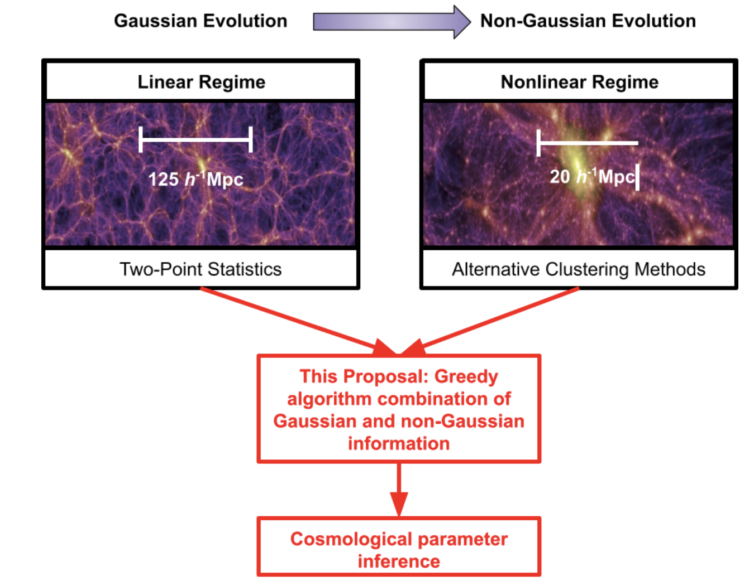
Figure 1: By combining information from both the linear and non-linear regimes of large-scale structure, this program will improve cosmological constraints relative to analyses that use either regime alone. The figure contrasts the linear (Gaussian) large-scale regime with the nonlinear (non-Gaussian) small-scale regime and highlights the different statistics used to probe each. The left panel shows a large-scale view of the density field in the linear regime, while the right panel zooms into smaller scales where nonlinear gravitational collapse produces clusters, filaments, and voids (Springel et al., 2005). The indicated ∼20 h⁻¹Mpc scale marks the approximate transition where nonlinear effects become important. Standard analyses rely primarily on linear statistics and therefore fail to capture the cosmological information redistributed into higher-order correlations and non-Gaussian features by nonlinear gravitational evolution. However, naively combining linear and nonlinear statistics produces large, highly covariant data vectors that require careful modeling. We propose a principled algorithm to identify and combine the most informative components of linear and nonlinear statistics into a single optimized data vector. This approach enables efficient recovery of non-Gaussian information while preserving the robustness of linear probes, yielding significantly stronger cosmological constraints than are possible with linear statistics alone.
Section 4: Importance and Broader Implications
a) Create a heading that states the broader impact/importance of the solution.
Maximizing the Scientific Return of DESI Through Gaussian and Non-Gaussian Information Extraction

b) What is the high level importance of the proposed products of your study to your subfield ?
How will your study advance the subfield? (this is a like a summary statement)
This work advances large-scale structure cosmology by addressing a central limitation: the inability to fully exploit nonlinear structure. By developing a framework that systematically extracts and combines Gaussian and non-Gaussian information, this project enables more complete use of existing data, improving cosmological constraints without requiring new observations. More broadly, it shifts the field from relying on limited summary statistics toward information-optimal analyses, opening new avenues for testing ΛCDM and models of structure formation.

c) Repeat Suitability:
i) Why now?
- Cosmology has entered a precision era in which surveys like DESI Collaboration are no longer limited by data volume but by modeling and analysis frameworks
- As DESI approaches sample-variance limits on large scales, further progress depends on extracting information from nonlinear regimes
- At the same time, advances in simulations, emulators, and simulation-based inference now make this feasible.

ii) How does this program relate to the funding call?
Which key science goals of HST/JWST does your proposal connect to ?
- JWST: https://webb.nasa.gov/content/science/index.html
- HST: https://www.stsci.edu/hst/about/key-science-themes
[ if applicable -> Observational] Repeat Why this facility?
This program directly supports DESI’s core science goals of:
- constraining dark energy through large-scale structure
- testing the ΛCDM paradigm
- improving measurements of structure growth and clustering

d) How does this study increase the legacy value of the facility/agency?
- What other subfields are advanced by these observations (GO) or data analysis/code/simulations (AR) ? [ Broader Impact]
- Reusable analysis tools: Publicly available emulator and optimization framework applicable to other surveys
- Cross-survey applicability: Direct relevance to next-generation experiments such as Euclid mission and Nancy Grace Roman Space Telescope
- Advancement of methodology: Contributions to simulation-based inference, likelihood-free methods, and high-dimensional data analysis
- Connections to galaxy formation physics: Improved constraints on galaxy bias, baryonic effects, and the galaxy–halo connection

And/OR
- Do the products of your proposal serve the community at large?
- By enabling the inclusion of nonlinear information, this work enhances the constraining power of DESI without additional observations, directly increasing the scientific return of the survey
- Provides a tool that allows future analyses to extract significantly more information from the same dataset, extending its scientific relevance beyond standard two-point analyses

