Sophie Clark
ASTR 578
Assignment 6: Proposal Outline
1. Revised Title
A JWST Investigation of Solar Systems in Formation: Do MHD Winds Drive Protoplanetary Disk Accretion & Evolution?
2. Revised Abstract
Planetary systems are born from protoplanetary disks whose mass and angular momentum evolution determine what kinds of planets can form. Simulations predict that radially extended magnetohydrodynamic (MHD) disk winds remove sufficient angular momentum to enable protoplanetary disk accretion, ultimately controlling both the mass reservoir and distribution of mass in the disk. However, MHD predictions for disk wind mass loss rates have never been tested with spatially and chemically resolved observations. We propose to obtain spatially resolved JWST NIRSpec IFU and MIRI MRS observations of slightly inclined (i ~ 60 - 70°) protoplanetary disks to measure wind morphologies and velocities. We will measure wind mass loss rates across a range of emission lines (each corresponding to a different radial extent) and compare them to observed accretion rates to determine the radial profile of wind mass removal. This first-ever observational test of MHD disk wind predictions will provide new constraints on angular momentum transport in disks. Observational validation of theoretical MHD models is critical to advance our understanding of protoplanetary disk evolution and will have broader implications for theories of star and planet formation.
Character count: 1250
Fact Importance of fact Problem Goal Solution Importance to subfield Broader implications

3. Proposal Scientific Justification Outline
Section 1: Facts, Problem & Summary paragraph (3/4 of a page)
- Descriptive heading (must be a statement): Disk evolution requires a redistribution of angular momentum
- Fact-based paragraph
  - Supporting facts
    - Planets form from material within the protoplanetary disk, with different solids able to condense at different disk radii (Armitage 2025)
    - Disks contain too much angular momentum for it to all be locked into planets and the central star—there must be another mechanism driving angular momentum loss or redistribution (Armitage 2015)
  - Nuanced conclusion for the paragraph: Simulations have shown that radially extended MHD winds could be responsible for angular momentum redistribution, and thus accretion
- Problem paragraph
  - Problem statement: However, to determine whether MHD winds are driving accretion, we need observational constraints on their mass loss rates
  - References needed to support problem:
    - Pascucci, I., Cabrit, S., Edwards, S., Gorti, U., Gressel, O., & Suzuki, T. K. (2023). The Role of Disk Winds in the Evolution and Dispersal of Protoplanetary Disks (Vol. 534). arXiv. Protostars and Planets VII. https://doi.org/10.48550/arXiv.2203.10068
    - Pascucci, I., Beck, T. L., Cabrit, S., Bajaj, N. S., Edwards, S., Louvet, F., Najita, J. R., Skinner, B. N., Gorti, U., Salyk, C., Brittain, S. D., Krijt, S., Muzerolle Page, J., Ruaud, M., Schwarz, K., Semenov, D., Duchêne, G., & Villenave, M. (2025). The nested morphology of disk winds from young stars revealed by JWST/NIRSpec observations. Nature Astronomy, 9, 81–89. https://doi.org/10.1038/s41550-024-02385-7
  - Why problem is critical to answer now? MHD winds have been shown to have profound effects on the disk surface density and solid migration, two crucial constraints in planet formation models (Pascucci et al. 2023)
- Synopsis paragraph
  - What is the proposal? (key component) “We propose”
    - We propose to observe disks spanning a range of accretion rates to constrain their wind morphologies and mass loss rates.
  - Why the facility? Can be related to funding call
    - JWST is the only facility with the spatial and spectral resolution to make these observations
  - What is the broader impact? Community deliverables?
    - We will constrain high-accuracy mass loss rate estimates for winds that can inform models and theories of MHD winds and disk evolution as a whole
Section 2: The Problem & Motivation/Narrative of the proposal
- Descriptive heading that states the problem: Do MHD winds remove enough angular momentum to drive accretion?
- Fact needed to set up the problem: Recent simulations have shown winds to be inefficient, having to remove a lot of mass to remove sufficient angular momentum—wind mass loss rate should end up being similar to the mass accretion rate
- What references support the problem? PPVII Review Chapter on MHD Disk winds (Pascucci et al. 2023)
- State why solving this problem advances the subfield: If MHD winds remove enough angular momentum to drive accretion, they will have profound effects on the disk characteristics as well, dictating future planet formation
- Identify the “key component” missing to solve the problem: Observations that give us both the morphology of the nested winds AND the velocity necessary to calculate their mass loss rate
- State that this program will generate the “key component” to solve the problem: This proposal aims to fill this gap and survey winds across a range of accretion rates
Section 3: The Strategy: HST/JWST + Target Solves the Problem (Generate the “Key Component”
- Descriptive heading: Our proposal: observe slightly-inclined disks with known winds
- What are you targeting ?
  - NIRSpec IFU and MIRI MRS observations of slightly inclined Class II disks
- Why this facility? (Why HST/JWST?)
  - JWST IFU and MIRI cover a range of emission features for winds—can study the morphology and mass loss rate for each feature to constrain the full radial profile of the wind
- Outline (bullets) the strategy to generate the key component
  - For GO: describe the proposed observations *briefly/succinctly*
    - 10 Class II, slightly inclined disks with known spectral wind tracers (as seen by other telescopes)
  - You must explain how the figure will be used to support the strategy
    - Slight inclination will allow velocity determination from spectra while still retaining the morphological observations we get from nested observations
    - Velocity information allows for mass loss rate calculation
- Outline the products of the program (tangible outcomes)
  - Mass loss rate estimates for a variety of emission lines and different disks—will be able to constrain the radial mass loss profile for MHD winds
- How do these products solve the problem?
  - Will have mass loss rates for disks with different accretion rates, allowing us to see how wind mass loss rate scales with and relates to accretion rate (thus answering whether winds drive accretion)
Include a Figure that explains the strategy/target/solution Add here your (revised) Figure from Assignment 4 (or you must create a new one if your proposal is different
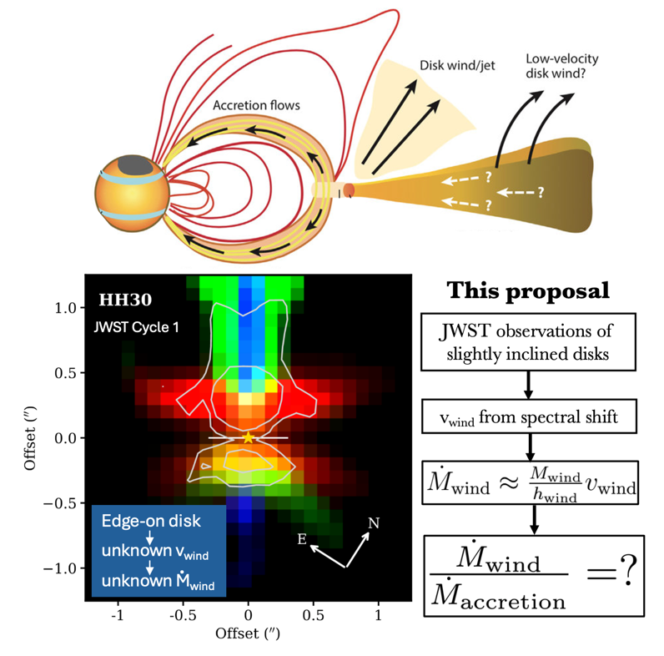
Section 4: Importance and Broader Implications
- Create a heading that states the broader impact/importance of the solution.
  - Understanding disk evolution and putting exoplanet observations in context
- What is the high level importance of the proposed products of your study to your subfield? How will your study advance the subfield?
  - Constraining
    - how much mass MHD winds are removing from disks
    - the angular momentum removal efficiency
    - how wind mass loss rate scales with accretion rate (do high accretors have higher mass loss rates?)
    - whether or not they are responsible for driving accretion and disk evolution
- Repeat Suitability:
  - Why now?
    - Currently receiving an unprecedented number of exoplanet observations—crucial that we can put them in context
    - Winds will affect planetary migration and solid drift
    - Understanding winds is crucial to understanding what types of planets can form where in the disk, and where they eventually end up
  - How does this program relate to the funding call? Which key science goals of HST/JWST does your proposal connect to?
    - JWST: https://webb.nasa.gov/content/science/index.html [ if applicable -> Observational] Repeat Why this facility?
      - JWST Science Theme: Star Lifecycle
      - “unravel the birth and early evolution of stars and planets”
      - Program will help uncover how protoplanetary disks evolve, and what mechanisms change disk structure, consequently affecting solar system formation
      - JWST is the only telescope that can give us the spatial and spectral resolution to dissect winds
- How does this study increase the legacy value of the facility/agency?
  - What other subfields are advanced by these observations (GO) [Broader Impact]
    - Observations can also be used to investigate jet mass loss rates, origins, velocities (which can then be used to estimate accretion rates)
    - Will also provide constraints on disk chemistry—what species are present in the disk, and where is each species dominant?
References
Armitage, P. J. (2025). Planet formation theory: An overview (arXiv:2412.11064). arXiv. https://doi.org/10.48550/arXiv.2412.11064
Armitage, P. J. (2015). Physical processes in protoplanetary disks. arXiv. https://doi.org/10.48550/arXiv.1509.06382
Pascucci, I., Beck, T. L., Cabrit, S., Bajaj, N. S., Edwards, S., Louvet, F., Najita, J. R., Skinner, B. N., Gorti, U., Salyk, C., Brittain, S. D., Krijt, S., Muzerolle Page, J., Ruaud, M., Schwarz, K., Semenov, D., Duchêne, G., & Villenave, M. (2025). The nested morphology of disk winds from young stars revealed by JWST/NIRSpec observations. Nature Astronomy, 9, 81–89. https://doi.org/10.1038/s41550-024-02385-7
Pascucci, I., Cabrit, S., Edwards, S., Gorti, U., Gressel, O., & Suzuki, T. K. (2023). The Role of Disk Winds in the Evolution and Dispersal of Protoplanetary Disks (Vol. 534). arXiv. Protostars and Planets VII. https://doi.org/10.48550/arXiv.2203.10068

