1) Revise Title
Constraining Dark Energy: Reducing Shape Noise of Shear Measurements using Kinematic Lensing

2) Revise abstract.
Adhere to word limit: The abstract must be written in standard ASCII and should be no longer than 20 lines of 85 characters of text. Use the HST/JWST Templates.

Weak gravitational lensing (WL) is a leading method of mapping the large-scale structure of the universe and its matter distribution. Precise measurements of galaxy shape distortions caused by WL, known as cosmic shear, enable tight constraints on the growth of cosmic structure and thus inform the physics driving the cosmic acceleration of the universe. However, the WL distortion of observed galaxies is 1% of the intrinsic ellipticities of galaxies, making it impossible to differentiate the WL signal from an unlensed galaxy. This issue is known as “shape noise”. We propose to validate a promising alternative method of shear measurement called kinematic lensing (KL) using JWST grism data of spiral galaxies in the SAPPHIRES dataset. KL combines photometric and spectroscopic measurements to break degeneracies of intrinsic galaxy shapes, robustly differentiating sheared and unsheared galaxies, and reducing shape noise by an order of magnitude. By applying KL to the JWST SAPPHIRES dataset, we will validate its efficiency and effectiveness with slitless spectroscopy and perform analysis on the roll-angle dependency of KL. The upcoming Nancy Grace Roman Telescope (Roman), which has a similar grism to JWST, launches later this year. It is thus crucial to thoroughly test KL using data taken with JWST’s grism to refine and improve the method for future Roman grism measurements. An empirically tested model of KL is critically needed to realize the promise of galaxy shape measurements to yield precision constraints on cosmic evolution and dark energy.

Science Justification will need to be 3 pages in total. This includes 1 figure, but not the bibliography.

Science Justification Outline
3) Provide an outline for your proposal (BULLETED POINTS that answer each of the below)
Section 1: Facts, Problem & Summary paragraph (3/4 of a page)
- What is the descriptive heading? It must be a statement
- Kinematic Lensing Solves the Issue of Shape Noise in Weak Lensing
- 1 fact-based paragraph:
  - State the fact leading the paragraph (the conclusion) – this should follow from the abstract.
- Weak gravitational lensing is a leading method of mapping the large-scale structure of the universe and its matter distribution.
  - What would be supporting facts (1-3)? Provide at least one paper citation per supporting fact.
- By averaging over galaxies, shear measurements can be used to create a shear map over a region of the sky. This map can then be converted into projected mass, allowing for a map of the dark matter distribution (Refregier 2003).
- Weak lensing directly measures mass, removing assumptions on physical models of the universe. This is a massive advantage over previous methods of mapping LSS (Hoekstra 2002).
- Cosmic shear, introduced through weak lensing distortions, provides the most reliable measurements since it is dominated by collisionless matter, avoiding issues that other probes face, like baryonic effects (Mandelbaum 2018).
  - What is the nuanced conclusion for the paragraph? This is the importance of the fact that should set the stage for the problem (should follow from abstract)
- Precise measurements of galaxy shape distortions caused by WL enable tight constraints on the growth of cosmic structure and thus inform the physics driving the cosmic acceleration of the universe.
- Problem paragraph:
  - What is “the problem” statement?
- Weak gravitational lensing distortion is 1% of intrinsic ellipticities, making it impossible to differentiate between lensed and unlensed galaxies. The issue is known as ‘shape noise’.
  - What references are needed to support the problem?
- Mandelbaum 2018 - weak lensing review
- Niemi et al. 2015 - weak lensing shape noise
- Huff et al. 2019 - kinematic lensing paper
  - Why is the problem critical to answer now? (nuanced conclusion)
- Stage 4 surveys, like Euclid and Roman, have the capability to provide the best data for lensing measurements than ever before
- Finding a solution to the shape noise issue will open the door for unprecedented precision cosmology results
- Synopsis paragraph:
  - What is the proposal? (identify key component) “We propose”
- We propose to validate the method of kinematic lensing using JWST SAPPHIRES data
- Kinematic lensing is a method which combines spectroscopic and photometric data to alleviate the degeneracies of galaxy shapes and reduce shape noise by an order of magnitude.
  - Why the facility? This can be related to the funding call.
- JWST has NIRCam, which provides high quality photometric and spectroscopic data respectively.
- JWST and Roman grism provide slitless spectroscopy data
  - Allows for robust validation of methods for future use of kinematic lensing measurements on Roman data, and possibly other future missions
- JWST SAPPHIRES has spiral galaxies, needed for the Tully-Fisher scaling relation and multiple roll angles (Sun et al. 2025)
  - What is the broader impact ? Community deliverables?
- New method of confidently measuring galaxy shapes (subfield impact)
- High precision cosmological constraints (era of precision cosmology)
- Opens the door for theoretical testing of different physical theories and models of the universe using empirical galaxy shape measurements

Section 2: The Problem & Motivation/Narrative of the proposal
- Identify a descriptive heading that states the problem
- Shape Noise dominates Weak Lensing measurements
- What fact do you need to start with to set up the problem?
- the WL distortion of observed galaxies is 1% of the intrinsic ellipticities of galaxies
- What references support the problem?
- Mandelbaum 2018 - weak lensing review
- Niemi et al. 2015 - weak lensing shape noise
- Huff et al. 2019 - kinematic lensing paper
- State why solving this problem advances the subfield.
- Shape noise will no longer be a massive source of statistical error, allowing for more precise measurements of galaxy shapes without needing large surveys of galaxies (order of 10² or 10³ galaxies per arcminute).
- With more precise galaxy shapes and shear measurements, tighter cosmological constraints may be produced.
- Identify the “key component” missing to solve the problem.
- Kinematic lensing is a method of galaxy shape measurement that combines kinematic information, provided by spectroscopy, with images of the galaxy, provided by photometry. Using this method, intrinsically elliptical galaxies can be robustly differentiated from lensed galaxies.
- State that this program will generate the “key component” to solve the problem.
- Using JWST SAPPHIRES data, we will be able to robustly verify kinematic lensing’s efficiency and accuracy using the NIRCam grisms, and validate the method as an improvement to the current leading method of weak lensing by reducing shape noise by an order of magnitude.

Section 3: The Strategy: HST/JWST + Target Solves the Problem (Generate the “Key Component”)
- Create a descriptive heading that states the strategy -> “This Proposal: Observe/Model This Thing”
- This Proposal: Validate Kinematic Lensing using JWST SAPPHIRES Spiral Galaxies
- What are you targeting ? (imaging/spectra/archival data of what astronomical object, or what physical mechanism/ simulations/data set )
- 2D spectra and image cutouts for spiral galaxies using NIRCam and its grism
- Why this facility? (Why HST/JWST? )
- JWST NIRCam grisms provide slitless spectroscopy, which provides clear kinematic information of the spiral galaxies
  - Allows for robust validation of methods for future use of kinematic lensing measurements on Roman data, and possibly other future missions
- NIRCam also provides the best photometric data currently available
- JWST SAPPHIRES has spiral galaxies, needed for the Tully-Fisher scaling relation and multiple roll angles (Sun et al. 2025)
- Outline (bullets) the strategy to generate the key component
- For AR/Theory: describe *briefly* the analysis method/proposed usage of simulations/codes and relation to existing/future HST/JWST data sets.
- You must explain how the figure will be used to support the strategy
- First, the JWST SAPPHIRES data will undergo preprocessing
  - Prepare the image cutouts and collect the intensity information (for the Sersic profile)
  - Remove the continuum from the 2D spectra
- Using the developing kinematic lensing pipeline, we will apply it to the real data
  - Incorporate JWST PSF models
  - Provide priors for the parameters we wish to fit
- Using the best fit values, we can use galaxy shapes to create maps of the matter distribution.
- Outline the products of the program (tangible outcomes)
- Galaxy shape measurements for a majority of the sample
- Improvements to preprocessing methods of the data (with kinematic lensing in mind)
- Map of dark matter distribution for survey area
- Cosmological parameters
(this may be a little optimistic)
- How do these products solve the problem?
- More and improved galaxy shape measurements, without significant statistical errors
- Improved methods allow for more efficient and accurate galaxy shape measurements, which further improves cosmological constraints.

Include a Figure that explains the strategy/target/solution
Add here your (revised) Figure from Assignment 4 (or you must create a new one if your proposal is different)
Figure and caption instructions are in Assignment 4.
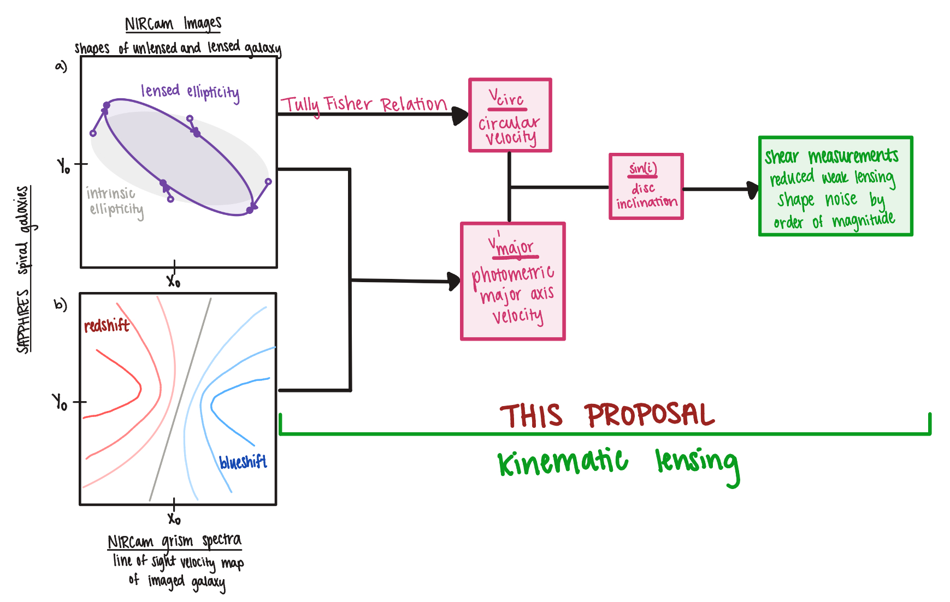
By combining photometric and spectroscopic JWST data, kinematic lensing can significantly reduce shape noise and allow for precise shear measurements, paving the way to map the matter distribution of the universe in the era of precision cosmology. The left hand of the figure shows the two separate measurements of spiral galaxies necessary for kinematic lensing. a) depicts how cosmic shear manifests in JWST NIRCam photometric samples, illustrating how an intrinsic galaxy shape (grey with open circles) changes due to lensing (purple with closed circles). b) depicts the NIRCam grism spectroscopic measurements as a line-of-sight velocity map, showing the redshift and blueshift of the galaxies. The right hand of the figure shows how the combination of photometric and spectroscopic measurements will result in a galaxy disc inclination (R.S. et al. 2023). Once the disc inclination is independently combined with the photometric measurements, kinematic lensing will produce shear measurements for the spiral galaxies included in the JWST SAPPHIRES data with reduced shear measurements from weak lensing by an order of magnitude. Weak lensing is severely limited by shape noise due to the inability to distinguish the difference between intrinsic ellipticities and those produced by weak lensing (panel a). We propose to apply the novel method of kinematic lensing to the JWST SAPPHIRES spiral galaxies to demonstrate shape noise can be reduced by an order of magnitude, validating this method as a pathway to yield tight constraints on cosmic evolution and dark energy models. This program will further calibrate the kinematic lensing technique with data from JWST’s grism, setting the stage for shear measurements using the Nancy Grace Roman Space Telescope’s grism.

Section 4: Importance and Broader Implications
- Create a heading that states the broader impact/importance of the solution.
- Kinematic Lensing Paves the Way for the Era of Precision Cosmology
- What is the high level importance of the proposed products of your study to your subfield? How will your study advance the subfield? (this is a like a summary statement)
- Within the era of precision cosmology, kinematic lensing will provide unprecedented precision of galaxy shape measurements, succeeding weak lensing as the leading and most reliable method for mapping large-scale structure.
- Repeat Suitability:
  - Why now?
- Upcoming Stage IV surveys, like the Nancy Grace Roman Telescope, will provide massive, unprecedented amounts of data. The ability to accurately, precisely, and efficiently analyze this data with kinematic lensing is essential.
  - How does this program relate to the funding call?
Which key science goals of HST/JWST does your proposal connect to ?
o JWST: https://webb.nasa.gov/content/science/index.html
o HST: https://www.stsci.edu/hst/about/key-science-themes
[ if applicable -> Observational] Repeat Why this facility?

- Early universe
  - being able to apply KL to high-z galaxies can also be crucial to understanding the extent at which it can perform high precision measurements.
  - Precise and accurate KL measurements will lead to tight cosmological constraints which further improves our understanding of the universe and the physical models that describe it.
- How does this study increase the legacy value of the facility/agency?
- What other subfields are advanced by these observations (GO) or data analysis/code/simulations (AR) ? [ Broader Impact]
And/OR
- Do the products of your proposal serve the community at large?
- The greater adoption of kinematic lensing as a means of measuring galaxy shapes could greatly advance the field of cosmology.
- By improving statistical error significantly and improving accuracy, the field will be able to test more physical models than ever before using the tight constraints on cosmological parameters.
- Validation of KL will allow for application to realistic simulations for other surveys, motivating future survey plans for JWST, Roman, and others.

