Assignment 6: proposal outline

Title: Constraining galaxy structure modelling: The critical role of gas in disrupting young clusters
Abstract:
An important number of stars in spiral galaxies like the Milky Way are believed to be formed within dense embedded clusters that are observed to cover a mass range of ${10}^{1}-{10}^{6}$ solar masses. Observations and cosmological simulations agree that gradients in the local gas density play an important role in the early evolution of clusters of the high mass end of the cluster mass distribution. However, current cosmological zoom-in simulations of galaxy evolution are unable to resolve low mass clusters, making it impossible to verify if low mass clusters are subject to the same disruptive mechanism with the ISM as the high mass ones. We propose to build N-body simulations of low mass clusters embedded within a realistic galactic potential that includes the contribution from the surrounding gas. The galactic potential will be interpolated from snapshots of cosmological simulations of spiral galaxies, which will allow us to compare the kinematic evolution of the low-mass clusters with the gas distribution from the cosmological simulation. The embedded cluster mass function is dominated by clusters at the low mass end, making the physics governing the lower mass limit critical to our understanding of stellar mass growth in spiral galaxies. The proposed hybrid simulations will enable a novel theoretical study that is needed to accurately interpret the physics of galaxy evolution using HST and JWST data of both resolved and unresolved spiral galaxies.

Section 1:
a) The early dissolution of stellar clusters in the light of the FIRE simulations: measuring the impact of the cold ISM in the disruption of young star clusters.
b)
i) Most stars are formed in clusters covering a mass range ${10}^{1}-{10}^{6}$ solar masses.
ii) Supporting evidence:
- Quintana et al. (2025) estimated that more than 50% of the stars in the Milky Way were formed within dense clusters.
- The open clusters mass function of the Milky Way was inferred by Piskunov et al. (2008) to be well described by a decreasing power-law in the mass range ${10}^{1}-{10}^{6}$.
- Bertolotto et al. (2027) showed that clusters with masses > 10^4 solar masses are spatially sheared when crossing regions with steep gas density gradients.
iii) To understand how stars populate the disc of their host spiral galaxies, we must understand how their cluster progenitors are destroyed.

c)
iv) Current cosmological zoom-in simulations of galaxy evolution are unable to resolve low mass clusters, making it impossible to verify if low mass clusters are subject to the same disruptive mechanism with the ISM as the high mass ones.
v) Supporting evidence:
- FIRE has a mass resolution of ~10^4 solar masses (Hopkins et al., 2018).
- AURIGA has a mass resolution of ~10^3 solar masses (Grand et al., 2024).
vi) Reasons why this is timely:
- We have the computational power to do N-bodies of low mass clusters.
- We need those results to interpret HST and JWST images (like the ones from PHANGS) and to compare to Gaia DR4 incoming time series astrometry.

d)
vii) Build N-body simulations of low mass clusters embedded within a realistic galactic potential that includes the contribution from the surrounding gas.
viii) This work will help extend the legacy of JWST archival data by providing results that will help interpret the structure of unresolved and resolved spiral galaxies within JWST images. This is relevant to one of the main tasks of JWST, which is to understand how galaxies form and evolve.
ix) This work is relevant to the following fields:
- Galaxy structure and dynamics: helps understand the structure and evolution of spiral galaxies.
- Stellar populations: helps understand the origin of stellar moving groups.
- Clusters in an ISM context: helps understand the interaction between feedback, ISM and clusters of stars.

Section 2:
a) Does cold interstellar gas contribute to the disruption of low-mass clusters?
b) The majority of clusters have masses lower than the resolution of cosmological zoom-in simulations.
c) Quintana et al. (2025), Hopkins et al. (2018), and Grand et al. (2024)
d) Solving this problem will help quantify the role of cold gas in the disruption of young stellar clusters.
e) We do not have direct N-bodies of low mass clusters in a full galactic environment (potential+gas+feedback).
f) This program will have direct N-bodies of low mass clusters in a full galactic environment that will tell us to what extent cold gas contributes to disrupting young clusters in a galaxy like the Milky Way.

Section 3:
a) This proposal will simulate young star clusters in a galactic environment.
b) We aim to quantify the contribution of cold interstellar gas in disrupting low-mass clusters.
c) This work would help extend the legacy of JWST archival data by providing results that will help interpret the structure of unresolved and resolved spiral galaxies within JWST images. This is relevant to one of the main tasks of JWST, which is to understand how galaxies form and evolve.
d) Strategy:
- Create star clusters initial positions and velocities by sampling from the initial conditions of previously identified high-mass clusters from FIRE simulations.
- integrate each cluster in time as an N-body simulation embedded in a potential interpolated from FIRE simulation snapshots.
- At each integration step, measure the impact of the local gas on the cluster the same way that Bertolotto et al. (2027) did for high mass clusters. Figure 1 shows how the distance to feedback shock fronts at the moment of disruption helped us quantify the role of gas on high-mass clusters; we intend to do the same for low-mass clusters.
- Perform this task for several simulated galaxies and see if differences in galaxy morphology (flocculent vs grand design for example).
e) This proposal will tell us:
- How frequent it is for clusters to be disrupted by the gas in different kinds of spiral galaxies.
- General disruption timescales as well as disruption timescales due to gas.
- Frequency of formation of moving groups due to feedback.
f) These products will help us understand the role of gas in disrupting low-mass clusters and how it compares to high-mass clusters.

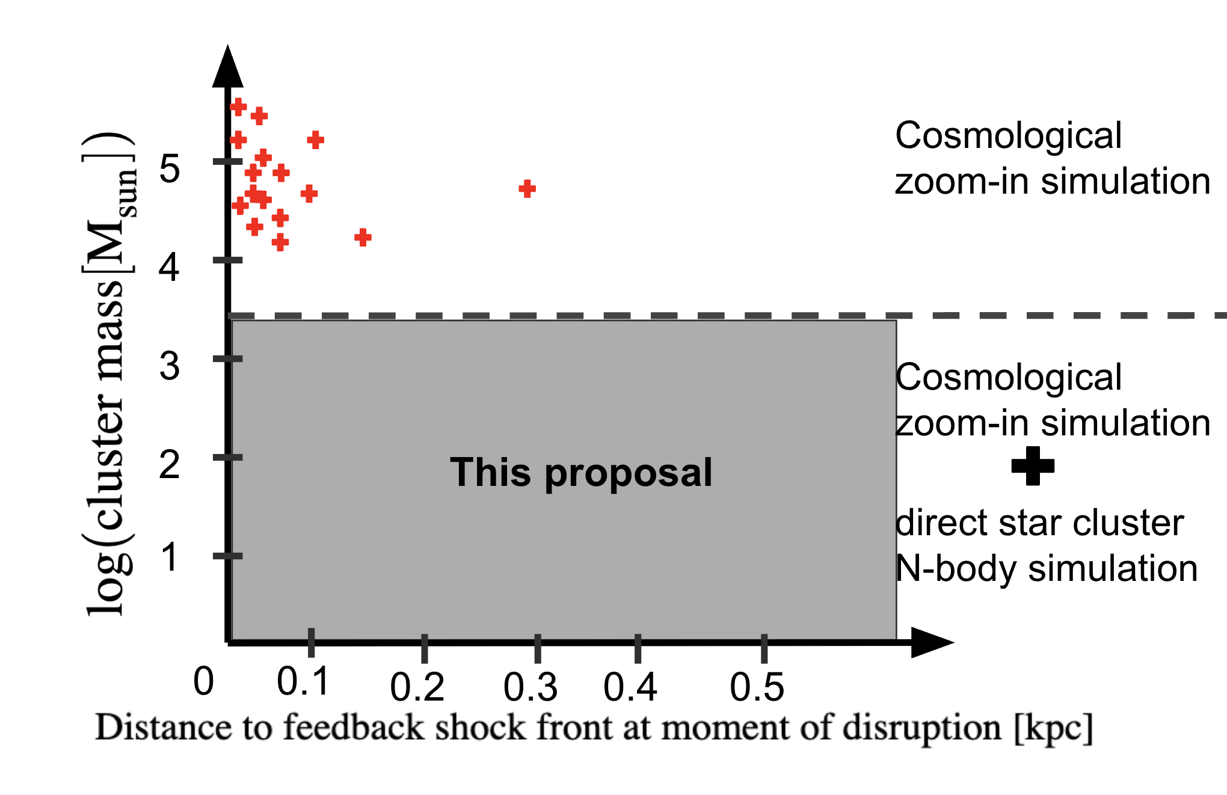
Figure 1: Many high-mass clusters are disrupted when they cross regions of steep gas density gradient between empty bubbles of feedback and cold interstellar gas. This proposal will help us see if it is also the case for low-mass clusters integrated in a cosmological zoom-in simulation. The plot shows the mass of identified massive clusters in a Milky Way-mass galaxy vs their distance to a feedback shock front at the moment of being disrupted.

Section 4:
a) A missing piece in the puzzles of galaxy structure and stellar cluster evolution.
b) This proposal will help us understand how clusters are disrupted and how their disruption contribute to the ever-evolving structure of the Milky Way.
c)
i) Why now?
- We have the computational power to do N-bodies of low mass clusters.
- We need those results to interpret HST and JWST images (like the ones from PHANGS) and to compare to Gaia DR4 incoming time series astrometry.
ii) This proposal is relevant to the following main objectives of JWST:
- Understand how galaxies evolve over time.
- Understand how the lifecycle of stars impact the structure of their host galaxies through feedback from Super Novae.
d) This work will help extend the legacy of JWST archival data by providing results that are relevant to the following fields:
- Galaxy structure and dynamics: helps understand the structure and evolution of spiral galaxies.
- Stellar populations: helps understand the origin of stellar moving groups.
- Clusters in an ISM context: helps understand the interaction between feedback, ISM and clusters of stars.

