Constraining Planet Occurrence in the Milky Way: The Missing Role of Dynamics

Stars and their planetary systems migrate many kiloparsecs over their lifetimes. Our Sun has migrated several kiloparsecs from its birth radius; therefore, identifying Sun-like stars requires accounting for stellar radial migration. Previous studies have shown that host star metallicity exhibits weak correlations with planet occurrence. This points to a degeneracy: stars with similar ages and metallicities can have very different dynamical histories. However, to break this degeneracy, we need a framework that connects the dynamical histories of stars with observed planet occurrence rates. We propose to build cutting-edge tracer particle simulations to predict the dynamical histories of stars in the thin disk of the Milky Way and reveal how these histories correlate with planet outcomes. We have access to high-resolution observational data and precision simulations from HST that make it possible to identify kinematic signatures of hosts that have experienced strong dynamical encounters with spiral arms. Comparing these populations within fixed metallicity ranges will help break the degeneracy between metallicity and dynamical history. Understanding whether there are dynamical differences between stars in the thin disk would redefine how we inform target selection for next-generation missions (HWO, Roman, Pandora). The results of this work are critical to ongoing HST exoplanets programs and broader efforts to understand the structure and evolution of planets and their host stars.

Section 1: Facts, Problem & Summary Paragraph

a) What is the descriptive heading? It must be a statement

Stellar Metallicity Alone Cannot Explain Planet Occurrence

b) 1 fact-based paragraph:
i) State the fact leading the paragraph (the conclusion) – this should follow from the abstract.

Understanding the dynamical history of a host star is critical and currently a missing parameter in determining planet occurrence.

ii) What would be supporting facts (1-3)? Provide at least one paper citation per supporting fact.

Stars and their planetary systems migrate several kiloparsecs over their lifetimes, and even the Sun has moved significantly from its birth radius. (Roškar+2012)

While previous studies have shown only weak correlations between host star metallicity and planet occurrence, this reflects a fundamental degeneracy: stars with similar ages and metallicities can have very different dynamical histories. (Sayeed+2025)

iii) What is the nuanced conclusion for the paragraph? This is the importance of the fact that should set the stage for the problem (should follow from abstract)

To break this degeneracy, we need to build a framework to understand whether the dynamical history of host stars is a fundamental parameter in planet occurrence.

c) Problem paragraph:
iv) What is “the problem” statement?

Stars with similar ages and metallicities can have very different dynamical histories.
However, to break this degeneracy, we need a framework that connects the dynamical
histories of stars with observed planet occurrence rates.

v) What references are needed to support the problem?

Sayeed+2025
Bashi+2021

vi) Why is the problem critical to answer now? (nuanced conclusion)

We have access to high-resolution observational data and precision simulations from HST that make it possible to identify kinematic signatures of hosts that have experienced strong dynamical encounters with spiral arms.

d) Synopsis paragraph:
vii) What is the proposal? (identify key component) “We propose”

We propose to build cutting-edge tracer particle simulations to predict the dynamical histories of stars in the thin disk of the Milky Way and reveal how these histories correlate with planet outcomes.

viii)Why the facility? This can be related to the funding call.

Archival HST datasets provide access to observations that make it possible to identify kinematic signatures of stars that have experienced dynamical perturbations. These measurements are critical for reconstructing stellar dynamical histories at the precision required to distinguish between dynamically distinct populations at fixed metallicity. The results of this work will directly support ongoing HST exoplanet programs and contribute to broader efforts to understand the co-evolution of planetary systems and their host stars.

ix) What is the broader impact ? Community deliverables?

Understanding whether there are dynamical differences between stars in the thin disk
would redefine how we inform target selection for next-generation missions (HWO, Roman, Pandora). We would produce a framework that incorporates radial migration as a physical prior for stellar radial migration.

Section 2: The Problem & Motivation/Narrative
a) Identify a descriptive heading that states the problem

The Role of Stellar Dynamics in Planet Occurrence Is Not Accounted for in Current Models

b) What fact do you need to start with to set up the problem?

Previous studies have shown that host star metallicity exhibits only weak correlations with planet occurrence, yet stars with similar metallicities can have vastly different dynamical histories. This points to a fundamental degeneracy: chemistry alone is insufficient to predict planet outcomes.

c) What references support the problem?

Sayeed+2025
Bashi+2021
Petigura+2018

d) State why solving this problem advances the subfield.

Understanding whether dynamical history of host stars drives variation in planet occurrence would fundamentally redefine how we inform target selection for exoplanet surveys.

e) Identify the “key component” missing to solve the problem.

We currently lack a tracer particle simulation–based framework that incorporates radial migration of host stars into models of planet occurrence, and we do not yet understand how perturbations experienced by host stars over their lifetimes affect their ability to retain planets.

f) State that this program will generate the “key component” to solve the problem.

This program will build cutting-edge tracer particle simulations to predict the dynamical histories of stars in the thin disk of the Milky Way and reveal how these histories correlate with planet outcomes.

Section 3: The Strategy: HST/JWST + Target Solves the Problem
a) Create a descriptive heading that states the strategy à “This Proposal: Observe/Model This Thing”

This Proposal: Modeling Stellar Dynamical Histories to Predict Planet Occurrence

b) What are you targeting ? (imaging/spectra/archival data of what astronomical object, or what physical mechanism/ simulations/data set )
[...] that make it possible to identify kinematic signatures of hosts that have experienced strong dynamical encounters with spiral arms.

c) Why this facility? (Why HST/JWST? )

We have access to high-resolution observational data and precision simulations from HST [...]

d) Outline (bullets) the strategy to generate the key component
- For GO: describe the proposed observations *briefly/succinctly*
- For AR/Theory: describe *briefly* the analysis method/proposed usage of simulations/codes and relation to existing/future HST/JWST data sets.
- Build tracer particle simulations of stars in the thin disk of the Milky Way to model how radial migration (referencing HST Archival simulation code).

- Use these simulations to predict observable kinematic signatures of stars that have experienced strong dynamical encounters over their lifetimes.

- Compare perturbed versus unperturbed stars with PLATO data, and figure out the amount of planet that each type of star has.

- You must explain how the figure will be used to support the strategy

Figure outlines clearly the difference between unperturbed and perturbed signatures; it also highlights how the degeneracy will be broken by keeping the metallicity of stars constant and just examining whether the dynamics plays a role in planet occurrence.

e) Outline the products of the program (tangible outcomes)
- tracer particle simulation → dynamical histories of host stars in the Milky Way thin disk particularly kinematic signatures that distinguish perturbed and unperturbed stars
- a comparative analysis linking dynamical history (perturbed vs. unperturbed) to planet occurrence rates.

f) How do these products solve the problem?
These products solve the problem by enabling us to isolate stars at fixed metallicity and separate them by dynamical history, thereby directly breaking the degeneracy between chemistry and dynamics. By comparing planet occurrence across perturbed and unperturbed host stars, we can determine whether dynamical history is a predictive factor in planet occurrence.


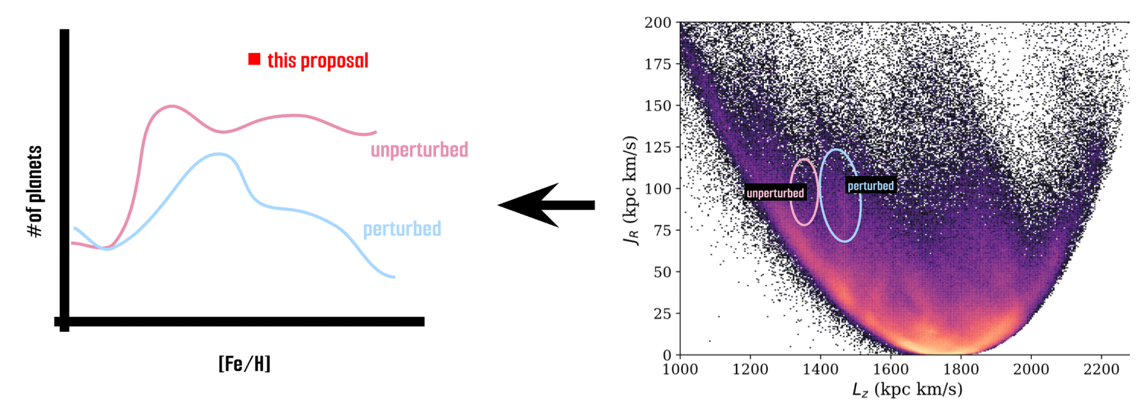

Fig 1. Radial migration of stars is the missing key to understanding planet occurrence in the Milky Way. The right panel shows the distribution of ∼7 × 10⁵ stars within 200 pc of the Sun in action space (JR, Lz), combining 6D kinematics from Gaia DR3, GALAH DR3, and APOGEE DR16 (Rampalli+2023). The diagonal over-densities (“wrinkles”) in this space trace dynamical perturbations, particularly at high JR (Smock et al., in prep.); the blue oval marks perturbed stars and the pink oval marks unperturbed stars. The left panel illustrates the core problem: at fixed metallicity ([Fe/H]), we aim to determine whether stellar dynamics alone (perturbed vs. unperturbed) drives differences in planet occurrence. Stars and their planetary systems migrate many kiloparsecs over their lifetimes, carrying with them the chemical fingerprints of their birthplaces and ages; however, metallicity alone is insufficient to explain planet occurrence, and we must account for the effects of radial migration. This program will build tracer particle simulations to make predictions about the dynamical histories of stars and then investigate how these histories correlate with planet outcomes. Understanding the impact of radial migration of stars and their planet systems is the missing key to finding exoplanets in our search for habitability.

Section 4: Importance and Broader Implications
a) Create a heading that states the broader impact/importance of the solution.

Incorporating Stellar Dynamics Will Improve Target Selection for Future Exoplanet Missions

b) What is the high level importance of the proposed products of your study to your subfield ? How will your study advance the subfield? (this is a like a summary statement)
Building a tracer particle simulation that incorporates radial migration and connects stellar dynamics to planet occurrence will be key to advancing the field of exoplanets in a Galactic context. There is currently limited understanding of whether—and how—the properties of host stars are linked to their planetary systems.
c) Repeat Suitability:
i) Why now?
This problem can now be addressed because we have access to high-resolution archival HST datasets that enable identification of kinematic signatures of stars that have experienced strong dynamical perturbations. At the same time, advances in tracer particle simulations allow us to model radial migration and reconstruct stellar dynamical histories at the precision required to distinguish between dynamically distinct populations at fixed metallicity. Together, these developments make it possible, for the first time, to directly connect stellar dynamics to planet occurrence.
ii) How does this program relate to the funding call?
This program directly aligns with HST’s exoplanet science theme of developing a deeper understanding of parent stars. As highlighted by HST, “the parent stars in these systems are also diverse, from stars similar in mass to the Sun, to much smaller, active stars…” While HST has established the diversity of stellar environments that host planets, the role of stellar dynamical history remains largely unexplored. This program extends that framework by introducing radial migration and dynamical perturbations as key factors in shaping planetary system outcomes.
Which key science goals of HST/JWST does your proposal connect to ?
JWST: https://webb.nasa.gov/content/science/index.html
HST: https://www.stsci.edu/hst/about/key-science-themes [ if applicable -> Observational] Repeat Why this facility?

d) How does this study increase the legacy value of the facility/agency?
- What other subfields are advanced by these observations (GO) or data analysis/code/simulations (AR) ? [ Broader Impact]
And/OR
- Do the products of your proposal serve the community at large?

This study increases the legacy value of HST by transforming archival datasets into a framework for reconstructing stellar dynamical histories, enabling new science beyond their original purpose. The tracer particle simulation–based framework and associated analysis tools will be broadly applicable to studies of Galactic structure, stellar populations, and exoplanet demographics. By connecting stellar dynamics to planet occurrence, this work advances multiple subfields, including Galactic archaeology and exoplanet science, and provides a reusable methodology that can be applied to current and future datasets from HST, JWST, and upcoming missions. All simulation outputs and analysis tools will be made available to the community, maximizing their utility for future studies.

