Disambiguating Exoplanet Direct Imaging Science: Refining orbits of Jovian planets targeted by future direct imaging missions with HST Fine Guidance Sensor Astrometry

The Abstract
Directly observing exoplanets around nearby stars based on prior knowledge of their orbits is one of the core missions of the Habitable Worlds Observatory (HWO), the Nancy Grace Roman Space Telescope Coronagraph Instrument (CGI) and the Lazuli Observatory. Exoplanet orbital priors are based primarily on radial velocity measurements of their host stars which do not constrain the planet’s mass and orbital position, inhibiting precise position predictions at any given time. However, scheduling exoplanet observations on future direct imaging missions is not possible without precise predictions of target planet positions. We propose a campaign to obtain high precision astrometry of the SPORES-HWO direct imaging target catalog to fully constrain the orbits of Jovian planets around these stars. Using the HST Fine Guidance Sensors (FGS), we will obtain sub-milliarcsecond astrometry for these targets which, when combined with literature precision radial velocity measurements, will produce complete planet orbit and mass constraints. High astrometric precision requires long temporal baselines - to have orbital constraints ready for the launch of Lazuli before 2030 and HWO in the 2040s, these observations need to begin now. The orbital constraints derived from this campaign are required to accurately compare exoplanet atmosphere models to optical-wavelength direct-imaging observations. HWO, CGI, and Lazuli will be unlocking this science for the first time ever, this campaign is thus critical to enabling it.
Gurtina if you’re reading this, the headings suck and I know they do. They’re rough placeholders, I’m literally at the 61” right now.

Section 1 - The Facts, The Problem, and Synopsis

What would a descriptive heading be? It must be a statement.
- Dependency of Direct imaging missions on precise planet orbit constraints.

First Paragraph: The Facts

What is the point you want to get across with this paragraph?
- Observations of known Jovian exoplanets is a core mission of these observatories

What facts support this point you're trying to get across?
- (Wolff 2026) RV planets with astrometry measurements are being targeted for the first month of observations with the Roman Space Telescope Coronagraph Instrument
- (Roy et al. 2026) Giant RV planets are a main goal of the Lazuli observatory

What is the significance of the point you want to get across with more nuance and detail?
- Successful observation of these targets requires scheduling them when they have the highest probability of detection. This requires good orbital prior knowledge.

Second Paragraph: The Problem

What is "the problem"?
- Many targets for these missions have orbital constraints based solely on Radial Velocity measurements, which is insufficient for a direct imaging mission.

What references support this problem?
- (Harada et al. 2025) SPORES-HWO catalog shows the RV coverage of the systems. They emphasize placing mass constraints on the planets in these systems, but that cannot be done with RV alone.
- (Thompson et al. 2025) Increasing amounts of astrometric points involved in an orbit fit greatly improve the orbital constraints for eps Eri b.

Why is this problem time-critical?
- As at minimum 1 orbit must be observed with RVs to constrain an orbit as far as RVs can, the same is true when incorporating astrometry data, a temporal baseline of astrometry of at least 1 orbit is necessary.

Third Paragraph: The Synopsis

What are you proposing? (Identify the key component)
- HST FGS observations of the targets in the SPORES-HWO catalog

Why this facility?
- A program with HST FGS offers a capability that Gaia DR4 lacks: The ability to target stars at times in their planets' orbits where the information return from an astrometric measurement is highest.

What is the broader impact? What are the community deliverables?
- This will provide a catalog of astrometric measurements of the SPORES-HWO direct imaging target catalog, directly leading to higher precision orbit constraints mass estimates for these targets.

Section 2 - The Problem & Motivation

What would be a descriptive heading that states the problem?
- Direct Imaging observation scheduling and interpretation relies on precise orbital constraints

What fact do you need to start with to set up the problem?
- Precise constraints on planet orbits are necessary for both scheduling and interpreting exoplanet direct imaging

What references support the problem?
- (Morgan et al. 2021) Improved prior knowledge of direct imaging targets increases the rate of exoplanet detections.
- (Wolff 2026) As an example for Roman CGI, precise priors on the orbit of eps Eri b have been important to understand when the planet is visible within the wide field of view observing mode.

Why does solving this problem advance the subfield?
- The subfield gets to directly image exoplanets: Successful, efficient direct imaging relies on knowing the planet is actually observable. And nondetections yield far more information if you know the planet is in the field of regard.
- The subfield gets to do the science: You can't figure out what the phase angle of your planet is, so you can't accurately compare the planet's photometry to atmospheric and cloud models.

What is the "key component" missing to solve the problem?
- Astrometry of these direct imaging targets to completely constrain their orbits in conjunction with literature RV measurements.

State this program will generate this "key component" to solve the problem
- Getting sub-milliarcsecond astrometry with the HST FGS of the SPORES-HWO catalog at high-information-carrying times of their orbits will provide these constraints.

Section 3 - The Strategy

What would be a descriptive heading that states the strategy?
- Placing precise orbital constraints on Jovian planet orbits with HST/FGS Astrometry

What are you targeting?
- SPORES-HWO catalog of Habitable Worlds Observatory target stars.

Why this facility?
- HST FGS is capable of sub-milliarcsecond astrometry necessary to constrain the orbits of Jovain-mass exoplanets
- The value of FGS in constraining exoplanet orbits has been proven in previous work and is being used actively for planning the observation phase of the Roman Space Telescope (eps Eri, ups And)
- You don't get to choose the cadence and timing of observations with Gaia DR4. If it misses high-information-content periods of the planet orbit, your constraints will suffer.

Describe the strategy to generate the key component:

For GO: Succinctly describe the proposed observations
- Start of multiple years of observations
- Begin with information-rich times in the orbits of high-priority targets for the most urgent missions (ex 14 Her for Roman, 47 UMa for Lazuli, etc.)
- Details:
  - Two orbits per target per epoch
  - 100-second on-target time per exposure
  - Neutral Density filter in place for bright targets
  - Gather multiple data points from which to median together at every epoch for a given target

For Archive/Theory: Briefly describe the analysis method & proposed usage of simulation/code and their relation to existing or future data sets
- GO proposal, see above

Explain how the figure will be used to support the strategy

What are the products/tangible outcomes of the program?
- Catalog of FGS-based astrometric measurements (similar to Gaia DR4 intermediates) and resulting orbit fits for observed targets.

How do these products solve the problem?
- New orbit fits generated from these observations go on to inform scheduling of and model comparisons from direct imaging campaigns.

The Figure - Visually explaining the strategy/target/solution

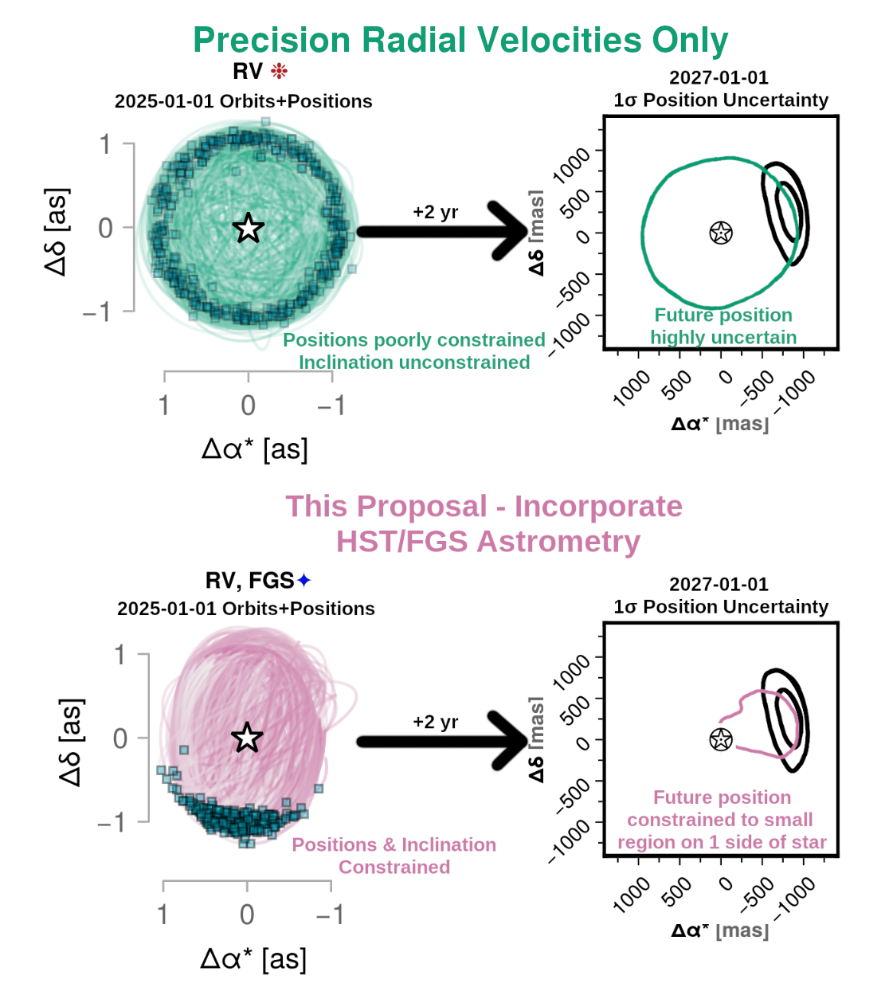
Orbital fits using only extreme-precision radial velocity (EPRV) measurements are insufficient to constrain the orbits of exoplanets for direct imaging missions. Absolute astrometric measurements from HST/FGS of stars targeted by direct imaging missions will greatly decrease planet position uncertainties. These are examples of planet position prediction based on EPRVs (Top) or EPRVs + HST/FGS astrometry (Bottom) for Jovian exoplanet eps Eri b. Left: Individual orbits (traced) and predicted locations for eps Eri b on 2025-01-01 (square points) for each case. Right: Predicted position of eps Eri b 2 years later (2027-01-01) based on these orbit fits. The black-outlined region is the uncertainty in the planet's position based on EPRV + HST/FGS + astrometry from Gaia & Hipparcos. Figure derived from Thompson et al. (2025).

Section 4 - Importance & Broader Implications

What would be a descriptive heading that states the broader impact/importance of the solution?
- Exoplanet science in the era of direct imaging depends on orbital constraints for correct analysis.

What is the high level importance of the proposed products of your study to your subfield?
- They let you do the science you want to do with these exoplanets.

How will your study advance the subfield?
- First catalog of uniformly-analyzed astrometric measurements from FGS for exoplanet targets.

Repeating the suitability

Why now?
- Gaia DR4 comes out in late 2026
- For Lazuli, orbits need to be precisely constrained before launch around 2030

How does this program relate to the funding call/science goals of the facility? (If applicable, e.g. for observational proposals, repeat "Why this facility?)
- Exoplanet exploration is a key science area of HST.
- Understanding orbits directly contributes to our understanding of the planets themselves.

How does this study increase the legacy value of the facility/agency?
- These observations will be used for fitting the orbits of these planets for decades to come, in the same way legacy RV campaigns have been used for decades.

What other subfields are advanced by this program? Do the products of your proposal serve the community at large?
- Exoplanet atmospheric modeling - For example, you can't tell if your planet is dimmer because of clouds or because you have the phase angle of the planet wrong

References:

Harada, C. K., Dressing, C. D., Turtelboom, E. V., et al. 2025, The Astronomical Journal, 170 (IOP), 343
Morgan, R., Savransky, D., Turmon, M., et al. 2021, Journal of Astronomical Telescopes, Instruments, and Systems, 7, 021220
Roy, A., Feldman, S., Klupar, P., et al. 2026 (arXiv), https://ui.adsabs.harvard.edu/abs/2026arXiv260102556R
Thompson, W., Nielsen, E. L., Ruffio, J.-B., Blunt, S., & Marois, C. 2025, The Astronomical Journal, 170 (IOP), 301
Wolff, S. G. 2026, https://www.youtube.com/watch?v=op5uRnq2rf0

