Below the resources has created using Terraform.

Azure storage:

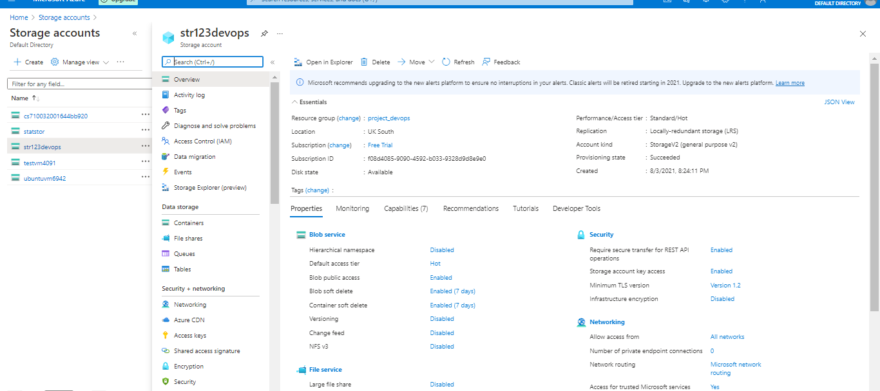

Azure app services:

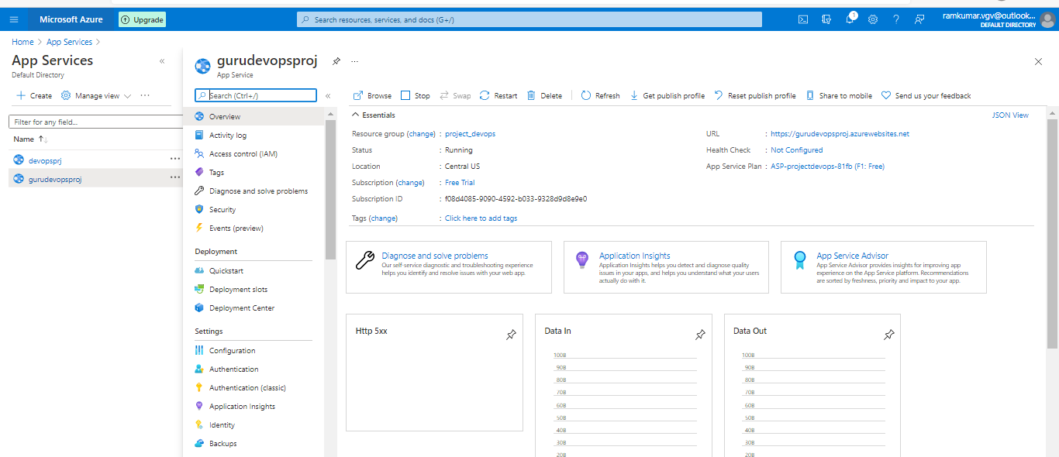

Azure container registries:

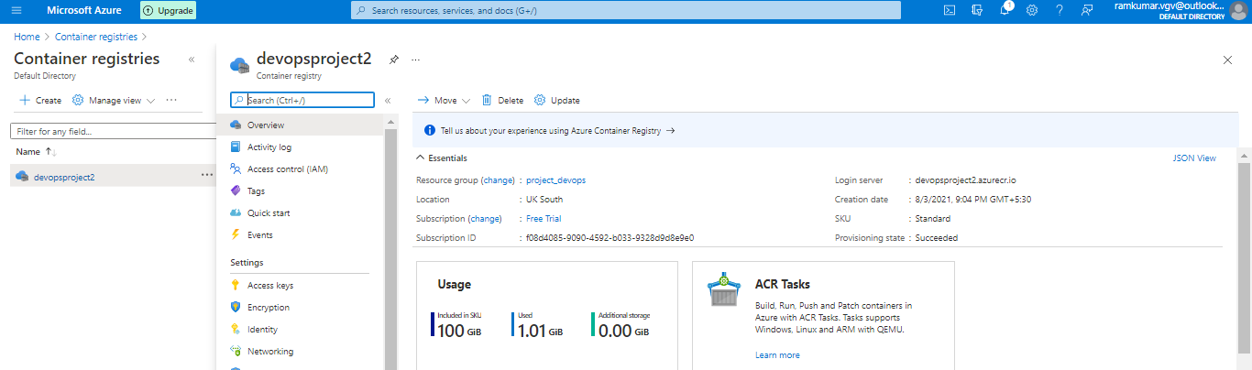

Azure mysql server with Database:

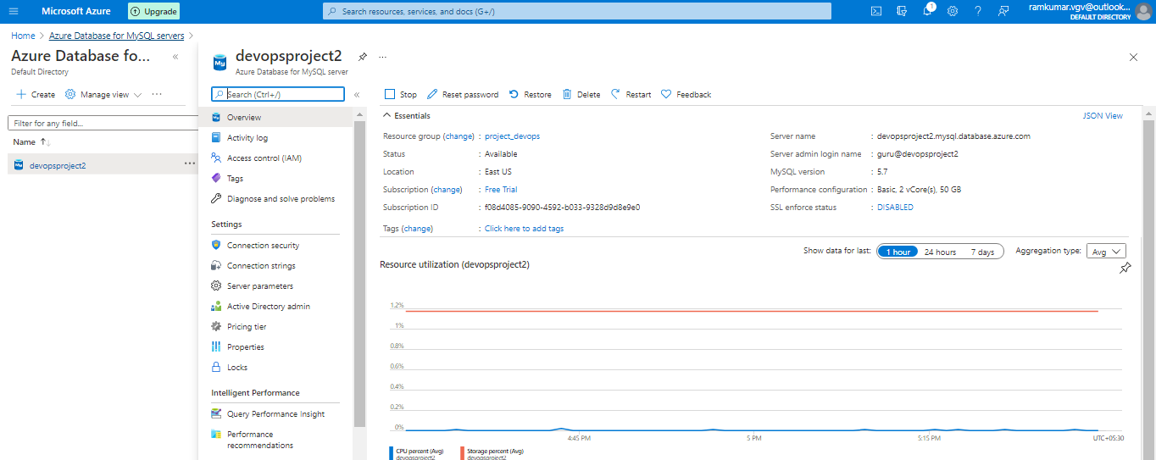

Azure kubernetes services:

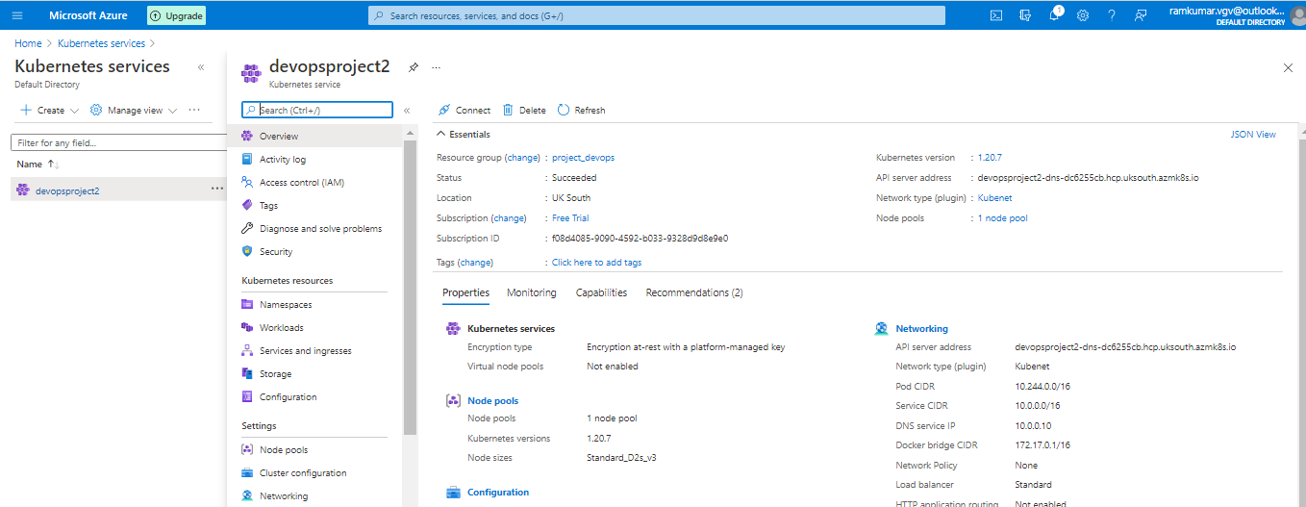

Uploading images to Azure Storage:

Azure storage with 'str123devops' has already created with Container (blob) storage using terraform.

created the new container con9 with Blob. changed access level to all. uploaded all images.

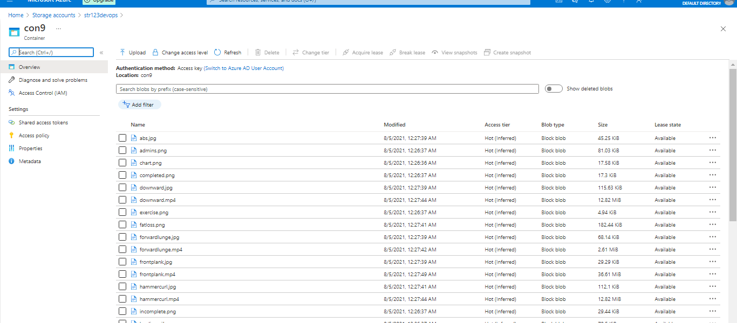

checked with sample link https://str123devops.blob.core.windows.net/con9/abs.jpg

My Sql Databae restored with sql data:

get the details from mysql server.

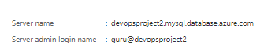

open the azure cloud shell, selected BASH.

mysql -h devopsproject2.mysql.database.azure.com -u guru@devopsproject2 -p

logged in with DB password.

created Databse name with guru.

MySQL [(none)]> use guru

updated the sql file “utf8mb4_0900_ai_ci' with “utf8mb4_unicode_ci”.

**MySQL [guru]>** mysql -h devopsproject2.mysql.database.azure.com -u guru@devopsproject2 -p

< fitnessbackup.sql

MySQL [guru]> show tables;

+----------------+

| Tables_in_guru |

+----------------+

| dailystatus |

| exercise |

| profile |

| progress |

| users |

| workout |

| workoutmap |

+----------------+

7 rows in set (0.063 sec)

checked all tables with data created successfully.

Private agent pool creation:

Azure is no longer supporting public pools due to limitation. so created private agent pool on own linux server.

created new project with devops. click on project settings.

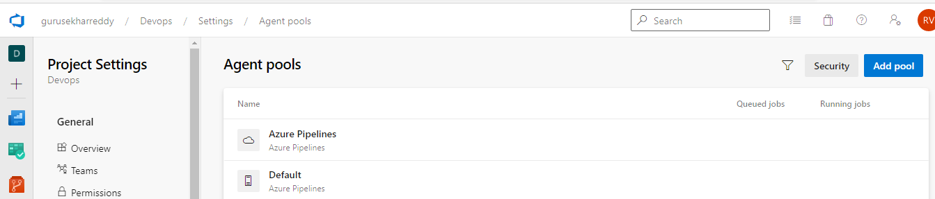

click on add pool. new pool -selfhosted and name given as mypool.

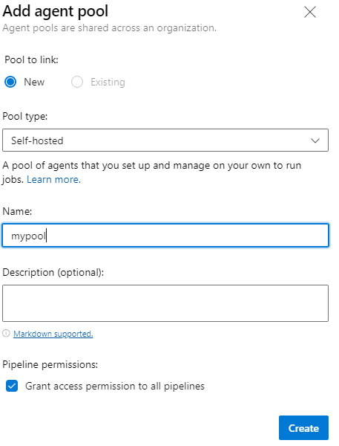

install the pool agent on local linux box as instruction given in next screen.

wget https://vstsagentpackage.azureedge.net/agent/2.190.0/vsts-agent-linux-x64-2.190.0.tar.gz

tar -zxf vsts-agent-linux-x64-2.190.0.tar.gz

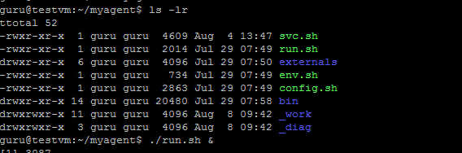

config.sh and run.sh

it asks for devops server details. gave as https://dev.azure.com/gurusekharreddy

now the node started the agent pool mypool.

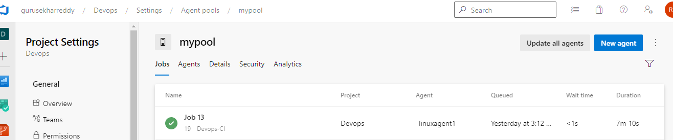

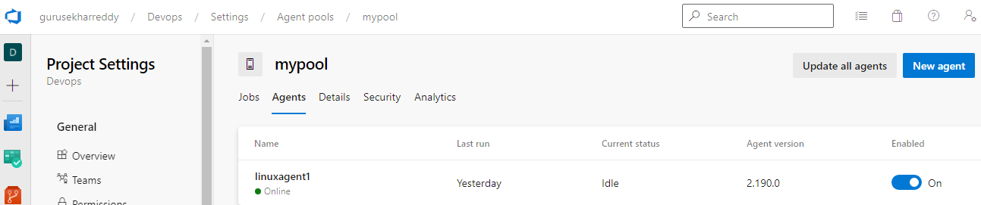

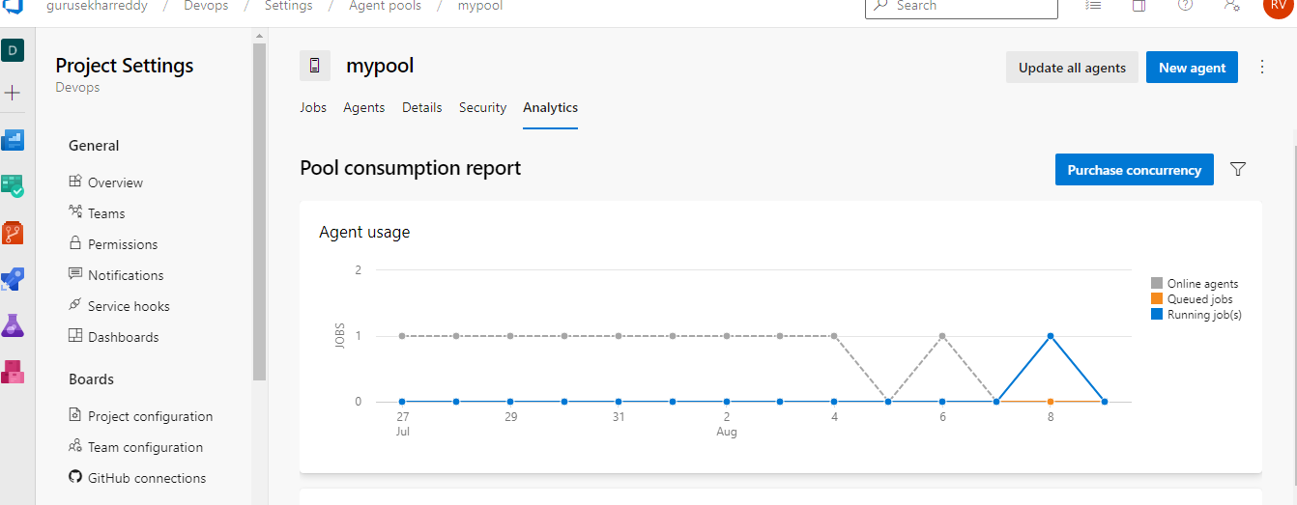

Azure devops project to maintain static website and code repostiory:

Used he Visual studio code, open the final app. updated all the image locations form local host to azure storage uploaded location.

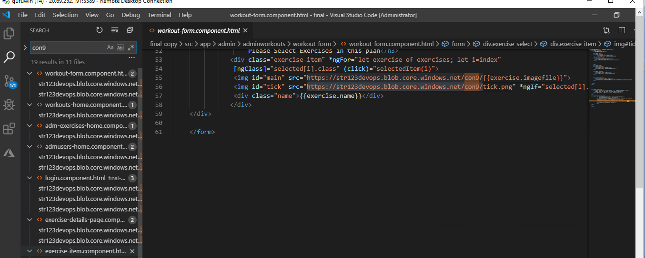

Total 19 files has updated.

i have installed the npm.ng packages and build , run from local host .

ng serve // which run the node js with 4700 port on local server. can able to get the static page.

opened the fitness-flask app from visual studio code.

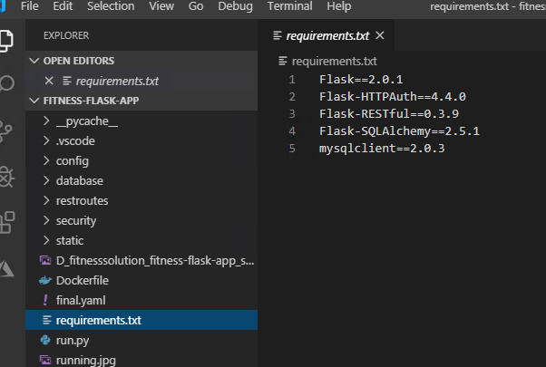

added the requirements.txt file as per requirment.

update run.py as with local http.

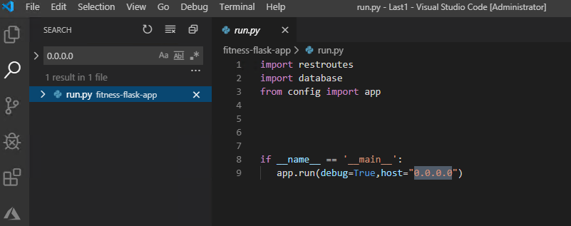

Added Docker file and updated as

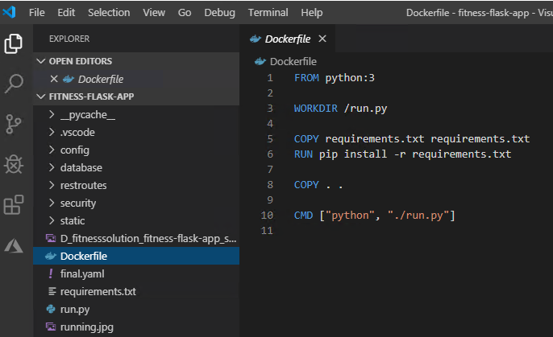

it get install python and related softwares.

updated DB connection file with SQL server login details.

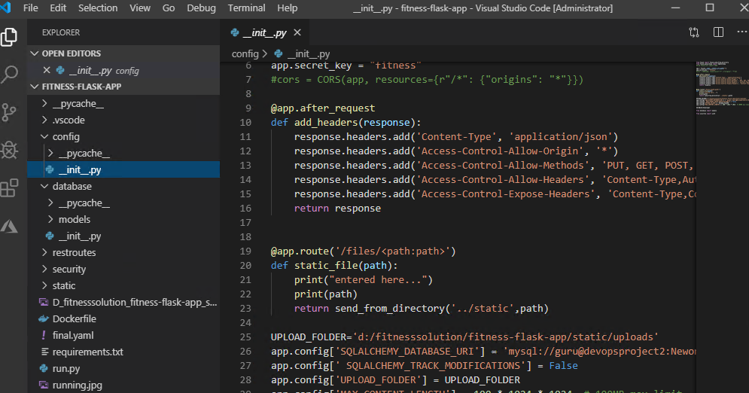

added final.yaml with.

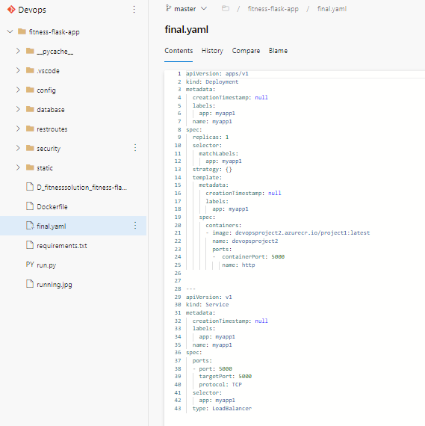

for kubectl deployment appname as myapp1 , pulling the image from container location.

created azure repo with name Devops.

https://gurusekharreddy@dev.azure.com/gurusekharreddy/Devops/_git/Devops

git remote add orgin https://gurusekharreddy@dev.azure.com/gurusekharreddy/Devops/_git/Devops

git push origin master

uploaded fitness-flask app to the repo.

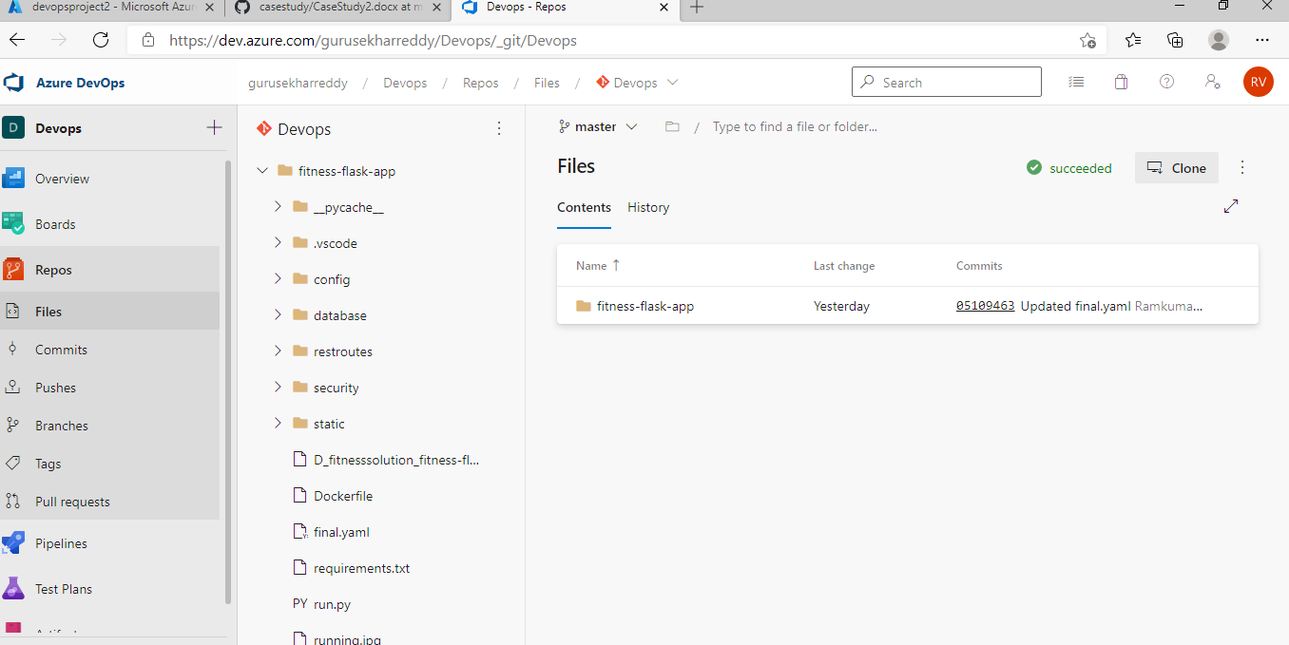

Created pipeline , clssic editor, seleect azure repo as devops which just created and branch with master. select pool as mypool which is running on our local agent.

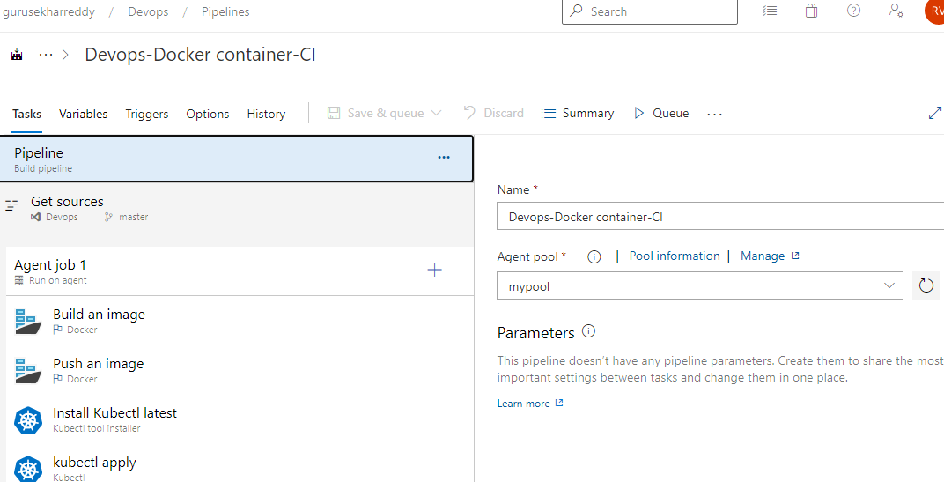

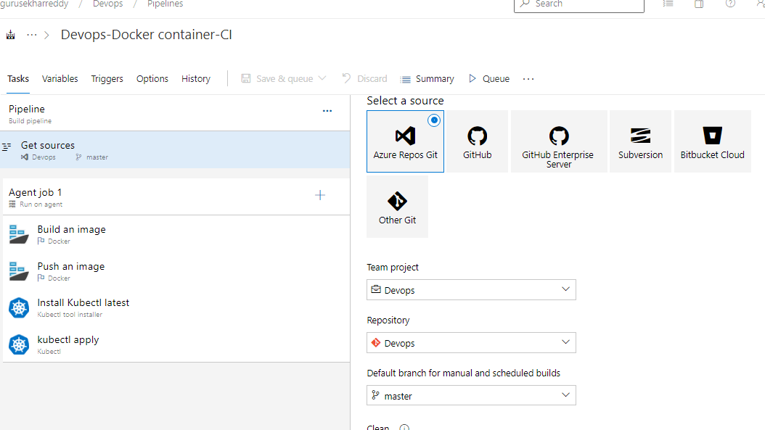



**added jobs as build docker build and push image. install kubectl and kubectl apply.**

**Build an image:**

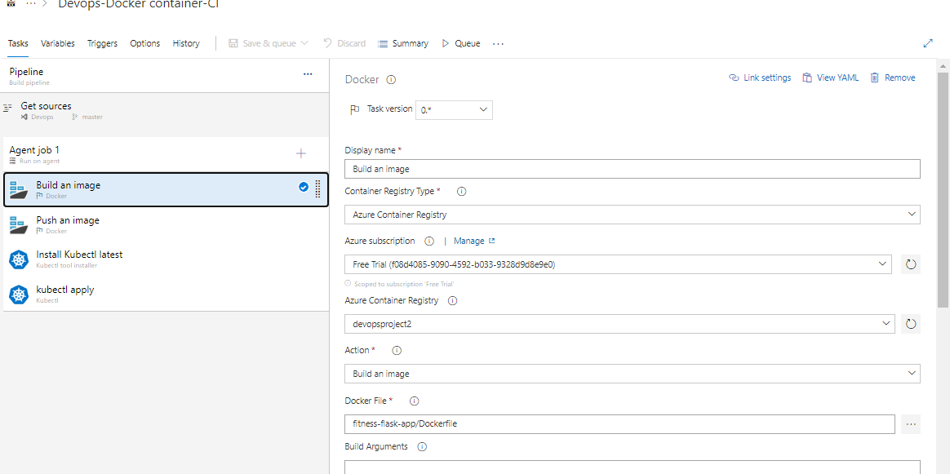

**Filled all details including container registry type as azure container registy, azure subscription. selected azure container registy with devopsproject2.**

**updated docker file with the latest file in repo. given image name as myapp1.**

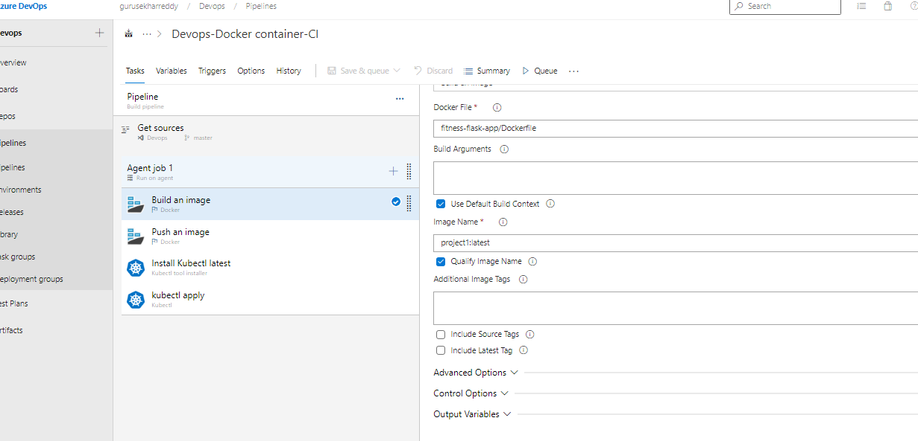

**push image with same details.**

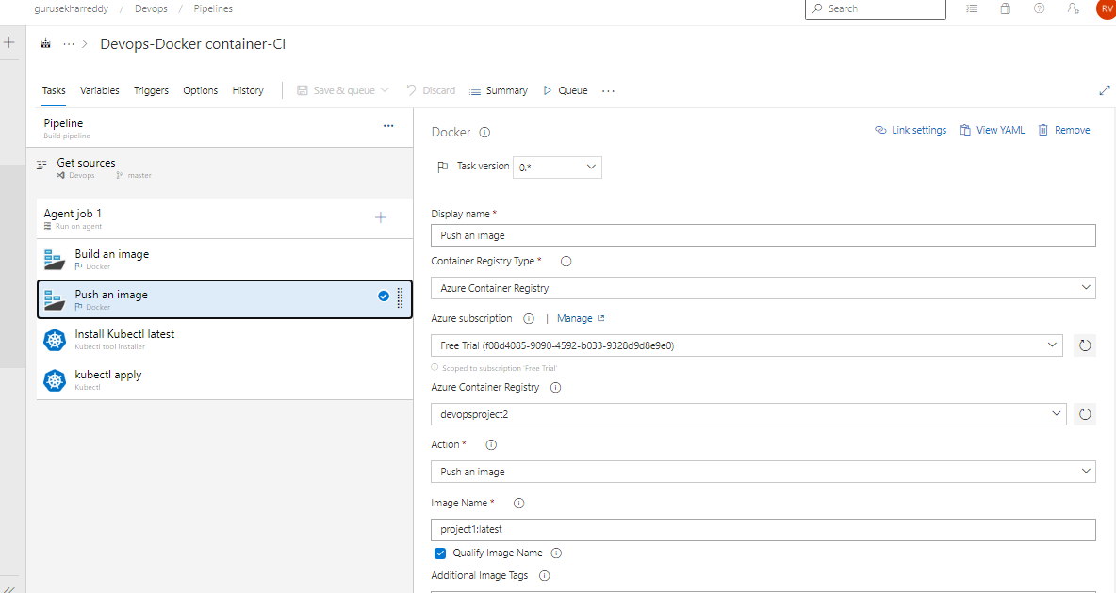

**install kubectl with safe side.**

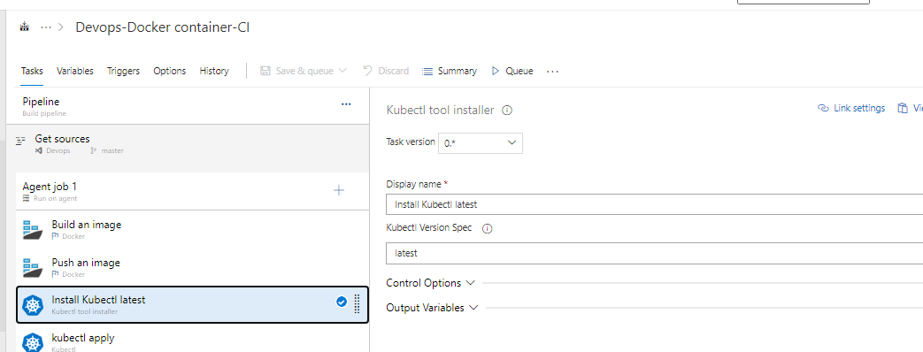

**Kubectl apply:**

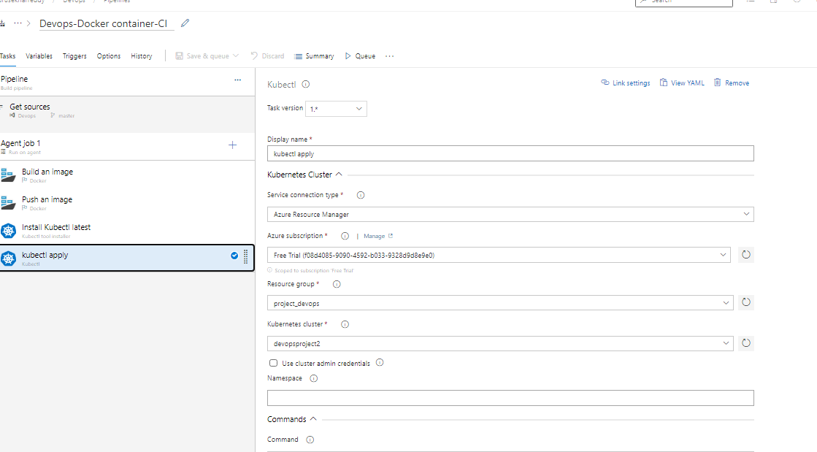

**given the details with kubernetes cluster name and file path name with repo.**



**Save and Queue for the pipeline to run.**

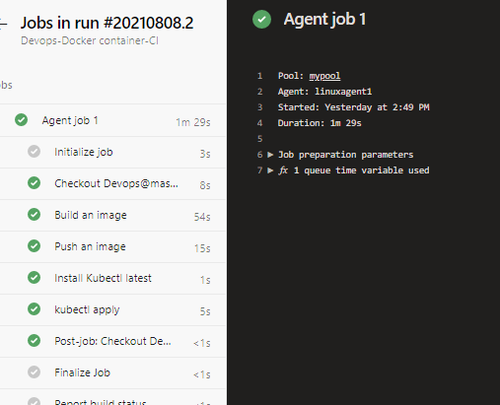

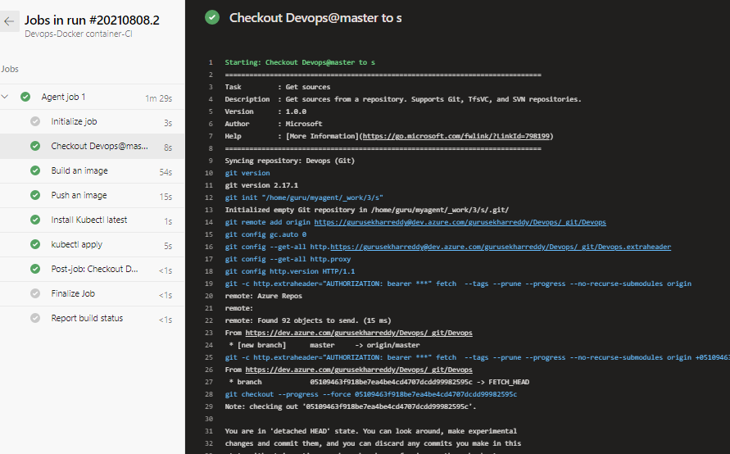

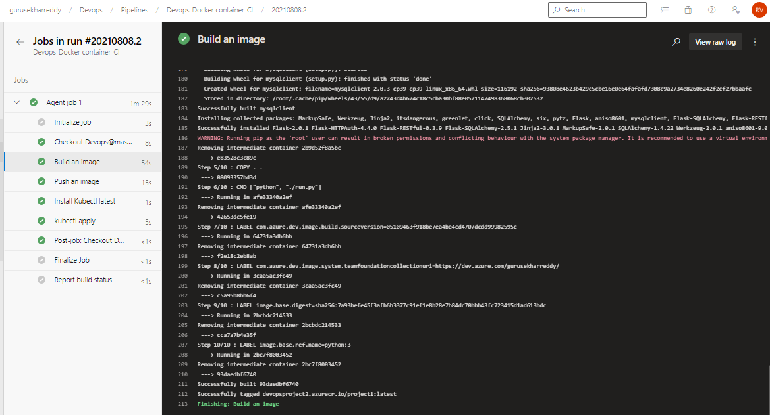

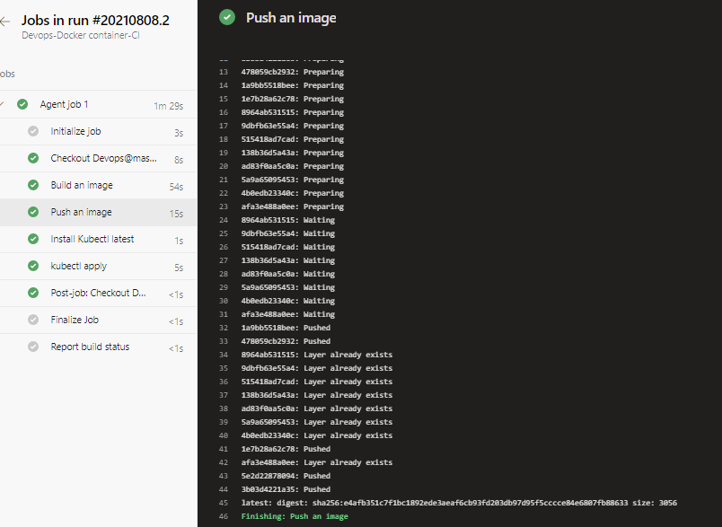

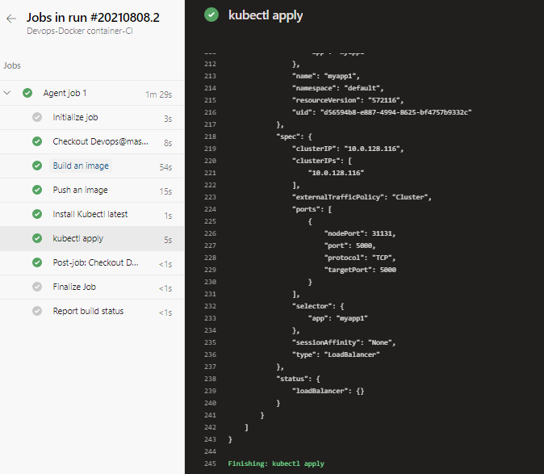

**Application has containerized , push and kubectl has applied with deployment and service.**

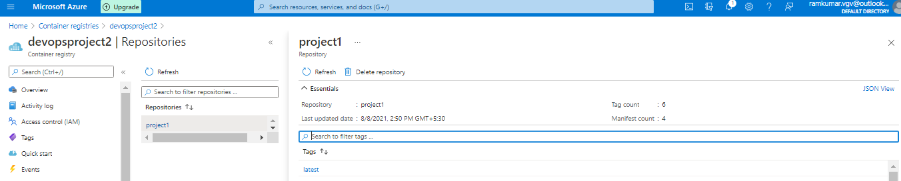

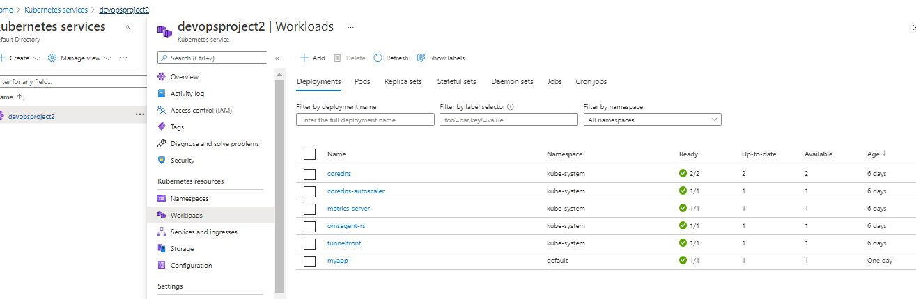

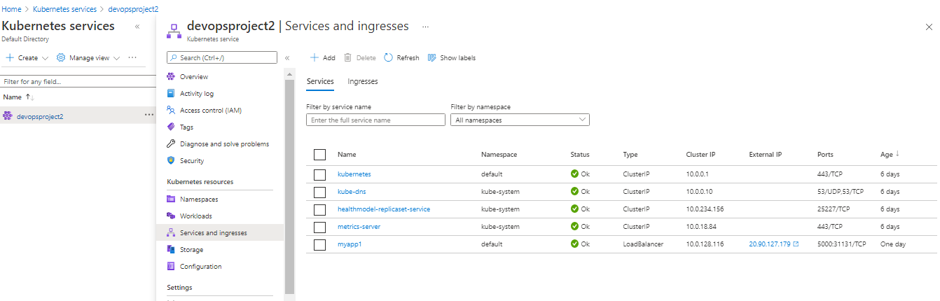

**checked the kubectl deployment and services from linux.**

**guru@testvm:~$ kubectl get all**

**NAME READY STATUS RESTARTS AGE**

**pod/myapp1-65955b7b54-sccvd 1/1 Running 0 25h**

**NAME TYPE CLUSTER-IP EXTERNAL-IP PORT(S) AGE**

**service/kubernetes ClusterIP 10.0.0.1 <none> 443/TCP 5d18h**

**service/myapp1 LoadBalancer 10.0.128.116 20.90.127.179 5000:31131/TCP 25h**

**NAME READY UP-TO-DATE AVAILABLE AGE**

**deployment.apps/myapp1 1/1 1 1 25h**

**NAME DESIRED CURRENT READY AGE**

**replicaset.apps/myapp1-65955b7b54 1 1 1 25h**

**guru@testvm:~$**

**check the app test with external ip with port.**

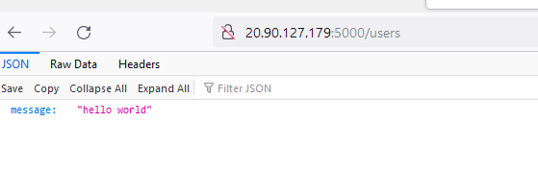

**Fitness-flaskapp was working fine from the backend.**

**Opened the final-copy node js front end app in visual sudio code and update the kubenetes external ip in all locations.**

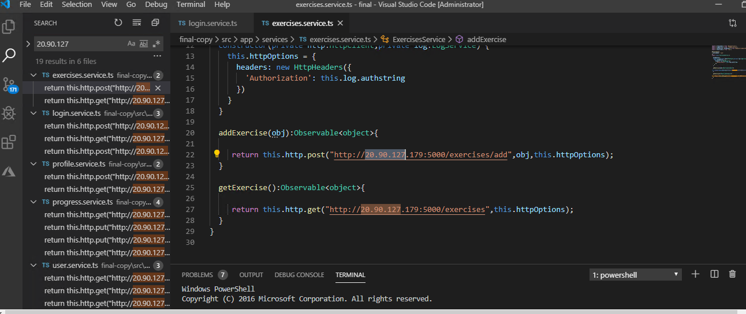

**created new azure repo with devops1.**

**git remote add origin** https://gurusekharreddy@dev.azure.com/gurusekharreddy/Devops/_git/devops1

git push origin master

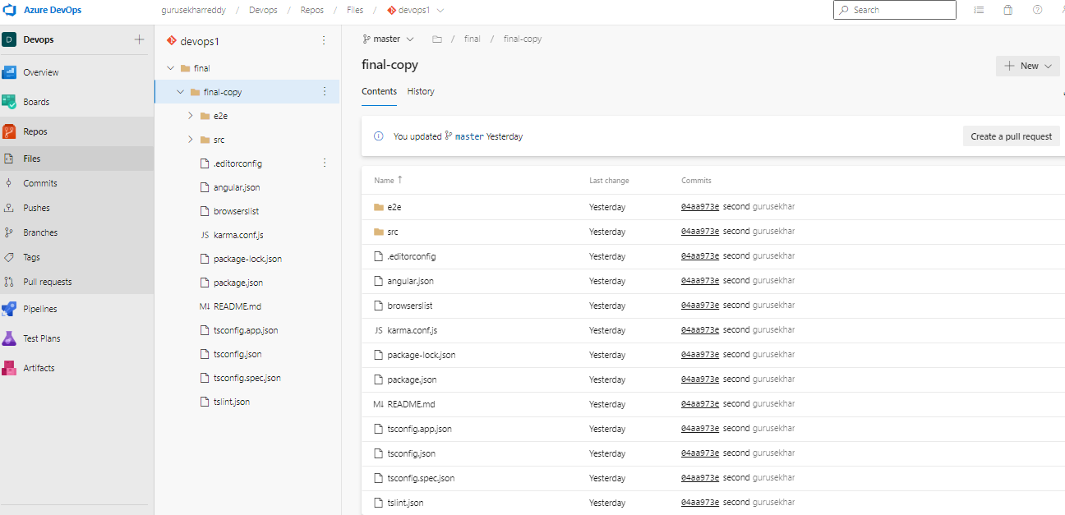

**azure created new pipeline.**

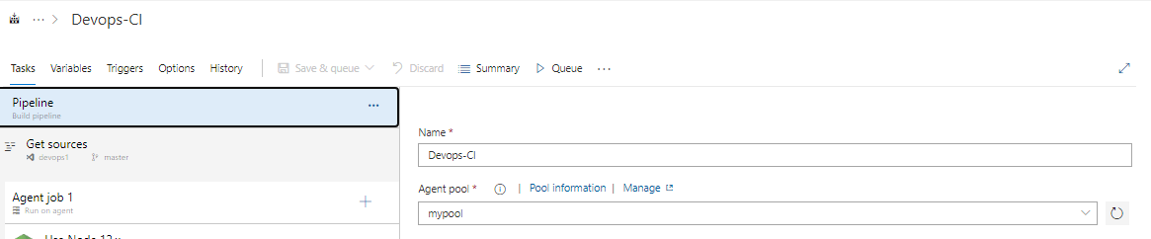

**select pool as mypool which is running in our linux box.**

**select source as the repo.**

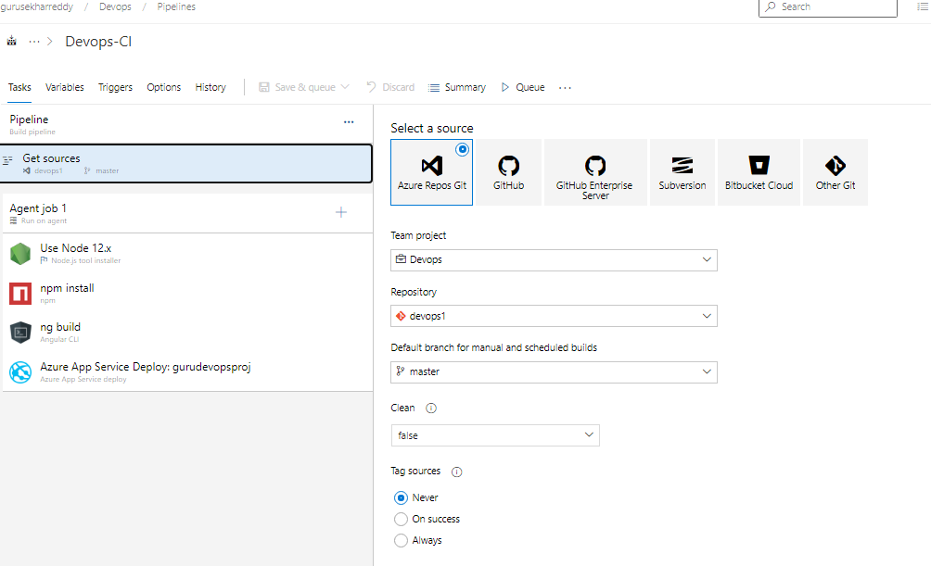

**added 4 agent jobs including node.js, npm install, ng build and azure app service deploy.**

**change node version to 12.x**

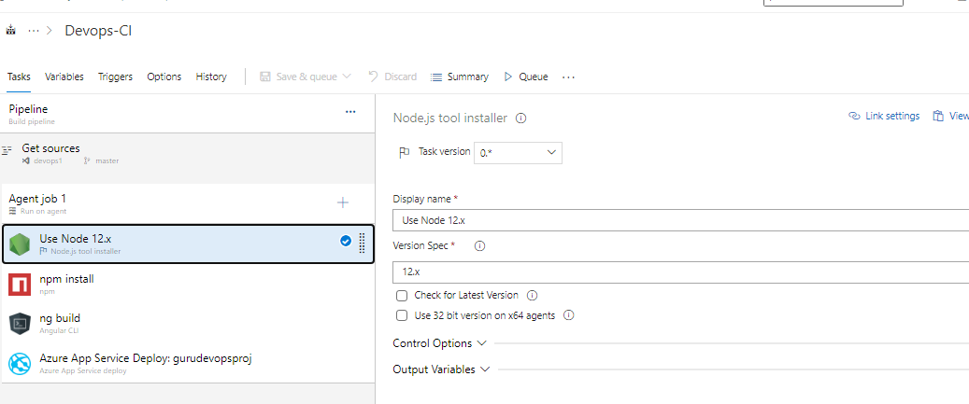

**npm install give the name as final/final-copy.**

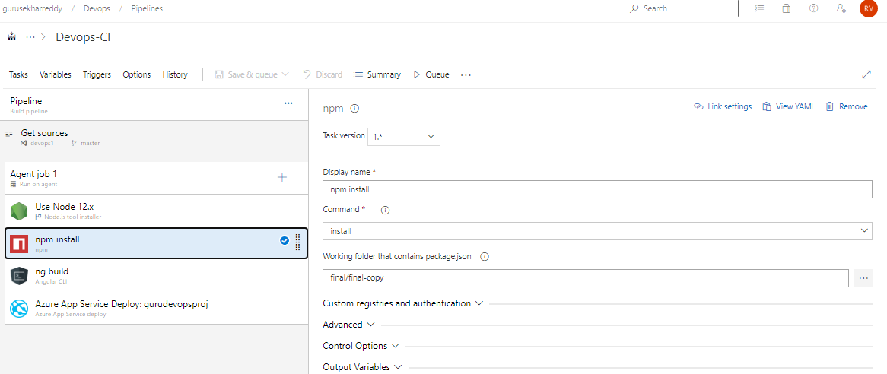

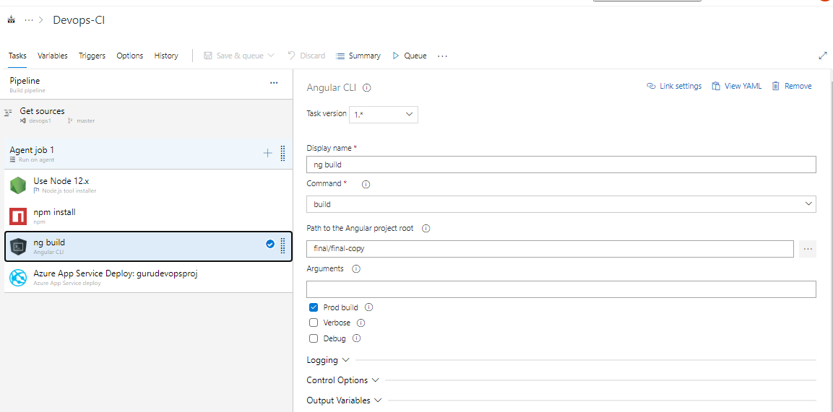

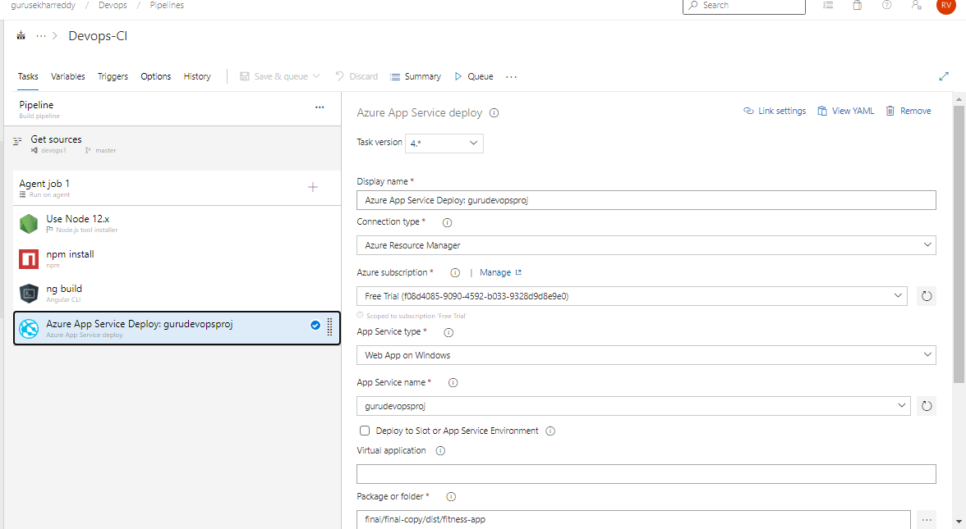

**for app services select packaging folder as final/final-copy/dist/fitness-app , creates once ng build completes.**

**save and Queue.**

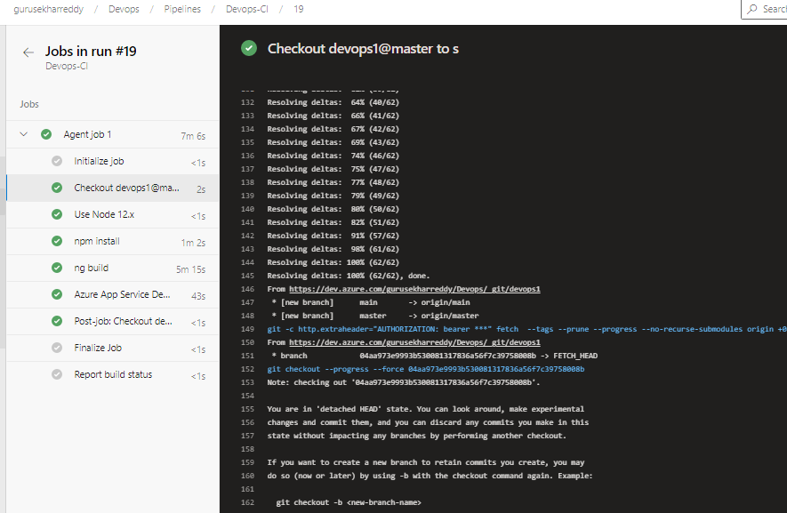

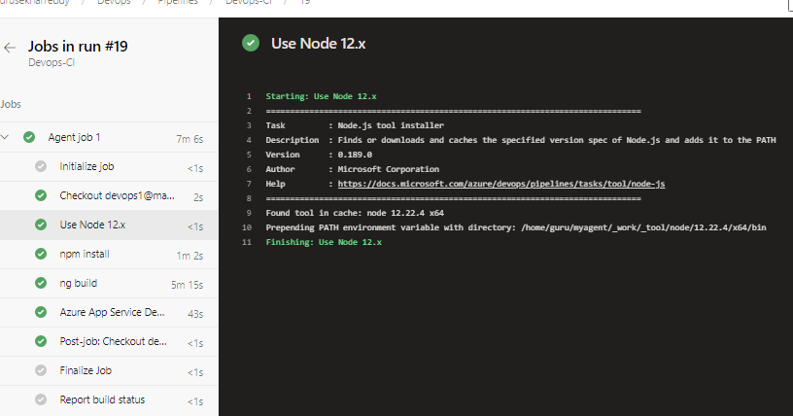

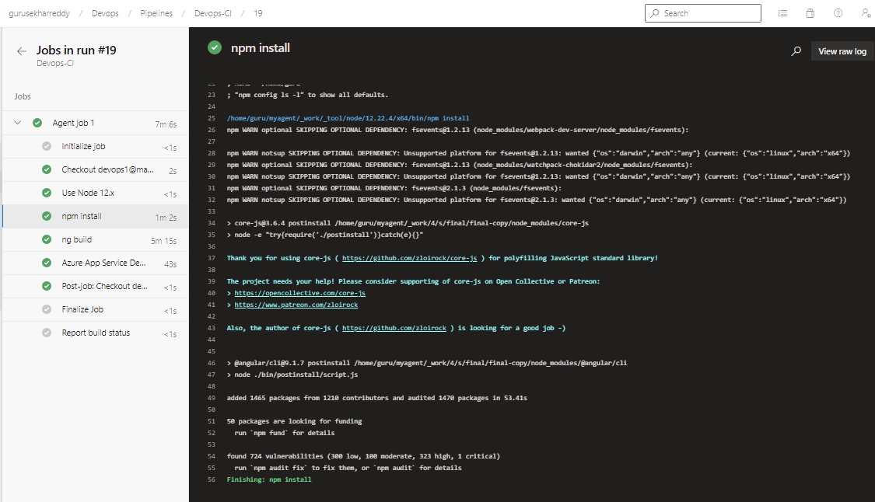

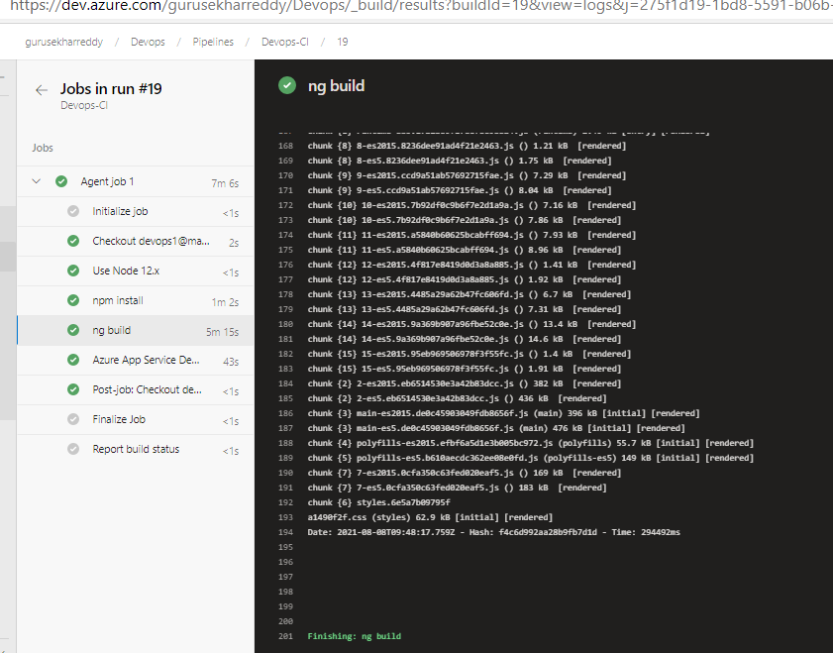

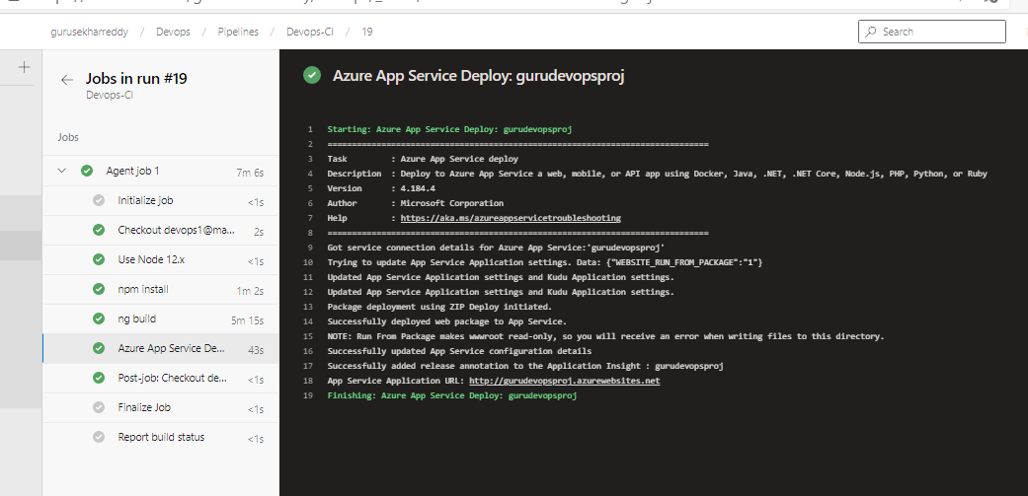

**node js app has deployed.**

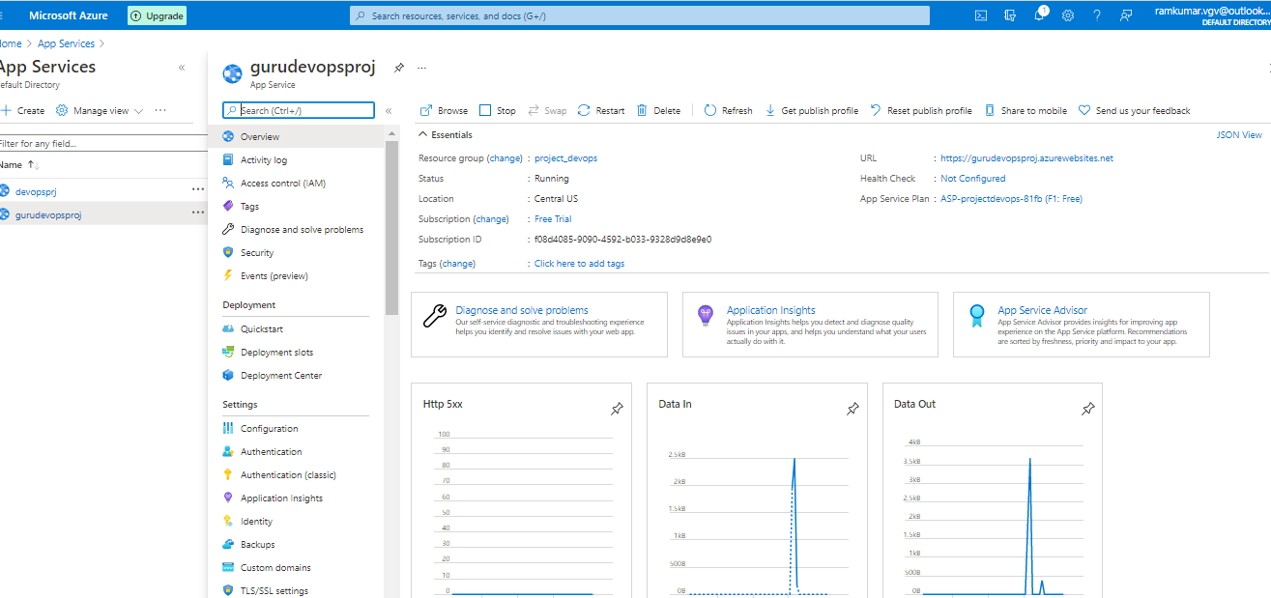

**try to access the app with http port , as it was mentioned in the code to use http for run.py.**

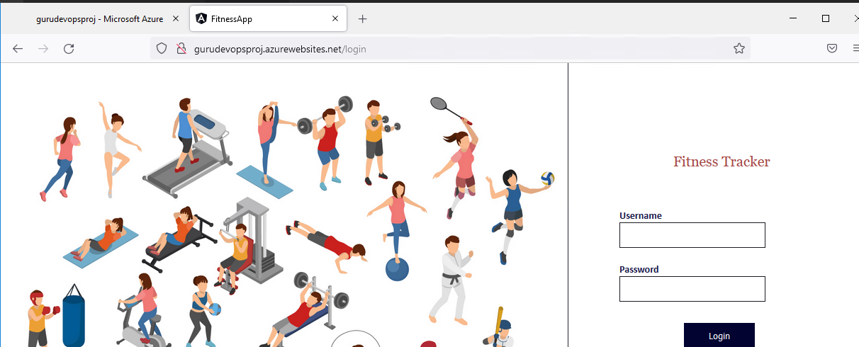

**For username and password get the details from guru database. select *from users;**

**used admin username as suraj and password as fitnessadmin.**

