Three Positives and a Cap: Measurement Artifacts in Single-Agent versus Multi-Agent LLM Comparisons

Guru R Bharadwaj
Independent Researcher
gururb20@gmail.com

Abstract
We set out to test whether emergent role differentiation in same-model LLM agent teams is causally real, using leave-one-out ablation rather than transcript reading. We could not run that test, and the reason is the contribution. Across three task difficulties, two serving instruments and two disjoint seed sets, we obtained three separate statistically significant results favouring multi-agent teams, and traced all three to measurement artifacts. Two were the same artifact: a per-turn token cap that is symmetric by construction and asymmetric in effect, because a single agent must emit an entire solution in its final turn while a team commits one its shared transcript already holds. The third was a small-sample baseline, a four-agent reference estimated from 48 episodes that a 3× larger sample did not reproduce. Removing all three, the effect of team size on this task family is flat: one agent scores 0.579, three agents 0.574 and four agents 0.576 across 896 episodes, a spread of 0.005. The only manipulation that moves the score reliably is giving a single agent more turns, which makes it worse. We report the artifact mechanism, the three diagnostics that caught it, and a bounded negative result. We argue the diagnostics are the transferable part: any comparison between architectures that consume a resource differently will land a shared limit asymmetrically, and standard reporting does not currently surface this.
1 Introduction
The claim we set out to test came from two 2026 results that had never been combined. Observational work established that same-model LLM teams appear to differentiate: agents settle into critic-like and planner-like behaviour that survives coding by an LLM judge [2]. Separately, causal ablation work showed that introspective judgements of agent contribution do not match what ablation measures, but applied it only to assigned roles, as an engineering tool for finding bottleneck agents [3]. Nobody had pointed the causal instrument at the emergent phenomenon. That was the intended contribution.
A design correction makes it a real experiment. A scalar performance drop when an agent is removed does not demonstrate specialization; it demonstrates participation. Remove any competent contributor from any team and output falls, which is equally true of four identical agents with no division of labour at all. The signature of specialization is an agent × task-component interaction: ablating an emergent critic must damage verification-loaded components more than planning-loaded ones, and ablating a planner must do the reverse. The main effect proves nothing; the crossover is the result.
That test requires an operating point where the team actually outperforms a single agent. Otherwise the ablation grid decomposes its own noise floor. We made that a preregistered stop condition, and establishing the operating point is where the project stopped. This paper is therefore about measurement rather than emergence.
Contributions.
1. A mechanism by which a per-turn token cap, identical across arms and therefore apparently controlled, produces a spurious multi-agent advantage that grows with task difficulty in exactly the shape a genuine collaboration benefit predicts (§4).
2. Three statistically significant pro-team results, each traced to its cause and each dissolving under the corresponding control (§4.3, §5).
3. A bounded negative result: at 8B on this task family, team size has no measurable effect (0.005 spread across 896 episodes), while giving one agent four times the turns makes it reliably worse (§6).
4. Seven reporting practices that would have caught these artifacts, and two instrument defects released rather than quietly fixed (§7, §8).
2 Related work
Emergent roles, observed. The MARL lineage, of which ROMA [1] is representative, produces emergent roles as learned embeddings. Those roles are architectural rather than linguistic, and the agents are not LLMs. The closest LLM result is observational [2]: 208 runs and 13,786 coded messages establish that unassigned same-model agents differentiate behaviourally, using LLM-judge coding and cosine similarity. It reports no causal test, and states the transcript-reading problem explicitly. It also uses several different LLMs, which leaves model heterogeneity as an open confound for any differentiation it observes.
Ablation, applied to assigned roles. Leave-one-out ablation of LLM agents is established as an engineering tool. [3] treats attribution as a cooperative game and finds that introspective LLM judgements do not faithfully approximate ablation behaviour, which is third-party evidence for the premise that transcript-reading and causal reality diverge. [4] approximates leave-one-out by introspection, and [5] eliminates agents dynamically for efficiency. In all three the roles are pre-assigned, and ablation optimises a system rather than validating that a division of labour is real.
The gap, and why we could not fill it. The observational half and the causal half have not been combined. Our design does combine them, and holds model identity fixed across agents so that any differentiation cannot come from model heterogeneity. What we report instead is the measurement problem that blocked the combination, because we believe it blocks others: the comparison that licenses an ablation study is itself much harder to measure than the literature's reporting conventions suggest.
3 Experimental setup
Table 1: experimental configuration. one model serves every agent in every condition, so observed differentiation cannot come from model heterogeneity — a control the prior observational work lacks.
Model | Meta-Llama-3.1-8B-Instruct, Q4_K_M, one model serving every agent
Serving | llama.cpp, 18,432 tokens per slot, 7 slots, one 24 GB RTX 4500 Ada
Task | synthetic multi-constraint scheduling; tagged constraint classes (arithmetic, search, verification, synthesis); deterministic per-component grader; satisfiable by construction
Difficulties | medium / hard / xhard — 16 / 24 / 36 jobs
Metrics | fraction (partial credit, primary), strict, feasible
Statistics | 20,000-draw permutation tests; 10,000-draw bootstrap intervals; ablation contrasts paired on instance
Corpus | ~2,900 episodes across all conditions; all transcripts released

Orchestration is hand-written on purpose. Every mainstream agent framework ships role scaffolding in its prompt templates, which would plant the structure the study claims to observe emerging. No agent is told to plan, criticise or verify; agents receive identical briefs and differ only in a name and a sampling seed.
Preregistration. Hypotheses, tests and falsification conditions were registered before the runs they govern, with amendments dated and justified. Two disciplines in those documents did the work reported below: a complete-case sensitivity row printed beside every headline number, and a fresh-seed rule forbidding a corpus from testing the hypothesis it generated. Neither was added after seeing a result.
3.1 Three confounds handled in the design
Compensation. Remove an agent and the survivors may reorganise to absorb its function, masking the specialization being measured. Ablation therefore runs three ways: live, in which compensation is allowed; frozen_replay, which regenerates surviving turns on the recorded schedule; and frozen_excise, which deletes the messages and re-reads the answer with zero model calls. Section 7 reports that the third of these does not work on real transcripts, and why.
Position versus identity. Roles may attach to turn order rather than to agent identity, which would be protocol rather than specialization. Speaking order is reshuffled every round, which drives a purely positional world to chance while leaving identity-bound roles untouched. Under a fixed order that same synthetic world scores 0.50 against a 0.25 chance baseline — enough to be mistaken for the real thing, which is why the reshuffle is not optional.
Symmetry breaking is the independent variable. Identical model, prompt and context produce identical output, and nothing can specialise. What breaks the tie — a name, a seed, a private scratchpad — is swept rather than fixed and forgotten. The question the design asks is whether minimal asymmetry amplifies into stable roles.
3.2 Validating the instrument before trusting it
The pipeline is run first against three synthetic worlds whose answer is known in advance: genuinely specialised agents, wholly undifferentiated ones, and agents whose behaviour tracks turn slot rather than identity. Diagonal dominance separates the specialised world from the other two but cannot separate positional from null, because both put ownership at chance by construction, and chance is 1/n rather than zero; interaction strength is what distinguishes those two. A pipeline that reports specialization in the null world is manufacturing its result. Catching that costs seconds on a mock backend; catching it after a GPU run costs the study.
4 A per-turn cap is not a shared constraint
4.1 Mechanism
Agents are capped at max_tokens per turn. The cap is identical across conditions, which is exactly what makes it look like a controlled variable. It is not, because the arms spend the resource differently:
• A single agent at k rounds must produce the complete final solution inside its own last turn. The answer competes with reasoning for one budget.
• A team at k rounds ends on a turn that commits an answer the shared transcript already contains. Its final turn can be a summary; the content was distributed across earlier turns and earlier agents.
The same cap therefore truncates an answer in one arm and a summary in the other. Because harder instances need longer answers, the artifact grows with instance size in exactly the shape a genuine collaboration benefit would predict. The confound and the hypothesis have the same functional form, because both scale with how much answer the instance requires.
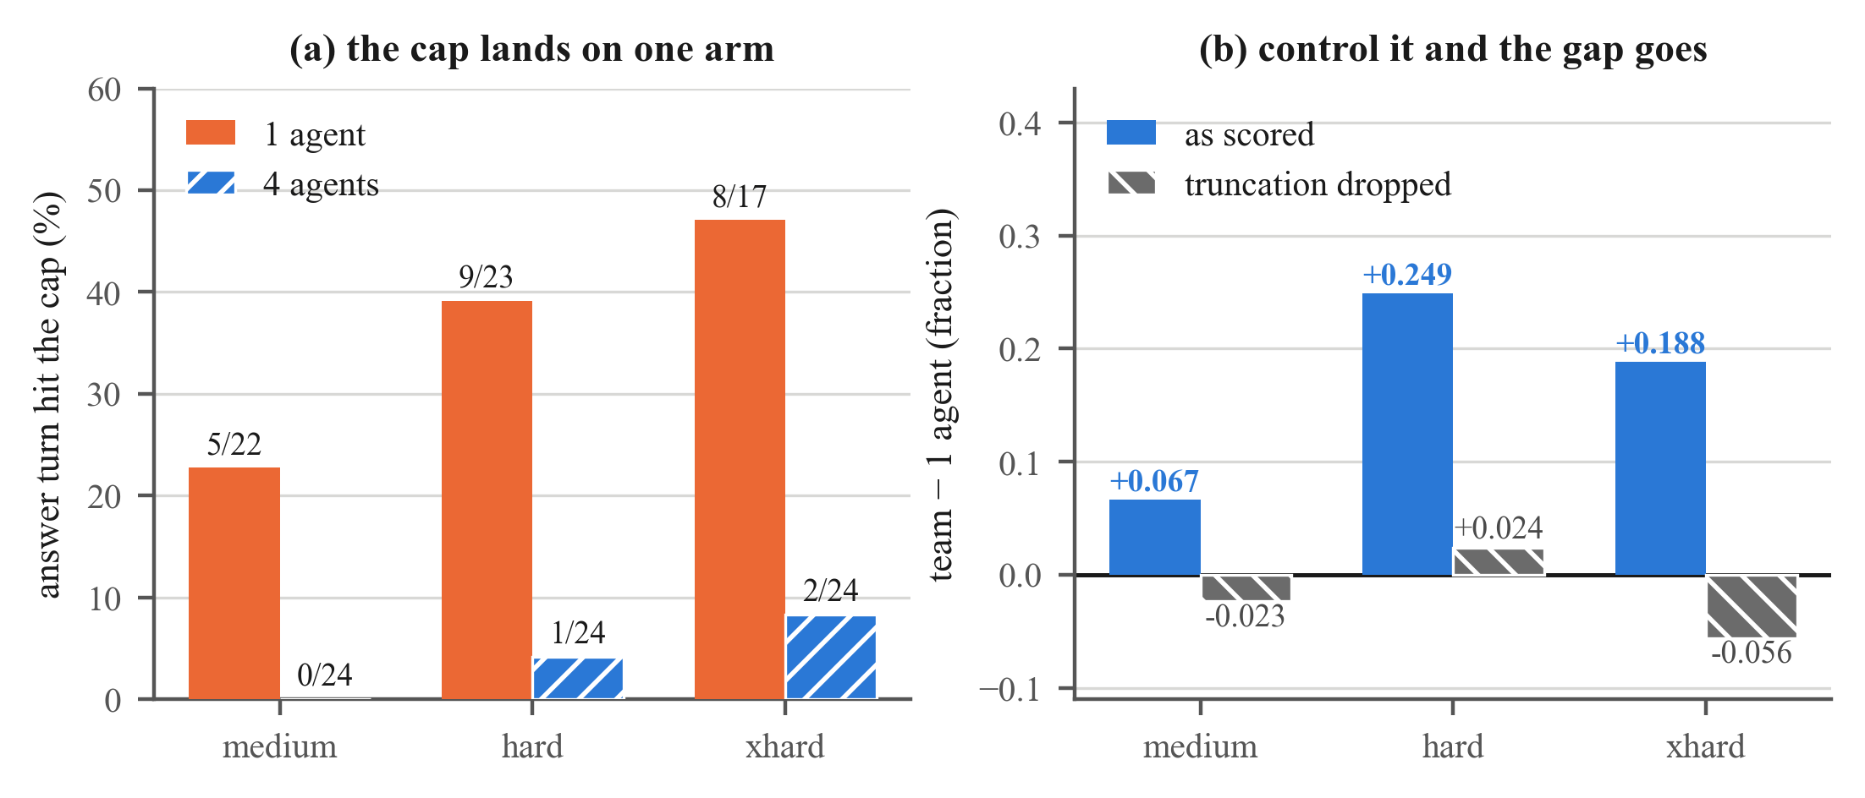
Figure 1: the cap is symmetric in specification and asymmetric in effect. (a) on the original instrument, the single-agent arm's answer-bearing turn hits the token cap on 23–47% of usable episodes while the team's does so on 0–8%, and the gap widens with difficulty. (b) the same corpus, scored as-is and with answer-turn-truncated episodes dropped from both arms. the headline gap trends upward across difficulty; the controlled gap does not trend at all and is negative at two tiers of three. a difficulty curve read without this control cannot be distinguished from the effect it was built to detect.
4.2 The asymmetry is measured, not assumed
On a matched turn budget at medium, the single agent emits 28,319 characters against the team's 13,877, a factor of 2.04×. Matching turns does not match generation: one agent restates the whole working solution every round, whereas four agents each add to a shared transcript. An arm described throughout our own preregistration as “matched budget” was matched on the resource we counted and unmatched on the one that mattered.
4.3 Rebuilding the instrument
The fix is not a larger cap everywhere, which would change the whole instrument. It is a separate budget for the one turn that gets parsed: answer_max_tokens = 3072 on the final agent turn, max_tokens unchanged at 1024 elsewhere, and max_model_len reduced so the slot geometry does not move. Holding everything else constant:
Table 2: the hard tier before and after the answer-budget instrument. the team's mean barely moves; the single agent's rises by +0.239, which is the whole of the original gap. nothing about the model or the task changed — the measurement had been reading its own cap.
hard | 1 agent | team | gap | d | answer turn cut (1 ag. / team)
original instrument | 0.342 | 0.591 | +0.249 | +1.09 | 9 / 23 vs 1 / 24
answer-budget instrument | 0.554 | 0.536 | −0.018 | −0.12 | 1 / 44 vs 3 / 48

Answer-turn truncation in the single-agent arm falls roughly five-fold across the corpus rather than to zero: the first 24 medium episodes had none, and extending to 48 turned up three more. The honest statement is reduced, not eliminated, and the complete-case sensitivity row is still printed beside every number below for that reason.
5 The baseline that did not reproduce
Our ablation pilot measured a per-agent participation effect of +0.055 [+0.024, +0.088] over 192 live-ablation episodes on seeds 0–47. Our own preregistration forbade testing that on the corpus that produced it, so we re-ran all four agents on seeds 1000–1149. Every arm reproduced except one.
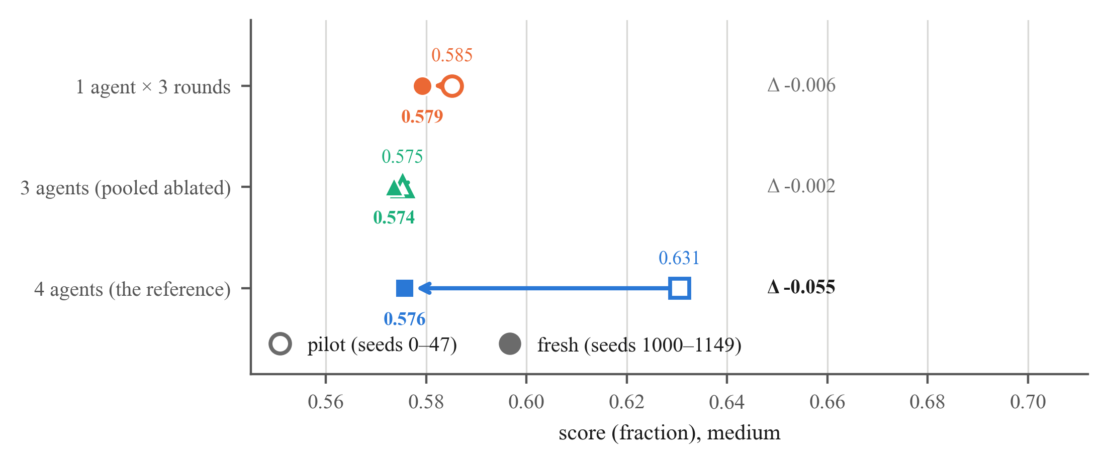
Figure 2: pilot against fresh seeds, per arm. the single-agent arm and the pooled three-agent ablated arms agree across seed sets to within 0.006 and 0.002 respectively; the four-agent reference — the arm every positive finding in the project was measured against — moves by 0.055, which is the size of the effect being claimed.
The three-agent arms agree to within 0.002 over 791 episodes (p = 0.909). This is not seed-range difficulty. The generator is deterministic in (seed, difficulty) and untouched across both runs; instances in the two ranges are structurally identical with zero variance (16 jobs, 5 workers, 29 constraints, 3 planted errors). Were the fresh range harder, the three-agent arms would carry the same penalty. They do not move at all.
It is sampling noise in a mean estimated from 48 episodes on an arm with sd ≈ 0.14, a standard error of ≈ 0.020 against effects of ≈ 0.05 being read off it. An unremarkable statistical fact that produced a headline finding, and one that a small-n pilot in this literature will reproduce routinely. What caught it was the fresh-seed rule, and it is worth being plain about what that rule caught: a headline result, in a project that had already survived seven corrections, produced entirely by a 48-episode reference.
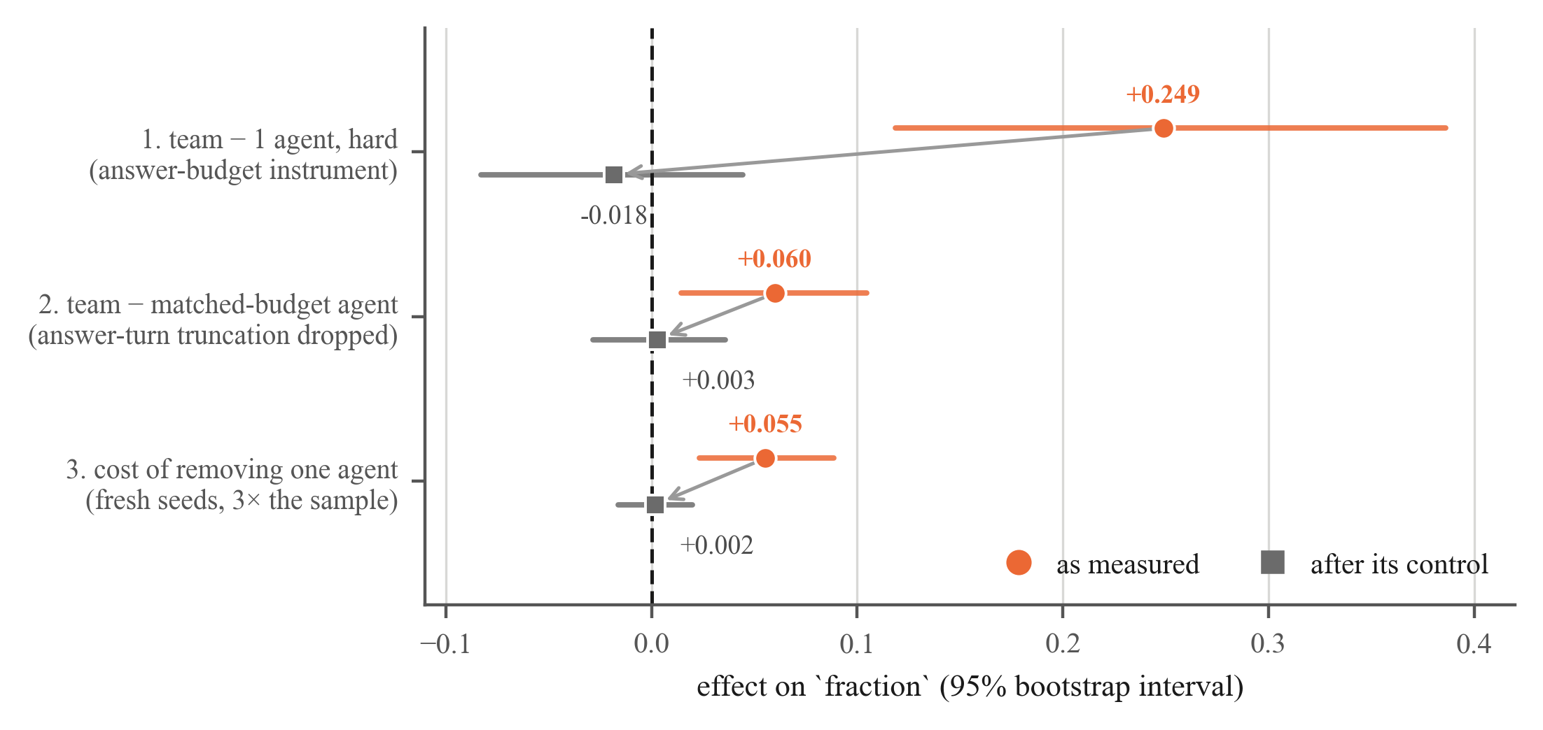
Figure 3: each significant pro-team result, as measured and after its control. finding 1 is the token cap (§4.3); finding 2 is the same cap surviving budget-matching, removed by the complete-case sensitivity row; finding 3 is the 48-episode reference (§5). all three corrections move toward zero and none reverses.
6 Results
6.1 What reproduced and what did not
Table 3: the central table. everything that failed to reproduce across independent seed sets is a positive measured against the 48-episode four-agent reference; everything that reproduced is a null or a negative. the asymmetry is the result.
quantity | pilot | fresh | p
failed to reproduce
four-agent reference | 0.631 | 0.576 | 0.031
gate: team − 1 agent | +0.045 | −0.003 | 0.868
C5: team − matched-budget agent | +0.126 | +0.060 → +0.003 corrected | 0.869
participation: per-agent ablation drop | +0.055 | +0.002 | 0.834
reproduced
1 agent × 3 rounds | 0.585 | 0.579 | 0.856
3 agents (pooled ablated) | 0.575 | 0.574 | 0.909
budget penalty, 3 vs 12 rounds, one agent | −0.081 | −0.063 | 0.011
generation asymmetry, 1 agent ÷ team | 1.87× | 2.04× | —
agent × component interaction | p = 0.928 | not re-run (no main effect) | —
fungibility Δ(frozen) − Δ(live) | −0.005 | — | —

6.2 Team size does nothing; more turns hurt
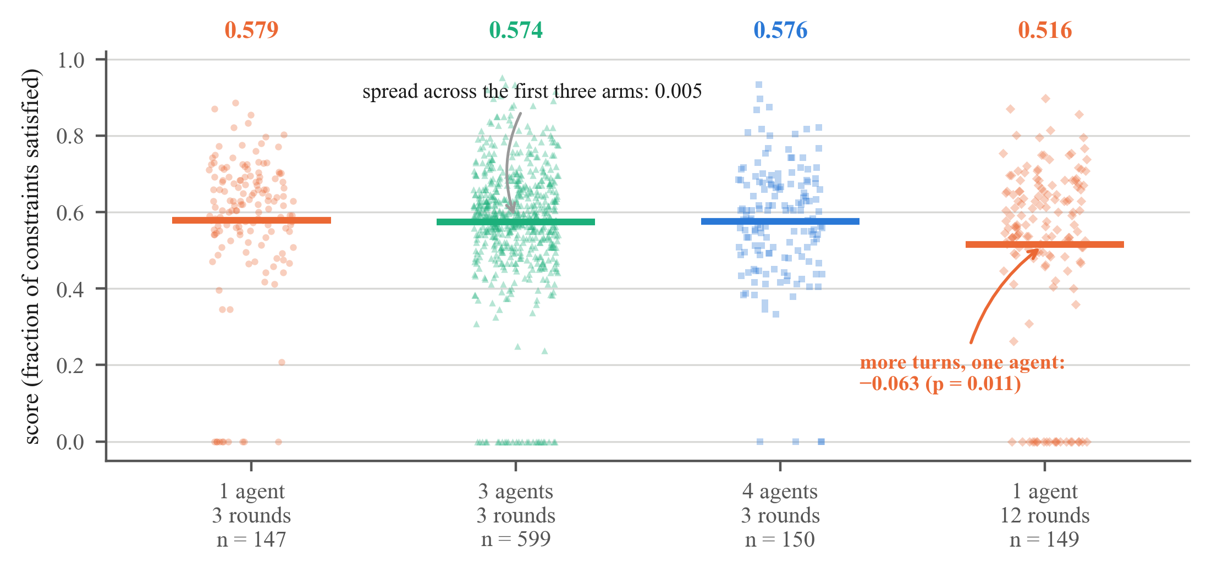
Figure 4: the headline, on fresh seeds with the artifacts removed, drawn as episodes rather than bars because the finding is that the distributions coincide. the first three arms span 0.005. the only manipulation that reliably moves the score is giving a single agent four times the turns, and it moves it down.
On fresh seeds one agent scores 0.579, three agents 0.574 and four agents 0.576 — a spread of 0.005 across 896 episodes. Team size does nothing on this task family at 8B. The only manipulation that reliably moves the score is giving a single agent the team's whole turn budget, and it moves it downward: 0.579 → 0.516, −0.063 at p = 0.011. Read together with the generation asymmetry of §4.2, the interpretation is that a single agent given twelve rounds spends them restating rather than improving.
6.3 Behavioural coding and the interaction test agree
Phase 2 coded 468 messages against an eight-action taxonomy. Agents within an episode differ no more in what they do than shuffling the labels among them produces (p = 0.451), and no agent identity carries a stable tendency across episodes (p = 1.00). The one robust behavioural result is between conditions rather than within teams: teams generate and lone agents audit — propose as a share of propose plus verify is 0.674 for teams against 0.403 for solo, p < 0.0001, with the mechanism stated before the test was run.
The ablation side agrees. The agent × component interaction is chi2 = 3.73, p = 0.928 over 768 observations from 48 episodes, with a double-centred residual matrix holding less structure than a true null would be expected to produce. Blocking compensation does not increase the damage either: Δ(frozen_replay) − Δ(live) = −0.005. Checked at three points as the pilot filled, every quantity constituting specialization halved as the sample doubled — agent spread 0.095 → 0.050 → 0.034, largest residual 0.052 → 0.027 — which is the signature of noise averaging out, not of an effect being resolved.
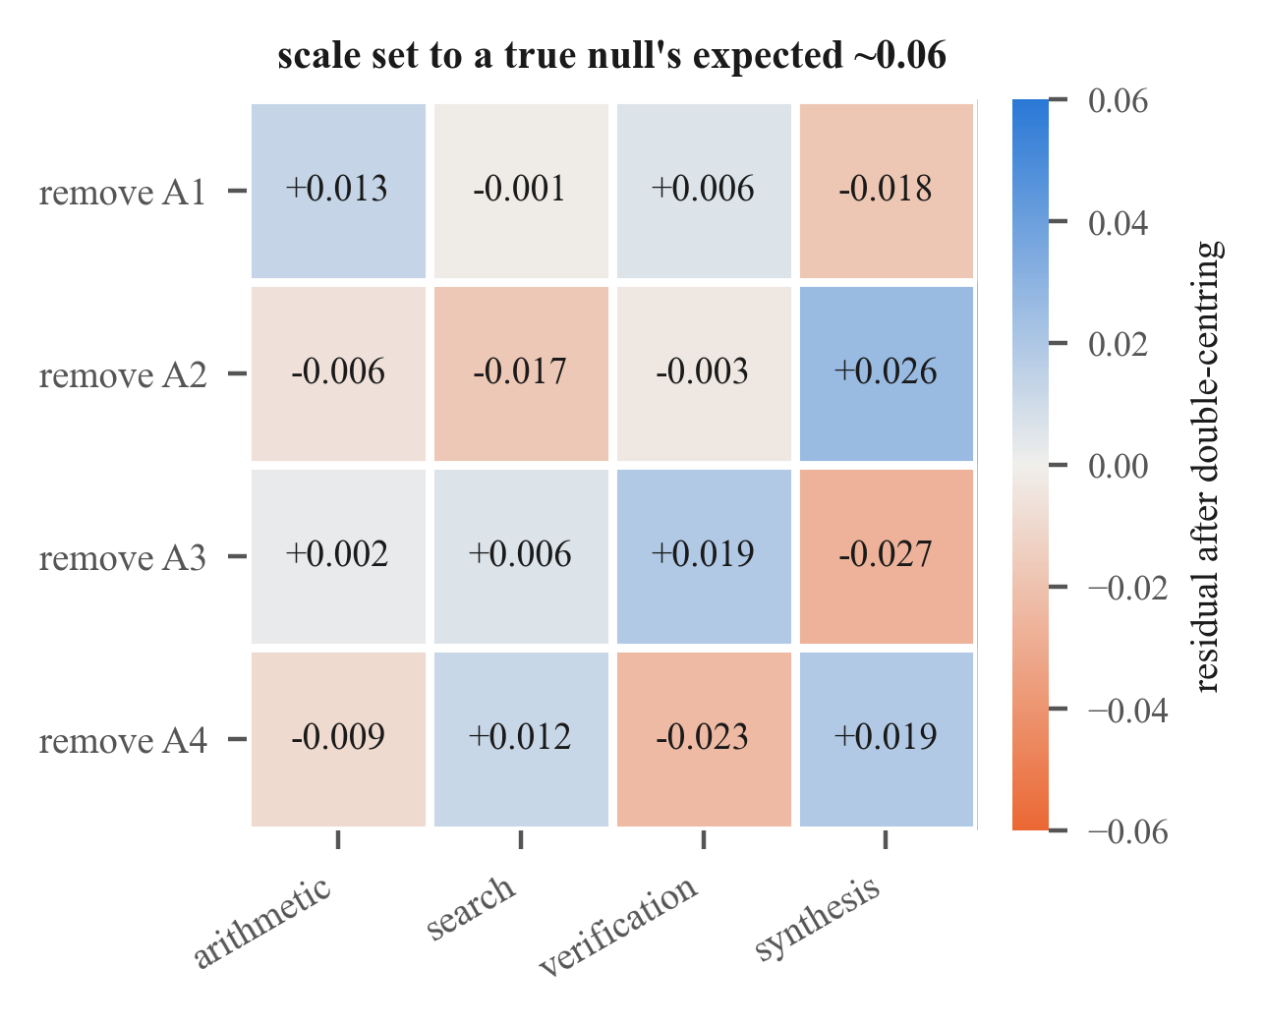
Figure 5: the double-centred ablation matrix from the pilot grid. main effects for agent and for component are removed, so specialization would appear as off-diagonal structure. the colour scale is set to the ≈0.06 a true null would produce; the observed residuals do not fill it.
The scope must be stated precisely. These are measured at an operating point where the team has no advantage over a single agent. A flat interaction and zero fungibility are what a zero main effect predicts; they are not independent confirmations of it. This is evidence that this task, at this scale, does not produce the team advantage that specialization would have to explain — not evidence that emergent specialization is absent in multi-agent LLM systems generally. The difference is between a bounded null and an unsupported universal.
7 Two instrument defects, reported rather than quietly fixed
Frozen-transcript excision does not work on real transcripts. Deleting an agent's messages and re-grading gives drops of ≈ 0.002 against live drops of 0.03–0.23, because agents restate the working solution constantly: the propagation index, the fraction of an agent's content echoed by others later, is 0.589. The contribution survives in the copies. Read naively this reports “the agent contributed nothing” when the truth is “this measurement does not work here.” We ship a diagnostic that detects the condition and selects which frozen mode to trust.
Our capacity control controlled one of the four cells it was quoted against. Lowering n_agents by one always removes the last agent, so only one live-ablation cell shares its roster. On that cell, 74% of the attributed drop was unexplained by head-count — too large to ignore, too under-powered to act on, and moot once the main effect went to zero. Both defects are released with the code rather than repaired silently, because a reader deciding whether to reuse this instrument needs them more than we need a clean methods section.
8 Recommendations
For anyone comparing single-agent and multi-agent LLM systems:
1. Print an answer-turn truncation count beside every headline number — not in an appendix. Our gate passed at two of three operating points on an artifact this column makes visible in one glance.
2. Report a complete-case sensitivity row. Dropping truncated episodes is post-hoc and biased; so is ignoring them. The two bracket the truth. Ours was right three times, including against a headline at p < 0.001.
3. A matched-budget arm is part of the comparison, not an extra. Without one, “four agents beat one” and “more tokens beat fewer” are the same measurement.
4. Match generation, not just turns. Our matched-budget arm let the single agent emit 2.04× the team's text. Turn count is not token count.
5. A single-agent baseline needs a single-agent prompt. Running n = 1 through a brief that says “the others” and “the group's last message is scored” measures the harness, and does so in the direction that flatters the team.
6. Never test a hypothesis on the corpus that generated it. This rule cost us one extra run and overturned our headline. Without it we would have published a 2,100-episode ablation grid decomposing an effect that does not exist — and every cell would have been internally consistent.
7. Any per-turn resource limit lands asymmetrically when the arms use the resource differently. This generalises past token caps to context windows, wall-clock budgets and tool-call quotas.
9 Limitations
• One model family, one scale. Llama-3.1-8B at Q4_K_M. Quantisation is lossy and not obviously neutral between arms: if 4-bit weights degrade long-context instruction-following more, the team arm absorbs more of the loss. That biases against a team advantage, so it weakens a null more than it would have weakened a positive, and we report it as such.
• One task family. Synthetic constrained scheduling, chosen because it is programmatically gradable with per-component scores and uncontaminated. A single task cannot support a claim about collaboration in general.
• feasible is uninformative. It runs 0.000–0.021 in nearly every arm; almost no episode produces a fully feasible solution. All comparisons here are between degrees of partial credit.
• The interaction test was not re-run on fresh seeds, because the fresh-seed run removed the main effect it would decompose. Our bound on it stands on the pilot corpus.
• Behavioural coding is bounded by judge quality. Our local judge agrees with a human at κ = 0.29 after four codebook revisions, against the ≈ 0.6 Phase 2 needs and the ≈ 0.78 convergent validity needs. Four codebooks moved κ from 0.07 to 0.29 and stopped, which reads as a model-capacity limit rather than a wording problem.
10 Future work
A 14B model. The preregistered response to “7–8B may be too weak to collaborate meaningfully.” A 14B fits the same 24 GB card at 4-bit. If a team advantage appears at 14B where none exists at 8B, that locates a capability threshold for collaboration — a more interesting finding than either of ours, and directly enabled by the artifact controls reported here. Our negative is explicitly scoped to 8B and does not predict the 14B outcome.
Role-label validation at usable agreement. Until the judge reaches usable κ, the transcript-derived half of the convergent-validity comparison cannot be interpreted: we have causal contribution profiles and no trustworthy labels to correlate them against. This is testable on the same 40 messages the moment a larger judge is on disk.
A task family where collaboration demonstrably pays. The strongest version of the original experiment needs an operating point that exists. Finding one — by scale, by task, or by protocol — is the prerequisite the whole ablation programme was blocked on.
11 Conclusion
We did not measure whether emergent roles in LLM teams are causally real. We measured that three independent significant results favouring teams were artifacts — two of a token cap that is symmetric in specification and asymmetric in effect, one of a 48-episode baseline — and that with those removed, team size has no effect on this task family at 8B. The negative result is bounded and honest. The mechanism is the contribution: a shared per-turn limit is not a shared constraint when the arms spend it differently, and the diagnostics that expose it are cheap, general, and currently absent from standard practice. Every artifact we removed made the gap smaller. Not once did one make it larger.

References
[1] T. Wang, H. Dong, V. Lesser and C. Zhang. ROMA: Multi-agent reinforcement learning with emergent roles. In Proceedings of the 37th International Conference on Machine Learning (ICML), 2020. arXiv:2003.08039.
[2] Behavioral differentiation without role assignment in same-model LLM agent groups. arXiv:2604.00026, 2026.
[3] Agents that matter: causal leave-one-out attribution for multi-agent LLM systems. arXiv:2605.27621, 2026.
[4] IntrospecLOO: approximating leave-one-out agent ablation by introspection. arXiv:2505.22192, 2025.
[5] AgentDropout: dynamic agent elimination for efficient multi-agent LLM inference. arXiv:2503.18891, 2025.

A Technical appendices and supplementary material
Nothing in this appendix is required to support the claims in the main paper. It records the per-tier detail behind the summary tables, for readers who want to check a specific operating point rather than take the aggregate on trust.
A.1 Every operating point, both instruments
Table 4: the full gate across three difficulty tiers on both instruments. cut is the number of usable episodes whose answer-bearing turn hit the token cap. sens. gap is the same contrast with those episodes dropped from both arms. on the original instrument the headline gap and the truncation column rise together and the sensitivity gap does not — the signature of §4. on the answer-budget instrument the two columns agree.
instrument / tier | 1 agent | team | gap | p | cut (1 ag. / team) | sens. gap
original
medium | 0.564 | 0.631 | +0.067 | 0.306 | 5 / 22 · 0 / 24 | −0.023
hard | 0.342 | 0.591 | +0.249 | 0.001 | 9 / 23 · 1 / 24 | +0.024
xhard | 0.310 | 0.499 | +0.188 | 0.019 | 8 / 17 · 2 / 24 | −0.056
answer-budget
medium | 0.585 | 0.631 | +0.045 | 0.246 | 3 / 48 · 0 / 48 | +0.006
hard | 0.554 | 0.536 | −0.018 | 0.573 | 1 / 44 · 3 / 48 | +0.004
xhard | 0.506 | 0.575 | +0.069 | 0.266 | 1 / 24 · 1 / 23 | +0.073
answer-budget, fresh seeds
medium | 0.579 | 0.576 | −0.003 | 0.868 | 8 / 147 · 4 / 150 | −0.015

A.2 Ablation cells, pilot and fresh
Table 5: per-agent live-ablation drops from the four-agent reference, paired on instance. on the pilot every cell is positive and the pooled effect clears zero; on fresh seeds the cells straddle zero, one of them negative, and the pooled effect does not. the three-agent arms themselves are nearly identical across the two seed sets (table 3) — it is the reference that moved.
removed | pilot drop | pilot 95% CI | fresh drop | fresh 95% CI
A1 | +0.049 | [−0.015, +0.118] | +0.000 | [−0.035, +0.037]
A2 | +0.037 | [−0.015, +0.092] | +0.014 | [−0.023, +0.053]
A3 | +0.064 | [−0.000, +0.130] | −0.023 | [−0.057, +0.012]
A4 | +0.071 | [+0.006, +0.139] | +0.016 | [−0.019, +0.051]
pooled | +0.055 | [+0.024, +0.088] | +0.002 | [−0.016, +0.020]
capacity control (n→3) | +0.019 | [−0.028, +0.062] | −0.017 | [−0.048, +0.014]

A.3 The pilot's three checkpoints
The pilot grid was inspected three times as it filled. The pooled drop held steady while every quantity that would constitute specialization halved as the sample doubled, which is what noise averaging out looks like rather than an effect being resolved. Reported because the shape of the failure is the transferable part: an interaction that is real should sharpen with n, not dissolve.
Table 6: the pilot ablation grid checked at three sample sizes.
checked at | episodes/agent | pooled drop | agent spread | largest residual | interaction p
75 done | ≈19 | +0.063 | 0.095 | — | 0.591
148 done | ≈37 | +0.050 | 0.050 | 0.052 | 0.820
192 done | 48 | +0.055 | 0.034 | 0.027 | 0.928

A.4 Behavioural coding: the taxonomy collapsed
468 messages were coded by a local judge against an eight-action taxonomy, with 0 unparseable responses and 0 judge errors. Two labels took 95.9% of the corpus: propose (294, 62.8%) and verify (155, 33.1%), followed by compute (8), other (6), agree (4), search (1), and synthesize and organize at zero. This is not an artifact of the solo episodes: within the 276 team messages, where organize, synthesize and agree are all available, the same two labels take 98.1%.
This independently breaks the convergent-validity phase. The mapping from actions to graded components uses exactly four actions — compute→arithmetic, search→search, verify→verification, synthesize→synthesis — and three of the four have essentially no data. Even with a usable ablation grid in hand, convergent validity would have been a test of verify alone rather than of the mapping. We report this as a design lesson: a taxonomy should be piloted against the corpus it will code before it is made load-bearing for a downstream test.

NeurIPS Paper Checklist
1. Claims
Question: Do the main claims made in the abstract and introduction accurately reflect the paper's contributions and scope?
Answer: [Yes]
Justification: The abstract states the artifact mechanism, the three corrected findings and the bounded negative result, and it names the scope limit explicitly (one task family, 8B, Q4_K_M). Section 6.3 states in the body that a flat interaction is what a zero main effect predicts rather than an independent confirmation of it, and Section 1 states that the intended experiment was not run.
Guidelines:
• The answer [N/A] means that the abstract and introduction do not include the claims made in the paper.
• The abstract and/or introduction should clearly state the claims made, including the contributions made in the paper and important assumptions and limitations. A [No] or [N/A] answer to this question will not be perceived well by the reviewers.
• The claims made should match theoretical and experimental results, and reflect how much the results can be expected to generalize to other settings.
• It is fine to include aspirational goals as motivation as long as it is clear that these goals are not attained by the paper.
2. Limitations
Question: Does the paper discuss the limitations of the work performed by the authors?
Answer: [Yes]
Justification: Section 9 is a dedicated limitations section covering model family and scale, the single task family, an uninformative third metric, the interaction test not being re-run on fresh seeds, and the judge-quality ceiling on behavioural coding. Section 7 additionally reports two defects in our own instrument rather than repairing them silently.
Guidelines:
• The answer [N/A] means that the paper has no limitation while the answer [No] means that the paper has limitations, but those are not discussed in the paper.
• The authors are encouraged to create a separate “Limitations” section in their paper.
• The paper should point out any strong assumptions and how robust the results are to violations of these assumptions.
• The authors should reflect on the scope of the claims made, e.g., if the approach was only tested on a few datasets or with a few runs.
• The authors should reflect on the factors that influence the performance of the approach.
• The authors should discuss the computational efficiency of the proposed algorithms and how they scale with dataset size.
• If applicable, the authors should discuss possible limitations of their approach to address problems of privacy and fairness.
• While the authors might fear that complete honesty about limitations might be used by reviewers as grounds for rejection, a worse outcome might be that reviewers discover limitations that aren't acknowledged in the paper. Reviewers will be specifically instructed to not penalize honesty concerning limitations.
3. Theory assumptions and proofs
Question: For each theoretical result, does the paper provide the full set of assumptions and a complete (and correct) proof?
Answer: [N/A]
Justification: The paper contains no theorems or formal proofs. Its claims are empirical and are supported by permutation tests, bootstrap intervals and a mixed-effects joint Wald test, all specified in Section 3 and reproducible from the released corpus.
Guidelines:
• The answer [N/A] means that the paper does not include theoretical results.
• All the theorems, formulas, and proofs in the paper should be numbered and cross-referenced.
• All assumptions should be clearly stated or referenced in the statement of any theorems.
• The proofs can either appear in the main paper or the supplemental material, but if they appear in the supplemental material, the authors are encouraged to provide a short proof sketch to provide intuition.
• Inversely, any informal proof provided in the core of the paper should be complemented by formal proofs provided in appendix or supplemental material.
• Theorems and Lemmas that the proof relies upon should be properly referenced.
4. Experimental result reproducibility
Question: Does the paper fully disclose all the information needed to reproduce the main experimental results of the paper to the extent that it affects the main claims and/or conclusions of the paper (regardless of whether the code and data are provided or not)?
Answer: [Yes]
Justification: Section 3 gives the model, quantisation, serving configuration, slot geometry, task generator, difficulty tiers, metrics and statistical procedures. Instance generation is deterministic in (seed, difficulty) and the exact seed ranges are stated in Section 5. The token budgets that constitute the corrected instrument are given numerically in Section 4.3. Every figure and table in the paper is regenerated from the released transcripts by a script in the repository.
Guidelines:
• The answer [N/A] means that the paper does not include experiments.
• If the paper includes experiments, a [No] answer to this question will not be perceived well by the reviewers: Making the paper reproducible is important, regardless of whether the code and data are provided or not.
• If the contribution is a dataset and/or model, the authors should describe the steps taken to make their results reproducible or verifiable.
• Depending on the contribution, reproducibility can be accomplished in various ways. In general, releasing code and data is often one good way to accomplish this, but reproducibility can also be provided via detailed instructions for how to replicate the results.
• While NeurIPS does not require releasing code, the conference does require all submissions to provide some reasonable avenue for reproducibility, which may depend on the nature of the contribution.
5. Open access to data and code
Question: Does the paper provide open access to the data and code, with sufficient instructions to faithfully reproduce the main experimental results, as described in supplemental material?
Answer: [Yes]
Justification: The full framework, the configuration files for every operating point, the episode transcripts for every condition, and the analysis and figure scripts are released together. A mock backend runs the entire pipeline end to end with no GPU, so the instrument can be validated before any compute is spent. A single command regenerates every number quoted in the paper from the transcripts.
Guidelines:
• The answer [N/A] means that paper does not include experiments requiring code.
• Please see the NeurIPS code and data submission guidelines (https://neurips.cc/public/guides/CodeSubmissionPolicy) for more details.
• While we encourage the release of code and data, we understand that this might not be possible, so [No] is an acceptable answer.
• The instructions should contain the exact command and environment needed to run to reproduce the results.
• The authors should provide instructions on data access and preparation.
• The authors should provide scripts to reproduce all experimental results for the new proposed method and baselines.
• At submission time, to preserve anonymity, the authors should release anonymized versions (if applicable).
6. Experimental setting/details
Question: Does the paper specify all the training and test details (e.g., data splits, hyperparameters, how they were chosen, type of optimizer) necessary to understand the results?
Answer: [Yes]
Justification: No training is performed; all agents are one frozen quantised checkpoint. The relevant settings are decoding and orchestration parameters — temperature, nucleus threshold, per-turn and answer-turn token budgets, agent count, round count, turn-order randomisation and symmetry-breaking mode — and these are given in Section 3 and Section 4.3, with the full resolved configuration released alongside each run directory.
Guidelines:
• The answer [N/A] means that the paper does not include experiments.
• The experimental setting should be presented in the core of the paper to a level of detail that is necessary to appreciate the results and make sense of them.
• The full details can be provided either with the code, in appendix, or as supplemental material.
7. Experiment statistical significance
Question: Does the paper report error bars suitably and correctly defined or other appropriate information about the statistical significance of the experiments?
Answer: [Yes]
Justification: Every headline contrast is reported with a 95% percentile bootstrap interval over 10,000 draws and a two-sided permutation p-value over 20,000 draws; both are stated in Section 3 and shown as intervals in Figures 2 and 3. Ablation contrasts are paired on instance, because the same instance is played by the intact team and by every ablated variant, and treating those rows as independent would shrink the standard errors. The interaction test uses episode as a random effect and is joint across all interaction coefficients rather than scanning for the smallest p.
Guidelines:
• The answer [N/A] means that the paper does not include experiments.
• The authors should answer [Yes] if the results are accompanied by error bars, confidence intervals, or statistical significance tests, at least for the experiments that support the main claims of the paper.
• The factors of variability that the error bars are capturing should be clearly stated.
• The method for calculating the error bars should be explained (closed form formula, call to a library function, bootstrap, etc.)
• The assumptions made should be given (e.g., Normally distributed errors).
• It should be clear whether the error bar is the standard deviation or the standard error of the mean.
• It is OK to report 1-sigma error bars, but one should state it.
• For asymmetric distributions, the authors should be careful not to show in tables or figures symmetric error bars that would yield results that are out of range.
• If error bars are reported in tables or plots, the authors should explain in the text how they were calculated and reference the corresponding figures or tables in the text.
8. Experiments compute resources
Question: For each experiment, does the paper provide sufficient information on the computer resources (type of compute workers, memory, time of execution) needed to reproduce the experiments?
Answer: [Yes]
Justification: All experiments run on a single 24 GB NVIDIA RTX 4500 Ada workstation GPU serving one 4-bit GGUF checkpoint to every agent, as stated in Section 3. The paper also discloses compute spent on work that does not appear in the results: three corpora lost to preflight-detectable conditions, a 2,100-episode ablation grid that was halted at its preregistered branch rule, and a full pilot grid superseded by the fresh-seed re-run of Section 5.
Guidelines:
• The answer [N/A] means that the paper does not include experiments.
• The paper should indicate the type of compute workers CPU or GPU, internal cluster, or cloud provider, including relevant memory and storage.
• The paper should provide the amount of compute required for each of the individual experimental runs as well as estimate the total compute.
• The paper should disclose whether the full research project required more compute than the experiments reported in the paper (e.g., preliminary or failed experiments that didn't make it into the paper).
9. Code of ethics
Question: Does the research conducted in the paper conform, in every respect, with the NeurIPS Code of Ethics https://neurips.cc/public/EthicsGuidelines?
Answer: [Yes]
Justification: The work uses a synthetic, programmatically generated task family and an openly available model checkpoint. It involves no human subjects, no personal data, no scraped corpora and no deployment. The one human-rater comparison reported is the author's own coding of forty of the system's own generated messages.
Guidelines:
• The answer [N/A] means that the authors have not reviewed the NeurIPS Code of Ethics.
• If the authors answer [No], they should explain the special circumstances that require a deviation from the Code of Ethics.
• The authors should make sure to preserve anonymity (e.g., if there is a special consideration due to laws or regulations in their jurisdiction).
10. Broader impacts
Question: Does the paper discuss both potential positive societal impacts and negative societal impacts of the work performed?
Answer: [Yes]
Justification: The positive impact is direct and is the paper's purpose: the diagnostics in Section 8 reduce the rate at which multi-agent LLM systems are reported as beneficial on the basis of measurement artifacts, which bears on procurement and deployment decisions that cite such comparisons. The plausible negative impact is that a bounded negative result is quoted beyond its scope as evidence that multi-agent systems do not work; Section 6.3 states the scope limit explicitly in anticipation of exactly that misreading. The work releases no model, no dataset of human origin and no capability uplift.
Guidelines:
• The answer [N/A] means that there is no societal impact of the work performed.
• If the authors answer [N/A] or [No], they should explain why their work has no societal impact or why the paper does not address societal impact.
• Examples of negative societal impacts include potential malicious or unintended uses, fairness considerations, privacy considerations, and security considerations.
• The conference expects that many papers will be foundational research and not tied to particular applications, let alone deployments.
• The authors should consider possible harms that could arise when the technology is being used as intended and functioning correctly, harms that could arise when the technology is being used as intended but gives incorrect results, and harms following from misuse of the technology.
• If there are negative societal impacts, the authors could also discuss possible mitigation strategies.
11. Safeguards
Question: Does the paper describe safeguards that have been put in place for responsible release of data or models that have a high risk for misuse (e.g., pre-trained language models, image generators, or scraped datasets)?
Answer: [N/A]
Justification: The paper releases no model weights and no scraped data. The released artifacts are an experimental harness, configuration files, and transcripts of a synthetic scheduling task generated by an already-public checkpoint. None of these carries a misuse risk requiring gated release.
Guidelines:
• The answer [N/A] means that the paper poses no such risks.
• Released models that have a high risk for misuse or dual-use should be released with necessary safeguards to allow for controlled use of the model, for example by requiring that users adhere to usage guidelines or restrictions to access the model or implementing safety filters.
• Datasets that have been scraped from the Internet could pose safety risks. The authors should describe how they avoided releasing unsafe images.
• We recognize that providing effective safeguards is challenging, and many papers do not require this, but we encourage authors to take this into account and make a best faith effort.
12. Licenses for existing assets
Question: Are the creators or original owners of assets (e.g., code, data, models), used in the paper, properly credited and are the license and terms of use explicitly mentioned and properly respected?
Answer: [Yes]
Justification: The model checkpoint is Meta-Llama-3.1-8B-Instruct, used under the Llama 3.1 Community License and named with its exact quantisation (Q4_K_M) in Section 3. Serving uses llama.cpp, which is MIT licensed and vendored with its license intact. Prior work whose findings motivate the design is cited in Section 2. The task instances are generated by our own code and are not derived from any existing dataset.
Guidelines:
• The answer [N/A] means that the paper does not use existing assets.
• The authors should cite the original paper that produced the code package or dataset.
• The authors should state which version of the asset is used and, if possible, include a URL.
• The name of the license (e.g., CC-BY 4.0) should be included for each asset.
• For scraped data from a particular source, the copyright and terms of service of that source should be provided.
• If assets are released, the license, copyright information, and terms of use in the package should be provided.
• For existing datasets that are re-packaged, both the original license and the license of the derived asset should be provided.
• If this information is not available online, the authors are encouraged to reach out to the asset's creators.
13. New assets
Question: Are new assets introduced in the paper well documented and is the documentation provided alongside the assets?
Answer: [Yes]
Justification: The released framework carries a research log recording every measurement, pivot and failure with its cost; preregistration documents with dated amendments; serving arithmetic for the quantised instrument; and per-module documentation of the analysis path. The two known instrument defects of Section 7 are documented in place rather than omitted, so that a reader reusing the harness meets them in the documentation rather than in their results.
Guidelines:
• The answer [N/A] means that the paper does not release new assets.
• Researchers should communicate the details of the dataset/code/model as part of their submissions via structured templates. This includes details about training, license, limitations, etc.
• The paper should discuss whether and how consent was obtained from people whose asset is used.
• At submission time, remember to anonymize your assets (if applicable).
14. Crowdsourcing and research with human subjects
Question: For crowdsourcing experiments and research with human subjects, does the paper include the full text of instructions given to participants and screenshots, if applicable, as well as details about compensation (if any)?
Answer: [N/A]
Justification: The paper involves no crowdsourcing and no human subjects. The single human-coded comparison is the author coding forty machine-generated messages against the project's own published codebook, which is released with the code.
Guidelines:
• The answer [N/A] means that the paper does not involve crowdsourcing nor research with human subjects.
• Including this information in the supplemental material is fine, but if the main contribution of the paper involves human subjects, then as much detail as possible should be included in the main paper.
• According to the NeurIPS Code of Ethics, workers involved in data collection, curation, or other labor should be paid at least the minimum wage in the country of the data collector.
15. Institutional review board (IRB) approvals or equivalent for research with human subjects
Question: Does the paper describe potential risks incurred by study participants, whether such risks were disclosed to the subjects, and whether Institutional Review Board (IRB) approvals (or an equivalent approval/review based on the requirements of your country or institution) were obtained?
Answer: [N/A]
Justification: The paper involves no human subjects and no participants, so no IRB approval or equivalent review was required.
Guidelines:
• The answer [N/A] means that the paper does not involve crowdsourcing nor research with human subjects.
• Depending on the country in which research is conducted, IRB approval (or equivalent) may be required for any human subjects research. If you obtained IRB approval, you should clearly state this in the paper.
• We recognize that the procedures for this may vary significantly between institutions and locations, and we expect authors to adhere to the NeurIPS Code of Ethics and the guidelines for their institution.
• For initial submissions, do not include any information that would break anonymity (if applicable), such as the institution conducting the review.
16. Declaration of LLM usage
Question: Does the paper describe the usage of LLMs if it is an important, original, or non-standard component of the core methods in this research? Note that if the LLM is used only for writing, editing, or formatting purposes and does not impact the core methodology, scientific rigor, or originality of the research, declaration is not required.
Answer: [Yes]
Justification: LLMs are the object of study rather than a tool applied to it, and their role is declared throughout. One quantised open-weights checkpoint produces every agent turn in every condition, which is the identical-weights control the design rests on. A separate local LLM judge performs behavioural coding of finished transcripts only; Section 9 reports that judge's agreement with a human rater and treats it as a bound on the coding results. No LLM was used to generate agent turns for a condition it also judged.
Guidelines:
• The answer [N/A] means that the core method development in this research does not involve LLMs as any important, original, or non-standard components.
• Please refer to our LLM policy in the NeurIPS handbook for what should or should not be described.

