**Ride sharing platform**

I am planning to do the project called "Ride sharing platform" where if I take my collage VIT university students travel to their hometown during long holiday there are several students from northern part of India and countries outside India. There arises a problem in cab booking from hostel to the specific airport or to their hometown. For e.g. if a student’s hometown is in Gujarat that student needs to travel from Vellore to Chennai airport where the cost of cab from Vellore to Chennai airport is 2500 or even more in festival time. It can be prevented by sharing the total cost of cab. For that a particular student who need to reduce the fare of the cab need to search student who needs a cab from Vellore to Chennai by using WhatsApp group or by asking individually. Our platform helps the student to find the cab sharing partner and reduce the cost of travelling. It is as simple as like the bus booking platform like redbus that we are implementing in booking car/cab.

**Pipeline:**

1.User log in is done by the OTP validation user enters the phone number get the otp enter the otp log-in after that user need to enter their name click ok and then go to the website.

2.The entire page should be like exact copy of the Real Redbus website (A-z) instead of bus there should be the car/cab.

3.After the login user should see the box which contains the starting location and end location , date , time After entering the details and user click on the fetch cab button it should take to the available cabs page.

4.In the available cab page allow the user to choose the car type (Innova, swift) the exact car image.

5. After the user click on the car type it takes to seat selection page where there will be exact car structure like bus structure in the red bus app user click on the required seat of the car from car structure as they need and then user click on ok.

6. after it takes to payment page and then after the user completed the payment by different modes of payment it allocates the seat to the user.

Technical stack:

1. Frontend: React, Tailwind CSS
2. Backend: Python, Flask
3. Database: MongoDB

1.Frontend part:

1. The frontend part consists of 4 parts namely login page, details page, selection page, payment page.
2. login page allows the user to login with the help of their phone number the user receives the otp and after entering the otp the user log in to the website after login the website should ask the user to enter the name.
3. after the perfect login it takes to the details page there will be option like start location, end location, date, time and search button the user need select the required field and click on the search button if any value Is not selected the website should ask the user to select the missing field. For date make a clean calender so that it will be easy to select for the time make digital clock so that user can enter the hour and min and select am or pm. The details page should be the exact copy of the real redbus website first page I need the same.

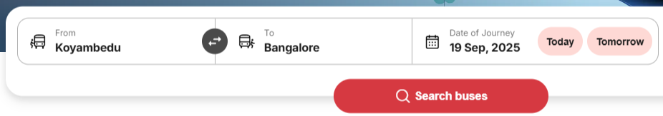

1. after user selects all the fields it should take to the selection page where display of available cab at the users selection should be shown. The available car box should contain the car number driver number and exact dummy image of the car.

1. after the user click on the view seats it should take to the seat selection area where the 2d modal allows the user to select the preferred seat

this img for bus I need it for car for e.g. Innova the 7 seater .

This should be in the left of the page.

In the right of the page there should be complete time line of the cab from start to finish like the img shown bellow.

After selecting the required seat of the cab, it should show pop up like this



In the bottom of the same page after clicking on the continue booking it should take to the payment page.

1. The payment page should be modern as like the same red bus website

Use blue and white colour palate the colouring the website should be more futuristic, advance animation, highly responsive, and easy to handle by the user.

Give the complete react and tailwind code that satisfies all the above requirements.

Note: As the backend is yet to design use mock data for all.