

SAVEETHA SCHOOL OF ENGINEERING, SIMATS
Department of Computer Science and Engineering
Assignment Information

Particular | Details
Name: | P. Guru
Register Number: | 192521010
Department: | IT
Programme: | B. Tech
Course Code & Course Name | CSA1522 – Cloud Computing and Big Data Analytics
Academic Year / Batch | 2026–27
Faculty Name | Dr P Rajaram
Assignment Title | Cloud-Based Placement Data Management and Big Data Analytics using ZOHO
Date of Issue | 31/08/2026
Date of Submission | 01/09/2026
Maximum Marks | 100
Course Outcome(s) – CO | CO1: Understand the cloud services with different service models.  CO2: Demonstrate the deployment of Virtualization and build a data center using virtualization tools.  CO3: Build methods to access cloud and various techniques to collaborate within cloud.
Bloom's Taxonomy Level | L3 – Apply and L4 – Analyse
SDG Mapping | SDG 4 – Quality Education  SDG 8 – Decent Work and Economic Growth  SDG 9 – Industry Innovation and Infrastructure  SDG 11 – Sustainable Cities and Communities
Industry | Applies cloud services, virtualization and distributed big-data processing to a ZOHO-based placement workflow, supporting scalable access, collaboration and analytics while considering security, privacy and responsible data use.

Problem Statement:

Design and evaluate a simple cloud-based placement data management and access solution for a university using the ZOHO platform. The placement cell needs a reliable way to organize placement information and provide controlled access to students and placement staff. Students shall select suitable IaaS, PaaS and SaaS service models, design a basic cloud architecture, create and configure virtual machines using Oracle VM VirtualBox, demonstrate secure access to a cloud-hosted web application or Web API, and show how users can collaborate through shared cloud resources.
Assessment Rubrics
Assessment Criterion / Marks | Excellent (4) | Good (3) | Satisfactory (2) | Needs Improvement (1)
CO1 – Cloud Service Models & Architecture 25 Marks | Correctly identifies the ZOHO requirements, selects appropriate IaaS/PaaS/SaaS models, and presents a complete architecture with clear justification. | Selects appropriate service models and presents a suitable architecture with minor gaps in justification or detail. | Identifies basic service models and provides a simple architecture, but the justification or mapping to requirements is limited. | Service models are unsuitable or misunderstood; architecture is missing/unclear and justification is inadequate.
CO2 – Virtualization & VM Deployment 25 Marks | Creates and configures two VMs correctly using Oracle VM VirtualBox; records CPU, memory, storage and networking; demonstrates communication and clearly explains the hypervisor. | Creates and configures both VMs successfully with mostly correct resources and networking; communication works with minor issues. | Creates the VMs and demonstrates basic operation, but configuration, networking, testing or explanation is incomplete. | VM creation/configuration is incorrect or incomplete; communication is not demonstrated and supporting evidence is insufficient.
CO3 – Cloud Access & Collaboration 25 Marks | Demonstrates secure cloud access successfully, including authentication/access control, clear request-response evidence and a practical collaboration workflow. | Demonstrates working cloud access and collaboration with minor gaps in security, explanation or evidence. | Demonstrates basic cloud access, but collaboration, authentication or security evidence is limited. | Cloud access or collaboration is non-functional, unclear, insecure or not supported by evidence.
Analysis, Validation & Engineering Justification 15 Marks | Compares feasible alternatives using clear criteria, performs relevant tests, interprets results accurately and gives a well-supported final decision. | Provides a reasonable comparison and testing with generally correct interpretation and justification. | Provides limited comparison or testing; interpretation and justification are basic. | Little or no meaningful comparison, testing, interpretation or engineering justification is provided.
Security, Privacy, Ethics & SDG Relevance 10 Marks | Clearly addresses security, privacy, ethical handling of placement data and relevant SDGs with specific application to the ZOHO scenario. | Addresses relevant security, privacy, ethical and SDG considerations with minor omissions. | Mentions general security, privacy, ethics or SDG points but gives limited connection to the problem. | Important security, privacy, ethical or SDG considerations are missing or inappropriate.

Deliverables
To receive full credit, each submission must include the following deliverables:
- Pseudo code
- Implementation & Results
- GitHub and GCR Upload

Cloud-Based Placement Data Management and Big Data Analytics using Zoho Creator

1. Objective
- This assignment's goal is to use Zoho Creator to build and implement a basic cloud-based placement data management system. In a centralized cloud application, the system keeps track of job offers, employer information, student placement data, and placement statistics.
- The tool facilitates collaborative data administration, offers students and placement professionals-controlled access, and permits rudimentary analytics to comprehend placement performance.
- SaaS, PaaS, and IaaS cloud service models, virtualization using Oracle VM VirtualBox, safe cloud access, and responsible student placement data management are all demonstrated by the system.

2. Problem Statement
- This assignment's goal is to use Zoho Creator to build and implement a basic cloud-based placement data management system. In a centralized cloud application, the system keeps track of job offers, employer information, student placement data, and placement statistics.
- The tool facilitates collaborative data administration, offers students and placement professionals controlled access, and permits rudimentary analytics to comprehend placement performance.
- SaaS, PaaS, and IaaS cloud service models, virtualization using Oracle VM VirtualBox, safe cloud access, and responsible student placement data management are all demonstrated by the system.

3.Technologies Required:

Component | Technology
Cloud Application | Zoho Creator
Cloud Service Model | SaaS / PaaS
Virtualization | Oracle VM VirtualBox
Programming/Logic | Zoho Creator Deluge
Database | Zoho Creator Forms/Reports
Front End | Zoho Creator Forms & Pages
Analytics | Zoho Creator Reports/Dashboards
Version Control | GitHub
Cloud Repository | GCR, if required by faculty
Browser | Google Chrome / Microsoft Edge

4. Modules:

Module 1 – Student Management
Store:
- Student ID
- Student Name
- Register Number
- Department
- Programme
- Year
- CGPA
- Email
- Phone Number
- Placement Status

Module 2 – Company Management
Store:
- Company ID
- Company Name
- Industry
- Job Role
- Location
- Package/LPA
- Eligibility CGPA
- Drive Date
- Number of Vacancies

Module 3 – Placement Drive Management
Store:
- Drive ID
- Company
- Drive Date
- Job Role
- Eligible Students
- Applied Students
- Shortlisted Students
- Selected Students
- Drive Status

Module 4 – Placement Result
Store:
- Result ID
- Student
- Company
- Job Role
- Selection Status
- Package
- Joining Date
- Placement Year

Module 5 – Analytics Dashboard
Display:
- Total Students
- Total Companies
- Total Placement Drives
- Total Selected Students
- Placement Percentage
- Average Package
- Highest Package
- Department-wise Placements
- Company-wise Selection
- Placement Status chart
This directly supports the assignment's requirement for analysis and engineering justification.

6. Cloud Architecture
Use this architecture in your assignment:
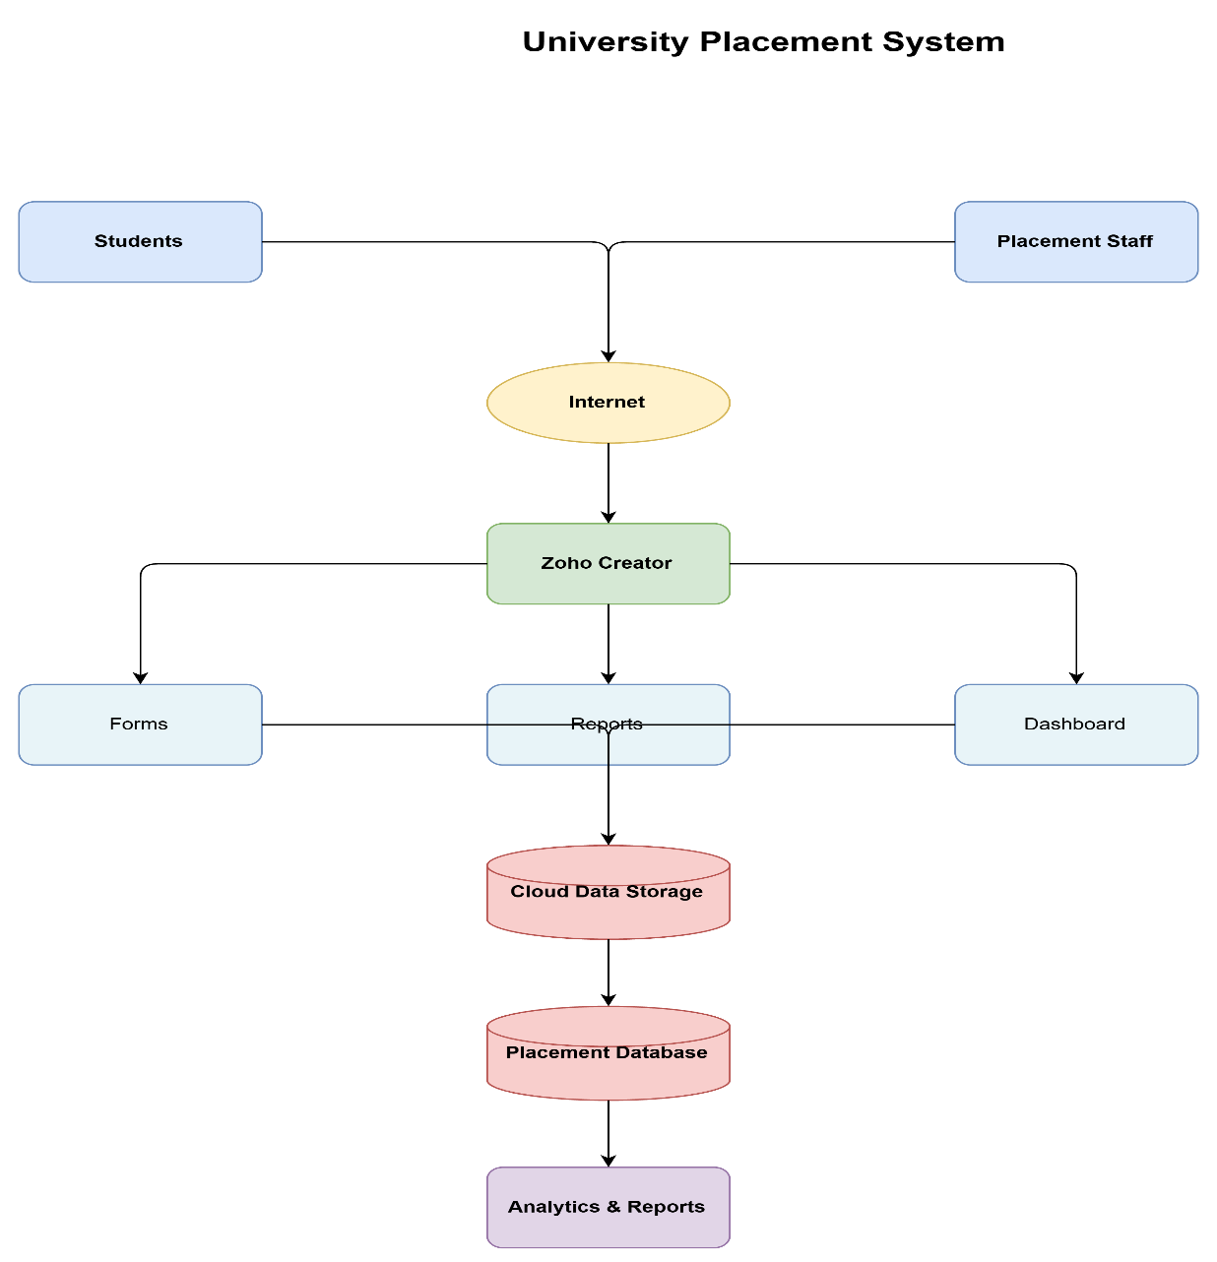

Architecture Explanation
- The students and placement staff access the application through the Internet. Zoho Creator acts as the cloud application platform where forms, reports, workflows and dashboards are created.
- Student and company information is stored in the cloud. Placement staff can add or update records, while students can access only the information permitted to them.
- The dashboard processes stored placement information and displays analytical results such as placement percentage, average package and department-wise selection.

6. Cloud Service Models
- This section is important because CO1 carries 25 marks. Your assignment specifically expects appropriate IaaS, PaaS and SaaS selection and justification.
IaaS – Infrastructure as a Service
Example: Virtual machines created using Oracle VM VirtualBox for demonstration.
- IaaS provides computing infrastructure such as virtual machines, storage and networking. In this assignment, virtual machines are used to demonstrate the infrastructure and virtualization layer.
PaaS – Platform as a Service
Example: Zoho Creator.
- Zoho Creator provides a development platform where forms, workflows, reports, dashboards and application logic can be created without managing the underlying server infrastructure.
SaaS – Software as a Service
Example:
- The completed cloud-based placement application accessed through a web browser.
- Users can access the application without installing or maintaining the application locally.
Comparison

Model | Example | Purpose
IaaS | Virtual Machine | Infrastructure/virtualization
PaaS | Zoho Creator | Application development
SaaS | Placement Application | End-user access

7. Virtualization Procedure
VM 1 – Application/Client VM
Suggested configuration:
- Name: Placement-Client-VM
- CPU: 2 cores
- RAM: 2 GB
- Storage: 20 GB
- Network: NAT/Host-Only
- Operating System: Ubuntu/Windows
VM 2 – Server/Analytics VM
- Name: Placement-Server-VM
- CPU: 2 cores
- RAM: 4 GB
- Storage: 25 GB
- Network: NAT/Host-Only
- Operating System: Ubuntu/Windows
- Oracle VM VirtualBox acts as the hypervisor and allows multiple virtual machines to operate on a single physical computer. The two VMs represent separate computing environments for the client/application and server/analytics components.

8. VM Communication Test
From VM 1, find the IP address of VM 2.
Use:
- ping <VM2-IP-address>
Example:
- ping 192.168.56.102
Result – VM Communication
This is useful because the rubric specifically asks for evidence that the VMs communicate.

9. Secure Cloud Access
Demonstrate:
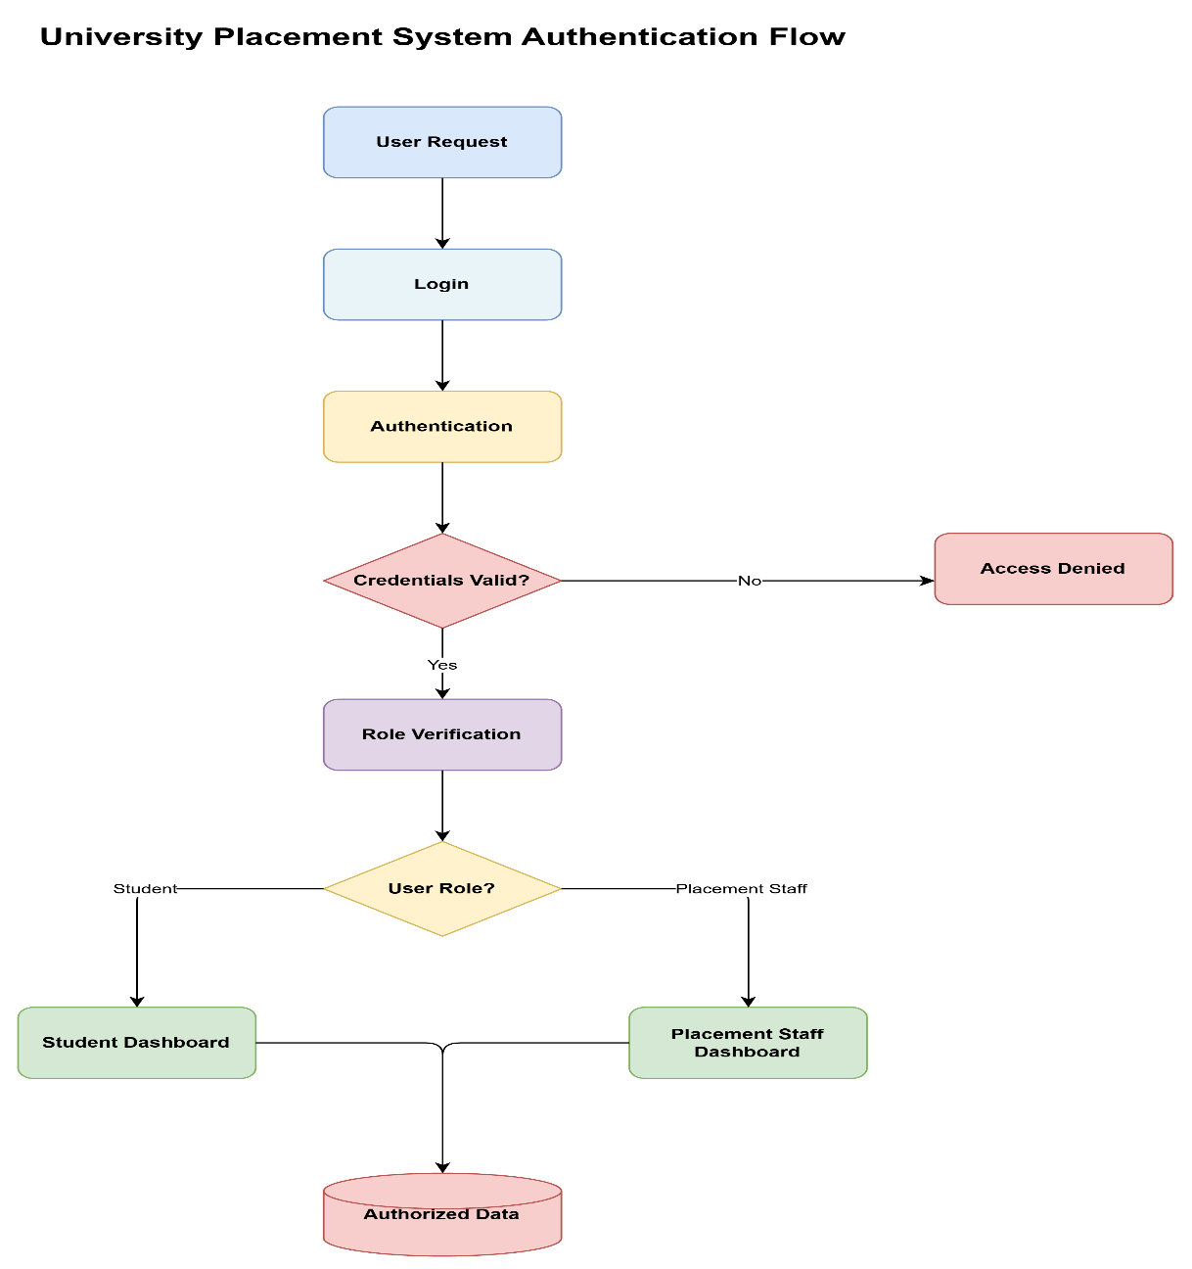
Mention these security measures:
- User authentication
- Role-based access
- Password protection
- Restricted access to student records
- HTTPS-based cloud access
- Avoiding unnecessary exposure of personal information
- Controlled sharing of placement data

11. Pseudocode:
BEGIN

Initialize cloud-based placement management system

Create Student Management module
Create Company Management module
Create Placement Drive module
Create Placement Result module

Register authorized users

FOR each user
Authenticate user
IF authentication is successful THEN
Identify user role

IF role = Placement Staff THEN
Allow student data management
Allow company data management
Allow placement drive management
Allow placement result management
Allow analytics access

ELSE IF role = Student THEN
Allow authorized student information
Allow placement drive viewing
Allow placement status viewing
END IF

ELSE
Deny access
END IF
END FOR

Store placement information in cloud

Generate reports

Calculate:
Total Students
Total Companies
Total Placed Students
Placement Percentage
Average Package
Highest Package

Display results using dashboard charts

END

12. Sample Data
Students

ID | Student | Department | CGPA | Status
S001 | Arun | CSE | 8.5 | Placed
S002 | Rahul | IT | 8.2 | Placed
S003 | Kavin | CSE | 7.8 | Not Placed
S004 | Priya | AI&DS | 9.0 | Placed
S005 | Divya | ECE | 8.6 | Placed
S006 | Hari | CSE | 7.5 | Not Placed
S007 | Anu | IT | 8.8 | Placed
S008 | Vishal | ECE | 7.9 | Not Placed
S009 | Sneha | AI&DS | 8.7 | Placed
S010 | Sanjay | CSE | 8.1 | Placed

13. Results
- The cloud-based placement data management system was successfully designed and implemented using Zoho Creator. Student, company, placement drive and placement result information were maintained through cloud-based forms and reports.
- The dashboard provided analytical information such as total students, total companies, placed students, placement percentage and average package.
- Two virtual machines were configured using Oracle VM VirtualBox and network communication between the virtual machines was demonstrated.
- Role-based access was implemented to provide different levels of access to students and placement staff. The application demonstrated cloud accessibility, centralized data management, collaboration and basic placement analytics.

14. Analysis

Parameter | Observation
Data Accessibility | Available through cloud
Collaboration | Multiple authorized users
Scalability | Can add more student/company records
Data Management | Centralized
Analytics | Dashboard and reports
Security | Authentication and access control
Availability | Accessible through Internet
Maintenance | Reduced local infrastructure requirement

15.Output screenshots:
ZOHO Screenshot:
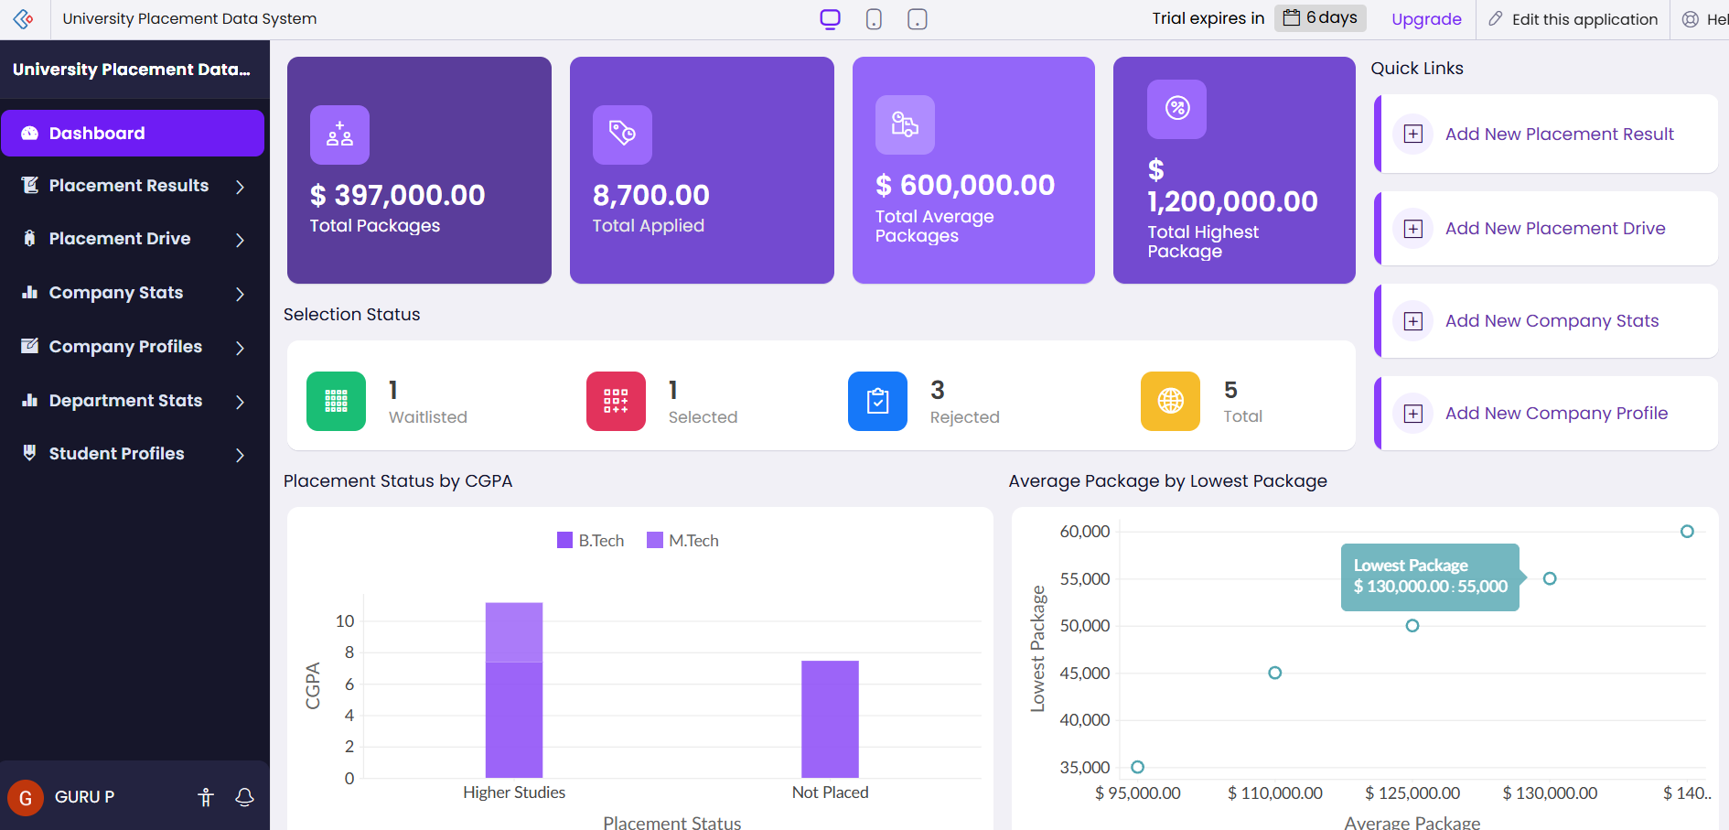

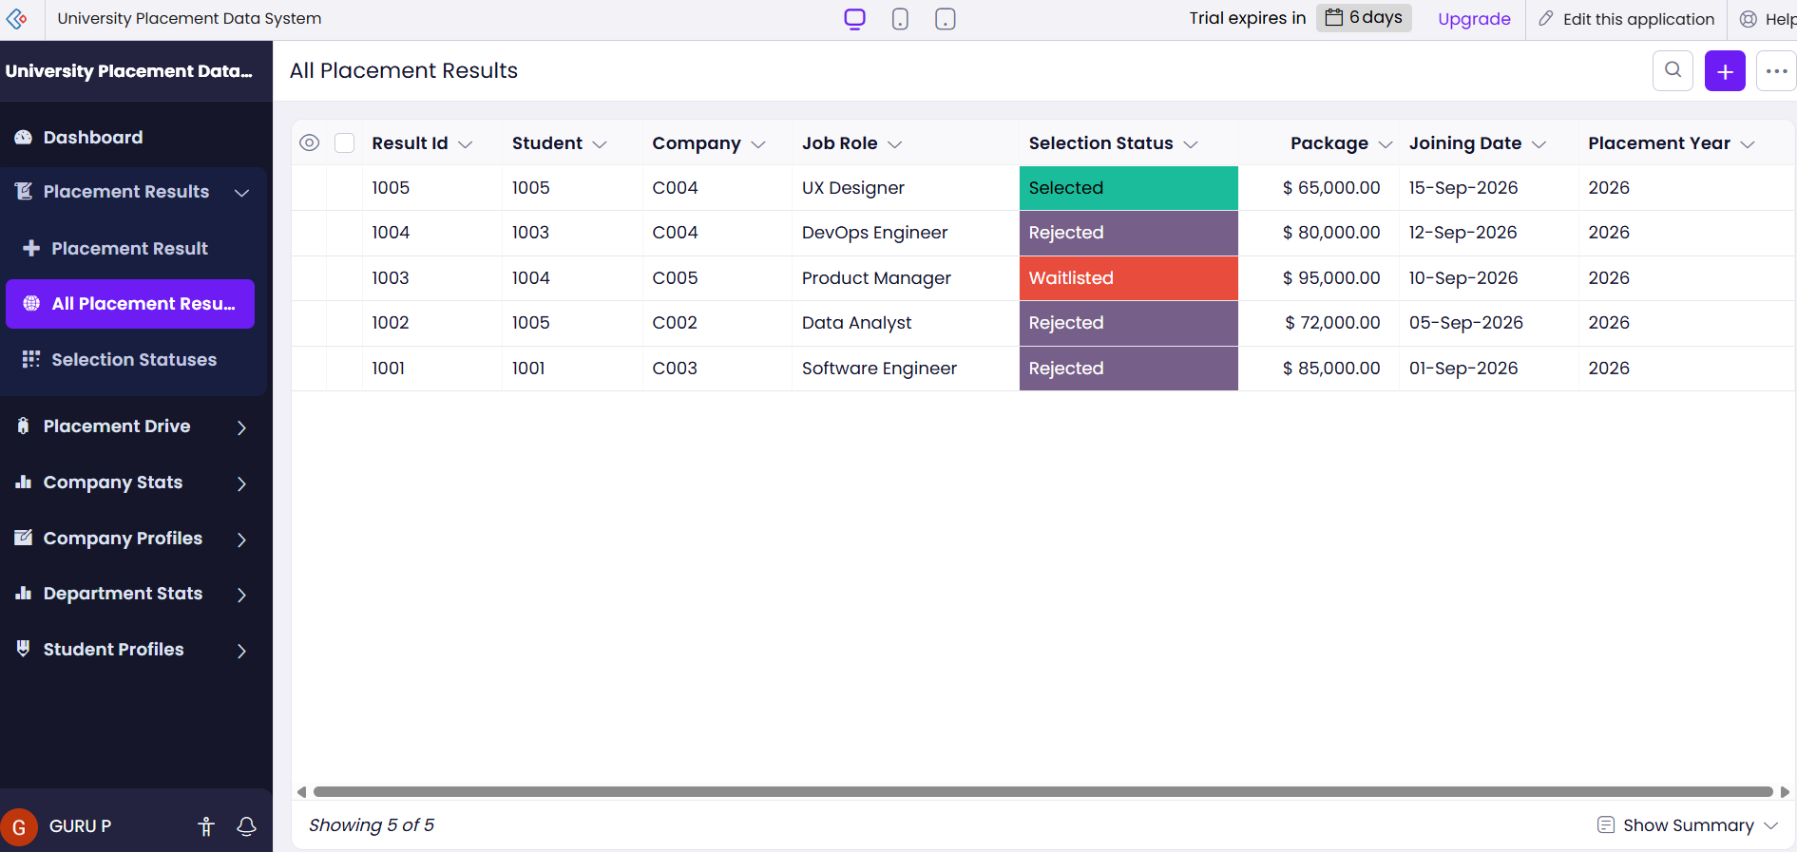

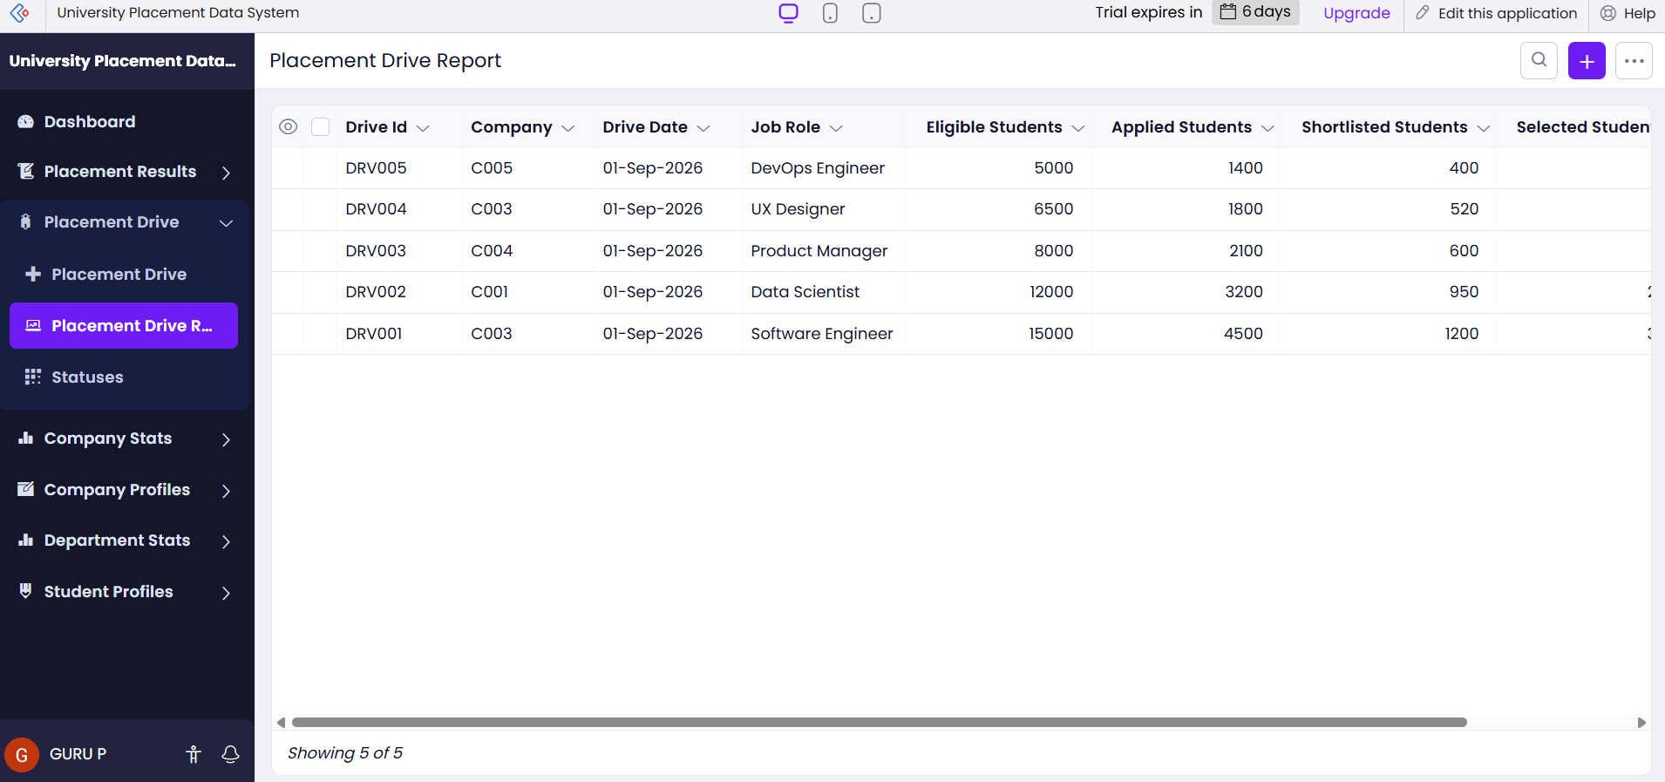

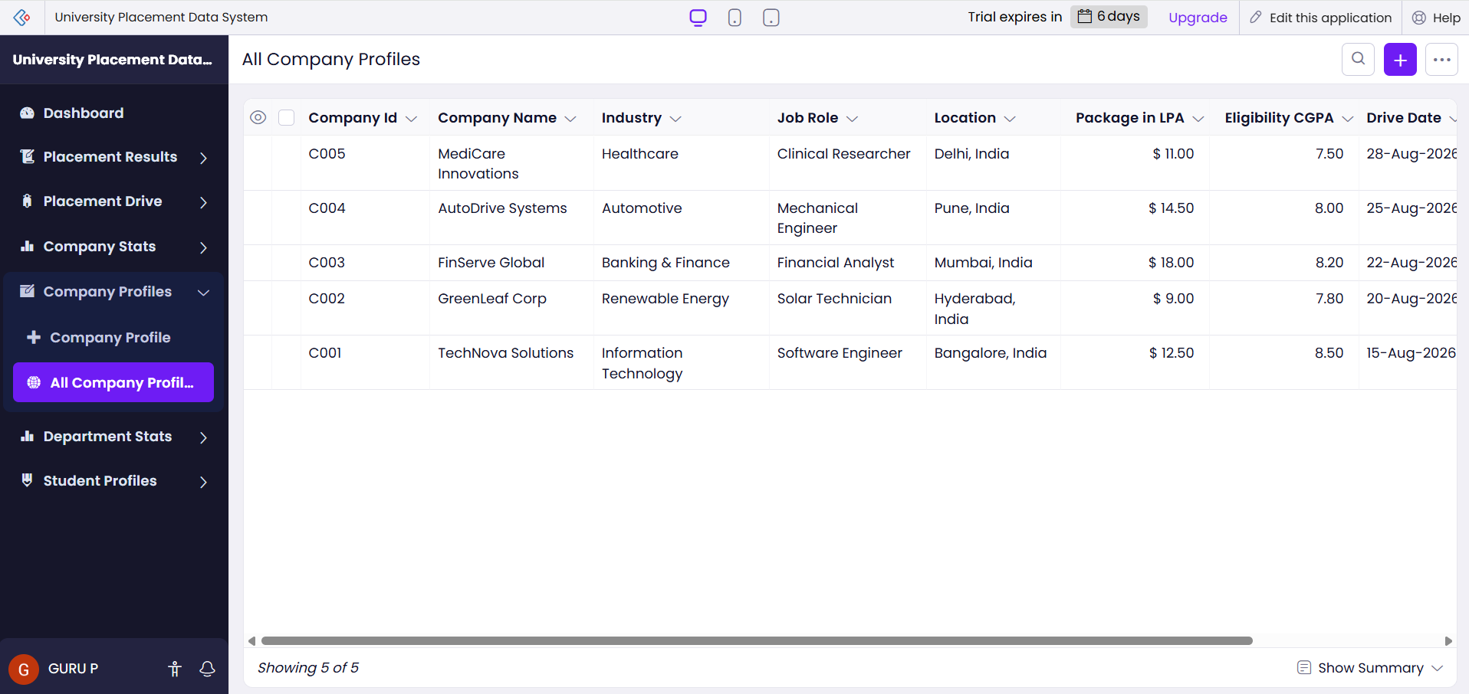

VMWARE SCREENSHOTS

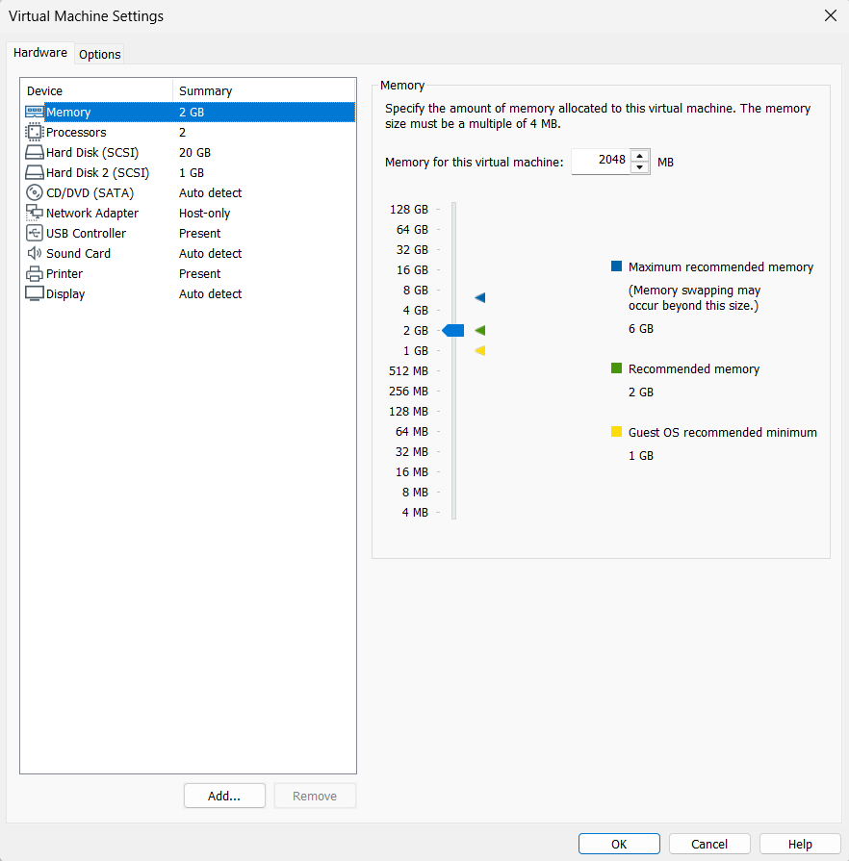
- VMware Placement-Client configuration.
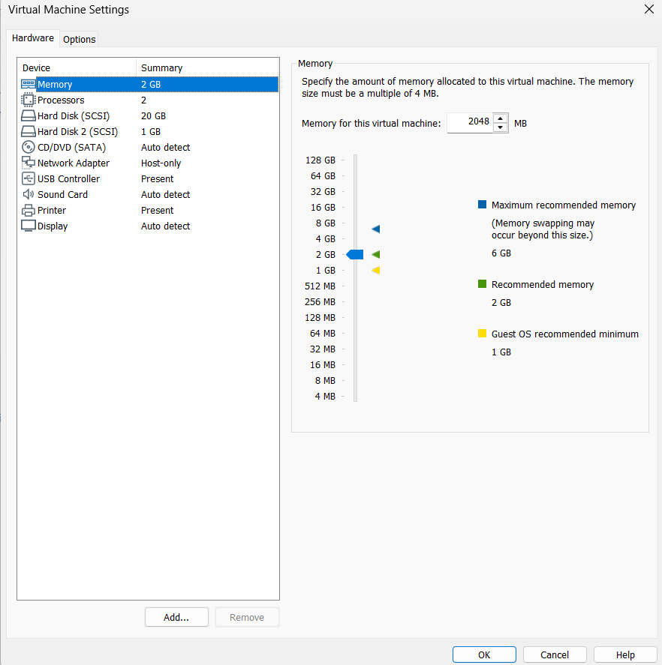

- Placement-Server IP address.
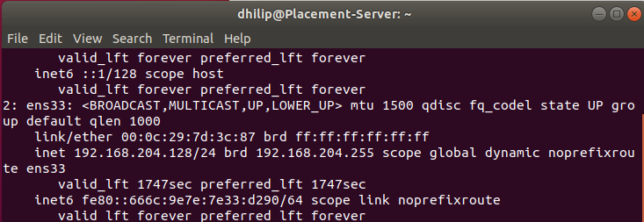
Placement-Client
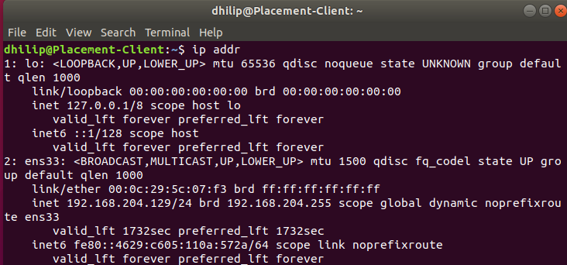
Client-to-Server successful ping.
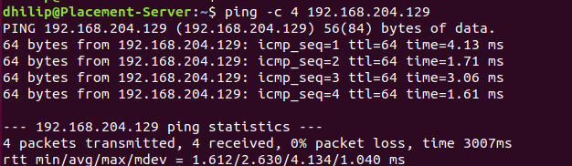
Server-to-Client successful ping.
