Sensor 1 —> soil temperature and moisture

python soil_sensor_publish.py -e endpoint -r Root_certificate -c Thing_Certificate -k Thing_private_key -id clientid -t iot/agritech

IOT core Thing
sensor_1 | spri_1
sensor_2 | spri_1
sensor_3 | spri_1
sensor_4 | spri_1

sensor_5 | spri_2
sensor_6 | spri_2
sensor_7 | spri_2
sensor_8 | spri_2

Thing Type - SoilSensor

IOT Core Thing - as mentioned above

IOT core group. Sensor_group

Group_name - farm1

sub_group - spri1 which has for sensors as things

AWS IoT Core : Policy Creation ¶
Every device in AWS IoT Core needs to have certain policies attached with them to perform any operation.
In this section, we are going to create policy for our things and set the topic name. The same topic name will be used again in the MQTT test client to see the pulished data on AWS IoT core.
Lets start the policy creation process by using below mentioned steps.
- Click on Secure and choose Policies. Click on the Create Policy and this will prompt you to the next page where you can create your own policy.
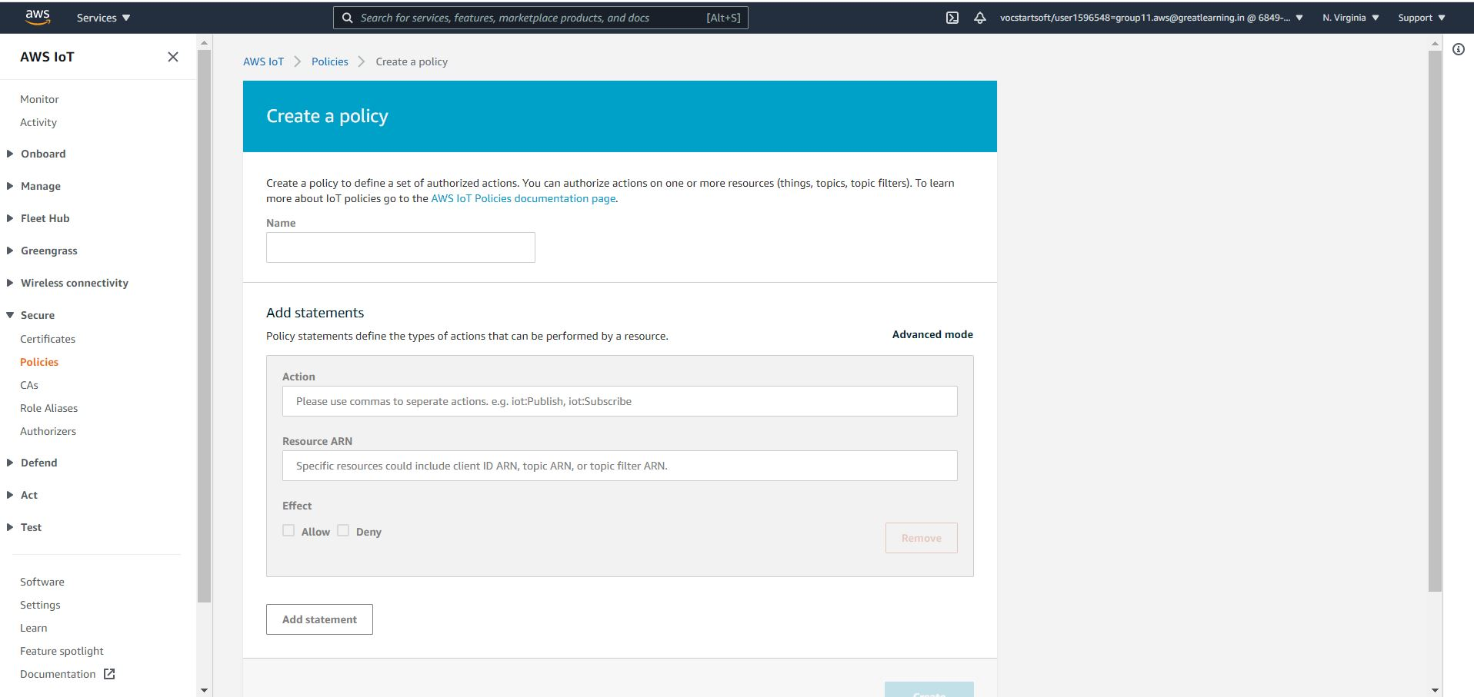

- Enter the name for your policy.
  - In the Action section enter iot:* .
  - In the next section enter *
  - In effect section choose Allow and then click on Create
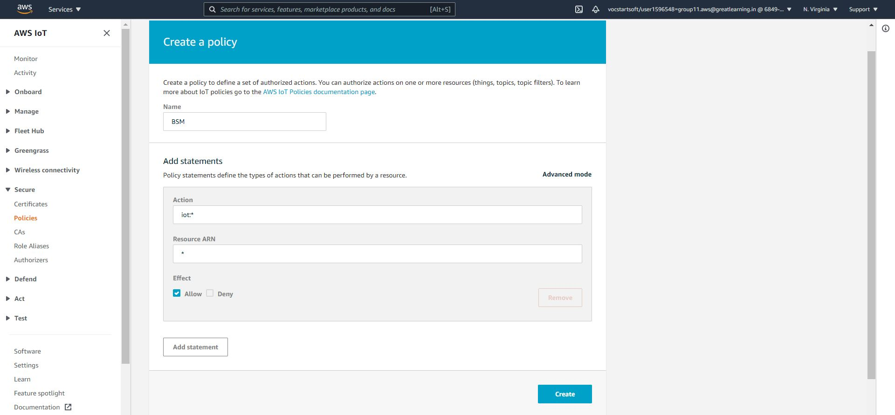

AWS IoT Core : Thing Creation ¶
We have created Types, Groups & Policy for our thing. Now we should create our first thing in AWS IoT core.
Please follow the below mentioned steps to create things.
- Go to AWS IoT core and click on Manage and then choose Things. If you do not have any Things available in your AWS IoT core, it will look like the image below.
- Click on Register a thing.
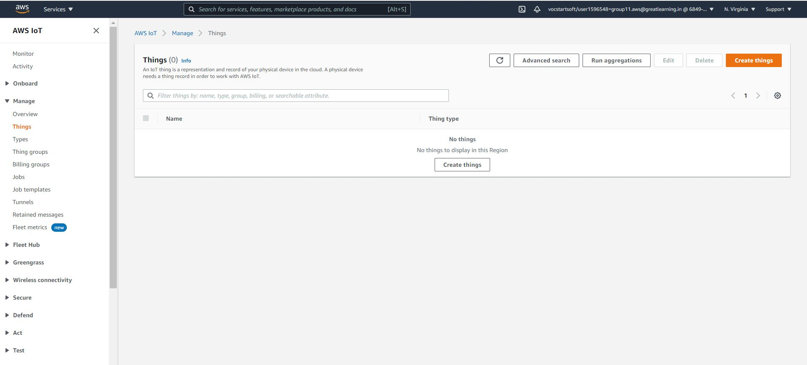

- Click on Create a multiple/single thing. (Choose the first option)
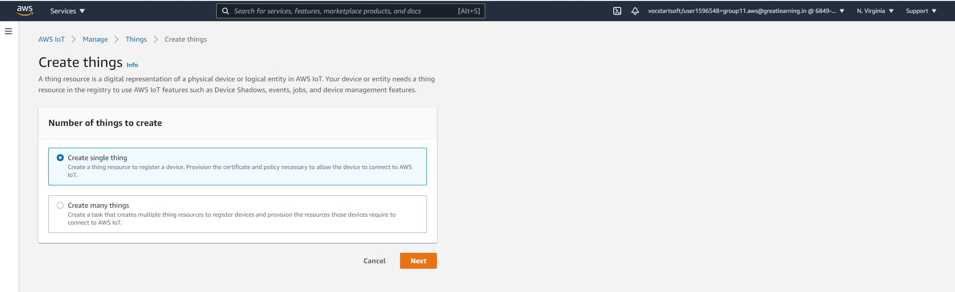

- Enter the details for your thing such as thing name (this is the equivalent of device id) and choose thing type and add it into the group we created in previous steps. Once done click on create.

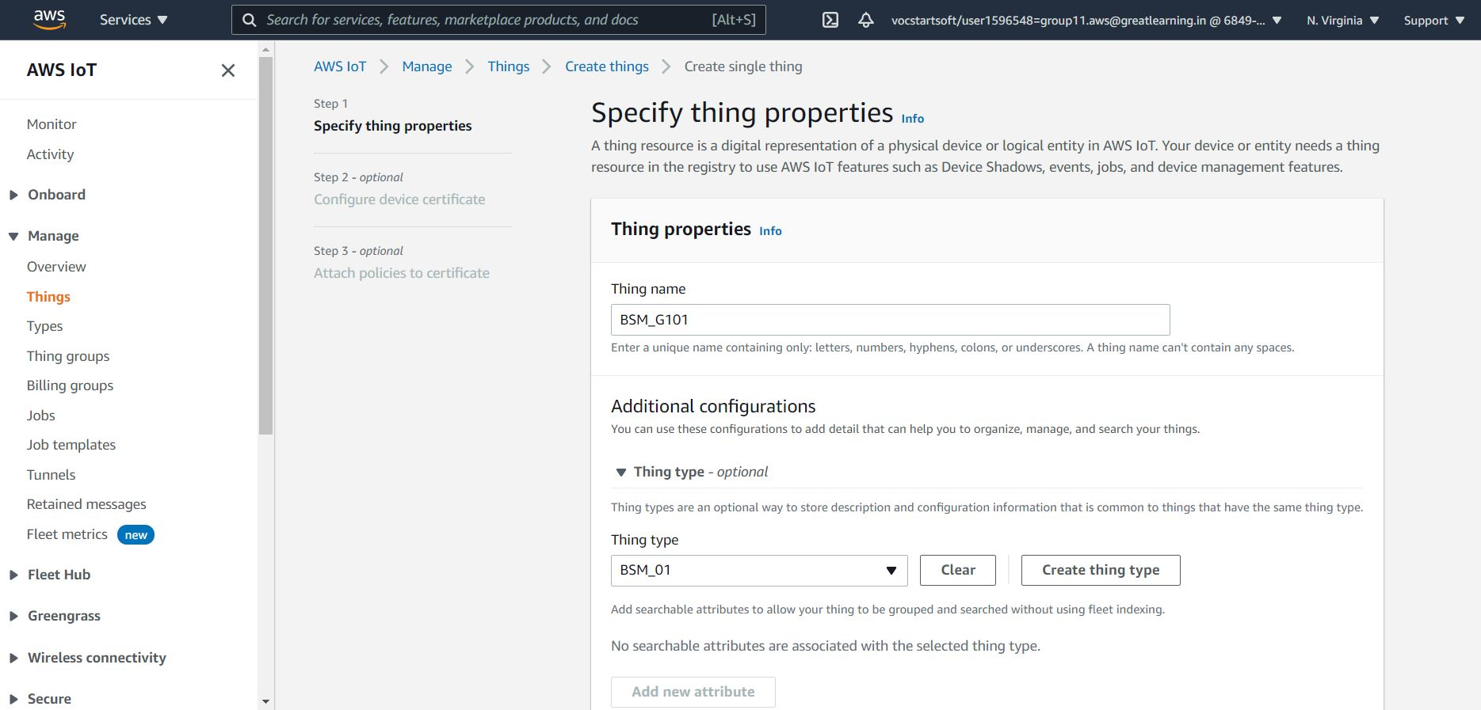
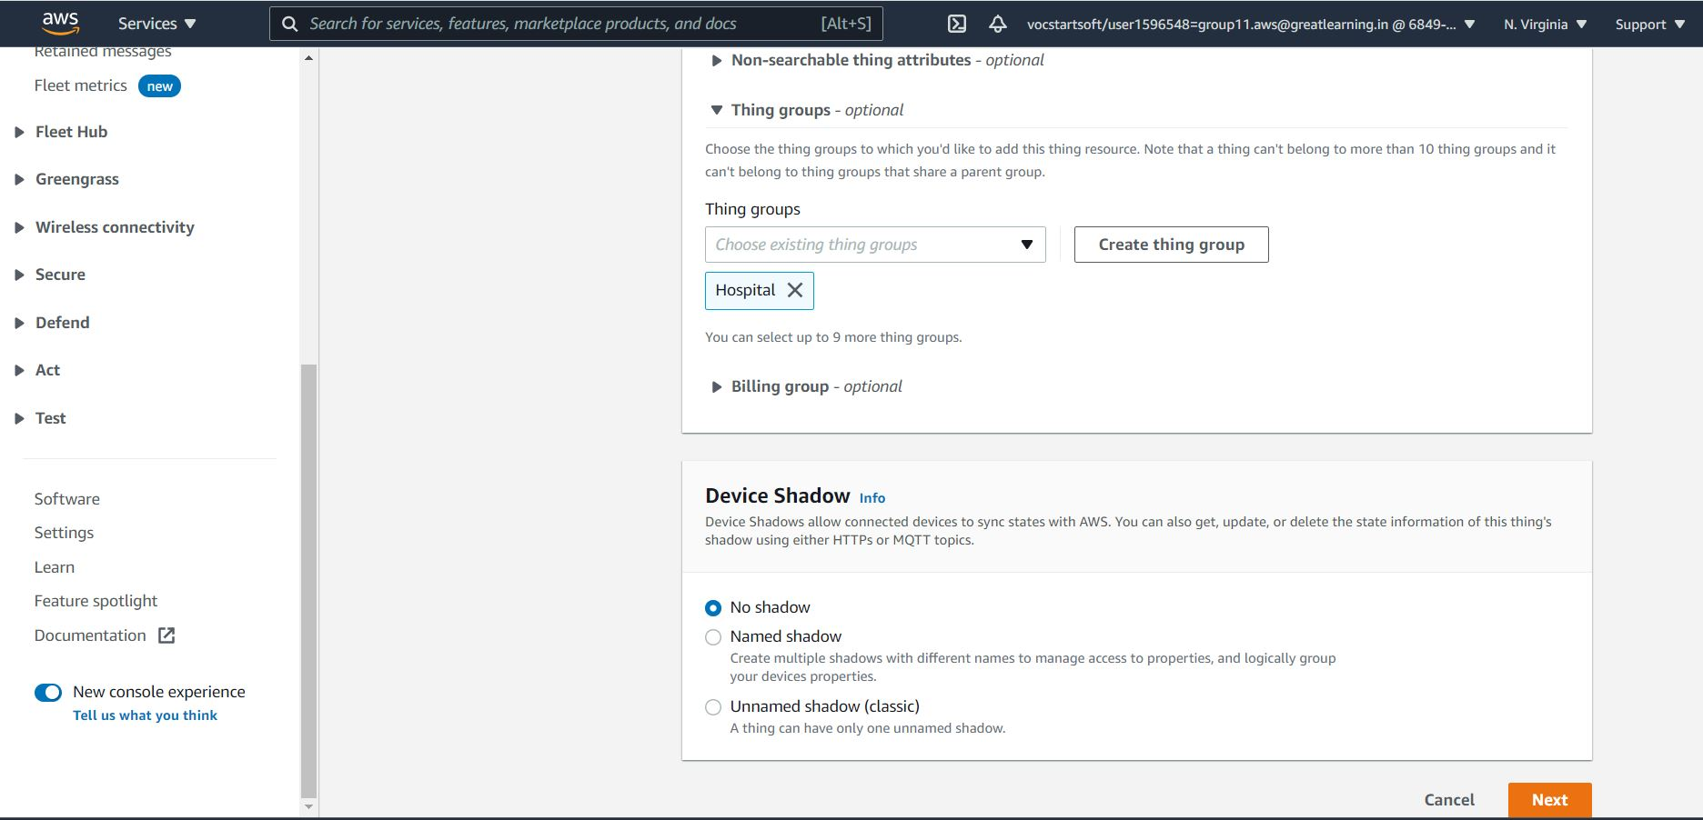
- In this step we are going to create the certificates for thing.
  - Click on the recommended option here to create the files in the next step.
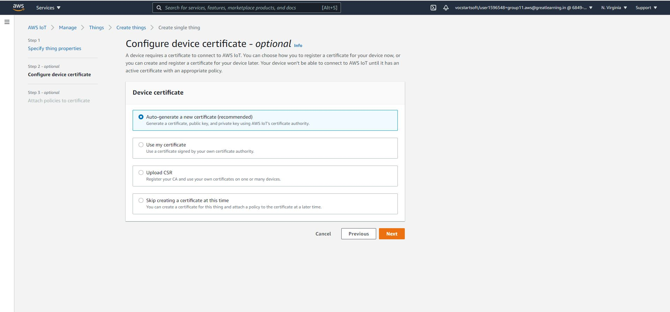

- Here We need to attach the policy that we created in the previous step.

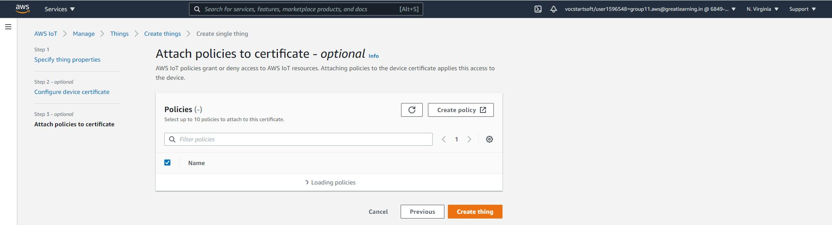

- Once the policy is attached with the thing the that we are creating. Next step will open window as mentioned below:
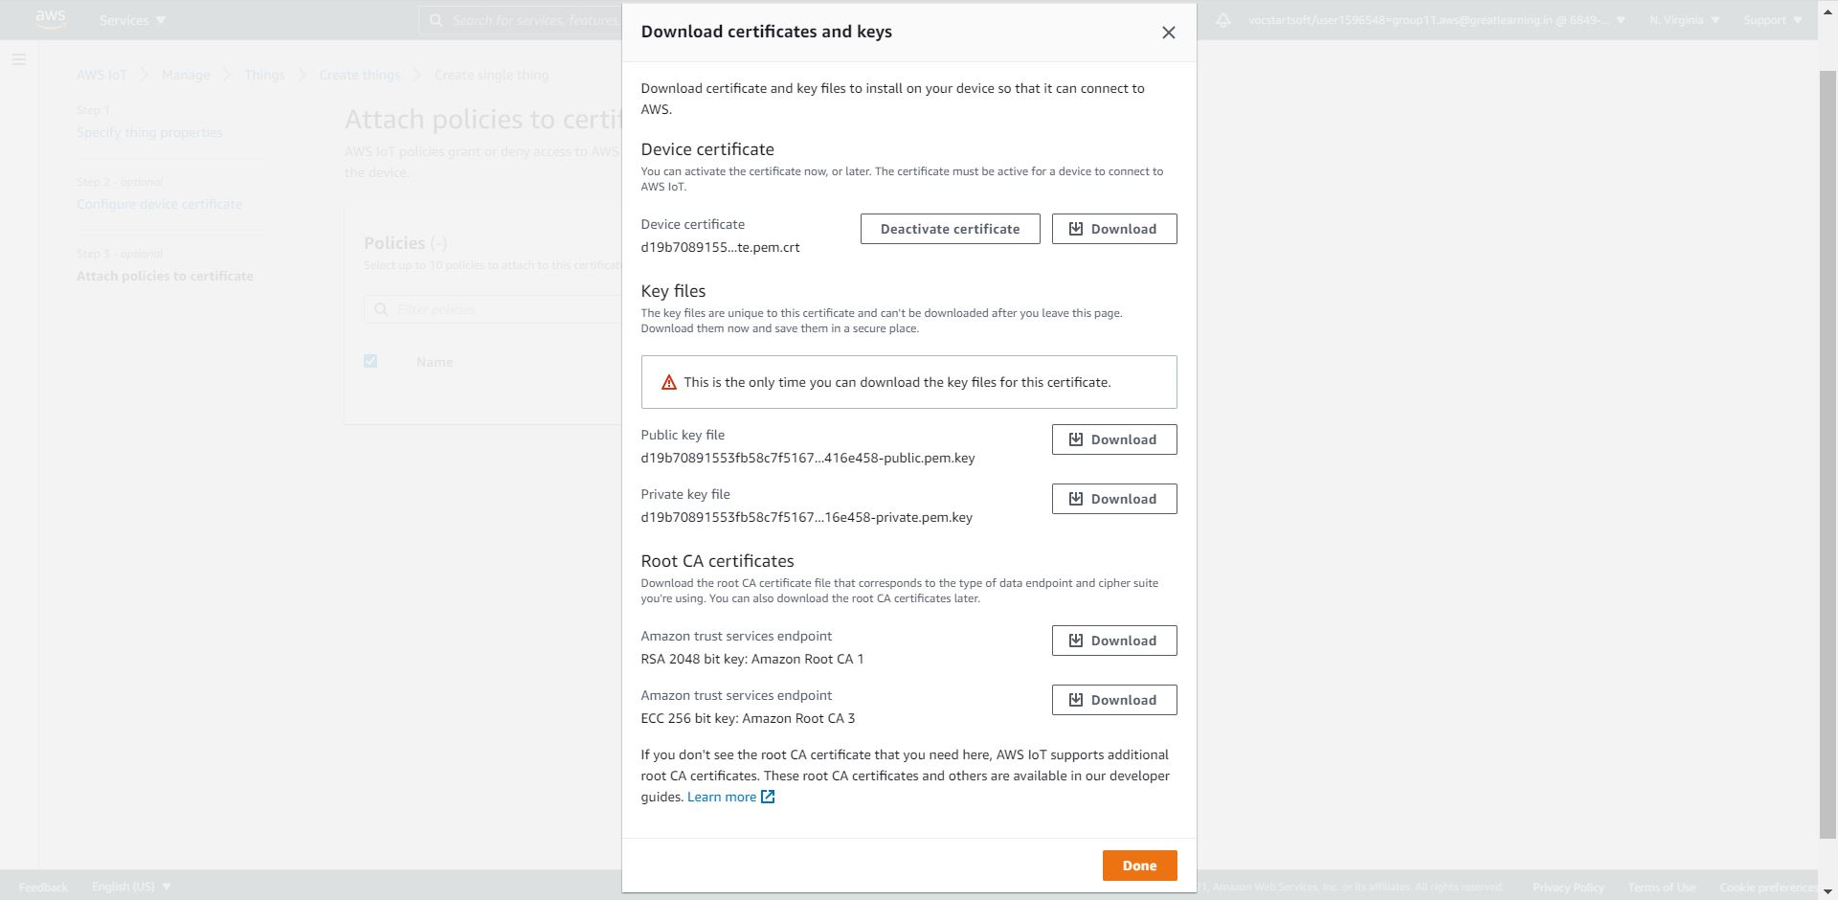
- Download all the certificates such Device certificate, public key file, private key file and root certificates. All the keys can be downloaded with a single click.

- Once policy is attached then click on Register thing in the above step, successful operation will create the thing for you.

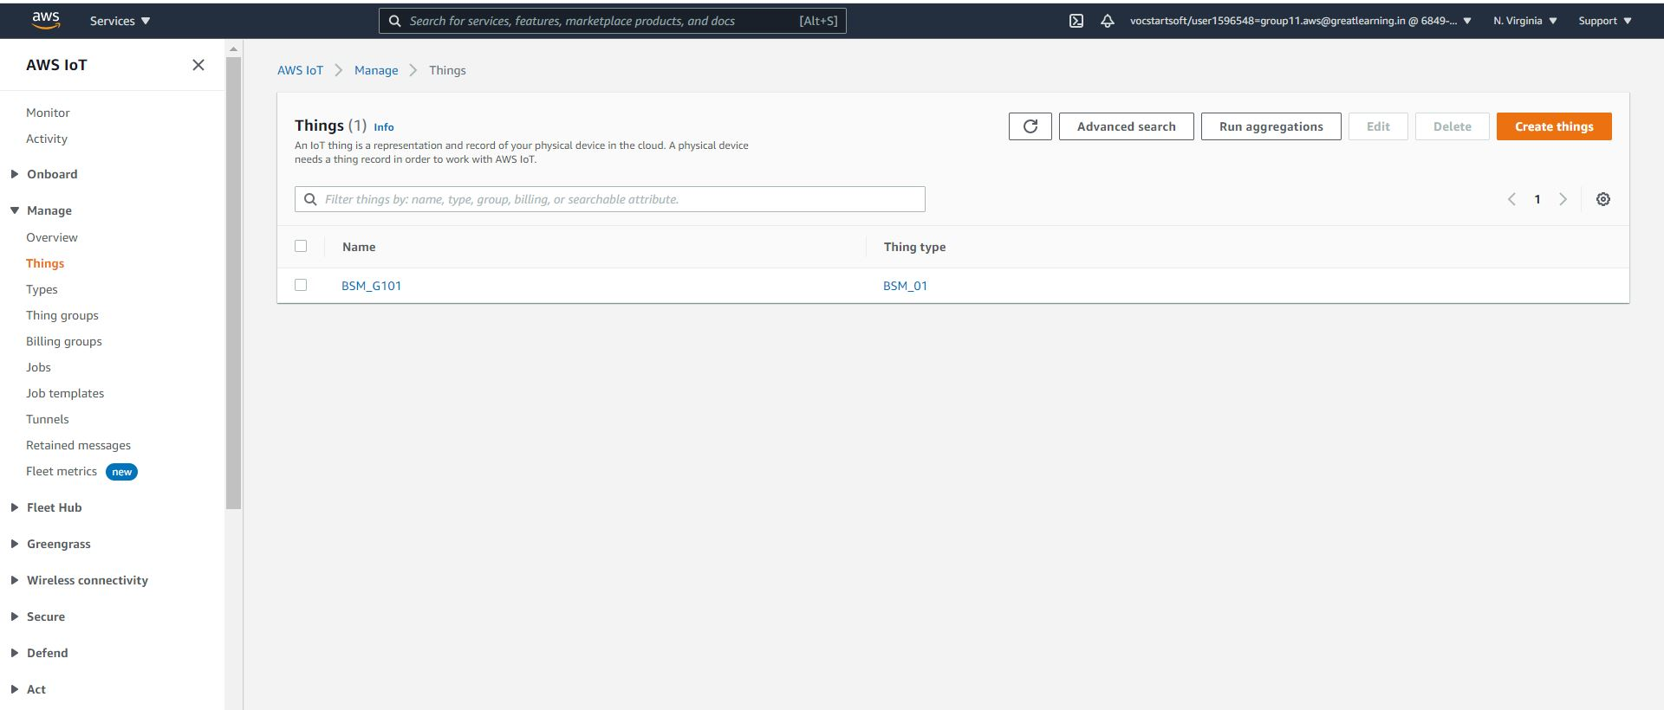
- To get the endpoint click on the created things. It will take you to the next page, Now click on Interact. It will look similar to the following image.
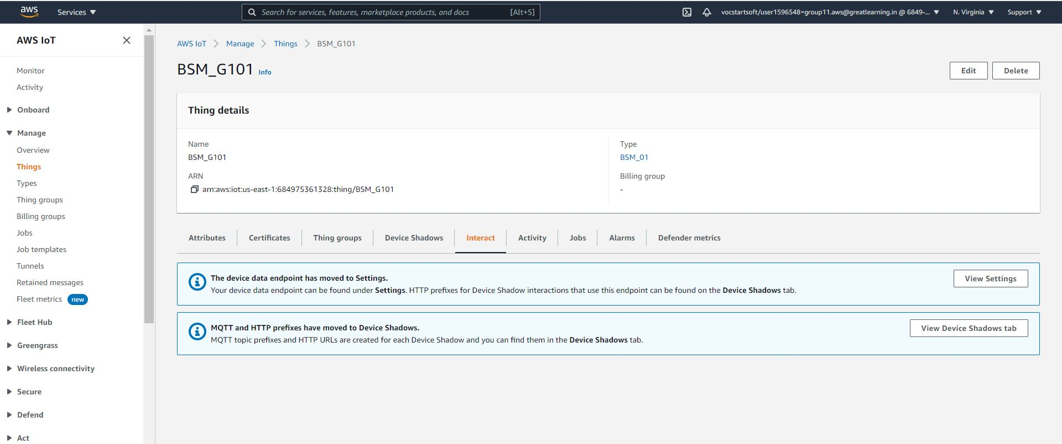
Click on view settings, it will take you to a new page similar to the following, copy the endpoint and keep it for future reference.
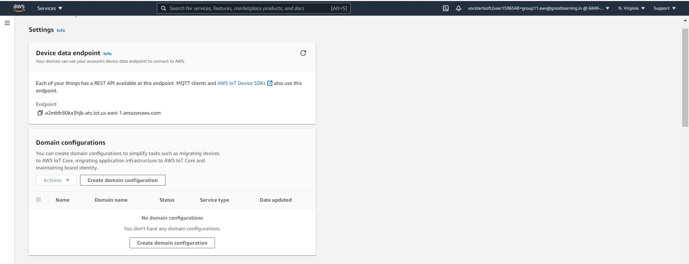
- Certificates and keys are downloaded in the previous steps.
- clientid can be a normal string, make sure that different clientid is provided to send data or multiple devices
- You can keep the topic_name that is easy to remember. Let's say iot/agritech

