8 PUZZLE PROBLEM-DFS
# DFS for 8 Puzzle

goal = (1, 2, 3, 4, 5, 6, 7, 8, 0)

def print_puzzle(state):
for i in range(0, 9, 3):
print(state[i:i+3])
print()

def dfs(state, path, visited):

# Goal reached
if state == goal:
return path

visited.add(state)

zero = state.index(0)
row = zero // 3
col = zero % 3

# Left, Down, Right, Up
moves = [
(0, -1),
(1, 0),
(0, 1),
(-1, 0)
]

for dr, dc in moves:

new_row = row + dr
new_col = col + dc

if 0 <= new_row < 3 and 0 <= new_col < 3:

new_pos = new_row * 3 + new_col

new_state = list(state)

# Swap 0 with tile
new_state[zero], new_state[new_pos] = \
new_state[new_pos], new_state[zero]

new_state = tuple(new_state)

if new_state not in visited:

result = dfs(
new_state,
path + [new_state],
visited
)

if result is not None:
return result

return None

# Main
print("Enter initial state:")

initial = []

for i in range(9):
initial.append(int(input()))

initial = tuple(initial)

solution = dfs(initial, [initial], set())

if solution:

print("\nSolution Found!")
print("Number of moves:", len(solution) - 1)

for i, state in enumerate(solution):
print("Step", i)
print_puzzle(state)

else:
print("No solution found.")

OUTPUT:
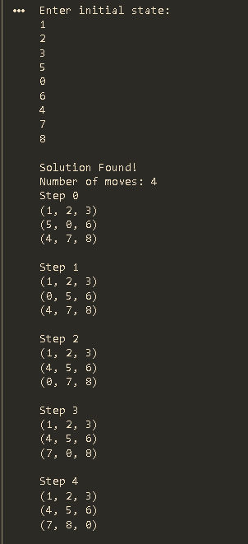

8 PUZZLE PROBLEM-IDS
# Iterative Deepening Search for 8 Puzzle

goal = (1, 2, 3, 4, 5, 6, 7, 8, 0)
def print_puzzle(state):
for i in range(0, 9, 3):
print(state[i:i+3])
print()
# Depth Limited Search
def dls(state, depth, path):

if state == goal:
return path

if depth == 0:
return None

zero = state.index(0)

row = zero // 3
col = zero % 3

# Left, Down, Right, Up
moves = [
(0, -1),
(1, 0),
(0, 1),
(-1, 0)
]
for dr, dc in moves:

new_row = row + dr
new_col = col + dc

if 0 <= new_row < 3 and 0 <= new_col < 3:

new_pos = new_row * 3 + new_col

new_state = list(state)

# Swap blank with tile
new_state[zero], new_state[new_pos] = \
new_state[new_pos], new_state[zero]

new_state = tuple(new_state)

# Avoid repeating states in current path
if new_state not in path:

result = dls(
new_state,
depth - 1,
path + [new_state]
)

if result is not None:
return result
return None
# IDS
def ids(initial):

depth = 0

while True:

print("Searching at depth:", depth)
result = dls(initial, depth, [initial])
if result is not None:
return result

depth += 1

# Main
print("Enter initial state:")

initial = []

for i in range(9):
initial.append(int(input()))

initial = tuple(initial)

solution = ids(initial)

print("\nSolution Found!")
print("Number of moves:", len(solution) - 1)

for i, state in enumerate(solution):

print("Step", i)
print_puzzle(state)

OUTPUT:

