TIC TAC TOE
import math

class TicTacToe:

def __init__(self):
self.board = [" " for _ in range(9)]

# Print the board
def print_board(self):
print(self.board[0], "|", self.board[1], "|", self.board[2])
print("--+---+--")
print(self.board[3], "|", self.board[4], "|", self.board[5])
print("--+---+--")
print(self.board[6], "|", self.board[7], "|", self.board[8])

# Check whether a player has won
def win(self, p):
winning_combinations = [
(0, 1, 2),
(3, 4, 5),
(6, 7, 8),
(0, 3, 6),
(1, 4, 7),
(2, 5, 8),
(0, 4, 8),
(2, 4, 6)
]

for a, b, c in winning_combinations:
if self.board[a] == p and self.board[b] == p and self.board[c] == p:
return True

return False

# Minimax algorithm
def minimax(self, ai):

# AI wins
if self.win("X"):
return 1

# Human wins
if self.win("O"):
return -1

# Draw
if " " not in self.board:
return 0

if ai == "X":
# MAX player
best = -math.inf

for i in range(9):
if self.board[i] == " ":
self.board[i] = "X"

score = self.minimax("O")

self.board[i] = " "

best = max(best, score)

return best

else:
# MIN player
best = math.inf

for i in range(9):
if self.board[i] == " ":
self.board[i] = "O"

score = self.minimax("X")

self.board[i] = " "

best = min(best, score)

return best

# Find the best move for AI
def ai_move(self):

best = -math.inf
move = 0

for i in range(9):

if self.board[i] == " ":

self.board[i] = "X"

score = self.minimax("O")

self.board[i] = " "

if score > best:
best = score
move = i

self.board[move] = "X"

# Main game
def play(self):

while True:

self.print_board()

# Human move
pos = int(input("Enter position (1-9): ")) - 1

if pos < 0 or pos > 8 or self.board[pos] != " ":
print("Invalid position!")
continue

self.board[pos] = "O"

# Check human win
if self.win("O"):
self.print_board()
print("You win!")
break

# Check draw
if " " not in self.board:
self.print_board()
print("Draw!")
break

# AI move
self.ai_move()

# Check AI win
if self.win("X"):
self.print_board()
print("AI wins!")
break

# Check draw
if " " not in self.board:
self.print_board()
print("Draw!")
break

# Create game
game = TicTacToe()

# Start game
game.play()

OUTPUT:
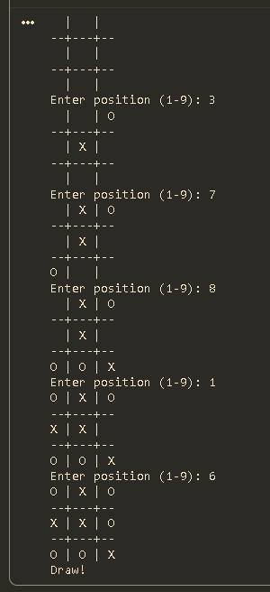

VACUUM CLEANER
class VacuumCleanerAgent:

def __init__(self, initial_location, room_a_status, room_b_status):
self.location = initial_location

self.environment = {
"A": room_a_status,
"B": room_b_status
}

self.cost = 0

# Display current state
def display_state(self):
print("\nCurrent Status:")
print("Agent Location:", self.location)
print("Room A:", self.environment["A"])
print("Room B:", self.environment["B"])
print("Cost:", self.cost)

# Vacuum cleaner agent
def run(self):

print("\nStarting Vacuum Cleaner Agent...")
self.display_state()

while self.environment[self.location] == 1:

print("Action: Suck dirt in Room", self.location)

# Clean the current room
self.environment[self.location] = 0

# Increase cost
self.cost += 1

self.display_state()

# Move to the other room
if self.environment["A"] == 1 or self.environment["B"] == 1:

if self.location == "A":
print("Action: Move Right to Room B")
self.location = "B"

else:
print("Action: Move Left to Room A")
self.location = "A"

self.cost += 1
self.display_state()

# Clean the new room
if self.environment[self.location] == 1:

print("Action: Suck dirt in Room", self.location)

self.environment[self.location] = 0
self.cost += 1

self.display_state()

print("\nGoal achieved: All rooms are clean!")
print("Total Performance Cost:", self.cost)

def main():

print("VACUUM CLEANER AGENT")
print("ENVIRONMENT SETUP")

# Get initial location
while True:
location = input("Enter initial agent location (A or B): ").upper()

if location in ["A", "B"]:
break

print("Invalid location! Please enter A or B.")

# Get Room A status
while True:
try:
status_a = int(input("Enter Room A status (1 for DIRTY, 0 for CLEAN): "))

if status_a in [0, 1]:
break

print("Invalid value! Enter 0 or 1.")

except ValueError:
print("Invalid input! Please enter an integer (0 or 1).")

# Get Room B status
while True:
try:
status_b = int(input("Enter Room B status (1 for DIRTY, 0 for CLEAN): "))

if status_b in [0, 1]:
break

print("Invalid value! Enter 0 or 1.")

except ValueError:
print("Invalid input! Please enter an integer (0 or 1).")

# Create agent
agent = VacuumCleanerAgent(location, status_a, status_b)

# Run agent
agent.run()

if __name__ == "__main__":
main()

OUTPUT:
