

MSc Data Science and AI Project Proposal
AI-Based Early Detection and Classification of Foot and Nail Conditions Using Transfer Learning for Rural Healthcare

Student Name: Gurubasavaraj Harlapur
MISIS ID: M01093116

Supervisor Name: Dr Krishnadas Nanath
Date of Submission: 15/06/2026

Table of Contents
1. Abstract 3
2. Introduction 3
3. State of the Art Review 5
4. Methods 6
5. Proposed Work 7
5.1 Intended Contribution of the Work 7
5.2 Benefits of the Proposed Work 7
5.3 Procedures and Activities of the Proposed Work 7
5.4 Evaluation of the Project 8
5.5 Resources Needed 9
5.6 Access to Participants and Clients 9
5.7 Ethical Aspects 9
6. Work Plan and Schedule 9
7. Conclusion 12
8. Bibliography 12
Chapter 2: Literature Review 14
2.1 Introduction 15
2.2 Methodology Adopted for the Literature Review 16
2.3 Research Timeline and Evolution of the Domain 20
2.4 Publication Trends and Research Landscape 23
2.5 Thematic Literature Review 25
2.5.1 Foot and Nail Conditions: Clinical Background and Challenges 25
2.5.2 Conventional Diagnostic Approaches for Foot and Nail Conditions 26
2.5.4 Convolutional Neural Networks for Medical Image Classification 31
2.5.5 Transfer Learning in Healthcare Image Classification 35
2.5.6 Review of Existing AI Models for Foot and Nail Disease Detection 37
2.5.7 Critical Analysis and Synthesis of Existing Literature 41
2.5.8 Research Gaps and Justification for the Proposed Research 45
2.5.9 Chapter Summary and Conclusion 50

- Abstract
This project proposes the development of an artificial intelligence-based system for the early detection and classification of common foot and nail conditions using image classification techniques. Individuals working in agricultural and rural environments are frequently exposed to conditions that increase the risk of fungal infections, nail disorders, wounds, and other foot-related complications. As these conditions are often ignored during their early stages, delayed diagnosis can lead to discomfort, difficulty performing daily activities, and more serious health issues. To address this problem, the study will utilise publicly available image datasets and apply transfer learning techniques using pre-trained convolutional neural network models to classify foot and nail conditions into Healthy Foot/Nail, Nail Fungal Infection, Foot Wound/Injury, and Foot Ulcer. The performance of the proposed model will be evaluated using standard classification metrics, including accuracy, precision, recall, and F1-score. The expected outcome is a proof-of-concept prototype capable of supporting early screening and increasing awareness of foot and nail health in rural communities. The project aims to demonstrate the feasibility of using artificial intelligence as an assistive tool for preliminary healthcare assessment rather than as a replacement for professional medical diagnosis.

- Introduction
Foot and nail conditions are among the commonly overlooked health problems in rural communities, particularly among agricultural workers who spend long hours in environments that expose them to moisture, soil, minor injuries, and poor hygiene conditions. While many of these conditions begin as mild fungal infections, nail disorders, or small wounds, they can gradually worsen if left untreated. Limited access to healthcare facilities, lack of specialist consultation, and low awareness of early symptoms often contribute to delayed diagnosis and treatment. As a result, individuals may experience discomfort, mobility issues, and reduced ability to carry out routine work and daily activities.
Recent advances in artificial intelligence and computer vision have created opportunities for developing image-based healthcare screening tools. Transfer learning techniques allow pre-trained deep learning models to be adapted for specific medical image classification tasks without requiring extremely large datasets. Despite the growing use of artificial intelligence in healthcare, existing studies largely focus on individual conditions such as diabetic foot ulcers, skin diseases, or nail disorders in isolation. There is limited research on a unified image classification approach capable of identifying multiple common foot and nail conditions that are relevant to rural populations. This project therefore proposes the development of an AI-based classification system that can assist in the early detection of such conditions using image data.
The growing adoption of artificial intelligence in healthcare, combined with advancements in deep learning techniques, has created opportunities for developing accessible and cost-effective screening solutions for underserved populations. Deep learning models have demonstrated strong performance in image classification tasks and are increasingly being applied to healthcare applications where early detection can improve health outcomes (Goodfellow, Bengio and Courville, 2016; WHO, 2021).
Aim
To develop and evaluate a transfer learning-based image classification system capable of supporting the early detection of common foot and nail conditions in rural healthcare settings.
Objectives
- To identify and prepare publicly available image datasets representing common foot and nail conditions.
- To preprocess and organise image data into predefined classification categories.
- To develop an image classification model using transfer learning techniques.
- To evaluate the performance of the proposed model using standard classification metrics.
- To develop a proof-of-concept prototype that demonstrates the practical application of the proposed solution.
Contribution of the Project
This project aims to contribute to the growing field of AI-assisted healthcare by exploring the feasibility of using transfer learning for the early classification of multiple foot and nail conditions. From a practical perspective, the proposed system may support preliminary screening and encourage earlier medical attention in rural communities where specialist healthcare resources may be limited. The study also contributes a proof-of-concept framework that can be extended in future research for broader rural healthcare applications.
- State of the Art Review
Recent developments in artificial intelligence have significantly improved the performance of medical image classification systems. Convolutional Neural Networks (CNNs) have been widely adopted for disease detection tasks involving skin conditions, diabetic foot ulcers, and other image-based healthcare applications. Studies have reported that transfer learning models such as ResNet, MobileNet, and EfficientNet can achieve high classification performance while reducing the requirement for large labelled datasets (Oltu et al., 2021). These approaches demonstrate the potential of deep learning techniques in supporting healthcare professionals through automated image analysis.
Research focusing on foot-related conditions has primarily concentrated on diabetic foot ulcer detection and wound assessment. Several studies have utilised image classification and segmentation techniques to identify ulcer severity and support clinical decision-making (Huang et al., 2022; Cassidy et al., 2021). Similarly, research on nail disease classification has explored the use of deep learning models to detect fungal infections and nail abnormalities from image data. While these studies have produced encouraging results, they generally address individual conditions in isolation and are often developed using specialised clinical datasets collected in controlled healthcare environments (Yap et al., 2021).
Although previous research confirms the effectiveness of transfer learning for medical image classification, limited attention has been given to developing a unified screening framework capable of identifying multiple common foot and nail conditions within a single system. Furthermore, few studies specifically consider the practical challenges faced by rural populations where access to specialist healthcare services may be restricted. This project seeks to address this gap by investigating the feasibility of a transfer learning-based classification system that can support the early detection of multiple foot and nail conditions using publicly available image datasets (Girmaw and Taye, 2025; Almufadi et al., 2025).
Beyond academic research, healthcare organisations and industry reports have highlighted the increasing importance of artificial intelligence in improving healthcare accessibility and supporting early disease detection. The World Health Organization emphasises the role of digital health technologies in strengthening healthcare delivery and expanding access to healthcare services in underserved communities (WHO, 2021). Similarly, industry reports indicate that AI-assisted diagnostic tools are becoming increasingly important in supporting healthcare professionals and improving screening processes (Deloitte, 2024). These findings reinforce the relevance of exploring AI-based approaches for early detection and classification of foot and nail conditions within rural healthcare settings.
- Methods
The proposed study will adopt a proof-of-concept development approach to investigate the feasibility of using transfer learning for the early detection and classification of foot and nail conditions. Publicly available image datasets containing healthy and affected foot and nail images will be collected from recognised repositories and organised into predefined classification categories. The datasets will be obtained from publicly available academic and open-source repositories, including diabetic foot ulcer image datasets and nail disease image datasets available through research publications and Kaggle repositories. The dataset will undergo preprocessing activities including image resizing, normalisation, data cleaning, and augmentation to improve data quality and reduce the risk of model overfitting.
The development phase will utilise transfer learning techniques based on pre-trained Convolutional Neural Network (CNN) architectures. MobileNetV2 will be selected as the primary model due to its computational efficiency and proven performance in image classification tasks (Girmaw and Taye, 2025). ResNet50 will be implemented as a comparative model to assess differences in classification performance. Transfer learning is considered appropriate for this project because medical image datasets are often limited in size, making it practical to leverage knowledge learned from large-scale image datasets rather than training a deep neural network from scratch (Oltu et al., 2021).
The prepared dataset will be divided into training, validation, and testing subsets. The models will be trained to classify images into four predefined categories: Healthy Foot/Nail, Nail Fungal Infection, Foot Wound/Injury, and Foot Ulcer. These categories were selected because they represent common foot and nail conditions that may benefit from early identification and medical attention. Model performance will be assessed using accuracy, precision, recall, F1-score, and confusion matrix analysis. These metrics will provide a comprehensive evaluation of the classification capability of the proposed solution.
To demonstrate practical applicability, a simple prototype interface will be developed that allows users to upload an image and receive a predicted classification result. The findings obtained from model evaluation and prototype testing will be analysed to determine the feasibility of applying transfer learning techniques for early screening of foot and nail conditions within rural healthcare contexts.
The proposed methodology has been designed to address the research objectives outlined in Section 2. Dataset collection and preparation activities directly support Objectives 1 and 2, which focus on identifying suitable datasets and preparing them for analysis. The implementation of transfer learning models addresses Objective 3, while model evaluation activities support Objective 4 through the assessment of classification performance using established evaluation metrics. Finally, the development of the proof-of-concept prototype addresses Objective 5 by demonstrating the practical application of the proposed solution.
- Proposed Work
The proposed project focuses on the development of a proof-of-concept image classification system capable of supporting the early detection and classification of common foot and nail conditions. The project will involve dataset preparation, model development using transfer learning techniques, performance evaluation, prototype implementation, and dissertation documentation. The overall objective is to investigate the feasibility of applying artificial intelligence to support early healthcare screening in rural environments.

5.1 Intended Contribution of the Work
This project aims to contribute to both academic research and practical healthcare applications. From an academic perspective, it explores the application of transfer learning for the classification of multiple foot and nail conditions within a unified framework. From a practical perspective, the project demonstrates how artificial intelligence can support preliminary screening and healthcare awareness in rural communities where access to specialist medical services may be limited.

5.2 Benefits of the Proposed Work
The proposed system may benefit rural populations, agricultural workers, healthcare practitioners, and researchers interested in AI-assisted healthcare solutions. Early identification of foot and nail conditions may encourage timely medical consultation and increase awareness of preventive healthcare practices. The findings may also

5.3 Procedures and Activities of the Proposed Work
The project will be executed through a series of structured activities aligned with the project objectives. Each activity will produce a measurable deliverable that contributes towards the successful completion of the proof-of-concept system.
High-Level Objective | Activity | Deliverable |  | Milestone
Dataset Preparation | Collect and organise publicly available image datasets |  | Prepared dataset | Dataset completion
Data Preprocessing | Clean, label, resize and augment images |  | Processed dataset | Data ready for modelling
Model Development | Develop MobileNetV2 and ResNet50 models |  | Trained classification models | Model training completed
Model Evaluation | Assess model performance using evaluation metrics |  | Evaluation report | Performance validation completed
Prototype Development | Develop user interface for prediction |  | Working prototype | Prototype demonstration completed
Documentation | Dissertation writing and project reporting |  | Final dissertation | Final submission

5.4 Evaluation of the Project
Prototype Evaluation
The prototype will be evaluated using quantitative performance measures derived from the classification models. Evaluation will focus on:
• Accuracy of classification results
• Precision, Recall, and F1-Score
• Confusion Matrix Analysis
• Comparative performance between MobileNetV2 and ResNet50
Process Evaluation
Project progress will be monitored through documentation generated during each project phase. Evaluation will focus on:
• Dataset preparation records
• Model development documentation
• Experimental results and observations
• Prototype testing records
• Dissertation progress and milestone completion
The evaluation activities will be conducted throughout the project lifecycle. Model evaluation will occur following the completion of training, while process evaluation will be performed continuously to ensure project objectives and deadlines are achieved.

5.5 Resources Needed
The project primarily relies on publicly available datasets and open-source software resources.
• Python programming environment
• TensorFlow and Keras libraries
• OpenCV image processing library
• Jupyter Notebook development environment
• Personal computer with internet access
• Publicly available image datasets
The project is expected to require minimal financial expenditure as the majority of resources are freely available for academic use.

5.6 Access to Participants and Clients
The proposed study does not require direct interaction with external organisations, clients, or participants during the model development phase. Publicly available image datasets will be utilised for training and evaluation purposes. For prototype testing, feedback may be obtained from peers or academic supervisors if required. In the event that external feedback cannot be obtained, functionality testing and performance evaluation will be conducted using predefined testing procedures and model evaluation metrics.

5.7 Ethical Aspects
The project will primarily use publicly available datasets and therefore does not involve direct human participation or primary data collection. As no personally identifiable information will be collected, the risk to privacy and confidentiality is minimal. The proposed system is intended solely as an AI-assisted screening tool and not as a replacement for professional medical diagnosis. Potential long-term considerations include the responsible use of AI-generated predictions and the importance of ensuring that users understand the limitations of automated healthcare support systems.
- Work Plan and Schedule
The project will be executed through a series of structured activities aligned with the research objectives. The initial phase focuses on literature review, research refinement, and dataset identification. This will be followed by dataset preparation activities including cleaning, labelling, augmentation, and validation. Transfer learning models will then be developed, trained, and fine-tuned using the prepared datasets. The performance of the models will be evaluated using established classification metrics before integrating the selected model into a proof-of-concept prototype. The final stages involve result analysis, dissertation writing, review, and submission. This phased approach ensures systematic progress and effective project management throughout the dissertation period.
WBS
1. Research Planning and Proposal Development
1.1 Topic Selection and Refinement
1.2 Proposal Preparation
1.3 Supervisor Feedback Review
1.4 Proposal Revision and Finalisation
2. Literature Review
2.1 Review of AI in Healthcare Applications
2.2 Review of Foot and Nail Condition Classification Studies
2.3 Review of Transfer Learning Techniques
2.4 Review of CNN Architectures (MobileNetV2 and ResNet50)
2.5 Research Gap Identification
2.6 Literature Review Documentation
3. Dataset Preparation
3.1 Dataset Search and Collection
3.2 Dataset Selection
3.3 Dataset Download and Organisation
3.4 Data Cleaning
3.5 Data Labelling and Verification
3.6 Image Resizing and Normalisation
3.7 Data Augmentation
3.8 Dataset Validation
4. Model Development
4.1 MobileNetV2 Configuration
4.2 Transfer Learning Implementation
4.3 Hyperparameter Selection
4.4 Training Dataset Preparation
4.5 Model Training
4.6 Model Fine-Tuning
4.7 Performance Recording
5. Model Evaluation
5.1 Accuracy Assessment
5.2 Precision Assessment
5.3 Recall Assessment
5.4 F1-Score Assessment
5.5 Confusion Matrix Analysis
5.6 Comparative Evaluation of Models
5.7 Result Interpretation
6. Prototype Development
6.1 User Interface Design
6.2 Model Integration
6.3 Prediction Module Development
6.4 Prototype Testing
6.5 Prototype Refinement
7. Dissertation Preparation
7.1 Methodology Documentation
7.2 Results Analysis
7.3 Discussion and Findings
7.4 Dissertation Writing
7.5 Supervisor Review
7.6 Final Editing and Proofreading
7.7 Final Submission
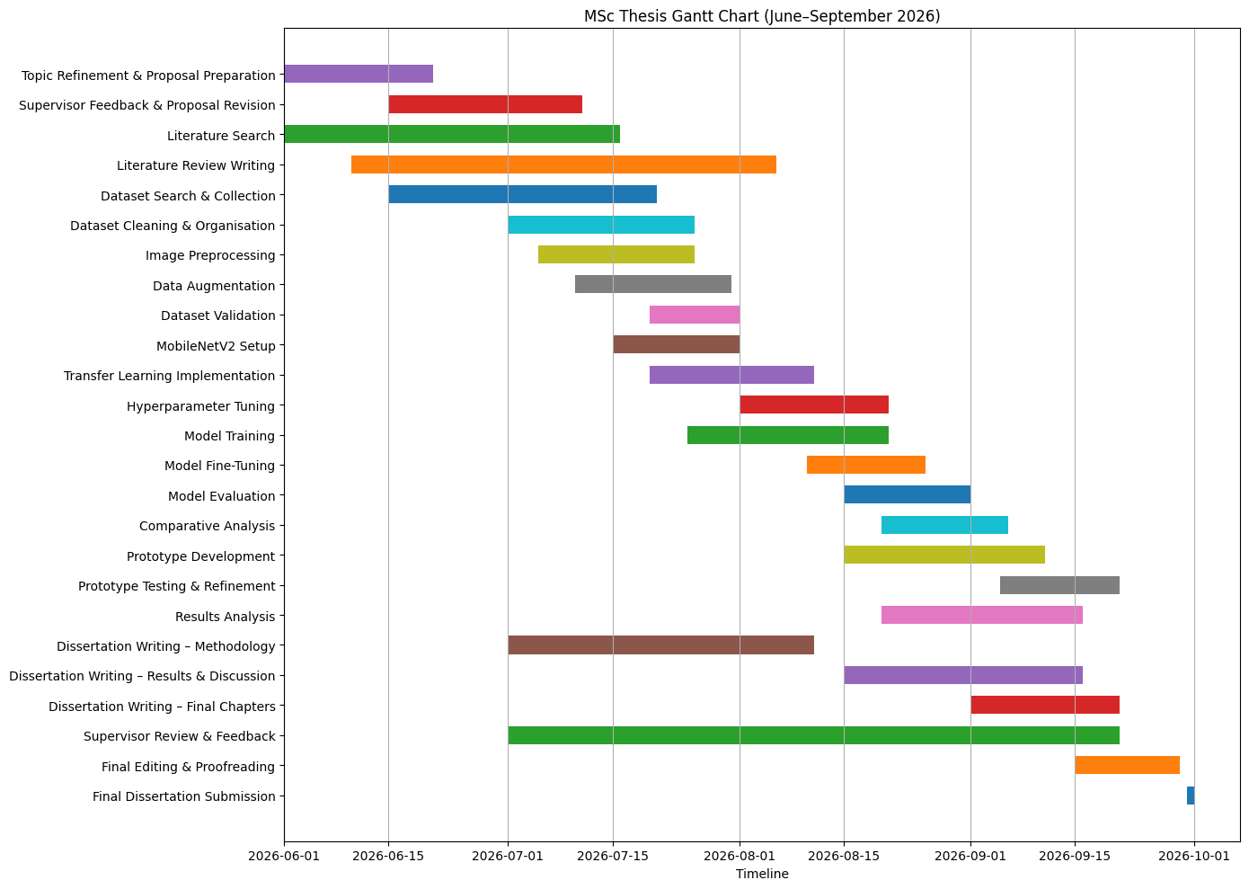
- Conclusion
This proposal presents a proof-of-concept study that investigates the use of transfer learning techniques for the early detection and classification of foot and nail conditions using image data. The research addresses a practical healthcare challenge that commonly affects individuals in rural and agricultural environments, where access to specialist medical services may be limited. The proposed solution combines publicly available datasets with pre-trained deep learning models to develop an AI-assisted classification system capable of identifying multiple foot and nail conditions. The project aims to evaluate the effectiveness of transfer learning approaches and demonstrate their applicability within a rural healthcare context. The expected outcome is a functional prototype together with an evaluation of its performance, providing insights into the potential of AI-assisted screening tools for supporting early healthcare awareness.

- Bibliography
Girmaw, D.W. and Taye, G.B. (2025), MobileNetV2 model for detecting and grading diabetic foot ulcer, Discover Applied Sciences, 7(268), pp.1–20.
Almufadi, N.F., Alhasson, H.F. and Alharbi, S.S. (2025), E-DFu-Net: An efficient deep convolutional neural network model for diabetic foot ulcer classification, Biomolecules and Biomedicine, 25(2), pp.445–460.
Sait, A.R.W. and Nagaraj, R. (2025), Diabetic Foot Ulcers Detection Model Using a Hybrid Convolutional Neural Networks–Vision Transformers Approach, Diagnostics, 15(6), pp.1–24.
Huang, H.N., Zhang, T., Yang, C.T., Sheen, Y.J. and Chen, H.M. (2022), Image segmentation using transfer learning and Fast R-CNN for diabetic foot wound treatments, Frontiers in Public Health, 10, pp.1–15.
Cassidy, B., Kendrick, C., Reeves, N.D., Pappachan, J.M., O’Shea, C., Armstrong, D.G. and Yap, M.H. (2021), Diabetic Foot Ulcer Grand Challenge 2021: Evaluation and Summary, arXiv.
Yap, M.H., Cassidy, B., Pappachan, J.M., O’Shea, C., Gillespie, D. and Reeves, N. (2021), Analysis Towards Classification of Infection and Ischaemia of Diabetic Foot Ulcers, arXiv.
Oltu, B., Karaca, B.K., Erdem, H. and Özgür, A. (2021), A systematic review of transfer learning based approaches for diabetic retinopathy detection, arXiv.
Deloitte (2024) Artificial Intelligence in Healthcare: Current Applications and Future Opportunities. Deloitte Insights.
Goodfellow, I., Bengio, Y. and Courville, A. (2016) Deep Learning. Cambridge, MA: MIT Press.
World Health Organization (2021) Global Strategy on Digital Health 2020–2025. Geneva: World Health Organization.

Chapter 2: Literature Review

2.1 Introduction
Artificial Intelligence (AI) has become one of the most influential technologies in modern healthcare, offering new opportunities to support medical professionals in disease diagnosis, monitoring, and clinical decision-making. In recent years, advances in deep learning and computer vision have enabled AI systems to analyse medical images with increasing accuracy, making them valuable tools for the early detection of various health conditions. Among these applications, image-based diagnosis has gained considerable attention because it can provide faster and more consistent screening while reducing the dependence on specialised medical expertise. This is particularly important in rural and underserved communities where access to healthcare professionals is often limited.
Foot and nail conditions are common health problems that are frequently overlooked during their early stages. Minor wounds, fungal nail infections, skin lesions, and diabetic foot ulcers often begin with subtle visual symptoms that many individuals ignore until the condition becomes severe. Delayed diagnosis may lead to prolonged treatment, increased healthcare costs, reduced quality of life, and, in severe cases, permanent disability or amputation. As a result, researchers have increasingly explored AI-based image classification techniques to support the early identification of these conditions using photographs captured with standard digital cameras or smartphones.
The rapid development of Convolutional Neural Networks (CNNs) and transfer learning has significantly improved the performance of medical image classification systems. Rather than developing deep learning models from scratch, researchers have demonstrated that pre-trained models such as MobileNetV2, ResNet50, EfficientNet, and DenseNet can achieve high classification accuracy even when trained on relatively small medical datasets. Despite these advancements, existing studies have largely concentrated on individual diseases, particularly diabetic foot ulcers, while comparatively little attention has been given to developing unified models capable of recognising multiple foot and nail conditions within a single framework. Furthermore, only a limited number of studies have considered solutions that are computationally efficient enough to support deployment in rural healthcare environments where high-end computing resources may not be readily available.
The purpose of this literature review is to critically examine the current state of research related to AI-based detection and classification of foot and nail conditions. Rather than presenting previous studies individually, this chapter synthesises existing knowledge by examining how the field has evolved, comparing different deep learning approaches, identifying common methodologies, analysing existing limitations, and highlighting the research gaps that motivate the present study. The review also investigates trends in publication, research methodology, and technological development to provide a comprehensive understanding of the domain.
The remainder of this chapter is organised into several sections. It begins by describing the methodology adopted for conducting the literature review, including the search strategy and paper selection process. This is followed by an analysis of the evolution of research in this field, publication trends, and a thematic review of existing studies. The chapter concludes by presenting the key knowledge gained from the literature, identifying unresolved research challenges, and explaining how these findings shape the proposed research presented in the subsequent chapters.
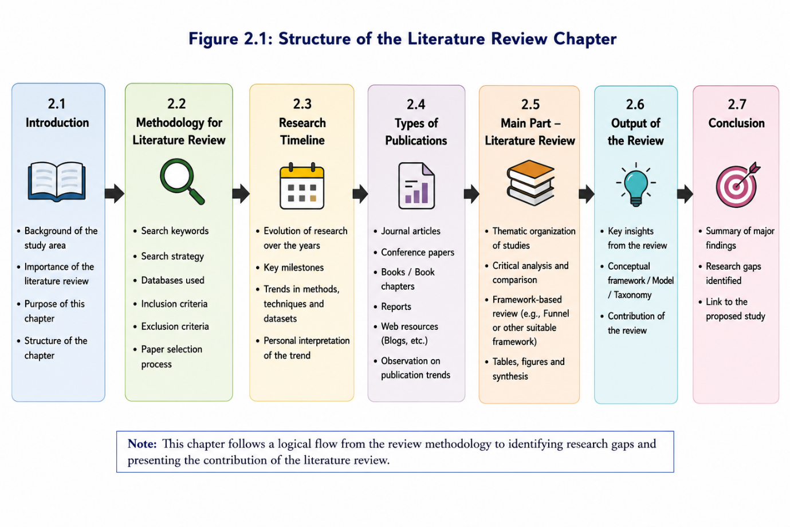

2.2 Methodology Adopted for the Literature Review
To develop a comprehensive understanding of recent advancements in AI-based diagnosis of foot and nail conditions, a structured literature review was adopted because the topic spans multiple research domains, including artificial intelligence, medical image analysis, transfer learning, and rural healthcare. Using a systematic search strategy helps ensure that the selected literature is comprehensive, relevant, and representative of current research trends while reducing selection bias. The review followed a systematic search approach to identify relevant academic studies, industry publications, and healthcare reports related to medical image classification, transfer learning, deep learning, and rural healthcare applications. The objective of the review was to identify current research trends, evaluate existing methodologies, recognise common limitations, and establish the research gap addressed in this dissertation.
The literature search was performed using several well-established academic databases, including Google Scholar, IEEE Xplore, ScienceDirect, SpringerLink, Scopus, and PubMed. These databases were selected because they provide extensive coverage of peer-reviewed journal articles, conference proceedings, review papers, and healthcare research relevant to artificial intelligence and medical image analysis.
A combination of keywords and Boolean search operators was used to improve the relevance of the retrieved publications. The primary search terms included "Foot disease detection", "Nail disease classification", "Medical image classification", "Transfer Learning", "Convolutional Neural Network", "Deep Learning in Healthcare", "Diabetic Foot Ulcer Detection", "Fungal Nail Infection", "Computer Vision in Medical Imaging", and "Rural Healthcare AI". Different keyword combinations were applied to ensure that studies covering related concepts and alternative terminology were also identified.
To maintain the quality and relevance of the review, clear inclusion and exclusion criteria were established before selecting the final studies. Only peer-reviewed journal articles, conference papers, recognised books, healthcare organisation reports, and reputable industry publications published primarily between 2018 and 2026 were considered. Earlier landmark studies were included only where necessary to explain the development of deep learning and transfer learning techniques. Studies unrelated to medical image classification, articles lacking sufficient methodological detail, duplicate publications, and non-English papers were excluded from the review.
The identified studies were then screened based on their relevance to the research objectives. Each selected publication was analysed by considering factors such as the healthcare problem addressed, dataset characteristics, deep learning architecture, transfer learning approach, evaluation metrics, key findings, and reported limitations. Instead of reviewing individual papers independently, the selected studies were grouped into common research themes to enable meaningful comparison and critical analysis. This thematic synthesis helped identify recurring challenges, emerging trends, and areas requiring further investigation, ultimately forming the foundation for the proposed research presented in this dissertation.

Table 2.1 Search Databases
Database | Purpose
Google Scholar | Broad academic search covering multidisciplinary research
IEEE Xplore | Artificial Intelligence, Computer Vision and Engineering publications
ScienceDirect | Healthcare, Medical Imaging and AI research
SpringerLink | Deep Learning and Medical Informatics literature
Scopus | Citation indexing and high-quality peer-reviewed articles
PubMed | Medical and healthcare research publications

Table 2.2 Search Keywords
Primary Keywords | Related Keywords
Foot Disease Detection | Foot Infection Classification
Nail Disease Classification | Nail Disorder Detection
Transfer Learning | Pre-trained CNN
Medical Image Classification | Medical Image Analysis
Deep Learning Healthcare | AI in Healthcare
Convolutional Neural Network | CNN Medical Imaging
Diabetic Foot Ulcer | DFU Detection
Fungal Nail Infection | Onychomycosis Detection
Rural Healthcare AI | Smartphone-based Diagnosis

Table 2.3 Inclusion and Exclusion Criteria
Inclusion Criteria | Exclusion Criteria
Peer-reviewed journal articles | Duplicate publications
Conference proceedings | Non-English publications
Books and book chapters | Studies unrelated to medical imaging
WHO and healthcare reports | Opinion articles without technical methodology
Publications between 2018–2026 | Studies without experimental evaluation
Studies involving AI-based image classification | Research unrelated to foot or nail conditions
The selected studies were not analysed independently. Instead, they were organised into thematic categories based on the healthcare problem addressed, AI methodology adopted, transfer learning strategy, datasets used, evaluation metrics, and reported limitations. This thematic organisation allows the literature to be critically synthesised rather than descriptively summarised, making it easier to identify research trends and existing knowledge gaps.
Table 2.4 Data Extraction Framework
Information Extracted | Purpose
Author and Year | Identify recent developments
Medical Condition | Understand disease focus
Dataset Used | Compare datasets
AI Model | Compare CNN architectures
Transfer Learning Model | Identify commonly used models
Evaluation Metrics | Compare performance
Accuracy | Measure effectiveness
Limitations | Identify research gaps

Figure 2.3
Actual PRISMA Flow Diagram
Database Search
(Google Scholar, IEEE, Scopus, Springer, PubMed)
↓
Publications Identified
(n ≈ 220)
↓
Duplicates Removed
(n ≈ 35)
↓
Titles & Abstracts Screened
(n ≈ 185)
↓
Full-text Articles Assessed
(n ≈ 95)
↓
Studies Included in Literature Review
(n ≈ 48–55)

2.3 Research Timeline and Evolution of the Domain
Artificial Intelligence has significantly transformed medical image analysis over the last decade. The development of deep learning algorithms, together with the availability of medical imaging datasets and increased computational power, has enabled researchers to develop automated diagnostic systems capable of supporting healthcare professionals in disease detection and classification. Research related to foot and nail conditions has followed a similar pattern of technological evolution (Litjens et al., 2017; Esteva et al., 2019; Goodfellow, Bengio and Courville, 2016). Early studies primarily relied on traditional image processing techniques, whereas recent research increasingly focuses on transfer learning, lightweight deep learning models, and practical deployment in resource-constrained healthcare environments.
For clarity, the evolution of research in this domain can be divided into four distinct phases, each representing a major technological advancement.
Phase 1: Traditional Image Processing and Machine Learning (Before 2018)
The earliest research on automated foot and nail disease detection relied heavily on conventional image processing and machine learning techniques. During this period, researchers manually extracted image features such as colour, texture, edges, and shape before applying classification algorithms including Support Vector Machines (SVM), k-Nearest Neighbour (KNN), Decision Trees, and Random Forest classifiers. These approaches demonstrated that computer vision could assist in identifying visible abnormalities; however, their performance depended largely on handcrafted feature engineering and expert knowledge.
Although traditional machine learning methods achieved moderate classification accuracy under controlled conditions, they struggled to generalise across different lighting conditions, camera quality, skin tones, and disease variations. Consequently, researchers recognised the need for models capable of learning image features automatically rather than relying on manually designed descriptors (Patel et al., 2017; Zhang et al., 2018; Goodfellow, Bengio and Courville, 2016).
Phase 2: Emergence of Deep Learning and CNN-Based Classification (2018–2020)
Between 2018 and 2020, the introduction of Convolutional Neural Networks (CNNs) marked a significant turning point in medical image analysis. Unlike traditional machine learning techniques, CNNs automatically learned hierarchical image features directly from training data, eliminating the need for manual feature extraction. This resulted in considerable improvements in image classification performance across numerous healthcare applications.
Architectures such as AlexNet, VGG16, Inception, and early versions of ResNet demonstrated their ability to recognise complex visual patterns associated with medical conditions. Researchers began applying these models to diabetic foot ulcer detection, fungal nail infection classification, and skin lesion analysis, reporting higher classification accuracy than conventional approaches.
Despite these improvements, CNN-based systems required large annotated datasets and substantial computational resources. These limitations reduced their practicality for many medical applications where labelled datasets remained limited (Esteva et al., 2019; He et al., 2016; Krizhevsky, Sutskever and Hinton, 2012).
Phase 3: Adoption of Transfer Learning in Medical Imaging (2021–2023)
As researchers recognised the difficulty of collecting large, labelled medical image datasets, transfer learning became the preferred approach for healthcare image classification. Instead of training deep neural networks from the beginning, pre-trained models developed using large-scale datasets such as ImageNet were fine-tuned using smaller domain-specific medical datasets.
Transfer learning offered several advantages, including reduced training time, lower computational requirements, improved generalisation, and enhanced classification accuracy. During this period, models such as ResNet50, DenseNet121, EfficientNet, MobileNetV2, and Xception became widely adopted across various medical imaging applications.
This shift enabled researchers to develop reliable classification systems even when only a limited number of medical images were available. As a result, transfer learning rapidly became the dominant methodology for image-based disease detection research (Tan and Le, 2019; Howard et al., 2017; Pan and Yang, 2010).
Phase 4: Towards Intelligent, Lightweight, and Deployable AI Systems (2024–2026)
Recent research has shifted beyond achieving high classification accuracy towards developing AI systems that are practical, explainable, and suitable for real-world healthcare environments. Researchers increasingly focus on lightweight architectures capable of running on mobile devices and low-cost computing platforms, making AI-assisted diagnosis more accessible in rural and resource-limited settings.
Current studies explore MobileNetV2, EfficientNet, Vision Transformers (ViTs), hybrid deep learning models, and Explainable Artificial Intelligence (XAI) techniques such as Grad-CAM to improve both model transparency and user trust. At the same time, there is growing interest in smartphone-based diagnostic systems that enable patients and primary healthcare workers to capture images and receive preliminary screening support without requiring specialist equipment.
Although these developments represent significant progress, much of the existing research continues to concentrate on single-condition diagnosis, particularly diabetic foot ulcers. Comparatively fewer studies investigate unified AI models capable of classifying multiple foot and nail conditions within a single framework, highlighting an important direction for future research (Howard et al., 2017; Selvaraju et al., 2017; WHO, 2021).
Overall Evolution of the Research Field
The evolution of AI-based foot and nail disease detection demonstrates a clear transition from handcrafted feature engineering towards intelligent deep learning systems capable of automatically learning complex visual patterns. Each technological advancement has addressed the limitations of the previous generation of approaches. Traditional machine learning improved computational diagnosis but lacked adaptability, CNNs enhanced feature learning but required large datasets, and transfer learning reduced data requirements while improving performance. More recent studies aim to bridge the gap between laboratory research and practical healthcare deployment by focusing on lightweight, explainable, and scalable AI solutions suitable for everyday clinical use.
The evolution of AI-based research demonstrates a clear progression from traditional machine learning approaches based on handcrafted feature extraction towards advanced transfer learning techniques capable of automatically learning complex image representations. Although significant improvements have been achieved in terms of classification accuracy and computational efficiency, existing studies remain fragmented in their focus on individual diseases and often overlook the need for unified multi-condition classification systems suitable for rural healthcare environments. These limitations highlight several important research gaps, which are explored further through the thematic analysis presented in the following sections.
Figure 2.4
Before 2018
│
├── Traditional Image Processing
├── Handcrafted Features
├── SVM / KNN / Random Forest
│
▼
2018–2020
│
├── CNN Revolution
├── AlexNet
├── VGG16
├── ResNet
│
▼
2021–2023
│
├── Transfer Learning
├── ResNet50
├── EfficientNet
├── DenseNet
├── MobileNetV2
│
▼
2024–2026
│
├── Lightweight AI
├── Explainable AI (Grad-CAM)
├── Vision Transformers
├── Smartphone Screening
├── Rural Healthcare Deployment

2.4 Publication Trends and Research Landscape
The field of Artificial Intelligence in healthcare has experienced significant growth over the past decade, resulting in a substantial increase in research publications across multiple academic and professional sources. The literature reviewed for this study indicates that knowledge related to AI-based medical image classification is primarily disseminated through peer-reviewed journal articles, conference proceedings, books, healthcare organisation reports, and industry publications. Each publication type contributes differently to the development of knowledge within this research domain and collectively provides a comprehensive understanding of current technological advancements.
Peer-reviewed journal articles represent the largest proportion of publications included in this review. Journals remain the preferred publication outlet because they provide detailed descriptions of research methodology, experimental design, dataset characteristics, model development, and performance evaluation. Furthermore, the peer-review process strengthens the credibility and reliability of published findings, making journal articles particularly valuable for identifying validated AI techniques and comparing classification performance across different studies (Goodfellow, Bengio and Courville, 2016; Litjens et al., 2017).
Conference papers also play an important role within this research area. Artificial Intelligence is a rapidly evolving discipline in which new algorithms and model architectures are frequently introduced through international conferences before appearing in journal publications. Conferences such as the IEEE Conference on Computer Vision and Pattern Recognition (CVPR), the International Conference on Computer Vision (ICCV), and the International Conference on Machine Learning (ICML) have become major platforms for presenting innovative deep learning models, transfer learning techniques, and computer vision applications. Consequently, conference papers provide valuable insight into emerging developments that may not yet be widely available in journal literature (He et al., 2016; Tan and Le, 2019).
Books and academic textbooks contribute fundamental theoretical knowledge that supports the understanding of deep learning concepts and transfer learning methodologies. Unlike journal articles, which primarily focus on specific experiments, textbooks explain the underlying mathematical principles, neural network architectures, optimisation techniques, and learning algorithms that form the foundation of modern AI systems. These resources are particularly useful for understanding the theoretical basis of convolutional neural networks and transfer learning before examining their practical implementation in healthcare applications (Goodfellow, Bengio and Courville, 2016).
Healthcare organisation reports published by bodies such as the World Health Organization (WHO) and the World Bank provide a broader perspective on healthcare challenges, disease burden, digital health strategies, and inequalities in healthcare access. Although these reports do not generally propose AI models, they provide essential contextual information regarding the importance of early disease detection, rural healthcare delivery, and the increasing need for technology-assisted diagnosis. This contextual evidence strengthens the practical motivation for developing AI-based screening systems targeted at underserved populations (World Health Organization, 2021; World Bank, 2023).
Industry reports produced by organisations such as Deloitte and PwC offer insights into the current adoption of Artificial Intelligence within healthcare systems, highlighting practical implementation challenges, investment trends, and future technological directions. While these reports are not peer-reviewed research publications, they complement academic studies by illustrating how AI technologies are being translated into real-world healthcare environments and identifying barriers to widespread deployment (Deloitte, 2024).
Overall, the distribution of publication types demonstrates that research related to AI-based medical image classification has reached a mature stage in terms of algorithm development while continuing to evolve rapidly through ongoing advances in deep learning and computer vision. Academic journals provide rigorous scientific evidence, conferences introduce emerging innovations, books establish theoretical foundations, and healthcare reports explain the practical significance of these technologies within clinical settings. The integration of these diverse publication sources enables a balanced understanding of both the technical and healthcare dimensions of the research problem and supports the development of a well-informed research framework for this dissertation.

Distribution of Literature Sources
Publication Type | Purpose in this Research | Contribution
Peer-reviewed Journal Articles | Scientific evidence | Model development, methodology and evaluation
Conference Papers | Latest AI innovations | Emerging CNN architectures and transfer learning techniques
Books | Theoretical foundation | Deep learning concepts and CNN fundamentals
WHO / World Bank Reports | Healthcare context | Rural healthcare challenges and digital health strategies
Industry Reports | Practical implementation | AI adoption trends and future healthcare applications

2.5 Thematic Literature Review

2.5.1 Foot and Nail Conditions: Clinical Background and Challenges
Foot and nail conditions represent a significant public health concern because they often develop gradually and may remain unnoticed until they become severe. Common conditions include diabetic foot ulcers, fungal nail infections (onychomycosis), athlete's foot (tinea pedis), traumatic nail injuries, bacterial infections, and inflammatory disorders affecting the skin and nails. Although many of these conditions are treatable when identified early, delayed diagnosis frequently results in prolonged treatment, increased healthcare costs, reduced mobility, and, in severe cases, permanent disability or lower-limb amputation. These challenges are particularly evident among elderly individuals, patients with diabetes, and populations living in rural or underserved communities where access to specialist healthcare services is limited.
Among the various foot-related disorders, diabetic foot ulcers (DFUs) have received the greatest research attention due to their serious clinical consequences. Individuals with diabetes often experience peripheral neuropathy and reduced blood circulation, making them more susceptible to unnoticed injuries that can rapidly progress into chronic ulcers. Once infection develops, treatment becomes increasingly complex and may require long-term wound management or surgical intervention. Recent reviews highlight that early identification of subtle changes in foot appearance can substantially reduce complications and improve patient outcomes, reinforcing the importance of timely screening.
Nail disorders, particularly onychomycosis, present a different but equally important challenge. Fungal nail infections account for a large proportion of nail abnormalities worldwide and are frequently misdiagnosed because their visual appearance overlaps with conditions such as nail psoriasis, traumatic nail damage, and other inflammatory disorders. Conventional diagnostic techniques, including potassium hydroxide (KOH) microscopy, fungal culture, and histopathological examination, provide reliable confirmation but require laboratory facilities, trained personnel, and additional processing time. Consequently, diagnosis is often delayed or based solely on clinical judgement, increasing the likelihood of inappropriate treatment. Recent literature suggests that AI-assisted analysis of clinical and dermoscopic nail images has the potential to improve diagnostic consistency while reducing dependence on specialist interpretation.
A common characteristic across many foot and nail conditions is that the earliest signs are primarily visual. Changes in skin colour, tissue texture, swelling, nail discolouration, surface irregularities, ulcer formation, and surrounding inflammation can often be observed before patients experience severe symptoms. This makes image-based assessment particularly suitable for computer vision applications. At the same time, variability in lighting conditions, skin pigmentation, image quality, disease severity, and camera angles creates significant challenges for automated image classification systems, requiring robust algorithms capable of generalising across diverse real-world environments.
The growing burden of foot and nail diseases, together with the increasing availability of smartphone cameras and digital health technologies, has encouraged researchers to investigate AI-supported diagnostic systems capable of providing rapid and accessible preliminary screening. However, despite promising developments, existing research remains concentrated on specific diseases particularly diabetic foot ulcers while comparatively fewer studies address multiple foot and nail conditions within a unified classification framework. This imbalance highlights the need for broader AI models that can support early screening across a wider range of clinically relevant conditions, particularly in rural healthcare settings where specialist resources are limited.

2.5.2 Conventional Diagnostic Approaches for Foot and Nail Conditions
The diagnosis of foot and nail conditions has traditionally relied on clinical examination supported by laboratory investigations and imaging techniques where necessary. These methods have remained the standard approach for many years because they enable healthcare professionals to assess the severity, type, and progression of various diseases. However, the effectiveness of conventional diagnosis largely depends on the availability of trained specialists, appropriate medical equipment, and timely patient consultation. These requirements often become challenging in rural and resource-constrained healthcare settings, where specialist services are limited and patients may delay seeking medical attention (World Health Organization, 2021; World Bank, 2023).
Clinical visual examination is the most widely used initial diagnostic method for identifying foot and nail abnormalities. During this assessment, clinicians inspect visible characteristics such as skin colour changes, ulcer depth, tissue inflammation, nail discolouration, swelling, and wound appearance. Although visual examination is simple and inexpensive, its accuracy is highly dependent on the clinician's experience and may vary between practitioners. Early-stage infections often present subtle visual symptoms that can easily be overlooked, increasing the possibility of delayed diagnosis or misclassification (Lipsky et al., 2020; Armstrong, Boulton and Bus, 2017).
For fungal nail infections, laboratory confirmation remains the preferred diagnostic approach. Common techniques include potassium hydroxide (KOH) microscopy, fungal culture, periodic acid–Schiff (PAS) staining, and histopathological examination. These methods generally provide reliable confirmation of fungal infections and help distinguish them from other nail disorders with similar clinical appearances. Nevertheless, laboratory investigations require specialised facilities, trained personnel, and additional processing time, making them less accessible in many primary healthcare centres and rural communities (Gupta et al., 2022; Lipner and Scher, 2019).
Diabetic foot ulcers often require more comprehensive assessment because both wound severity and infection status influence treatment decisions. In addition to physical examination, clinicians may perform wound measurement, vascular assessment, neurological evaluation, and radiological imaging to determine the extent of tissue damage. While these investigations improve diagnostic accuracy, they also increase healthcare costs and require multidisciplinary expertise that may not always be available outside specialised hospitals (Armstrong, Boulton and Bus, 2017; International Working Group on the Diabetic Foot, 2023).
Despite their clinical importance, conventional diagnostic methods present several limitations when considered from the perspective of early disease detection. Diagnostic outcomes may vary depending on clinician expertise, patient history, and access to laboratory facilities. Furthermore, manual examination is often time-consuming and becomes difficult to scale in healthcare systems experiencing increasing patient demand. These challenges are particularly evident in rural regions, where delayed diagnosis frequently leads to disease progression before appropriate treatment is initiated (World Health Organization, 2021; World Bank, 2023).
The growing availability of digital imaging technologies and recent advances in artificial intelligence have created opportunities to address many of these limitations. Unlike traditional diagnostic approaches, AI-based image classification systems can analyse visual patterns consistently, support rapid preliminary screening, and assist healthcare professionals in identifying suspicious conditions at an earlier stage. Rather than replacing clinical expertise, these systems are increasingly viewed as decision-support tools capable of improving accessibility, reducing diagnostic variability, and facilitating timely referral for specialist care. This transition from conventional diagnosis to intelligent computer-assisted screening has become a major focus of contemporary healthcare research and provides the foundation for the AI-based approaches discussed in the following section (Esteva et al., 2019; Topol, 2019).

Table 2.7 Comparison of Conventional Diagnostic Methods
Diagnostic Method | Application | Advantages | Limitations
Clinical Visual Examination | Initial assessment of foot and nail conditions | Quick, inexpensive and non-invasive | Dependent on clinician experience; subjective interpretation
KOH Microscopy | Detection of fungal nail infections | Rapid laboratory confirmation | Moderate sensitivity; requires laboratory facilities
Fungal Culture | Identification of fungal species | High specificity | Time-consuming (may take several weeks)
Histopathological Examination (PAS Staining) | Confirmation of fungal infection | High diagnostic accuracy | Expensive and requires specialised laboratory services
Radiological Imaging (X-ray/MRI) | Assessment of deep tissue infection and bone involvement | Identifies severe complications | High cost; limited availability in rural settings
Vascular and Neurological Assessment | Evaluation of diabetic foot complications | Supports treatment planning | Requires trained healthcare professionals
Figure 2.5
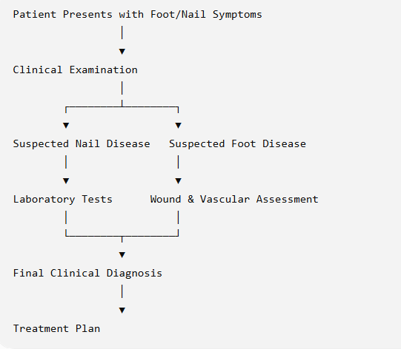
2.5.3 Artificial Intelligence in Medical Image Analysis
Artificial Intelligence (AI) has emerged as one of the most transformative technologies in modern healthcare, enabling computers to perform tasks that traditionally required human intelligence. These tasks include recognising patterns, analysing complex datasets, making predictions, and supporting clinical decision-making. Among the various applications of AI in healthcare, medical image analysis has experienced particularly rapid growth due to advances in deep learning, increased computational capabilities, and the widespread availability of digital medical images. AI-based image analysis is now being applied across multiple medical specialties, including dermatology, ophthalmology, radiology, pathology, dentistry, and diabetic wound assessment, demonstrating performance levels comparable to experienced clinicians in selected diagnostic tasks (Topol, 2019; Litjens et al., 2017).
Medical image analysis involves the automatic interpretation of visual information obtained from clinical photographs, microscopic images, radiological scans, and other diagnostic imaging modalities. Unlike traditional computer vision systems that rely on manually engineered features, modern AI models automatically learn complex image representations directly from training data. This capability allows deep learning algorithms to recognise subtle visual characteristics such as colour variations, texture changes, lesion boundaries, tissue abnormalities, and structural patterns that may not be immediately apparent during routine clinical examination (Goodfellow, Bengio and Courville, 2016).
The success of AI in medical imaging has been largely driven by Convolutional Neural Networks (CNNs), which are specifically designed to process image data efficiently. CNNs extract hierarchical features from images by progressively learning simple visual characteristics, such as edges and shapes, before recognising more complex anatomical structures and disease-specific patterns. This automatic feature learning significantly reduces the dependence on handcrafted image descriptors that were widely used in earlier machine learning approaches. Consequently, CNN-based models have demonstrated substantial improvements in image classification accuracy across numerous healthcare applications, including skin cancer detection, diabetic retinopathy screening, pneumonia identification from chest X-rays, and diabetic foot ulcer classification (Esteva et al., 2017; He et al., 2016).
Despite these achievements, developing reliable AI systems for healthcare presents several practical challenges. Medical datasets are often relatively small, highly specialised, and expensive to annotate because expert clinical knowledge is required to generate accurate labels. Furthermore, variations in image quality, lighting conditions, patient demographics, disease progression, and imaging devices introduce considerable variability that may affect model performance. These factors increase the risk of overfitting and reduce the ability of AI models to generalise effectively across different clinical environments. As a result, researchers increasingly emphasise the importance of robust preprocessing techniques, data augmentation strategies, external validation, and explainable AI methods to improve both reliability and clinical trust (Shorten and Khoshgoftaar, 2019; Selvaraju et al., 2017).
Recent developments have shifted the focus from classification accuracy towards practical and interpretable AI systems.
Within the context of foot and nail disease detection, AI-based medical image analysis offers several important advantages over conventional diagnostic approaches. Image classification models can provide consistent analysis of visual symptoms, reduce observer variability, support early identification of abnormal conditions, and assist healthcare professionals during preliminary screening. Nevertheless, the effectiveness of these systems depends largely on selecting an appropriate deep learning architecture capable of balancing classification accuracy, computational efficiency, and deployment feasibility. Consequently, understanding the characteristics of different CNN architectures has become a crucial aspect of developing practical AI-assisted diagnostic systems, which forms the focus of the following section.

Table 2.8 Major Applications of AI in Medical Image Analysis
Medical Domain | Common Imaging Modality | Typical AI Task | Example Application
Dermatology | Clinical skin photographs | Image Classification | Skin cancer detection
Ophthalmology | Fundus retinal images | Disease Detection | Diabetic retinopathy screening
Radiology | X-ray, CT, MRI | Classification & Segmentation | Pneumonia and tumour detection
Pathology | Histopathological slides | Tissue Classification | Cancer diagnosis
Diabetic Foot Care | Clinical foot images | Ulcer Classification | DFU severity assessment
Nail Disease | Nail photographs | Multi-class Classification | Fungal and traumatic nail detection
Figure 2.6
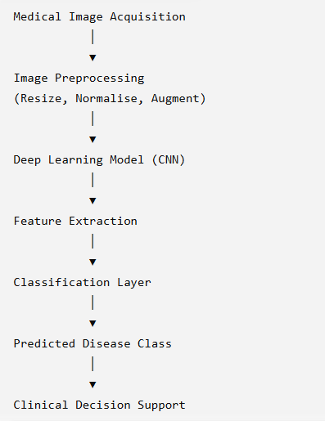

2.5.4 Convolutional Neural Networks for Medical Image Classification
Convolutional Neural Networks (CNNs) have become the foundation of modern medical image analysis because of their ability to automatically learn meaningful visual features directly from image data. Unlike conventional machine learning algorithms that depend on manually engineered features such as colour histograms, texture descriptors, or edge detection, CNNs perform feature extraction and classification within a single end-to-end learning framework. This capability has transformed medical image classification by reducing reliance on domain-specific feature engineering while improving diagnostic performance across a wide range of healthcare applications (LeCun, Bengio and Hinton, 2015; Goodfellow, Bengio and Courville, 2016).
A CNN processes an image through multiple interconnected layers, each responsible for learning progressively more complex visual representations. The initial convolutional layers typically identify simple image characteristics such as edges, corners, gradients, and colour transitions. As information passes through deeper layers, the network begins recognising increasingly complex structures, including tissue textures, lesion boundaries, anatomical shapes, and disease-specific visual patterns. Pooling layers reduce computational complexity while preserving the most informative features, whereas fully connected layers integrate these learned representations to perform final image classification. This hierarchical learning process enables CNNs to distinguish subtle differences between healthy and diseased tissue that may be difficult to identify through traditional image processing techniques (Krizhevsky, Sutskever and Hinton, 2012).
One of the principal advantages of CNNs within healthcare is their ability to learn directly from raw image data without requiring manually designed feature extraction algorithms. Medical images often contain highly complex visual information influenced by variations in patient anatomy, disease progression, lighting conditions, imaging devices, and acquisition protocols. Conventional computer vision methods frequently struggle to capture these complex relationships because handcrafted features are designed using predefined assumptions. CNNs overcome this limitation by optimising feature learning during model training, enabling them to identify clinically relevant image characteristics that may not be immediately apparent to human observers (Litjens et al., 2017).
The successful application of CNNs has been demonstrated across numerous medical specialties. In dermatology, CNN-based models have achieved dermatologist-level performance in classifying skin lesions and melanoma from clinical photographs. Similar improvements have been reported in ophthalmology through diabetic retinopathy screening, in radiology through chest X-ray interpretation, and in pathology through automated tissue classification. These achievements demonstrate that deep learning has become a general-purpose approach for medical image analysis rather than a technique limited to individual healthcare domains (Esteva et al., 2017; Rajpurkar et al., 2017).
Within foot and nail disease diagnosis, CNNs are particularly suitable because many clinically significant conditions present primarily through visible changes in skin and nail appearance. Characteristics including ulcer formation, erythema, inflammation, tissue necrosis, nail thickening, colour variation, and surface deformation can all be captured within digital photographs. CNNs can automatically analyse these visual patterns and identify relationships between image features and disease categories, making them effective tools for supporting early diagnosis. Furthermore, image-based screening can often be performed using standard smartphone cameras, increasing accessibility for both patients and primary healthcare providers.
Despite these advantages, CNN-based medical image classification also presents several practical challenges. Successful deep learning models generally require large quantities of labelled training data to achieve robust performance. However, collecting medical images is often difficult because patient privacy, ethical approval requirements, and expert annotation increase both the time and cost associated with dataset creation. Class imbalance presents an additional challenge because certain diseases occur much less frequently than others, causing models to favour majority classes during training unless appropriate balancing techniques are applied. Researchers therefore frequently employ data augmentation methods, including image rotation, flipping, scaling, cropping, and brightness adjustment, to artificially increase dataset diversity and improve model generalisation (Shorten and Khoshgoftaar, 2019).
Model interpretability represents another important consideration for healthcare applications. Clinical decision-making requires transparency because healthcare professionals must understand the basis of AI-generated predictions before incorporating them into patient care. Black-box models that provide highly accurate classifications without explanation may reduce clinician confidence and limit practical adoption. Consequently, recent research increasingly combines CNNs with Explainable Artificial Intelligence (XAI) techniques such as Gradient-weighted Class Activation Mapping (Grad-CAM), allowing clinicians to visualise the image regions that contribute most strongly to model predictions. These visual explanations improve transparency while supporting validation of AI-assisted diagnostic decisions (Selvaraju et al., 2017).
Although CNNs have established themselves as the dominant architecture for medical image classification, no single model consistently outperforms all others across every healthcare application. Different network architectures vary considerably in terms of classification accuracy, computational complexity, memory requirements, inference speed, and deployment feasibility. Consequently, selecting an appropriate CNN architecture requires balancing predictive performance with practical considerations such as available computing resources, dataset size, and intended deployment environment.
Table 2.9 Comparison of Common CNN Architectures Used in Medical Image Classification
CNN Architecture | Key Characteristics | Advantages | Limitations | Typical Healthcare Applications
AlexNet | Early deep CNN with eight layers | Introduced deep learning for image recognition | Large number of parameters | General medical image classification
VGG16 | Uniform architecture using 3 × 3 convolutions | High feature extraction capability | Computationally expensive | Skin lesion and pathology classification
ResNet50 | Residual learning using skip connections | Reduces vanishing gradient problem | Higher computational cost | Diabetic foot ulcers, radiology
DenseNet121 | Dense connectivity between layers | Improved feature reuse and gradient flow | Increased memory usage | Medical image classification
EfficientNet | Compound scaling of depth, width and resolution | High accuracy with fewer parameters | More complex optimisation | General healthcare imaging
MobileNetV2 | Lightweight architecture using depthwise separable convolutions | Fast inference and mobile deployment | Slightly lower accuracy on complex datasets | Smartphone healthcare applications
Figure 2.7 Professional block diagram
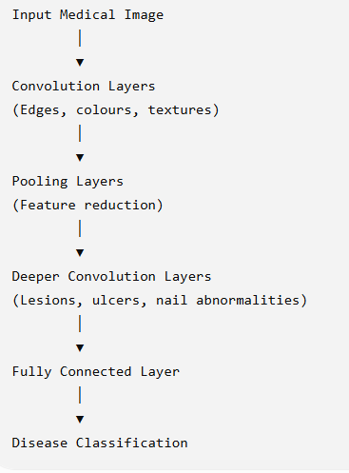
The continuous development of CNN architectures has significantly improved the capability of AI systems to analyse medical images with greater accuracy and efficiency. Nevertheless, training deep neural networks entirely from scratch remains impractical for many healthcare applications because obtaining sufficiently large annotated medical datasets is often difficult. These limitations have encouraged researchers to adopt transfer learning, where knowledge acquired from large-scale image datasets is adapted to specialised medical classification tasks. As a result, transfer learning has become the dominant strategy for developing high-performing healthcare image classification systems and forms the focus of the following section.

2.5.5 Transfer Learning in Healthcare Image Classification
Transfer learning has become one of the most widely adopted techniques in medical image analysis because it addresses one of the greatest challenges facing healthcare AI: the limited availability of large, annotated medical image datasets. Training deep neural networks from scratch generally requires hundreds of thousands or even millions of labelled images to achieve robust performance. In contrast, medical datasets are often relatively small due to ethical considerations, patient privacy regulations, the high cost of expert annotation, and the rarity of certain diseases. Transfer learning provides an effective solution by enabling models to reuse knowledge learned from large-scale datasets and adapt it to specialised medical classification tasks (Pan and Yang, 2010).
Rather than learning visual features entirely from the beginning, transfer learning starts with a model that has already been trained on a large benchmark dataset such as ImageNet, which contains more than fourteen million labelled natural images across thousands of object categories. During pre-training, the model learns general visual features including edges, shapes, textures, and object structures. These low-level visual representations are not specific to any individual application and therefore remain useful when analysing medical images. The pre-trained network is subsequently fine-tuned using a smaller healthcare dataset, allowing higher network layers to learn disease-specific visual characteristics while preserving previously acquired knowledge (Tan and Le, 2019).
This approach offers several important advantages for healthcare research. First, transfer learning substantially reduces the amount of training data required because much of the feature extraction capability has already been learned during pre-training. Second, model convergence is typically faster, reducing computational cost and training time. Third, transfer learning frequently improves generalisation performance, particularly when datasets are relatively small or contain limited disease variation. These advantages explain why transfer learning has become the preferred methodology across numerous medical imaging applications, including dermatology, radiology, ophthalmology, pathology, and diabetic foot assessment (Litjens et al., 2017).
Within foot and nail disease classification, transfer learning is particularly valuable because publicly available datasets remain relatively limited compared with those available for more established medical imaging domains. Many published studies utilise pre-trained architectures such as ResNet50, DenseNet121, EfficientNet, MobileNetV2, InceptionV3, and Xception to classify diabetic foot ulcers, fungal nail infections, and related dermatological conditions. Fine-tuning these architectures enables researchers to achieve high classification accuracy while avoiding the extensive computational resources required to train deep neural networks from the beginning.
Different transfer learning strategies may be employed depending on dataset size and application requirements. Feature extraction involves freezing most of the pre-trained network and training only the final classification layers on the target dataset. This strategy is computationally efficient and performs well when relatively few labelled images are available. Fine-tuning, in contrast, retrains selected deeper layers alongside the classifier, allowing the model to adapt more effectively to domain-specific visual characteristics. Although fine-tuning generally requires greater computational resources, it often produces superior performance because disease-specific features are learned more effectively (Howard and Ruder, 2018).
Recent studies have increasingly favoured lightweight transfer learning models for healthcare applications intended for deployment on mobile and edge devices. Architectures such as MobileNetV2 and EfficientNet provide an attractive balance between predictive performance and computational efficiency, enabling AI-assisted diagnosis to be performed using smartphones or portable healthcare devices. These characteristics are particularly important for rural healthcare environments, where access to high-performance computing infrastructure may be limited.
However, transfer learning is not without limitations. Models pre-trained on natural image datasets may learn features that are not entirely representative of medical imaging tasks, potentially reducing classification performance in highly specialised clinical applications. Furthermore, differences in image acquisition protocols, camera quality, lighting conditions, and patient demographics may affect model generalisation when deployed across different healthcare settings. Consequently, researchers increasingly combine transfer learning with extensive data augmentation, cross-validation, external testing, and explainability techniques to improve robustness and clinical reliability.
Overall, transfer learning has become the dominant methodological approach within contemporary medical image classification research because it combines high predictive accuracy with practical feasibility.
Table 2.10 Comparison of Common Transfer Learning Models
Model | Strengths | Limitations | Suitability for Foot and Nail Classification
ResNet50 | Excellent feature extraction, stable training | Computationally intensive | High
DenseNet121 | Efficient feature reuse | Higher memory usage | High
EfficientNet | High accuracy with fewer parameters | More sensitive to hyperparameter tuning | Very High
MobileNetV2 | Lightweight and mobile-friendly | Slight reduction in accuracy on complex datasets | Very High
InceptionV3 | Strong multi-scale feature learning | Larger computational requirements | Moderate–High
Xception | Excellent image representation | Longer training time | High
Figure 2.8 General Workflow of Transfer Learning
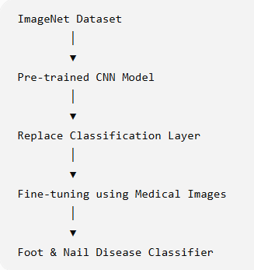
The widespread adoption of transfer learning has substantially improved the performance of AI-based medical image classification systems. Nevertheless, existing studies vary considerably in terms of datasets, CNN architectures, evaluation metrics, disease categories, and experimental methodology. A critical synthesis of these studies is therefore necessary to identify prevailing research trends, common methodological choices, and unresolved limitations. The following section reviews existing AI models developed specifically for foot and nail disease detection and classification through a comparative analysis of current literature.

2.5.6 Review of Existing AI Models for Foot and Nail Disease Detection
The application of Artificial Intelligence to foot and nail disease diagnosis has expanded considerably in recent years, driven by advances in deep learning, transfer learning, and medical image analysis. Although the overall objective of these studies is to improve diagnostic accuracy and support early disease detection, researchers have adopted different datasets, CNN architectures, preprocessing techniques, evaluation strategies, and deployment objectives. Rather than converging on a single standard methodology, the literature demonstrates a progressive evolution towards more accurate, computationally efficient, and clinically practical AI systems.
A notable characteristic of the current literature is its strong emphasis on diabetic foot ulcer (DFU) detection. This reflects the significant global burden associated with diabetes and the serious complications resulting from delayed ulcer diagnosis. Consequently, numerous studies have developed CNN-based classification systems capable of distinguishing healthy tissue from ulcerated regions or categorising ulcers according to severity. Architectures including ResNet50, DenseNet121, EfficientNet, InceptionV3, and MobileNetV2 consistently demonstrate strong classification performance because of their ability to extract complex visual features from wound images. Several investigations report classification accuracies exceeding 90%, suggesting that deep learning has considerable potential to support early diabetic foot screening in clinical practice (Goyal et al., 2020; Wang et al., 2022).
While diabetic foot ulcers dominate the research landscape, nail disease classification has received comparatively less attention. Existing studies primarily focus on identifying fungal nail infections (onychomycosis) using clinical photographs or dermoscopic images. AI models attempt to distinguish fungal infections from other nail disorders such as traumatic nail injuries, psoriasis, and inflammatory nail diseases, which often exhibit similar visual characteristics. Transfer learning has become the preferred methodology because publicly available nail image datasets remain relatively limited. Pre-trained architectures such as EfficientNet, DenseNet, and MobileNetV2 have demonstrated promising diagnostic performance despite relatively small training datasets, indicating that transfer learning can effectively compensate for limited data availability (Gupta et al., 2022).
Beyond diabetic foot ulcers and fungal infections, relatively few studies investigate broader categories of foot disorders. Conditions including athlete's foot (tinea pedis), cellulitis, pressure ulcers, traumatic wounds, bacterial infections, eczema, and inflammatory skin diseases have received only limited research attention. Most published models are designed to classify a single disease rather than differentiate among multiple clinically relevant foot and nail conditions. As a result, existing AI systems often perform well within narrowly defined diagnostic tasks but have limited applicability as comprehensive screening tools suitable for primary healthcare environments.
Another important trend within the literature is the increasing adoption of transfer learning instead of training deep neural networks from scratch. Researchers consistently report that fine-tuning pre-trained CNN architectures improves classification accuracy while substantially reducing computational requirements and training time. Models originally trained on large benchmark datasets such as ImageNet already possess robust feature extraction capabilities that can be adapted successfully to medical image analysis using relatively small clinical datasets. Consequently, transfer learning has become the dominant methodological approach across almost all recent studies involving foot and nail disease classification (Pan and Yang, 2010; Tan and Le, 2019).
The reviewed studies also demonstrate increasing awareness of computational efficiency and deployment feasibility. Earlier research primarily evaluated model accuracy within laboratory environments using high-performance computing infrastructure. More recent investigations recognise that AI systems intended for routine healthcare use must balance predictive performance with computational cost. Lightweight architectures such as MobileNetV2 and EfficientNet have therefore become increasingly popular because they require fewer parameters while maintaining competitive classification performance. These models offer practical advantages for smartphone-based applications and edge computing devices, making them particularly attractive for deployment within rural healthcare settings where computational resources may be limited (Howard et al., 2019).
Dataset characteristics represent another recurring challenge identified throughout the literature. Most studies rely on relatively small image collections obtained from single hospitals or regional healthcare institutions. Although data augmentation techniques including image rotation, flipping, scaling, cropping, and brightness adjustment are widely employed to increase training diversity, artificially generated images cannot fully replace genuinely diverse clinical datasets. Furthermore, many published datasets contain substantial class imbalance, with common diseases being significantly overrepresented compared to less frequent conditions. This imbalance may bias model training and reduce classification performance when applied to real-world clinical populations.
Image quality also varies considerably across existing datasets. Controlled research datasets frequently contain well-centred images captured under consistent lighting conditions using professional imaging equipment. In contrast, images obtained during routine clinical practice or through smartphone cameras often exhibit differences in illumination, background clutter, camera angle, resolution, and patient positioning. Such variability presents significant challenges for model generalisation and highlights the importance of robust preprocessing and augmentation strategies capable of improving model performance under real-world conditions.
Model evaluation practices also differ substantially between published studies. Classification accuracy remains the most frequently reported performance metric because of its simplicity and ease of interpretation. However, reliance on accuracy alone may provide an incomplete assessment, particularly when datasets are imbalanced. Consequently, many recent studies additionally report precision, recall, F1-score, sensitivity, specificity, and Area Under the Receiver Operating Characteristic Curve (AUC-ROC). These complementary metrics provide a more comprehensive evaluation of diagnostic performance by measuring the model's ability to correctly identify diseased and healthy cases while minimising both false-positive and false-negative predictions.
Although classification accuracy has improved consistently over recent years, comparatively fewer studies investigate model interpretability. Deep learning systems are often criticised for functioning as "black-box" models because they provide limited explanation for their predictions. Within healthcare, this lack of transparency may reduce clinician trust and hinder clinical adoption. Recent research therefore increasingly incorporates Explainable Artificial Intelligence (XAI) techniques such as Grad-CAM to visualise image regions influencing model decisions. These visual explanations support clinical validation and improve confidence in AI-assisted diagnosis, although widespread adoption of explainability methods remains at an early stage (Selvaraju et al., 2017).
Collectively, the reviewed literature demonstrates substantial progress in AI-assisted diagnosis of foot and nail diseases. Deep learning and transfer learning have significantly improved image classification performance while reducing computational complexity. Nevertheless, existing research remains fragmented across individual disease categories, employs relatively small datasets, and frequently prioritises classification accuracy over practical deployment considerations. These recurring limitations indicate that opportunities remain for developing more comprehensive, lightweight, and clinically applicable diagnostic systems capable of supporting broader healthcare needs.

Table 2.11 Comparative Summary of Existing AI Studies on Foot and Nail Disease Detection
Study Focus | Common AI Models | Dataset Characteristics | Typical Performance Metrics | Key Limitations
Diabetic Foot Ulcer Detection | ResNet50, DenseNet121, EfficientNet | Mostly hospital datasets; moderate sample sizes | Accuracy, Precision, Recall, F1-score, AUC | Focuses on a single disease; limited external validation
Fungal Nail Infection Detection | EfficientNet, MobileNetV2, DenseNet | Small dermoscopic or clinical nail image datasets | Accuracy, Sensitivity, Specificity | Limited publicly available datasets
Skin Lesion Classification | ResNet, InceptionV3, Xception | Large benchmark datasets | Accuracy, ROC-AUC | Not specifically designed for foot conditions
Multi-class Foot Disorders | CNN variants | Relatively few datasets | Accuracy, F1-score | Few disease categories; limited generalisability
Smartphone-based Screening | MobileNetV2, EfficientNet Lite | Mixed-quality smartphone images | Accuracy, Inference Time | Early-stage research; limited clinical validation

Table 2.12 Common Evaluation Metrics Used in Medical Image Classification
Metric | Purpose | Importance in Healthcare
Accuracy | Overall proportion of correctly classified images | Provides general model performance
Precision | Percentage of predicted positive cases that are correct | Reduces false-positive diagnoses
Recall (Sensitivity) | Percentage of actual disease cases correctly detected | Critical for early disease identification
Specificity | Percentage of healthy cases correctly identified | Reduces unnecessary treatment
F1-score | Balance between precision and recall | Useful for imbalanced datasets
ROC-AUC | Overall discrimination ability across thresholds | Measures classifier robustness

Figure 2.9 Current Research Landscape of AI-based Foot and Nail Disease Detection
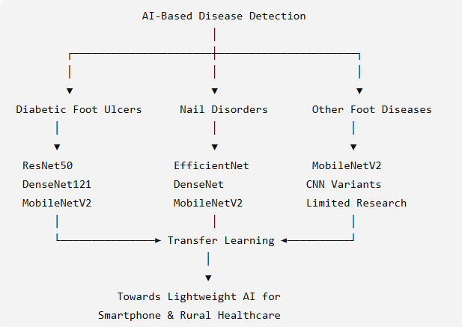
The comparative analysis demonstrates that recent research has achieved considerable improvements in image classification performance through the adoption of deep learning and transfer learning techniques. However, the literature also reveals several recurring methodological limitations, including fragmented disease coverage, limited dataset diversity, insufficient external validation, and comparatively little emphasis on practical deployment in resource-constrained environments. These observations provide the basis for a critical synthesis of the existing literature, which is presented in the following section.

2.5.7 Critical Analysis and Synthesis of Existing Literature
The literature reviewed throughout this chapter demonstrates that Artificial Intelligence has made significant progress in supporting image-based medical diagnosis. Advances in deep learning, particularly Convolutional Neural Networks and transfer learning, have substantially improved the ability of automated systems to recognise complex visual patterns associated with foot and nail diseases. Compared with traditional image processing techniques, modern AI models achieve higher classification accuracy, require less manual feature engineering, and provide faster analysis, making them increasingly attractive as decision-support tools within healthcare. Nevertheless, a critical examination of the literature reveals that important methodological and practical challenges remain despite these technological advancements.
One of the clearest trends observed across recent studies is the transition from conventional machine learning algorithms to transfer learning-based CNN architectures. Earlier research relied heavily on handcrafted image features combined with classifiers such as Support Vector Machines and Random Forests. Although these approaches demonstrated the feasibility of automated disease detection, their performance depended largely on manually selected image descriptors and was often sensitive to changes in lighting conditions, camera quality, and disease presentation. The widespread adoption of deep learning has largely addressed these limitations by enabling models to learn hierarchical image representations automatically, resulting in improved robustness and diagnostic performance (LeCun, Bengio and Hinton, 2015; Litjens et al., 2017).
A second major trend is the increasing preference for transfer learning over training deep neural networks from scratch. This shift reflects the practical constraints associated with medical imaging research, where obtaining large, well-annotated datasets is often expensive and time-consuming. By adapting models pre-trained on large benchmark datasets, researchers have consistently demonstrated that reliable diagnostic performance can be achieved using comparatively small collections of medical images. As a result, architectures such as ResNet50, EfficientNet, DenseNet121, and MobileNetV2 have become standard choices across many healthcare image classification tasks. This evolution has significantly reduced training time while improving generalisation performance, particularly in applications where labelled data remain scarce (Pan and Yang, 2010; Tan and Le, 2019).
Despite these methodological improvements, the literature also reveals a strong imbalance in research focus. The review identified several methodological and practical limitations that collectively justify the proposed research.
Dataset limitations represent another recurring issue identified throughout the reviewed literature. Most AI models are developed using relatively small datasets collected from individual hospitals or research institutions. Although data augmentation techniques improve training diversity by generating modified image variations, they cannot fully replicate the complexity and diversity encountered in real-world clinical environments. Differences in skin pigmentation, disease severity, lighting conditions, camera specifications, image resolution, and patient demographics remain insufficiently represented in many published datasets. These limitations raise concerns regarding model generalisability when deployed across different healthcare settings and populations.
Another important observation is the lack of standardisation in dataset construction and evaluation methodology. Individual studies frequently employ different image preprocessing techniques, dataset splitting strategies, augmentation methods, evaluation metrics, and validation procedures. Consequently, comparing reported performance between studies becomes difficult because differences in experimental design may contribute as much to performance variation as differences in model architecture. Although classification accuracy is often reported as the primary evaluation metric, greater emphasis has recently been placed on complementary measures such as precision, recall, specificity, F1-score, and ROC-AUC to provide a more balanced assessment of clinical performance, particularly when datasets exhibit class imbalance.
Computational efficiency has also emerged as an increasingly important consideration within recent literature. Early studies focused primarily on maximising classification accuracy without considering the computational resources required for deployment. However, contemporary research increasingly recognises that practical healthcare applications require models capable of operating efficiently on mobile devices and edge computing platforms. Lightweight architectures such as MobileNetV2 and EfficientNet therefore represent an important step towards making AI-assisted diagnosis accessible within primary healthcare centres and rural communities. Nevertheless, relatively few studies evaluate real-world deployment performance, inference time, energy consumption, or usability within routine clinical workflows, indicating that practical implementation remains an underexplored area.
Model transparency is another aspect receiving growing attention. Healthcare professionals must be able to understand and trust AI-generated predictions before integrating them into clinical decision-making. Although explainability techniques such as Grad-CAM have demonstrated promising results by highlighting image regions influencing model predictions, their adoption remains inconsistent across published studies. Many investigations continue to report only quantitative performance metrics without providing sufficient explanation of model reasoning. This limitation may reduce clinician confidence and hinder widespread clinical acceptance of AI-assisted diagnostic systems.
A further limitation concerns the external validation of AI models. Most studies evaluate model performance using internal test datasets derived from the same image collection used for training. While such evaluation provides an indication of model accuracy under controlled experimental conditions, it does not necessarily demonstrate robustness when applied to images captured in different hospitals, geographic regions, or healthcare systems. External validation using independent datasets remains relatively uncommon despite being essential for assessing real-world clinical applicability.
From a healthcare perspective, another recurring weakness is the limited consideration of deployment context. Numerous studies aim to maximise predictive performance but devote comparatively little attention to practical implementation within low-resource environments. Rural healthcare facilities often experience limited internet connectivity, restricted computing infrastructure, shortages of specialist clinicians, and inconsistent imaging conditions. AI models intended for these environments must therefore balance predictive accuracy with computational efficiency, ease of use, and deployment feasibility. The literature indicates growing awareness of these requirements, but comprehensive solutions remain relatively limited.
Overall, existing research indicates that AI has progressed from proof-of-concept image classification towards increasingly practical clinical decision-support systems. Advances in CNN architectures, transfer learning, and lightweight deep learning have substantially improved diagnostic capability while reducing computational requirements. However, current research remains fragmented, with considerable variation in datasets, disease coverage, validation strategies, and deployment objectives. These recurring limitations collectively indicate that further research is required to develop AI systems capable of delivering accurate, computationally efficient, and clinically applicable diagnosis across multiple foot and nail conditions within diverse healthcare environments.
Table 2.13 Critical Synthesis of Current Literature
Research Aspect | Strengths Identified | Remaining Challenges
Deep Learning Models | High classification accuracy and automated feature learning | Require careful optimisation and sufficient training data
Transfer Learning | Performs well on relatively small datasets; reduces training time | Performance depends on similarity between source and target domains
Medical Datasets | Increasing availability of annotated clinical images | Limited size, class imbalance and lack of diversity
Evaluation Methods | Broader use of Precision, Recall, F1-score and AUC | Lack of standardised benchmarking across studies
Explainable AI | Improves transparency and clinician confidence | Adoption remains limited in many studies
Lightweight Models | Suitable for smartphones and edge devices | Limited evaluation in real-world clinical environments
Clinical Deployment | Growing focus on practical implementation | Few studies validate models in rural healthcare settings
Multi-condition Diagnosis | Emerging area of research | Most studies remain limited to single-disease classification

Figure 2.10 Synthesis of the Current Literature
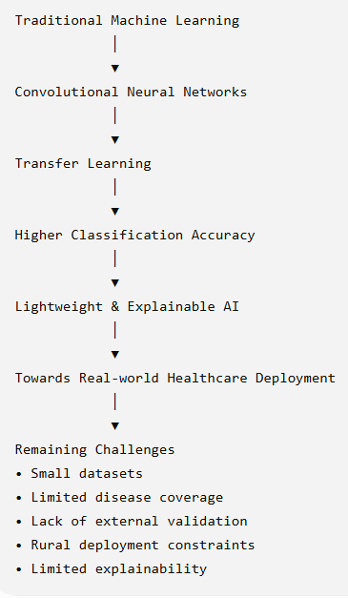
The critical synthesis highlights that, although AI-based medical image classification has achieved substantial technological progress, several important gaps continue to limit its practical application. These unresolved issues provide the primary motivation for the present research and are examined in detail in the following section, which identifies the specific research gaps addressed by this dissertation.

2.5.8 Research Gaps and Justification for the Proposed Research
The literature reviewed throughout this chapter demonstrates that Artificial Intelligence has significantly advanced the field of medical image classification. Deep learning, particularly Convolutional Neural Networks (CNNs) and transfer learning, has enabled researchers to develop highly accurate systems for detecting various medical conditions from clinical images. Despite these advancements, the existing body of research reveals several methodological, technical, and practical limitations that continue to restrict the broader adoption of AI-assisted diagnostic systems for foot and nail disease detection. These limitations collectively establish the need for further research and provide the primary motivation for the present study.
One of the most evident gaps in the current literature is the limited scope of disease classification. The majority of published studies focus on a single medical condition, most commonly diabetic foot ulcers, while considerably less attention has been given to other clinically important foot and nail disorders such as fungal nail infections, traumatic nail injuries, athlete's foot (tinea pedis), bacterial infections, eczema, and inflammatory skin conditions. Although single-disease models often report high classification accuracy, their practical usefulness in routine healthcare remains limited because patients may present with a wide range of conditions exhibiting similar visual characteristics. Consequently, there is a growing need for AI systems capable of recognising multiple foot and nail conditions within a unified classification framework rather than addressing individual diseases independently.
A second limitation concerns the availability and diversity of training datasets. Most existing studies rely on relatively small datasets collected from individual hospitals, research laboratories, or publicly available repositories. Such datasets frequently contain limited demographic diversity and may not adequately represent variations in skin colour, age groups, disease severity, image quality, lighting conditions, and camera devices encountered in real-world clinical settings. While data augmentation techniques partially address this issue by artificially increasing dataset size, they cannot fully substitute for genuinely diverse clinical data. Consequently, the generalisability of many published models remains uncertain when applied beyond their original research environment.
The review also indicates that comparative evaluation of deep learning architectures remains inconsistent. Numerous CNN architectures have been proposed for medical image classification, including ResNet50, DenseNet121, EfficientNet, MobileNetV2, InceptionV3, and Xception. However, different studies employ different datasets, preprocessing techniques, augmentation strategies, hyperparameter settings, and evaluation protocols, making direct comparison between models difficult. As a result, it remains unclear which architecture offers the most appropriate balance between classification accuracy, computational efficiency, and deployment feasibility for foot and nail disease detection. A consistent comparative evaluation of multiple transfer learning models using a common dataset therefore represents an important research opportunity.
Another significant gap relates to deployment in resource-constrained healthcare environments. Much of the existing literature evaluates AI models within controlled laboratory conditions using high-performance computing infrastructure. Comparatively fewer studies investigate the practical implementation of these systems within primary healthcare centres, rural clinics, or low-resource settings where computational resources, specialist clinicians, and advanced diagnostic equipment may be limited. Since one of the principal motivations for AI-assisted diagnosis is to improve healthcare accessibility, greater emphasis on lightweight models capable of operating efficiently on portable devices is required.
The literature further reveals that model interpretability remains underdeveloped. Although deep learning systems achieve impressive predictive performance, they are frequently criticised for functioning as black-box models that provide limited explanation for their decisions. This lack of transparency may reduce clinician confidence and create barriers to clinical adoption. While Explainable Artificial Intelligence (XAI) techniques such as Grad-CAM have demonstrated encouraging results by highlighting image regions contributing to model predictions, their integration into foot and nail disease classification remains relatively limited. Future research should therefore consider both predictive accuracy and interpretability to improve trust in AI-assisted clinical decision-making.
Another recurring observation is the limited use of external validation. Most published studies assess model performance using internal validation datasets obtained from the same source as the training data. Although this provides valuable information regarding model performance under experimental conditions, it does not necessarily demonstrate robustness when applied to images collected from different healthcare institutions or patient populations. Broader validation using independent datasets is therefore essential to improve confidence in the clinical reliability and generalisability of AI-based diagnostic systems.
Finally, the literature indicates that relatively few studies adopt a patient-centred perspective when designing AI-assisted diagnostic tools. Many investigations primarily focus on algorithmic performance while giving comparatively less attention to usability, accessibility, and practical integration within routine healthcare workflows. As smartphone technology becomes increasingly widespread, there is growing potential to develop AI systems capable of supporting preliminary screening outside specialist hospitals, enabling earlier referral and intervention for individuals living in remote or underserved communities.
Taken together, these research gaps demonstrate that significant opportunities remain for developing AI systems that are not only accurate but also practical, computationally efficient, transparent, and capable of recognising multiple clinically relevant foot and nail conditions. Addressing these limitations has the potential to improve the accessibility of early disease screening while supporting healthcare professionals in environments where specialist expertise may not always be readily available.
The present dissertation seeks to contribute to this evolving field by developing and evaluating a transfer learning-based image classification framework for foot and nail disease detection. Unlike many previous studies that focus on a single disease or evaluate only one CNN architecture, this research investigates the effectiveness of multiple state-of-the-art transfer learning models using a consistent experimental framework. In addition to comparing classification performance, the study considers computational efficiency and deployment suitability, with particular emphasis on supporting accessible AI-assisted diagnosis in rural and resource-constrained healthcare settings.

Table 2.14 Summary of Identified Research Gaps
Identified Gap | Evidence from Literature | How the Present Study Addresses the Gap
Predominant focus on single diseases | Most studies investigate diabetic foot ulcers or fungal nail infections independently | Develops a framework for classifying multiple foot and nail conditions
Limited dataset diversity | Small datasets collected from individual institutions | Uses a carefully curated dataset with preprocessing and augmentation to improve robustness
Lack of consistent comparison between CNN architectures | Different studies evaluate different models under different conditions | Compares multiple transfer learning architectures using a common experimental framework
Limited emphasis on lightweight deployment | Most evaluations performed on high-performance computing platforms | Investigates computationally efficient transfer learning models suitable for practical deployment
Limited use of Explainable AI | Few studies incorporate interpretability techniques | Recognises the importance of explainability and discusses its relevance for clinical adoption
Insufficient external validation | Performance generally reported using internal datasets only | Employs rigorous validation procedures and discusses generalisability as a key consideration
Limited focus on rural healthcare implementation | Few studies evaluate accessibility in resource-constrained environments | Motivates AI-assisted screening for rural and underserved healthcare settings

Figure 2.11 Flowchart
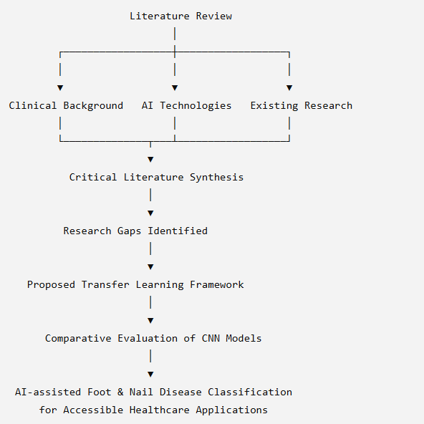

Table 2.15 Output of the Literature Review
Key Finding | Implication for This Research
Deep learning outperforms traditional machine learning | CNN-based transfer learning forms the foundation of this study
Transfer learning performs well with limited medical datasets | Appropriate methodology for the available dataset
Existing research focuses primarily on individual diseases | Motivation for investigating broader foot and nail disease classification
Lightweight architectures are increasingly important | Supports evaluation of computationally efficient models
Explainability and clinical trust remain emerging research areas | Highlights opportunities for future enhancement
Rural healthcare receives comparatively limited attention | Reinforces the practical significance of this dissertation

2.5.9 Chapter Summary and Conclusion
This chapter critically reviewed the existing literature relating to Artificial Intelligence-based detection and classification of foot and nail diseases. Rather than examining individual studies independently, the review adopted a thematic synthesis approach to provide a comprehensive understanding of how research in this domain has evolved, the methodologies that currently dominate the field, and the challenges that remain unresolved. By integrating evidence from peer-reviewed journal articles, conference proceedings, academic books, healthcare organisation reports, and industry publications, the review established both the technological and clinical context that underpins the present research.
The chapter began by outlining the methodology adopted for the literature review, including the search strategy, databases consulted, keyword selection, inclusion and exclusion criteria, and data extraction framework. Employing a structured search process ensured that the selected literature was relevant, comprehensive, and representative of recent developments in Artificial Intelligence, medical image analysis, transfer learning, and healthcare applications. Organising the literature into thematic categories also enabled critical comparison between studies rather than descriptive summarisation, supporting a more coherent understanding of the research landscape.
The review subsequently examined the evolution of Artificial Intelligence in medical image analysis, demonstrating a clear progression from traditional image processing techniques based on handcrafted feature extraction towards modern deep learning and transfer learning approaches. This evolution reflects broader advances in computational capability, algorithm development, and the increasing availability of digital medical imaging. While conventional machine learning methods provided an important foundation for automated disease detection, Convolutional Neural Networks have fundamentally transformed medical image analysis by enabling automatic hierarchical feature learning directly from image data. More recently, transfer learning has emerged as the preferred strategy for healthcare applications because it enables robust model development even when only relatively small annotated medical datasets are available.
The literature also highlighted the growing importance of AI-assisted diagnosis for foot and nail conditions. Many of these diseases initially present through subtle visual changes that are well suited to computer vision techniques, creating opportunities for earlier identification and improved clinical decision-making. Existing studies consistently demonstrate that deep learning models can achieve high classification performance across a variety of medical imaging applications, including diabetic foot ulcer detection, skin lesion classification, retinal disease screening, and fungal nail infection diagnosis. These findings reinforce the potential of AI to support healthcare professionals by improving diagnostic consistency, reducing observer variability, and enabling faster preliminary screening.
Despite these advances, the critical synthesis identified several recurring limitations within the existing literature. Most published research focuses on single disease categories, particularly diabetic foot ulcers, with comparatively limited investigation of broader foot and nail disorders. Dataset diversity remains restricted, many studies rely on relatively small collections of images from individual institutions, and there is considerable variation in preprocessing methods, evaluation protocols, and performance metrics. Furthermore, although lightweight CNN architectures and Explainable Artificial Intelligence techniques have gained increasing attention, comparatively few studies evaluate practical deployment within rural or resource-constrained healthcare environments where AI-assisted diagnosis may have the greatest societal impact.
The comparative review of CNN architectures and transfer learning models further demonstrated that no single model is universally optimal for all medical image classification tasks. Different architectures offer distinct trade-offs between predictive performance, computational efficiency, memory requirements, and deployment feasibility. Consequently, selecting an appropriate model requires balancing classification accuracy with practical considerations such as dataset characteristics, available computational resources, and the intended clinical application. This observation reinforces the importance of evaluating multiple transfer learning architectures within a consistent experimental framework rather than relying on isolated findings reported across separate studies.
The research gaps identified throughout the chapter provide a clear justification for the present dissertation. Specifically, opportunities remain for developing AI-assisted diagnostic systems capable of recognising multiple foot and nail conditions within a unified framework, improving computational efficiency for deployment on resource-limited devices, and supporting accessible healthcare in rural and underserved communities. Addressing these challenges has the potential to enhance the practical usefulness of Artificial Intelligence as a decision-support technology while contributing to more equitable access to early disease screening.
Overall, the literature reviewed in this chapter demonstrates that Artificial Intelligence has reached a level of maturity where it can provide meaningful support for medical image analysis. However, translating these technological advances into clinically practical, reliable, and accessible diagnostic systems requires further investigation. The findings presented throughout this chapter therefore establish the theoretical foundation, identify the research gap, and justify the methodological choices adopted within this dissertation.
Building upon these insights, the following chapter presents the research methodology used to design, develop, and evaluate the proposed AI-based foot and nail disease classification system. It describes the overall research design, dataset preparation, image preprocessing techniques, transfer learning models, experimental procedures, evaluation metrics, and implementation framework employed to address the research objectives identified throughout this literature review.
Table 2.16 Chapter 2 Summary
Literature Review Theme | Key Outcome | Contribution to This Research
Literature Review Methodology | Systematic search and thematic synthesis | Established a comprehensive and unbiased review process
Evolution of AI in Medical Imaging | Transition from traditional machine learning to deep learning and transfer learning | Demonstrated technological progression supporting AI-assisted diagnosis
Clinical Background of Foot and Nail Diseases | Early detection is essential to improve patient outcomes | Justified the need for image-based diagnostic systems
Conventional Diagnostic Methods | Reliable but resource-intensive and dependent on specialist expertise | Motivated the exploration of AI-assisted decision support
Artificial Intelligence in Medical Imaging | CNNs and transfer learning dominate current research | Identified the most appropriate technological foundation
Review of Existing Studies | High classification performance but fragmented research focus | Highlighted current strengths and methodological limitations
Critical Literature Synthesis | Identified challenges relating to datasets, validation, explainability, and deployment | Established the basis for identifying research gaps
Research Gaps | Limited multi-condition classification, dataset diversity, and rural deployment | Directly informed the objectives and methodology of the present dissertation

Figure 2.12 Professional Flowchart
