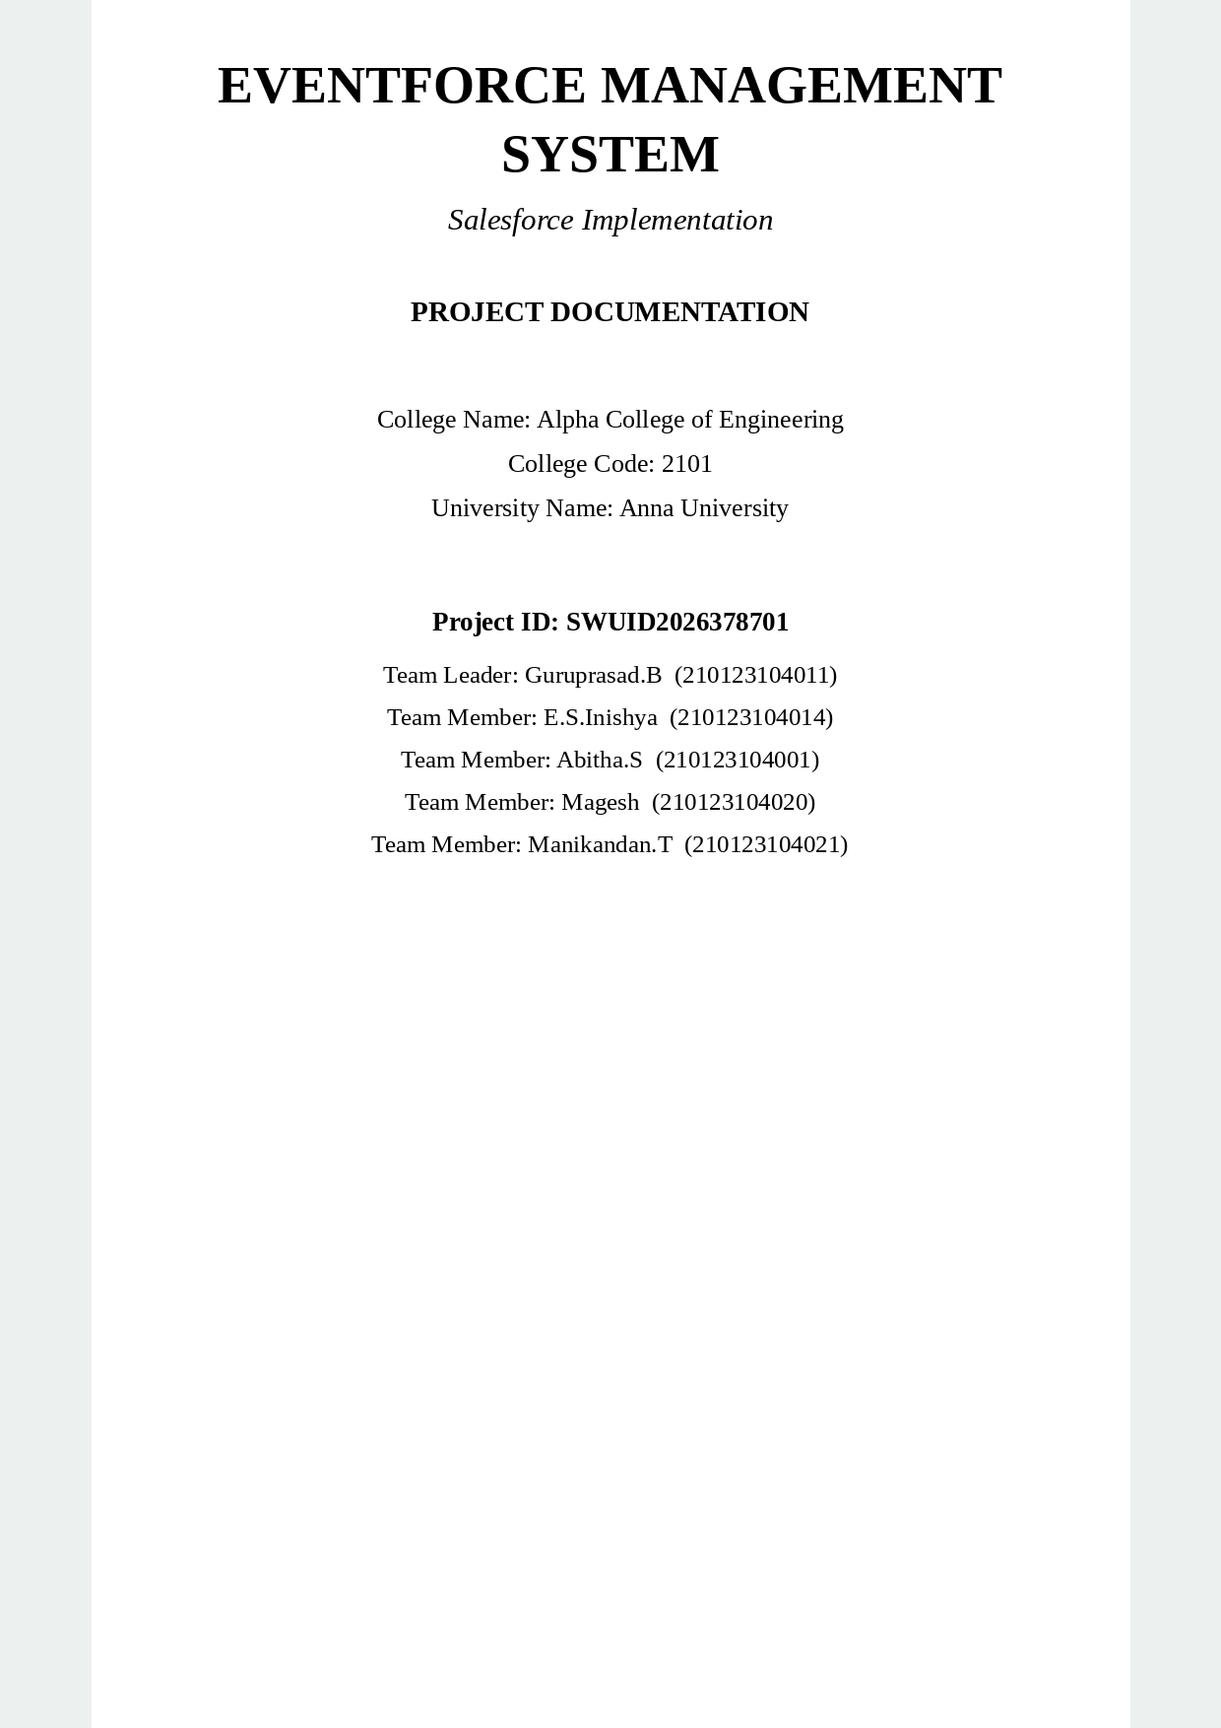

Table of Contents
- 1. Project Overview
- 2. Objectives and Business Value
- 3. Phase 1 – Requirement Analysis
- 4. Phase 2 – Backend Development and Data Model
- 5. Phase 3 – UI Customization and Data Migration
- 6. Phase 4 – Testing and Security
- 7. Data Model and ER Diagram
- 8. Automation Components
- 9. Security Model
- 10. Testing Results and Evidence
- 11. Phase 5 – Deployment Strategy
- 12. Maintenance, Monitoring & Troubleshooting
- 13. Project Documentation Summary
- 14. Salesforce Demo Video Structure
- 15. Conclusion
- 16. Team Members

1. Project Overview
The EventForce Management System is a Salesforce-based CRM solution designed to streamline and automate event-planning operations. The system provides a centralized environment for managing event, client, vendor, and feedback information while using Salesforce automation, validation, approval, security, reporting, and analytics capabilities.
The project is implemented in a Salesforce Developer Org for academic purposes. The implementation follows real-world CRM concepts by mapping business requirements to Salesforce configuration and development features.

1.1 Purpose
- Centralize event-related information in Salesforce.
- Maintain accurate event, client, vendor, and feedback data.
- Reduce repetitive manual work using automation.
- Control business processes through validation and approval mechanisms.
- Provide secure, role-appropriate access to CRM information.
- Provide reports and dashboards for monitoring and analytics.
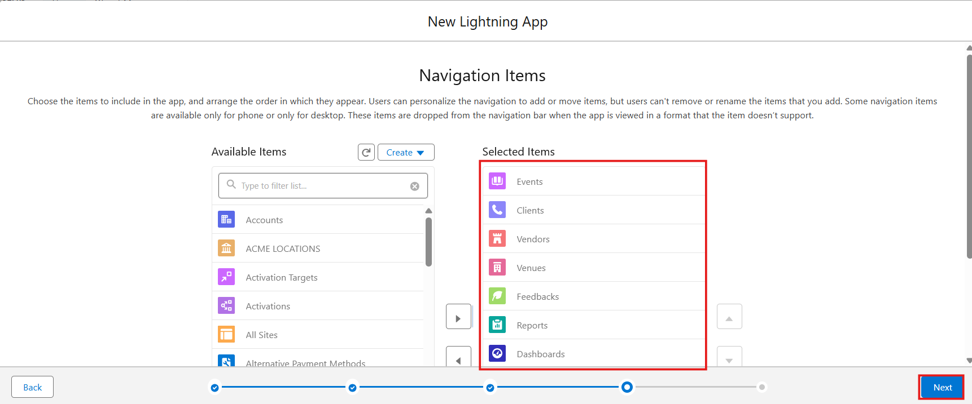
Figure 1: EventForce (Event Planner) Lightning app navigation items: Events, Clients, Vendors, Venues, Feedbacks, Reports and Dashboards
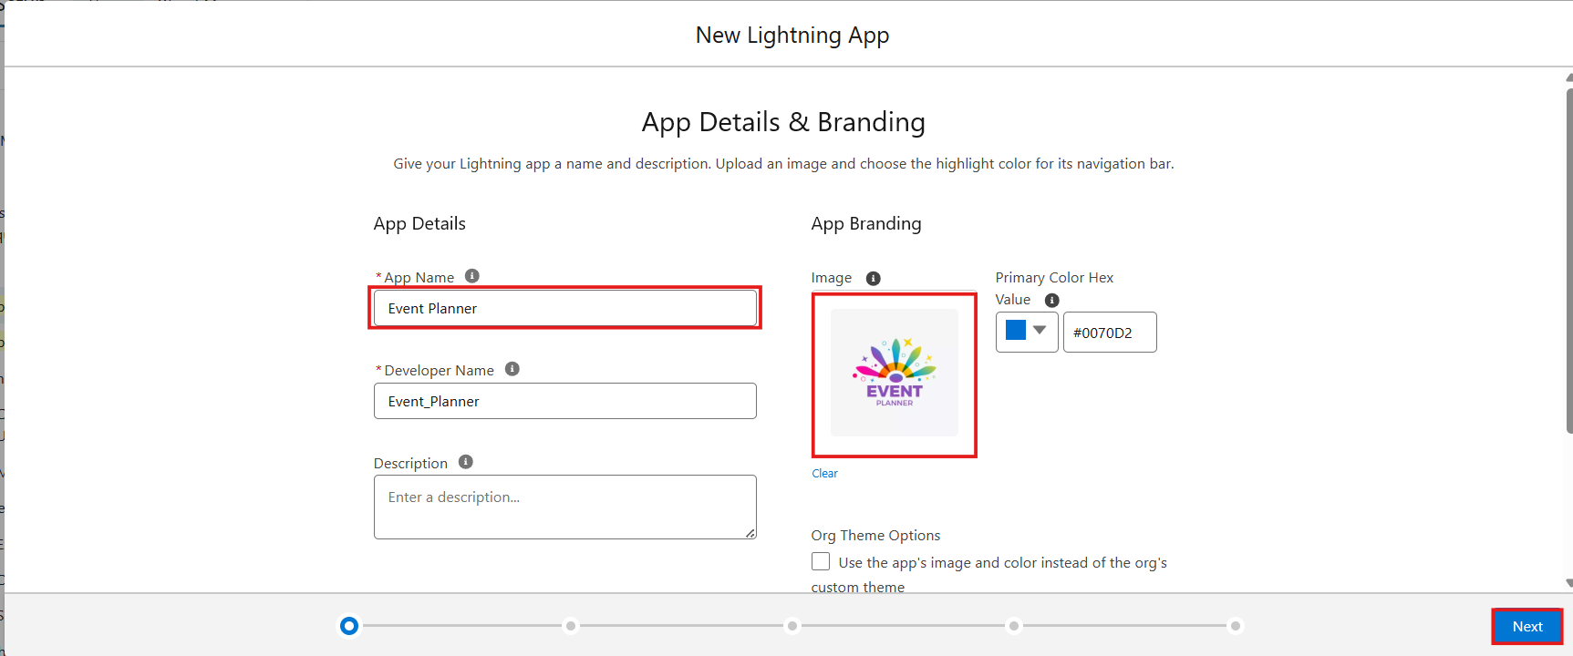
Figure 2: Lightning app details and branding for the EventForce app

2. Objectives and Business Value
- Create a centralized CRM for event-planning operations.
- Improve the accuracy and consistency of event, client, vendor, and feedback data.
- Automate repetitive activities and reminders.
- Implement validation rules to prevent incorrect or incomplete data.
- Use approval processes for controlled business operations.
- Use Apex logic where programmatic processing is required.
- Implement Profiles, Roles, Permission Sets, and Sharing Rules for controlled access.
- Provide reports and dashboards for event-related insights.
- Support maintainability, scalability, training, and future enhancement.

3. Phase 1 – Requirement Analysis
The first phase identifies and organizes the business and technical requirements of the EventForce CRM.

3.1 Requirement Areas
- Event management
- Client management
- Vendor management
- Feedback management
- Automation and reminders
- Approval processes
- Validation and data quality
- Security and access control
- Reports and dashboards

3.2 Functional Requirements
- Users should be able to create and maintain event records.
- Users should be able to maintain client and vendor information.
- Users should be able to record feedback.
- Invalid data should be restricted through validation rules.
- Relevant processes should be automated through Salesforce Flows and Apex logic.
- Records requiring authorization should be handled through an Approval Process.
- Authorized users should be able to access reports and dashboards.

4. Phase 2 – Backend Development and Data Model
Backend development establishes the Salesforce objects, fields, relationships, validation rules, automation logic, and Apex components needed to support EventForce business requirements.

4.1 Core Business Entities
- Event
- Client
- Vendor
- Feedback

4.2 Data Management
- Configure required Salesforce objects and fields.
- Define relationships among business entities.
- Configure required and optional fields.
- Apply validation rules for data quality.
- Implement declarative automation and Apex logic as required.

4.3 Data Migration
Data migration covers the preparation, mapping, import, and verification of event-related information when existing data is transferred into Salesforce.
- Prepare source data.
- Map source fields to Salesforce fields.
- Import the required records.
- Verify imported values and relationships.
- Correct data-quality issues identified during verification.

5. Phase 3 – UI Customization and Data Migration

5.1 UI Customization
The EventForce user interface is organized around the custom Salesforce application and its key objects. Users can navigate to records, create and update information, and access related reports and dashboards.
- App Launcher and EventForce application
- Event record navigation
- Client, Vendor, and Feedback navigation
- Record creation and editing
- Validation feedback during data entry
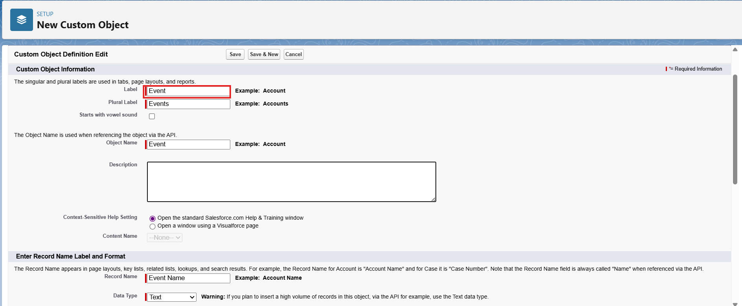
Figure 3: Event custom object definition
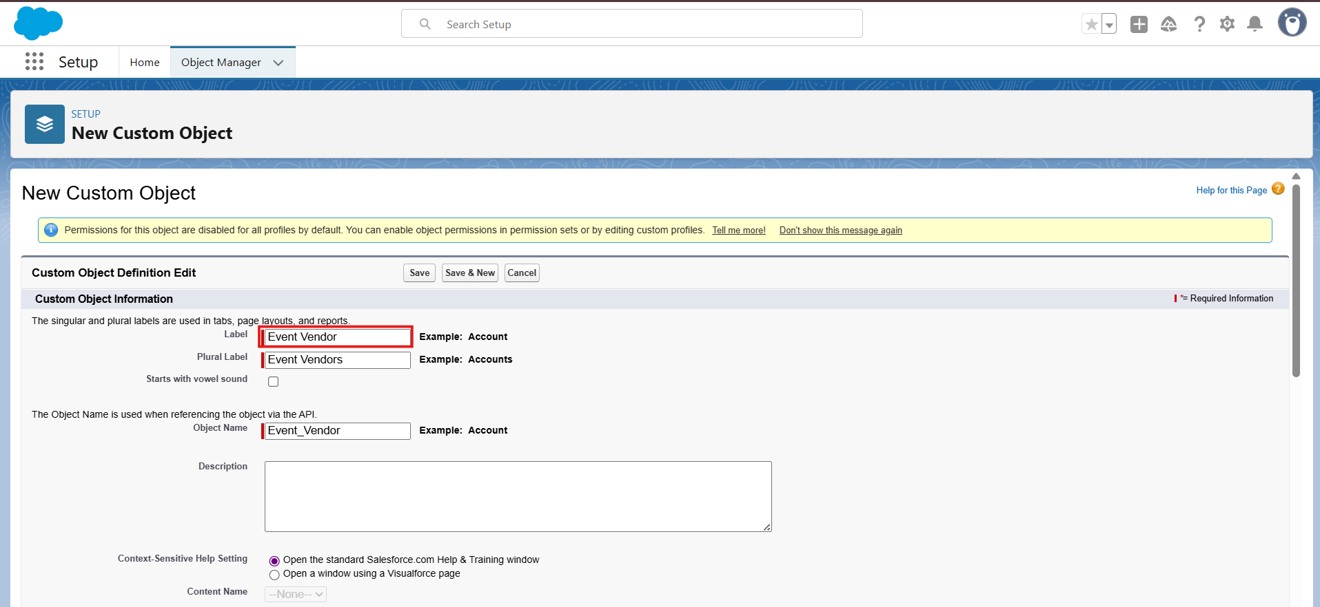
Figure 4: EventVendor junction object linking Event and Vendor
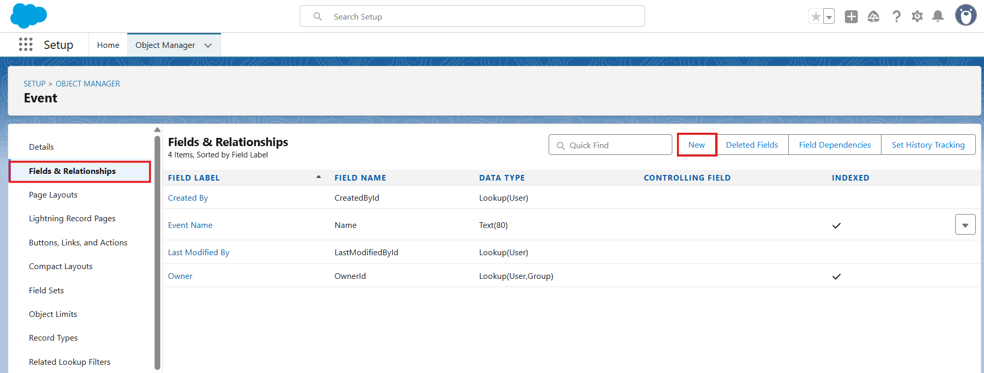
Figure 5: Fields & Relationships configured on the Event object
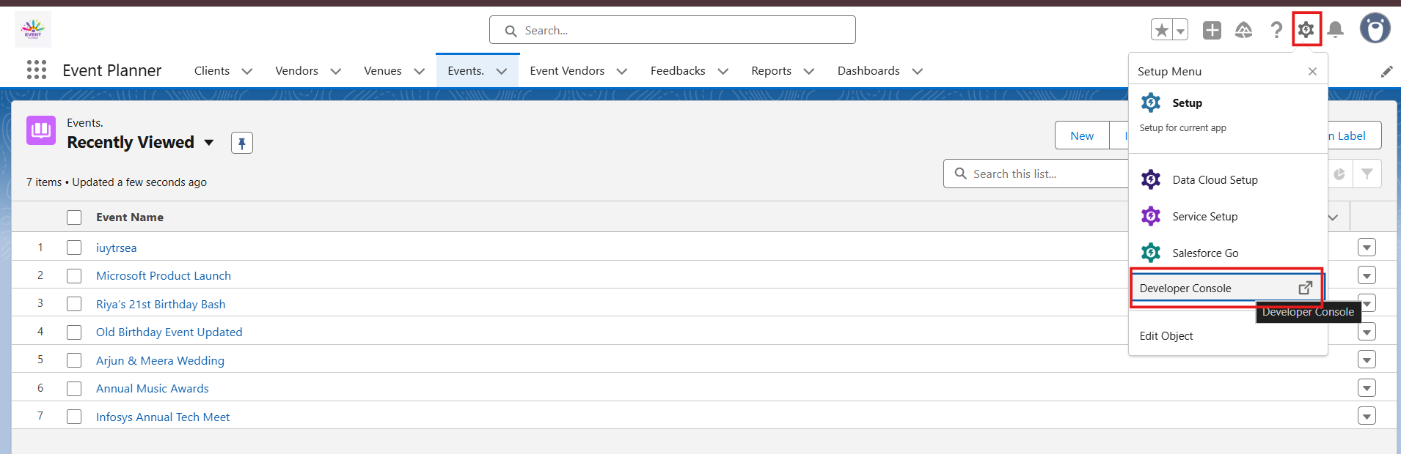
Figure 6: Event Planner app showing the object tabs and the Event records list
[ SCREENSHOT PLACEHOLDER: Event / Client record creation - to be added ]

5.2 Data Migration
Data migration is treated as a controlled activity: source information is checked, fields are mapped, records are imported, and the result is validated inside Salesforce.

6. Phase 4 – Testing and Security

6.1 Testing
- Object and field configuration testing
- Record creation and update testing
- Validation-rule testing
- Flow testing
- Approval-process testing
- Apex testing
- Security and permission testing
- Report and dashboard testing

6.2 Security
Security is implemented using Salesforce access-control mechanisms to ensure that users receive appropriate access to the system and its data.
- Profiles
- Roles
- Permission Sets
- Sharing Rules
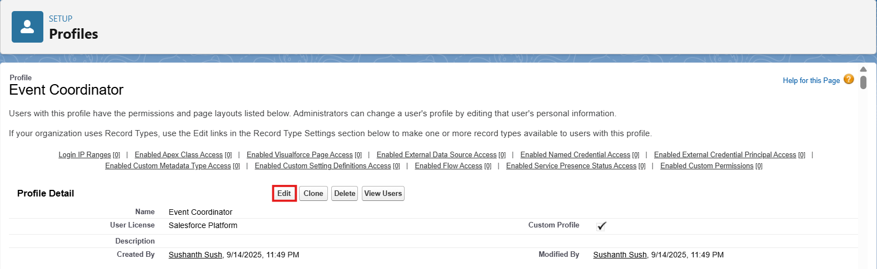
Figure 7: Event Coordinator profile
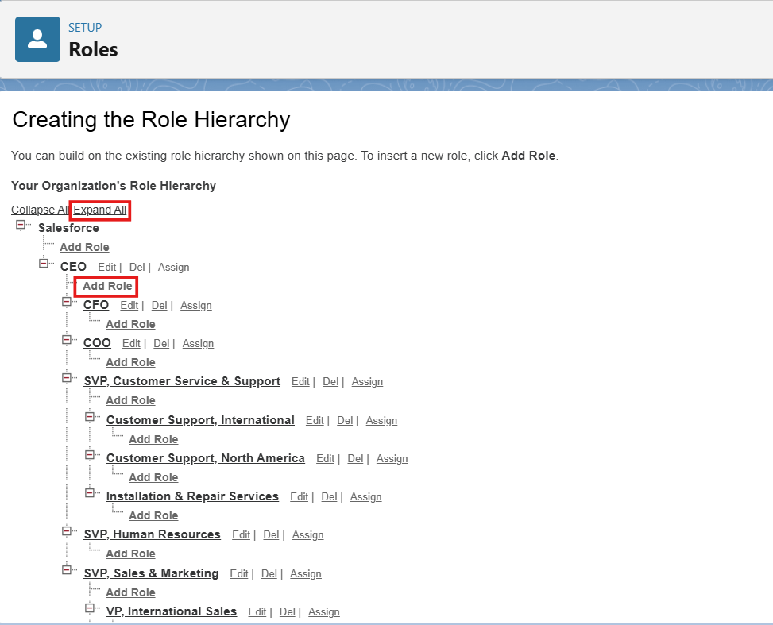
Figure 8: Role hierarchy configured for EventForce
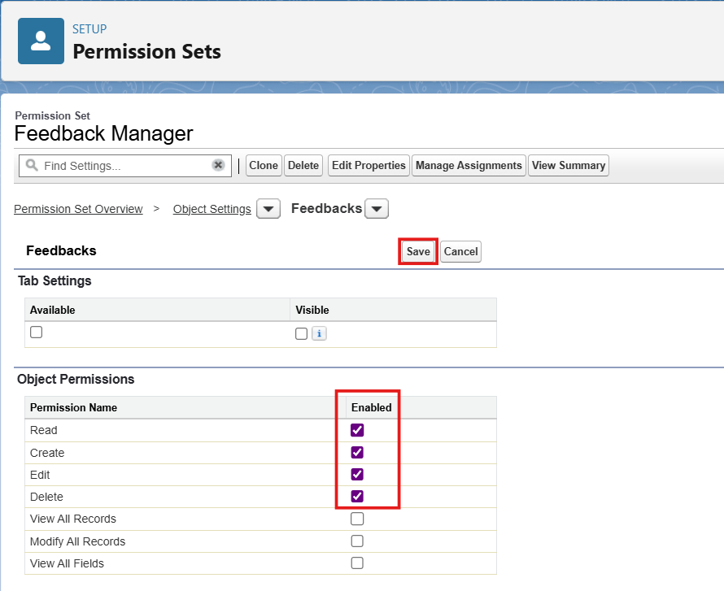
Figure 9: Feedback Manager permission set: object permissions on Feedback
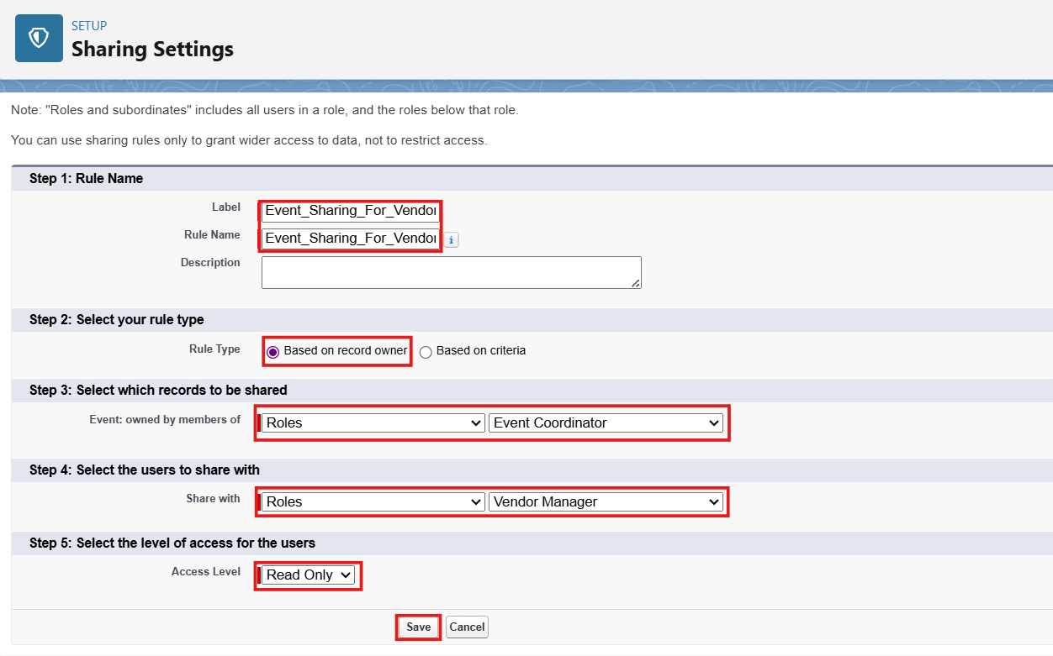
Figure 10: Sharing rule Event_Sharing_For_Vendors (read-only access for Vendor Manager)

7. Data Model and ER Diagram
The EventForce data model represents the main CRM entities required for event-planning operations. The core entities are Event, Client, Vendor, and Feedback. The final ER diagram should show the actual relationships and fields configured in the Salesforce org.
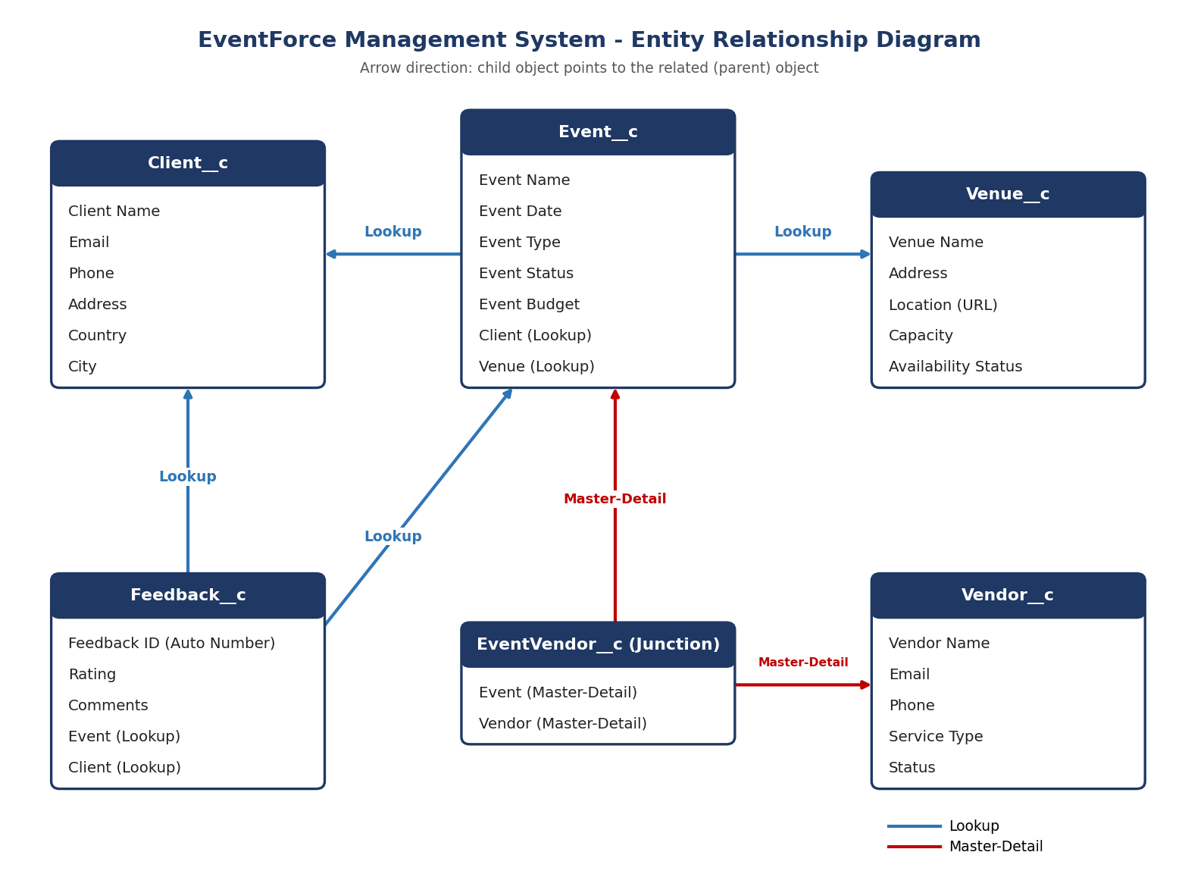
Figure 11: EventForce ER diagram: custom objects and the Lookup / Master-Detail relationships configured in the org
Note: The ER diagram should reflect the actual relationships configured in the Salesforce Developer Org; do not add relationships that are not implemented.

8. Automation Components

8.1 Salesforce Flows
Flows automate business processes without requiring code for every operation. EventForce includes a highlighted 3-Day Reminder Flow for event-related reminders.

8.2 3-Day Reminder Flow
The 3-Day Reminder Flow is a key EventForce automation highlighted for the project demonstration. It supports timely reminders for upcoming event-related activities according to the configured flow conditions and actions.
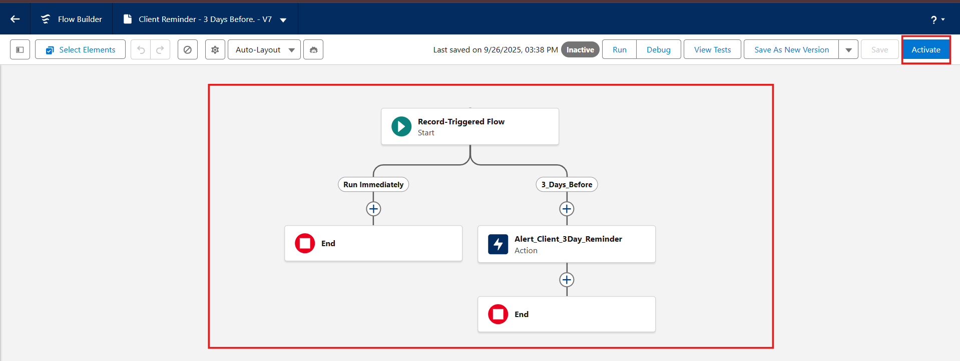
Figure 12: Client Reminder - 3 Days Before: record-triggered flow with scheduled path and Send Email action
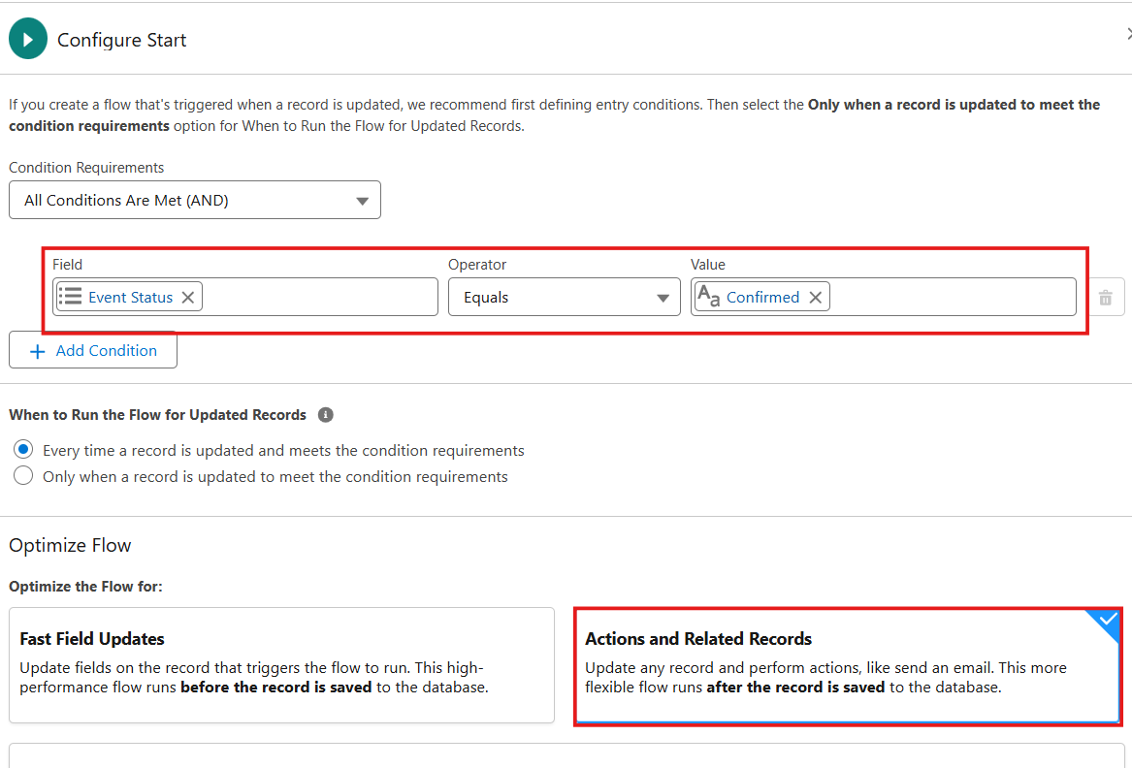
Figure 13: Flow start condition: Event Status equals Confirmed
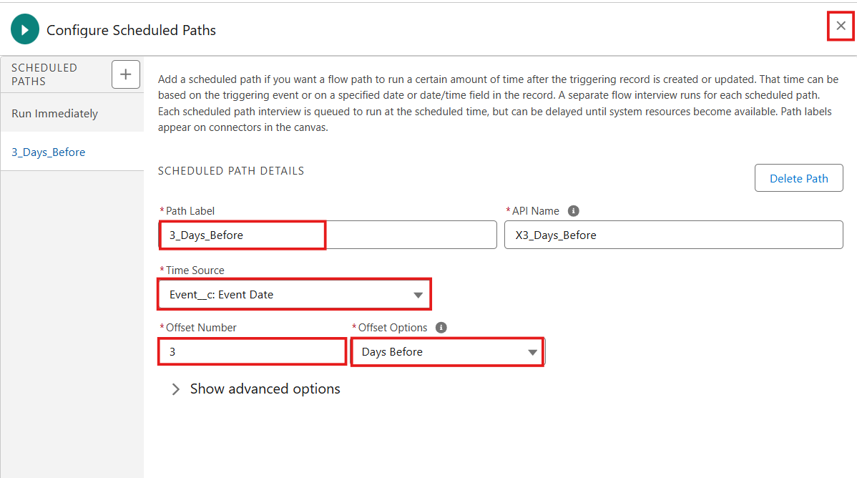
Figure 14: Scheduled path 3_Days_Before using Event Date as the time source
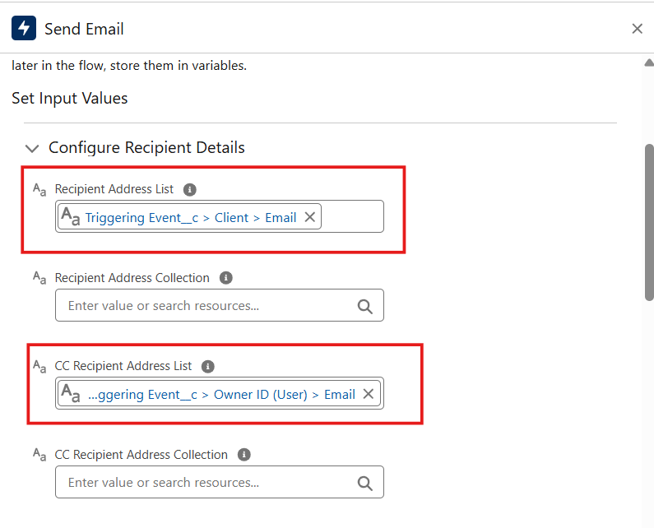
Figure 15: Send Email action: recipient is the Client email, CC is the Event Owner
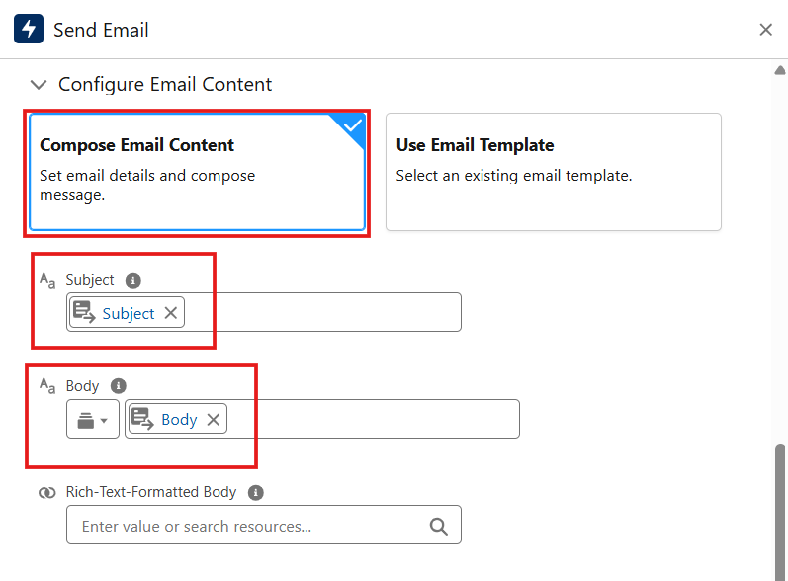
Figure 16: Email content composed from the Subject and Body text templates

8.3 Approval Process
The Approval Process provides a controlled mechanism for records that require review and authorization. The demonstration should show submission, approval/rejection, and the resulting Salesforce actions configured for the process.
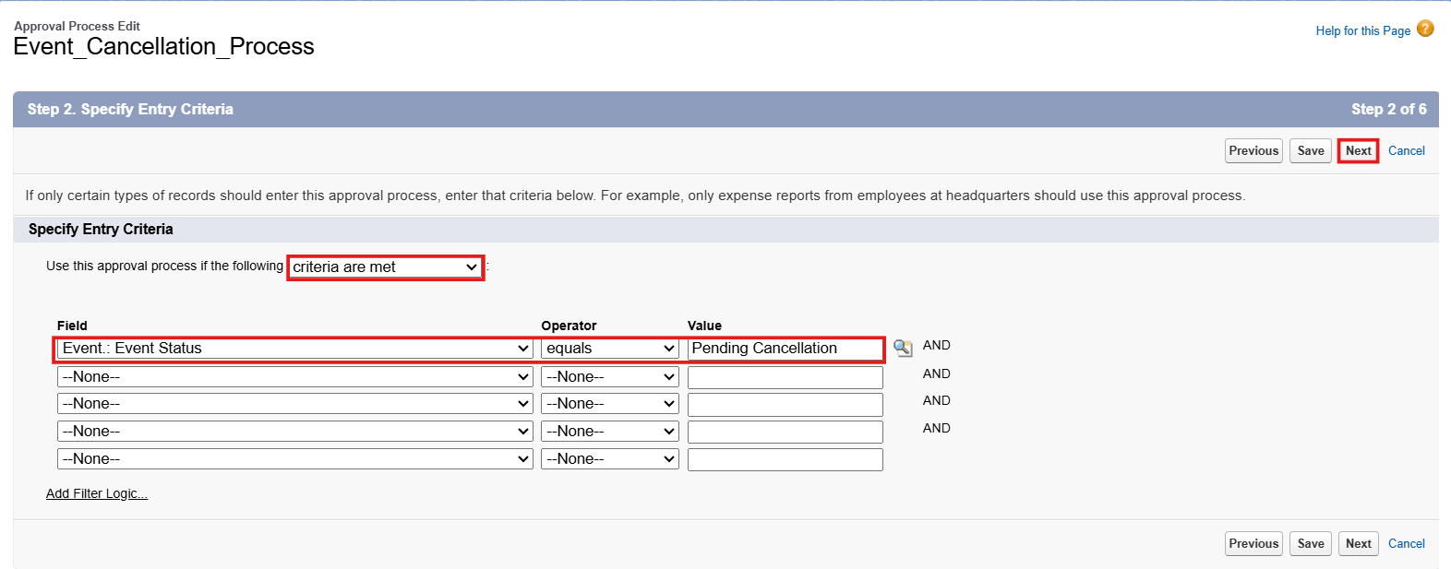
Figure 17: Event_Cancellation_Process entry criteria: Event Status equals Pending Cancellation
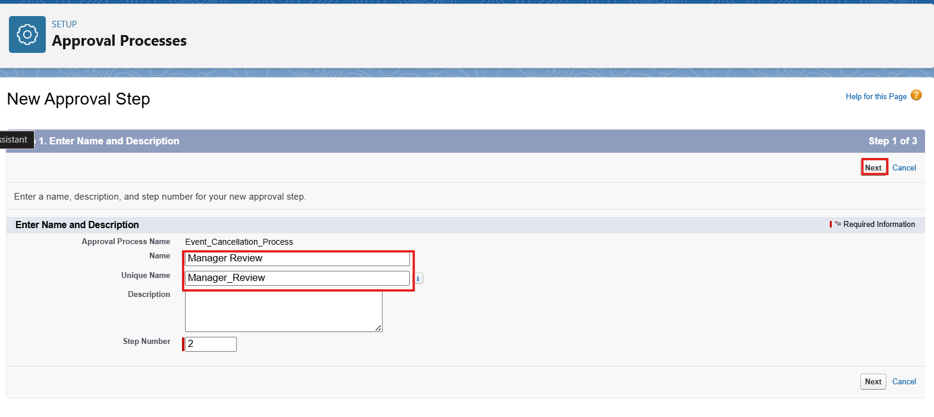
Figure 18: Approval step: Manager Review
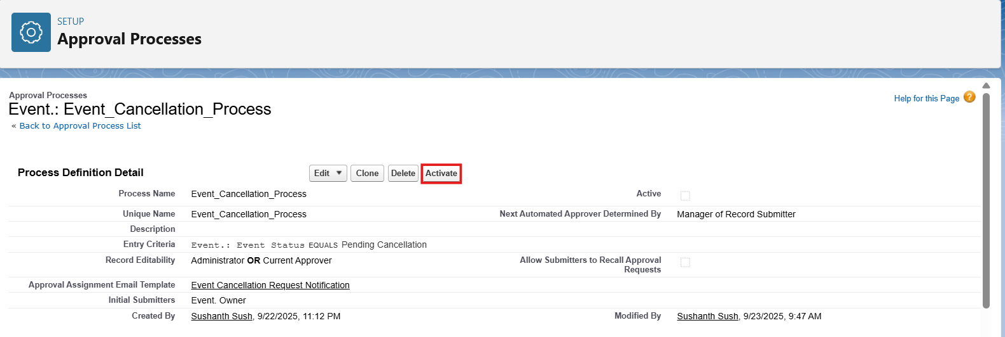
Figure 19: Approval process definition and activation
[ SCREENSHOT PLACEHOLDER: Event record submitted for approval - to be added ]

8.4 Validation Rules
Validation Rules protect data quality by preventing records from being saved when defined business conditions are not satisfied.
[ SCREENSHOT PLACEHOLDER: Validation rule configuration (Email_Valid_Address on Client) and validation error - to be added ]

8.5 Apex Logic
Apex is used where programmatic logic is required. Apex triggers/classes should be tested and monitored using appropriate Salesforce debugging and test practices.
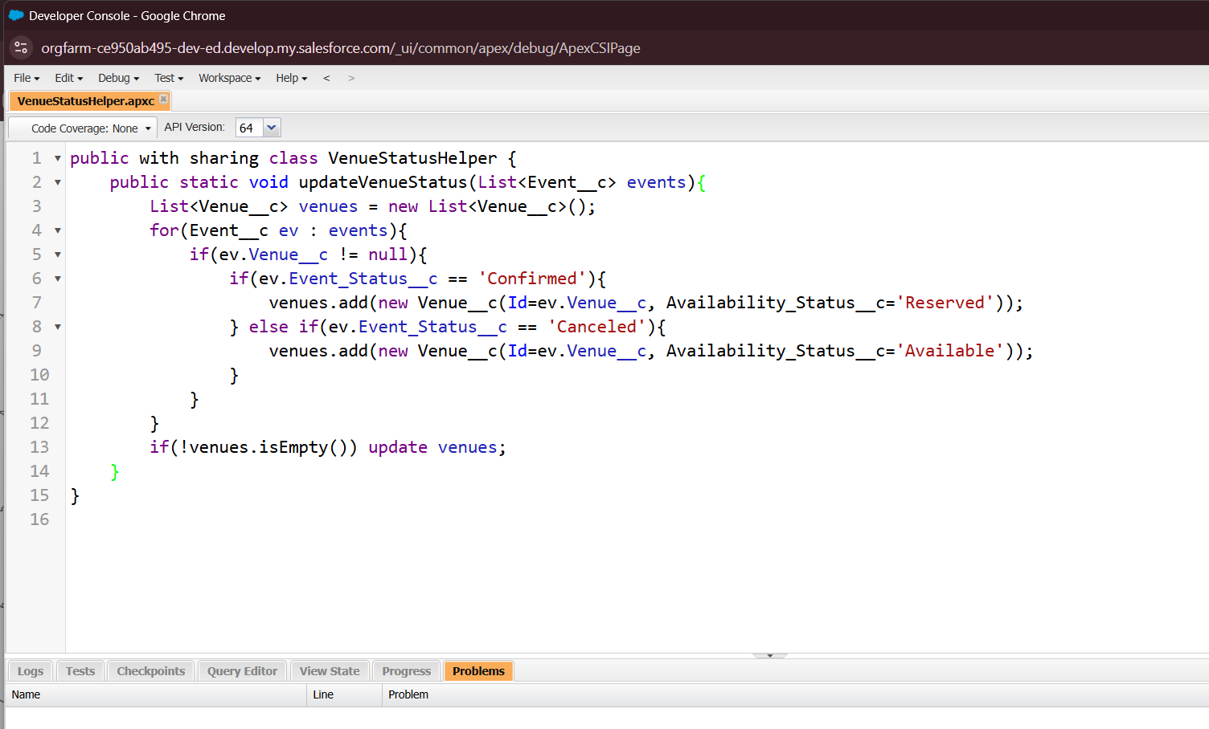
Figure 20: VenueStatusHelper class: updates Venue availability to Reserved or Available
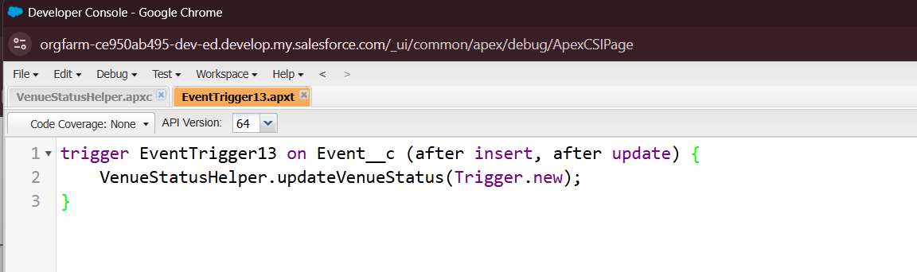
Figure 21: EventTrigger13 calls VenueStatusHelper after insert and update
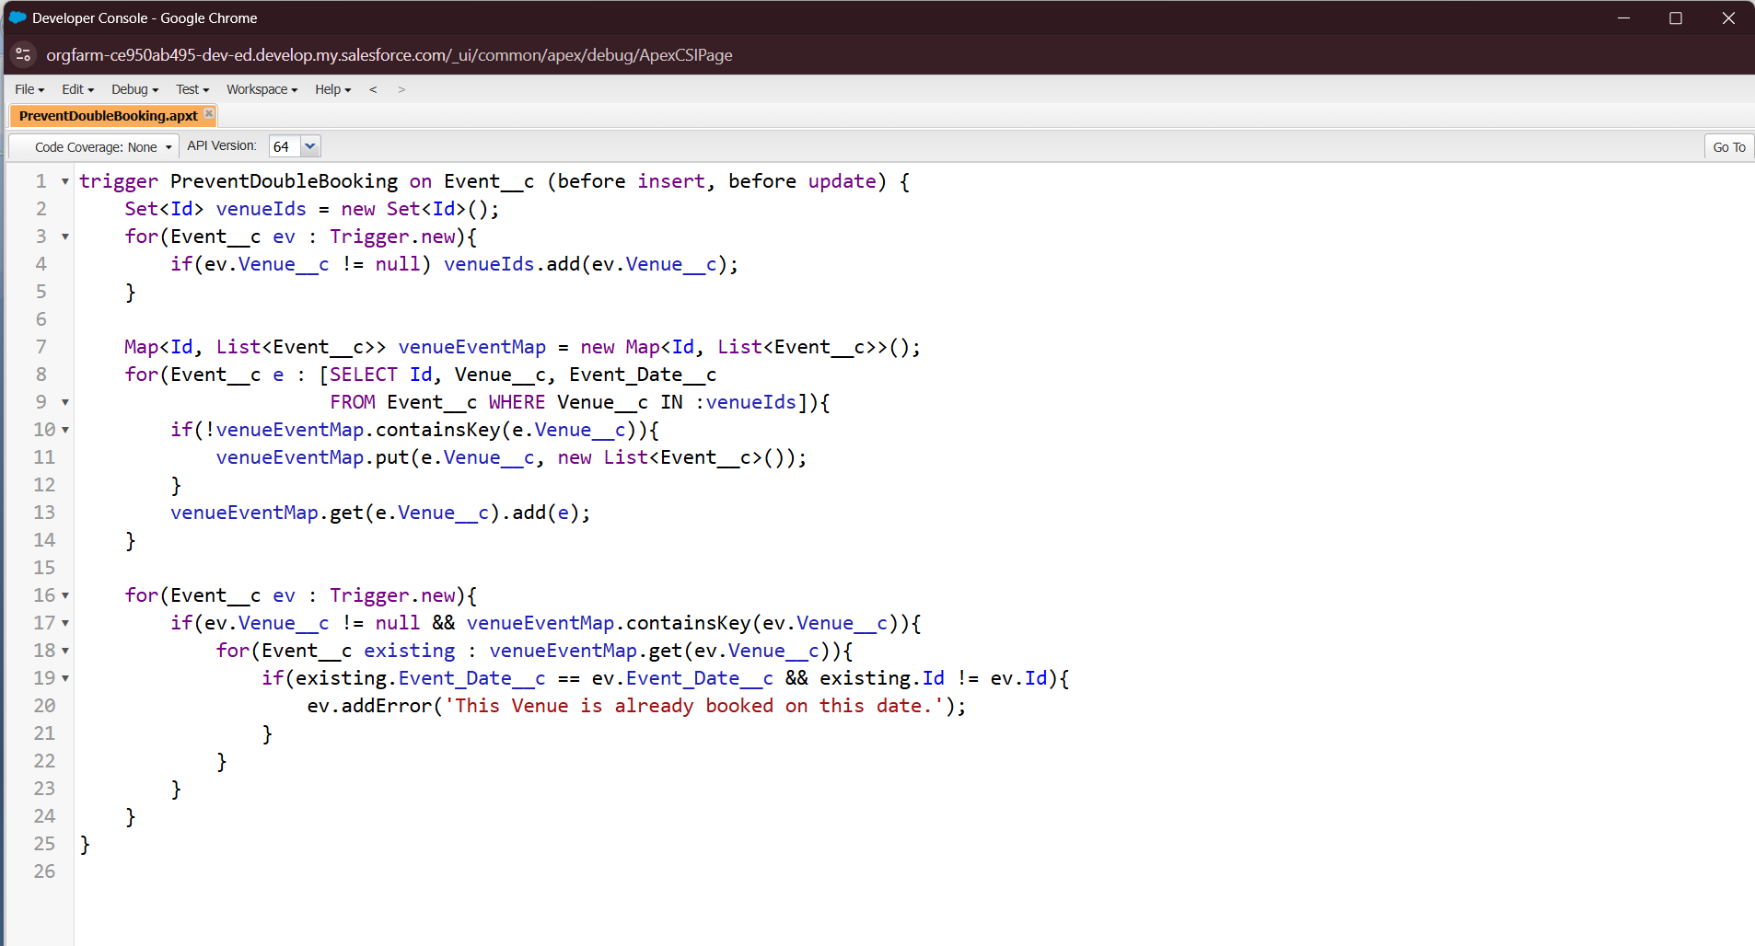
Figure 22: PreventDoubleBooking trigger blocks two events at the same venue on the same date

9. Security Model

9.1 Profiles
Profiles provide baseline permissions for users, including object, field, application, and system access.
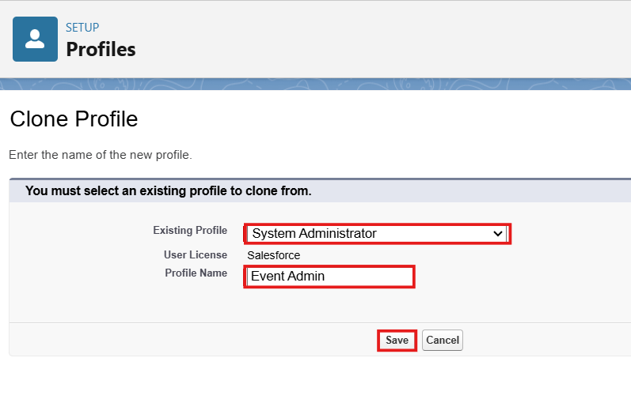
Figure 23: Event Admin profile cloned from System Administrator
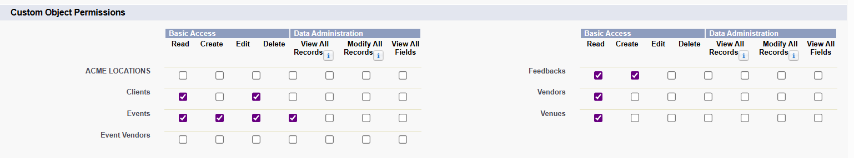
Figure 24: Custom object permissions configured on a project profile

9.2 Roles
Roles establish organizational hierarchy and can influence record visibility.
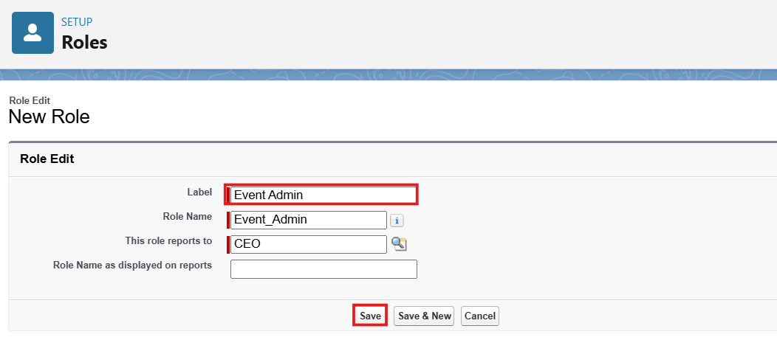
Figure 25: Event Admin role creation in the role hierarchy

9.3 Permission Sets
Permission Sets provide additional permissions to users without changing their primary profile.
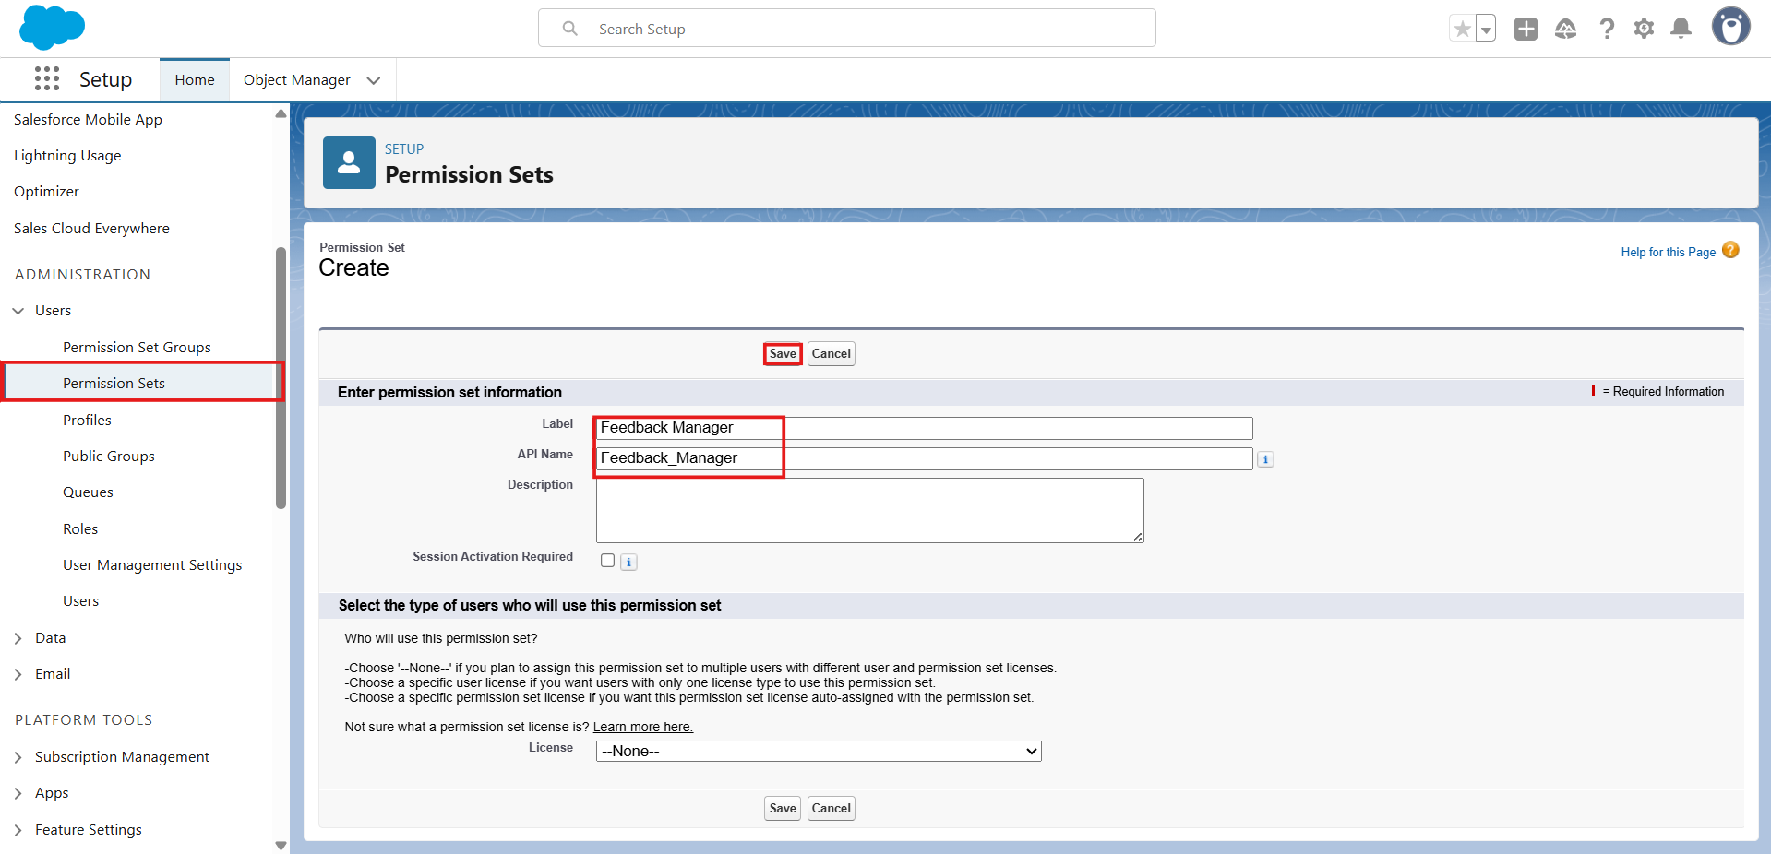
Figure 26: Feedback Manager permission set created
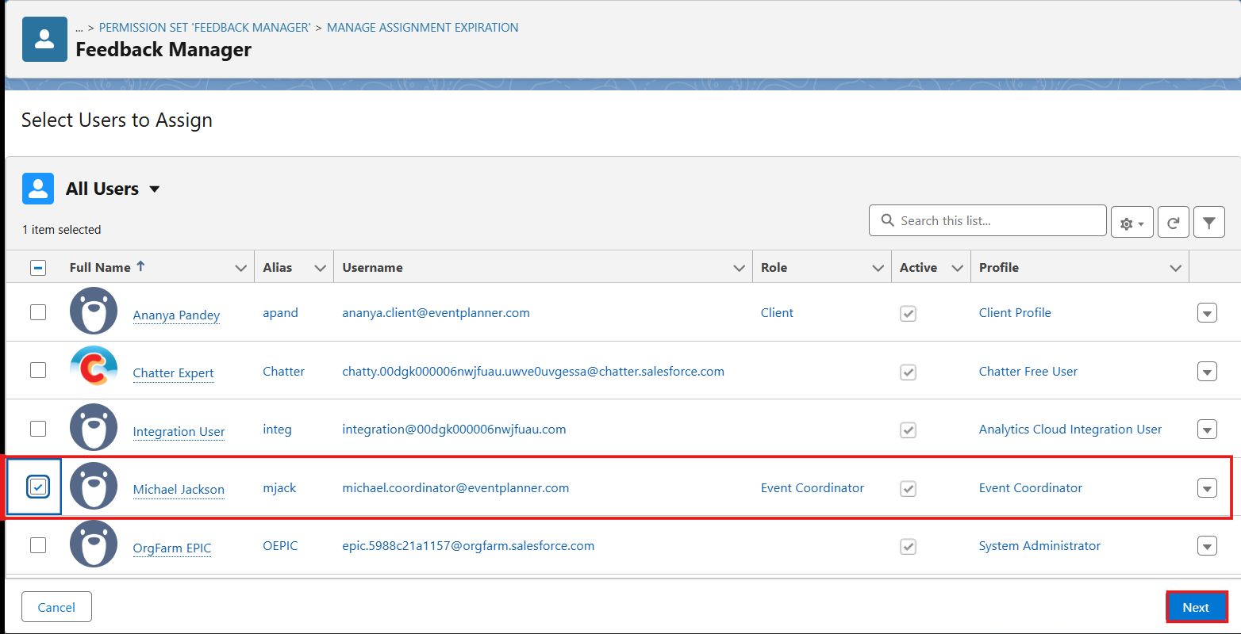
Figure 27: Feedback Manager permission set assigned to an Event Coordinator user

9.4 Sharing Rules
Sharing Rules can extend record access when the default organization-wide access does not provide the required visibility.
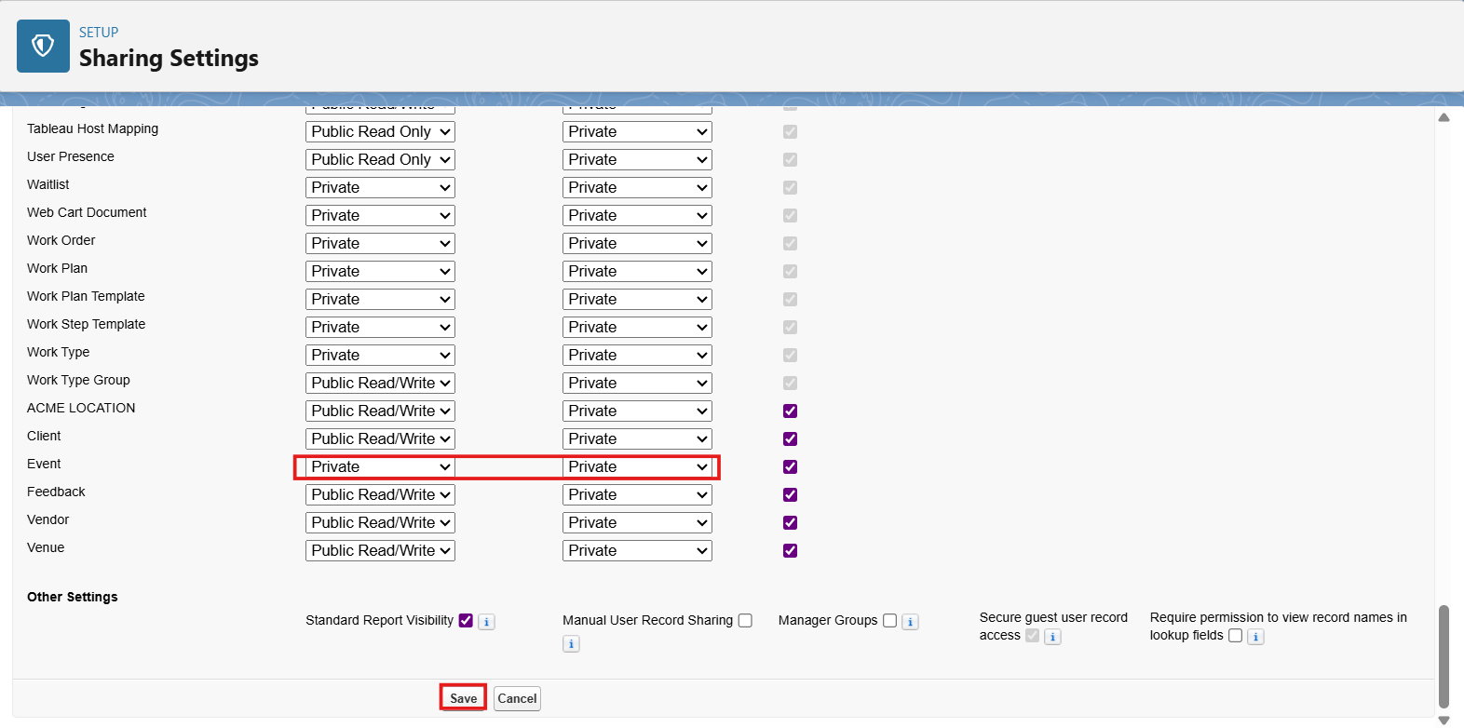
Figure 28: Organization-wide defaults: Event set to Private
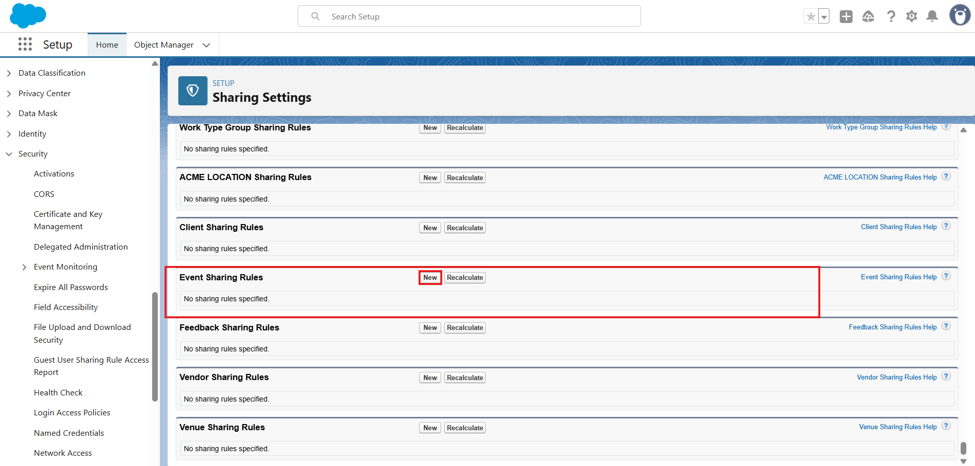
Figure 29: Event Sharing Rules section in Sharing Settings

9.5 Security Objective
- Prevent unauthorized access.
- Provide appropriate access to Salesforce features and records.
- Protect business information.
- Support controlled collaboration.

10. Testing Results and Evidence
Testing confirms that EventForce features behave according to the implemented requirements.
Test Area | Test Activity | Expected Result | Evidence
Validation Rule | Enter invalid/incomplete data | Record is prevented or appropriate validation message is shown | Screenshot pending (see Section 8.4)
3-Day Reminder Flow | Run/meet configured flow conditions | Configured reminder/action executes | Figures 12-16 (Section 8.2)
Approval Process | Submit record for approval | Correct approval route and outcome are applied | Figures 17-19 (Section 8.3); approval request screenshot pending
Apex Logic | Execute relevant Apex functionality | Expected processing occurs without unhandled errors | Figures 20-22 (Section 8.5)
Security | Access records with different permissions | Access matches configured security | Figures 7-10 (Section 6.2) and Section 9 figures
Reports | Run EventForce reports | Report returns relevant records and information | Figures 30-31 (Section 10.1)
Dashboard | Open EventForce dashboard | Configured analytics are displayed | Figure 32 (Section 10.1)
The following screenshots from the Salesforce Developer Org provide evidence for report, dashboard and scheduled-processing testing.

10.1 Report and Dashboard Evidence
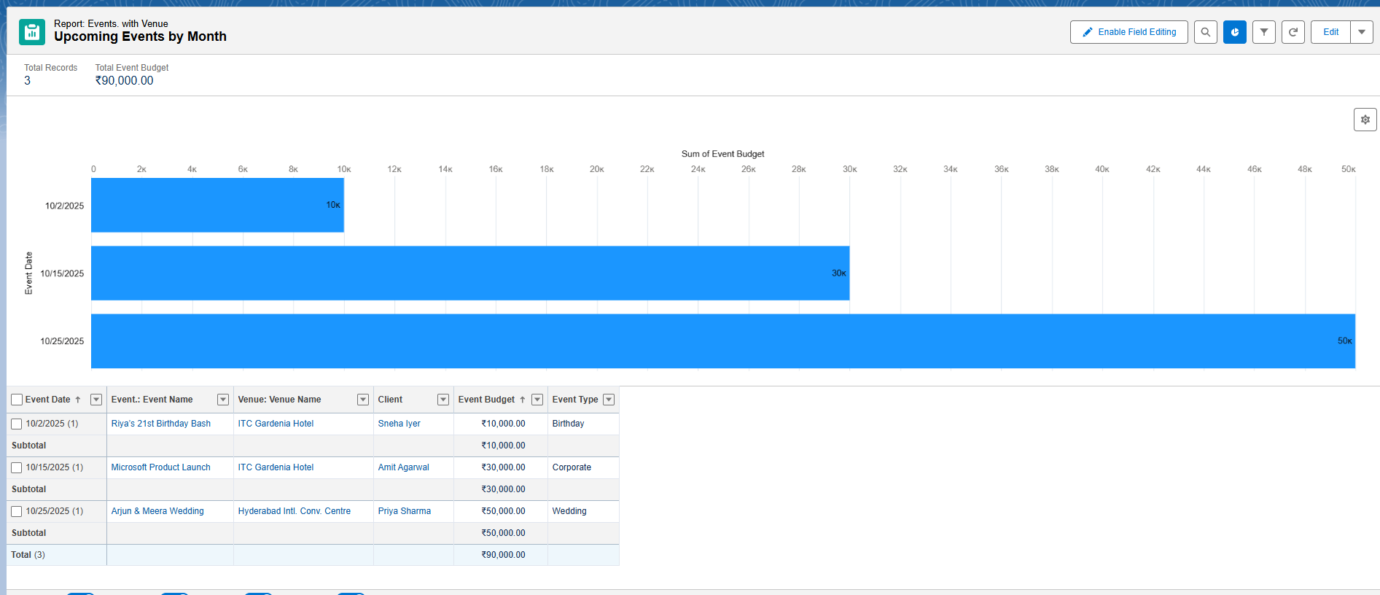
Figure 30: Upcoming Events by Month report
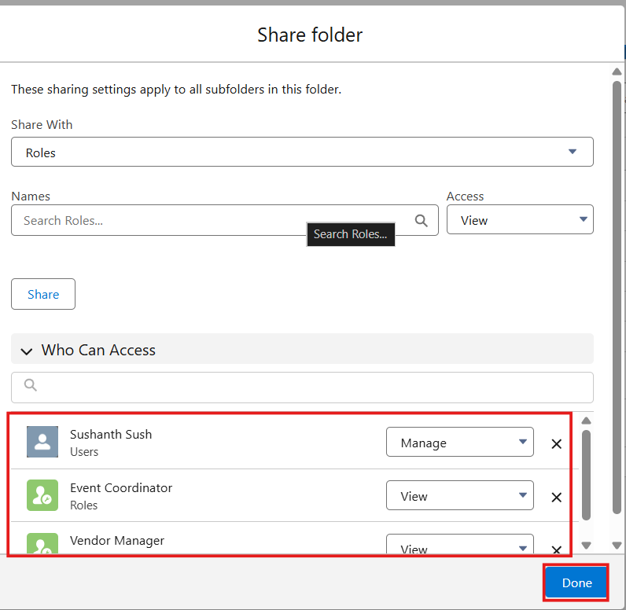
Figure 31: EventForce Report folder shared with the Event Coordinator and Vendor Manager roles
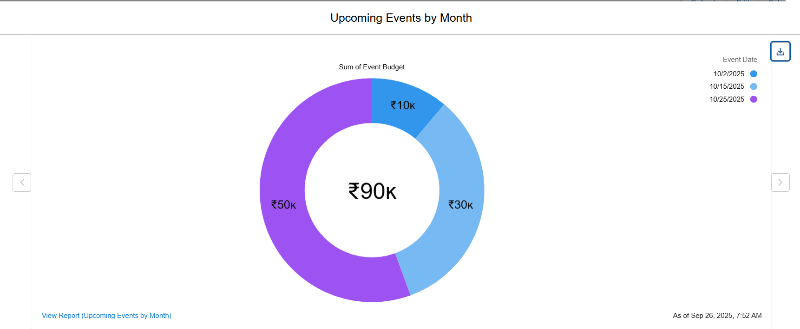
Figure 32: EventForce Operations Dashboard: Upcoming Events by Month donut chart

10.2 Apex Batch and Scheduled Job Evidence
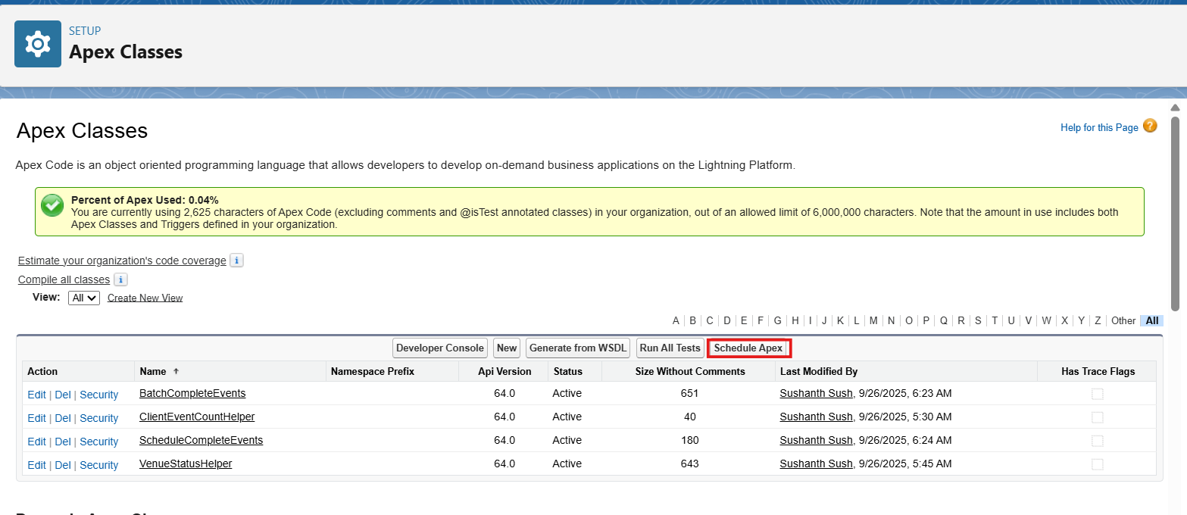
Figure 33: Apex classes deployed in the org, including BatchCompleteEvents
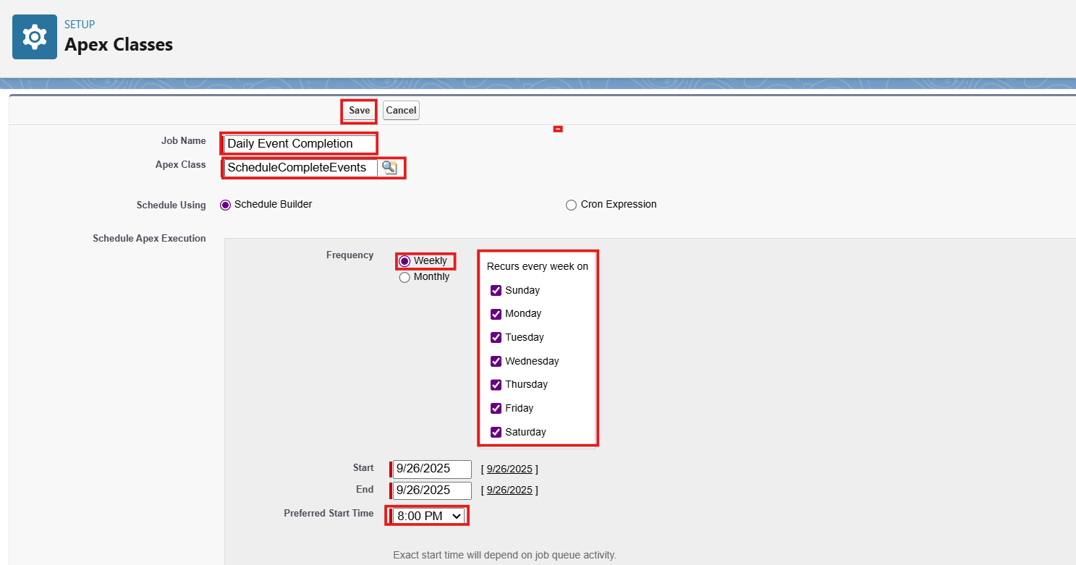
Figure 34: Scheduled Apex job configured to run every day

11. Phase 5 – Deployment Strategy
The EventForce system is implemented in a Salesforce Developer Org for academic purposes. A deployment-oriented approach is followed by completing configuration, testing automation and security, verifying reports, and performing final validation before demonstration.
- Complete Salesforce configuration and development.
- Test objects, fields, validation rules, flows, approvals, and Apex.
- Verify security configurations.
- Verify reports and dashboards.
- Perform final functional testing.
- Document the implemented solution.
- Demonstrate the completed application.

12. Maintenance, Monitoring & Troubleshooting
In the EventForce Management System, maintenance activities ensure that event, client, vendor, and feedback data remain accurate and up to date.

12.1 Monitoring
Regular monitoring of flows, Apex jobs, and approval processes helps identify potential issues or failed automations early.
- Review flow execution and failures.
- Monitor Apex jobs and relevant execution results.
- Review approval-process status.
- Check data quality and record consistency.
- Review access and permission-related issues.

12.2 Troubleshooting
- Resolve user-access errors and permission conflicts.
- Debug Apex triggers and flow logic.
- Adjust validation rules when business requirements evolve.
- Adjust sharing settings when access requirements change.
- Verify automation conditions and actions after configuration changes.
Although implemented in a Developer Org for academic purposes, these practices replicate real-world CRM management, supporting long-term stability, scalability, and trust within the Salesforce ecosystem.

13. Project Documentation Summary
Project documentation serves as a complete record of the EventForce Management System, capturing its purpose, data model, configurations, automation, security, and testing processes. It ensures that business requirements are mapped correctly to Salesforce functionalities and supports future scalability, training, and maintenance.
- Business Overview and Objectives
- Phase-wise Implementation: Requirement → Development → UI → Testing → Security
- Data Model and ER Diagram
- Automation Components: Flows, Approval Process, Validation Rules, and Apex logic
- Security Model: Profiles, Roles, Permission Sets, and Sharing Rules
- Testing Results and Sample Screenshots
Proper documentation provides a blueprint for future developers and administrators, supporting consistent development, compliance, and smooth knowledge transfer.

14. Salesforce Demo Video Structure
1. Introduction: Introduce the presenter, project title, and purpose.
2. App Overview: Show the EventForce custom app in App Launcher and the key objects.
3. UI Demonstration: Demonstrate record creation, validation rules, and navigation.
4. Automation Showcase: Display Flows, the Approval Process, and Apex logic.
5. Security Setup: Explain Profiles, Roles, Permission Sets, and Sharing Rules.
6. Reports & Dashboards: Show insights and analytics.
7. Debugging & Fixes: Mention how issues were identified and resolved.
8. Conclusion: Summarize project outcomes and learning.
Recommended duration: 5–10 minutes. Use your own voice, maintain HD screen clarity, minimize background noise, and follow the order Introduction → UI → Automation → Security → Reports → Summary.
The demonstration should highlight the unique automations, especially the 3-Day Reminder Flow and Approval Process.

15. Conclusion
The EventForce Management System demonstrates how Salesforce can streamline and automate event-planning operations through customized objects, automation, and analytics. The system brings event, client, vendor, and feedback information into a centralized CRM environment while supporting data quality, controlled access, business approvals, and reporting.
Although built within a Developer Org for academic purposes, the project reflects real-world CRM implementation practices by combining strong data models, automation logic, security controls, testing, monitoring, troubleshooting, and user experience design.
This phase marks the culmination of the project lifecycle, ensuring that the system is fully tested, documented, and prepared as a foundation for enterprise-level deployment and maintenance.

16. Team Members
S. No. | Team Member
1 | Guruprasad.B
2 | Inishya E.S
3 | Abitha.S
4 | Magesh.B
5 | Manikandan.T

