Design and Analysis of Algorithm Lab Manual

Institution : RGUKT Ongole.

Language : C (C11) / C with GTK 3 / SQLite, as applicable. Compile each experiment separately.

Index of Experiments :

No. | Experiment | Topic
1 | GUI-Based Student Database Management System | GTK 3 + SQLite, CRUD + Login
2 | GUI-Based Student Information Search | GTK 3, Linear Search
3 | Student Fee Management System | Structures, Arrays, File Handling
4 | Basic Array, Searching and Sorting Programs | Arrays, Linear Search, Sorting
5 | Shortest Route Using Dijkstra's Algorithm | Greedy, Graphs
6 | People Counting in an Image | Thresholding, Flood Fill (BFS)
7 | Simple Face Recognition | Image Comparison, MAD
8 | Beginner Image Processing | Pixel-Level Operations

Student Name :M.Guru Dasarath Reddy
ID Number :O230748
Section :2
Year :E-2
Semester :Sem-1
Academic Year :2026-27

Experiment 1 - GUI-Based Student Database Management System

Date :__________ Faculty signature : ____________________

Aim : To develop a GUI-based Student Database Management System in C using GTK 3 for the interface and SQLite for permanent data storage, featuring login authentication and full CRUD (Create, Read, Update, Delete) operations on student fee records.

Software required : C compiler supporting C11, GTK 3 development libraries, SQLite3 development libraries, a text editor.

Concept
A GUI application separates the interface (windows, buttons, tables) from the underlying logic. This program uses GTK 3 to build a login window and a dashboard window, and SQLite as an embedded relational database to persist student records across program runs. Login credentials are verified against a users table; student records are stored, searched, updated and deleted using SQL statements bound with sqlite3_prepare_v2/sqlite3_bind_*, which is safer than string concatenation.

Algorithm
- Initialize GTK and apply CSS styling.
- Open (or create) the SQLite database file and create the users and students tables if they do not exist.
- Insert a default admin user (admin / admin123) if one does not already exist.
- Display the login window; read username and password from the entry fields.
- Query the users table for a matching username/password pair; if found, destroy the login window and open the dashboard window, otherwise show an error dialog.
- On the dashboard, read student fields from the form and, depending on the button clicked, perform an INSERT, UPDATE, DELETE, or SELECT (search/refresh) on the students table.
- Refresh the GtkListStore/GtkTreeView after every modification so the table reflects the current database state.
- Close the database connection when the application exits.

Worked observation
Step | User action | System response
1 | Enter admin / admin123, click Login | check_login() returns 1; dashboard window opens
2 | Fill Student ID = 101, Name = Ravi, click Add | student_exists() returns 0; INSERT executes; table refreshes with 1 row
3 | Enter Student ID = 101, click Search by ID | refresh_student_table("101") shows only that row
4 | Change Paid Fee, click Update | UPDATE executes on student_id = '101'; table refreshes
5 | Click Delete, confirm Yes | DELETE executes; row removed from table

C program
/*
Student Database Management System with Login Authentication
Language : C
GUI : GTK 3
Database : SQLite

Default Login:
Username: admin
Password: admin123

Compile in Ubuntu:
gcc student_auth_gui.c -o student_auth_gui `pkg-config --cflags --libs gtk+-3.0` -lsqlite3

Run:
./student_auth_gui
*/

#include <gtk/gtk.h>
#include <sqlite3.h>
#include <stdio.h>
#include <stdlib.h>
#include <string.h>

#define DB_FILE "student_database.db"

sqlite3 *db;

GtkWidget *login_window;
GtkWidget *entry_username;
GtkWidget *entry_password;

GtkWidget *dashboard_window;
GtkWidget *entry_student_id;
GtkWidget *entry_name;
GtkWidget *entry_branch;
GtkWidget *entry_year;
GtkWidget *combo_scholarship;
GtkWidget *entry_total_fee;
GtkWidget *entry_paid_fee;
GtkWidget *tree_view;
GtkListStore *student_store;

void show_message(GtkWindow *parent, const char *title, const char *message, GtkMessageType type);
void apply_css();
void open_database();
void create_tables();
void create_default_admin();
int check_login(const char *username, const char *password);
int student_exists(const char *student_id);
void show_login_window();
void show_dashboard_window();
void clear_student_form();
void refresh_student_table(const char *specific_id);
void set_combo_scholarship(const char *value);
const char *get_combo_scholarship();

void on_login_clicked(GtkWidget *widget, gpointer data);
void on_add_clicked(GtkWidget *widget, gpointer data);
void on_update_clicked(GtkWidget *widget, gpointer data);
void on_delete_clicked(GtkWidget *widget, gpointer data);
void on_search_clicked(GtkWidget *widget, gpointer data);
void on_clear_clicked(GtkWidget *widget, gpointer data);
void on_refresh_clicked(GtkWidget *widget, gpointer data);
void on_logout_clicked(GtkWidget *widget, gpointer data);
void on_tree_selection_changed(GtkTreeSelection *selection, gpointer data);

void apply_css() {
GtkCssProvider *provider;
provider = gtk_css_provider_new();
gtk_css_provider_load_from_data(
provider,
"window { background: #F4F6F7; }"
"#title_label { font-size: 24px; font-weight: bold; color: #1A5276; }"
"#small_title_label { font-size: 20px; font-weight: bold; color: #1A5276; }"
"button { padding: 8px; font-weight: bold; }"
"entry { padding: 5px; }"
"treeview { font-size: 12px; }",
-1,
NULL
);
gtk_style_context_add_provider_for_screen(
gdk_screen_get_default(),
GTK_STYLE_PROVIDER(provider),
GTK_STYLE_PROVIDER_PRIORITY_APPLICATION
);
g_object_unref(provider);
}

void show_message(GtkWindow *parent, const char *title, const char *message, GtkMessageType type) {
GtkWidget *dialog;
dialog = gtk_message_dialog_new(parent, GTK_DIALOG_MODAL, type, GTK_BUTTONS_OK, "%s", message);
gtk_window_set_title(GTK_WINDOW(dialog), title);
gtk_dialog_run(GTK_DIALOG(dialog));
gtk_widget_destroy(dialog);
}

int is_empty(const char *text) {
return text == NULL || strlen(text) == 0;
}

const char *get_combo_scholarship() {
int active_index = gtk_combo_box_get_active(GTK_COMBO_BOX(combo_scholarship));
if (active_index == 1) return "Non-Scholarship";
return "Scholarship";
}

void set_combo_scholarship(const char *value) {
if (strcmp(value, "Scholarship") == 0) {
gtk_combo_box_set_active(GTK_COMBO_BOX(combo_scholarship), 0);
} else {
gtk_combo_box_set_active(GTK_COMBO_BOX(combo_scholarship), 1);
}
}

void open_database() {
int result = sqlite3_open(DB_FILE, &db);
if (result != SQLITE_OK) {
printf("Database opening failed: %s\n", sqlite3_errmsg(db));
exit(1);
}
}

void create_tables() {
char *error_message = NULL;
const char *users_table =
"CREATE TABLE IF NOT EXISTS users ("
"id INTEGER PRIMARY KEY AUTOINCREMENT,"
"username TEXT UNIQUE NOT NULL,"
"password TEXT NOT NULL,"
"role TEXT NOT NULL"
");";
const char *students_table =
"CREATE TABLE IF NOT EXISTS students ("
"student_id TEXT PRIMARY KEY,"
"name TEXT NOT NULL,"
"branch TEXT NOT NULL,"
"year TEXT NOT NULL,"
"scholarship TEXT NOT NULL,"
"total_fee REAL NOT NULL,"
"paid_fee REAL NOT NULL"
");";
if (sqlite3_exec(db, users_table, NULL, NULL, &error_message) != SQLITE_OK) {
printf("Error creating users table: %s\n", error_message);
sqlite3_free(error_message);
}
if (sqlite3_exec(db, students_table, NULL, NULL, &error_message) != SQLITE_OK) {
printf("Error creating students table: %s\n", error_message);
sqlite3_free(error_message);
}
}

void create_default_admin() {
char *error_message = NULL;
const char *insert_admin =
"INSERT OR IGNORE INTO users(username, password, role) VALUES('admin', 'admin123', 'Admin');";
if (sqlite3_exec(db, insert_admin, NULL, NULL, &error_message) != SQLITE_OK) {
printf("Error creating default admin: %s\n", error_message);
sqlite3_free(error_message);
}
}

int check_login(const char *username, const char *password) {
sqlite3_stmt *stmt;
int login_success = 0;
const char *sql = "SELECT COUNT(*) FROM users WHERE username = ? AND password = ?;";
if (sqlite3_prepare_v2(db, sql, -1, &stmt, NULL) != SQLITE_OK) return 0;
sqlite3_bind_text(stmt, 1, username, -1, SQLITE_STATIC);
sqlite3_bind_text(stmt, 2, password, -1, SQLITE_STATIC);
if (sqlite3_step(stmt) == SQLITE_ROW) {
if (sqlite3_column_int(stmt, 0) > 0) login_success = 1;
}
sqlite3_finalize(stmt);
return login_success;
}

int student_exists(const char *student_id) {
sqlite3_stmt *stmt;
int exists = 0;
const char *sql = "SELECT COUNT(*) FROM students WHERE student_id = ?;";
if (sqlite3_prepare_v2(db, sql, -1, &stmt, NULL) != SQLITE_OK) return 0;
sqlite3_bind_text(stmt, 1, student_id, -1, SQLITE_STATIC);
if (sqlite3_step(stmt) == SQLITE_ROW) {
if (sqlite3_column_int(stmt, 0) > 0) exists = 1;
}
sqlite3_finalize(stmt);
return exists;
}

void show_login_window() {
GtkWidget *main_box, *title_label, *grid, *label_username, *label_password, *login_button, *note_label;
login_window = gtk_window_new(GTK_WINDOW_TOPLEVEL);
gtk_window_set_title(GTK_WINDOW(login_window), "Student Database Login");
gtk_window_set_default_size(GTK_WINDOW(login_window), 420, 260);
gtk_window_set_position(GTK_WINDOW(login_window), GTK_WIN_POS_CENTER);
gtk_container_set_border_width(GTK_CONTAINER(login_window), 20);
g_signal_connect(login_window, "destroy", G_CALLBACK(gtk_main_quit), NULL);
main_box = gtk_box_new(GTK_ORIENTATION_VERTICAL, 12);
gtk_container_add(GTK_CONTAINER(login_window), main_box);
title_label = gtk_label_new("STUDENT DATABASE LOGIN");
gtk_widget_set_name(title_label, "title_label");
gtk_box_pack_start(GTK_BOX(main_box), title_label, FALSE, FALSE, 5);
grid = gtk_grid_new();
gtk_grid_set_row_spacing(GTK_GRID(grid), 10);
gtk_grid_set_column_spacing(GTK_GRID(grid), 10);
gtk_box_pack_start(GTK_BOX(main_box), grid, FALSE, FALSE, 5);
label_username = gtk_label_new("Username:");
label_password = gtk_label_new("Password:");
entry_username = gtk_entry_new();
entry_password = gtk_entry_new();
gtk_entry_set_visibility(GTK_ENTRY(entry_password), FALSE);
gtk_entry_set_invisible_char(GTK_ENTRY(entry_password), '*');
gtk_grid_attach(GTK_GRID(grid), label_username, 0, 0, 1, 1);
gtk_grid_attach(GTK_GRID(grid), entry_username, 1, 0, 1, 1);
gtk_grid_attach(GTK_GRID(grid), label_password, 0, 1, 1, 1);
gtk_grid_attach(GTK_GRID(grid), entry_password, 1, 1, 1, 1);
login_button = gtk_button_new_with_label("Login");
gtk_box_pack_start(GTK_BOX(main_box), login_button, FALSE, FALSE, 5);
g_signal_connect(login_button, "clicked", G_CALLBACK(on_login_clicked), NULL);
note_label = gtk_label_new("Default login: username = admin, password = admin123");
gtk_box_pack_start(GTK_BOX(main_box), note_label, FALSE, FALSE, 5);
gtk_widget_show_all(login_window);
}

void on_login_clicked(GtkWidget *widget, gpointer data) {
const char *username = gtk_entry_get_text(GTK_ENTRY(entry_username));
const char *password = gtk_entry_get_text(GTK_ENTRY(entry_password));
if (is_empty(username) || is_empty(password)) {
show_message(GTK_WINDOW(login_window), "Login Error", "Please enter username and password.", GTK_MESSAGE_WARNING);
return;
}
if (check_login(username, password)) {
gtk_widget_destroy(login_window);
show_dashboard_window();
} else {
show_message(GTK_WINDOW(login_window), "Login Failed", "Invalid username or password.", GTK_MESSAGE_ERROR);
}
}

void show_dashboard_window() {
GtkWidget *main_box, *title_label, *form_frame, *form_grid, *button_box;
GtkWidget *add_button, *update_button, *delete_button, *search_button, *clear_button, *refresh_button, *logout_button;
GtkWidget *scroll_window;
GtkCellRenderer *renderer;
GtkTreeViewColumn *column;
GtkTreeSelection *selection;

dashboard_window = gtk_window_new(GTK_WINDOW_TOPLEVEL);
gtk_window_set_title(GTK_WINDOW(dashboard_window), "Student Database Management System");
gtk_window_set_default_size(GTK_WINDOW(dashboard_window), 1050, 650);
gtk_window_set_position(GTK_WINDOW(dashboard_window), GTK_WIN_POS_CENTER);
gtk_container_set_border_width(GTK_CONTAINER(dashboard_window), 12);
g_signal_connect(dashboard_window, "destroy", G_CALLBACK(gtk_main_quit), NULL);

main_box = gtk_box_new(GTK_ORIENTATION_VERTICAL, 10);
gtk_container_add(GTK_CONTAINER(dashboard_window), main_box);
title_label = gtk_label_new("STUDENT DATABASE MANAGEMENT SYSTEM");
gtk_widget_set_name(title_label, "small_title_label");
gtk_box_pack_start(GTK_BOX(main_box), title_label, FALSE, FALSE, 5);

form_frame = gtk_frame_new("Student Information");
gtk_box_pack_start(GTK_BOX(main_box), form_frame, FALSE, FALSE, 5);
form_grid = gtk_grid_new();
gtk_grid_set_row_spacing(GTK_GRID(form_grid), 8);
gtk_grid_set_column_spacing(GTK_GRID(form_grid), 10);
gtk_container_set_border_width(GTK_CONTAINER(form_grid), 10);
gtk_container_add(GTK_CONTAINER(form_frame), form_grid);

entry_student_id = gtk_entry_new();
entry_name = gtk_entry_new();
entry_branch = gtk_entry_new();
entry_year = gtk_entry_new();
combo_scholarship = gtk_combo_box_text_new();
entry_total_fee = gtk_entry_new();
entry_paid_fee = gtk_entry_new();

gtk_combo_box_text_append_text(GTK_COMBO_BOX_TEXT(combo_scholarship), "Scholarship");
gtk_combo_box_text_append_text(GTK_COMBO_BOX_TEXT(combo_scholarship), "Non-Scholarship");
gtk_combo_box_set_active(GTK_COMBO_BOX(combo_scholarship), 0);

gtk_grid_attach(GTK_GRID(form_grid), gtk_label_new("Student ID:"), 0, 0, 1, 1);
gtk_grid_attach(GTK_GRID(form_grid), entry_student_id, 1, 0, 1, 1);
gtk_grid_attach(GTK_GRID(form_grid), gtk_label_new("Name:"), 2, 0, 1, 1);
gtk_grid_attach(GTK_GRID(form_grid), entry_name, 3, 0, 1, 1);
gtk_grid_attach(GTK_GRID(form_grid), gtk_label_new("Branch:"), 0, 1, 1, 1);
gtk_grid_attach(GTK_GRID(form_grid), entry_branch, 1, 1, 1, 1);
gtk_grid_attach(GTK_GRID(form_grid), gtk_label_new("Year:"), 2, 1, 1, 1);
gtk_grid_attach(GTK_GRID(form_grid), entry_year, 3, 1, 1, 1);
gtk_grid_attach(GTK_GRID(form_grid), gtk_label_new("Scholarship:"), 0, 2, 1, 1);
gtk_grid_attach(GTK_GRID(form_grid), combo_scholarship, 1, 2, 1, 1);
gtk_grid_attach(GTK_GRID(form_grid), gtk_label_new("Total Fee:"), 2, 2, 1, 1);
gtk_grid_attach(GTK_GRID(form_grid), entry_total_fee, 3, 2, 1, 1);
gtk_grid_attach(GTK_GRID(form_grid), gtk_label_new("Paid Fee:"), 0, 3, 1, 1);
gtk_grid_attach(GTK_GRID(form_grid), entry_paid_fee, 1, 3, 1, 1);

button_box = gtk_box_new(GTK_ORIENTATION_HORIZONTAL, 8);
gtk_box_pack_start(GTK_BOX(main_box), button_box, FALSE, FALSE, 5);

add_button = gtk_button_new_with_label("Add Student");
update_button = gtk_button_new_with_label("Update");
delete_button = gtk_button_new_with_label("Delete");
search_button = gtk_button_new_with_label("Search by ID");
clear_button = gtk_button_new_with_label("Clear Form");
refresh_button = gtk_button_new_with_label("Refresh Table");
logout_button = gtk_button_new_with_label("Logout");

gtk_box_pack_start(GTK_BOX(button_box), add_button, TRUE, TRUE, 2);
gtk_box_pack_start(GTK_BOX(button_box), update_button, TRUE, TRUE, 2);
gtk_box_pack_start(GTK_BOX(button_box), delete_button, TRUE, TRUE, 2);
gtk_box_pack_start(GTK_BOX(button_box), search_button, TRUE, TRUE, 2);
gtk_box_pack_start(GTK_BOX(button_box), clear_button, TRUE, TRUE, 2);
gtk_box_pack_start(GTK_BOX(button_box), refresh_button, TRUE, TRUE, 2);
gtk_box_pack_start(GTK_BOX(button_box), logout_button, TRUE, TRUE, 2);

g_signal_connect(add_button, "clicked", G_CALLBACK(on_add_clicked), NULL);
g_signal_connect(update_button, "clicked", G_CALLBACK(on_update_clicked), NULL);
g_signal_connect(delete_button, "clicked", G_CALLBACK(on_delete_clicked), NULL);
g_signal_connect(search_button, "clicked", G_CALLBACK(on_search_clicked), NULL);
g_signal_connect(clear_button, "clicked", G_CALLBACK(on_clear_clicked), NULL);
g_signal_connect(refresh_button, "clicked", G_CALLBACK(on_refresh_clicked), NULL);
g_signal_connect(logout_button, "clicked", G_CALLBACK(on_logout_clicked), NULL);

student_store = gtk_list_store_new(8,
G_TYPE_STRING, G_TYPE_STRING, G_TYPE_STRING, G_TYPE_STRING,
G_TYPE_STRING, G_TYPE_STRING, G_TYPE_STRING, G_TYPE_STRING);

tree_view = gtk_tree_view_new_with_model(GTK_TREE_MODEL(student_store));
gtk_tree_view_set_grid_lines(GTK_TREE_VIEW(tree_view), GTK_TREE_VIEW_GRID_LINES_BOTH);

renderer = gtk_cell_renderer_text_new();
column = gtk_tree_view_column_new_with_attributes("Student ID", renderer, "text", 0, NULL);
gtk_tree_view_append_column(GTK_TREE_VIEW(tree_view), column);
renderer = gtk_cell_renderer_text_new();
column = gtk_tree_view_column_new_with_attributes("Name", renderer, "text", 1, NULL);
gtk_tree_view_append_column(GTK_TREE_VIEW(tree_view), column);
renderer = gtk_cell_renderer_text_new();
column = gtk_tree_view_column_new_with_attributes("Branch", renderer, "text", 2, NULL);
gtk_tree_view_append_column(GTK_TREE_VIEW(tree_view), column);
renderer = gtk_cell_renderer_text_new();
column = gtk_tree_view_column_new_with_attributes("Year", renderer, "text", 3, NULL);
gtk_tree_view_append_column(GTK_TREE_VIEW(tree_view), column);
renderer = gtk_cell_renderer_text_new();
column = gtk_tree_view_column_new_with_attributes("Scholarship", renderer, "text", 4, NULL);
gtk_tree_view_append_column(GTK_TREE_VIEW(tree_view), column);
renderer = gtk_cell_renderer_text_new();
column = gtk_tree_view_column_new_with_attributes("Total Fee", renderer, "text", 5, NULL);
gtk_tree_view_append_column(GTK_TREE_VIEW(tree_view), column);
renderer = gtk_cell_renderer_text_new();
column = gtk_tree_view_column_new_with_attributes("Paid Fee", renderer, "text", 6, NULL);
gtk_tree_view_append_column(GTK_TREE_VIEW(tree_view), column);
renderer = gtk_cell_renderer_text_new();
column = gtk_tree_view_column_new_with_attributes("Pending Fee", renderer, "text", 7, NULL);
gtk_tree_view_append_column(GTK_TREE_VIEW(tree_view), column);

selection = gtk_tree_view_get_selection(GTK_TREE_VIEW(tree_view));
g_signal_connect(selection, "changed", G_CALLBACK(on_tree_selection_changed), NULL);

scroll_window = gtk_scrolled_window_new(NULL, NULL);
gtk_widget_set_vexpand(scroll_window, TRUE);
gtk_container_add(GTK_CONTAINER(scroll_window), tree_view);
gtk_box_pack_start(GTK_BOX(main_box), scroll_window, TRUE, TRUE, 5);

refresh_student_table(NULL);
gtk_widget_show_all(dashboard_window);
}

void clear_student_form() {
gtk_entry_set_text(GTK_ENTRY(entry_student_id), "");
gtk_entry_set_text(GTK_ENTRY(entry_name), "");
gtk_entry_set_text(GTK_ENTRY(entry_branch), "");
gtk_entry_set_text(GTK_ENTRY(entry_year), "");
gtk_combo_box_set_active(GTK_COMBO_BOX(combo_scholarship), 0);
gtk_entry_set_text(GTK_ENTRY(entry_total_fee), "");
gtk_entry_set_text(GTK_ENTRY(entry_paid_fee), "");
}

void on_add_clicked(GtkWidget *widget, gpointer data) {
sqlite3_stmt *stmt;
const char *student_id, *name, *branch, *year, *scholarship;
double total_fee, paid_fee;
const char *sql =
"INSERT INTO students(student_id, name, branch, year, scholarship, total_fee, paid_fee) VALUES(?, ?, ?, ?, ?, ?, ?);";

student_id = gtk_entry_get_text(GTK_ENTRY(entry_student_id));
name = gtk_entry_get_text(GTK_ENTRY(entry_name));
branch = gtk_entry_get_text(GTK_ENTRY(entry_branch));
year = gtk_entry_get_text(GTK_ENTRY(entry_year));
scholarship = get_combo_scholarship();
total_fee = atof(gtk_entry_get_text(GTK_ENTRY(entry_total_fee)));
paid_fee = atof(gtk_entry_get_text(GTK_ENTRY(entry_paid_fee)));

if (is_empty(student_id) || is_empty(name) || is_empty(branch) || is_empty(year)) {
show_message(GTK_WINDOW(dashboard_window), "Missing Data", "Please fill Student ID, Name, Branch and Year.", GTK_MESSAGE_WARNING);
return;
}
if (student_exists(student_id)) {
show_message(GTK_WINDOW(dashboard_window), "Duplicate ID", "Student ID already exists. Use Update instead.", GTK_MESSAGE_ERROR);
return;
}
if (sqlite3_prepare_v2(db, sql, -1, &stmt, NULL) != SQLITE_OK) {
show_message(GTK_WINDOW(dashboard_window), "Database Error", "Unable to prepare insert query.", GTK_MESSAGE_ERROR);
return;
}
sqlite3_bind_text(stmt, 1, student_id, -1, SQLITE_STATIC);
sqlite3_bind_text(stmt, 2, name, -1, SQLITE_STATIC);
sqlite3_bind_text(stmt, 3, branch, -1, SQLITE_STATIC);
sqlite3_bind_text(stmt, 4, year, -1, SQLITE_STATIC);
sqlite3_bind_text(stmt, 5, scholarship, -1, SQLITE_STATIC);
sqlite3_bind_double(stmt, 6, total_fee);
sqlite3_bind_double(stmt, 7, paid_fee);

if (sqlite3_step(stmt) == SQLITE_DONE) {
show_message(GTK_WINDOW(dashboard_window), "Success", "Student record added successfully.", GTK_MESSAGE_INFO);
clear_student_form();
refresh_student_table(NULL);
} else {
show_message(GTK_WINDOW(dashboard_window), "Insert Failed", "Could not add student record.", GTK_MESSAGE_ERROR);
}
sqlite3_finalize(stmt);
}

void on_update_clicked(GtkWidget *widget, gpointer data) {
sqlite3_stmt *stmt;
const char *student_id, *name, *branch, *year, *scholarship;
double total_fee, paid_fee;
const char *sql =
"UPDATE students SET name = ?, branch = ?, year = ?, scholarship = ?, total_fee = ?, paid_fee = ? WHERE student_id = ?;";

student_id = gtk_entry_get_text(GTK_ENTRY(entry_student_id));
name = gtk_entry_get_text(GTK_ENTRY(entry_name));
branch = gtk_entry_get_text(GTK_ENTRY(entry_branch));
year = gtk_entry_get_text(GTK_ENTRY(entry_year));
scholarship = get_combo_scholarship();
total_fee = atof(gtk_entry_get_text(GTK_ENTRY(entry_total_fee)));
paid_fee = atof(gtk_entry_get_text(GTK_ENTRY(entry_paid_fee)));

if (is_empty(student_id)) {
show_message(GTK_WINDOW(dashboard_window), "Missing ID", "Enter Student ID or select a record from the table.", GTK_MESSAGE_WARNING);
return;
}
if (!student_exists(student_id)) {
show_message(GTK_WINDOW(dashboard_window), "Not Found", "Student ID not found. Add the record first.", GTK_MESSAGE_ERROR);
return;
}
if (sqlite3_prepare_v2(db, sql, -1, &stmt, NULL) != SQLITE_OK) {
show_message(GTK_WINDOW(dashboard_window), "Database Error", "Unable to prepare update query.", GTK_MESSAGE_ERROR);
return;
}
sqlite3_bind_text(stmt, 1, name, -1, SQLITE_STATIC);
sqlite3_bind_text(stmt, 2, branch, -1, SQLITE_STATIC);
sqlite3_bind_text(stmt, 3, year, -1, SQLITE_STATIC);
sqlite3_bind_text(stmt, 4, scholarship, -1, SQLITE_STATIC);
sqlite3_bind_double(stmt, 5, total_fee);
sqlite3_bind_double(stmt, 6, paid_fee);
sqlite3_bind_text(stmt, 7, student_id, -1, SQLITE_STATIC);

if (sqlite3_step(stmt) == SQLITE_DONE) {
show_message(GTK_WINDOW(dashboard_window), "Success", "Student record updated successfully.", GTK_MESSAGE_INFO);
refresh_student_table(NULL);
} else {
show_message(GTK_WINDOW(dashboard_window), "Update Failed", "Could not update student record.", GTK_MESSAGE_ERROR);
}
sqlite3_finalize(stmt);
}

void on_delete_clicked(GtkWidget *widget, gpointer data) {
sqlite3_stmt *stmt;
const char *student_id;
GtkWidget *dialog;
int response;
const char *sql = "DELETE FROM students WHERE student_id = ?;";

student_id = gtk_entry_get_text(GTK_ENTRY(entry_student_id));

if (is_empty(student_id)) {
show_message(GTK_WINDOW(dashboard_window), "Missing ID", "Enter Student ID or select a record from the table.", GTK_MESSAGE_WARNING);
return;
}
if (!student_exists(student_id)) {
show_message(GTK_WINDOW(dashboard_window), "Not Found", "Student ID not found.", GTK_MESSAGE_ERROR);
return;
}

dialog = gtk_message_dialog_new(GTK_WINDOW(dashboard_window), GTK_DIALOG_MODAL, GTK_MESSAGE_QUESTION,
GTK_BUTTONS_YES_NO, "Are you sure you want to delete Student ID: %s?", student_id);
response = gtk_dialog_run(GTK_DIALOG(dialog));
gtk_widget_destroy(dialog);
if (response != GTK_RESPONSE_YES) return;

if (sqlite3_prepare_v2(db, sql, -1, &stmt, NULL) != SQLITE_OK) {
show_message(GTK_WINDOW(dashboard_window), "Database Error", "Unable to prepare delete query.", GTK_MESSAGE_ERROR);
return;
}
sqlite3_bind_text(stmt, 1, student_id, -1, SQLITE_STATIC);
if (sqlite3_step(stmt) == SQLITE_DONE) {
show_message(GTK_WINDOW(dashboard_window), "Deleted", "Student record deleted successfully.", GTK_MESSAGE_INFO);
clear_student_form();
refresh_student_table(NULL);
} else {
show_message(GTK_WINDOW(dashboard_window), "Delete Failed", "Could not delete student record.", GTK_MESSAGE_ERROR);
}
sqlite3_finalize(stmt);
}

void on_search_clicked(GtkWidget *widget, gpointer data) {
const char *student_id = gtk_entry_get_text(GTK_ENTRY(entry_student_id));
if (is_empty(student_id)) {
show_message(GTK_WINDOW(dashboard_window), "Missing ID", "Enter Student ID to search.", GTK_MESSAGE_WARNING);
return;
}
if (!student_exists(student_id)) {
show_message(GTK_WINDOW(dashboard_window), "Not Found", "No student found with this ID.", GTK_MESSAGE_ERROR);
refresh_student_table(NULL);
return;
}
refresh_student_table(student_id);
}

void on_clear_clicked(GtkWidget *widget, gpointer data) { clear_student_form(); }
void on_refresh_clicked(GtkWidget *widget, gpointer data) { refresh_student_table(NULL); }
void on_logout_clicked(GtkWidget *widget, gpointer data) {
gtk_widget_destroy(dashboard_window);
show_login_window();
}

void refresh_student_table(const char *specific_id) {
sqlite3_stmt *stmt;
GtkTreeIter iter;
char total_text[30], paid_text[30], pending_text[30];

const char *sql_all =
"SELECT student_id, name, branch, year, scholarship, total_fee, paid_fee, (total_fee - paid_fee) AS pending_fee FROM students ORDER BY student_id;";
const char *sql_one =
"SELECT student_id, name, branch, year, scholarship, total_fee, paid_fee, (total_fee - paid_fee) AS pending_fee FROM students WHERE student_id = ?;";

gtk_list_store_clear(student_store);

if (specific_id == NULL || strlen(specific_id) == 0) {
if (sqlite3_prepare_v2(db, sql_all, -1, &stmt, NULL) != SQLITE_OK) return;
} else {
if (sqlite3_prepare_v2(db, sql_one, -1, &stmt, NULL) != SQLITE_OK) return;
sqlite3_bind_text(stmt, 1, specific_id, -1, SQLITE_STATIC);
}

while (sqlite3_step(stmt) == SQLITE_ROW) {
const unsigned char *student_id = sqlite3_column_text(stmt, 0);
const unsigned char *name = sqlite3_column_text(stmt, 1);
const unsigned char *branch = sqlite3_column_text(stmt, 2);
const unsigned char *year = sqlite3_column_text(stmt, 3);
const unsigned char *scholarship = sqlite3_column_text(stmt, 4);
double total_fee = sqlite3_column_double(stmt, 5);
double paid_fee = sqlite3_column_double(stmt, 6);
double pending_fee = sqlite3_column_double(stmt, 7);

snprintf(total_text, sizeof(total_text), "%.2f", total_fee);
snprintf(paid_text, sizeof(paid_text), "%.2f", paid_fee);
snprintf(pending_text, sizeof(pending_text), "%.2f", pending_fee);

gtk_list_store_append(student_store, &iter);
gtk_list_store_set(student_store, &iter,
0, (const char *)student_id, 1, (const char *)name, 2, (const char *)branch,
3, (const char *)year, 4, (const char *)scholarship,
5, total_text, 6, paid_text, 7, pending_text, -1);
}
sqlite3_finalize(stmt);
}

void on_tree_selection_changed(GtkTreeSelection *selection, gpointer data) {
GtkTreeModel *model;
GtkTreeIter iter;
gchar *student_id, *name, *branch, *year, *scholarship, *total_fee, *paid_fee, *pending_fee;

if (gtk_tree_selection_get_selected(selection, &model, &iter)) {
gtk_tree_model_get(model, &iter,
0, &student_id, 1, &name, 2, &branch, 3, &year,
4, &scholarship, 5, &total_fee, 6, &paid_fee, 7, &pending_fee, -1);

gtk_entry_set_text(GTK_ENTRY(entry_student_id), student_id);
gtk_entry_set_text(GTK_ENTRY(entry_name), name);
gtk_entry_set_text(GTK_ENTRY(entry_branch), branch);
gtk_entry_set_text(GTK_ENTRY(entry_year), year);
set_combo_scholarship(scholarship);
gtk_entry_set_text(GTK_ENTRY(entry_total_fee), total_fee);
gtk_entry_set_text(GTK_ENTRY(entry_paid_fee), paid_fee);

g_free(student_id); g_free(name); g_free(branch); g_free(year);
g_free(scholarship); g_free(total_fee); g_free(paid_fee); g_free(pending_fee);
}
}

int main(int argc, char *argv[]) {
gtk_init(&argc, &argv);
apply_css();
open_database();
create_tables();
create_default_admin();
show_login_window();
gtk_main();
sqlite3_close(db);
return 0;
}

Sample execution

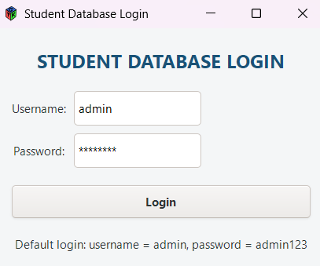

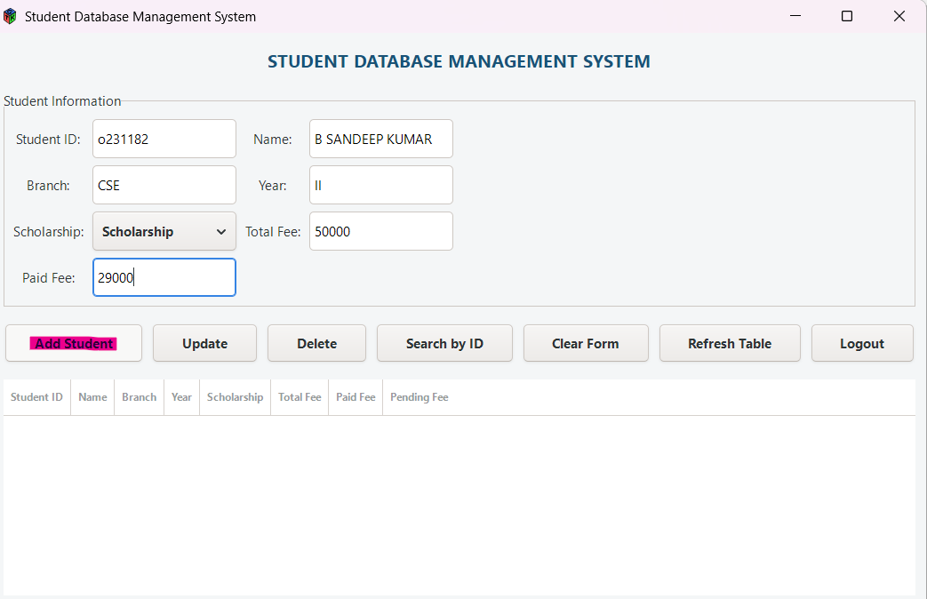

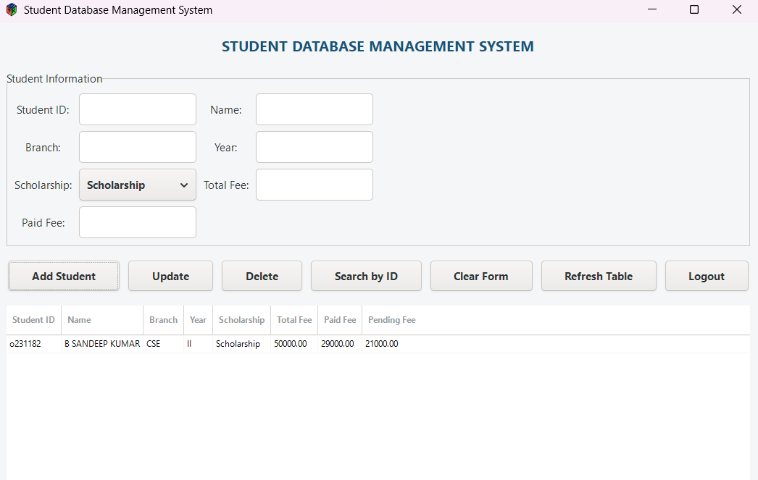

Complexity and Properties
Login, Add, Search-by-ID, Update, and Delete each rely on a single SQL statement using the primary/indexed key, so each is effectively O(1)* (B-tree indexed lookup). A full table refresh is O(n), since every row is read and sorted. Extra space is O(n) — one GtkListStore row per displayed record, and the SQLite file itself grows linearly with the number of records. This is a stateful, persistent application (unlike a plain sorting program) — state survives program restarts through the database file.

Additional test observations
- Login with wrong password → "Invalid username or password."
- Add Student with duplicate Student ID → "Student ID already exists. Use Update instead."
- Delete non-existent Student ID → "Student ID not found."

Viva questions
- Why use prepared statements (sqlite3_prepare_v2) instead of building SQL strings directly? Prevents SQL injection and handles special characters safely.
- Why is the primary key on student_id important for performance? It lets SQLite use a B-tree index for near-constant-time lookup instead of a full table scan.
- What happens to the data when the program closes? It persists in student_database.db because SQLite writes to disk.

Result: A GUI-based Student Database Management System with login authentication was developed and executed successfully; CRUD operations and permanent SQLite storage were verified.

Experiment 2 - GUI-Based Student Information Search Application

Date : __________ Faculty signature : ____________________

Aim : To develop a small graphical desktop application in C that accepts a Student ID, searches an array of student structures using linear search, and displays the corresponding student details in a GUI built with GTK 3.

Software required : C compiler supporting C11, GTK 3 development libraries, a text editor.

Concept
Unlike Experiment 1, this program keeps its data in a fixed in-memory array of structures (no database), and demonstrates linear search directly on that array in response to a GUI button click, connected through GTK's signal/callback mechanism.

Algorithm
- Declare a fixed array of Student structures with sample records.
- Build a window containing an entry box, Search and Clear buttons, and a result label.
- On "Search" click (or Enter key), read the entered ID and validate it is numeric.
- Traverse the array from index 0; compare students[i].id with the entered ID.
- If a match is found, format and display the student's details; otherwise display "STUDENT NOT FOUND".
- On "Clear" click, reset the entry box and result label to their defaults.

Worked observation
Iteration | i | students[i].id | Comparison | Result
1 | 0 | 101 | 101 == 103? | False
2 | 1 | 102 | 102 == 103? | False
3 | 2 | 103 | 103 == 103? | True → display record

C program
#include <gtk/gtk.h>
#include <stdio.h>
#include <stdlib.h>
#include <string.h>

#define TOTAL_STUDENTS 5

struct Student
{
int id;
char name[50];
char branch[20];
int year;
float feeDue;
char hostel[50];
};

struct Student students[TOTAL_STUDENTS] =
{
{101, "Ravi Kumar", "CSE", 2, 0, "Krishna Hostel"},
{102, "Suresh Babu", "ECE", 3, 12500, "Godavari Hostel"},
{103, "Anjali", "CSE", 2, 5000, "Krishna Hostel"},
{104, "Praveen", "EEE", 4, 0, "Penna Hostel"},
{105, "Divya", "MECH", 3, 8500, "Godavari Hostel"}
};

GtkWidget *entry_id;
GtkWidget *label_result;

void search_student(GtkWidget *widget, gpointer data)
{
const char *id_text;
char *end_pointer;
long entered_id;
int i;
int found = 0;
char result[600];
(void)widget;
(void)data;

id_text = gtk_entry_get_text(GTK_ENTRY(entry_id));
if (strlen(id_text) == 0)
{
gtk_label_set_text(GTK_LABEL(label_result), "Please enter a Student ID.");
return;
}

entered_id = strtol(id_text, &end_pointer, 10);
if (*end_pointer != '\0' || entered_id <= 0)
{
gtk_label_set_text(GTK_LABEL(label_result), "Invalid ID. Enter numbers only.");
return;
}

for (i = 0; i < TOTAL_STUDENTS; i++)
{
if (students[i].id == entered_id)
{
if (students[i].feeDue == 0)
{
snprintf(result, sizeof(result),
"STUDENT FOUND\n\nID : %d\nName : %s\nBranch : %s\nYear : %d\nHostel : %s\nFee Status : PAID",
students[i].id, students[i].name, students[i].branch, students[i].year, students[i].hostel);
}
else
{
snprintf(result, sizeof(result),
"STUDENT FOUND\n\nID : %d\nName : %s\nBranch : %s\nYear : %d\nHostel : %s\nFee Due : Rs. %.2f",
students[i].id, students[i].name, students[i].branch, students[i].year, students[i].hostel, students[i].feeDue);
}
gtk_label_set_text(GTK_LABEL(label_result), result);
found = 1;
break;
}
}

if (found == 0)
{
gtk_label_set_text(GTK_LABEL(label_result), "STUDENT NOT FOUND\n\nNo student exists with the entered ID.");
}
}

void clear_data(GtkWidget *widget, gpointer data)
{
(void)widget;
(void)data;
gtk_entry_set_text(GTK_ENTRY(entry_id), "");
gtk_label_set_text(GTK_LABEL(label_result), "Student details will appear here.");
gtk_widget_grab_focus(entry_id);
}

void activate(GtkApplication *app, gpointer user_data)
{
GtkWidget *window, *main_box, *title_label, *instruction_label;
GtkWidget *button_box, *search_button, *clear_button, *result_frame;
(void)user_data;

window = gtk_application_window_new(app);
gtk_window_set_title(GTK_WINDOW(window), "RGUKT Student Finder");
gtk_window_set_default_size(GTK_WINDOW(window), 600, 500);
gtk_container_set_border_width(GTK_CONTAINER(window), 25);

main_box = gtk_box_new(GTK_ORIENTATION_VERTICAL, 15);
gtk_container_add(GTK_CONTAINER(window), main_box);

title_label = gtk_label_new("RGUKT STUDENT FINDER");
gtk_box_pack_start(GTK_BOX(main_box), title_label, FALSE, FALSE, 5);

instruction_label = gtk_label_new("Enter Student ID");
gtk_box_pack_start(GTK_BOX(main_box), instruction_label, FALSE, FALSE, 0);

entry_id = gtk_entry_new();
gtk_entry_set_placeholder_text(GTK_ENTRY(entry_id), "Example: 103");
gtk_entry_set_max_length(GTK_ENTRY(entry_id), 10);
gtk_box_pack_start(GTK_BOX(main_box), entry_id, FALSE, FALSE, 0);

button_box = gtk_box_new(GTK_ORIENTATION_HORIZONTAL, 10);
gtk_box_set_homogeneous(GTK_BOX(button_box), TRUE);
gtk_box_pack_start(GTK_BOX(main_box), button_box, FALSE, FALSE, 0);

search_button = gtk_button_new_with_label("SEARCH STUDENT");
clear_button = gtk_button_new_with_label("CLEAR");
gtk_box_pack_start(GTK_BOX(button_box), search_button, TRUE, TRUE, 0);
gtk_box_pack_start(GTK_BOX(button_box), clear_button, TRUE, TRUE, 0);

result_frame = gtk_frame_new("Search Result");
gtk_box_pack_start(GTK_BOX(main_box), result_frame, TRUE, TRUE, 10);

label_result = gtk_label_new("Student details will appear here.");
gtk_label_set_xalign(GTK_LABEL(label_result), 0.0);
gtk_label_set_yalign(GTK_LABEL(label_result), 0.0);
gtk_label_set_selectable(GTK_LABEL(label_result), TRUE);
gtk_container_set_border_width(GTK_CONTAINER(label_result), 20);
gtk_container_add(GTK_CONTAINER(result_frame), label_result);

g_signal_connect(search_button, "clicked", G_CALLBACK(search_student), NULL);
g_signal_connect(clear_button, "clicked", G_CALLBACK(clear_data), NULL);
g_signal_connect(entry_id, "activate", G_CALLBACK(search_student), NULL);

gtk_widget_show_all(window);
gtk_widget_grab_focus(entry_id);
}

int main(int argc, char **argv)
{
GtkApplication *app;
int status;
app=gtk_application_new("in.ac.rgukt.studentfinder",G_APPLICATION_FLAGS_NONE);
g_signal_connect(app, "activate", G_CALLBACK(activate), NULL);
status = g_application_run(G_APPLICATION(app), argc, argv);
g_object_unref(app);
return status;
}

Sample execution

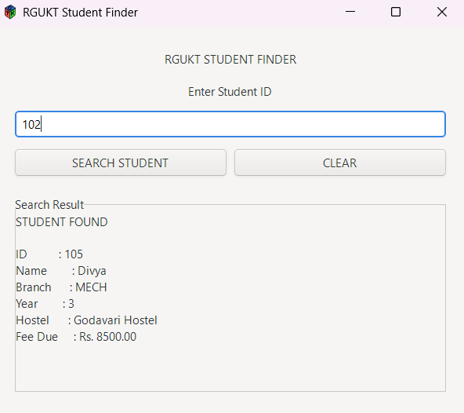

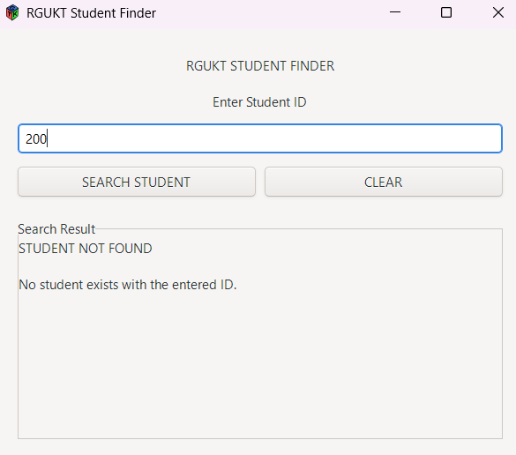
Complexity and Properties
Best case O(1) — ID at index 0. Worst case O(N) — ID at end or absent (N = TOTAL_STUDENTS = 5, fixed). Extra space O(N) for the array (bounded), and O(1) for local variables and widget objects.

Additional test observations
- ID = 101 → PAID status shown.
- Empty entry, click Search → "Please enter a Student ID."
- Entry = "10a" → "Invalid ID. Enter numbers only."

Viva questions
- Why is linear search sufficient here instead of binary search? The array is unsorted by ID and very small (N = 5), so a full scan is cheap and simple.
- What triggers search_student() besides the Search button? Pressing Enter inside the ID entry box ("activate" signal).
- Why check *end_pointer != '\0' after strtol? To detect trailing non-numeric characters and reject invalid input.

Result : A GUI-based Student Information Search Application was developed successfully; linear search correctly located and displayed matching records, and correctly reported "not found" for absent IDs.

Experiment 3 - Student Fee Management System

Date : __________ Faculty signature : _____

Aim : To design and implement a menu-driven C program using structures, arrays, and file handling that maintains student fee records — supporting addition, search, update, deletion, display, sorting, and permanent CSV storage.

Software required : C compiler supporting C11, a text editor.

Concept
Records are held in an array of Student structures in memory during program execution, and are loaded from / saved to a CSV file (students_fee_records.csv) at startup and after every modification, so data persists between runs without needing a database.

Algorithm
- On startup, call loadRecords() to read existing CSV data into the array.
- Display a menu; based on the user's choice, call the corresponding function (Add, Search, Update, Delete, Display, Sort, etc.).
- addStudent() — check for duplicate ID with findStudentById() (linear scan); if unique, append to the array.
- searchStudent()/updateStudent()/deleteStudent() — locate the record via findStudentById(), then act on it (display, modify, or shift-and-remove).
- sortByPendingFee()/sortByName() — copy records into a temporary array and sort using qsort() with a custom comparator.
- After every modification, call saveRecords() to rewrite the entire CSV file.
- Repeat until the user selects Exit.

Worked observation
Operation | Before | After
Add S101 (Total 40000, Paid 30000) | 0 records | 1 record, Pending = 10000
Update: add payment 10000 | Paid = 30000 | Paid = 40000, Status = FULLY PAID
Sort by Pending Fee | Unsorted | Highest pending first
Delete S101 | 1 record | 0 records

C program
#include <stdio.h>
#include <stdlib.h>
#include <string.h>
#include <ctype.h>

#define MAX_STUDENTS 1000
#define DATA_FILE "students_fee_records.csv"

typedef struct {
char id[20];
char name[60];
char branch[30];
char year[15];
char scholarship[25];
double tuitionFee;
double hostelFee;
double messFee;
double examFee;
double otherFee;
double paidFee;
} Student;

void clearScreen();
void pauseScreen();
void printMainHeader(int count);
void printLine(char ch, int length);
void trimNewline(char str[]);
void sanitizeInput(char str[]);
void inputString(const char *label, char value[], int size);
int inputInt(const char *label, int min, int max);
double inputDouble(const char *label, double min);
double getTotalFee(Student s);
double getPendingFee(Student s);
void loadRecords(Student students[], int *count);
void saveRecords(Student students[], int count);
int findStudentById(Student students[], int count, const char id[]);
void addStudent(Student students[], int *count);
void searchStudent(Student students[], int count);
void displayStudentDetails(Student s);
void displayAllStudents(Student students[], int count);
void updateStudent(Student students[], int count);
void deleteStudent(Student students[], int *count);
void displayPendingStudents(Student students[], int count);
void displayScholarshipStudents(Student students[], int count);
void displayNonScholarshipStudents(Student students[], int count);
void sortByPendingFee(Student students[], int count);
void sortByName(Student students[], int count);
void printTableHeader();
void printStudentRow(Student s, int serialNo);
int comparePendingDesc(const void *a, const void *b);
int compareNameAsc(const void *a, const void *b);

int main() {
Student students[MAX_STUDENTS];
int count = 0;
int choice;
loadRecords(students, &count);
while (1) {
clearScreen();
printMainHeader(count);
printf("\n");
printf(" 1. Add New Student Fee Record\n");
printf(" 2. Search Student by ID\n");
printf(" 3. Display All Student Records\n");
printf(" 4. Update Fee / Student Details\n");
printf(" 5. Delete Student Record\n");
printf(" 6. Display Pending Fee Students\n");
printf(" 7. Display Scholarship Students\n");
printf(" 8. Display Non-Scholarship Students\n");
printf(" 9. Sort Records by Pending Fee\n");
printf("10. Sort Records by Student Name\n");
printf("11. Save Records Manually\n");
printf("12. Exit\n\n");
printLine('-', 72);
choice = inputInt("Enter your choice", 1, 12);
clearScreen();
switch (choice) {
case 1: addStudent(students, &count); saveRecords(students, count); break;
case 2: searchStudent(students, count); break;
case 3: displayAllStudents(students, count); break;
case 4: updateStudent(students, count); saveRecords(students, count); break;
case 5: deleteStudent(students, &count); saveRecords(students, count); break;
case 6: displayPendingStudents(students, count); break;
case 7: displayScholarshipStudents(students, count); break;
case 8: displayNonScholarshipStudents(students, count); break;
case 9: sortByPendingFee(students, count); break;
case 10: sortByName(students, count); break;
case 11:
saveRecords(students, count);
printf("\nRecords saved successfully into '%s'.\n", DATA_FILE);
break;
case 12:
saveRecords(students, count);
printf("\nThank you. Records saved successfully.\n");
printf("Exiting Student Fee Management System...\n\n");
return 0;
}
pauseScreen();
}
return 0;
}

void clearScreen() {
#ifdef _WIN32
system("cls");
#else
system("clear");
#endif
}

void pauseScreen() {
char temp[10];
printf("\nPress ENTER to continue...");
fgets(temp, sizeof(temp), stdin);
}

void printLine(char ch, int length) {
int i;
for (i = 0; i < length; i++) putchar(ch);
putchar('\n');
}

void printMainHeader(int count) {
printLine('=', 72);
printf(" STUDENT FEE MANAGEMENT SYSTEM\n");
printf(" RGUKT ONGOLE CAMPUS\n");
printLine('=', 72);
printf(" Total Records: %d\n", count);
printLine('-', 72);
}

void trimNewline(char str[]) { str[strcspn(str, "\n")] = '\0'; }

void sanitizeInput(char str[]) {
int i;
for (i = 0; str[i] != '\0'; i++) {
if (str[i] == ',') str[i] = ' ';
}
}
void inputString(const char *label, char value[], int size) {
while (1) {
printf("%s: ", label);
if (fgets(value, size, stdin) == NULL) { printf("Invalid input. Try again.\n"); continue; }
trimNewline(value);
sanitizeInput(value);
if (strlen(value) == 0) printf("This field cannot be empty. Try again.\n");
else break;
}
}

int inputInt(const char *label, int min, int max) {
char buffer[100];
int value;
char extra;
while (1) {
printf("%s (%d-%d): ", label, min, max);
if (fgets(buffer, sizeof(buffer), stdin) == NULL) { printf("Invalid input. Try again.\n"); continue; }
if (sscanf(buffer, "%d %c", &value, &extra) != 1) { printf("Enter a valid number.\n"); continue; }
if (value < min || value > max) { printf("Enter a number between %d and %d.\n", min, max); continue; }
return value;
}
}

double inputDouble(const char *label, double min) {
char buffer[100];
double value;
char extra;
while (1) {
printf("%s: ", label);
if (fgets(buffer, sizeof(buffer), stdin) == NULL) { printf("Invalid input. Try again.\n"); continue; }
if (sscanf(buffer, "%lf %c", &value, &extra) != 1) { printf("Enter a valid amount.\n"); continue; }
if (value < min) { printf("Amount cannot be less than %.2lf.\n", min); continue; }
return value;
}
}

double getTotalFee(Student s) { return s.tuitionFee + s.hostelFee + s.messFee + s.examFee + s.otherFee; }
double getPendingFee(Student s) { return getTotalFee(s) - s.paidFee; }

void loadRecords(Student students[], int *count) {
FILE *fp;
char line[500];
char *token;
int field;
fp = fopen(DATA_FILE, "r");
if (fp == NULL) { *count = 0; return; }
*count = 0;
fgets(line, sizeof(line), fp);
while (fgets(line, sizeof(line), fp) != NULL) {
Student s;
field = 0;
memset(&s, 0, sizeof(Student));
token = strtok(line, ",\n");
while (token != NULL) {
switch (field) {
case 0: strncpy(s.id, token, sizeof(s.id) - 1); break;
case 1: strncpy(s.name, token, sizeof(s.name) - 1); break;
case 2: strncpy(s.branch, token, sizeof(s.branch) - 1); break;
case 3: strncpy(s.year, token, sizeof(s.year) - 1); break;
case 4: strncpy(s.scholarship, token, sizeof(s.scholarship) - 1); break;
case 5: s.tuitionFee = atof(token); break;
case 6: s.hostelFee = atof(token); break;
case 7: s.messFee = atof(token); break;
case 8: s.examFee = atof(token); break;
case 9: s.otherFee = atof(token); break;
case 10: s.paidFee = atof(token); break;
}
field++;
token = strtok(NULL, ",\n");
}
if (field >= 11 && *count < MAX_STUDENTS) { students[*count] = s; (*count)++; }
}
fclose(fp);
}

void saveRecords(Student students[], int count) {
FILE *fp;
int i;
fp = fopen(DATA_FILE, "w");
if (fp == NULL) { printf("\nError: Unable to save records.\n"); return; }
fprintf(fp, "ID,Name,Branch,Year,Scholarship,TuitionFee,HostelFee,MessFee,ExamFee,OtherFee,PaidFee\n");
for (i = 0; i < count; i++) {
fprintf(fp, "%s,%s,%s,%s,%s,%.2lf,%.2lf,%.2lf,%.2lf,%.2lf,%.2lf\n",
students[i].id, students[i].name, students[i].branch, students[i].year, students[i].scholarship,
students[i].tuitionFee, students[i].hostelFee, students[i].messFee, students[i].examFee,
students[i].otherFee, students[i].paidFee);
}
fclose(fp);
}

int findStudentById(Student students[], int count, const char id[]) {
int i;
for (i = 0; i < count; i++) if (strcmp(students[i].id, id) == 0) return i;
return -1;
}

void addStudent(Student students[], int *count) {
Student s;
char id[20];
int index;
int scholarshipChoice;
printMainHeader(*count);
printf("\nADD NEW STUDENT FEE RECORD\n");
printLine('-', 72);
if (*count >= MAX_STUDENTS) { printf("\nRecord limit reached. Cannot add more students.\n"); return; }
inputString("Enter Student ID", id, sizeof(id));
index = findStudentById(students, *count, id);
if (index != -1) {
printf("\nA student with this ID already exists.\n");
printf("Use update option to modify the existing record.\n");
return;
}
memset(&s, 0, sizeof(Student));
strcpy(s.id, id);
inputString("Enter Student Name", s.name, sizeof(s.name));
inputString("Enter Branch / Section", s.branch, sizeof(s.branch));
inputString("Enter Year / Class", s.year, sizeof(s.year));
printf("\nScholarship Status\n1. Scholarship\n2. Non-Scholarship\n");
scholarshipChoice = inputInt("Choose status", 1, 2);
strcpy(s.scholarship, scholarshipChoice == 1 ? "Scholarship" : "Non-Scholarship");
printf("\nEnter Fee Details\n");
printLine('-', 72);
s.tuitionFee = inputDouble("Tuition Fee", 0);
s.hostelFee = inputDouble("Hostel Fee", 0);
s.messFee = inputDouble("Mess Fee", 0);
s.examFee = inputDouble("Exam Fee", 0);
s.otherFee = inputDouble("Other Fee", 0);
s.paidFee = inputDouble("Amount Already Paid", 0);
students[*count] = s;
(*count)++;
printf("\nStudent fee record added successfully.\nRecord saved automatically.\n");
}

void searchStudent(Student students[], int count) {
char id[20];
int index;
printMainHeader(count);
printf("\nSEARCH STUDENT BY ID\n");
printLine('-', 72);
if (count == 0) { printf("\nNo records available.\n"); return; }
inputString("Enter Student ID", id, sizeof(id));
index = findStudentById(students, count, id);
if (index == -1) printf("\nNo student found with ID: %s\n", id);
else displayStudentDetails(students[index]);
}

void displayStudentDetails(Student s) {
double total = getTotalFee(s);
double pending = getPendingFee(s);
printf("\n");
printLine('=', 72);
printf(" STUDENT FEE DETAILS\n");
printLine('=', 72);
printf(" Student ID : %s\n", s.id);
printf(" Student Name : %s\n", s.name);
printf(" Branch / Section : %s\n", s.branch);
printf(" Year / Class : %s\n", s.year);
printf(" Scholarship Status : %s\n", s.scholarship);
printLine('-', 72);
printf(" Tuition Fee : Rs. %10.2lf\n", s.tuitionFee);
printf(" Hostel Fee : Rs. %10.2lf\n", s.hostelFee);
printf(" Mess Fee : Rs. %10.2lf\n", s.messFee);
printf(" Exam Fee : Rs. %10.2lf\n", s.examFee);
printf(" Other Fee : Rs. %10.2lf\n", s.otherFee);
printLine('-', 72);
printf(" Total Fee : Rs. %10.2lf\n", total);
printf(" Paid Fee : Rs. %10.2lf\n", s.paidFee);
if (pending > 0) {
printf(" Pending Fee : Rs. %10.2lf\n", pending);
printf(" Fee Status : PENDING\n");
} else if (pending == 0) {
printf(" Pending Fee : Rs. %10.2lf\n", 0.00);
printf(" Fee Status : FULLY PAID\n");
} else {
printf(" Pending Fee : Rs. %10.2lf\n", 0.00);
printf(" Extra Paid Amount : Rs. %10.2lf\n", -pending);
printf(" Fee Status : EXTRA PAID / ADVANCE\n");
}
printLine('=', 72);
}

void displayAllStudents(Student students[], int count) {
int i;
printMainHeader(count);
printf("\nALL STUDENT FEE RECORDS\n");
printLine('-', 118);
if (count == 0) { printf("\nNo records available.\n"); return; }
printTableHeader();
for (i = 0; i < count; i++) printStudentRow(students[i], i + 1);
printLine('-', 118);
}

void updateStudent(Student students[], int count) {
char id[20];
int index, choice, scholarshipChoice;
double amount;
printMainHeader(count);
printf("\nUPDATE STUDENT FEE / DETAILS\n");
printLine('-', 72);
if (count == 0) { printf("\nNo records available.\n"); return; }
inputString("Enter Student ID", id, sizeof(id));
index = findStudentById(students, count, id);
if (index == -1) { printf("\nNo student found with ID: %s\n", id); return; }
displayStudentDetails(students[index]);
printf("\nWhat do you want to update?\n1. Add Fee Payment\n2. Set Paid Fee Amount\n3. Edit Fee Components\n4. Edit Student Personal Details\n5. Edit Scholarship Status\n6. Cancel Update\n");
choice = inputInt("Enter choice", 1, 6);
switch (choice) {
case 1:
amount = inputDouble("Enter additional payment amount", 0);
students[index].paidFee += amount;
printf("\nPayment added successfully.\n");
break;
case 2:
students[index].paidFee = inputDouble("Enter new paid fee amount", 0);
printf("\nPaid fee updated successfully.\n");
break;
case 3:
printf("\nEnter Updated Fee Components\n");
printLine('-', 72);
students[index].tuitionFee = inputDouble("Tuition Fee", 0);
students[index].hostelFee = inputDouble("Hostel Fee", 0);
students[index].messFee = inputDouble("Mess Fee", 0);
students[index].examFee = inputDouble("Exam Fee", 0);
students[index].otherFee = inputDouble("Other Fee", 0);
printf("\nFee components updated successfully.\n");
break;
case 4:
inputString("Enter Updated Student Name", students[index].name, sizeof(students[index].name));
inputString("Enter Updated Branch / Section", students[index].branch, sizeof(students[index].branch));
inputString("Enter Updated Year / Class", students[index].year, sizeof(students[index].year));
printf("\nStudent details updated successfully.\n");
break;
case 5:
printf("\nScholarship Status\n1. Scholarship\n2. Non-Scholarship\n");
scholarshipChoice = inputInt("Choose status", 1, 2);
strcpy(students[index].scholarship, scholarshipChoice == 1 ? "Scholarship" : "Non-Scholarship");
printf("\nScholarship status updated successfully.\n");
break;
case 6:
printf("\nUpdate cancelled.\n");
return;
}
printf("Record saved automatically.\n");
}

void deleteStudent(Student students[], int *count) {
char id[20];
int index, confirm, i;
printMainHeader(*count);
printf("\nDELETE STUDENT RECORD\n");
printLine('-', 72);
if (*count == 0) { printf("\nNo records available.\n"); return; }
inputString("Enter Student ID to delete", id, sizeof(id));
index = findStudentById(students, *count, id);
if (index == -1) { printf("\nNo student found with ID: %s\n", id); return; }
displayStudentDetails(students[index]);
printf("\nAre you sure you want to delete this record?\n1. Yes, delete\n2. No, cancel\n");
confirm = inputInt("Enter choice", 1, 2);
if (confirm == 2) { printf("\nDelete cancelled.\n"); return; }
for (i = index; i < *count - 1; i++) students[i] = students[i + 1];
(*count)--;
printf("\nStudent record deleted successfully.\nRecords saved automatically.\n");
}

void displayPendingStudents(Student students[], int count) {
int i, found = 0;
printMainHeader(count);
printf("\nPENDING FEE STUDENTS\n");
printLine('-', 118);
if (count == 0) { printf("\nNo records available.\n"); return; }
printTableHeader();
for (i = 0; i < count; i++) {
if (getPendingFee(students[i]) > 0) { printStudentRow(students[i], found + 1); found++; }
}
printLine('-', 118);
if (found == 0) printf("\nNo pending fee records found.\n");
else printf("\nTotal Pending Students: %d\n", found);
}

void displayScholarshipStudents(Student students[], int count) {
int i, found = 0;
printMainHeader(count);
printf("\nSCHOLARSHIP STUDENTS\n");
printLine('-', 118);
if (count == 0) { printf("\nNo records available.\n"); return; }
printTableHeader();
for (i = 0; i < count; i++) {
if (strcmp(students[i].scholarship, "Scholarship") == 0) { printStudentRow(students[i], found + 1); found++; }
}
printLine('-', 118);
if (found == 0) printf("\nNo scholarship student records found.\n");
else printf("\nTotal Scholarship Students: %d\n", found);
}

void displayNonScholarshipStudents(Student students[], int count) {
int i, found = 0;
printMainHeader(count);
printf("\nNON-SCHOLARSHIP STUDENTS\n");
printLine('-', 118);
if (count == 0) { printf("\nNo records available.\n"); return; }
printTableHeader();
for (i = 0; i < count; i++) {
if (strcmp(students[i].scholarship, "Non-Scholarship") == 0) { printStudentRow(students[i], found + 1); found++; }
}
printLine('-', 118);
if (found == 0) printf("\nNo non-scholarship student records found.\n");
else printf("\nTotal Non-Scholarship Students: %d\n", found);
}

void sortByPendingFee(Student students[], int count) {
Student temp[MAX_STUDENTS];
int i;
printMainHeader(count);
printf("\nSTUDENTS SORTED BY PENDING FEE - HIGHEST FIRST\n");
printLine('-', 118);
if (count == 0) { printf("\nNo records available.\n"); return; }
for (i = 0; i < count; i++) temp[i] = students[i];
qsort(temp, count, sizeof(Student), comparePendingDesc);
printTableHeader();
for (i = 0; i < count; i++) printStudentRow(temp[i], i + 1);
printLine('-', 118);
}

void sortByName(Student students[], int count) {
Student temp[MAX_STUDENTS];
int i;
printMainHeader(count);
printf("\nSTUDENTS SORTED BY NAME - A TO Z\n");
printLine('-', 118);
if (count == 0) { printf("\nNo records available.\n"); return; }
for (i = 0; i < count; i++) temp[i] = students[i];
qsort(temp, count, sizeof(Student), compareNameAsc);
printTableHeader();
for (i = 0; i < count; i++) printStudentRow(temp[i], i + 1);
printLine('-', 118);
}

int comparePendingDesc(const void *a, const void *b) {
Student s1 = *(Student *)a;
Student s2 = *(Student *)b;
double p1 = getPendingFee(s1);
double p2 = getPendingFee(s2);
if (p1 < p2) return 1;
if (p1 > p2) return -1;
return 0;
}

int compareNameAsc(const void *a, const void *b) {
Student s1 = *(Student *)a;
Student s2 = *(Student *)b;
return strcmp(s1.name, s2.name);
}

void printTableHeader() {
printf("%-5s %-14s %-22s %-12s %-8s %-17s %12s %12s %12s\n",
"S.No", "Student ID", "Name", "Branch", "Year", "Scholarship", "Total", "Paid", "Pending");
printLine('-', 118);
}

void printStudentRow(Student s, int serialNo) {
double total = getTotalFee(s);
double pending = getPendingFee(s);
if (pending < 0) pending = 0;
printf("%-5d %-14.14s %-22.22s %-12.12s %-8.8s %-17.17s %12.2lf %12.2lf %12.2lf\n",
serialNo, s.id, s.name, s.branch, s.year, s.scholarship, total, s.paidFee, pending);
}

Sample execution

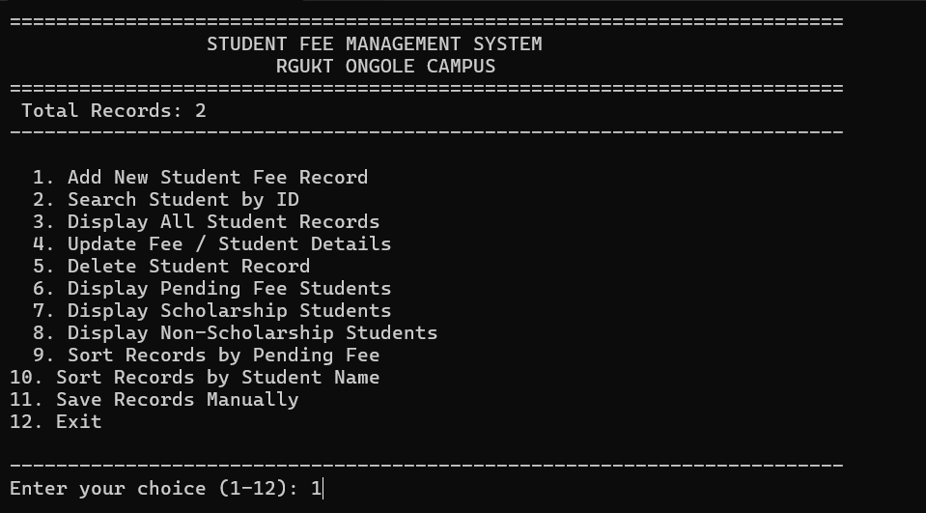

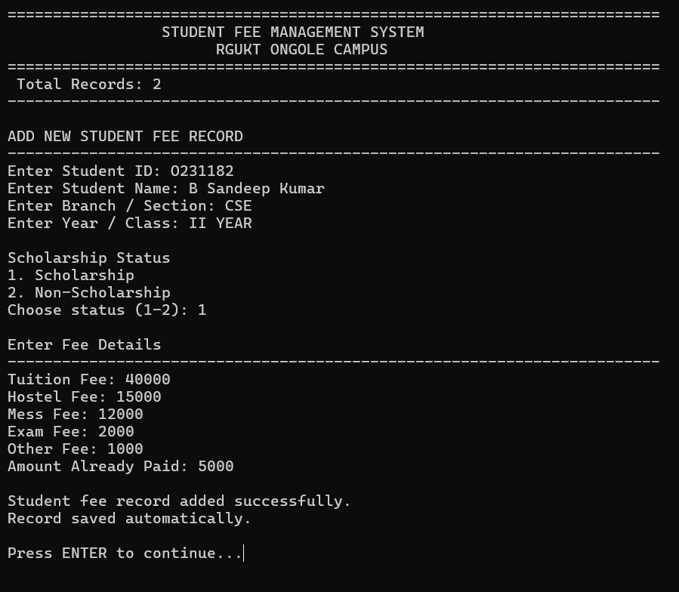

Complexity and Properties
Add/Search/Update/Delete/Display-filter operations are all O(n) because findStudentById() performs a linear scan. Sorting is O(n log n) via qsort(). Loading and saving the CSV are O(n). Extra space O(n) — bounded by MAX_STUDENTS = 1000, plus a temporary array of the same size used during sorting.

Additional test observations
- Add duplicate Student ID → "A student with this ID already exists."
- Delete non-existent ID → "No student found with ID."
- Sort by Pending Fee on empty list → "No records available."

Viva questions
- Why is the CSV rewritten completely on every save instead of appending? Because updates and deletes change existing rows/positions, not just add new ones.
- Why use qsort() instead of writing bubble sort manually here? qsort() is a tested, generic library routine (O(n log n) average), more efficient than writing an O(n²) sort by hand.
- What happens if a name contains a comma? sanitizeInput() replaces commas with spaces to avoid corrupting the CSV format.

Result : The Student Fee Management System was implemented and executed successfully; add, search, update, delete, filter, sort, and persistent CSV storage were all verified.

Experiment 4 - Basic Array, Searching and Sorting Programs

Date : __________ Faculty signature : ____________________

Aim : To write and execute a set of basic C programs demonstrating array operations, linear search, and the three elementary sorting algorithms (Bubble, Selection, Insertion), including single-pass and instrumented variants.

Software required : C compiler supporting C11, a text editor.

Program 4.1 - Read and Display an Array

Concept : An array is a fixed-size collection of elements of the same type stored in contiguous memory, accessed using an index. Reading elements into it and displaying them is the most basic array operation, forming the foundation for every other program in this set.

Algorithm
- Read n, the number of elements.
- Using a loop, read n integers into array a.
- Using a second loop, print all n elements of a.

Worked observation
Step | Action | Array state
Input n = 5 | — | uninitialized
Read loop | Reads 9, 4, 7, 2, 6 | a = {9,4,7,2,6}
Display loop | Prints each element | Output: 9 4 7 2 6

C program
#include <stdio.h>
int main() {
int n, i;
int a[50];
printf("Enter number of elements: ");
scanf("%d", &n);
printf("Enter %d elements: ", n);
for(i = 0; i < n; i++) {
scanf("%d", &a[i]);
}
printf("Array elements are: ");
for(i = 0; i < n; i++) {
printf("%d ", a[i]);
}
return 0;}
Sample execution

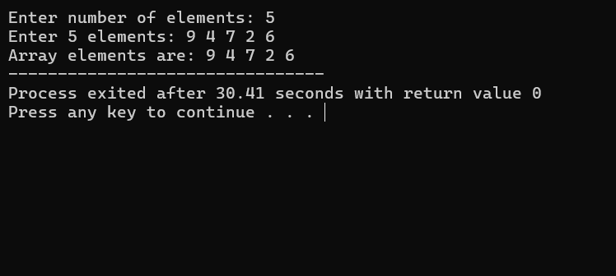

Complexity and Properties : Two separate loops each run n times (one to read, one to display) → Time O(n). One array of size n is used → Space O(n).

Program 4.2 - Find the Sum of Array Elements

Concept : Aggregation over an array means combining all its elements into a single summary value using an accumulator variable, updated once per element in a single pass.

Algorithm
- Read n and initialize sum = 0.
- For each element read, immediately add it to sum.
- Print the final value of sum.

Worked observation
i | a[i] | sum after adding
0 | 3 | 3
1 | 5 | 8
2 | 2 | 10
3 | 8 | 18

C program
#include <stdio.h>
int main() {
int n, i, sum = 0;
int a[50];
printf("Enter number of elements: ");
scanf("%d", &n);
printf("Enter %d elements: ", n);
for(i = 0; i < n; i++) {
scanf("%d", &a[i]);
sum = sum + a[i];
}
printf("Sum = %d", sum);
return 0;
}

Sample execution

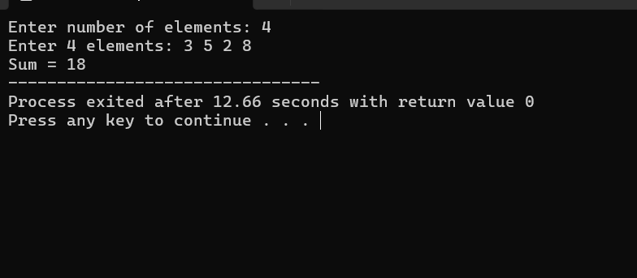

Complexity and Properties : A single loop runs n times, reading and adding each element once → Time O(n). One array of size n plus one accumulator variable → Space O(n).

Program 4.3 - Find the Largest Element in an Array

Concept : Finding an extreme value (max/min) uses a running-best variable, initialized to the first element, then updated whenever a strictly better candidate is found while scanning the rest of the array once.

Algorithm
- Read n elements into a.
- Set max = a[0].
- For i from 1 to n−1, if a[i] > max, update max = a[i].
- Print max.

Worked observation
i | a[i] | max after comparison
— | a[0]=12 | 12
1 | 5 | 12 (unchanged)
2 | 19 | 19 (updated)
3 | 7 | 19 (unchanged)

C program
#include <stdio.h>
int main() {
int n, i, max;
int a[50];
printf("Enter number of elements: ");
scanf("%d", &n);
printf("Enter %d elements: ", n);
for(i = 0; i < n; i++) {
scanf("%d", &a[i]);
}
max = a[0];
for(i = 1; i < n; i++) {
if(a[i] > max) {
max = a[i];
}
}
printf("Largest element = %d", max);
return 0;
}

Sample execution

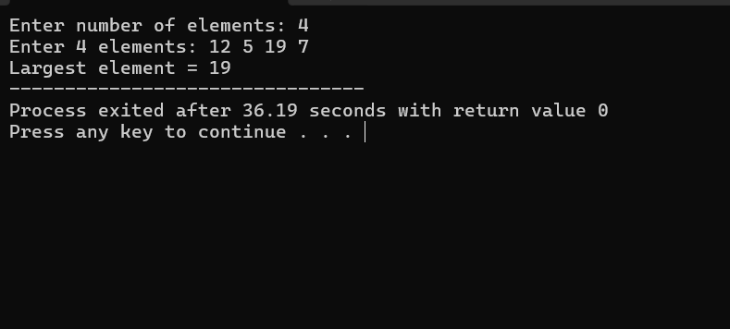

Complexity and Properties : Reading loop O(n) + comparison loop O(n) → Time O(n). One array of size n plus one variable → Space O(n).

Program 4.4 - Find the Smallest Element in an Array

Concept : Identical strategy to finding the maximum, but the comparison is reversed — the running-best variable is updated whenever a strictly smaller candidate is found.

Algorithm
- Read n elements into a.
- Set min = a[0].
- For i from 1 to n−1, if a[i] < min, update min = a[i].
- Print min.
Worked observation
i | a[i] | min after comparison
— | a[0]=12 | 12
1 | 5 | 5 (updated)
2 | 19 | 5 (unchanged)
3 | 7 | 5 (unchanged)
C program
#include <stdio.h>
int main() {
int n, i, min;
int a[50];
printf("Enter number of elements: ");
scanf("%d", &n);
printf("Enter %d elements: ", n);
for (i = 0; i < n; i++) {
scanf("%d", &a[i]);
}
min = a[0];
for (i = 1; i < n; i++) {
if (a[i] < min) {
min = a[i];
}
}
printf("Smallest element = %d", min);
return 0;
}

Sample execution

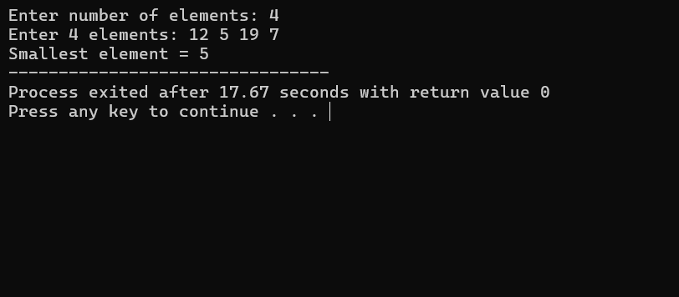

Complexity and Properties : One loop to read (O(n)) and one loop to compare each element with min (O(n)) → Time O(n). One array of size n → Space O(n).

Program 4.5 - Swap Two Numbers Using a Temporary Variable

Concept : Swapping two variables directly (a = b; b = a;) loses the original value of a. A third, temporary variable is used to hold one value safely while the exchange happens.

Algorithm
- Read two integers a and b.
- Store a in temp.
- Assign b to a.
- Assign temp (the original a) to b.
- Print the swapped values.

Worked observation
Step | a | b | temp
Initial | 10 | 25 | —
temp = a | 10 | 25 | 10
a = b | 25 | 25 | 10
b = temp | 25 | 10 | 10

C program
#include <stdio.h>
int main() {
int a, b, temp;
printf("Enter two numbers: ");
scanf("%d %d", &a, &b);
temp = a;
a = b;
b = temp;
printf("After swapping: a = %d, b = %d", a, b);
return 0;
}

Sample execution

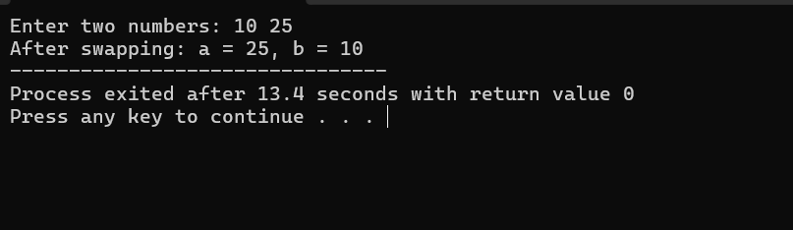

Complexity and Properties : Only a fixed number of assignment operations are performed regardless of input → Time O(1). Only three variables (a, b, temp) are used → Space O(1).
Program 4.6 - Swap Adjacent Elements in an Array

Concept : Extending the two-variable swap idea to pairs of neighbouring array elements: the array is processed two positions at a time, swapping each pair using a temporary variable.

Algorithm
- Read n elements into a.
- For i = 0, 2, 4, ... (step 2) while i < n−1, swap a[i] and a[i+1] using temp.
- Print the resulting array.

Worked observation
Pair index i | Before | After
0 | (9,4) | (4,9)
2 | (7,2) | (2,7)
4 | (6,1) | (1,6)

C program
#include <stdio.h>
int main() {
int n, i, temp;
int a[50];
printf("Enter number of elements: ");
scanf("%d", &n);
printf("Enter %d elements: ", n);
for (i = 0; i < n; i++) {
scanf("%d", &a[i]);
}
for (i = 0; i < n - 1; i += 2) {
temp = a[i];
a[i] = a[i + 1];
a[i + 1] = temp;
}
printf("Array after swapping adjacent elements: ");
for (i = 0; i < n; i++) {
printf("%d ", a[i]);
}
return 0;
}

Sample execution

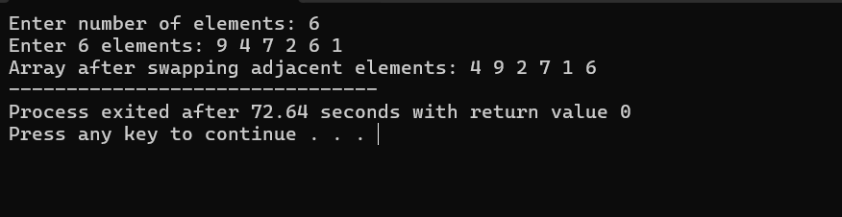

Complexity and Properties : Reading is O(n), swapping pairs is O(n/2), displaying is O(n) → Time O(n). One array of size n plus a temp variable → Space O(n).

Program 4.7 - Linear Search in an Array

Concept : Linear (sequential) search checks each element of the array one by one, starting from the first, comparing it with the search key, and stops as soon as a match is found (or the array is exhausted).

Algorithm
- Read n elements into a and read the key to search for.
- For i from 0 to n−1, compare a[i] with key.
- If equal, record found = 1, print the position (i+1), and stop searching (break).
- If the loop completes without a match, print "Element not found".

Worked observation
i | a[i] | a[i] == key(11)?
0 | 8 | No
1 | 3 | No
2 | 11 | Yes → stop, position = 3

C program
#include <stdio.h>
int main() {
int n, i, key, found = 0;
int a[50];
printf("Enter number of elements: ");
scanf("%d", &n);
printf("Enter %d elements: ", n);
for (i = 0; i < n; i++) {
scanf("%d", &a[i]);
}
printf("Enter element to search: ");
scanf("%d", &key);
for (i = 0; i < n; i++) {
if (a[i] == key) {
found = 1;
printf("Element found at position %d", i + 1);
break;
}
}
if (found == 0) {
printf("Element not found");
}
return 0;
}

Sample execution

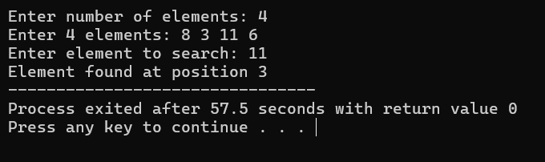

Complexity and Properties : Best case O(1) (key found at first position), Worst case O(n) (key at end or not present). One array of size n → Space O(n).

Program 4.8 - Count Even and Odd Numbers in an Array

Concept : Classification over an array means testing a property of each element (here, parity using the modulus operator %) and incrementing one of two separate counters based on the result.

Algorithm
- Read n elements into a, checking each element's parity as it is read.
- If a[i] % 2 == 0, increment even; otherwise increment odd.
- Print both counts after the loop.

Worked observation
a[i] | a[i] % 2 | Counter incremented
2 | 0 | even
7 | 1 | odd
10 | 0 | even
5 | 1 | odd
8 | 0 | even

C program
#include <stdio.h>
int main() {
int n, i, even = 0, odd = 0;
int a[50];
printf("Enter number of elements: ");
scanf("%d", &n);
printf("Enter %d elements: ", n);
for (i = 0; i < n; i++) {
scanf("%d", &a[i]);
if (a[i] % 2 == 0) {
even++;
} else {
odd++;
}
}
printf("Even count = %d\n", even);
printf("Odd count = %d", odd);
return 0;
}

Sample execution

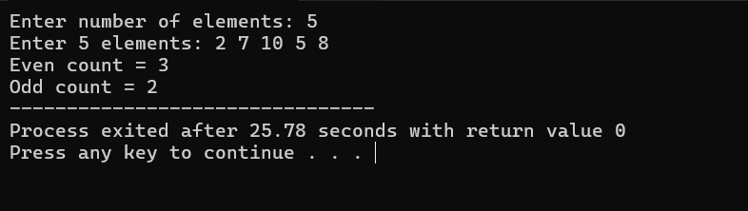

Complexity and Properties : A single loop checks each element once → Time O(n). One array of size n plus two counters → Space O(n).

Program 4.9 - Reverse an Array

Concept : Displaying an array in reverse order requires no rearrangement of the actual array in memory — only traversing it from the last index down to the first while printing.

Algorithm
- Read n elements into a.
- For i from n−1 down to 0, print a[i].

Worked observation
Original | Reversed traversal order
a[0]=4, a[1]=8, a[2]=1, a[3]=6 | a[3], a[2], a[1], a[0] = 6, 1, 8, 4

C program
#include <stdio.h>
int main() {
int n, i;
int a[50];
printf("Enter number of elements: ");
scanf("%d", &n);
printf("Enter %d elements: ", n);
for (i = 0; i < n; i++) {
scanf("%d", &a[i]);
}
printf("Array in reverse order: ");
for (i = n - 1; i >= 0; i--) {
printf("%d ", a[i]);
}
return 0;
}

Sample execution

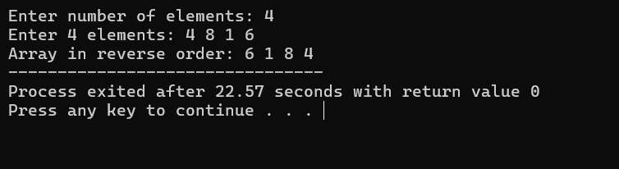

Complexity and Properties : Reading is O(n) and printing in reverse is O(n) → Time O(n). One array of size n → Space O(n).

Program 4.10 - Check Whether an Array is Already Sorted

Concept : An array is sorted in ascending order if every element is less than or equal to the one after it. Checking this requires comparing each adjacent pair exactly once and stopping early at the first violation.

Algorithm
- Read n elements into a; set sorted = 1.
- For i from 0 to n−2, if a[i] > a[i+1], set sorted = 0 and break.
- Print "sorted" if sorted == 1, else print "not sorted".

Worked observation
Pair | a[i] > a[i+1]?
(2,4) | No
(4,6) | No
(6,9) | No
Loop completes | sorted = 1

C program
#include <stdio.h>
int main() {
int n, i, sorted = 1;
int a[50];
printf("Enter number of elements: ");
scanf("%d", &n);
printf("Enter %d elements: ", n);
for (i = 0; i < n; i++) {
scanf("%d", &a[i]);
}
for (i = 0; i < n - 1; i++) {
if (a[i] > a[i + 1]) {
sorted = 0;
break;
}
}
if (sorted == 1) {
printf("Array is already sorted in ascending order");
} else {
printf("Array is not sorted");
}
return 0;}
Sample execution

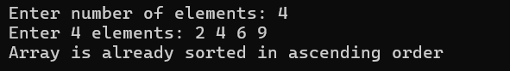

Complexity and Properties : Best case O(1) (unsorted at the very first pair), Worst case O(n) (already sorted, so loop runs fully). One array of size n → Space O(n).

Program 4.11 - Bubble One Largest Element to the End (Single Pass)

Concept : A single pass of bubble sort compares every pair of adjacent elements exactly once, swapping out-of-order pairs. After one full pass, the largest element is guaranteed to have "bubbled" to the last position.

Algorithm
- Read n elements into a.
- For i from 0 to n−2, if a[i] > a[i+1], swap them.
- Print the array after this single pass.

Worked observation
Pass index i | Comparison | Action | Array state
0 | 7 > 3 | Swap | 3 7 9 2
1 | 7 > 9? No | No swap | 3 7 9 2
2 | 9 > 2 | Swap | 3 7 2 9

C program
#include <stdio.h>
int main() {
int n, i, temp;
int a[50];
printf("Enter number of elements: ");
scanf("%d", &n);
printf("Enter %d elements: ", n);
for (i = 0; i < n; i++) {
scanf("%d", &a[i]);
}
for (i = 0; i < n - 1; i++) {
if (a[i] > a[i + 1]) {
temp = a[i];
a[i] = a[i + 1];
a[i + 1] = temp;
}
}
printf("Array after one bubble pass: ");
for (i = 0; i < n; i++) {
printf("%d ", a[i]);
}
return 0;
}

Sample execution

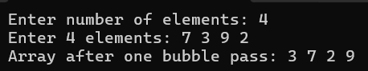

Complexity and Properties : A single pass compares n−1 adjacent pairs → Time O(n). One array of size n plus a temp variable → Space O(n).

Program 4.12 - Complete Bubble Sort

Concept : Repeating the single bubble pass (Program 11) n−1 times, with the inner loop shrinking each time (since the largest remaining elements settle at the end), fully sorts the array.

Algorithm
- Read n elements into a.
- For i from 0 to n−2 (outer pass), for j from 0 to n−2−i (inner comparison), swap a[j] and a[j+1] if out of order.
- Print the fully sorted array.

Worked observation
Pass | Array state after pass
Initial | 5 1 4 2
Pass 1 | 1 4 2 5
Pass 2 | 1 2 4 5
Pass 3 | 1 2 4 5 (no change)

C program
#include <stdio.h>
int main() {
int n, i, j, temp;
int a[50];
printf("Enter number of elements: ");
scanf("%d", &n);
printf("Enter %d elements: ", n);
for (i = 0; i < n; i++) {
scanf("%d", &a[i]);
}
for (i = 0; i < n - 1; i++) {
for (j = 0; j < n - 1 - i; j++) {
if (a[j] > a[j + 1]) {
temp = a[j];
a[j] = a[j + 1];
a[j + 1] = temp;
}
}
}
printf("Sorted array: ");
for (i = 0; i < n; i++) {
printf("%d ", a[i]);
}
return 0;
}

Sample execution

Complexity and Properties : The outer loop runs n−1 times and the inner loop runs up to n−1−i times, giving Best/Average/Worst case = O(n²) (no early-exit mechanism). One array of size n plus a temp variable (in-place sort) → Space O(n).

Program 4.13 - Bubble Sort with Early Stop (Optimized Bubble Sort)

Concept : Adding a swapped flag lets the algorithm detect when a pass makes no swaps at all — meaning the array is already sorted — and exit early instead of running all n−1 passes unconditionally.

Algorithm
- Read n elements into a.
- For each outer pass, reset swapped = 0; perform the inner comparison/swap loop, setting swapped = 1 whenever a swap occurs.
- After the inner loop, if swapped == 0, break out of the outer loop immediately.
- Print the sorted array.
Worked observation
Pass | swapped? | Action
1 | 0 (no swaps needed, already sorted) | break immediately

C program
#include <stdio.h>
int main() {
int n, i, j, temp, swapped;
int a[50];
printf("Enter number of elements: ");
scanf("%d", &n);
printf("Enter %d elements: ", n);
for (i = 0; i < n; i++) {
scanf("%d", &a[i]);
}
for (i = 0; i < n - 1; i++) {
swapped = 0;
for (j = 0; j < n - 1 - i; j++) {
if (a[j] > a[j + 1]) {
temp = a[j];
a[j] = a[j + 1];
a[j + 1] = temp;
swapped = 1;
}
}
if (swapped == 0) {
break;
}
}
printf("Sorted array: ");
for (i = 0; i < n; i++) {
printf("%d ", a[i]);
}
return 0;
}

Sample execution

Complexity and Properties : Best case O(n) (already sorted, one pass with no swaps then break), Worst case O(n²) (reverse sorted array). One array of size n plus temp and swapped variables → Space O(n).

Program 4.14 - Select the Smallest Element and Place it First (Single Pass of Selection Sort)

Concept : A single pass of selection sort scans the entire array once to find the index of the smallest element, then swaps it into the first position — the core operation that, when repeated, forms complete selection sort.

Algorithm
- Read n elements into a.
- Set minIndex = 0.
- For i from 1 to n−1, if a[i] < a[minIndex], update minIndex = i.
- Swap a[0] and a[minIndex] using a temp variable.
- Print the resulting array.

Worked observation
i | a[i] | a[i] < a[minIndex]? | minIndex
— | a[0]=8 | — | 0
1 | 3 | Yes | 1
2 | 6 | No | 1
3 | 2 | Yes | 3
Swap a[0] and a[3] |  |  | 2 3 6 8

C program
#include <stdio.h>
int main() {
int n, i, minIndex, temp;
int a[50];
printf("Enter number of elements: ");
scanf("%d", &n);
printf("Enter %d elements: ", n);
for (i = 0; i < n; i++) {
scanf("%d", &a[i]);
}
minIndex = 0;
for (i = 1; i < n; i++) {
if (a[i] < a[minIndex]) {
minIndex = i;
}
}
temp = a[0];
a[0] = a[minIndex];
a[minIndex] = temp;
printf("Array after selecting first minimum: ");
for (i = 0; i < n; i++) {
printf("%d ", a[i]);
}
return 0;
}

Sample execution

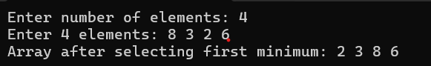

Complexity and Properties : Finding the minimum requires scanning all n elements once → Time O(n). One array of size n plus minIndex and temp → Space O(n).

Program 4.15 - Complete Selection Sort

Concept : Repeating the single-pass idea (Program 14) for every starting position i = 0 to n−2 — each time finding the minimum of the remaining unsorted suffix and swapping it into position i — produces a fully sorted array using at most n−1 swaps total.

Algorithm
- Read n elements into a.
- For i from 0 to n−2: set minIndex = i; for j from i+1 to n−1, update minIndex if a[j] < a[minIndex].
- Swap a[i] and a[minIndex] if they differ.
- Print the sorted array.

Worked observation
Pass | Array state after pass | Minimum selected
Initial | 64 25 12 22 | —
Pass 1 | 12 25 64 22 | 12
Pass 2 | 12 22 64 25 | 22
Pass 3 | 12 22 25 64 | 25

C program
#include <stdio.h>
int main() {
int n, i, j, minIndex, temp;
int a[50];
printf("Enter number of elements: ");
scanf("%d", &n);
printf("Enter %d elements: ", n);
for (i = 0; i < n; i++) {
scanf("%d", &a[i]);
}
for (i = 0; i < n - 1; i++) {
minIndex = i;
for (j = i + 1; j < n; j++) {
if (a[j] < a[minIndex]) {
minIndex = j;
}
}
temp = a[i];
a[i] = a[minIndex];
a[minIndex] = temp;
}
printf("Sorted array: ");
for (i = 0; i < n; i++) {
printf("%d ", a[i]);
}
return 0;
}

Sample execution

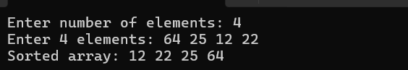

Complexity and Properties : The outer loop runs n−1 times, and for each iteration the inner loop scans the remaining unsorted part — this always gives Best/Average/Worst case = O(n²), since the search for minimum runs regardless of existing order. One array of size n plus minIndex and temp (in-place sort) → Space O(n).

Program 4.16 - Insert One Element into the Sorted Left Part (Single Pass of Insertion Sort)

Concept : A single pass of insertion sort takes one element (the "key") and shifts all larger elements in the already-sorted left part one position right, then places the key into the resulting gap — the core operation of insertion sort applied to just the second element.

Algorithm
- Read n elements into a.
- Set key = a[1] and j = 0.
- While j >= 0 and a[j] > key, shift a[j] to a[j+1] and decrement j.
- Place key at a[j+1].
- Print the resulting array.

Worked observation
Step | a[j] | Comparison | Action
key = a[1] = 4 | a[0] = 9 | 9 > 4 | Shift 9 right, j--
j = -1 | loop ends | — | Insert 4 at a[0]

C program
#include <stdio.h>
int main() {
int n, i, key, j;
int a[50];
printf("Enter number of elements: ");
scanf("%d", &n);
printf("Enter %d elements: ", n);
for (i = 0; i < n; i++) {
scanf("%d", &a[i]);
}
key = a[1];
j = 0;
while (j >= 0 && a[j] > key) {
a[j + 1] = a[j];
j--;
}
a[j + 1] = key;
printf("Array after inserting second element correctly: ");
for (i = 0; i < n; i++) {
printf("%d ", a[i]);
}
return 0;
}

Sample execution

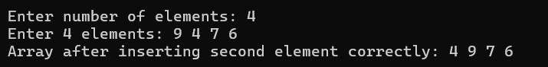

Complexity and Properties : In the worst case the key shifts through the sorted part once → Time O(n), bounded by the size of the sorted portion so far. One array of size n plus key and j → Space O(n).

Program 4.17 - Complete Insertion Sort

Concept : Repeating the single-key-insertion idea (Program 16) for every element from index 1 to n−1 — each time inserting the current key into its correct position within the growing sorted prefix — produces a fully sorted array.

Algorithm
- Read n elements into a.
- For i from 1 to n−1: set key = a[i], j = i−1.
- While j >= 0 and a[j] > key, shift a[j] to a[j+1] and decrement j.
- Place key at a[j+1].
- Print the sorted array.

Worked observation
Pass | Key | Array state after pass
Initial | — | 5 2 4 6 1
Pass i=1 | 2 | 2 5 4 6 1
Pass i=2 | 4 | 2 4 5 6 1
Pass i=3 | 6 | 2 4 5 6 1
Pass i=4 | 1 | 1 2 4 5 6

C program
#include <stdio.h>
int main() {
int n, i, key, j;
int a[50];
printf("Enter number of elements: ");
scanf("%d", &n);
printf("Enter %d elements: ", n);
for (i = 0; i < n; i++) {
scanf("%d", &a[i]);
}
for (i = 1; i < n; i++) {
key = a[i];
j = i - 1;
while (j >= 0 && a[j] > key) {
a[j + 1] = a[j];
j--;
}
a[j + 1] = key;
}
printf("Sorted array: ");
for (i = 0; i < n; i++) {
printf("%d ", a[i]);
}
return 0;
}
Sample execution

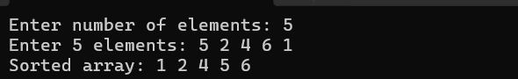

Complexity and Properties : Best case O(n) (already sorted array, inner while loop never shifts), Worst case O(n²) (reverse sorted array, every element shifts through the entire sorted part). One array of size n plus key and j (in-place sort) → Space O(n).

Program 4.18 - Count Number of Comparisons in Bubble Sort

Concept : Instrumenting an algorithm means adding counters to measure its internal behavior (here, the number of comparisons) without changing its logic — useful for empirically verifying theoretical complexity.

Algorithm
- Read n elements into a; initialize comparisons = 0.
- Perform standard bubble sort (nested loops), incrementing comparisons on every inner-loop iteration, regardless of whether a swap occurs.
- Print the sorted array and the total comparison count.

Worked observation
n | Pairs compared per full pass structure | Total comparisons for n=3
3 | (n-1)+(n-2)+...+1 = n(n-1)/2 | 3(2)/2 = 3

C program
#include <stdio.h>
int main() {
int n, i, j, temp, comparisons = 0;
int a[50];
printf("Enter number of elements: ");
scanf("%d", &n);
printf("Enter %d elements: ", n);
for (i = 0; i < n; i++) {
scanf("%d", &a[i]);
}
for (i = 0; i < n - 1; i++) {
for (j = 0; j < n - 1 - i; j++) {
comparisons++;
if (a[j] > a[j + 1]) {
temp = a[j];
a[j] = a[j + 1];
a[j + 1] = temp;
}
}
}
printf("Sorted array: ");
for (i = 0; i < n; i++) {
printf("%d ", a[i]);
}
printf("\nComparisons = %d", comparisons);
return 0;
}

Sample execution

Complexity and Properties : Since a comparison happens on every inner-loop iteration regardless of order, this always runs in O(n²) — same as standard Bubble Sort (no early exit). One array of size n plus a comparisons counter → Space O(n).

Program 4.19 - Count Number of Swaps in Bubble Sort

Concept : Similar instrumentation to Program 18, but counting only the actual swap operations rather than every comparison — this count varies with the input's initial disorder, unlike the comparison count which is fixed by n.

Algorithm
- Read n elements into a; initialize swaps = 0.
- Perform standard bubble sort; increment swaps only when an actual swap occurs (i.e., when a[j] > a[j+1]).
- Print the sorted array and total swap count.

Worked observation
Array | Bubble sort swaps
3 1 2 | Swap(3,1)→1 3 2; Swap(3,2)→1 2 3; total = 2 swaps

C program
#include <stdio.h>
int main() {
int n, i, j, temp, swaps = 0;
int a[50];
printf("Enter number of elements: ");
scanf("%d", &n);
printf("Enter %d elements: ", n);
for (i = 0; i < n; i++) {
scanf("%d", &a[i]);
}
for (i = 0; i < n - 1; i++) {
for (j = 0; j < n - 1 - i; j++) {
if (a[j] > a[j + 1]) {
temp = a[j];
a[j] = a[j + 1];
a[j + 1] = temp;
swaps++;
}
}
}
printf("Sorted array: ");
for (i = 0; i < n; i++) {
printf("%d ", a[i]);
}
printf("\nSwaps = %d", swaps);
return 0;
}
Sample execution

Complexity and Properties : The comparison structure is identical to standard Bubble Sort (all pairs checked every pass) → Time O(n²), regardless of how many actual swaps occur. One array of size n plus a swaps counter → Space O(n).

Program 4.20 - Compare Bubble Sort, Selection Sort and Insertion Sort on the Same Input

Concept : Running all three sorting algorithms independently on identical copies of the same input array allows a direct, fair comparison of their outputs (which should always agree) and, when instrumented separately, their comparison/swap counts.

Algorithm
- Read n elements into original.
- Copy original into three separate arrays: b, s, in.
- Sort b using bubbleSort(), s using selectionSort(), and in using insertionSort().
- Print all three sorted arrays.

Worked observation
Array | Result after respective sort
b (Bubble) | 1 3 4 5
s (Selection) | 1 3 4 5
in (Insertion) | 1 3 4 5

C program
#include <stdio.h>
void bubbleSort(int a[], int n) {
int i, j, temp;
for (i = 0; i < n - 1; i++) {
for (j = 0; j < n - 1 - i; j++) {
if (a[j] > a[j + 1]) {
temp = a[j];
a[j] = a[j + 1];
a[j + 1] = temp;
}
}
}
}
void selectionSort(int a[], int n) {
int i, j, minIndex, temp;
for (i = 0; i < n - 1; i++) {
minIndex = i;
for (j = i + 1; j < n; j++) {
if (a[j] < a[minIndex]) {
minIndex = j;
}
}
temp = a[i];
a[i] = a[minIndex];
a[minIndex] = temp;
}
}
void insertionSort(int a[], int n) {
int i, key, j;
for (i = 1; i < n; i++) {
key = a[i];
j = i - 1;
while (j >= 0 && a[j] > key) {
a[j + 1] = a[j];
j--;
}
a[j + 1] = key;
}
}
void copyArray(int src[], int dest[], int n) {
int i;
for (i = 0; i < n; i++) {
dest[i] = src[i];
}
}
void printArray(int a[], int n) {
int i;
for (i = 0; i < n; i++) {
printf("%d ", a[i]);
}
printf("\n");
}
int main() {
int n, i;
int original[50], b[50], s[50], in[50];
printf("Enter number of elements: ");
scanf("%d", &n);
printf("Enter %d elements: ", n);
for (i = 0; i < n; i++) {
scanf("%d", &original[i]);
}
copyArray(original, b, n);
copyArray(original, s, n);
copyArray(original, in, n);
bubbleSort(b, n);
selectionSort(s, n);
insertionSort(in, n);
printf("Bubble Sort: ");
printArray(b, n);
printf("Selection Sort: ");
printArray(s, n);
printf("Insertion Sort: ");
printArray(in, n);
return 0;
}
Sample execution

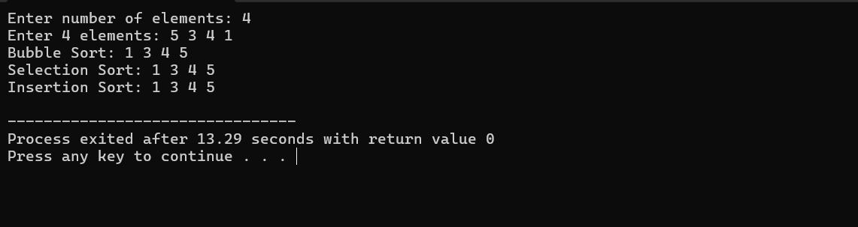

Complexity and Properties : Each sorting function individually runs in O(n²) (Bubble, Selection, Insertion in the worst case), and copying arrays takes O(n) each. Since the three sorts run one after another (not nested), the overall time complexity is O(n²). Four arrays of size n (original, b, s, in) are used → Space O(n).

Viva questions
- Why does plain Bubble Sort (Program 12) always run in O(n²) even on sorted input, while the optimized version (Program 13) does not? Plain Bubble Sort has no mechanism to detect an early sorted state; the swapped flag in Program 13 provides that.
- Why is Selection Sort's time complexity always O(n²) regardless of input order? It always scans the remaining unsorted part to find the minimum, even if the array is already sorted.
- Between Bubble, Selection and Insertion Sort, which performs the fewest swaps in general? Selection Sort — at most one swap per outer iteration (n−1 swaps total).
- Why does Insertion Sort (Program 17) achieve O(n) on already-sorted input? The inner while condition a[j] > key is never true, so no shifting occurs and each key is placed immediately.
- What is the difference between the comparison count (Program 18) and the swap count (Program 19) for the same input? Comparisons always total n(n−1)/2 for plain Bubble Sort regardless of order; swaps depend on how out-of-order the input is.

Result : All twenty basic C programs on arrays, searching, and sorting were implemented, compiled, and executed successfully, and their outputs, worked traces, and complexity behaviors were verified individually for each program.

Experiment 5 - Shortest Route Using Dijkstra's Algorithm

Date : __________ Faculty signature : ____________________

Aim : To implement Dijkstra's algorithm in C to find the shortest distance and the actual shortest route from a chosen source vertex to every reachable vertex in a weighted graph with non-negative edge weights, using an adjacency matrix.

Software required : C compiler supporting C11, a text editor.

Concept
Dijkstra's is a greedy algorithm: it repeatedly selects the unvisited vertex with the smallest tentative distance, marks it visited (final), and relaxes (updates) the distances of its neighbours. Because all edge weights are non-negative, once a vertex is marked visited its shortest distance can never improve, which is what makes the greedy choice safe.

Algorithm
- Read n vertices and the n × n adjacency matrix (0 = no direct edge); reject negative weights.
- Initialize dist[] to infinity for all vertices except the source (0), visited[] to 0, and parent[] to −1.
- Repeat (n − 1) times: find the unvisited vertex u with the smallest dist[u] using findMinDistance(); mark it visited.
- For every unvisited neighbour v of u, if dist[u] + graph[u][v] < dist[v], update dist[v] and set parent[v] = u.
- After all vertices are processed, print dist[] for every vertex and reconstruct each route by following parent[] back to the source.

Worked observation
Step | Vertex finalized | dist[] state | Route so far
1 | A (source) | A=0 | —
2 | C | A=0, C=1 | A → C
3 | B | A=0, C=1, B=3 | A → C → B
4 | D | A=0, C=1, B=3, D=4 | A → C → B → D
5 | E | A=0, C=1, B=3, D=4, E=7 | A → C → B → D → E

C program
#include <stdio.h>
#define MAX 20
#define INF 1000000000

int findMinDistance(int dist[], int visited[], int n)
{
int min = INF;
int minIndex = -1;
for (int i = 0; i < n; i++)
{
if (visited[i] == 0 && dist[i] < min)
{
min = dist[i];
minIndex = i;
}
}
return minIndex;
}

void printPath(int parent[], int destination)
{
int path[MAX];
int length = 0;
int current = destination;
while (current != -1)
{
path[length] = current;
length++;
current = parent[current];
}
for (int i = length - 1; i >= 0; i--)
{
printf("%c", 'A' + path[i]);
if (i != 0) printf(" -> ");
}
}

void dijkstra(int graph[MAX][MAX], int n, int source)
{
int dist[MAX];
int visited[MAX];
int parent[MAX];

for (int i = 0; i < n; i++)
{
dist[i] = INF;
visited[i] = 0;
parent[i] = -1;
}
dist[source] = 0;

for (int count = 0; count < n - 1; count++)
{
int u = findMinDistance(dist, visited, n);
if (u == -1) break;
visited[u] = 1;

for (int v = 0; v < n; v++)
{
if (visited[v] == 0 &&
graph[u][v] > 0 &&
dist[u] != INF &&
dist[u] + graph[u][v] < dist[v])
{
dist[v] = dist[u] + graph[u][v];
parent[v] = u;
}
}
}

printf("\nShortest routes from vertex %c:\n", 'A' + source);
printf("------------------------------------------------------\n");
printf("Destination\tDistance\tRoute\n");
printf("------------------------------------------------------\n");

for (int i = 0; i < n; i++)
{
printf("%c\t\t", 'A' + i);
if (dist[i] == INF)
{
printf("INF\t\tNo route\n");
}
else
{
printf("%d\t\t", dist[i]);
printPath(parent, i);
printf("\n");
}
}
}

int main(void)
{
int graph[MAX][MAX];
int n;
int source;

printf("SHORTEST ROUTE USING DIJKSTRA'S ALGORITHM\n");
printf("=========================================\n");
printf("Enter number of vertices (maximum %d): ", MAX);
scanf("%d", &n);

if (n <= 0 || n > MAX)
{
printf("Invalid number of vertices.\n");
return 1;
}

printf("\nVertices are named A, B, C, ...\n");
printf("Enter the adjacency matrix.\n");
printf("Use 0 when there is no direct edge.\n\n");

for (int i = 0; i < n; i++)
{
for (int j = 0; j < n; j++)
{
scanf("%d", &graph[i][j]);
if (graph[i][j] < 0)
{
printf("Negative edge weights are not allowed in Dijkstra's algorithm.\n");
return 1;
}
}
}

printf("\nEnter source vertex number (A=0, B=1, C=2, ...): ");
scanf("%d", &source);
if (source < 0 || source >= n)
{
printf("Invalid source vertex.\n");
return 1;
}

dijkstra(graph, n, source);
return 0;
}

Sample execution

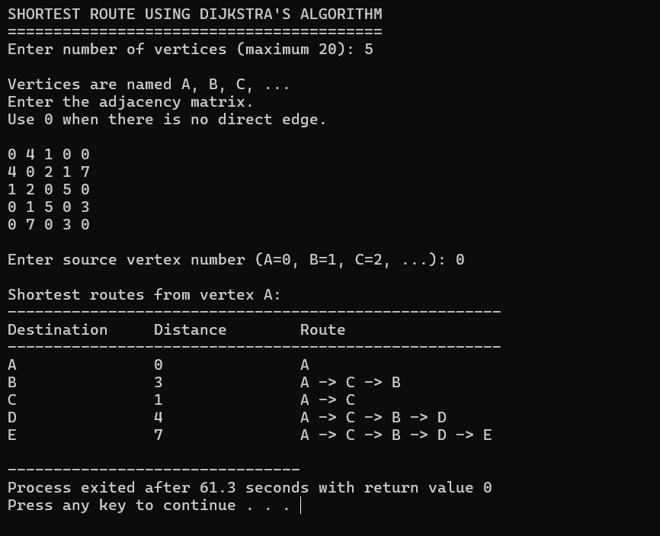

Complexity and Properties
Initializing arrays is O(V); finding the minimum-distance unvisited vertex is O(V) per round, run for up to V rounds; relaxing neighbours is O(V) per round. Overall time O(V²). Space: adjacency matrix is O(V²); dist[], visited[], parent[] are each O(V). Overall space O(V²), dominated by the matrix. An adjacency-list plus min-heap implementation would improve this to O((V+E) log V) for sparse graphs.

Additional test observations
- Disconnected vertex → dist[] remains INF → printed as "No route".
- Negative edge weight entered → program rejects input immediately.
- Single-vertex graph (n = 1) → only the source is printed with distance 0.

Viva questions
- Why doesn't Dijkstra's algorithm work correctly with negative edge weights? A vertex marked visited (finalized) could later be improved by a negative edge from an unvisited vertex, violating the greedy assumption.
- Why is findMinDistance() called n − 1 times, not n times? The source vertex's distance (0) is already fixed before the loop starts; only the remaining n − 1 vertices need to be finalized.
Result : Dijkstra's algorithm was implemented and executed successfully; correct shortest distances and routes from the source vertex were verified against manual computation.
Experiment 6 - People Counting in an Image Using Connected Components

Date : __________ Faculty signature : ____________________

Aim : To write a C program that reads a grayscale PGM image, applies thresholding to separate dark foreground pixels from a light background, groups neighbouring foreground pixels into connected components using flood fill (BFS with a queue), rejects small components as noise, counts the remaining components as people, and saves a marked output image with bounding boxes.

Software required : C compiler supporting C11, a text editor, sample ASCII PGM (P2) images.

Concept
An image is a grid of brightness values. Thresholding converts each pixel into foreground (dark, possible person) or background (light) based on a cut-off brightness. Neighbouring foreground pixels are grouped using flood fill, a breadth-first traversal implemented with an explicit FIFO queue and an 8-neighbour connectivity rule, so diagonal pixels count as connected too. Components smaller than a minimum area are treated as noise and discarded.

Algorithm
- Read the PGM image into a 1-D pixel array (readPGM).
- Threshold every pixel: dark (< threshold) → 1 (foreground), else → 0 (background).
- Scan the image row by row; on encountering an unvisited foreground pixel, run floodFill() from it.
- In floodFill(), push the starting pixel onto a queue, mark it visited, then repeatedly dequeue a pixel, update the component's area and bounding box, and enqueue any of its 8 unvisited foreground neighbours.
- If the resulting component's area ≥ minimum area, accept it and increment the people count.
- Draw a bounding-box rectangle around every accepted component on a copy of the original image.
- Save the marked image and print each accepted component's area and bounding box.

Worked observation
Binary grid segment | Connected component found | Area | Accepted (min area = 120)?
Large silhouette block | Component 1 | 622 | Yes
Small stray dark dot | Component 2 | 35 | No (noise)
Large silhouette block | Component 3 | 772 | Yes

C program
#include <stdio.h>
#include <stdlib.h>
#include <string.h>
#include <ctype.h>

#define MAX_TOKEN 256

typedef struct { int x; int y; } Pixel;
typedef struct { int area; int minX, minY, maxX, maxY; } Component;

int readToken(FILE *fp, char *token, int maxLen) {
int c;
int i = 0;
while ((c = fgetc(fp)) != EOF) {
if (isspace(c)) continue;
if (c == '#') {
while ((c = fgetc(fp)) != EOF && c != '\n') { }
continue;
}
break;
}
if (c == EOF) return 0;
do {
if (i < maxLen - 1) token[i++] = (char)c;
c = fgetc(fp);
} while (c != EOF && !isspace(c) && c != '#');
if (c == '#') { while ((c = fgetc(fp)) != EOF && c != '\n') { } }
token[i] = '\0';
return 1;
}

int readPGM(const char *filename, int **image, int *width, int *height, int *maxValue) {
FILE *fp = fopen(filename, "r");
char token[MAX_TOKEN];
int total, i;
if (fp == NULL) { printf("Error: Could not open %s\n", filename); return 0; }
if (!readToken(fp, token, MAX_TOKEN) || strcmp(token, "P2") != 0) {
printf("Error: Only ASCII PGM (P2) images are supported.\n");
fclose(fp);
return 0;
}
if (!readToken(fp, token, MAX_TOKEN)) { fclose(fp); return 0; }
*width = atoi(token);
if (!readToken(fp, token, MAX_TOKEN)) { fclose(fp); return 0; }
*height = atoi(token);
if (!readToken(fp, token, MAX_TOKEN)) { fclose(fp); return 0; }
*maxValue = atoi(token);
if (*width <= 0 || *height <= 0 || *maxValue <= 0) {
printf("Error: Invalid PGM header.\n");
fclose(fp);
return 0;
}
total = (*width) * (*height);
*image = (int *)malloc(total * sizeof(int));
if (*image == NULL) { printf("Error: Not enough memory.\n"); fclose(fp); return 0; }
for (i = 0; i < total; i++) {
if (!readToken(fp, token, MAX_TOKEN)) {
printf("Error: Image ended before all pixels were read.\n");
free(*image);
*image = NULL;
fclose(fp);
return 0;
}
(*image)[i] = atoi(token);
}
fclose(fp);
return 1;
}

int writePGM(const char *filename, const int *image, int width, int height, int maxValue) {
FILE *fp = fopen(filename, "w");
int x, y;
if (fp == NULL) { printf("Error: Could not create %s\n", filename); return 0; }
fprintf(fp, "P2\n%d %d\n%d\n", width, height, maxValue);
for (y = 0; y < height; y++) {
for (x = 0; x < width; x++) fprintf(fp, "%d ", image[y * width + x]);
fprintf(fp, "\n");
}
fclose(fp);
return 1;
}

void thresholdImage(const int *image, unsigned char *binary, int total, int threshold) {
int i;
for (i = 0; i < total; i++) binary[i] = (image[i] < threshold) ? 1 : 0;
}

Component floodFill(const unsigned char *binary, unsigned char *visited,
int width, int height, int startX, int startY, Pixel *queue) {
int front = 0;
int rear = 0;
Component c;
int dx, dy;

c.area = 0;
c.minX = c.maxX = startX;
c.minY = c.maxY = startY;

queue[rear].x = startX;
queue[rear].y = startY;
rear++;
visited[startY * width + startX] = 1;

while (front < rear) {
Pixel p = queue[front++];
c.area++;
if (p.x < c.minX) c.minX = p.x;
if (p.x > c.maxX) c.maxX = p.x;
if (p.y < c.minY) c.minY = p.y;
if (p.y > c.maxY) c.maxY = p.y;

for (dy = -1; dy <= 1; dy++) {
for (dx = -1; dx <= 1; dx++) {
int nx, ny, index;
if (dx == 0 && dy == 0) continue;
nx = p.x + dx;
ny = p.y + dy;
if (nx >= 0 && nx < width && ny >= 0 && ny < height) {
index = ny * width + nx;
if (binary[index] == 1 && visited[index] == 0) {
visited[index] = 1;
queue[rear].x = nx;
queue[rear].y = ny;
rear++;
}
}
}
}
}
return c;
}

void drawRectangle(int *image, int width, int height,
int minX, int minY, int maxX, int maxY, int value) {
int x, y;
if (minX < 0) minX = 0;
if (minY < 0) minY = 0;
if (maxX >= width) maxX = width - 1;
if (maxY >= height) maxY = height - 1;
for (x = minX; x <= maxX; x++) { image[minY * width + x] = value; image[maxY * width + x] = value; }
for (y = minY; y <= maxY; y++) { image[y * width + minX] = value; image[y * width + maxX] = value; }
}

int countPeople(const int *image, int width, int height,
int threshold, int minArea,
int *markedImage, Component *accepted, int maxAccepted) {
int total = width * height;
unsigned char *binary = (unsigned char *)calloc(total, sizeof(unsigned char));
unsigned char *visited = (unsigned char *)calloc(total, sizeof(unsigned char));
Pixel *queue = (Pixel *)malloc(total * sizeof(Pixel));
int x, y;
int count = 0;

if (binary == NULL || visited == NULL || queue == NULL) {
printf("Error: Not enough memory for processing.\n");
free(binary); free(visited); free(queue);
return -1;
}

thresholdImage(image, binary, total, threshold);

for (y = 0; y < height; y++) {
for (x = 0; x < width; x++) {
int index = y * width + x;
if (binary[index] == 1 && visited[index] == 0) {
Component c = floodFill(binary, visited, width, height, x, y, queue);
if (c.area >= minArea) {
if (count < maxAccepted) accepted[count] = c;
count++;
}
}
}
}

memcpy(markedImage, image, total * sizeof(int));
for (x = 0; x < count && x < maxAccepted; x++) {
drawRectangle(markedImage, width, height,
accepted[x].minX, accepted[x].minY,
accepted[x].maxX, accepted[x].maxY, 0);
}

free(binary); free(visited); free(queue);
return count;
}

int main(void) {
char filename[256];
int *image = NULL;
int *markedImage = NULL;
Component *people = NULL;
int width, height, maxValue;
int threshold = 150;
int minArea = 120;
int count, i;

printf("============================================\n");
printf(" SIMPLE PEOPLE COUNTER USING C\n");
printf("============================================\n");
printf("This program works best with a light background\n");
printf("and dark, separated human-like silhouettes.\n\n");

printf("Enter PGM image filename: ");
if (scanf("%255s", filename) != 1) return 1;

if (!readPGM(filename, &image, &width, &height, &maxValue)) return 1;

printf("\nImage loaded successfully.\n");
printf("Width : %d pixels\n", width);
printf("Height : %d pixels\n", height);
printf("Max value : %d\n", maxValue);

printf("\nEnter threshold (recommended 150): ");
scanf("%d", &threshold);
printf("Enter minimum object area (recommended 120): ");
scanf("%d", &minArea);

markedImage = (int *)malloc(width * height * sizeof(int));
people = (Component *)malloc(width * height * sizeof(Component));

if (markedImage == NULL || people == NULL) {
printf("Error: Not enough memory.\n");
free(image); free(markedImage); free(people);
return 1;
}

count = countPeople(image, width, height, threshold, minArea, markedImage, people, width * height);

if (count < 0) { free(image); free(markedImage); free(people); return 1; }

printf("\n============================================\n");
printf("RESULT: Estimated number of people = %d\n", count);
printf("============================================\n");

for (i = 0; i < count; i++) {
printf("Person %d: area=%d pixels, box=(%d,%d) to (%d,%d)\n",
i + 1, people[i].area, people[i].minX, people[i].minY, people[i].maxX, people[i].maxY);
}

if (writePGM("counted_output.pgm", markedImage, width, height, maxValue)) {
printf("\nMarked image saved as counted_output.pgm\n");
}

printf("\nImportant: This is a beginner image-processing project,\n");
printf("not a production AI people detector.\n");

free(image); free(markedImage); free(people);
return 0;
}

Sample execution

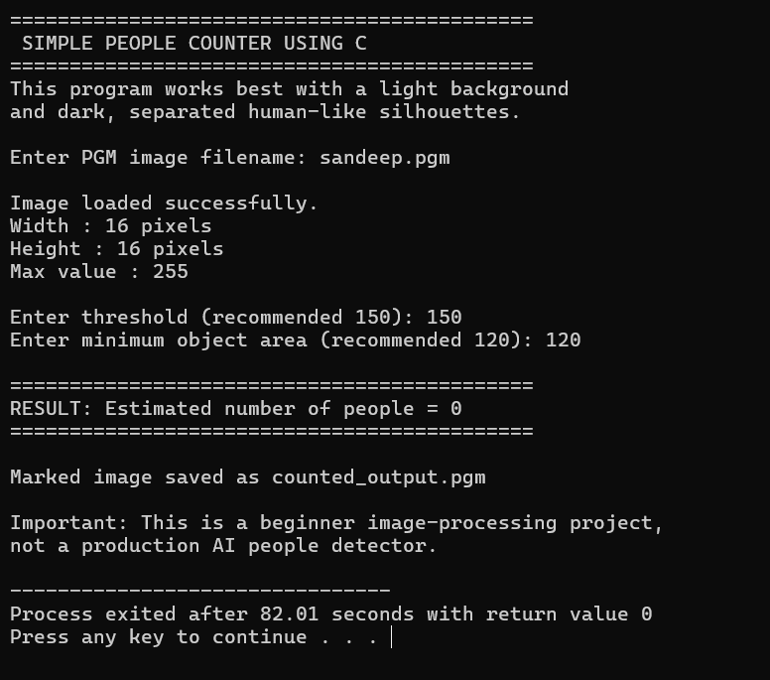

Complexity and Properties
Let P = width × height. readPGM, thresholdImage, and writePGM are each O(P). Every foreground pixel is flood-filled exactly once across all calls combined (via visited[]), so the entire connected-component labeling pass is O(P), not O(P) per component. Overall time O(P). Space: image, binary, visited, queue, and markedImage are each O(P) — dominating overall space at O(P).

Additional test observations
- Threshold too low (e.g. 80) → parts of people may disappear, undercounting.
- Threshold too high (e.g. 250) → almost everything becomes foreground, overcounting.
- Minimum area too high (e.g. 900) → all people rejected as "noise".

Viva questions
- Why use a queue (BFS) instead of recursion for flood fill? Avoids stack-overflow risk for large connected regions and matches the FIFO nature of level-by-level exploration.
- Why is visited[] necessary? To ensure each foreground pixel is processed only once, keeping the total work O(P) rather than reprocessing pixels.
- Why might two people touching each other be miscounted as one? Their foreground pixels become 8-connected into a single component.

Result : The people-counting program was implemented and executed successfully; connected components above the minimum area were correctly counted and marked with bounding boxes, while smaller noise components were rejected.

Experiment 7 - Simple Face Recognition Using PGM Templates

Date : __________ Faculty signature : ____________________

Aim : To write a menu-driven C program that registers grayscale face images (resized to 32×32 and brightness-normalized), stores them as templates in a text database, and recognizes a test face by comparing it against all registered faces using Mean Absolute Difference (MAD), accepting the best match only if it falls below a threshold.

Software required : C compiler supporting C11, a text editor, sample ASCII PGM (P2) face images.

Concept
A face image is standardized (resized to a fixed 32×32 grid, brightness-normalized to 0–255) so that any two faces can be compared pixel-by-pixel regardless of their original size or lighting. Similarity is measured using Mean Absolute Difference (MAD) — the average of the absolute pixel-wise differences. A smaller MAD means more similar images; a threshold decides whether the closest match is accepted or rejected as "Unknown".

Algorithm
- prepareFace(): load a PGM image, resize it to 32×32 using nearest-neighbour sampling, and stretch its brightness range to 0–255.
- registerFace(): prepare the face and append the name and its 1,024 pixel values to faces.db.
- recognizeFace(): prepare the test face, then read each saved face template from faces.db one at a time and compute MAD against the test face using compareFaces().
- Track the smallest MAD found (bestDifference) and its associated name.
- If bestDifference ≤ UNKNOWN_THRESHOLD (38.0), report the best match; otherwise report "Unknown face".

Worked observation
Comparison | MAD | Decision
Arun | 9.74 | Smallest so far
Beena | 16.79 | Larger
Charan | 16.93 | Larger
Result | best = Arun, 9.74 | 9.74 ≤ 38.0 → RECOGNIZED as Arun

C program
#include <stdio.h>
#include <stdlib.h>
#include <string.h>
#include <math.h>

#define FACE_SIZE 32
#define MAX_PIXELS 262144
#define DATABASE_FILE "faces.db"
#define UNKNOWN_THRESHOLD 38.0

typedef struct { int width; int height; int maxValue; int *pixels; } Image;

void freeImage(Image *img) {
if (img->pixels != NULL) { free(img->pixels); img->pixels = NULL; }
}

int readToken(FILE *fp, char *token, int size) {
int c;
int i = 0;
while ((c = fgetc(fp)) != EOF) {
if (c == '#') { while ((c = fgetc(fp)) != '\n' && c != EOF) { ; } }
else if (c != ' ' && c != '\n' && c != '\t' && c != '\r') break;
}
if (c == EOF) return 0;
do {
if (i < size - 1) token[i++] = (char)c;
c = fgetc(fp);
} while (c != EOF && c != ' ' && c != '\n' && c != '\t' && c != '\r' && c != '#');
if (c == '#') { while ((c = fgetc(fp)) != '\n' && c != EOF) { ; } }
token[i] = '\0';
return 1;
}

int loadPGM(const char *filename, Image *img) {
FILE *fp = fopen(filename, "r");
char token[100];
int total, i;
img->pixels = NULL;
if (fp == NULL) { printf("Could not open image file: %s\n", filename); return 0; }
if (!readToken(fp, token, sizeof(token)) || strcmp(token, "P2") != 0) {
printf("This program needs an ASCII PGM (P2) image.\n");
fclose(fp);
return 0;
}
if (!readToken(fp, token, sizeof(token))) { fclose(fp); return 0; }
img->width = atoi(token);
if (!readToken(fp, token, sizeof(token))) { fclose(fp); return 0; }
img->height = atoi(token);
if (!readToken(fp, token, sizeof(token))) { fclose(fp); return 0; }
img->maxValue = atoi(token);
total = img->width * img->height;
if (img->width <= 0 || img->height <= 0 || total > MAX_PIXELS || img->maxValue <= 0) {
printf("Invalid or too-large image.\n");
fclose(fp);
return 0;
}
img->pixels = (int *)malloc(total * sizeof(int));
if (img->pixels == NULL) { printf("Not enough memory.\n"); fclose(fp); return 0; }
for (i = 0; i < total; i++) {
if (!readToken(fp, token, sizeof(token))) {
printf("Image ended before all pixels were read.\n");
freeImage(img);
fclose(fp);
return 0;
}
img->pixels[i] = atoi(token);
}
fclose(fp);
return 1;
}

void resizeToFace(const Image *img, int face[FACE_SIZE][FACE_SIZE]) {
int r, c;
for (r = 0; r < FACE_SIZE; r++) {
for (c = 0; c < FACE_SIZE; c++) {
int srcRow = r * img->height / FACE_SIZE;
int srcCol = c * img->width / FACE_SIZE;
int value = img->pixels[srcRow * img->width + srcCol];
value = value * 255 / img->maxValue;
face[r][c] = value;
}
}
}

void normalizeFace(int face[FACE_SIZE][FACE_SIZE]) {
int r, c;
int minValue = 255;
int maxValue = 0;
for (r = 0; r < FACE_SIZE; r++)
for (c = 0; c < FACE_SIZE; c++) {
if (face[r][c] < minValue) minValue = face[r][c];
if (face[r][c] > maxValue) maxValue = face[r][c];
}
if (maxValue == minValue) return;
for (r = 0; r < FACE_SIZE; r++)
for (c = 0; c < FACE_SIZE; c++)
face[r][c] = (face[r][c] - minValue) * 255 / (maxValue - minValue);
}

int prepareFace(const char *filename, int face[FACE_SIZE][FACE_SIZE]) {
Image img;
if (!loadPGM(filename, &img)) return 0;
resizeToFace(&img, face);
normalizeFace(face);
freeImage(&img);
return 1;
}

void registerFace(void) {
char name[50];
char filename[200];
int face[FACE_SIZE][FACE_SIZE];
FILE *fp;
int r, c;

printf("\nEnter a name (one word): ");
scanf("%49s", name);
printf("Enter the PGM face-image filename: ");
scanf("%199s", filename);

if (!prepareFace(filename, face)) { printf("Registration failed.\n"); return; }

fp = fopen(DATABASE_FILE, "a");
if (fp == NULL) { printf("Could not open the face database.\n"); return; }

fprintf(fp, "%s\n", name);
for (r = 0; r < FACE_SIZE; r++)
for (c = 0; c < FACE_SIZE; c++)
fprintf(fp, "%d ", face[r][c]);
fprintf(fp, "\n");

fclose(fp);
printf("Face registered successfully for %s.\n", name);
}

double compareFaces(int a[FACE_SIZE][FACE_SIZE], int b[FACE_SIZE][FACE_SIZE]) {
long totalDifference = 0;
int r, c;
for (r = 0; r < FACE_SIZE; r++)
for (c = 0; c < FACE_SIZE; c++)
totalDifference += abs(a[r][c] - b[r][c]);
return (double)totalDifference / (FACE_SIZE * FACE_SIZE);
}

void recognizeFace(void) {
char filename[200];
int testFace[FACE_SIZE][FACE_SIZE];
int savedFace[FACE_SIZE][FACE_SIZE];
char savedName[50];
char bestName[50] = "Unknown";
double bestDifference = 1000000.0;
double difference;
double similarity;
FILE *fp;
int r, c;
int count = 0;

printf("\nEnter the PGM image to recognize: ");
scanf("%199s", filename);

if (!prepareFace(filename, testFace)) { printf("Could not prepare the test face.\n"); return; }

fp = fopen(DATABASE_FILE, "r");
if (fp == NULL) { printf("No face database found. Register at least one face first.\n"); return; }

while (fscanf(fp, "%49s", savedName) == 1) {
int ok = 1;
for (r = 0; r < FACE_SIZE && ok; r++) {
for (c = 0; c < FACE_SIZE; c++) {
if (fscanf(fp, "%d", &savedFace[r][c]) != 1) { ok = 0; break; }
}
}
if (!ok) break;

difference = compareFaces(testFace, savedFace);
printf("Compared with %-15s : difference = %.2f\n", savedName, difference);

if (difference < bestDifference) { bestDifference = difference; strcpy(bestName, savedName); }
count++;
}
fclose(fp);

if (count == 0) { printf("The database is empty.\n"); return; }

similarity = 100.0 * (1.0 - bestDifference / 255.0);
if (similarity < 0.0) similarity = 0.0;

printf("\nBest comparison: %s\n", bestName);
printf("Average pixel difference: %.2f\n", bestDifference);
printf("Simple similarity score: %.1f%%\n", similarity);

if (bestDifference <= UNKNOWN_THRESHOLD) printf("RESULT: Face recognized as %s\n", bestName);
else printf("RESULT: Unknown face\n");
}

void listFaces(void) {
FILE *fp = fopen(DATABASE_FILE, "r");
char name[50];
int value;
int i;
int count = 0;

if (fp == NULL) { printf("No face database found.\n"); return; }

printf("\nRegistered people:\n");
while (fscanf(fp, "%49s", name) == 1) {
printf(" %d. %s\n", ++count, name);
for (i = 0; i < FACE_SIZE * FACE_SIZE; i++) {
if (fscanf(fp, "%d", &value) != 1) { fclose(fp); return; }
}
}
if (count == 0) printf(" No faces registered yet.\n");
fclose(fp);
}

void clearDatabase(void) {
char answer;
printf("Are you sure you want to delete all registered faces? (y/n): ");
scanf(" %c", &answer);
if (answer == 'y' || answer == 'Y') {
if (remove(DATABASE_FILE) == 0) printf("Face database deleted.\n");
else printf("Database was already empty or could not be deleted.\n");
} else {
printf("Nothing was deleted.\n");
}
}

int main(void) {
int choice;
do {
printf("\n========================================\n");
printf(" BEGINNER FACE RECOGNITION IN C\n");
printf("========================================\n");
printf("1. Register a face\n2. Recognize a face\n3. List registered people\n4. Clear face database\n5. Exit\n");
printf("Enter your choice: ");

if (scanf("%d", &choice) != 1) { printf("Invalid input.\n"); return 0; }

switch (choice) {
case 1: registerFace(); break;
case 2: recognizeFace(); break;
case 3: listFaces(); break;
case 4: clearDatabase(); break;
case 5: printf("Program ended.\n"); break;
default: printf("Please choose a number from 1 to 5.\n");
}
} while (choice != 5);

return 0;
}

Sample execution

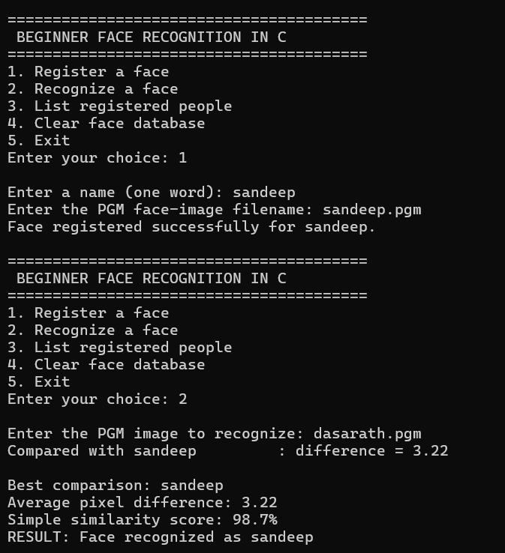

Complexity and Properties
Let P = original image size, S = 32×32 = 1,024 (constant), N = registered faces. prepareFace() is O(P + S) ≈ O(P). compareFaces() is O(S) = O(1). recognizeFace() overall is O(P + N·S) ≈ O(P + N), linear in image size and number of registered people. Space: O(P) temporarily while loading/resizing; the on-disk database grows as O(N·S) = O(N); only one saved template is held in memory at a time during comparison (O(S) = O(1)).

Additional test observations
- Testing with the exact same registered image → MAD ≈ 0 → always recognized.
- Testing with an unrelated pattern → MAD well above 38.0 → "Unknown face".
- Threshold set too low → even the correct person may be rejected as Unknown.

Viva questions
- Why resize every face to the same 32×32 size? So pixel-by-pixel comparison is meaningful; images of different original sizes can't be compared directly.
- Why is a threshold needed even after finding the smallest MAD? Because the closest match among registered faces may still be a completely different person if no true match is registered.
- Why is abs() used in compareFaces()? To ensure positive and negative pixel differences don't cancel each other out.
Result : The face recognition program was implemented and executed successfully; registered faces were correctly matched via minimum MAD, and an unrelated test pattern was correctly rejected as "Unknown face" using the threshold rule.
Experiment 8 - Beginner Image Processing on PGM Images

Date : __________ Faculty signature : ____________________

Aim : To develop a menu-driven C program that reads a grayscale image in ASCII PGM (P2) format and applies pixel-level image processing operations (Negative, Brightness, Threshold, Horizontal Flip, Blur, Edge Detection), saving each result as a new PGM file.

Software required : C compiler supporting C11, a text editor, sample ASCII PGM (P2) images.

Concept
Each operation transforms pixel values using a simple, well-defined rule: Negative inverts brightness; Brightness adds/subtracts a constant (clamped to valid range); Threshold produces pure black/white based on a cut-off; Horizontal Flip mirrors columns; Blur averages a 3×3 neighbourhood; Edge Detection applies Sobel-style convolution kernels (Gx, Gy) to estimate local intensity change.

Algorithm
- Read the PGM image into memory (readPGM), storing width, height, maxValue, and a 1-D pixel array.
- Display a menu of operations; create an output image the same size as the input (createLike).
- Apply the selected operation function, writing results into the output image:
  - Negative: output[i] = maxValue − input[i]
  - Brightness: output[i] = clamp(input[i] + amount, maxValue)
  - Threshold: output[i] = maxValue if input[i] ≥ threshold, else 0
  - Horizontal Flip: output[row][width−1−col] = input[row][col]
  - Blur: average of the up-to-9 valid neighbours in a 3×3 window
  - Edge Detection: convolve with Gx and Gy Sobel kernels; edgeStrength = |Gx| + |Gy|, clamped
- Save the output as a new PGM file and repeat until the user exits.

Worked observation
Operation | Input pixel(s) | Output
Negative (maxValue=255) | 60 | 255 − 60 = 195
Brightness (+40) | 60 | clamp(60+40, 255) = 100
Threshold (t=150) | 60, 200 | 0, 255
Horizontal Flip | row = [A,B,C] | [C,B,A]

C program
#include <stdio.h>
#include <stdlib.h>
#include <string.h>
#include <ctype.h>

typedef struct { int width; int height; int maxValue; int *pixel; } Image;

int clamp(int value, int maxValue) {
if (value < 0) return 0;
if (value > maxValue) return maxValue;
return value;
}

int indexOf(const Image *img, int row, int col) { return row * img->width + col; }

int nextToken(FILE *fp, char *token, int size) {
int ch;
while ((ch = fgetc(fp)) != EOF) {
if (isspace(ch)) continue;
if (ch == '#') { while ((ch = fgetc(fp)) != EOF && ch != '\n') { } continue; }
int i = 0;
token[i++] = (char)ch;
while (i < size - 1 && (ch = fgetc(fp)) != EOF) {
if (isspace(ch)) break;
if (ch == '#') { while ((ch = fgetc(fp)) != EOF && ch != '\n') { } break; }
token[i++] = (char)ch;
}
token[i] = '\0';
return 1;
}
return 0;
}

int readPGM(const char *fileName, Image *img) {
FILE *fp = fopen(fileName, "r");
char token[100];
if (fp == NULL) { printf("Error: Could not open %s\n", fileName); return 0; }
if (!nextToken(fp, token, sizeof(token)) || strcmp(token, "P2") != 0) {
printf("Error: This program needs an ASCII PGM (P2) file.\n");
fclose(fp);
return 0;
}
if (!nextToken(fp, token, sizeof(token))) { fclose(fp); return 0; }
img->width = atoi(token);
if (!nextToken(fp, token, sizeof(token))) { fclose(fp); return 0; }
img->height = atoi(token);
if (!nextToken(fp, token, sizeof(token))) { fclose(fp); return 0; }
img->maxValue = atoi(token);
if (img->width <= 0 || img->height <= 0 || img->maxValue <= 0 || img->maxValue > 65535) {
printf("Error: Invalid PGM header.\n");
fclose(fp);
return 0;
}
long totalPixels = (long)img->width * img->height;
img->pixel = (int *)malloc(totalPixels * sizeof(int));
if (img->pixel == NULL) { printf("Error: Not enough memory.\n"); fclose(fp); return 0; }
for (long i = 0; i < totalPixels; i++) {
if (!nextToken(fp, token, sizeof(token))) {
printf("Error: Image contains fewer pixels than expected.\n");
free(img->pixel);
img->pixel = NULL;
fclose(fp);
return 0;
}
img->pixel[i] = clamp(atoi(token), img->maxValue);
}
fclose(fp);
return 1;
}

int writePGM(const char *fileName, const Image *img) {
FILE *fp = fopen(fileName, "w");
if (fp == NULL) { printf("Error: Could not create %s\n", fileName); return 0; }
fprintf(fp, "P2\n");
fprintf(fp, "# Created by beginner C image processing project\n");
fprintf(fp, "%d %d\n", img->width, img->height);
fprintf(fp, "%d\n", img->maxValue);
for (int row = 0; row < img->height; row++) {
for (int col = 0; col < img->width; col++) fprintf(fp, "%d ", img->pixel[indexOf(img, row, col)]);
fprintf(fp, "\n");
}
fclose(fp);
return 1;
}

int createLike(const Image *source, Image *result) {
result->width = source->width;
result->height = source->height;
result->maxValue = source->maxValue;
long totalPixels = (long)source->width * source->height;
result->pixel = (int *)malloc(totalPixels * sizeof(int));
if (result->pixel == NULL) { printf("Error: Not enough memory for output image.\n"); return 0; }
return 1;
}

void makeNegative(const Image *input, Image *output) {
long totalPixels = (long)input->width * input->height;
for (long i = 0; i < totalPixels; i++) output->pixel[i] = input->maxValue - input->pixel[i];
}

void changeBrightness(const Image *input, Image *output, int amount) {
long totalPixels = (long)input->width * input->height;
for (long i = 0; i < totalPixels; i++) output->pixel[i] = clamp(input->pixel[i] + amount, input->maxValue);
}

void applyThreshold(const Image *input, Image *output, int threshold) {
long totalPixels = (long)input->width * input->height;
for (long i = 0; i < totalPixels; i++)
output->pixel[i] = (input->pixel[i] >= threshold) ? input->maxValue : 0;
}

void flipHorizontal(const Image *input, Image *output) {
for (int row = 0; row < input->height; row++) {
for (int col = 0; col < input->width; col++) {
int newCol = input->width - 1 - col;
output->pixel[indexOf(output, row, newCol)] = input->pixel[indexOf(input, row, col)];
}
}
}

void blurImage(const Image *input, Image *output) {
for (int row = 0; row < input->height; row++) {
for (int col = 0; col < input->width; col++) {
int sum = 0;
int count = 0;
for (int dr = -1; dr <= 1; dr++) {
for (int dc = -1; dc <= 1; dc++) {
int r = row + dr;
int c = col + dc;
if (r >= 0 && r < input->height && c >= 0 && c < input->width) {
sum += input->pixel[indexOf(input, r, c)];
count++;
}
}
}
output->pixel[indexOf(output, row, col)] = sum / count;
}
}
}

void detectEdges(const Image *input, Image *output) {
int gxKernel[3][3] = { {-1, 0, 1}, {-2, 0, 2}, {-1, 0, 1} };
int gyKernel[3][3] = { {-1, -2, -1}, { 0, 0, 0}, { 1, 2, 1} };
for (int row = 0; row < input->height; row++) {
for (int col = 0; col < input->width; col++) {
if (row == 0 || col == 0 || row == input->height - 1 || col == input->width - 1) {
output->pixel[indexOf(output, row, col)] = 0;
continue;
}
int gx = 0, gy = 0;
for (int kr = -1; kr <= 1; kr++) {
for (int kc = -1; kc <= 1; kc++) {
int value = input->pixel[indexOf(input, row + kr, col + kc)];
gx += value * gxKernel[kr + 1][kc + 1];
gy += value * gyKernel[kr + 1][kc + 1];
}
}
int edgeStrength = abs(gx) + abs(gy);
output->pixel[indexOf(output, row, col)] = clamp(edgeStrength, input->maxValue);
}
}
}

void showImageInfo(const Image *img) {
printf("\nImage information\n");
printf("Width : %d pixels\n", img->width);
printf("Height : %d pixels\n", img->height);
printf("Maximum gray: %d\n", img->maxValue);
printf("Total pixels: %ld\n\n", (long)img->width * img->height);
}

int main(void) {
Image input = {0, 0, 0, NULL};
Image output = {0, 0, 0, NULL};
char fileName[200];
int choice;

printf("=============================================\n");
printf(" BEGINNER IMAGE PROCESSING IN C\n");
printf("=============================================\n");
printf("Enter the input PGM file name: ");
scanf("%199s", fileName);

if (!readPGM(fileName, &input)) return 1;

printf("Image loaded successfully!\n");
showImageInfo(&input);

do {
printf("Choose an operation:\n");
printf("1. Create negative image\n2. Change brightness\n3. Convert to black and white (threshold)\n");
printf("4. Flip horizontally\n5. Blur image\n6. Detect edges\n7. Show image information\n0. Exit\n");
printf("Enter choice: ");
scanf("%d", &choice);

if (choice == 0) break;
if (choice == 7) { showImageInfo(&input); continue; }
if (choice < 1 || choice > 6) { printf("Invalid choice. Please try again.\n\n"); continue; }

if (!createLike(&input, &output)) { free(input.pixel); return 1; }

if (choice == 1) {
makeNegative(&input, &output);
writePGM("negative.pgm", &output);
printf("Done! Output saved as negative.pgm\n\n");
}
else if (choice == 2) {
int amount;
printf("Enter brightness amount (-255 to 255): ");
scanf("%d", &amount);
changeBrightness(&input, &output, amount);
writePGM("brightness.pgm", &output);
printf("Done! Output saved as brightness.pgm\n\n");
}
else if (choice == 3) {
int threshold;
printf("Enter threshold (0 to %d): ", input.maxValue);
scanf("%d", &threshold);
threshold = clamp(threshold, input.maxValue);
applyThreshold(&input, &output, threshold);
writePGM("threshold.pgm", &output);
printf("Done! Output saved as threshold.pgm\n\n");
}
else if (choice == 4) {
flipHorizontal(&input, &output);
writePGM("horizontal_flip.pgm", &output);
printf("Done! Output saved as horizontal_flip.pgm\n\n");
}
else if (choice == 5) {
blurImage(&input, &output);
writePGM("blur.pgm", &output);
printf("Done! Output saved as blur.pgm\n\n");
}
else if (choice == 6) {
detectEdges(&input, &output);
writePGM("edge.pgm", &output);
printf("Done! Output saved as edge.pgm\n\n");
}

free(output.pixel);
output.pixel = NULL;

} while (1);

free(input.pixel);
printf("Program closed. Goodbye!\n");
return 0;
}

Sample execution

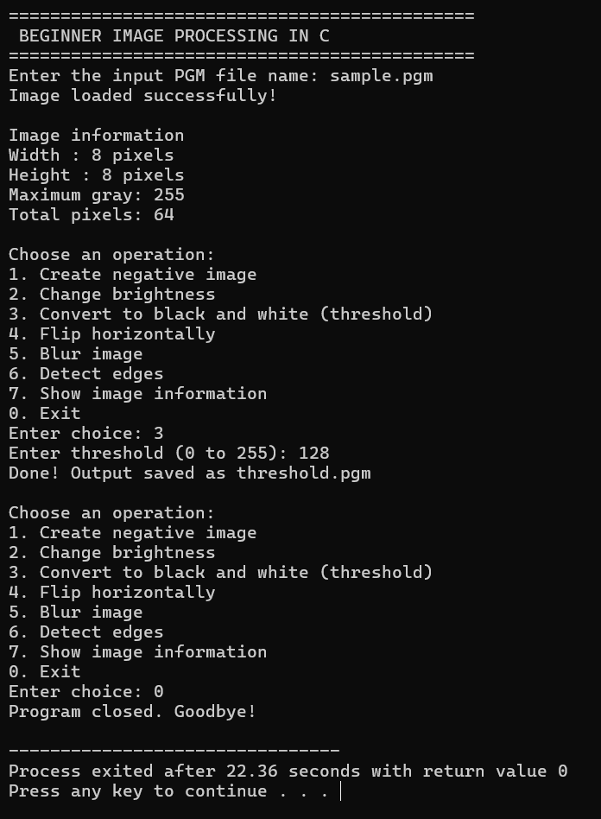

Complexity and Properties
Let n = W × H (total pixels). Reading, writing, Negative, Brightness, Threshold, and Horizontal Flip are each O(n). Blur and Edge Detection are O(9n) = O(n), since each pixel involves a fixed 3×3 (9-cell) neighbourhood scan. Overall time O(n) for every operation. Space: input and output pixel arrays are each O(n); kernels for edge detection are fixed 3×3 (O(1)). Overall space O(n).
Additional test observations
- Brightness +255 on a bright pixel → clamped at maxValue (255), never overflows.
- Threshold = 0 → entire image becomes white (every pixel ≥ 0).
- Edge Detection on a uniform (flat) image → all edge strengths are 0.

Viva questions
- Why does Blur produce a slightly darker/lighter border compared to the interior? Border pixels have fewer than 9 valid neighbours (some fall outside the image), so the divisor count is smaller.
- Why are two separate kernels (Gx, Gy) used in edge detection? Gx detects vertical edges (horizontal intensity change) and Gy detects horizontal edges (vertical intensity change); combining both estimates edge strength in any direction.
- Why is clamp() used throughout the program? To keep every computed pixel value within the valid 0 to maxValue range, preventing overflow or invalid PGM output.

Result : The beginner image processing program was implemented and executed successfully; Negative, Brightness, Threshold, Horizontal Flip, Blur, and Edge Detection operations all produced correct output images as verified by inspecting sample pixel values.

