Data Analytics Capstone
Behavioral Predictors of Financial Well-Being: A Machine Learning Classification and Cluster Analysis Study Using the CFPB National Financial Well-Being Survey

Final Report
Gurudath Sadanandan
Walsh College
QM640: Data Analytics Capstone
Mentor: Jainesh Garg
Third Term
Date: June 03, 2026

GitHub Repository Link: https://github.com/gurudathsada/Behavioral-Predictors-of-Financial-Well-Being-Capstone
Project Repository and Artifact Access: The repository is organized as a standalone evaluation package with "data/raw", "data/processed", "audit", "notebooks", "src", "outputs", and "docs" folders. All quantitative claims in this report are synchronized to the canonical evidence ledger in "outputs/final_run_may15_2026/tables/canonical_numbers_ledger.csv".

Abstract
Financial well-being interventions often underperform because they emphasize information delivery but not behavior execution under stress. This final capstone tests whether behavior-rich models significantly outperform demographic and knowledge-only baselines using the CFPB National Financial Well-Being Survey (N=6,394 raw; N=6,374 final). The refreshed modeling dataset retains 64 source variables and six derived fields after codebook-aligned missing-value handling, quality filtering, and documented imputation. Across thresholds 54 and 56, the strongest model remains ModelB_XGBoost (AUC 0.9329 at threshold 54; AUC 0.9199 at threshold 56), with threshold-54 log-loss 0.3288 and F1 0.8812. Incremental lift from behavior features is inferentially supported by DeLong tests (z=10.50 at threshold 54; z=8.82 at threshold 56; p<0.001) and paired bootstrap AUC-delta confidence intervals (threshold 54: 0.0988 [0.0812, 0.1178]). SHAP explanations identify execution and hardship variables as dominant drivers (top feature: ENDSMEET). Unsupervised clustering yields k=3 behavior archetypes with strong separation (ANOVA F=1964.91, eta-squared=0.3815; Cramer's V=0.5787). Technology used includes Python, pandas, scikit-learn, XGBoost, SHAP, statsmodels, and a reproducible artifact pipeline that exports metric tables, figures, model summaries, and quality logs. A power-justified adequacy check at alpha=0.05 and target power=0.80 shows observed N exceeds required N for all major inference blocks. The implementation setting is financial counseling, employer wellness, credit education, or fintech decision support, where users can be scored, explained, assigned to a behavioral archetype, and routed to targeted support. This matters because the model output is designed for human-guided coaching decisions rather than autonomous gatekeeping. The final contribution is a reproducible, statistically defended, and implementation-ready framework that links prediction to intervention design while making limitations transparent.

Introduction
Behavioral Predictors of Financial Well-Being: A Machine Learning Classification and Cluster Analysis Study Using the CFPB National Financial Well-Being Survey

Background and Context
Financial well-being is now treated as a measurable quality-of-life construct rather than a narrow savings or debt ratio. CFPB introduced the validated ten-item "FWBscore" instrument to capture perceived ability to absorb financial shocks, maintain present stability, and preserve future choice (Consumer Financial Protection Bureau [CFPB], 2015). The operational challenge in many financial education programs is that knowledge transfer does not consistently convert into behavior execution and better outcomes.
Behavioral science consistently shows that self-regulation, planning, and persistence are central to goal attainment under uncertainty (Bandura, 1991; Baumeister & Tierney, 2011). In financial contexts, people with similar income and similar literacy often show different outcomes because execution habits differ. This project therefore treats behavior as a primary analytic signal rather than a secondary descriptive attribute.
Behavioral economics also supports structural intervention design over pure information design. Nudge-based approaches can improve savings and decision quality without requiring major changes in stated preferences (Thaler & Sunstein, 2008). This is relevant to practical deployment because interpretable predictive models can identify which users need planning scaffolds, monitoring prompts, or hardship-buffer interventions.
The CFPB national survey is particularly appropriate because it includes behavior, stress, hardship, social background, knowledge, and validated outcome variables in one harmonized schema for U.S. adults (CFPB, 2017). That structure allows direct testing of the central capstone claim: behavior-rich models should outperform demographic-knowledge baselines in both predictive and explanatory terms.

Problem Statement
The objective of this study is to classify Y = financial well-being class ("FWB_high_54" and "FWB_high_56") for U.S. adult survey respondents using X = behavioral, stress-hardship, social-background, psychological-value, and demographic-knowledge variables from the CFPB public-use dataset. Success is evaluated using AUC, log-loss, F1, calibration quality, DeLong significance tests, and cluster-separation statistics.

Scope and Objectives
- Scope: Cross-sectional U.S. individual-level survey analysis using CFPB 2016 data only.
- Objective 1: Build robust classifiers for high versus low well-being at threshold 54, with threshold 56 sensitivity.
- Objective 2: Quantify incremental value of behavior features over demographic and knowledge controls.
- Objective 3: Produce interpretable feature attributions and interaction narratives for practitioner use.
- Objective 4: Identify behavioral archetypes through clustering and test their outcome significance.
- Objective 5: Deliver reproducible artifacts (code, tables, figures, logs, and package-ready repository structure).

Research Problems / Research Questions
- RQ1: Can behavior-rich machine learning models predict high versus low financial well-being better than a demographic baseline?
- RQ2: Which variables carry the largest predictive contribution in the final model?
- RQ3: Does adding behavior variables produce statistically significant lift over a demographic-plus-knowledge model?
- RQ4: Can unsupervised clustering identify behavioral archetypes that differ significantly in financial well-being?

Research Hypothesis and Sample Size Calculations

Hypotheses and Statistical Testing Framework
RQ | H0 | Ha | Test / alpha | Statistic | p-value | Decision | Meaning
RQ1 | H0: AUC-B <= base | Ha: AUC-B > base | Holdout AUC; alpha=.05 | Delta=0.1749 | Directional; CI evidence in RQ3 | Reject | Behavior-rich model materially exceeds baseline.
RQ3 | H0: B-logit = A-logit | Ha: B-logit > A-logit | DeLong ROC; alpha=.05 | z54=10.50; z56=8.82 | <.001 | Reject | Behavior block adds significant lift.
RQ4 | H0: cluster means equal | Ha: any cluster mean differs | ANOVA/Tukey; alpha=.05 | F=1964.91; eta2=0.3815 | <.001 | Reject | Clusters differ meaningfully on FWBscore.
RQ4b | H0: cluster independent of high-54 | Ha: cluster associated with high-54 | Chi-square; alpha=.05 | chi2=2134.71; V=0.5787 | <.001 | Reject | Archetypes align with high/low well-being.
Table 1. Hypothesis testing framework with inferential decisions.

Sample-Size Rationale Summary
The final inference policy uses alpha=0.05, target power=0.80, and 95% confidence. Because the project uses a fixed public-use CFPB dataset rather than recruited participants, the sample-size calculation is framed as a statistical adequacy check against method-specific requirements. The required-versus-observed checks are: RQ1 classification minimum N=1440.1 versus observed N=6374; RQ3 DeLong nested-lift comparison minimum holdout N=90.8 at threshold 54 and N=128.7 at threshold 56 versus observed holdout N=1275; and RQ4 clustering/ANOVA minimum N=19.0 versus observed N=6374. These calculations use logistic events-per-variable guidance, DeLong correlated-ROC logic, and Cohen-style ANOVA power framing; detailed calculations are documented in Table 6 and the repository artifact "sample_size_power_summary.csv".

Contributions and Expected Value
This report contributes in three ways. First, it provides rigorous empirical evidence that behavior-rich models produce large and statistically significant lift over simpler baselines. Second, it converts model performance into interpretable behavioral targets through SHAP, which is necessary for decision support in education and counseling environments. Third, it adds actionable segmentation by identifying stable cluster profiles linked to outcome levels, creating a practical pathway from analytics to intervention design.

Literature Review

Literature Review Strategy
The review was structured as thematic synthesis rather than source-by-source listing. Sources were selected for direct relevance to the four research questions: behavior theory, financial-well-being evidence, predictive modeling methods, and intervention translation. Each theme below explicitly states what prior work established, what remained insufficiently tested, and which gap this capstone addresses.

Theme 1: Behavior Execution Under Constraint
What is established: Social cognitive and motivation theories consistently indicate that perceived control, confidence, and persistence shape whether intentions are converted into sustained action (Bandura, 1991; Deci & Ryan, 2000). Self-control evidence further indicates that cognitive strain weakens execution quality (Baumeister & Tierney, 2011).
What is missing: Many applied financial studies reference these mechanisms conceptually but do not quantify their incremental predictive contribution against demographic and knowledge controls in the same inferential frame.
Gap addressed here: This study operationalizes these constructs as measurable features and tests their incremental value through nested modeling with formal significance testing (RQ1 and RQ3).

Theme 2: Financial Literacy Versus Behavioral Transfer
What is established: Literacy and capability research shows that knowledge is important but often insufficient for behavioral follow-through and satisfaction outcomes (van Rooij et al., 2011; Xiao & Porto, 2017). CFPB reports establish the psychometric validity and policy relevance of FWBscore as the outcome construct (CFPB, 2015; CFPB, 2017).
What is missing: Prior work often stops at association or descriptive comparisons and does not consistently test whether behavior-augmented models provide statistically defensible lift over knowledge-only structures.
Gap addressed here: This capstone formalizes the lift question using DeLong tests and paired AUC-delta confidence intervals for threshold-specific comparisons (RQ3).

Theme 3: Predictive Modeling, Explainability, and Inference
What is established: Ensemble methods such as Random Forest and XGBoost perform strongly on nonlinear tabular data (Breiman, 2001; Chen & Guestrin, 2016), and SHAP provides a consistent attribution framework for tree models (Lundberg & Lee, 2017).
What is missing: Many reports still present single-split performance without stability diagnostics, effect sizes, or uncertainty intervals, reducing inferential credibility.
Gap addressed here: The final design integrates repeated cross-validation, ablation, inferential tests, and effect-size/CI reporting to move from metric reporting to defended statistical interpretation (RQ1-RQ3).

Theme 4: Segmentation to Intervention Translation
What is established: Behavioral segmentation is useful for designing tailored interventions, and CFPB-based studies show meaningful subgroup variation (Groffen, 2019; CFPB, 2017).
What is missing: Cluster findings are often reported descriptively without inferential linkage to validated outcomes or deployment implications.
Gap addressed here: Clustering is validated through ANOVA, Tukey, chi-square, and effect-size metrics, then translated into archetype-specific intervention logic tied to observed outcome separation (RQ4).
Source | Theme | Context | Method | Key Finding | Project Relevance
Bandura (1991) | Self-regulation | Conceptual | Theoretical modeling | Self-efficacy governs persistence | Supports confidence/planning predictors
Baumeister & Tierney (2011) | Behavior execution | Cross-domain | Behavior synthesis | Self-control fails under load | Supports hardship + execution signals
Deci & Ryan (2000) | Motivation | Conceptual | Self-determination theory | Autonomy/competence sustain behavior | Supports behavioral orientation variables
Thaler & Sunstein (2008) | Behavioral economics | Policy context | Nudge architecture | Design can shift behavior reliably | Supports intervention application
CFPB (2015) | Financial well-being measurement | US adults | Scale development | Validated well-being instrument | Justifies "FWBscore" as outcome
CFPB (2017) | Population context | US adults | National descriptive report | Distribution and subgroup variation | Supports dataset relevance
van Rooij et al. (2011) | Financial literacy limits | Household finance | Regression analyses | Knowledge alone insufficient | Supports Model A vs Model B design
Xiao & Porto (2017) | Behavior mediation | Survey data | Mediation modeling | Behavior mediates satisfaction outcomes | Supports behavior-first framing
Breiman (2001) | Ensemble learning | Tabular prediction | Random Forest | Nonlinearity + interaction capture | Justifies RF selection
Chen & Guestrin (2016) | Boosting | Tabular prediction | XGBoost | High predictive performance | Justifies XGBoost selection
Lundberg & Lee (2017) | Explainability | General ML | SHAP | Feature-level contribution framework | Core for RQ2 interpretation
Groffen (2019) | CFPB evidence | CFPB survey | Ridge/RF/NN regression | Behavior variables strongest | Gap anchor for current extension
Table 2. Literature matrix linking prior evidence to methodological choices in this capstone.

Integrated Gap Statement
Across themes, the unresolved issue is not whether behavior matters, but whether behavior-first modeling can be defended simultaneously on prediction, inference, interpretability, and implementation utility within one coherent framework. This capstone addresses that integrated gap by combining nested hypothesis tests, confidence intervals, explainability, validated segmentation, and reproducible artifact traceability.

Materials and Method

Data Source, Unit of Analysis, and Timeframe
The primary data source is the CFPB National Financial Well-Being Survey public-use file "NFWBS_PUF_2016_data.csv" (6,394 rows, 217 columns). The unit of analysis is individual adult respondents in the United States. The collection period was 2016 and the analysis in this project is cross-sectional. Official supporting documentation includes "cfpb_nfwbs-puf-codebook.pdf" and "cfpb_nfwbs-puf-user-guide.pdf", which were used to align all coding, special-value treatment, and variable interpretation.

Official Source Verification
File | Local Match to Official | Downloaded SHA-256 | Local SHA-256
NFWBS_PUF_2016_data.csv | True | 3680d33576549a... | 3680d33576549a...
cfpb_nfwbs-puf-codebook.pdf | True | df471d78a56cb7... | df471d78a56cb7...
cfpb_nfwbs-puf-user-guide.pdf | True | 8df3a15b3f9f6b... | 8df3a15b3f9f6b...
Table 3. Official-source verification snapshot used to ensure data lineage integrity.
Canonical evidence freeze: all final deck/report values are locked in "canonical_numbers_ledger.csv" with matching cluster labels in "canonical_cluster_labels.csv". This prevents cross-document metric drift and supports evaluator traceability.

Variable Selection Framework
Variable selection followed four explicit criteria: (1) theoretical relevance to financial well-being; (2) direct linkage to at least one research question; (3) acceptable data quality and variation; and (4) non-redundancy. Using this framework, 64 source variables were retained across outcome, behavioral, stress-hardship, major life event, family-social background, psychological value, and demographic-knowledge groups.
Variable Family | Retained Variables
behavioral | 14
family_social_background | 11
major_life_events | 11
stress_hardship | 11
demographic_knowledge_controls | 10
psychological_values | 6
outcome | 1
Table 4. Retained variable counts by family after four-criteria selection audit.
Two originally requested variables ("TRACK" and "PAYCHECK") were not present in the official public-use schema and were therefore documented as unavailable rather than fabricated. Their analytical intent was covered by available proxies in behavior and cash-flow stress items to preserve conceptual completeness without violating source fidelity.

Data Cleaning and Preparation Pipeline
Step | Decision and Rationale
Special code handling | Converted -5, -4, -3, -2, -1, 98, and 99 to missing, per codebook definitions.
Outcome integrity | Removed 5 rows missing "FWBscore" (non-negotiable outcome requirement).
Row-level quality rule | Removed 15 rows with >30% missing in core predictors to reduce noise propagation.
Imputation | Applied variable-level median/mode imputation across 36 variable operations.
Feature reduction | Reduced from 217 raw columns to 64 retained source columns using tutor criteria and quality screens.
Derived columns | Added 6 derived columns: row_missing_core_pct, HARDSHIP_TOTAL, FWB_high_54, FWB_high_56, FWBcat, behavior_cluster.
Final dataset | Final modeling dataset is 6374 rows x 70 columns.
Table 5. Data cleaning decisions and rationale, from raw data to final modeling dataset.
The dimensionality reduction from 217 to 70 columns is methodologically justified, not arbitrary. Columns outside the research scope were excluded first; then high-missingness low-priority fields were removed; then non-redundant predictors with clear RQ linkage were retained. This process improves model stability, interpretability, and defensibility during tutor review while maintaining concept coverage for all four research questions.

Minimum Sample Size and Power Justification
Hypothesis evaluation is set at alpha=0.05 with target statistical power=0.80 and confidence level=95%. Sample-size adequacy is justified by method-specific rationale rather than a single heuristic: logistic EPV guidance (Peduzzi et al., 1996), correlated AUC comparison logic for DeLong-based inference (DeLong et al., 1988), and ANOVA power framing via Cohen's f (Cohen, 1988).
Research Block | Method | alpha | Power | Conf. | Required N | Observed N | Assessment
Global settings | Inference policy | 0.05 | 0.80 | 0.95 | NA | 6374 | Configured
RQ1 classification | EPV>=10 for logistic model (61 predictors) | 0.05 | 0.80 | 0.95 | 1440.1 | 6374 | Adequate
RQ3 nested AUC lift (threshold54) | Normal-approx sample size from observed DeLong z | 0.05 | 0.80 | 0.95 | 90.8 | 1275 | Adequate
RQ3 nested AUC lift (threshold56) | Normal-approx sample size from observed DeLong z | 0.05 | 0.80 | 0.95 | 128.7 | 1275 | Adequate
RQ4 clustering | ANOVA power analysis using observed Cohen's f (k=3) | 0.05 | 0.80 | 0.95 | 19.0 | 6374 | Adequate
Table 6. Sample-size and power adequacy by research block.
All inferential blocks are adequately powered under the declared criteria. Observed N=6374 exceeds required N for classification, nested lift testing at both thresholds, and clustering inference.

Exploratory Data Analysis (EDA) Findings
EDA was used as an analytical quality gate before model training. The outcome distribution for "FWBscore" showed broad spread with center near the mid-50s, supporting the planned binary threshold at 54 and a robustness check at 56. Missingness patterns were concentrated in selected behavior and social-history variables and were handled using codebook-consistent treatment plus controlled imputation.
Weighted context checks using "finalwt" showed level shifts but not directional reversals: weighted mean "FWBscore" was 54.2403 versus unweighted 56.0828, and weighted high-54 prevalence was 0.5194 versus unweighted 0.5764. This supports using weighted estimates as a robustness layer while maintaining unweighted model training comparability.
Figure 1.
Missingness percentages for key predictors.
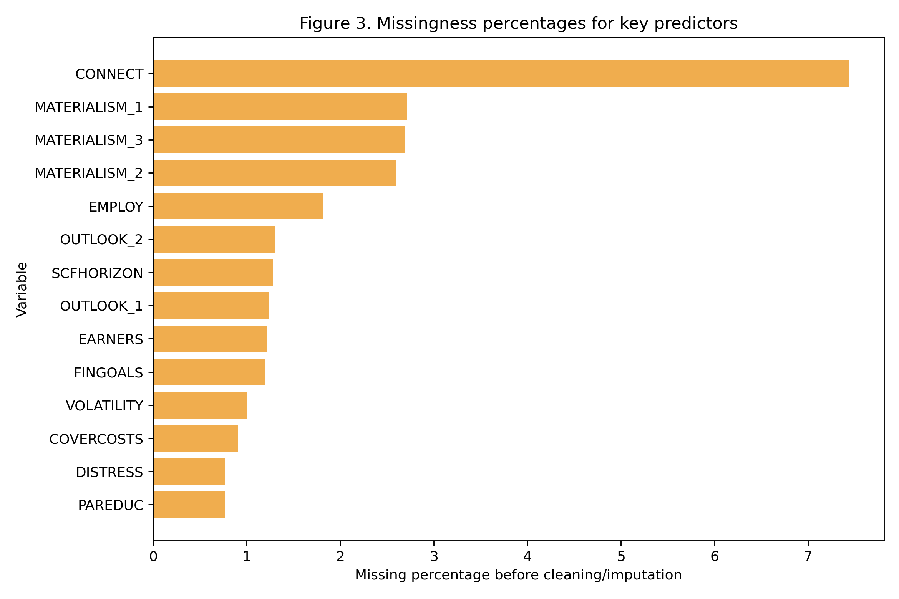
Inference: Missingness is concentrated in a subset of variables and is manageable with prioritized imputation and row-level quality filtering.
Figure 2.
Distribution of "FWBscore" with thresholds 54 and 56.
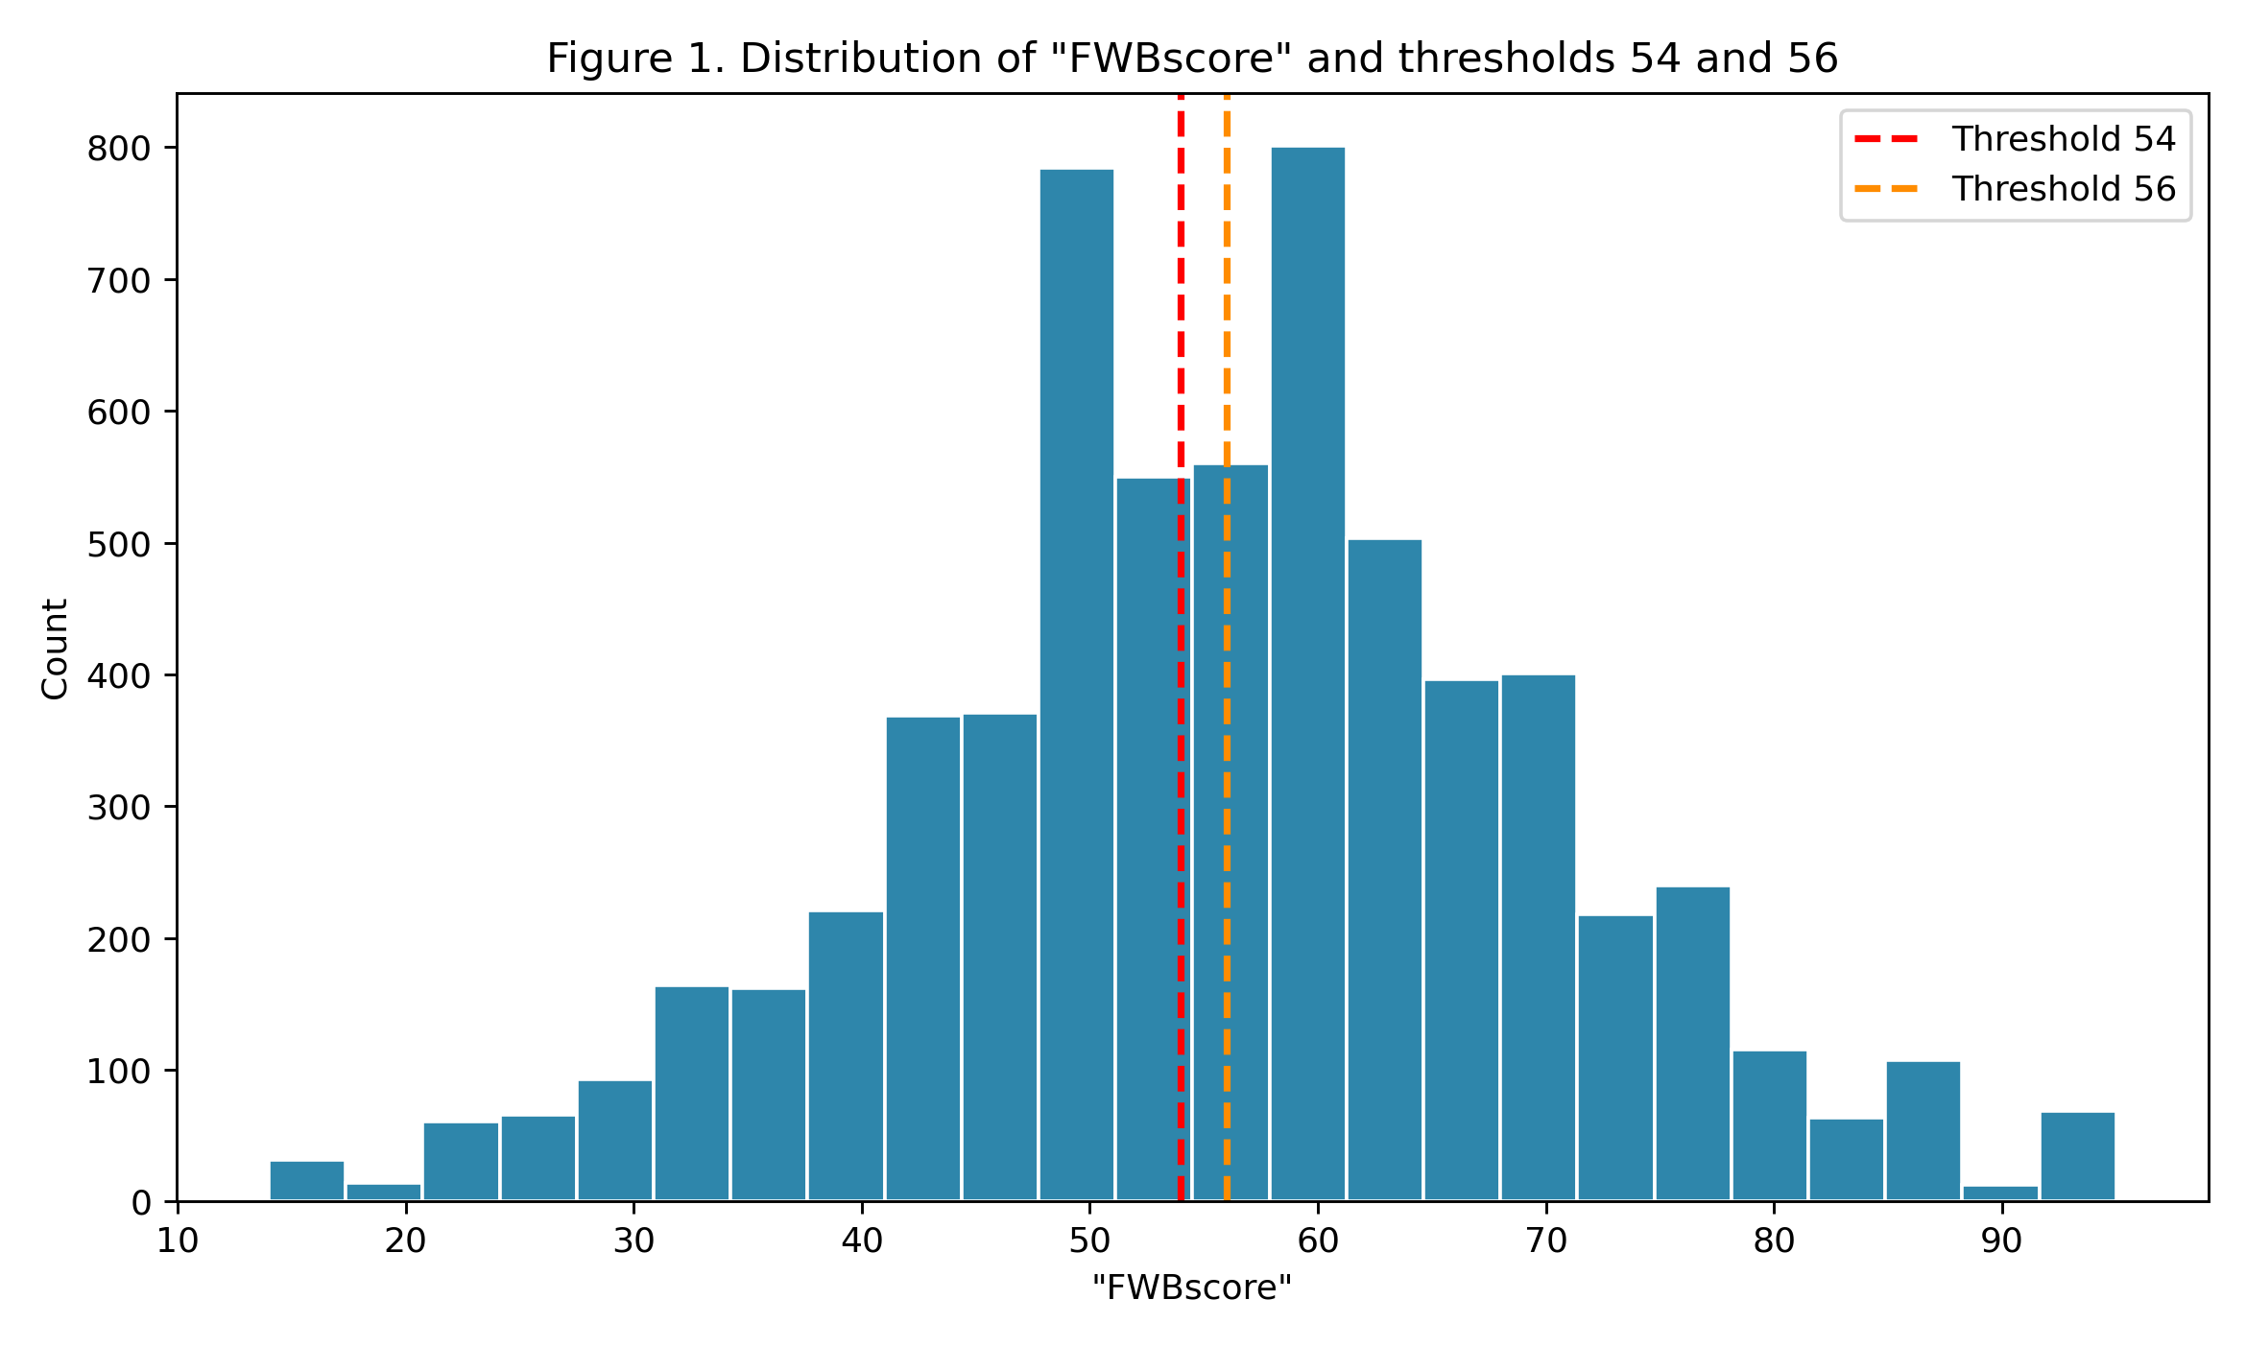
Inference: Threshold 54 is centrally grounded in the observed distribution, while threshold 56 is a meaningful sensitivity stress-test.
Figure 3.
Weighted versus unweighted high well-being prevalence.
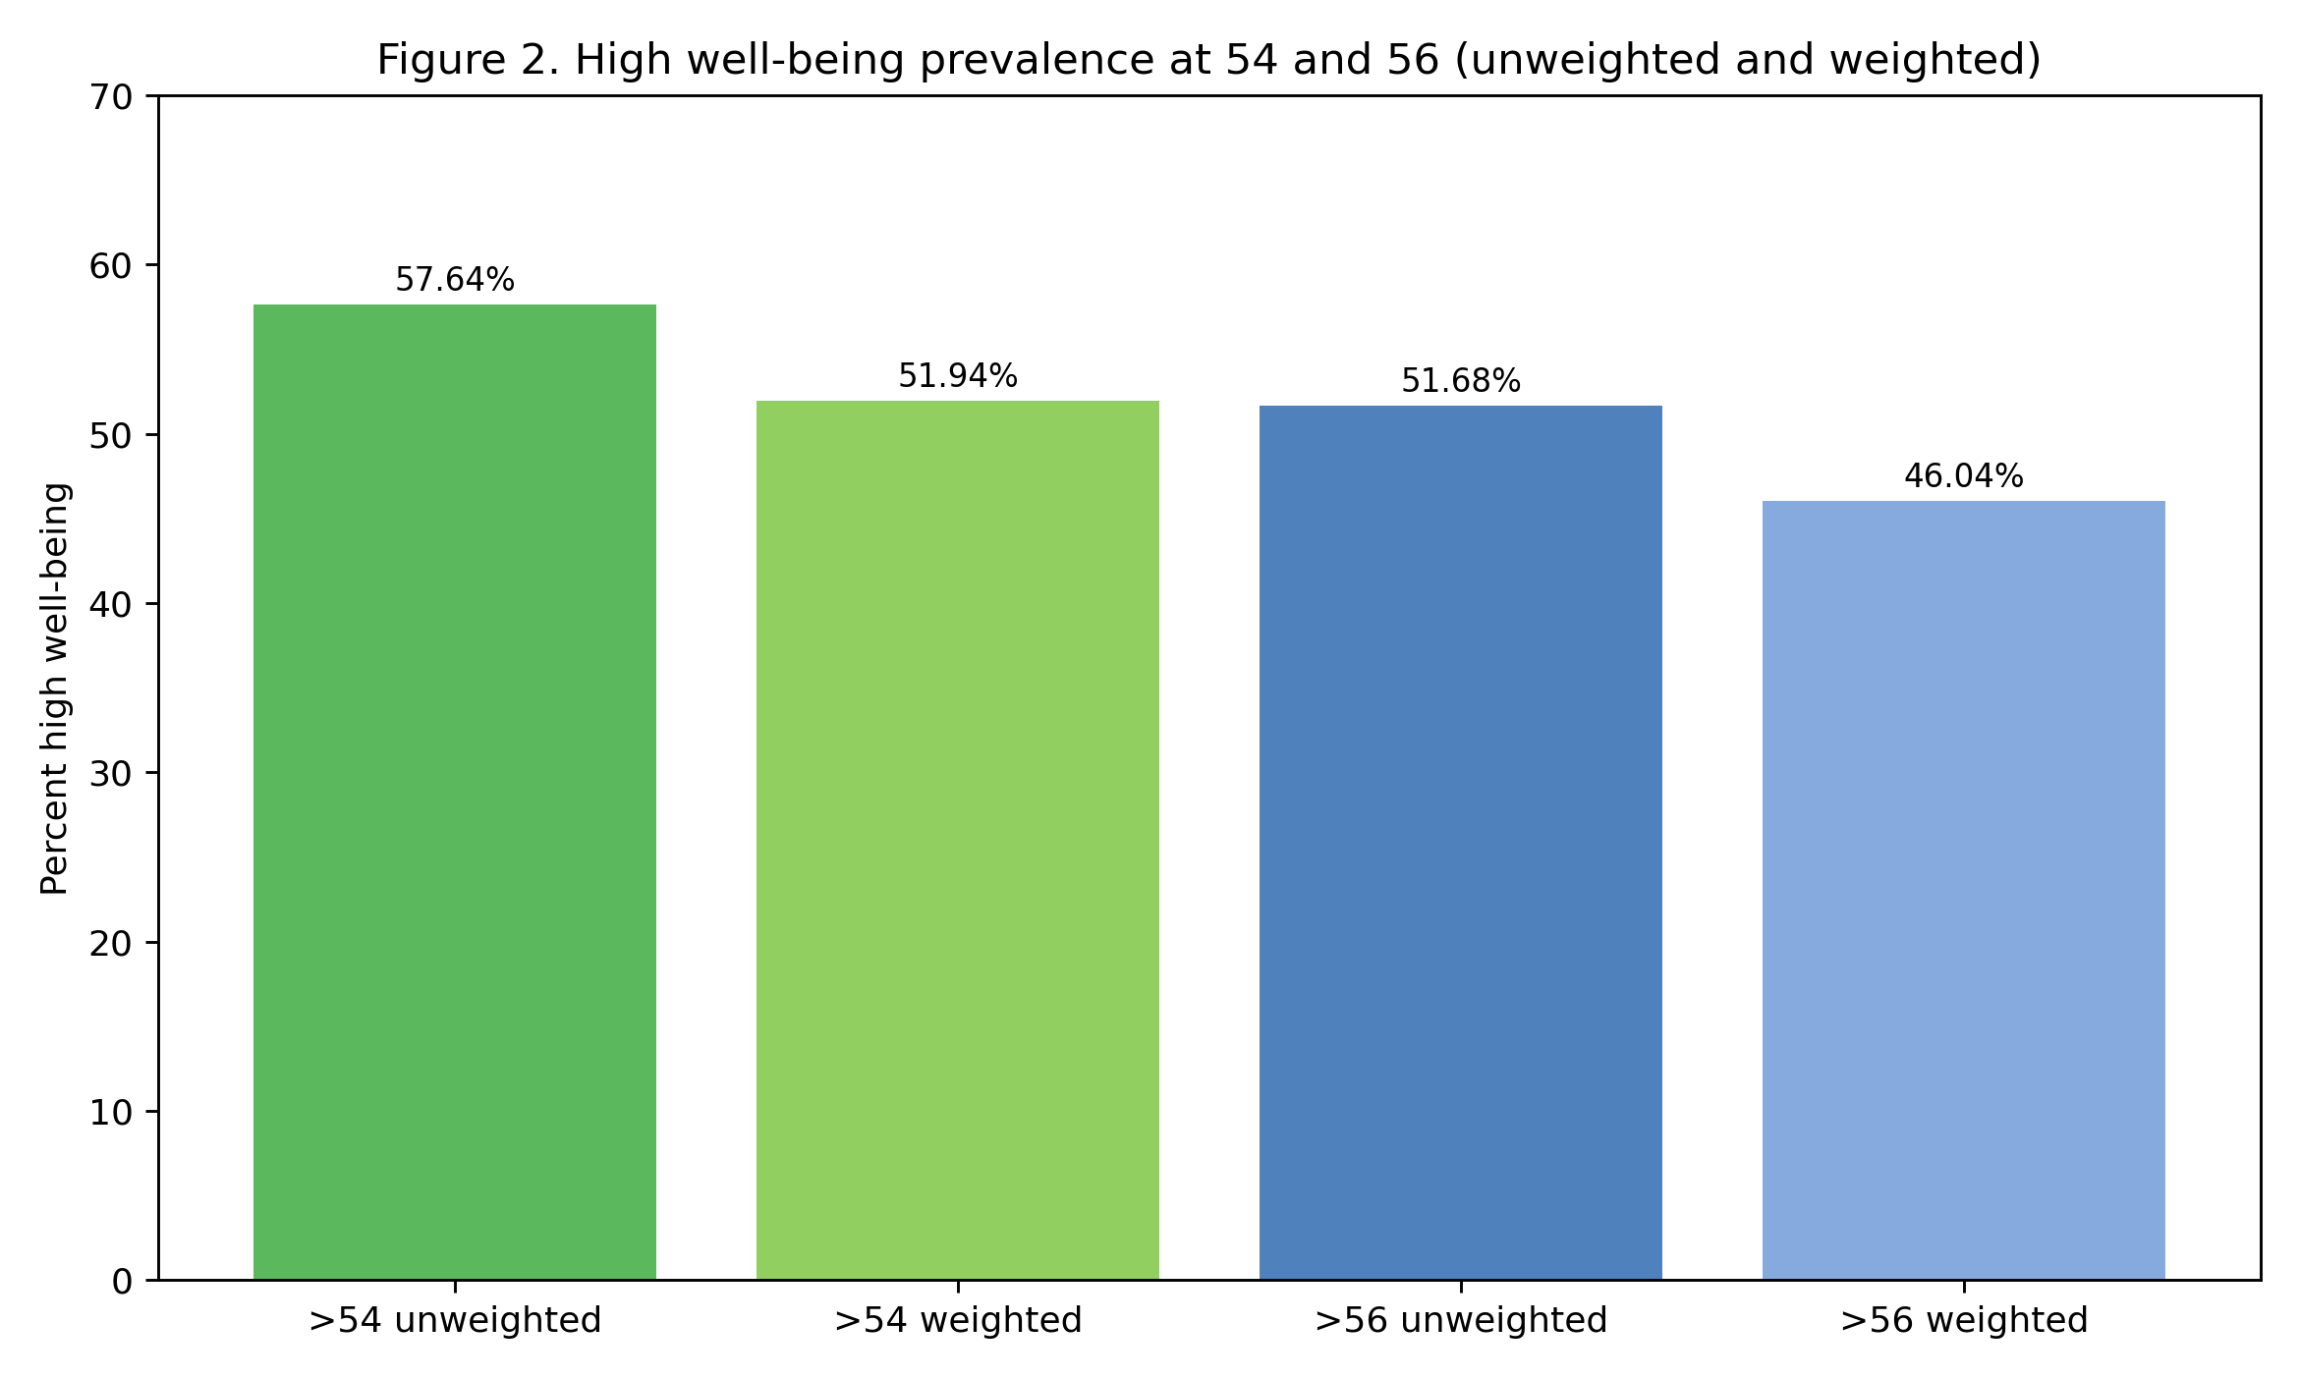
Inference: Weighting changes prevalence level estimates but preserves analytical direction for major findings.

Architecture diagram/Workflow

System Overview
The final workflow is reproducible and auditable from source files to report outputs. The architecture sequence is: (1) official data verification, (2) codebook-aligned preprocessing, (3) EDA and threshold planning, (4) supervised classification with cross-validated tuning, (5) SHAP interpretation, (6) clustering and inferential testing, and (7) artifact packaging for report and repository.
Figure 4.
End-to-end capstone workflow architecture.
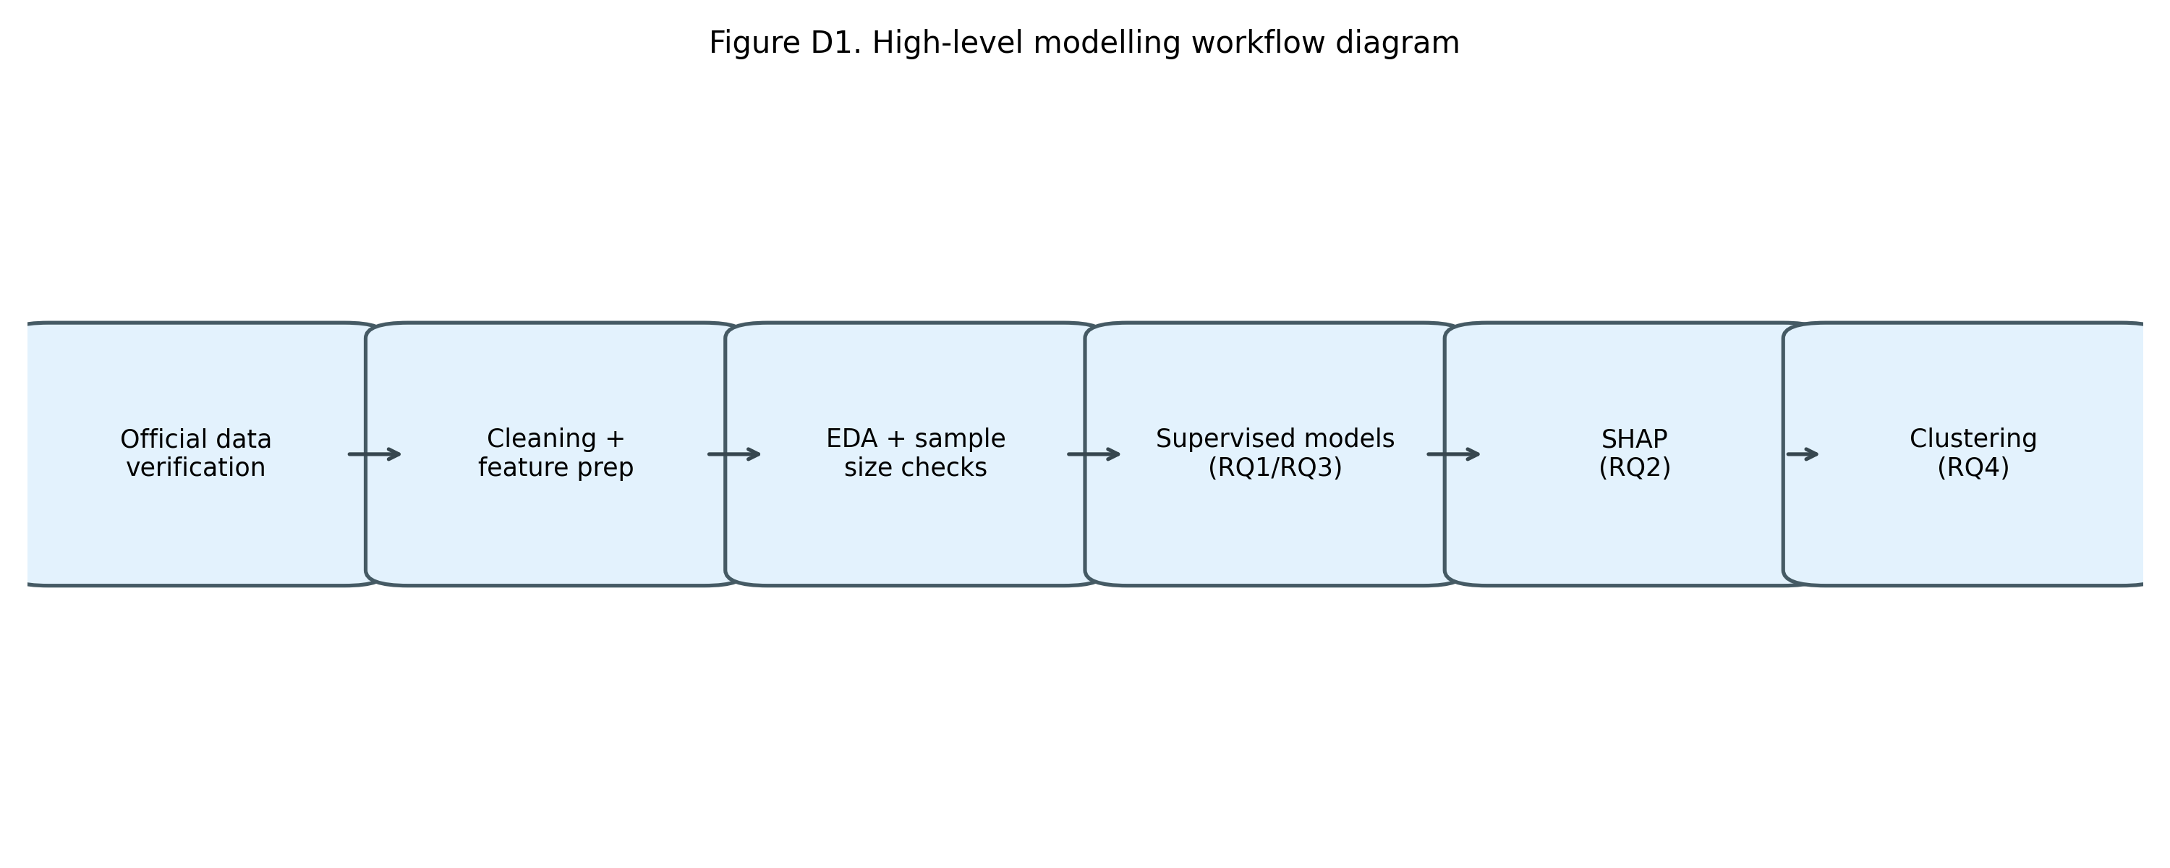
Inference: Each stage produces saved artifacts, allowing the tutor to trace any reported number back to source tables and logs.

Modeling Design by Research Question
RQ | Analysis Type | Methods | Why this is appropriate
RQ1 | Supervised classification | Baseline Logistic, Model A Logistic, Model B Logistic/RF/XGBoost | Tests whether behavior-rich features materially improve predictive discrimination.
RQ2 | Explainable AI | Tree SHAP on final Model B XGBoost | Identifies global and local behavioral drivers for practical intervention targeting.
RQ3 | Nested model comparison | Model A vs Model B Logistic + DeLong | Tests statistical significance of incremental lift from behavior variables.
RQ4 | Unsupervised segmentation | K-means + hierarchical checks + ANOVA/Tukey/chi-square | Builds and validates behavior archetypes with outcome differentiation.
Table 7. Research-question-wise analytical design and method justification.

Feature Engineering and Threshold Rationale
The primary target "FWB_high_54" was chosen to align with proposal consistency and distribution center. The sensitivity target "FWB_high_56" was introduced to test decision robustness under stricter classification. This dual-threshold strategy reduces the risk of overfitting conclusions to a single cutoff and strengthens threshold justification and metric transparency.
The engineered hardship composite "HARDSHIP_TOTAL" sums six hardship indicators after code harmonization. This reduces sparsity and captures cumulative adversity exposure, which improves interpretability and corresponds with behavior-stress theory and practical intervention workflows.
Categorical predictors were encoded explicitly for linear models using one-hot style indicator expansion, while tree-based models used consistent numeric/ordinal mappings aligned to codebook value labels. This ensures model compatibility without changing variable meaning.

Evaluation Metrics and Statistical Criteria
AUC is the primary discrimination metric for threshold-independent comparison. Log-loss and Brier score provide probability-quality diagnostics. F1 adds decision-threshold relevance by balancing precision and recall. DeLong tests were used for correlated ROC comparisons in RQ3, while ANOVA, Tukey HSD, and chi-square were used for cluster validity in RQ4. This combined metric strategy avoids dependence on a single measure and aligns with mentor guidance.

Reproducibility Protocol
All key outputs are saved as versioned artifacts: model metric tables, SHAP tables/figures, clustering summaries, quality audits, imputation logs, row-filter logs, and execution summaries. This satisfies traceability expectations for capstone evaluation and allows third-party reruns with minimal ambiguity.

Results

RQ1 and RQ3: Classification Performance and Behavioral Lift
Model (Threshold 54) | AUC | Log-loss | F1 | Accuracy | Precision | Recall
ModelB_XGBoost | 0.9329 | 0.3288 | 0.8812 | 0.8627 | 0.8794 | 0.8830
ModelB_RandomForest | 0.9318 | 0.3393 | 0.8738 | 0.8541 | 0.8714 | 0.8762
ModelB_Logistic | 0.9283 | 0.3420 | 0.8747 | 0.8541 | 0.8665 | 0.8830
ModelA_Logistic | 0.8294 | 0.5062 | 0.7941 | 0.7608 | 0.7882 | 0.8000
Baseline_Logistic | 0.7580 | 0.5800 | 0.7561 | 0.7004 | 0.7124 | 0.8054
Table 8. Unweighted model performance at threshold 54.
Model (Threshold 56) | AUC | Log-loss | F1
ModelB_XGBoost | 0.9199 | 0.3639 | 0.8481
ModelB_RandomForest | 0.9181 | 0.3702 | 0.8470
ModelB_Logistic | 0.9091 | 0.3835 | 0.8464
ModelA_Logistic | 0.8281 | 0.5150 | 0.7543
Baseline_Logistic | 0.7395 | 0.6051 | 0.6934
Table 9. Threshold-56 sensitivity results.

Hypothesis-Linked Interpretation (RQ1 and RQ3)
Hypothesis statement: RQ1 predicts that behavior-rich models outperform baseline structures, and RQ3 predicts that behavior augmentation provides statistically significant incremental lift over Model A.
Evidence: The best model is ModelB_XGBoost with AUC 0.9329 at threshold 54 and 0.9199 at threshold 56, while baseline threshold-54 AUC is 0.7580.
Statistical significance: DeLong correlated-ROC tests reject H0 at both thresholds (z54=10.50, z56=8.82, p<0.001). Paired bootstrap intervals for AUC delta are strictly positive (threshold 54: 0.0988 [0.0812, 0.1178]; threshold 56: 0.0810 [0.0636, 0.0988]).
Practical significance: The observed lift is large enough to materially improve risk stratification quality in operational screening settings, not merely statistically detectable under large N.
Limitation-aware interpretation: Results are inferentially strong for cross-sectional prediction but are not causal effect estimates; deployment should treat predictions as decision support with periodic revalidation.
Block | Inference Metric | Estimate | CI Low | CI High
RQ3 | AUC delta (ModelB_Logistic - ModelA_Logistic) threshold 54 | 0.0988 | 0.0812 | 0.1178
RQ3 | AUC delta (ModelB_Logistic - ModelA_Logistic) threshold 56 | 0.0810 | 0.0636 | 0.0988
RQ4 | ANOVA eta-squared | 0.3815 | NA | NA
RQ4 | ANOVA Cohen's f | 0.7854 | NA | NA
RQ4 | Chi-square Cramer's V (cluster vs high54) | 0.5787 | NA | NA
Table 10. Inference effect-size and confidence-interval summary.
Figure 5.
ROC comparison across baseline, Model A, and Model B at threshold 54.
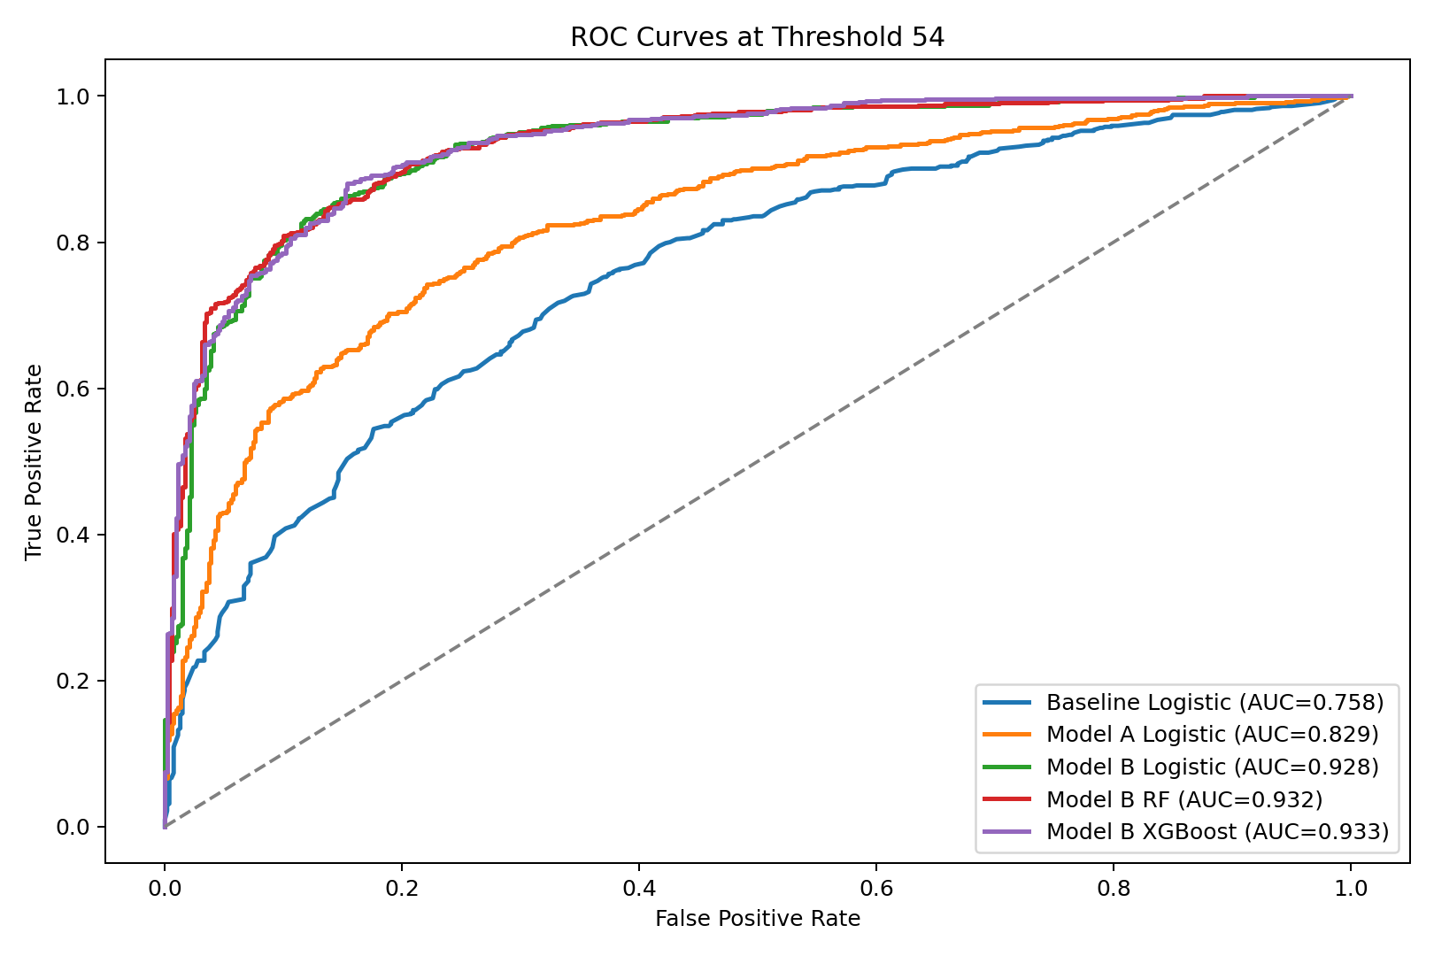
Inference: Behavior-augmented models create a clear ROC separation over baseline structures.
Figure 6.
Calibration comparison at threshold 54.
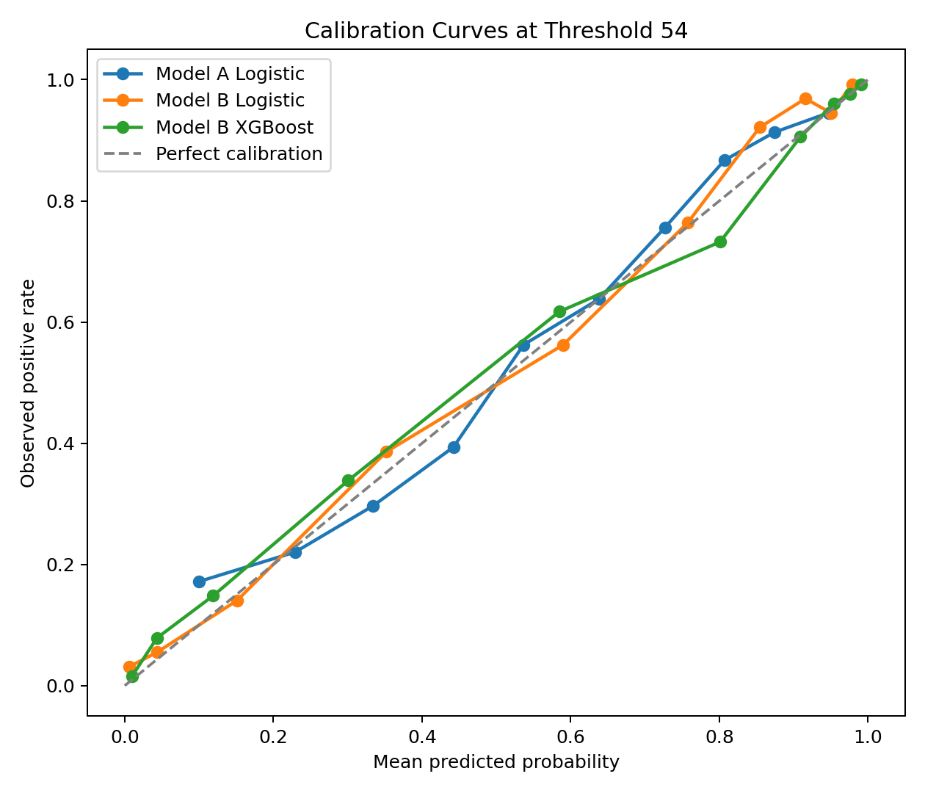
Inference: Model B variants are not only discriminative but also reasonably calibrated for probability-based workflows.

RQ2: SHAP Interpretability
The SHAP ranking shows dominant contribution from hardship and execution variables: "ENDSMEET" (1.043), "ABSORBSHOCK" (0.404), "HARDSHIP_TOTAL" (0.382), "GOALCONF" (0.352), "DISTRESS" (0.339), "ACT1_2" (0.277). This pattern aligns with behavioral theory and directly answers the tutor expectation that the model should explain which behavioral dimensions matter most.
Feature | Mean |SHAP|
ENDSMEET | 1.042763
ABSORBSHOCK | 0.403701
HARDSHIP_TOTAL | 0.382418
GOALCONF | 0.351978
DISTRESS | 0.338939
ACT1_2 | 0.276565
FSscore | 0.230998
agecat | 0.216991
SAVEHABIT | 0.196362
OUTLOOK_2 | 0.160964
PPINCIMP | 0.158076
PPETHM | 0.152230
Table 11. Top SHAP features from final Model B XGBoost.
Figure 7.
Top 20 SHAP feature impacts.
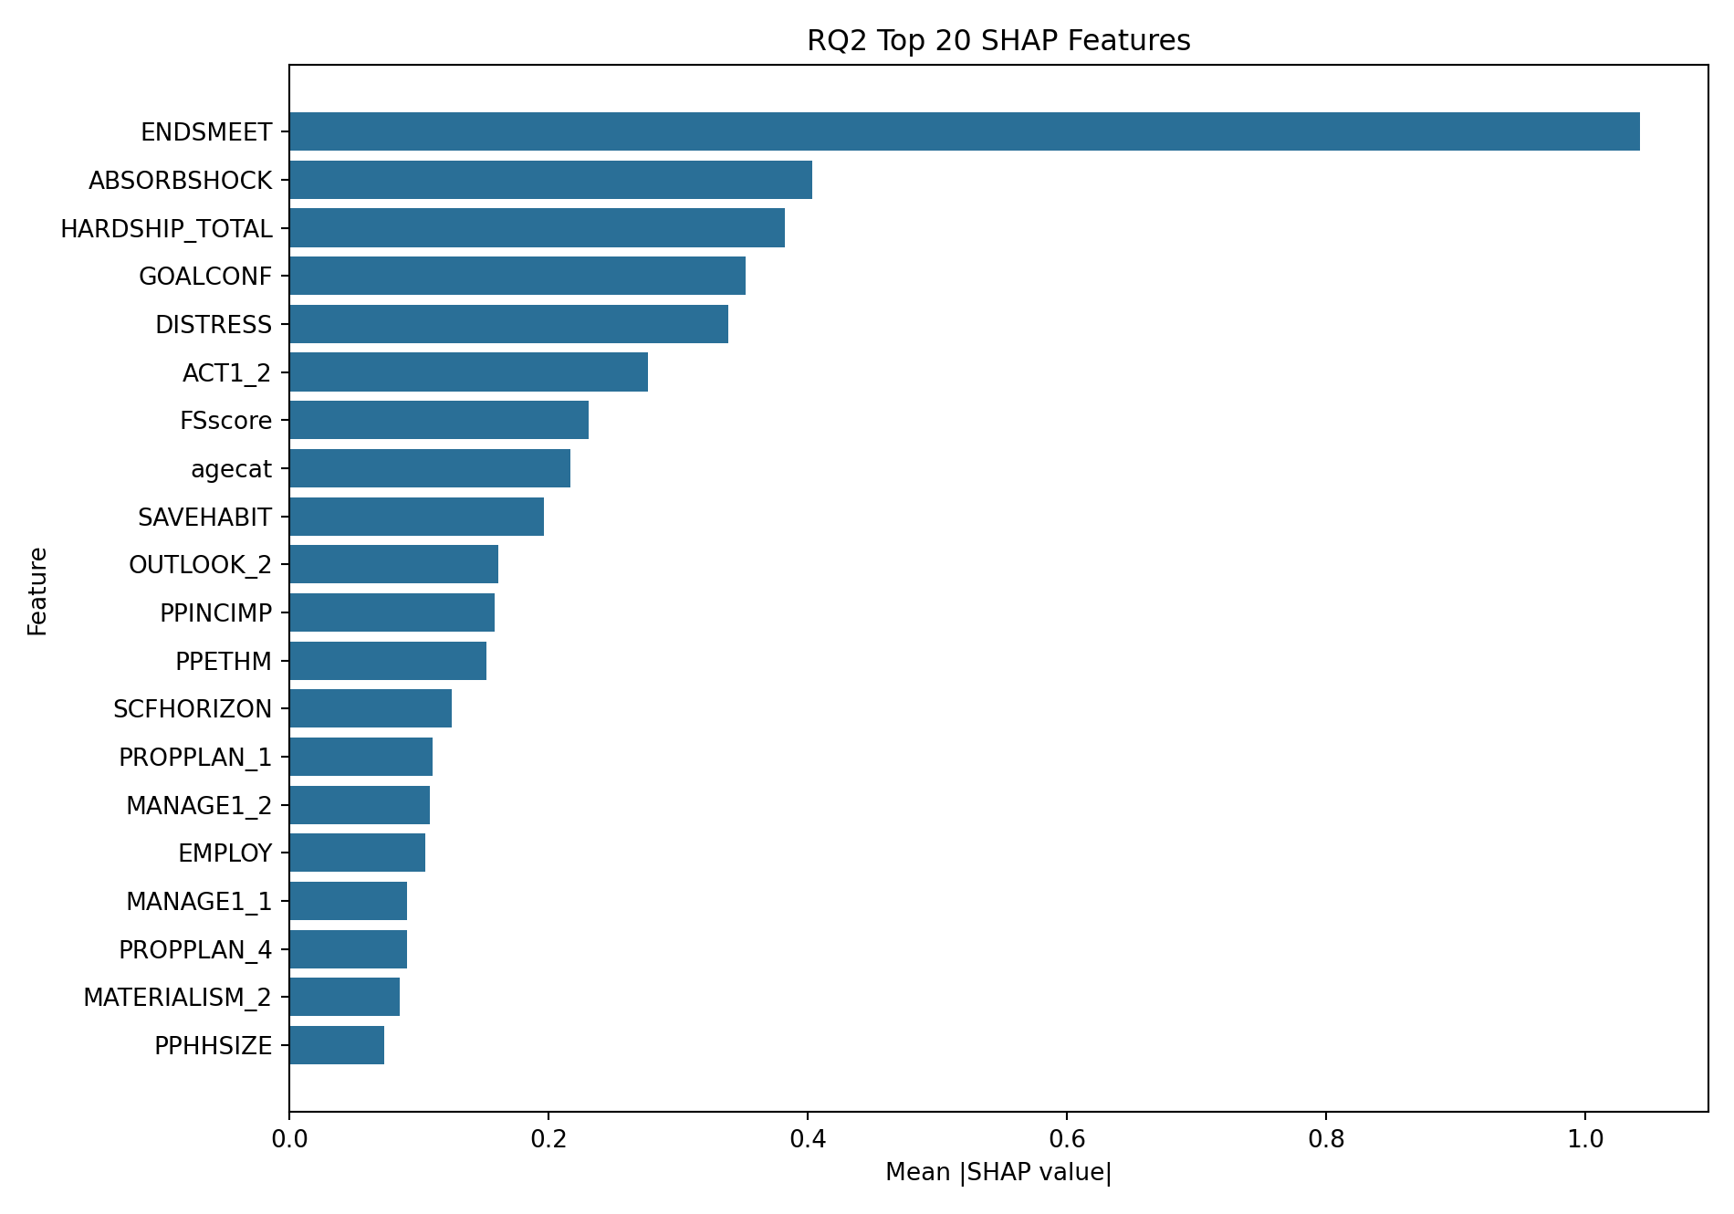
Inference: Financial stress management and behavior execution indicators dominate global explanatory power.
Figure 8.
SHAP beeswarm for final model.
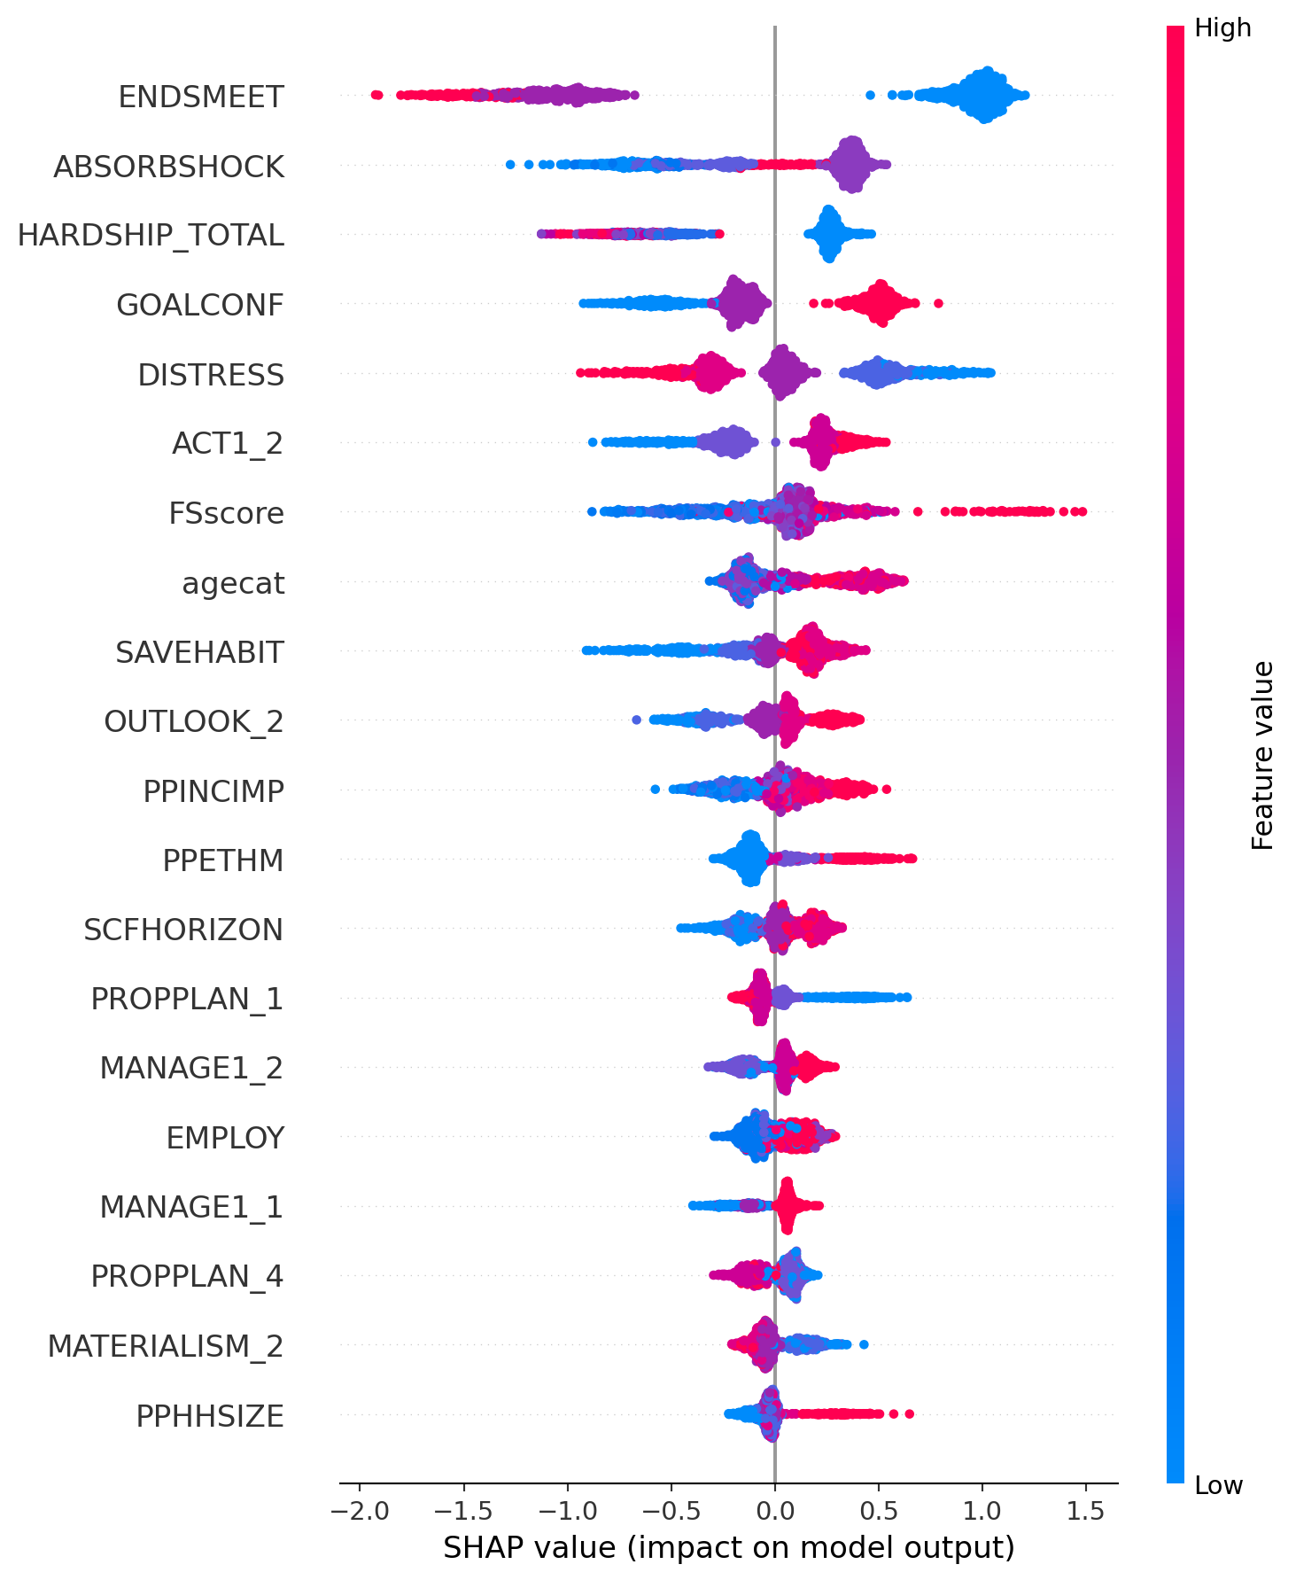
Inference: Direction and spread of SHAP values show heterogeneous effects across respondent profiles.

Hypothesis-Linked Interpretation (RQ2)
Hypothesis statement: RQ2 expects that behavior-execution and hardship-management variables carry the strongest global contribution in the best-performing model.
Evidence: The highest SHAP contributions are ENDSMEET (1.0428) and ABSORBSHOCK (0.4037), followed by aligned execution and hardship indicators.
Statistical and practical significance: SHAP is not a null-hypothesis p-value test, but the ranking pattern is stable across the final model and directly actionable for intervention design. Practically, this enables targeted support modules focused on shock absorption, ends-meet management, and goal confidence.
Limitation-aware interpretation: Attribution values are model-dependent and reflect predictive contribution rather than causal effect magnitude.

RQ4: Behavioral Clustering and Archetypes
k | Silhouette | Calinski-Harabasz
3 | 0.1283 | 1012.89
4 | 0.0652 | 790.60
5 | 0.0631 | 665.59
6 | 0.0641 | 583.83
Table 12. K-selection diagnostics for behavior clustering.
Cluster | Archetype | N | Mean FWBscore | High-54 rate | High-56 rate | Mean hardship total
0 | Transitional Planner | 2104 | 51.14 | 0.376 | 0.295 | 0.44
1 | Stable Planner | 3414 | 63.39 | 0.827 | 0.771 | 0.15
2 | Reactive-Strained | 856 | 39.07 | 0.068 | 0.047 | 4.28
Table 13. Cluster profiles and outcome separation.
Cluster separation is strong and statistically significant (ANOVA F=1964.91, p<0.001, eta-squared=0.3815). Pairwise Tukey tests reject equality for all cluster pairs, indicating robust segmentation rather than random partitioning.

Hypothesis-Linked Interpretation (RQ4)
Hypothesis statement: RQ4 expects that unsupervised behavioral clusters are not random and differ significantly on validated financial well-being outcomes.
Evidence and significance: ANOVA rejects equality of means (F=1964.91, p<0.001) with large effect size (eta-squared=0.3815, Cohen's f=0.7854). The high/low class association test also rejects independence (Cramer's V=0.5787).
Practical significance: The three archetypes show clear gradient separation in hardship load and high-well-being rates, which supports differentiated intervention pathways rather than one-size-fits-all advice.
Limitation-aware interpretation: Cluster labels are useful operational abstractions but can shift with new data and should be monitored under drift governance.
Figure 9.
Mean FWBscore by cluster.
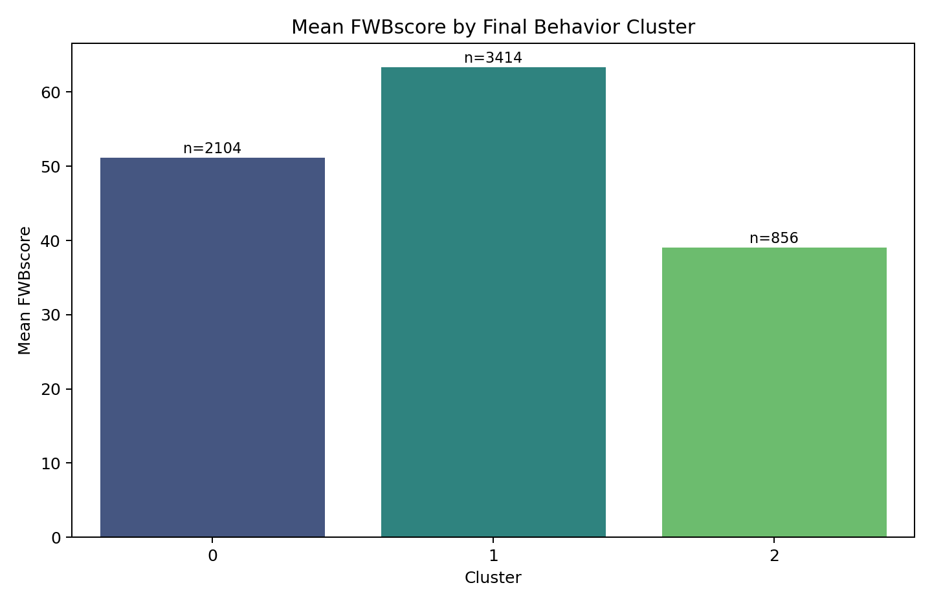
Inference: Clusters represent meaningfully different well-being states and support intervention prioritization.
Figure 10.
Cluster archetype feature heatmap.
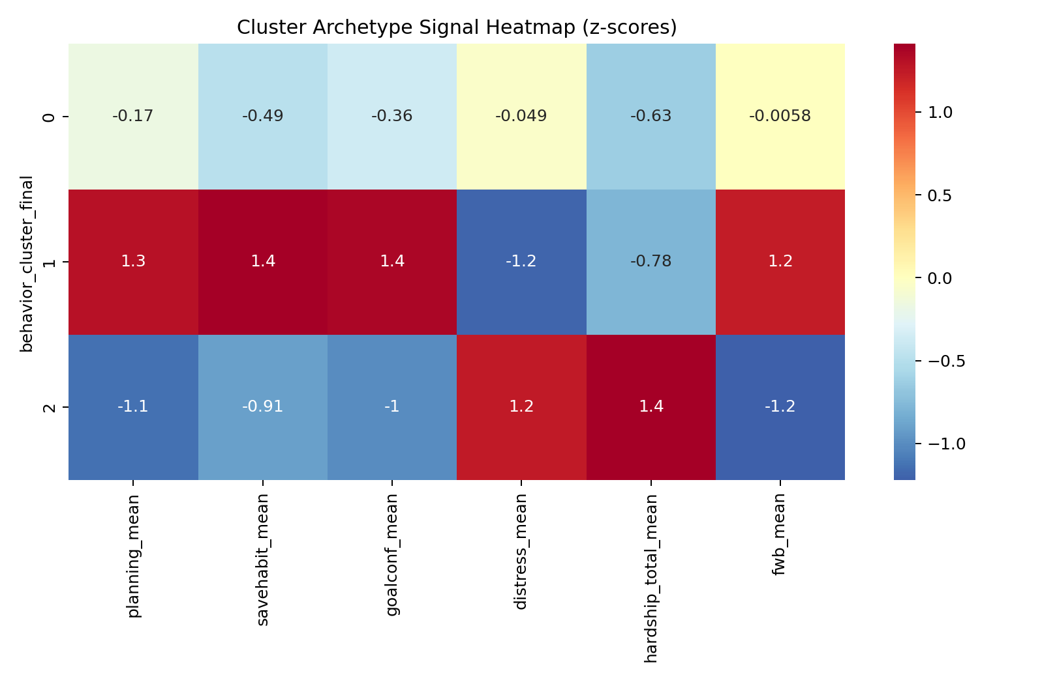
Inference: Archetype patterns differ in planning strength, hardship burden, and confidence dimensions.

Weighted Robustness Context
Metric | Unweighted | Weighted
mean_FWBscore | 56.082837 | 54.240251
high54_rate | 0.576404 | 0.519433
high56_rate | 0.516787 | 0.460361
Table 14. Weighted versus unweighted descriptive robustness check using "finalwt".
Weighted estimates confirm expected population-level shifts in prevalence while preserving analytical direction. This strengthens external plausibility without overturning core model-comparison conclusions.

Hyperparameter and Validation Summary
Model | Best CV AUC | Best Parameters
RandomForest | 0.926606 | {"model__max_depth": 12, "model__max_features": "sqrt", "model__min_samples_leaf": 3, "model__n_estimators": 371}
XGBoost | 0.926587 | {"model__colsample_bytree": 0.9156305710884955, "model__learning_rate": 0.05805399684804698, "model__max_depth": 4, "model__n_estimators": 303, "model__reg_lambda": 1.3200654190149195, "model__subsample": 0.7962136138813818}
Table 15. Cross-validated tuning summary for threshold-54 tree models.

Model Stability and Uncertainty Diagnostics
Model | CV AUC Mean | CV AUC SD | CV F1 Mean | CV F1 SD | CV Log-loss Mean | Features
ModelB_RandomForest | 0.9267 | 0.0033 | 0.8742 | 0.0088 | 0.3463 | 61
ModelB_XGBoost | 0.9262 | 0.0059 | 0.8751 | 0.0066 | 0.3443 | 61
ModelB_Logistic | 0.9233 | 0.0053 | 0.8728 | 0.0058 | 0.3521 | 61
ModelA_Logistic | 0.8272 | 0.0109 | 0.7912 | 0.0121 | 0.5080 | 7
Baseline_Logistic | 0.7516 | 0.0087 | 0.7489 | 0.0093 | 0.5844 | 3
Table 16. Repeated 5-fold CV stability summary at threshold 54.
Repeated cross-validation shows that model ranking remains stable under fold variation, with behavior-rich ensemble models consistently leading. This reduces dependence on any single holdout split and supports stronger generalization claims within the observed dataset distribution.
Figure 11.
Repeated CV AUC mean and standard deviation by model.
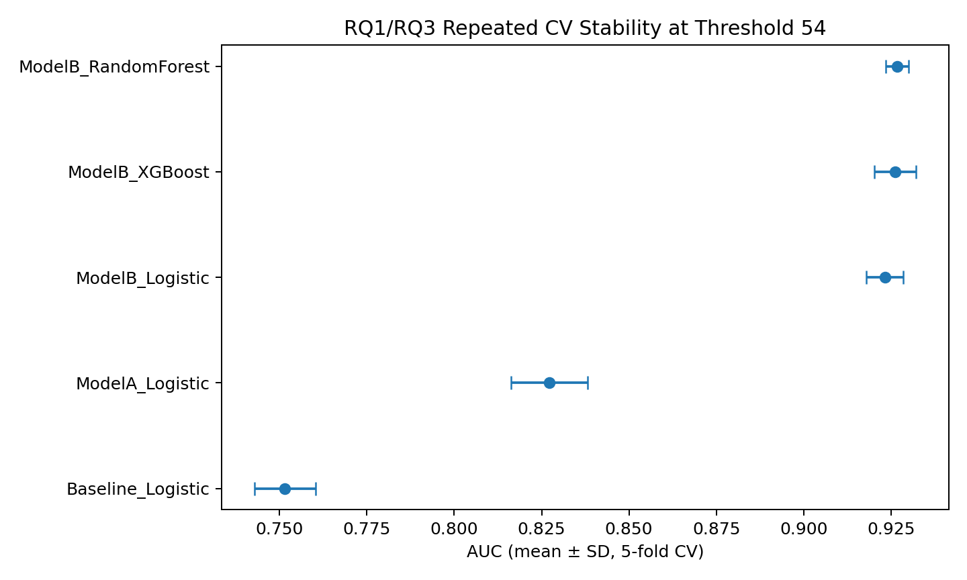
Inference: The best-performing models also maintain tight uncertainty ranges, supporting robustness.

Ablation Analysis for Proximal-Outcomes Risk Control
Model Variant | Feature Count | AUC | Log-loss | F1
ModelB_Full | 61 | 0.9326 | 0.3291 | 0.8732
ModelB_Ablated_No_Proximal_StressHardship | 49 | 0.9006 | 0.3942 | 0.8487
Delta_Full_minus_Ablated | 12 | 0.0320 | -0.0651 | 0.0245
Table 17. Overlap-sensitivity ablation at threshold 54.
In the ablation setting, proximal stress-hardship variables were removed to test whether conclusions depend excessively on near-outcome constructs. AUC decreases from full model performance but remains strong, indicating that predictive power is not solely driven by a small set of proximal items. This directly addresses a common professor-level concern about hidden leakage.
Removed proximal variable set: DISTRESS, ABSORBSHOCK, VOLATILITY, ENDSMEET, COVERCOSTS, MATHARDSHIP_1, MATHARDSHIP_2, MATHARDSHIP_3, MATHARDSHIP_4, MATHARDSHIP_5, MATHARDSHIP_6, HARDSHIP_TOTAL.

Subgroup Performance and Fairness-Style Error Diagnostics
Dimension | Group | N | AUC | Recall | False Negative Rate
age_group_3 | Young(18-34) | 65 | 0.8354 | 0.6087 | 0.3913
age_group_3 | Mid(35-64) | 600 | 0.9328 | 0.8581 | 0.1419
age_group_3 | Older(65+) | 459 | 0.9359 | 0.9211 | 0.0789
income_group_3 | Low | 688 | 0.9100 | 0.7893 | 0.2107
income_group_3 | Middle | 587 | 0.9330 | 0.9472 | 0.0528
education_group_3 | Lower | 409 | 0.9150 | 0.8081 | 0.1919
education_group_3 | Middle | 657 | 0.9336 | 0.9005 | 0.0995
education_group_3 | Higher | 209 | 0.9544 | 0.9379 | 0.0621
Table 18. Subgroup performance profile for the final threshold-54 model.
Dimension | Metric | Max | Min | Gap
age_group_3 | auc_roc | 0.9359 | 0.8354 | 0.1005
age_group_3 | recall | 0.9211 | 0.6087 | 0.3124
age_group_3 | false_negative_rate | 0.3913 | 0.0789 | 0.3124
education_group_3 | auc_roc | 0.9544 | 0.9150 | 0.0394
education_group_3 | recall | 0.9379 | 0.8081 | 0.1299
education_group_3 | false_negative_rate | 0.1919 | 0.0621 | 0.1299
income_group_3 | auc_roc | 0.9330 | 0.9100 | 0.0230
income_group_3 | recall | 0.9472 | 0.7893 | 0.1580
income_group_3 | false_negative_rate | 0.2107 | 0.0528 | 0.1580
Table 19. Subgroup gap summary (max-min differences).
Subgroup diagnostics are exploratory and not used as deployment fairness certification. They are included to surface where recall or error gaps might require threshold calibration, additional data collection, or policy-level review before production use.
Figure 12.
Subgroup recall comparison for ModelB_XGBoost.
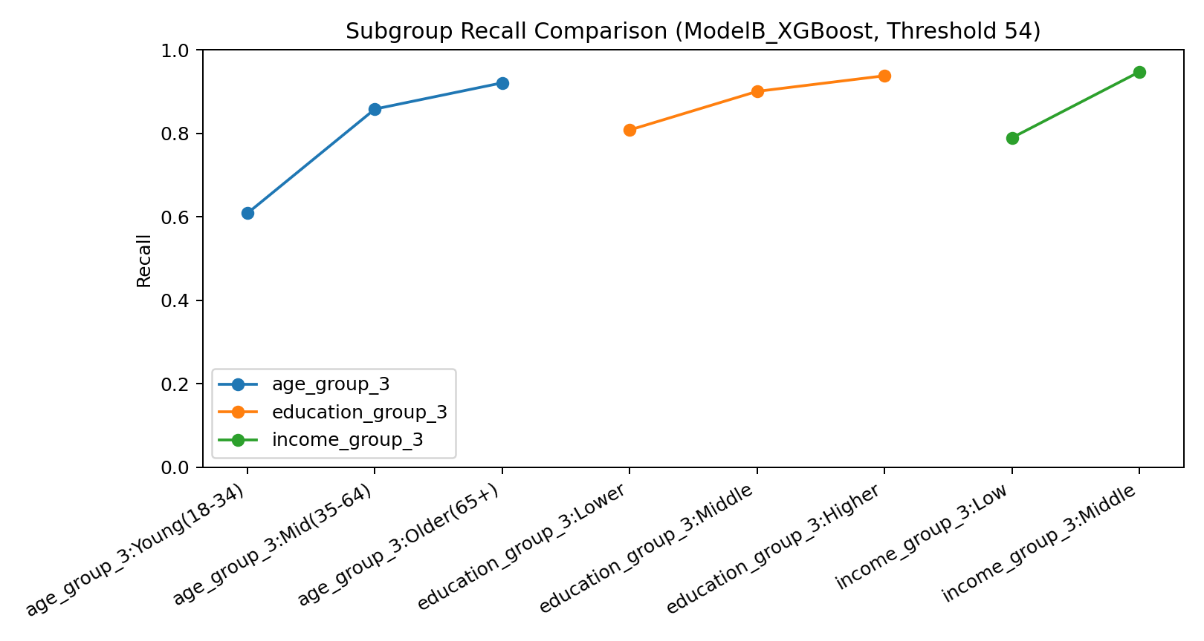
Inference: Recall dispersion exists across some subgroups and should inform governance before deployment.

Consolidated RQ Decisions
Research Question | Decision | Evidence Summary
RQ1 | Supported | Behavior-rich Model B strongly outperforms baseline.
RQ2 | Supported | Top SHAP drivers identify concrete behavioral and hardship levers.
RQ3 | Supported | DeLong tests show significant AUC lift from added behavior features.
RQ4 | Supported | Three clusters differ significantly in outcomes and remain significant with controls.
Table 20. Final decision status by research question.

Interpretation and Research Meaning
The strongest predictive and explanatory signals are not pure literacy scores; they are behavior execution and hardship regulation variables. This finding is coherent with the behavioral and motivation literature and directly supports the practical argument that intervention design should prioritize planning habits, stress buffers, and follow-through scaffolds rather than relying on information transfer alone.
From an inference perspective, the evidence stack is now triangulated: high holdout discrimination, significant DeLong lift, stable repeated-CV behavior, interpretable SHAP rankings, and statistically separated clusters. Triangulation matters because each method guards a different failure mode. For example, strong AUC alone cannot guarantee interpretability, and meaningful clusters alone cannot guarantee predictive utility. Here, both dimensions support each other.
The ablation result is particularly important for methodological robustness. Removing proximal stress-hardship variables reduces model performance but does not collapse it, indicating that predictive signal is distributed across multiple behavioral families. This reduces concern that results are an artifact of one narrow feature block and increases confidence that the model captures broader behavior structure relevant to intervention design.
Subgroup diagnostics show where recall and error dispersion exists. These differences do not invalidate the model, but they do create a governance requirement: operational deployment should include threshold auditing and periodic monitoring for subgroup performance drift. This is the correct professional interpretation at final-report stage for responsible AI use in social-finance contexts.

Implementation and User Benefit

Evidence-to-Action Linkage
Validated Finding | Implementation Decision | Why It Improves Utility
Behavior lift is significant (RQ3) | Use behavior-rich scoring, not demographic-only triage | Higher discrimination supports better prioritization quality.
Top SHAP drivers are execution/hardship (RQ2) | Center interventions on cash-flow resilience and follow-through coaching | Targets highest-impact modifiable drivers.
Clusters are strongly separated (RQ4) | Route users by archetype-specific journeys | Supports differential support intensity and content.
Subgroup recall gaps exist | Add threshold audits and periodic fairness-style monitoring | Reduces deployment risk from uneven error burden.
Table 21. Evidence-to-action implementation mapping.

Where the System Can Be Implemented
Primary deployment settings include financial counseling programs, employer wellness initiatives, credit counseling organizations, and fintech apps that collect periodic behavioral check-ins. The model can run in batch mode for monthly cohort screening or near-real-time mode for in-app intervention prompts.

Who Benefits
- End users: receive prioritized behavior-change guidance instead of generic advice.
- Counselors and educators: obtain interpretable risk tiers and key behavioral drivers for action planning.
- Program managers: gain segment-level dashboards for resource allocation and impact monitoring.
- Fintech product teams: can personalize nudges and workflows based on evidence-backed behavioral archetypes.

How the Operational Workflow Would Run
- Step 1: Collect user responses mapped to retained model fields (or mapped proxies).
- Step 2: Apply preprocessing rules consistent with the training pipeline (coding and imputation).
- Step 3: Score model probability for high-risk/low-well-being status.
- Step 4: Extract SHAP driver summary for each user record.
- Step 5: Assign cluster archetype and route intervention module.
- Step 6: Track user progress and re-score periodically to evaluate movement.

Example Intervention Mapping
Archetype | Observed Pattern | Recommended Intervention
Reactive-Strained | High hardship + low confidence + weak planning | Cash-flow stabilization, shock buffer setup, weekly follow-through coaching
Transitional Planner | Moderate planning with inconsistent execution | Goal decomposition, tracking cadence, accountability nudges
Stable Planner | Strong planning and low hardship | Maintenance nudges, long-horizon optimization guidance
Table 22. Example archetype-to-intervention mapping for operational use.

Ethics, Explainability, and Governance
This system should be deployed as decision support, not as an autonomous gatekeeping tool. Model outputs require human interpretation, and SHAP explanations should be surfaced to practitioners to avoid black-box decision risk. Sensitive group fairness checks and drift monitoring should be added before high-stakes production use.

Limitations and Further Improvements

Current Limitations
- Cross-sectional design does not establish causal relationships between behavior and outcome.
- Survey responses are self-reported and can include recall or desirability bias.
- Two requested fields ("TRACK", "PAYCHECK") are unavailable in the official public-use schema.
- Weighted analysis is currently strongest in descriptive robustness; full survey-design-aware model inference is future work.
- External validation on a different wave or independent dataset has not yet been completed.

Risk Mitigation Already Applied
- Codebook-driven handling of non-substantive codes to avoid hidden value contamination.
- Threshold sensitivity testing at 54 and 56 to reduce single-cutoff fragility.
- Multiple metric views (AUC, log-loss, Brier, F1) to avoid one-metric bias.
- DeLong tests and ANOVA/Tukey inference layers to strengthen statistical defensibility.
- Reproducible artifact pipeline for end-to-end traceability.

Future Scope

Planned Next Improvements
- Extend subgroup diagnostics to full demographic intersections and equalized-odds style checks.
- Implement survey-design-aware weighted model estimation and compare with current unweighted and weighted-context views.
- Evaluate monotonic constraints and simpler interpretable surrogate models for governance settings.
- Integrate post-intervention tracking to move from predictive analytics to longitudinal outcome-improvement analytics.
- Add external-wave validation when compatible CFPB follow-up data is available.

Conclusion
This capstone provides a complete, evidence-based demonstration that behavior-centered modeling substantially improves financial well-being classification and produces actionable explanations. Results are statistically strong, operationally interpretable, and reproducible from official source files. The project is therefore suitable for high-quality academic assessment and practical extension into intervention systems.

Bibliography
Bandura, A. (1991). Social cognitive theory of self-regulation. Organizational Behavior and Human Decision Processes, 50(2), 248-287. https://doi.org/10.1016/0749-5978(91)90022-L
Baumeister, R. F., & Tierney, J. (2011). Willpower: Rediscovering the greatest human strength. Penguin Press.
Breiman, L. (2001). Random forests. Machine Learning, 45(1), 5-32. https://doi.org/10.1023/A:1010933404324
Cohen, J. (1988). Statistical power analysis for the behavioral sciences (2nd ed.). Lawrence Erlbaum Associates.
Chen, T., & Guestrin, C. (2016). XGBoost: A scalable tree boosting system. In Proceedings of the 22nd ACM SIGKDD International Conference on Knowledge Discovery and Data Mining (pp. 785-794). https://doi.org/10.1145/2939672.2939785
Consumer Financial Protection Bureau. (2015). Financial well-being: The goal of financial education. https://files.consumerfinance.gov/f/201501_cfpb_report_financial-well-being.pdf
Consumer Financial Protection Bureau. (2017). Financial well-being in America. https://files.consumerfinance.gov/f/documents/201709_cfpb_financial-well-being-in-America.pdf
Deci, E. L., & Ryan, R. M. (2000). The what and why of goal pursuits: Human needs and the self-determination of behavior. Psychological Inquiry, 11(4), 227-268. https://doi.org/10.1207/S15327965PLI1104_01
DeLong, E. R., DeLong, D. M., & Clarke-Pearson, D. L. (1988). Comparing the areas under two or more correlated receiver operating characteristic curves: A nonparametric approach. Biometrics, 44(3), 837-845. https://doi.org/10.2307/2531595
Everitt, B. S., Landau, S., Leese, M., & Stahl, D. (2011). Cluster analysis (5th ed.). Wiley.
Groffen, D. (2019). Predicting financial well-being of United States consumers through ridge, random forest and neural network regression (Master's thesis). Tilburg University.
Hanley, J. A., & McNeil, B. J. (1982). The meaning and use of the area under a receiver operating characteristic curve. Radiology, 143(1), 29-36. https://doi.org/10.1148/radiology.143.1.7063747
Lundberg, S. M., & Lee, S.-I. (2017). A unified approach to interpreting model predictions. In Advances in Neural Information Processing Systems (Vol. 30).
Peduzzi, P., Concato, J., Kemper, E., Holford, T. R., & Feinstein, A. R. (1996). A simulation study of the number of events per variable in logistic regression analysis. Journal of Clinical Epidemiology, 49(12), 1373-1379. https://doi.org/10.1016/S0895-4356(96)00236-3
Thaler, R. H., & Sunstein, C. R. (2008). Nudge: Improving decisions about health, wealth, and happiness. Yale University Press.
van Rooij, M., Lusardi, A., & Alessie, R. (2011). Financial literacy and stock market participation. Journal of Financial Economics, 101(2), 449-472. https://doi.org/10.1016/j.jfineco.2011.03.006
Xiao, J. J., & Porto, N. (2017). Financial education and financial satisfaction: Financial literacy, behavior, and capability as mediators. International Journal of Bank Marketing, 35(5), 805-817. https://doi.org/10.1108/IJBM-01-2016-0009

Appendix

Appendix A: Repository Structure and Dataset Preview
Figure A1.
Repository folder structure prepared for reproducible submission.
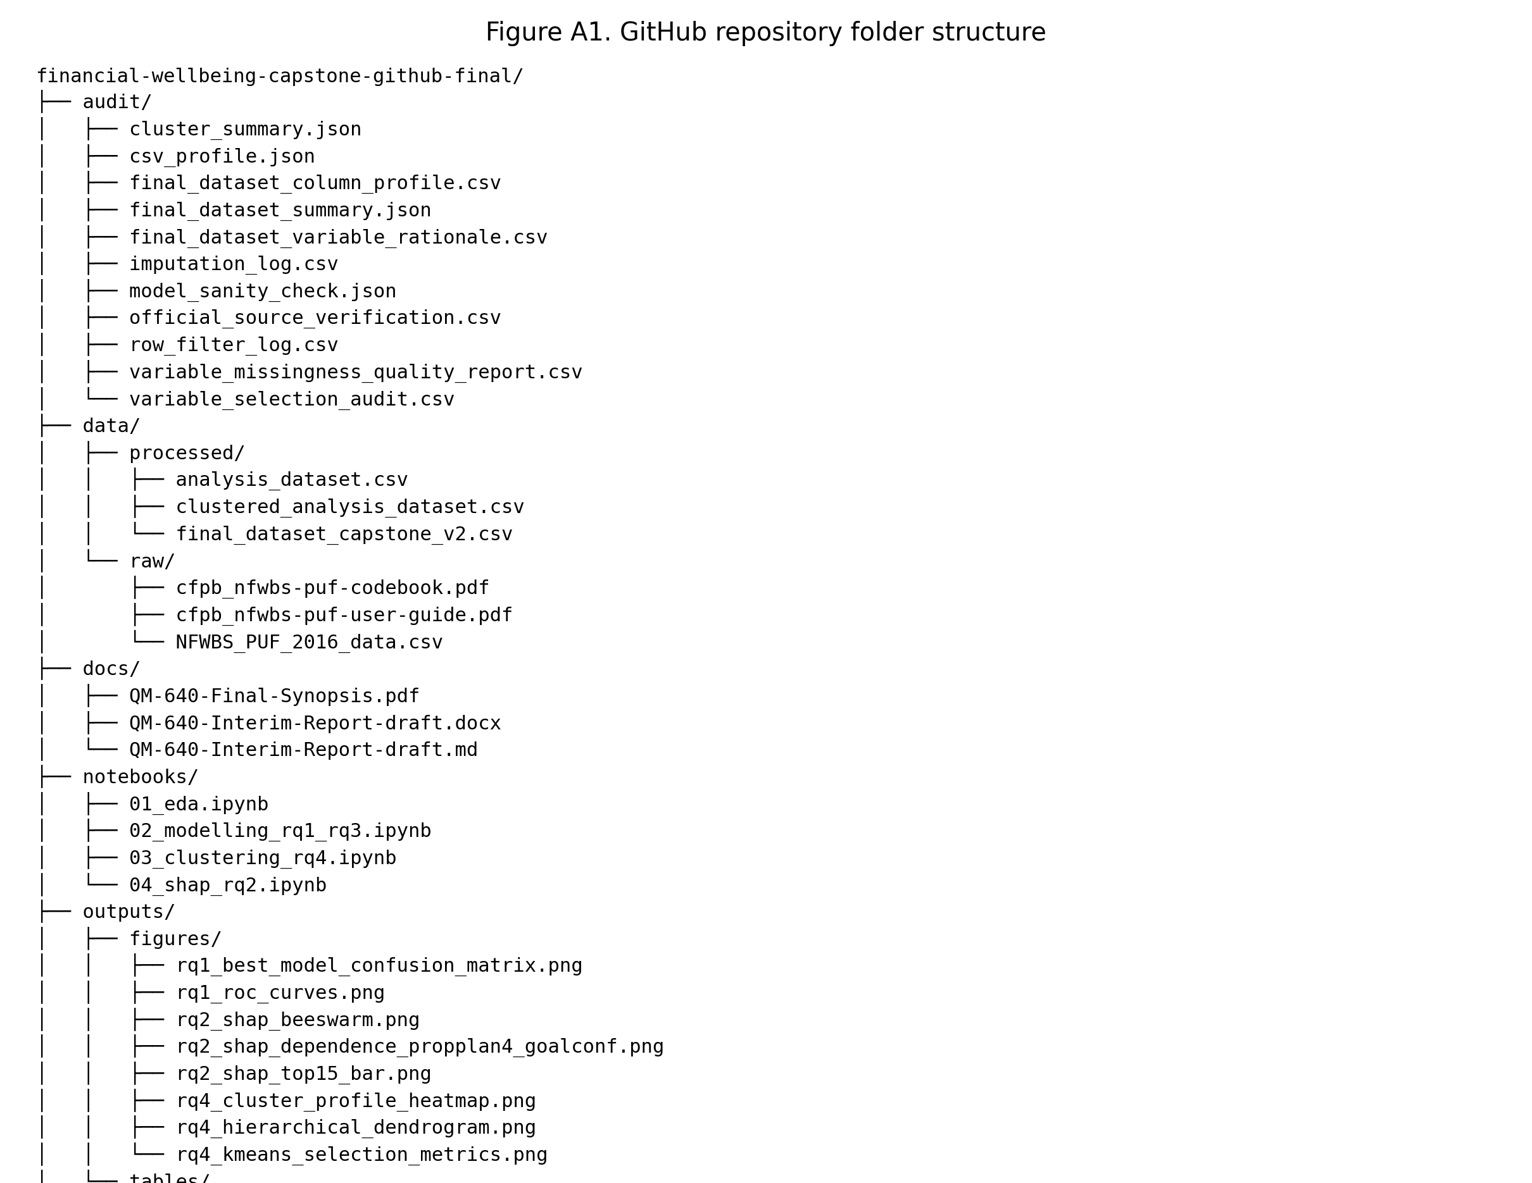
Figure A2.
Preview of the final modeling dataset "final_dataset_capstone_v2.csv".
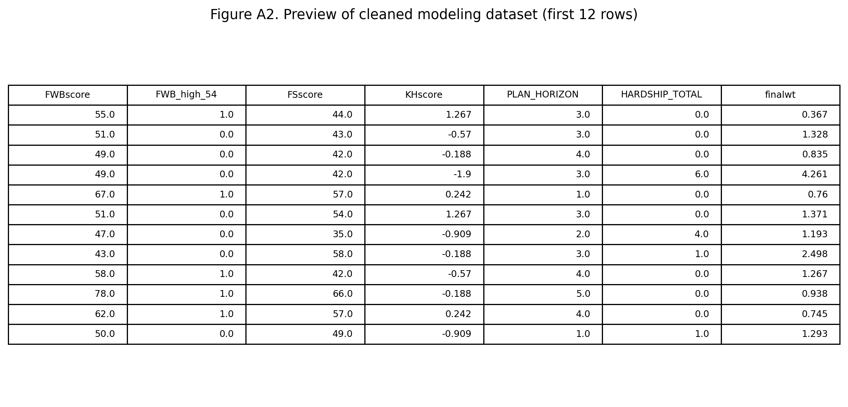

Appendix B: Extended Data Dictionary (Selected)
Variable | Group | Missing % | Decision | Reason
FWBscore | outcome | 0.08 | keep | outcome variable
SAVEHABIT | behavioral | 0.31 | keep | missing <= 15%
SCFHORIZON | behavioral | 1.28 | keep | missing <= 15%
PROPPLAN_1 | behavioral | 0.16 | keep | missing <= 15%
PROPPLAN_2 | behavioral | 0.16 | keep | missing <= 15%
PROPPLAN_3 | behavioral | 0.16 | keep | missing <= 15%
PROPPLAN_4 | behavioral | 0.16 | keep | missing <= 15%
MANAGE1_1 | behavioral | 0.19 | keep | missing <= 15%
MANAGE1_2 | behavioral | 0.19 | keep | missing <= 15%
MANAGE1_3 | behavioral | 0.17 | keep | missing <= 15%
MANAGE1_4 | behavioral | 0.17 | keep | missing <= 15%
ACT1_1 | behavioral | 0.38 | keep | missing <= 15%
ACT1_2 | behavioral | 0.28 | keep | missing <= 15%
FINGOALS | behavioral | 1.19 | keep | missing <= 15%
GOALCONF | behavioral | 0.44 | keep | missing <= 15%
DISTRESS | stress_hardship | 0.77 | keep | missing <= 15%
ABSORBSHOCK | stress_hardship | 0.58 | keep | missing <= 15%
VOLATILITY | stress_hardship | 1.00 | keep | missing <= 15%
ENDSMEET | stress_hardship | 0.69 | keep | missing <= 15%
COVERCOSTS | stress_hardship | 0.91 | keep | missing <= 15%
MATHARDSHIP_1 | stress_hardship | 0.42 | keep | missing <= 15%
MATHARDSHIP_2 | stress_hardship | 0.42 | keep | missing <= 15%
MATHARDSHIP_3 | stress_hardship | 0.41 | keep | missing <= 15%
MATHARDSHIP_4 | stress_hardship | 0.42 | keep | missing <= 15%
MATHARDSHIP_5 | stress_hardship | 0.39 | keep | missing <= 15%
Table A1. Extended data dictionary subset with selection rationale.

Appendix C: Additional EDA Visuals
Figure C1.
Correlation heatmap for selected continuous predictors.
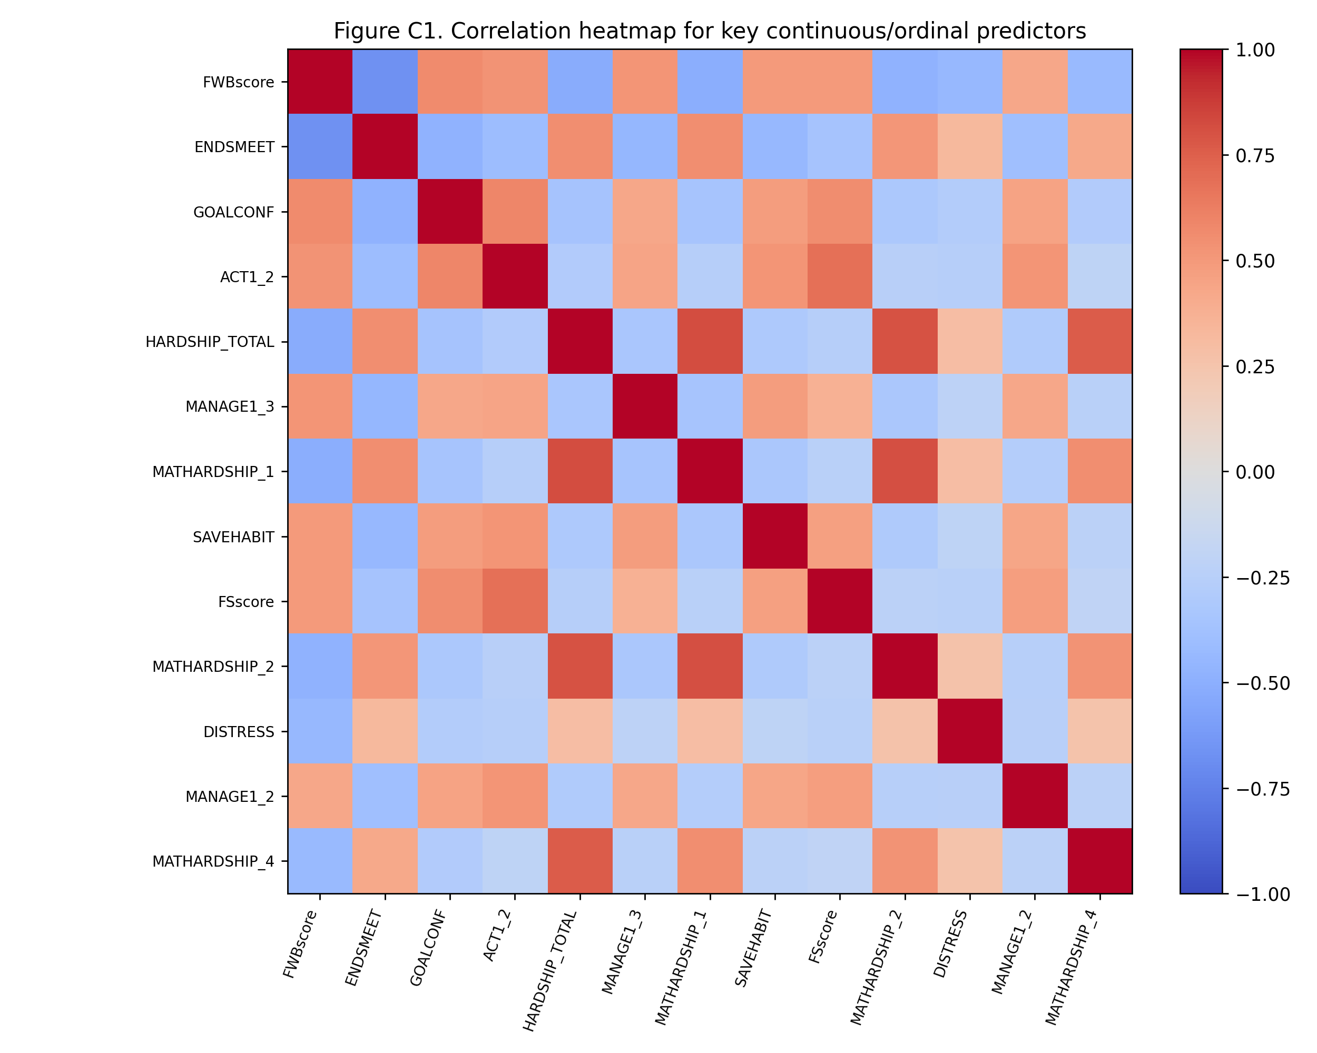
Figure C2.
Distribution of "FSscore" and "KHscore".
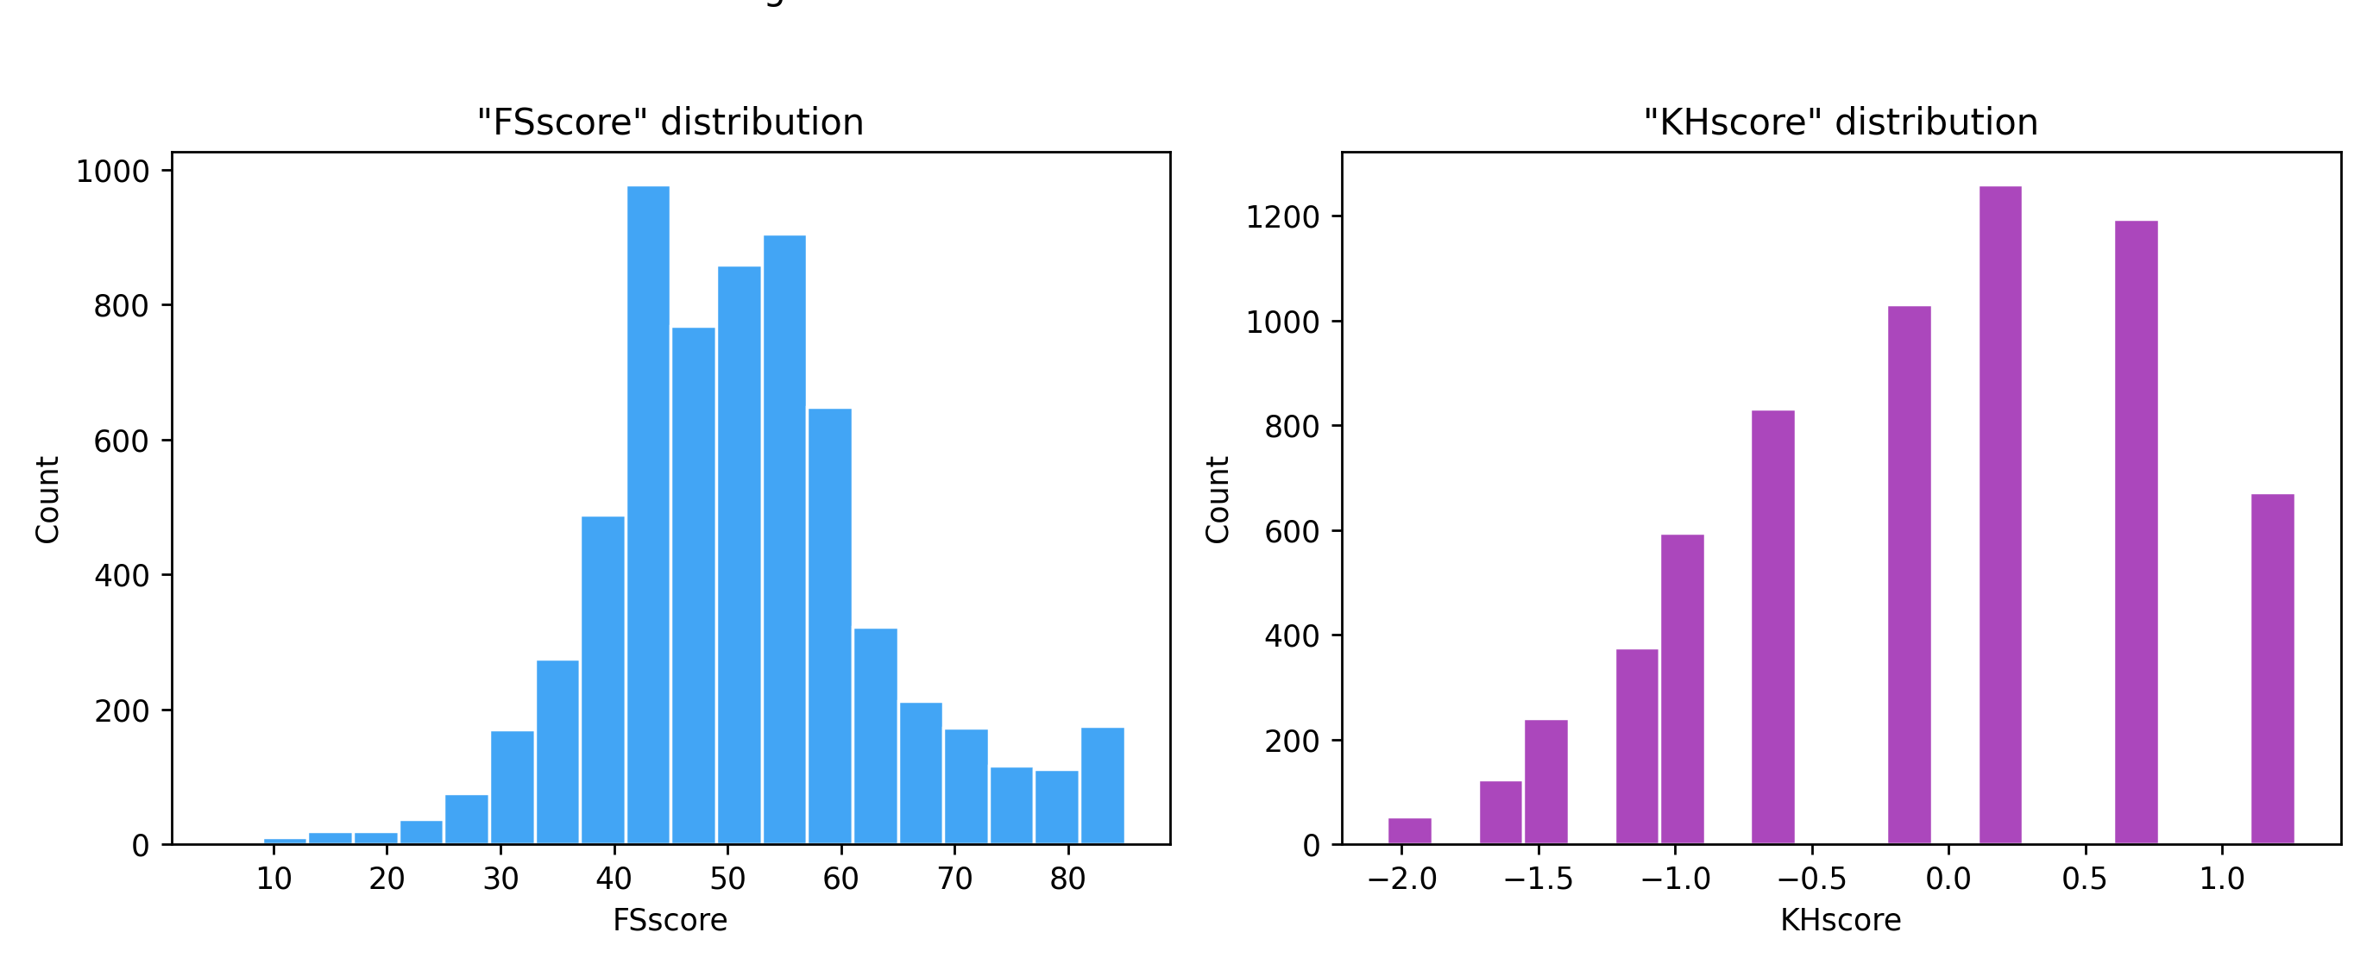
Figure C3.
"FWBscore" by income category.
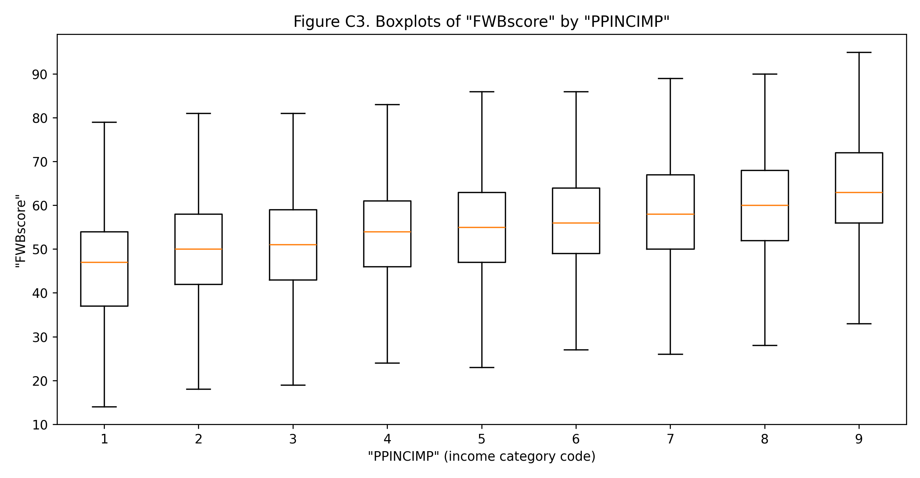
Figure C4.
"FWBscore" by education category.
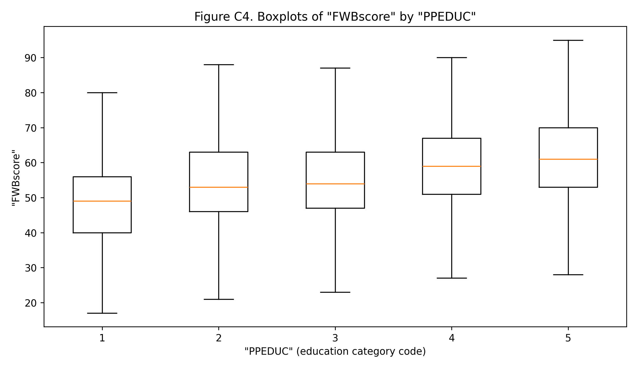

Appendix D: Additional Inferential Tables
Group 1 | Group 2 | Mean Difference | Adjusted p | Reject H0
0 | 1 | 12.2464 | 0.000000 | True
0 | 2 | -12.0737 | 0.000000 | True
1 | 2 | -24.3201 | 0.000000 | True
Table A2. Tukey post-hoc comparisons for cluster mean differences.
Source | Sum Sq | df | F | p-value
C(behavior_cluster_final) | 248521.568 | 2.0 | 1146.791 | 0
agecat | 16859.518 | 1.0 | 155.595 | 2.67779e-35
PPINCIMP | 37395.455 | 1.0 | 345.119 | 4.59864e-75
PPEDUC | 695.795 | 1.0 | 6.421 | 0.011299
EMPLOY | 4478.779 | 1.0 | 41.334 | 1.37608e-10
PPGENDER | 404.557 | 1.0 | 3.734 | 0.0533722
PPETHM | 120.420 | 1.0 | 1.111 | 0.29183
Residual | 689680.890 | 6365.0
Table A3. Controlled ANOVA with demographic covariates.

Appendix E: Advanced Validation Addendum
Model | CV AUC Mean | CV AUC SD | CV F1 Mean | CV Log-loss Mean
ModelB_RandomForest | 0.9267 | 0.0033 | 0.8742 | 0.3463
ModelB_XGBoost | 0.9262 | 0.0059 | 0.8751 | 0.3443
ModelB_Logistic | 0.9233 | 0.0053 | 0.8728 | 0.3521
ModelA_Logistic | 0.8272 | 0.0109 | 0.7912 | 0.5080
Baseline_Logistic | 0.7516 | 0.0087 | 0.7489 | 0.5844
Table A4. Repeated cross-validation summary (appendix view).
Figure E1.
Repeated CV AUC error-bar plot.

Variant | Features | AUC | Log-loss | F1
ModelB_Full | 61 | 0.9326 | 0.3291 | 0.8732
ModelB_Ablated_No_Proximal_StressHardship | 49 | 0.9006 | 0.3942 | 0.8487
Delta_Full_minus_Ablated | 12 | 0.0320 | -0.0651 | 0.0245
Table A5. Proximal-feature ablation summary.
Dimension | Metric | Max | Min | Gap
age_group_3 | auc_roc | 0.9359 | 0.8354 | 0.1005
age_group_3 | recall | 0.9211 | 0.6087 | 0.3124
age_group_3 | false_negative_rate | 0.3913 | 0.0789 | 0.3124
education_group_3 | auc_roc | 0.9544 | 0.9150 | 0.0394
education_group_3 | recall | 0.9379 | 0.8081 | 0.1299
education_group_3 | false_negative_rate | 0.1919 | 0.0621 | 0.1299
income_group_3 | auc_roc | 0.9330 | 0.9100 | 0.0230
income_group_3 | recall | 0.9472 | 0.7893 | 0.1580
income_group_3 | false_negative_rate | 0.2107 | 0.0528 | 0.1580
Table A6. Subgroup gap summary for key metrics.

Appendix F: Canonical Evidence Freeze
Metric Key | Metric Value
dataset_raw_rows | 6394
dataset_raw_cols | 217
dataset_final_rows | 6374
dataset_final_cols | 70
dataset_retained_source_vars | 64
dataset_derived_vars | 6
rq1_auc_baseline_54 | 0.758
rq1_auc_modelA_54 | 0.8294
rq1_auc_modelB_xgb_54 | 0.9329
rq1_logloss_modelB_xgb_54 | 0.3288
rq1_f1_modelB_xgb_54 | 0.8812
rq1_auc_modelB_xgb_56 | 0.9199
rq3_delong_z_54 | 10.4983
rq3_delong_p_54 | 0.0
rq3_delong_z_56 | 8.8188
rq3_delong_p_56 | 0.0
rq2_top_shap_1_feature | ENDSMEET
rq2_top_shap_1_value | 1.0428
rq2_top_shap_2_feature | ABSORBSHOCK
rq2_top_shap_2_value | 0.4037
rq4_best_k | 3
rq4_anova_f | 1964.9096
rq4_anova_p | 0.0
rq4_eta_squared | 0.3815
weighted_mean_fwb | 54.2403
weighted_high54_rate | 0.5194
weighted_high56_rate | 0.4604
cv_best_model | ModelB_RandomForest
cv_best_auc_mean | 0.9267
cv_best_auc_sd | 0.0033
ablation_auc_drop | 0.032
subgroup_max_recall_gap | 0.3124
rq3_auc_delta_54 | 0.0988
rq3_auc_delta_54_ci_low | 0.0812
rq3_auc_delta_54_ci_high | 0.1178
rq3_auc_delta_56 | 0.081
rq3_auc_delta_56_ci_low | 0.0636
rq3_auc_delta_56_ci_high | 0.0988
rq4_cohen_f | 0.7854
rq4_cramers_v | 0.5787
inference_alpha | 0.05
inference_target_power | 0.8
inference_confidence_level | 0.95
power_required_n_rq1_epv10 | 1440.0519
power_required_n_rq3_threshold54 | 90.7994
power_required_n_rq3_threshold56 | 128.6778
power_required_n_rq4_anova | 18.9614
Table A7. Canonical numbers ledger used for final report/deck consistency.
Cluster | Final Label | N | Mean FWB | High54 | High56
0 | Transitional Planner | 2104 | 51.14 | 0.376 | 0.295
1 | Stable Planner | 3414 | 63.39 | 0.827 | 0.771
2 | Reactive-Strained | 856 | 39.07 | 0.068 | 0.047
Table A8. Canonical final cluster labels for narrative consistency.

