Instructions  
Please use Python for the second task; stick to one framework and do not spend more than 2-3 hours of your time. We are mostly interested in seeing the way you approach the problem and your coding skills. Rather than coming up with a complex but not finished solution, it's better to create a simple but finished and well-documented one. We would like to see a well-structured and maintainable code that is easy to read and understand. You could also add some comments in the code describing in simple words what you would do differently or what would you add if you had more time. Provide your solution in a git repository of your choice if possible or as a PDF document for Task 1 and as a zip archive for Task 2.  
Task 1  
Imagine the following situation: you are joining a cross-functional team which builds a front-end application using REST APIs. You are a first QA engineer and need to establish a  
QA process in the team.  
**1. What would you do in your first few days of work? Where would you start?**

**[Ans:]**

1. As a first step, I will introduce myself to the team and give a brief introduction about my role as QA Engineer and also tell about the benefits of having QA in the product development cycle.

There are somethings here to consider:

a. The product is already released to production and company has decided to form separate QA team who is responsible for testing the quality before delivery.

b. Product is getting built from scratch.

1. I will request development teams for KT sessions to understand the current process and product. Before attending the sessions, I will prepare myself by going through the product admin guide, see any pre-recorded video sessions,wiki page about the product to get fair idea. Also, will be recording the KT session as it would definately help new colleagues joining my team. I will ask the Dev team to involve me in all technical discussions and daily stand up going forward. This will reduce their time to explain me about the feature they are planning to develop/enhance and also I can share my thoughts/ideas.
2. I will get the stats of open issues currently in my project from my manager(leader) or dev team to get an idea on areas/modulus which needs more attention.
3. Will start creating test cases for existing features with correct info. I will also see if there are any test cases already written by DEV.I will change them if they are not framed correctly and get it approved.Also, will review unit tests and integration tests.
4. I will ask DEV to correctly fill Definition of done(DOD) criteria for each dev task. I will start testing the code which has gone to master i.e. in QA_READY state, close or re-assign them after testing.

**2. Which process would you establish around testing new functionality?**

1.All the activities done below will be part of sprint and will be captured either jira task , rally task or other tracking tool with proper estimations.In the stand up, I will update the status of my task and raise any blockers.

2.I will read the specification/requirement for the new features and will get my doubts clarified.I need to be clear on why the feature is getting implemented.I will update the document if there are any missing items in document.I will check with PM to get clear information about the delivery time of the feature. I will update PM and dev team if more time is required for the feature to be tested. Will interact with my manager or QA folks in other product teams so that I am clear on methodologies/strategies they follow during testing. This is because test strategy differ across organisations and I have learn it and should not deviate from it. I will also take online tests for the same if company has one. I will gather information about sprint duration, stand up timings, tools which they use for tracking sprint like jira or rally etc, test case management,reporting bugs.

3. Will check with the dev team and understand the impacted areas so that there will not be regressions. Develop/document test plan with test cases for new feature and will share test case document with the DEV team for review. I will incorporate all review comments in the document. If Dev and QA team(if there are more than one QA) is ok, then I will upload the test case document in the test management tool.

4. I will monitor test results from existing test automation for CI and nightly runs. Use industry standard Jenkins software and implementing CI/CD approach in Flow QA setup and also reporting coverage metrics and giving overall flow statistics for full traceability from requirement to deployment

5. I will start executing the test cases and will update the test results regularily in testcase management tool like bugzilla or testrail etc. I will report the defects as early as possible in tools like bugzilla or test rail. In the defect, will add meaningful summary or heading, description of the problem, customer or end user impact, steps to reproduce , expected and actual results, build version, log information which will help DEV for diagnosing the problem, right priority and severity. Update the test case after fix from failed to pass and close the bug with my verification comments.

6. I will perform regression tests, stability tests, performance tests, exploratory tests, security tests etc.

7. After testing is complete, will send out the test report summary having the data of test cases executed, old features tested, automation results for last 3 days(or week).

**3. Which techniques or best practices in terms of code architecture and test design would you use in your automated tests?**

**[Ans:]**

1. Best practise would be to follow, test pyramid. In short, there must be more unit tests than integration test, less end to end test than integration test. This will help in early detection of issue. 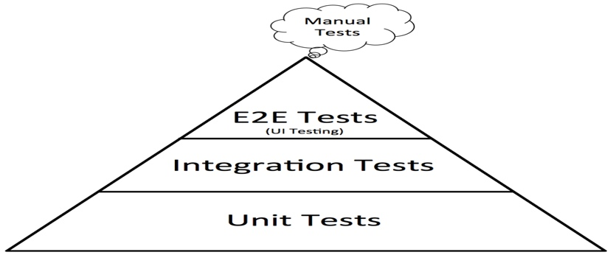

2. If there are API for automation, then best methodology would be to use TDD.

3. I will create a private branch, i will raise the PR for the same. In the PR, adding DEV and my QA team members, I will add results of last 3 runs as test result of automation runs, if some tests are Failing, then I will add the bug id in my PR. Once the PR gets reviewed and approved, I will merge this to master branch of repo.

4. Automation code needs to run effectively as a part of Continuous integration(CI) using Jenkins or bamboo. This must catch genuine issues after each check-in(or commit) from DEV to bit bucket repo or perforce. The test runs are against private builds where code changes are either not reviewed and not approved i.e. pull request is raised for merging into master branch.

4. Automation code needs to run on nightly bases on master build from Jenkins or bamboo.

If there is no automation framework, then bringing up automation framework:

1. I will analyse the technology that suits my requirement i.e. either python or Java or JavaScript etc. If I am the only one person in the team then i will choose the technology which i am more comfortable and that supports my need, if there is a team then majority wins. If Company has a specific language then that takes the priority because there might be a common automation dashboard which will make automation job easy to represent test automation results on it.

2. I will investigate on libraries available and plan accordingly. This is important as the framework should be robust and have to choose opensource so that company need not have to pay for license.

For example,

|  |  |  |
| --- | --- | --- |
| **Areas** | **Python** | **Java** |
| **API** | python requests | REST Assured Library |
| **CLI** | pexpect or paramiko | SSH library |
| **Database(mysql)** | Mysql connector | JDBC lib |
| **UI Automation** | Front end is non angular then selenium  If Angular, cypress or protractor. Also, its Javascript(nodejs) so we need to have 2 automation framework one specific to UI. | Selenium with java |
| **Writing tests** | Pytest or robot | TestNG or Junit |
| **Operating system** | Linux or Mac or Windows[Personal choise] | Linux or Mac or Windows[Personal choice] |

3. Do a POC with team member and get the inputs. Create wiki page with design document it.

4. After approval, i will create a repository for automation and also start designing the framework as per design.

5. I will plan for the tests which needs to go as a part of CI and nightly. Not all tests are required to be run as a part of CI as build result will take more time. Use correct markers so that it will be easy to run specific tests if there is any quick fix(or patch) in future.

6. Also,If application supports micro-service architecture with API support then i will create contract test as a part of CI pipeline.

7. After each automation runs, i will implement emails notification with build number on which it ran along with execution result summary.

**Task 2**  
**How would you approach test automation of an HTTP API of some service? Choose a service from this list**[**https://github.com/toddmotto/public-apis**](https://github.com/toddmotto/public-apis)**or any other of your choice. It is better to pick one without authorization as it is easier to test.  
Document several test cases. Implement one or two automated tests based on the test cases. Write the tests as if they were a part of a real project**.

**Solution:**

I have chosen the API exposed by fake API service on <https://reqres.in/>. There are user APIs exposed here. I have implement test cases which shows CRUD operations on user api.

1. Please find the repo link below and readme file has information on how to run the application.

<https://github.com/gurudattvshenoy/api_automation>

git clone <https://github.com/gurudattvshenoy/api_automation.git>

1. Currently this framework has libraries for automation of API, few tests, inbuild logging and reporting feature.
2. Also, more tests can be automated as a part of enhancement to this repository. Proper marking of test cases can be done here. When there are more tests, we can mark/categorise tests which are eligible for smoke, regression, exit tests, contract tests.
3. More documentation/docstrings can be added.
4. Integrated with Jenkins for CI(continuos integration) on private builds and also can schedule nightly on master build.
5. Create automation dashboard, can integrate this framework with automation dashboard with nice graphical charts for each runs during CI and nightly runs as well.

Some of the test cases for the feature are added at: <https://github.com/gurudattvshenoy/ApiTestCases>