

CanPar Shipping Module

Installation and user manual

Version 1.0

Contents

Introduction 3

Installation and Upgrade 4

Installation Method: FTP 6

Upgrading via FTP 10

Configuring the Module 11

Using the Module 13

Frontend 13

Administration 14

Creating Shipments 14

Printing Labels 17

FAQ 18

# Introduction

This guide aims to provide you with sufficient understanding of how the module works. We will cover the basics of unpacking your module, to configuring it and setting it up, all the way to creating your first test order. This manual is jam packed with images which should help explain topics more thoroughly.

Along the way, please take note of the following symbols:

* **Warning**  
  This is something that you should take heed of, when configuring or using the module. Failure to comply to this warning could produce undesired results.
* **Informational**  
  These often include additional information that may or may not be so obvious to the end user.
* **Reminder**  
  Information that was mentioned elsewhere will also be repeated when this pops up.

# Installation and Upgrade

The list of files included with your module purchase:

* CanPar Shipping module file
* Unit Converter Magento Connect file
* This documentation

Please ensure that you have all the files necessary for this installation. If you are missing any of the files, please use the information at the end of this guide to have them sent to you.

When installing a new module, it is important that your website or web store meets the requirements to properly run the module. If you fail to meet any one of these requirements, you may experience conflicts on your site/store after installing the module or attempting to use it.

To confirm you site meets the basic requirements of front end functionality, place a test order. If you are unable to checkout with basic Magento payment (check/money order) and shipping (flat rate) modules enabled, do not attempt installation until you are able to do so.

The CanPar Shipping module requires your webhost/server must meet the following minimum specifications:

* Magento Community Edition 1.6+ or Magento Enterprise Edition 1.12+
* Apache 2.0+
* PHP 5.2+
* SOAP must be installed on your server
* MySQL
* The server hosting the site operates on Linux OS
* **We do not test, warrant or guarantee our modules for Magento installations running on Windows Server/IIS. Please contact your hosting provider to determine the Web Server and Operating System of your Magento store.**

Before installing this module please ensure you have:

* You have created backups of your site and its database.
* Compilation has been disabled in Magento.
* All your caches have been disabled in Magento.
* Log out of the Magento Admin Panel.
* **We recommend that you first install the module(s) on a development site before introducing the module to your live, production site.**

## Installation Method: FTP

* **The files required are: CanPar Shipping module file and Unit Converter file.**

Step 1: Download the files you received and extract them onto your local machine.

Step 2: Using your preferred FTP Client, connect to the server where your store resides. We will need to be in the root directory of your store (you should see "app", "lib", "skin", etc directories).

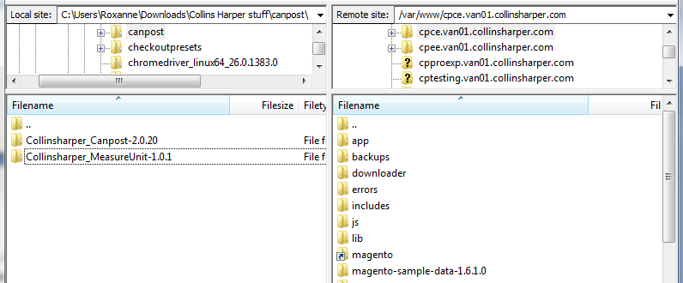

Install these packages one at time starting with the **Unit Converter file (Measure Unit)**.

* **The Unit Converter module must be installed prior to installing the CanPar Shipping module. Failure to do so, could result in fatal PHP errors due to dependencies between these modules.**

Step 3: On your local machine, using the FTP client, navigate to the location of where you extracted the Measure Unit module. Copy the extracted contents into the root directory of your site.

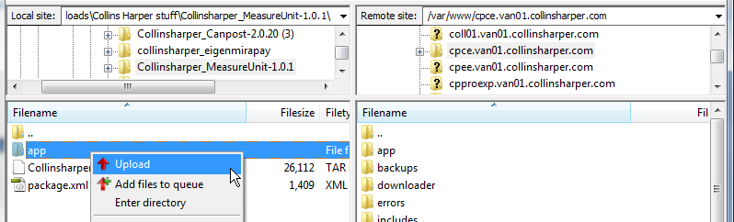

Step 4: Log into your Magento Admin Panel and verify that the module is installed.

Navigate to System > Configuration > Catalog. You should see the following:

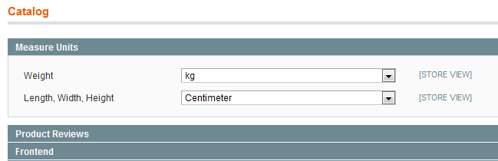

If you fail to see the module, this could be due to your cache being enabled, or you were logged in during the installation. Follow these steps in the order specified, to have the module appear:

a. Go to System > Cache Management.  
 b. Flush the Cache Storage.   
 c. Log out from the Admin Panel.  
 d. Log back into the Admin Panel, and try step 4 again.

Step 5: Log out of your Magento Admin panel.

Step 6: Follow the same procedure to install the Collins Harper CanPar module by FTP. Upload all the contents of the package to your site.

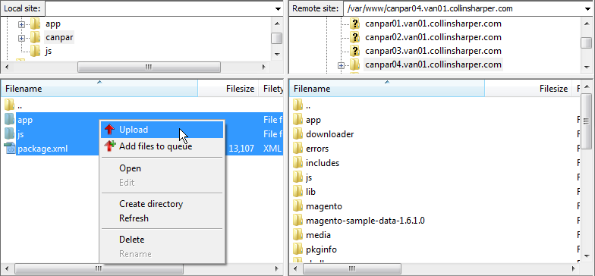

Step 7: Please note, if you have a custom theme, you must manually copy the template files included with the module inside your theme. For example if your theme folder is :

*/app/design/frontend/<your package>/<your theme>/*

You must copy the files located inside the Module deployment located here:

*/app/design/frontend/default/default/*

Into your theme folder.

Step 8: Log into your Magento Admin panel and verify that the module is installed.

Navigate to System > Configuration > Shipping Methods. You should see the following:

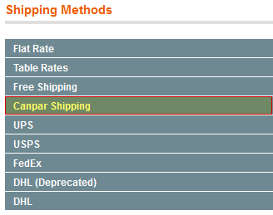

If you fail to see the module, this could be due to your cache being enabled, or you were logged in during the installation. Follow these steps in the order specified, to have the module appear:

a. Go to System > Cache Management.  
 b. Flush the Cache Storage.   
 c. Log out from the Admin Panel.  
 d. Log back into the Admin Panel, and try step 7 again.

## Upgrading via FTP

* **CanPar module updates/upgrades only apply to the CanPar module. The Measure Unit/Unit Converter module, as well as other modules, will remain unaffected.**
* **Before performing an upgrade, please heed the** **recommendations stated earlier****.**

1. To upgrade the CanPar module, download the update/upgrade file that you received and extract its contents onto your local drive.

2. Following the same procedure outlined earlier, use your FTP client to connect to server where your site resides. We want to be in the root of your Magento installation (you should see app, lib, skin, etc, directories).

3. Upload the contents of the package to your site. Overwrite any existing files when prompted.

# Configuring the Module

Navigate to System > Configuration > Shipping Methods. You should see the following:



Once you click on the row titled CanPar Shipping, it will expand to show you the settings panel for the module.

|  |  |
| --- | --- |
| ***Setting*** | ***Description*** |
| Enabled | Select Yes to enable the module for use |
| Debug Mode | Select Yes to log all communication from your site to CanPar. The information is stored in the Magento System log for debugging purposes. |
| Title | The text in this box is presented on the front end to designate CanPar shipping options |
| Email | Store Owner’s email address |
| Password | CanPar Assigned API Password. This is supplied by your CanPar representative during sign up for service. |
| Shipping Account Number. | CanPar Assigned Account Number. This is supplied by your CanPar representative during sign up for service. |
| API URL | This is filled in by default and should only be changed if advised to do so by a CanPar representative |
| Add on API URL | This is filled in by default and should only be changed if advised to do so by a CanPar representative |
| Business API URL | This is filled in by default and should only be changed if advised to do so by a CanPar representative |
| Use Address Line 2 | Select Yes to use the address line two of the Magento Address form for the purposes of printing labels |
| Apply Association Discount | Select Yes to apply the Association Discount. Contact your CanPar representative for more information. |

|  |  |
| --- | --- |
| ***Setting*** | ***Description*** |
| Apply Individual Discount | Select Yes to apply the Individual Discount. Contact your CanPar representative for more information. |
| Apply Invoice Discount | Select Yes to apply the Individual Discount. Contact your CanPar representative for more information. |
| Fail Over Rate Title | If your site is unable to communicate with CanPar and cannot retrieve rates, the module will enter Fail Over Mode. When this happens, the module will offer customers a flat Fail Over Rate so they are still able to checkout. This text box specifies the title shown to the customer when the module is in Fail Over Mode |
| Fail Over Rate Cost | Enter a flat rate shipping cost that customers will be presented with when the module is in Fail Over mode |
| Default Weight | Enter the fail over shipment weight to be used if you do not have weights assigned to products. |
| Default Weight Unit | Specify the unit of measure for the Default Weight |
| Default Dimensional Unit | Specify the unit of measure for Parcel dimentions. |
| Chain Of Signature |  |
| Dangerous Goods | Select yes if you require shipping labels to be marked as “Dangerous Goods”. Contact your CanPar representative for more information. |
| Instruction | Enter up to 40 characters to be applied as instructions on all shipping labels. |
| Allowed Shipping Services | Specify all shipping methods that you would like to offer your customers. Please note that not all shipping methods are offered for all package sizes and destinations. Only available options will be presented to the customer |
| Handling Fee Type | Choose either fixed or variable rate handling fee that will be added to all shipping quotes presented to customers during checkout. |
| Handling Fee | Enter the magnitude of the Handling Fee. |
| Pickup Address Is Residential | Choose Yes if you are shipping FROM a residential address |
| Lead time for order processing | If you do not fulfil orders the same day they are ordered, you can enter a lead time here. This will inflate estimated shipping times by x number of days to provide realistic estimated arrival dates to the customer. |
| Ship to applicable countries | Set to ‘All Allowed Countries’ if you’d like to use CanPar for all of the default Magento allowed countries set in System -> configuration ->General -> General -> Allow Countries |
| Ship to specific countries | If the previous setting is set to “Specific Countries” you can override the countries where CanPar is offered. For example, you may elect to use CanPar for Canadian shipments and UPS for international shipments. If so, you would only select Canada from the list. Use ‘control click’ technique to select multiple entries. |

# Using the Module

This portion of the manual is divided into front end customer facing functionality and back end administration functionality.

## Frontend

On your store's front end, add any items you wish to checkout with into your cart.

Proceed through the checkout steps (enter billing info, shipping info). When you reach the shipping methods section, be sure to choose a shipping method from the CanPar module.

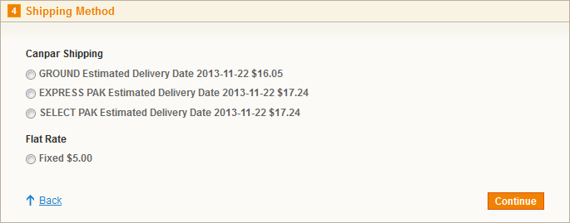

When you select one of the shipping methods, additional options will appear below.

Please note that any option you select will modify the current rate price.

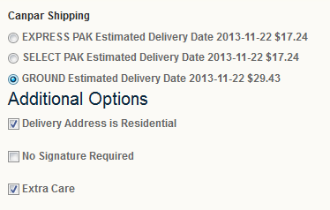

Enter your payment information, review your order, and place the order.

## Administration

Now that the order has been placed, it's time to log into your Magento Admin panel.

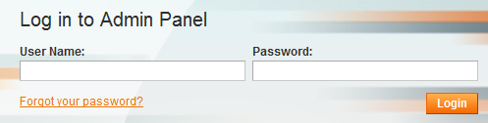

### Creating Shipments

Go to Sales > Orders, and you should see the order that was just placed. Click on that order to open it.

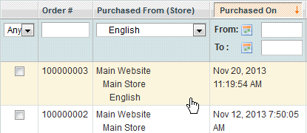

We need to approve it for shipment, before we start printing any labels.  
Click on 'Approve Shipment' near the top-right set of buttons.

  
*\*Note: In some cases, the button may appear as . It serves the same purpose.*

You may specify any quantity you want to ship at this moment. You may ship the remainder of the order at a different date or when stock becomes available.  
Click on 'Submit Shipment' to approve the shipment!

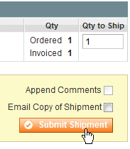

Now a message at the top states that the shipment has been successfully created.



Now if we go to Sales > CanPar Shipment, we should see our new shipment.

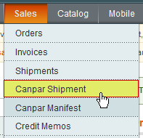

Select the shipment we just created, and under 'Actions' select 'Create CanPar Shipments'.  
Select Submit to create the CanPar shipment.

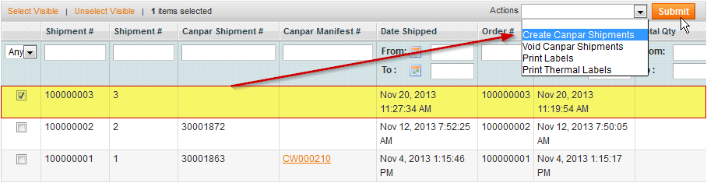

You should be on the same page, but notice that the new shipment now has a CanPar Shipment #.

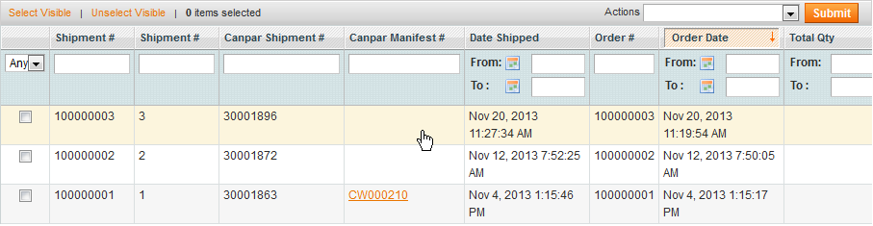

Go to Sales > CanPar Manifest. We will create a CanPar Manifest.

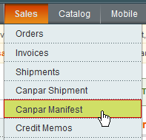

Click on "Run End of Day" and this will create a manifest for the shipments that you created (today).



### Printing Labels

After you've approved the shipment and added it to the manifest, we can print the shipping labels. Go to Sales > CanPar Shipment, to get started.

Place a checkmark on the shipment(s) that you would like labels for.  
Please note, that the shipment must have a CanPar Shipment # in order to get labels.

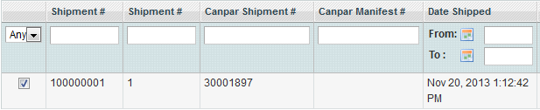

Under Actions, select the 'Print Labels' option, and hit Submit.

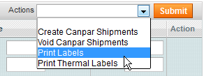

Depending on your web browser settings, you should receive a prompt asking you whether to open the file now or save the PDF file and print it later. Choose either option.

Congratulations! You have successfully generated your shipping label!

### Printing the Manifest Document

After running the *End of day* command (page 16), you will see a new manifest in the manifest grid.

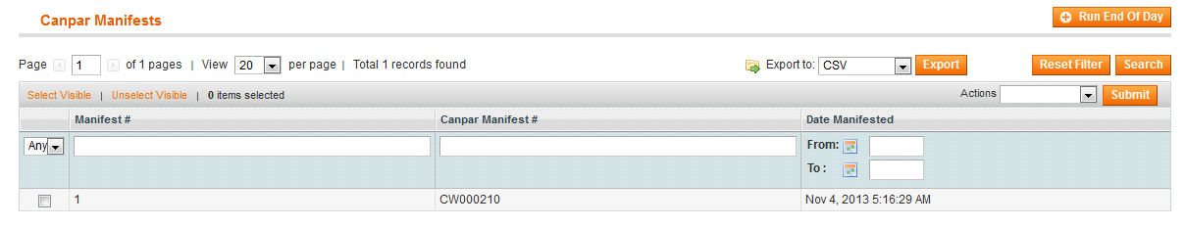

Simply click on the row that represents the newly created manifest and it will begin the download of a PDF document. Print that document to print your Manifest.

# FAQ

If you run into any questions/issues during/after the installations, or questions/issues when using our module, check out these points below and see if they apply to your situation.

#### I cannot see the module installed on the front end

Please ensure it is enabled and configured correctly (Configuring the Module page 11 of this document). If that doesn’t work, refresh the Magento Cache.

If that does not resolve the issue, review the module settings (page 11) and see if the setting *Allowed Shipping Services* specifies a restricted set of options. For example, if you are shipping a heavy parcel and the only allowed option is *SELECT LETTER*, no rates will be returned because *SELECT LETTER* cannot be used for parcels weighing over one pound. Similarly, if allowed options are restricted, it may be that the shipment cannot be sent to a certain destination because the allowed options are not offered for that location.

If that does not resolve the issue, see Step 7 on page 8 of this guide.

If you have the module in debug mode (see page 11) please look for additional information found in the file var/log/system.log. This information will be required when you contact CanPar for support.

#### I cannot see the module installed on the back end

Please clear the Magento Cache and ensure you have logged out and then back into the admin section after installation.

#### During checkout the module only ever offers the fail over rate

This happens when the module is unable to retrieve rates. Causes for this include:

* You do not have a valid account configured.
* Your server does not have SOAP installed.
* One of the API Urls are incorrect.

If you have the module in debug mode (see page 11) please look for additional information found in the file var/log/system.log. This information will be required when you contact CanPar for support.