rydFixr – End-to-End Application Documentation
1. Introduction
rydFixr is a trust-first, service-based digital marketplace designed to connect bike owners (customers) with verified bike mechanics (Fixperts), fuel providers, inspectors (Verified Assist), and an operations/admin team through a single backend system.
rydFixr focuses on fair pricing, safety, accountability, and reliability, solving long-standing problems in bike repairs and on-road assistance such as price uncertainty, lack of proof, no written guarantees, and safety concerns during travel.
rydFixr is not an ecommerce platform. It is a repair-execution and mobility-assurance platform, where trust and process matter more than discounts.

2. Core Principles of rydFixr
- Transparency over cheap pricing
- Guaranteed Fixpert earnings
- Customer protection through process, not refunds
- Clear separation of labour and parts
- Single backend, multiple role-based interfaces
- Safety before scale

3. Platform Architecture Overview
rydFixr operates on a single centralized backend that serves multiple role-based interfaces. Interfaces never communicate directly with each other. All communication is orchestrated through backend APIs, database state changes, and real-time events.
Interfaces in rydFixr
- Customer Interface
- Fixpert Interface
- Inspector Interface (Verified Assist)
- Petrol (Fuel) Interface
- Admin / Operations Interface
- Payments & Escrow Module (Admin-restricted)

4. Customer Interface
Purpose
To enable customers to safely book repairs, approve pricing, verify work, and make secure payments.
Key Features
- Book bike repair or fuel request
- Select issue type (engine, electrical, servicing, etc.)
- View transparent price breakup
- Approve Fixpert quotation
- Make escrow-based payment
- View repair photos/videos
- Approve completion
- Request rework (within stipulated time)
- Enable Safe Ride feature
- Rate Fixpert and Inspector
- Access repair history and digital records

5. Fixpert Interface (Mechanic Interface)
Purpose
To allow Fixperts to accept jobs, perform repairs, and earn guaranteed income without customer-chasing or bargaining.
Key Features
- Accept or reject repair requests
- View job scope and rework policy
- Mandatory acceptance of rework policy before pricing
- Enter labour cost (take-home amount)
- Enter replacement parts cost (actual cost)
- Upload repair proof (photos/videos)
- Perform free rework within stipulated time if required
- Track earnings and reward points
- Redeem reward points into money
- View trust score and performance metrics

6. Inspector Interface – “Verified Assist”
Purpose
To act as a neutral trust layer between Fixpert and Customer for high-risk or high-value repairs.
Who is a rydFixr Inspector?
- A verified on-ground or assigned observer
- Trained and approved by rydFixr
- Not involved in repair execution
Key Responsibilities
- Observe repair process
- Capture independent photos/videos
- Validate repair steps using checklist
- Flag irregularities
- Submit neutral verification report
Inspector involvement is conditional, not mandatory for all jobs.

7. Petrol / Fuel Interface (Emergency Fuel Service)
Purpose
To provide emergency fuel assistance when customers are stranded.
Rules & Constraints
- Maximum fuel delivery: 2 Litres only
- Fuel price strictly based on current petrol rate per litre
- Additional handling fee and delivery fee applied
- No platform commission on fuel price itself
Key Features
- Accept fuel delivery requests
- Confirm quantity and delivery
- Update delivery status
- Simple payment confirmation
This service is meant strictly for emergency use, not bulk fuel delivery.

8. Admin / Operations Interface
Purpose
To control platform integrity, trust, payments, and safety.
Key Responsibilities
- Approve and suspend Fixperts, Inspectors, Petrol partners
- Handle disputes and escalations
- Monitor Safe Ride cases
- Override job states when required
- Manage location-based platform fees
- Control rework policies and durations
- Review fraud or misuse cases
- Access analytics and operational metrics

9. Pricing & Fair Repair Model
Separation of Costs (Mandatory)
- Labour Cost
  - Entered by Fixpert as take-home earning
  - Platform fee applies ONLY on labour
- Replacement Parts Cost
  - Entered separately
  - Actual cost only
  - Requires bill/photo proof
  - No platform fee applied
Location-Based Platform Fee (on labour only)
- Villages / Mandals: Lower percentage
- Towns / District HQs: Medium percentage
- Cities / Metros: Higher percentage
Customer Pays
Labour + Platform Fee + Inspector Fee (if any) + Parts
Fixpert Receives
100% Labour (take-home) + 100% Parts

10. Warranty & Rework Policy (Sustainable Model)
Key Rules
- ❌ No refunds (rydFixr is not ecommerce)
- ✅ Only free rework within stipulated time
- Rework is done by the same Fixpert
- Rework duration depends on problem type
Rework Windows (Examples)
- Minor repairs: 3–7 days
- Regular servicing: 7 days
- Engine/Electrical work: 15 days
- Diagnostic jobs: No rework
Reward Mechanism
If no issue is reported during the rework window:
- Fixpert receives reward points
- Points are redeemable into real money
This encourages quality-first repairs.

11. Safe Ride Feature (Customer Safety System)
Purpose
To ensure customer safety during long or sensitive rides by active monitoring from the rydFixr team.
How Safe Ride Works
- Customer enables Safe Ride
- Ride is monitored by rydFixr until destination confirmation
- Automated safety calls are triggered:
  - First call after 20–30 minutes
  - If answered → ride marked safe
  - If missed:
    - Second call after 3 minutes
    - Third (final) call after 1–2 minutes
- If all automated calls are missed:
  - Case is escalated to Admin team
  - Manual calls attempted
  - GPS movement checked
- If GPS is stationary for extended time and no response:
  - Admin team contacts nearest police station
  - Ambulance/hospital emergency initiated if required
Safe Ride prioritizes human intervention over automation.

12. Why Customers Can Trust rydFixr
- Transparent pricing with breakup
- No hidden charges
- Escrow-based payment protection
- Proof-based repairs
- Written rework guarantee
- Inspector (Verified Assist) support
- Safety monitoring (Safe Ride)
- Digital service records
- Clear escalation path
rydFixr guarantees accountability, not unrealistic perfection.

13. Why Fixperts Trust rydFixr
- Guaranteed take-home earnings
- No commission on parts
- No bargaining with customers
- Clear rework rules
- Performance-based rewards
- Transparent policies
- Predictable payouts

14. Final Summary
rydFixr is a carefully designed, trust-centric platform that balances the needs of customers, Fixperts, and operations without relying on unsustainable discounts or risky refund policies.
It transforms bike repair and mobility assistance into a documented, verifiable, and accountable service ecosystem, where:
- Customers feel protected
- Fixperts feel respected
- The platform remains sustainable
rydFixr does not promise the cheapest repair.
It promises the fairest, safest, and most accountable repair experience.

15. System Implementation Flowcharts & Process Flows
Below are implementation-level process flows for every major system in rydFixr. These are written in a developer- and architect-friendly format, so they can be directly converted into flowcharts, sequence diagrams, or BPMN diagrams.

15.1 Overall System Communication Flow
Architecture Principle: Single backend, multiple role-based interfaces.
Flow (High Level):
- Any interface (Customer / Fixpert / Inspector / Petrol / Admin) sends a request
- Backend API validates authentication & role
- Business logic is executed
- Database state is updated
- Events/notifications are triggered
- Relevant interfaces receive updates
Interface → API Gateway → Business Logic → Database
↓
Events / Notifications
↓
Other Interfaces Update

15.2 Customer Repair Booking Flow
Purpose: Create a repair job safely.
Flow:
- Customer logs in
- Selects bike & location
- Chooses issue type (engine, electrical, service, etc.)
- System shows expected price range
- Customer submits repair request
- Job status = OPEN
- Nearby Fixperts are notified
State Transitions:
NEW → OPEN

15.3 Fixpert Job Acceptance & Pricing Flow
Purpose: Ensure fair pricing and rework accountability.
Flow:
- Fixpert views available jobs
- Selects a job
- System displays:
  - Job scope
  - Rework policy
- Fixpert must click Accept Rework Policy
- Labour input field enabled
- Fixpert enters labour (take-home amount)
- Fixpert enters parts cost (if required)
- Quote submitted
- Job status = QUOTED
Validation Rules:
- Labour must be within allowed range
- Parts require proof upload

15.4 Customer Quote Approval & Escrow Payment Flow
Purpose: Secure money before repair starts.
Flow:
- Customer views Fixpert quote
- System calculates:
  - Platform fee (location-based)
  - Inspector fee (if any)
- Transparent breakup shown
- Customer approves quote
- Customer makes payment
- Payment held in escrow
- Job status = PAID

15.5 Repair Execution & Proof Upload Flow
Purpose: Capture repair evidence.
Flow:
- Fixpert starts repair
- Job status = IN_PROGRESS
- Fixpert uploads photos/videos
- Inspector (if assigned) uploads verification
- Fixpert marks repair completed
- Job status = AWAITING_APPROVAL

15.6 Customer Approval & Payment Release Flow
Purpose: Release money only after satisfaction.
Flow:
- Customer reviews repair proof
- Customer approves completion
- Escrow triggers payout split:
  - Labour → Fixpert
  - Parts → Fixpert
  - Platform fee → rydFixr
  - Inspector fee → Inspector
- Job status = COMPLETED
- Rework window timer starts

15.7 Rework-Only Warranty Flow
Purpose: Handle post-repair issues safely.
Flow:
- Customer reports same issue within rework window
- System validates eligibility
- Job status = REWORK_REQUESTED
- Fixpert notified
- Fixpert performs rework (no labour charge)
- Fixpert uploads new proof
- Customer reviews
- Job status = REWORK_COMPLETED
Rules:
- No refunds
- Same Fixpert responsible

15.8 Fixpert Reward Points Flow
Purpose: Incentivize quality work.
Flow:
- Rework window expires
- No issues reported
- System auto-credits reward points
- Points added to Fixpert wallet
- Fixpert can redeem points to cash

15.9 Inspector (Verified Assist) Flow
Purpose: Neutral verification.
Flow:
- Inspector assigned by system/admin
- Inspector visits/observes repair
- Uploads independent proof
- Submits checklist report
- Inspector fee released after job completion

15.10 Emergency Fuel Delivery Flow
Purpose: Provide limited emergency fuel.
Flow:
- Customer requests fuel
- System enforces max 2L limit
- Petrol partner notified
- Fuel delivered
- Handling & delivery fee applied
- Payment confirmed
- Job closed

15.11 Safe Ride Feature Flow
Purpose: Ensure customer safety during travel.
Flow:
- Customer enables Safe Ride
- Backend starts monitoring session
- Automated call after 20–30 mins
  - Answered → Mark safe
- If unanswered:
  - Second call after 3 mins
  - Third call after 1–2 mins
- If still unanswered:
  - Case escalated to Admin
- Admin attempts manual calls
- GPS movement checked
- If stationary & no response:
  - Police station contacted
  - Ambulance/hospital alerted
- Customer confirms destination reached
- Safe Ride session closed

15.12 Admin Monitoring & Escalation Flow
Purpose: Maintain platform integrity.
Flow:
- Admin dashboard shows live jobs
- Flags raised (payment, safety, disputes)
- Admin intervenes if required
- Overrides job/payment states if needed
- Logs all actions for audit

15.13 Job State Machine (Summary)
NEW
↓
OPEN
↓
QUOTED
↓
PAID
↓
IN_PROGRESS
↓
AWAITING_APPROVAL
↓
COMPLETED
↓
(REWORK_REQUESTED → REWORK_COMPLETED)
↓
CLOSED

16. Implementation Readiness Summary
- All flows are state-driven
- No direct interface-to-interface communication
- Backend orchestrates logic & security
- Easily convertible to flowcharts & sequence diagrams
This completes the system-level implementation blueprint for rydFixr.

**Refer the below for detailed working mechanism of rydfixr & basic prototype model of rydFixr application**
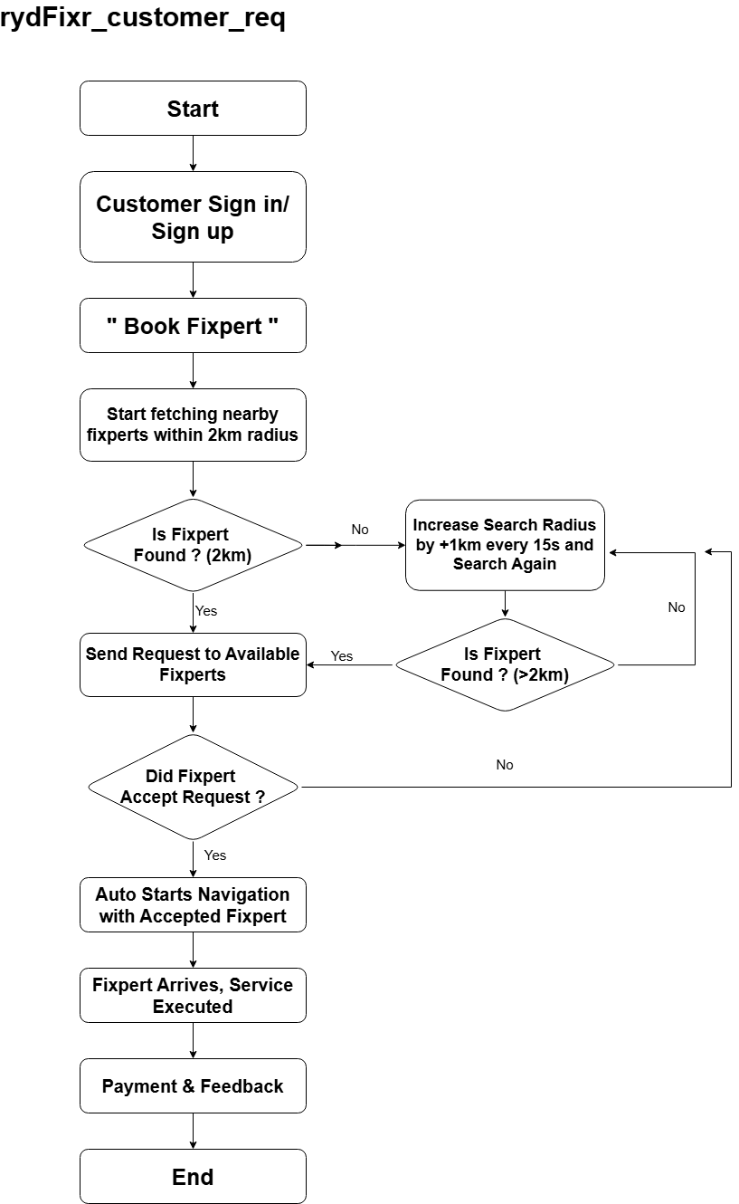
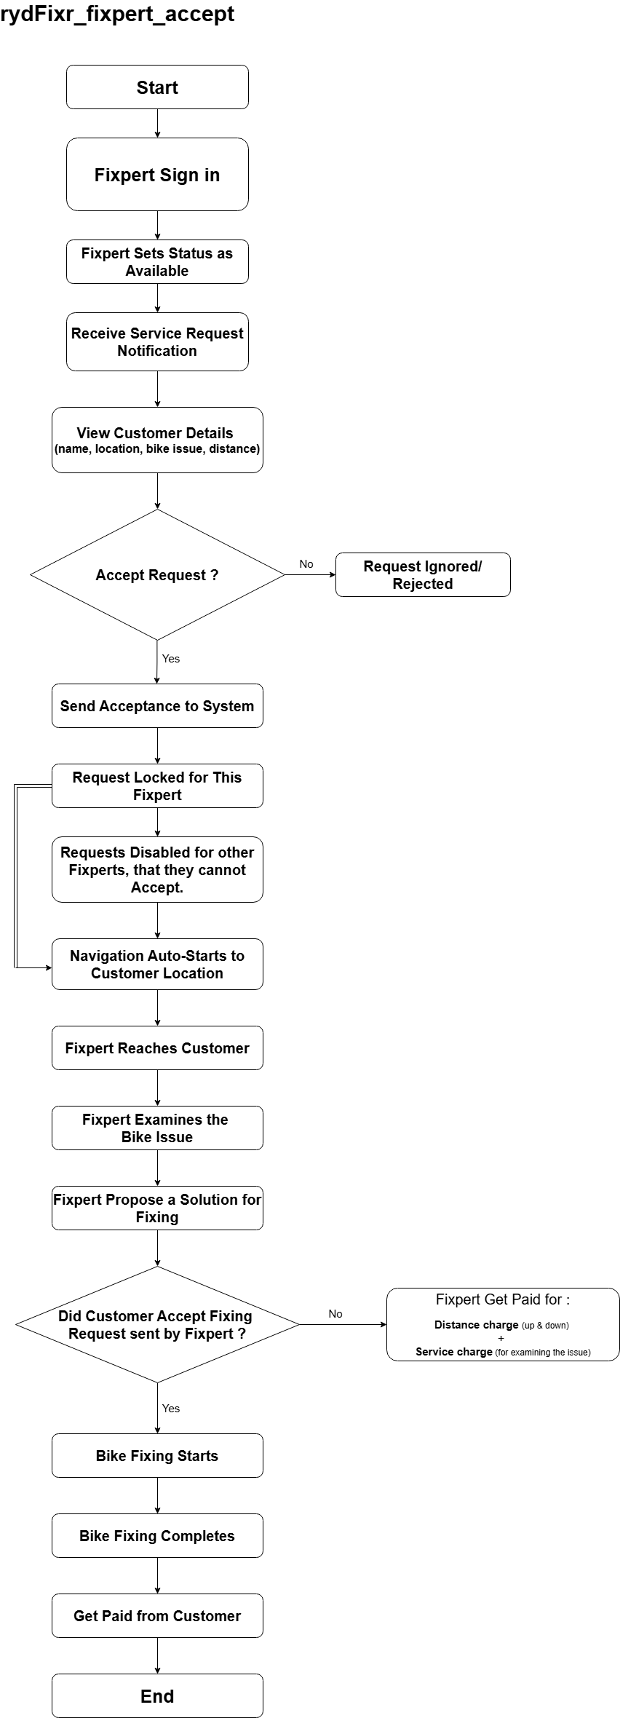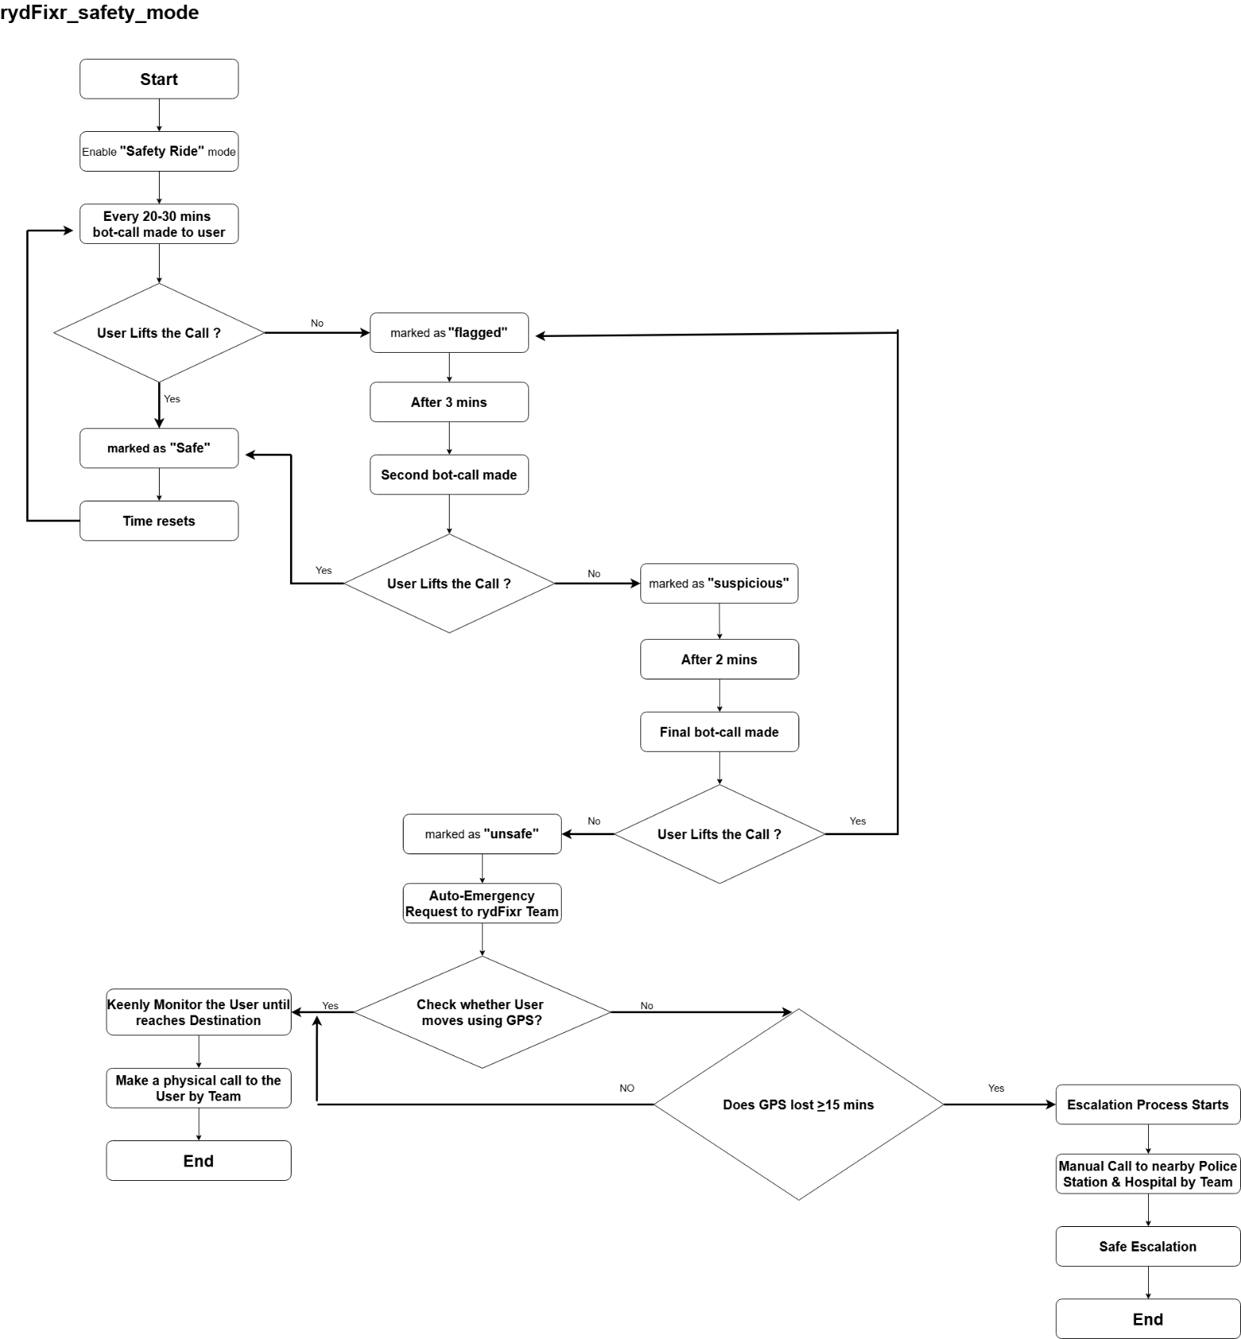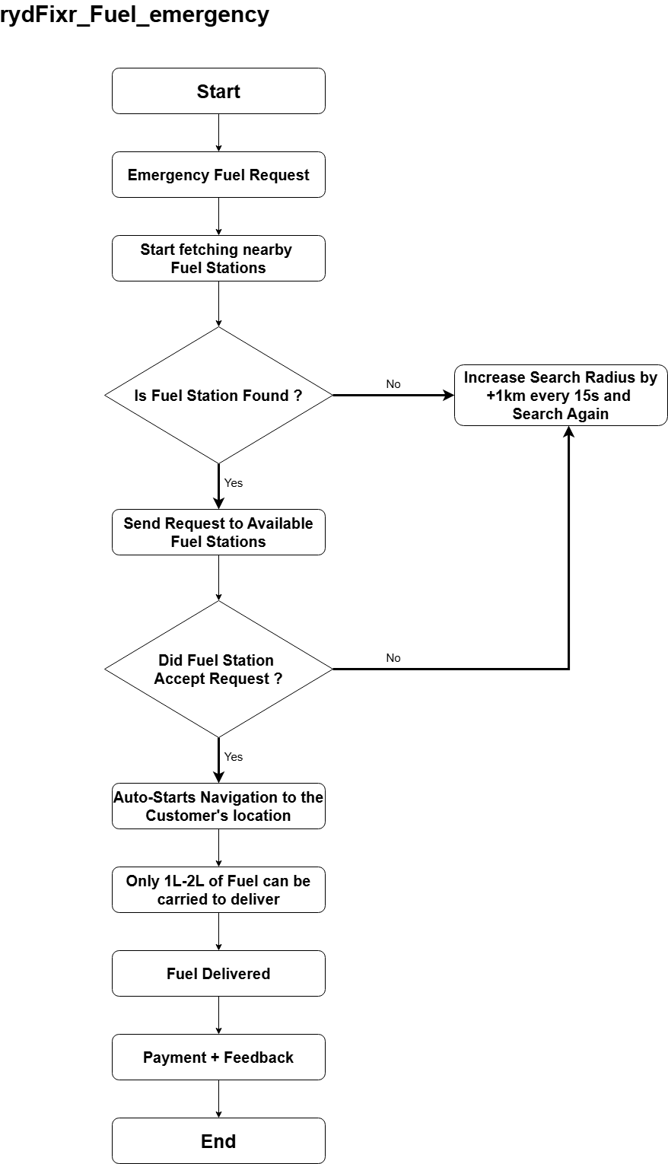
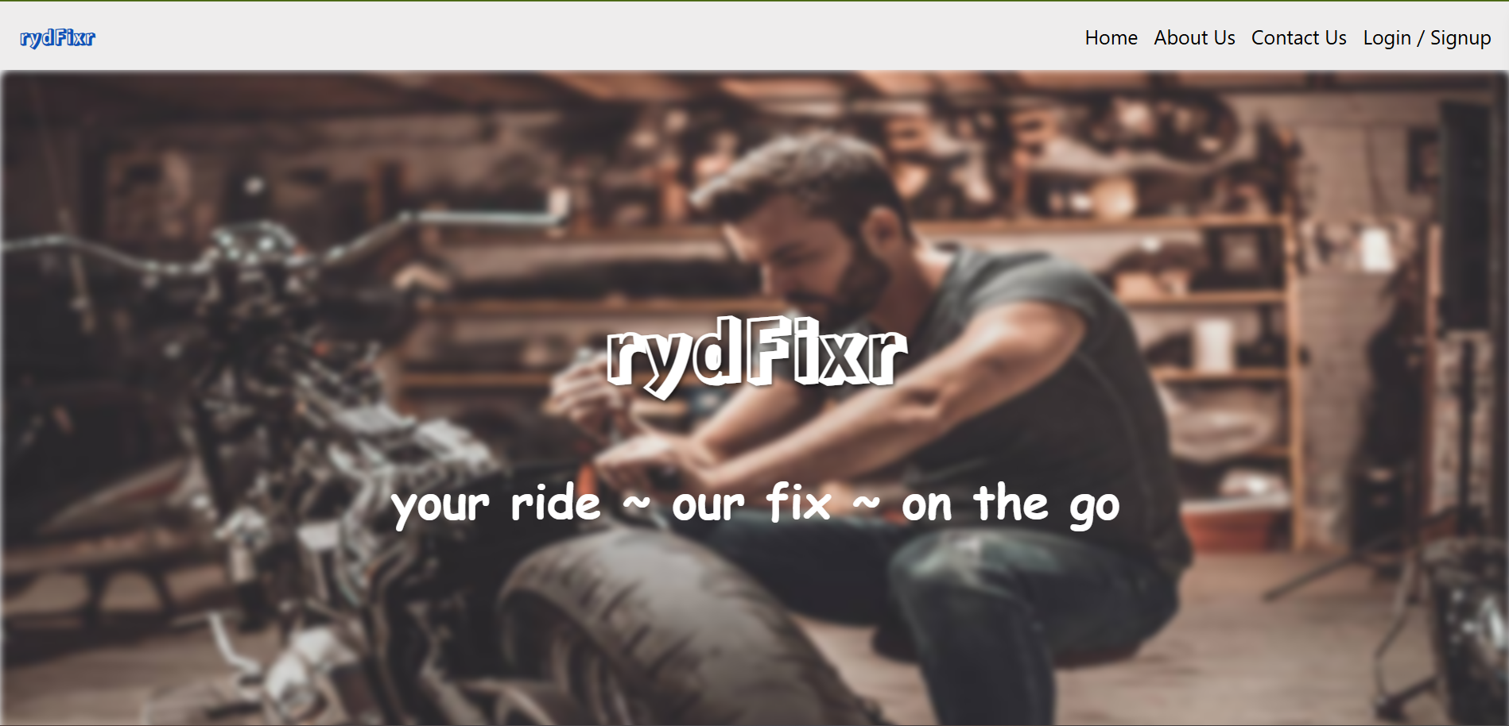
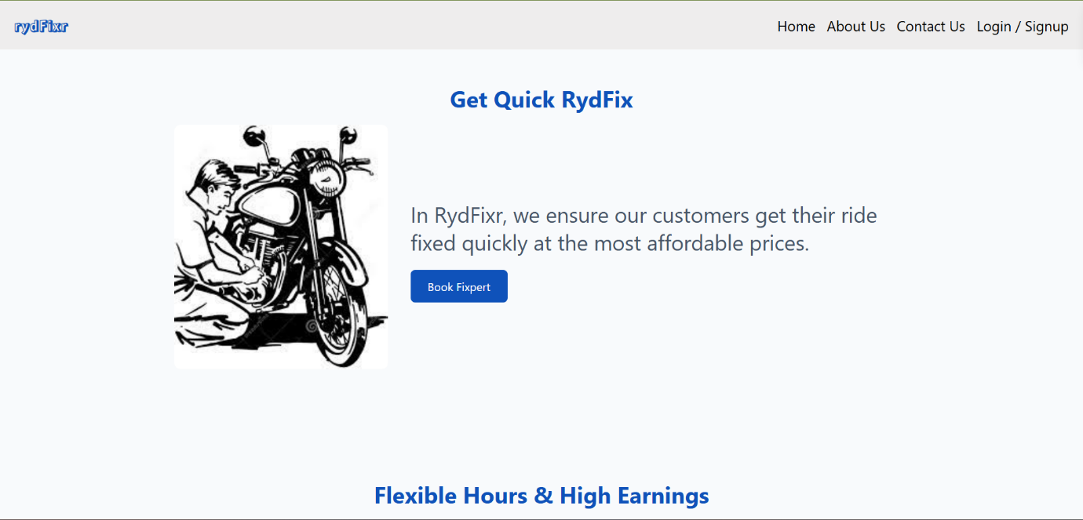
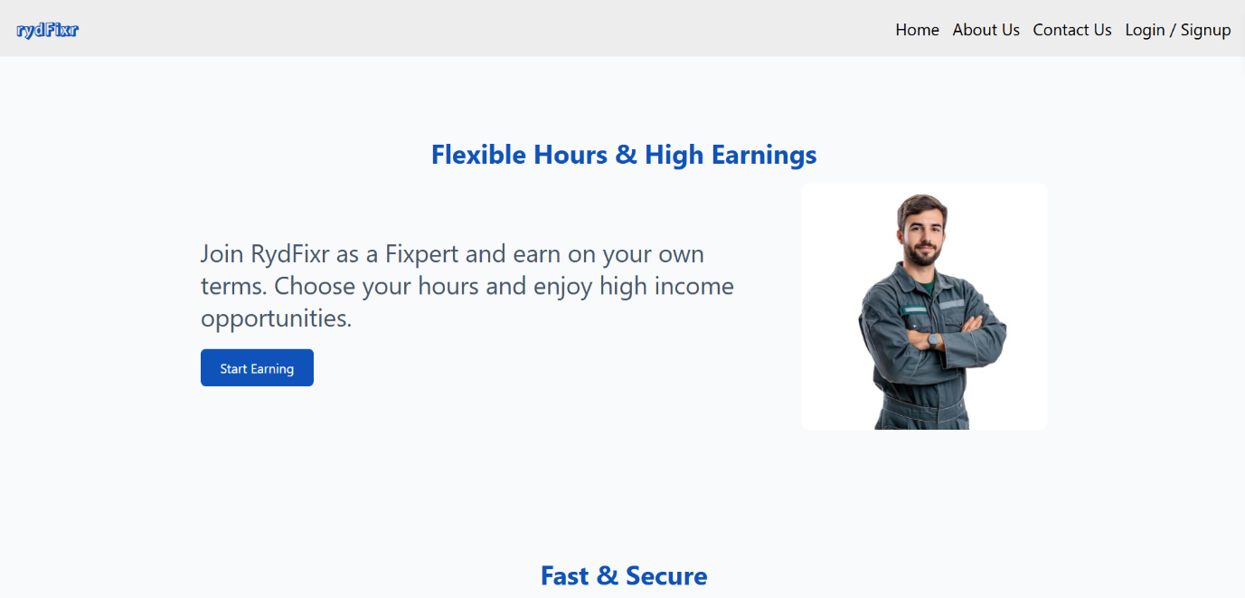
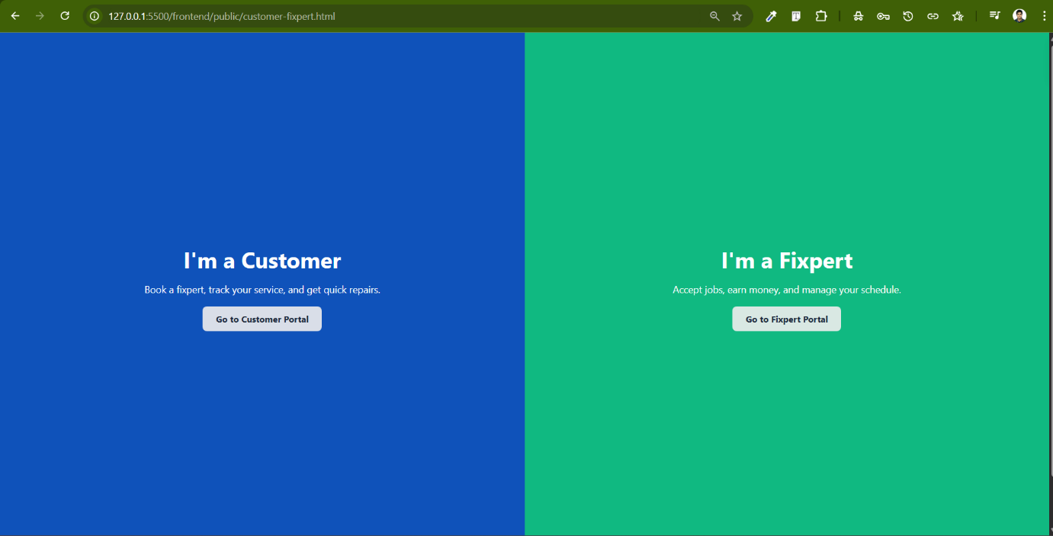
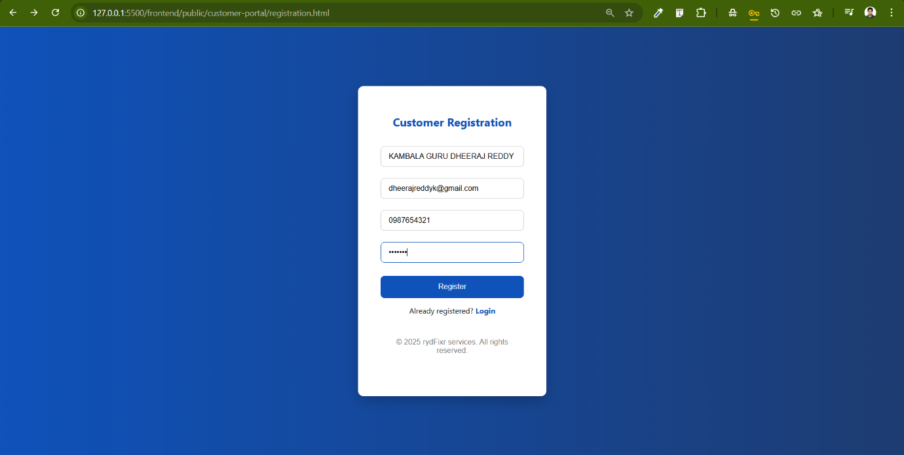
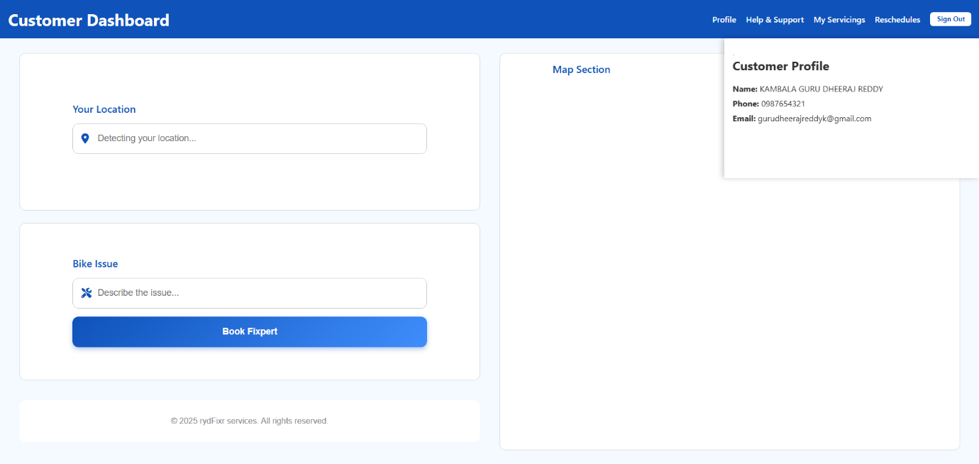
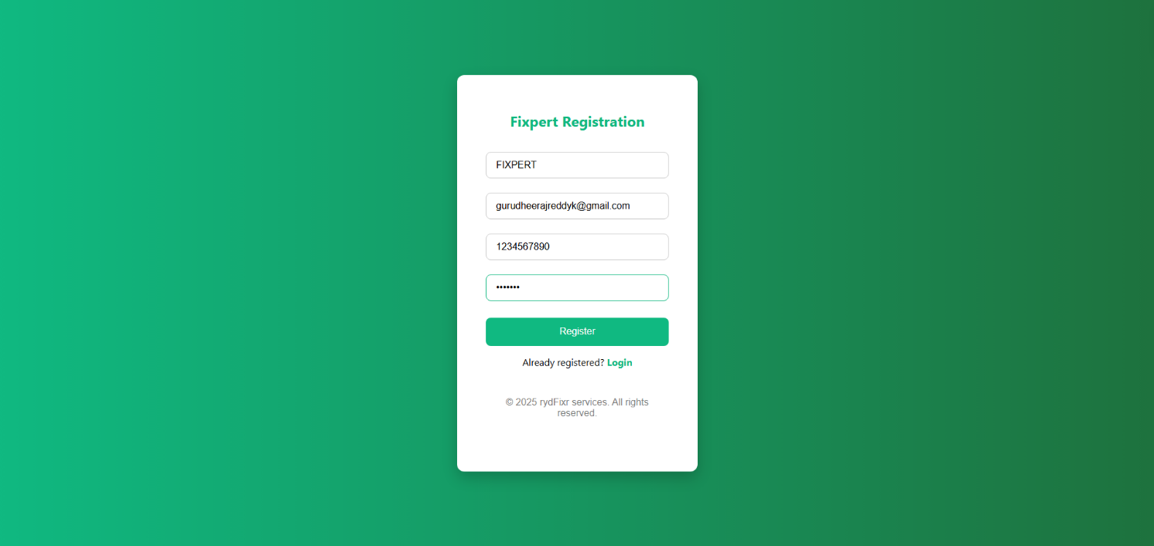
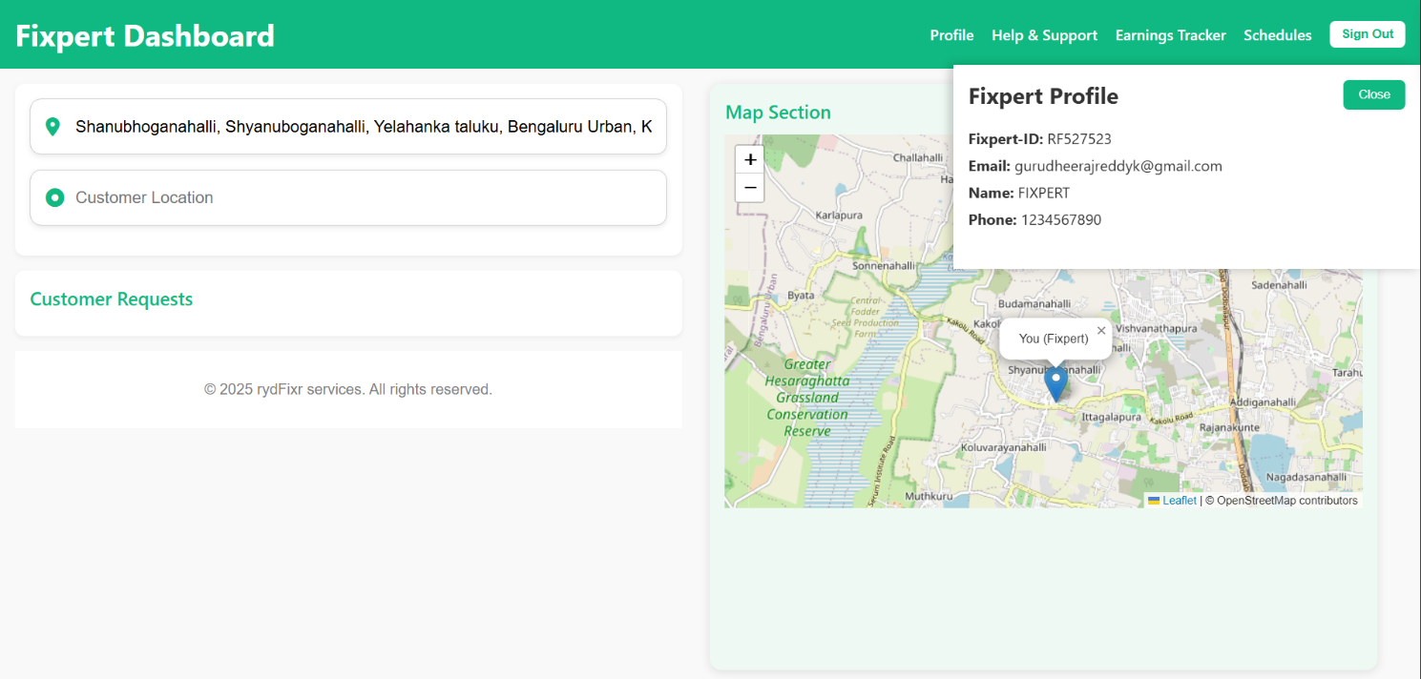

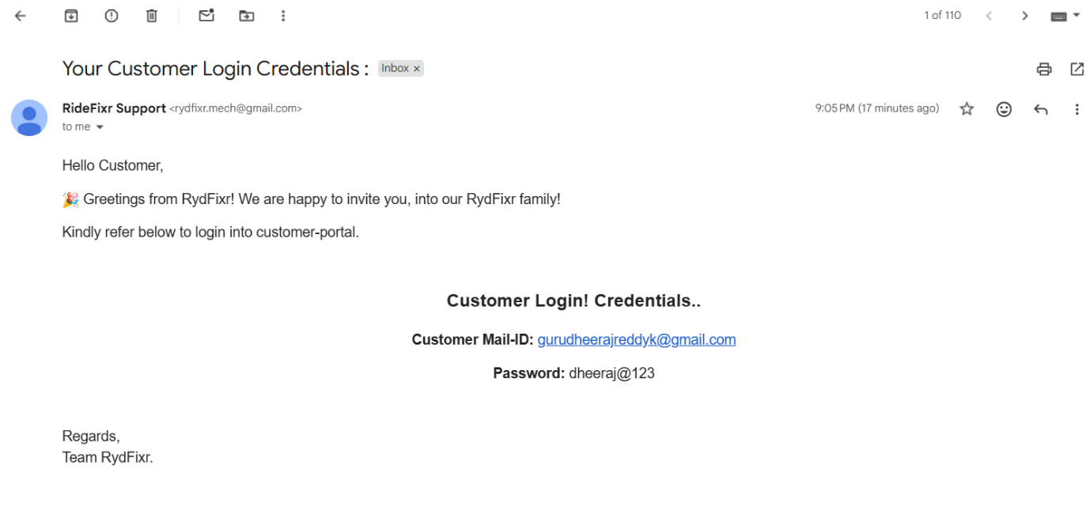

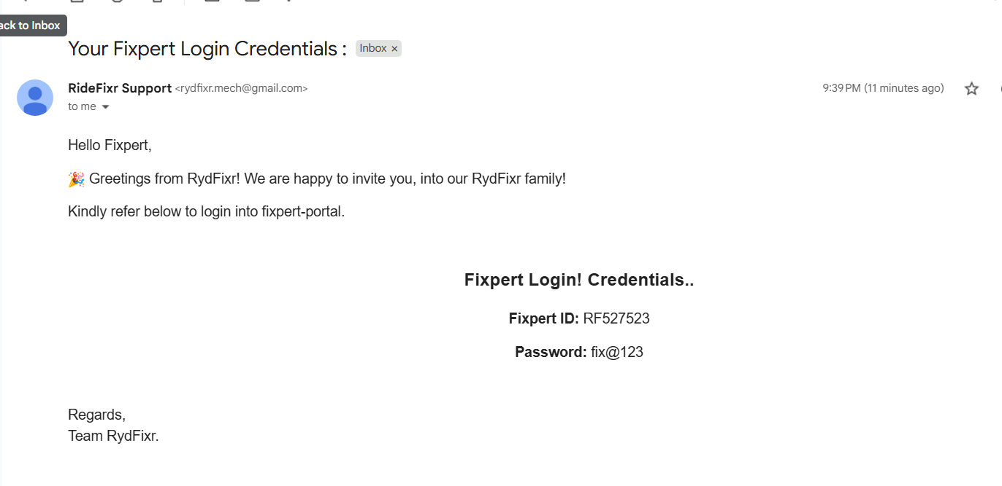

17. Comparative Analysis of rydFixr with existing Bike Service Platforms :
Platform | Core Services Provided | Limitations / Gaps | How rydFixr Improves or Differentiates
Urban Company | • On-demand home services  • Bike servicing as a category  • Fixed pricing | • No real-time mechanic tracking  • No safety monitoring during ride  • Limited transparency after booking | • Real-time Fixpert tracking via map  • “Safe Ride” live monitoring feature  • Continuous service status updates
GoMechanic | • Scheduled bike servicing  • Service packages  • Workshop-based servicing | • No instant mechanic discovery  • No live GPS tracking  • No customer safety workflow | • Instant Fixpert matching within 10 km radius  • Live route & location tracking  • Safety escalation mechanism
BikeWo | • Doorstep bike servicing  • Periodic maintenance | • Weak real-time communication  • No ride monitoring after booking  • No emergency handling | • Two-way real-time communication  • Automated safety calls  • Admin-controlled emergency flow
ReadyAssist | • Roadside assistance  • Breakdown support  • Towing services | • Reactive support only (after breakdown)  • No continuous ride monitoring  • No proactive safety checks | • Proactive “Safe Ride” monitoring  • Automated periodic safety calls  • GPS movement validation and admin escalation
Royal Brothers | • Bike rentals  • Basic service support | • Rental-focused, not repair-centric  • No Fixpert–customer matching  • No real-time service tracking | • Service-first platform  • Dynamic Fixpert assignment  • Full service lifecycle monitoring
Local Bike Shops (Offline) | • Immediate repairs• Low service cost | • No digital tracking  • No service history  • No customer safety assurance | • Digital service records  • GPS-based service tracking  • Safety-focused service workflow

