This is the “readme” file associated with this project:

Project file structure has not been changed. Extra data files have been generated from the provided matlab utility.

1. Your code should compile. > Code complies with no issues

cmake .. && make

-- Configuring done

-- Generating done

-- Build files have been written to: /Users/i806414/Documents/dev/Udacity/carnd/term2/CarND-Extended-Kalman-Filter-Project-master/build

**Scanning dependencies of target ExtendedKF**

[ 20%] Building CXX object CMakeFiles/ExtendedKF.dir/src/main.cpp.o

[ 40%] Building CXX object CMakeFiles/ExtendedKF.dir/src/tools.cpp.o

[ 60%] Building CXX object CMakeFiles/ExtendedKF.dir/src/FusionEKF.cpp.o

[ 80%] Building CXX object CMakeFiles/ExtendedKF.dir/src/kalman_filter.cpp.o

[100%] **Linking CXX executable ExtendedKF**

[100%] Built target ExtendedKF

1. px, py, vx, vy output coordinates must have an RMSE <= [.11, .11, 0.52, 0.52] when using the file: "obj_pose-laser-radar-synthetic-input.txt which is the same data file the simulator uses for Dataset 1"

Attached screenshot

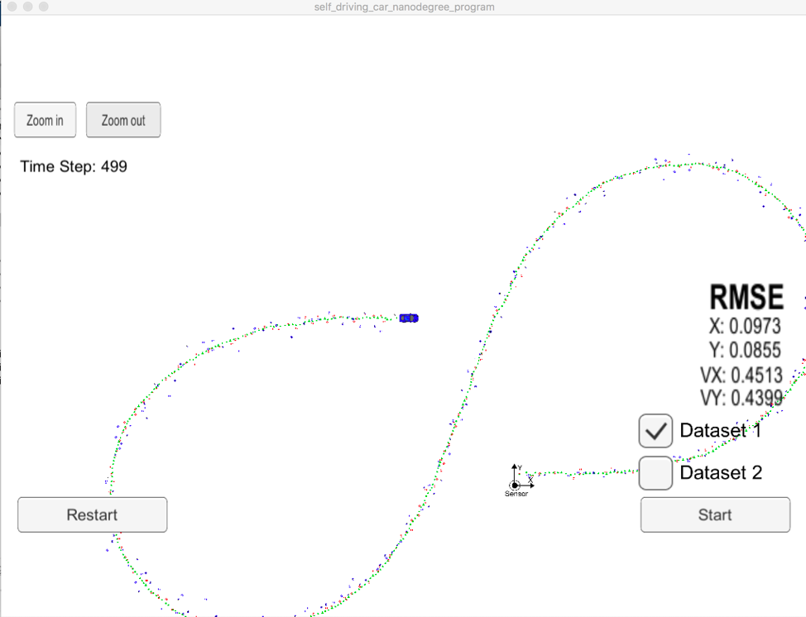

1. Your Sensor Fusion algorithm follows the general processing flow as taught in the preceding lessons.

Code follows the flow as instructed

1. Your Kalman Filter algorithm handles the first measurements appropriately.

Line 87…in FusionEKF.cpp

1. Your Kalman Filter algorithm first predicts then updates

FusionEKF.cpp Line 137 is predict and line 166 is update sections resp.

1. Your Kalman Filter can handle radar and lidar measurements

Yes handles both

1. Your algorithm should avoid unnecessary calculations.

Implemented as per guidelines