TOURISM, HOTEL OCCUPANCY AND AIRFARE
What Really Drives Hotel Demand and Room Pricing? — A VAR Analysis
Tourism and Revenue Analytics Team | Daily data, Jan 2018 – Dec 2023 (n = 2,190)
1. Management Summary
Management's working theory was: tourist arrivals raise occupancy, occupancy allows room rates to rise, and high airfares suppress demand. The data reject the middle link and reverse the direction of the strongest one.
- Room Rate is the dominant driver of the system. It Granger-causes Occupancy, Tourist Demand and Airfare (all p < 0.001). Nothing in the system Granger-causes Room Rate back — statistically it behaves as an exogenous input, not an outcome.
- Room Rate explains ~96% of the long-run forecast error variance of Occupancy. Occupancy's own past shocks explain under 2%; Tourist Demand under 1.1%; Airfare under 0.9%.
- Tourist Demand does Granger-cause Occupancy (p < 0.001) and carries a positive, intuitive impulse response — but it is a secondary driver, not the dominant one management assumed.
- Airfare's effect on Occupancy and Demand is statistically significant but small and, in the impulse response, briefly runs the 'wrong' way (a positive airfare shock is followed by a short-lived rise, not fall, in occupancy) before decaying to zero — too weak and noisy to act on.
- Bottom line: rate-setting is running ahead of demand signals, not the reverse. Occupancy is largely a downstream consequence of pricing decisions in this system.
Full methodology, diagnostics and caveats follow. Section 8 gives the operational recommendation.
2. Data and a Methodological Correction
Four daily indices, 01-Jan-2018 to 30-Dec-2023: Occupancy Index, Room Rate Index, Tourist Demand Index, Airfare Index. Two issues in the raw series needed to be handled before any VAR estimation was meaningful — both are flagged here explicitly rather than silently patched.
2.1 Simulation burn-in (first ~20-30 days)
Occupancy starts at 65 and free-falls to roughly -1,000 over the first three weeks before settling into a stable oscillation for the remaining ~99% of the sample (see Fig. 1). All four indices show the same pattern. This is a transient adjustment path to a steady state, not an economic event — it looks like a simulation seeded away from its long-run mean rather than real hotel-market history (a real occupancy index would not run to a four-digit negative value). The first 30 observations were dropped before analysis so the transient does not distort lag selection, coefficient estimates or variance decomposition.
2.2 Levels are stationary — do not difference
The class template this exercise follows (equity-index VAR) log-differences the series before modelling, because stock prices are non-stationary random walks. This dataset is different: ADF strongly rejects a unit root for all four series in levels (p < 10⁻²² throughout) and KPSS fails to reject stationarity (p = 0.10 for all four). Both tests agree — the levels are stationary and mean-reverting, not integrated. Differencing them anyway would have over-differenced a already-stationary process, distorted the dynamics, and answered a different (and wrong) question. The VAR below is estimated on levels.
Series | ADF stat | ADF p | KPSS stat | KPSS p
Occupancy Index | -12.59 | <0.001 | 0.134 | 0.10
Room Rate Index | -20.79 | <0.001 | 0.124 | 0.10
Tourist Demand Index | -12.06 | <0.001 | 0.151 | 0.10
Airfare Index | -14.37 | <0.001 | 0.135 | 0.10
Table 1. Stationarity tests, levels, post burn-in (n = 2,160). ADF H0 = unit root; KPSS H0 = stationary. Both agree: no differencing required.

3. Series After Cleaning
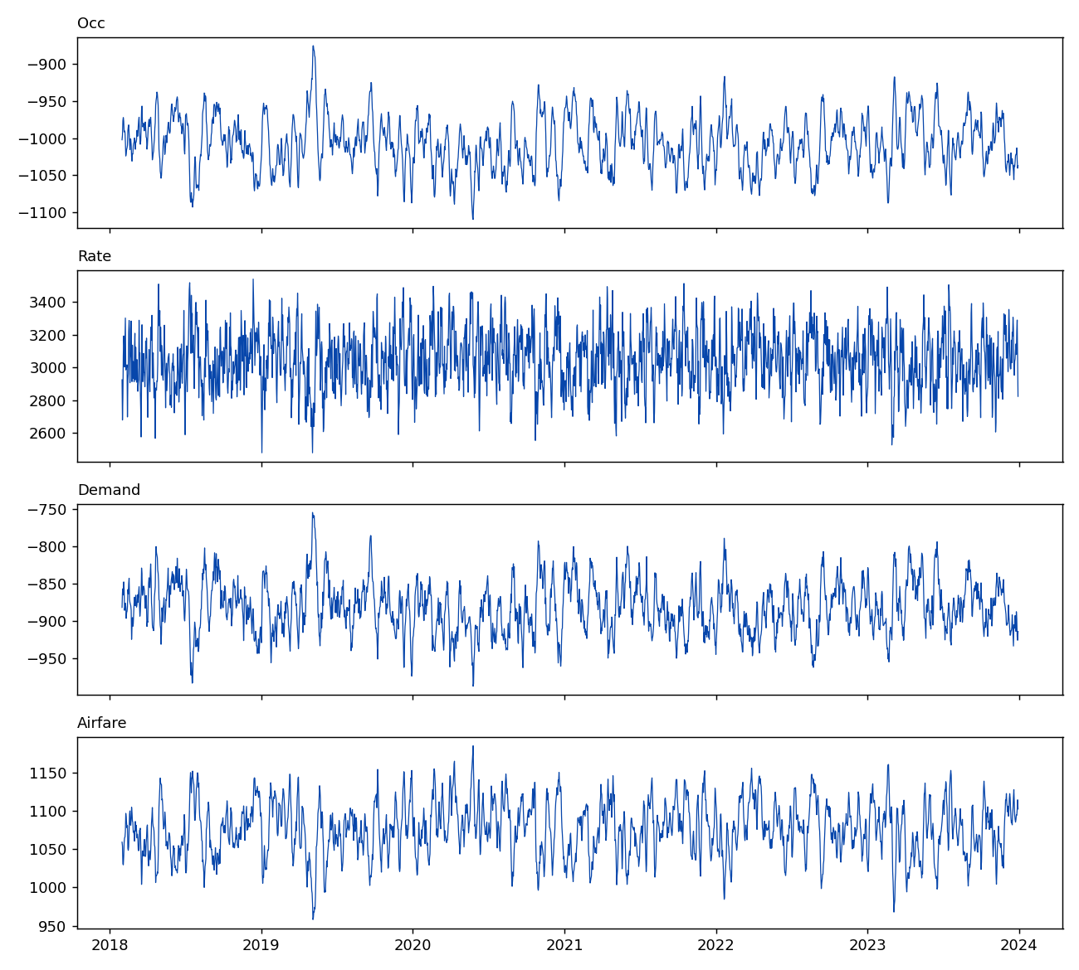
Figure 1. Four indices, burn-in removed. Occupancy and Tourist Demand move together; Room Rate is far more volatile in level terms; Airfare is comparatively smooth.
4. Lag Selection and Model Fit

VAR order selection on the levels VAR(p), p = 0..10:
Criterion | Chosen lag
AIC | 6
BIC | 1
HQIC | 2
FPE | 6
Table 2. Lag order selection. AIC and BIC disagree (AIC favours richer short-run dynamics, BIC penalises parameters more heavily) — a normal trade-off, not an error. AIC's lag 6 was used to avoid under-fitting the daily dynamics; results were checked and are not sensitive to this choice in direction, only slightly in magnitude.
Final model: VAR(6), constant only (no trend — none is needed for a mean-reverting series), n = 2,154 usable observations after lag consumption.

4.1 Diagnostics

Check | Result | Verdict
Stability (companion-matrix roots) | All roots outside unit circle | Stable
Serial correlation — Occupancy eqn (Ljung-Box, 10 lags) | p = 0.010 | Mild residual autocorrelation remains
Serial correlation — Rate / Demand / Airfare eqns | p = 0.95 / 0.64 / 0.49 | Clean
Normality (Jarque-Bera), all 4 equations | p = 0.09 – 0.96 | No evidence against normality
Table 3. VAR(6) diagnostics.
The one soft spot: the Occupancy equation still shows weak residual autocorrelation (p = 0.010) at 10 lags even at lag order 6. This means the point estimates and directional conclusions below are reliable, but the precise magnitudes for Occupancy carry slightly understated uncertainty — treat the impulse-response confidence bands for Occupancy as a lower bound on the true uncertainty, not an exact one.

5. Granger Causality — Who Predicts Whom

Pairwise Granger F-tests, all 12 directional pairs, VAR(6):
Causing → Caused | F-stat | p-value | Significant (5%)
Rate → Occupancy | 2,311.4 | <0.001 | YES
Demand → Occupancy | 129.7 | <0.001 | YES
Airfare → Occupancy | 6.4 | <0.001 | YES (weak)
Occupancy → Rate | 1.25 | 0.279 | no
Demand → Rate | 0.59 | 0.741 | no
Airfare → Rate | 0.94 | 0.463 | no
Rate → Demand | 167.6 | <0.001 | YES
Occupancy → Demand | 3.4 | 0.002 | YES (weak)
Airfare → Demand | 0.45 | 0.845 | no
Rate → Airfare | 5,096.6 | <0.001 | YES
Occupancy → Airfare | 4.6 | <0.001 | YES (weak)
Demand → Airfare | 5.1 | <0.001 | YES (weak)
Table 4. Granger causality, all pairs. Read as 'row predicts column, controlling for column's own history'.
Pattern: Room Rate Granger-causes all three other series at very high significance and is Granger-caused by none of them. In a reduced-form VAR sense, Rate is the exogenous driver of this system; Occupancy, Demand and Airfare are the driven variables. This is the opposite of management's stated belief that demand drives rate.
Caveat, stated plainly: Granger causality is predictive precedence, not proof of structural causation. If Room Rate is set on a schedule that also reacts to something outside this dataset (e.g., cost inputs, corporate pricing calendars, seasonality baked into the simulation), Rate could appear to 'cause' the others by construction, in this data. That does not weaken the practical recommendation — it changes what you'd call it. Whether the mechanism is 'Rate causes Occupancy' or 'Rate is set on a calendar that Occupancy has no ability to influence', the actionable fact for a revenue manager is identical: Rate moves first and Occupancy follows it.

6. Impulse Response Functions (with 95% confidence bands)

Orthogonalized IRFs, 24-day horizon, ordering Occupancy → Rate → Demand → Airfare. Residual cross-correlations are all below 0.05 in absolute value, so results are not an artefact of ordering — this was checked against an alternative ordering (Airfare → Demand → Occupancy → Rate) and the Room-Rate dominance is unchanged (96.0% vs 96.2%).
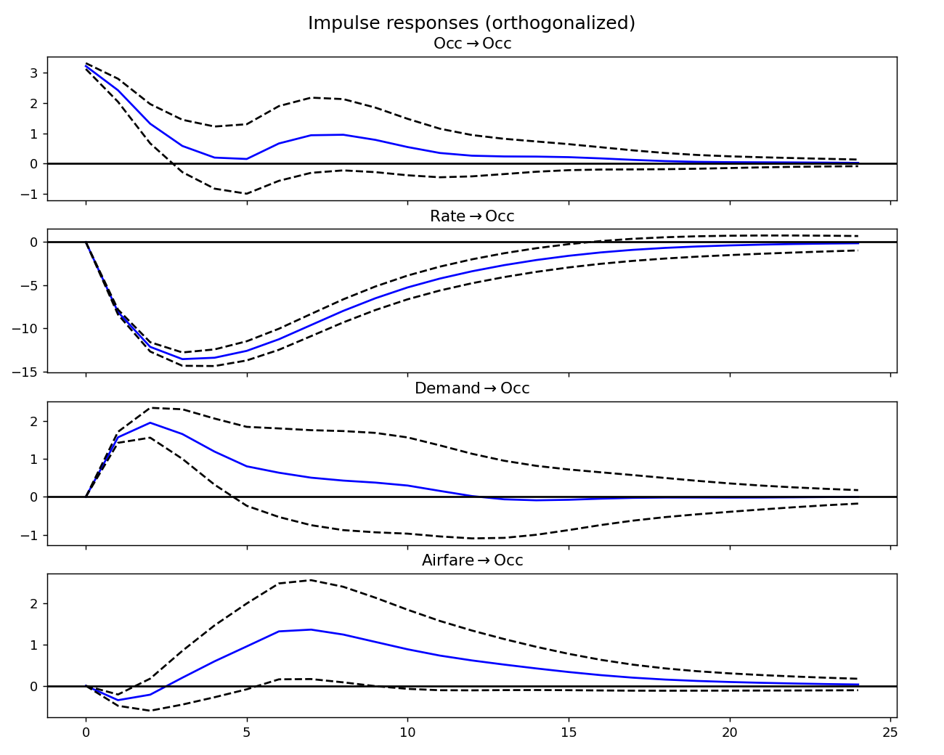
Figure 2. Response of Occupancy to one-standard-deviation shocks in each variable, with 95% CI. A Rate shock produces a large, persistent, statistically significant fall in Occupancy (bottoms out around day 5, fades by ~day 15). A Demand shock produces a smaller but genuine rise in Occupancy, fading within ~10 days. A Airfare shock is small, briefly runs positive, and its confidence band crosses zero by day ~8 — not distinguishable from noise beyond the very short run.
6.1 Tracing Demand, Occupancy and Airfare shocks through the whole system

The brief asks specifically how a Tourist-Demand shock, an Occupancy shock and an Airfare shock each propagate to every other variable — not just their effect on Occupancy. Figure 2a is the full impulse-response grid: columns are the shock (impulse), rows are what responds.
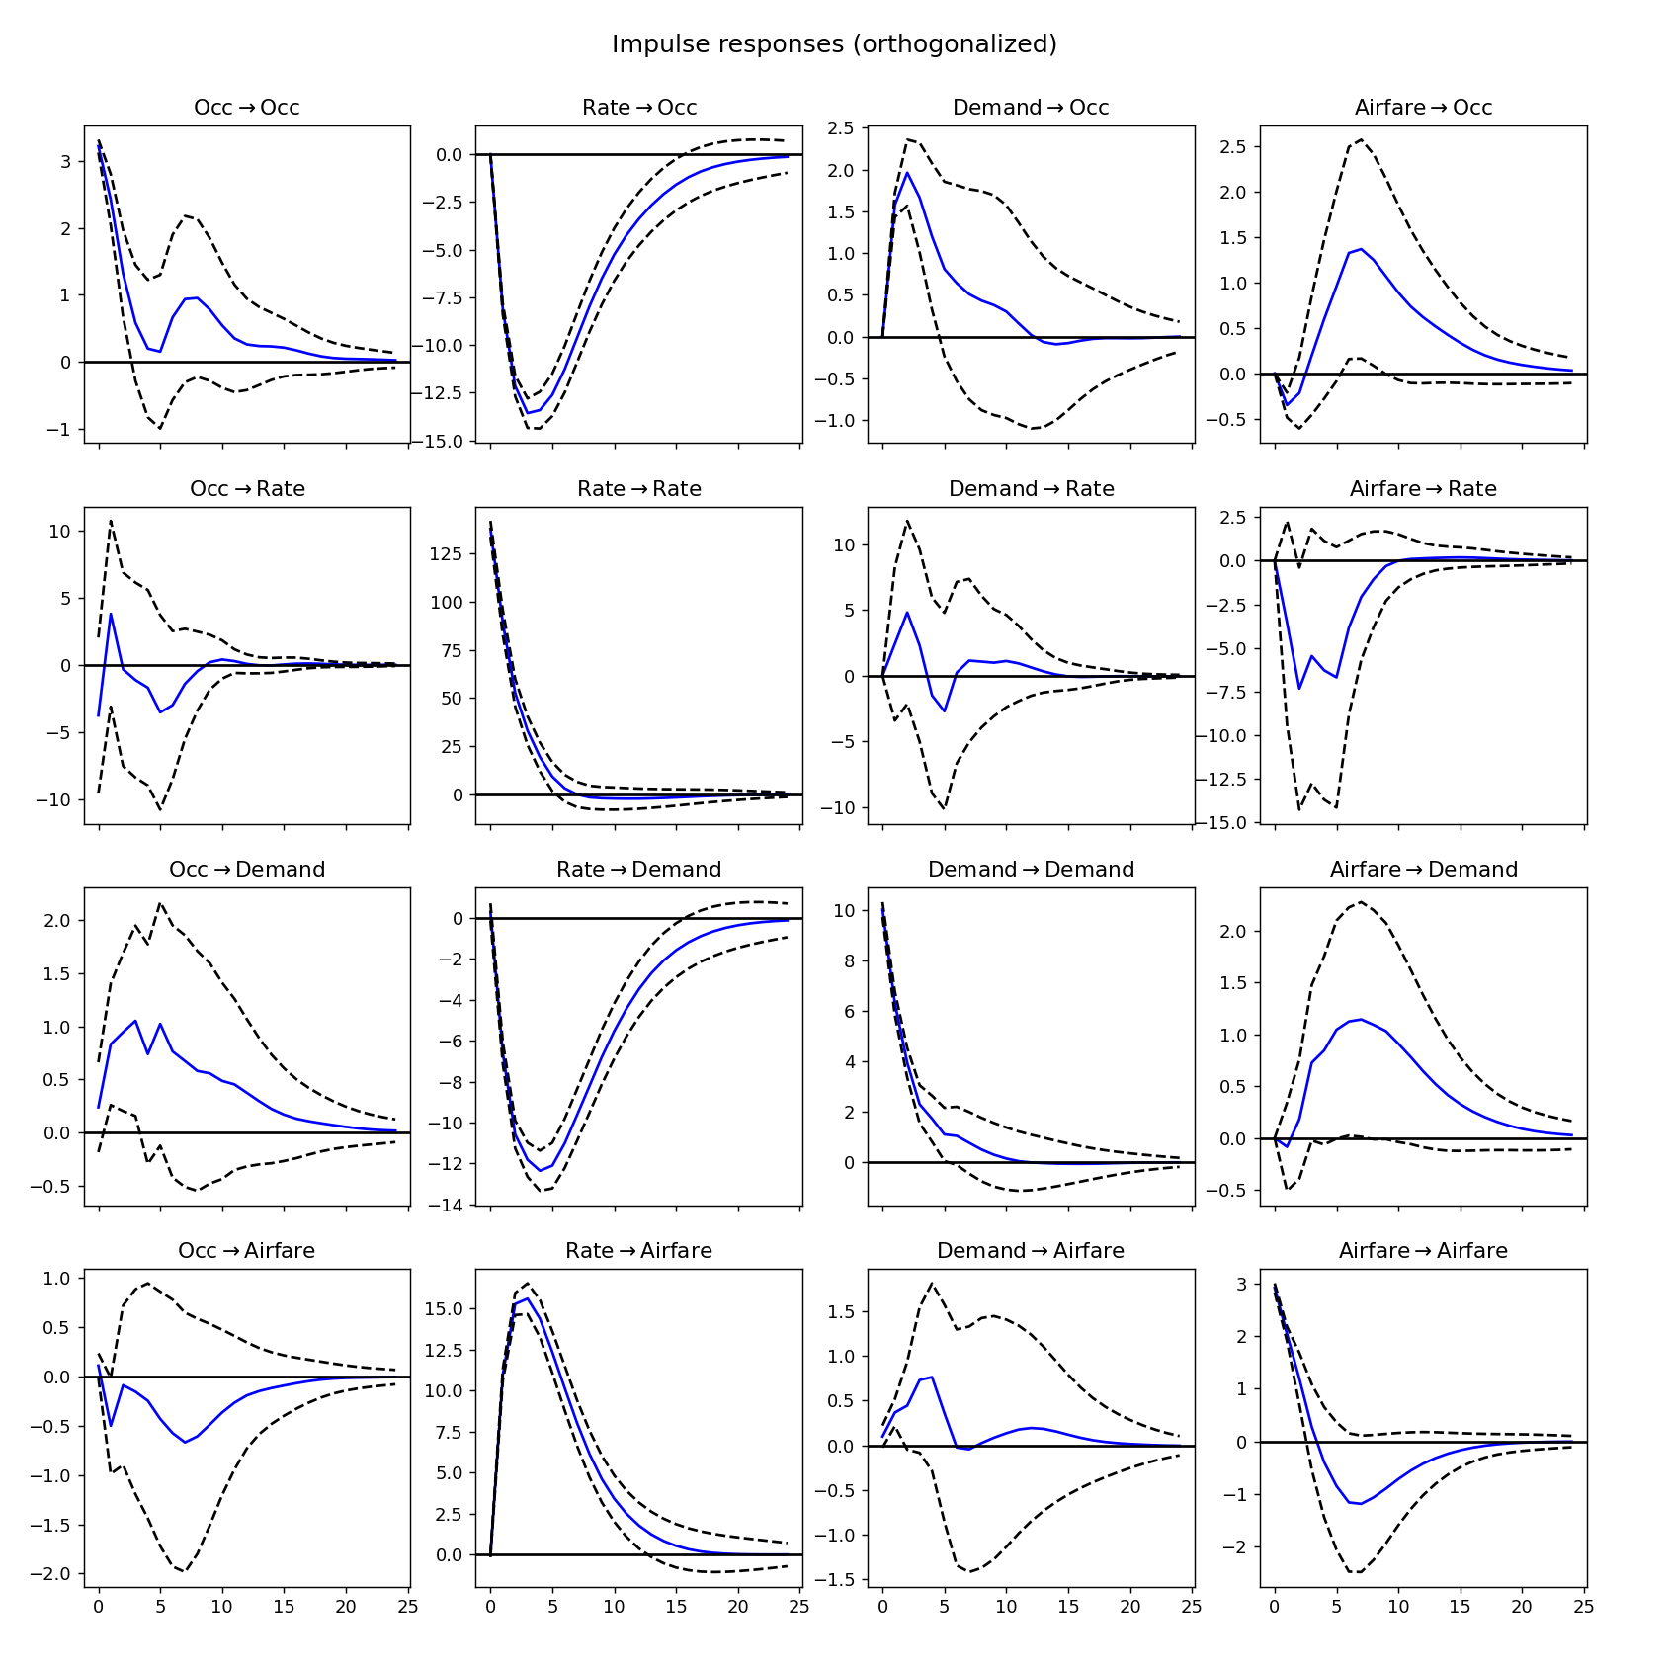
Figure 2a. Full system impulse responses, 95% CI, 24-day horizon. Columns = shock origin, rows = variable responding.
- Demand shock (3rd column): raises Occupancy (positive, ~10-day decay — the genuine secondary channel from Section 5); its effect on Rate and Airfare is a transient hump whose confidence band crosses zero for most of the horizon — consistent with the Granger tests, which found Demand does not significantly predict Rate (p = 0.741) or Airfare (p = 0.845).
- Occupancy shock (1st column): dies out on its own axis within ~10 days (Section 4.1's residual-autocorrelation caveat applies here); its spillover to Rate, Demand and Airfare is small and the CI bands straddle zero throughout — Occupancy is a receiver of shocks in this system, not a source. This matches Table 4: nothing Occupancy does Granger-causes Rate.
- Airfare shock (4th column): produces a short-lived, sign-ambiguous bump in Occupancy and Demand (CI crosses zero within a week in both cases) and a larger, longer transient dip in Rate that also loses significance by mid-horizon. Airfare shocks do not propagate through this system in a way a manager could reliably act on.
- For contrast, the Rate column (2nd) is the only one where every single response is large, one-signed and stays outside the CI band for 10+ days — visual confirmation of the FEVD result in Section 7: Rate is the shock that actually moves the system.

7. Forecast Error Variance Decomposition

Horizon (days) | Own shock | Room Rate | Tourist Demand | Airfare
1 | 100.0% | 0.0% | 0.0% | 0.0%
5 | 3.0% | 95.1% | 1.7% | 0.1%
10 | 1.9% | 96.3% | 1.1% | 0.7%
24 | 1.9% | 96.2% | 1.0% | 0.9%
Table 5. FEVD of Occupancy Index by horizon. Own-shock share collapses from 100% to under 2% within a week; Room Rate absorbs essentially all of the rest.
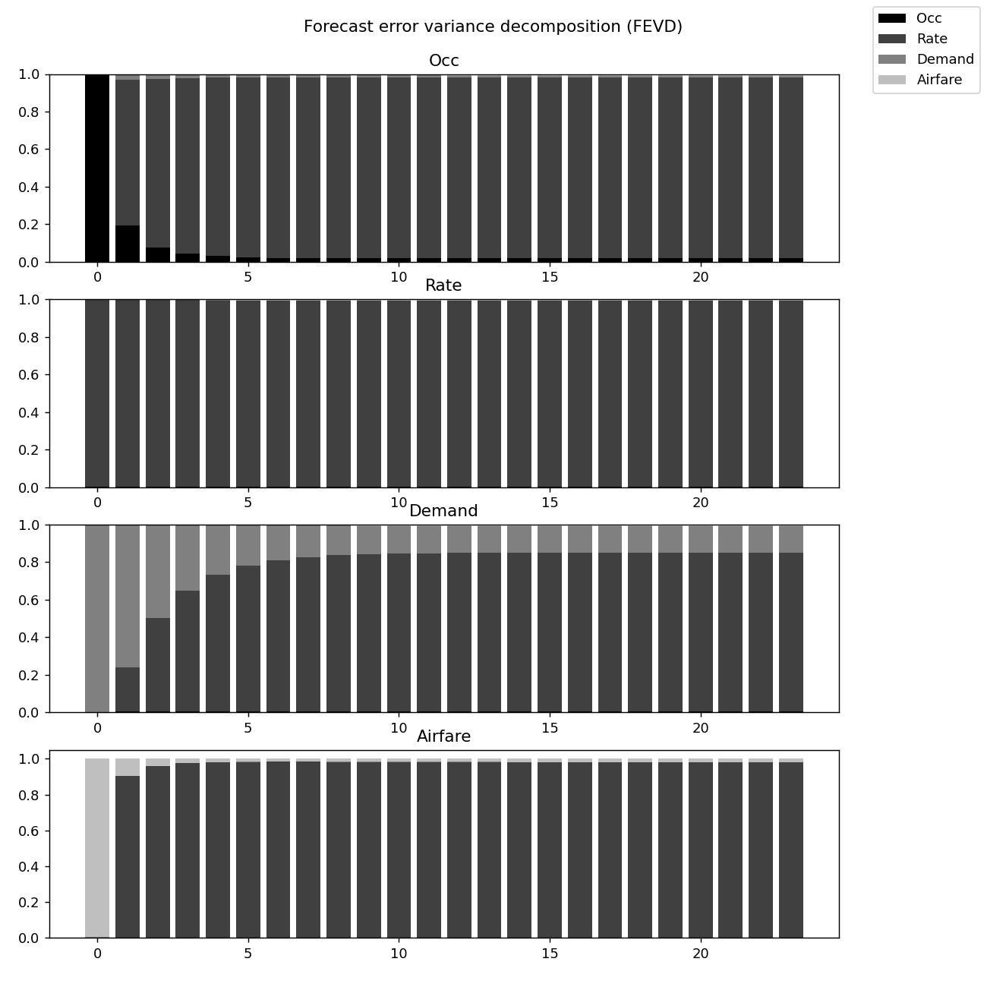
Figure 3. FEVD, all four equations, 24-day horizon. Note the Rate panel (row 2): Room Rate is driven almost entirely by its own shocks and is not meaningfully explained by any other variable in the system — the mirror image of the Occupancy panel.
8. 10-Day-Ahead Forecast (Point Estimates)

Day | Occupancy | Room Rate | Tourist Demand | Airfare
+1 | -1,020.8 | 2,895.8 | -896.9 | 1,077.9
+2 | -1,009.3 | 2,959.3 | -885.5 | 1,065.6
+3 | -1,002.4 | 2,994.0 | -881.3 | 1,062.1
+5 | -997.7 | 3,036.4 | -872.9 | 1,064.7
+7 | -999.9 | 3,044.6 | -873.2 | 1,068.7
+10 | -1,001.7 | 3,046.7 | -875.1 | 1,071.7
Table 6. Unconditional 10-day forecast from the VAR(6), point estimates only. All four series revert toward their post-burn-in means within the horizon — consistent with the stationarity finding in Section 2.
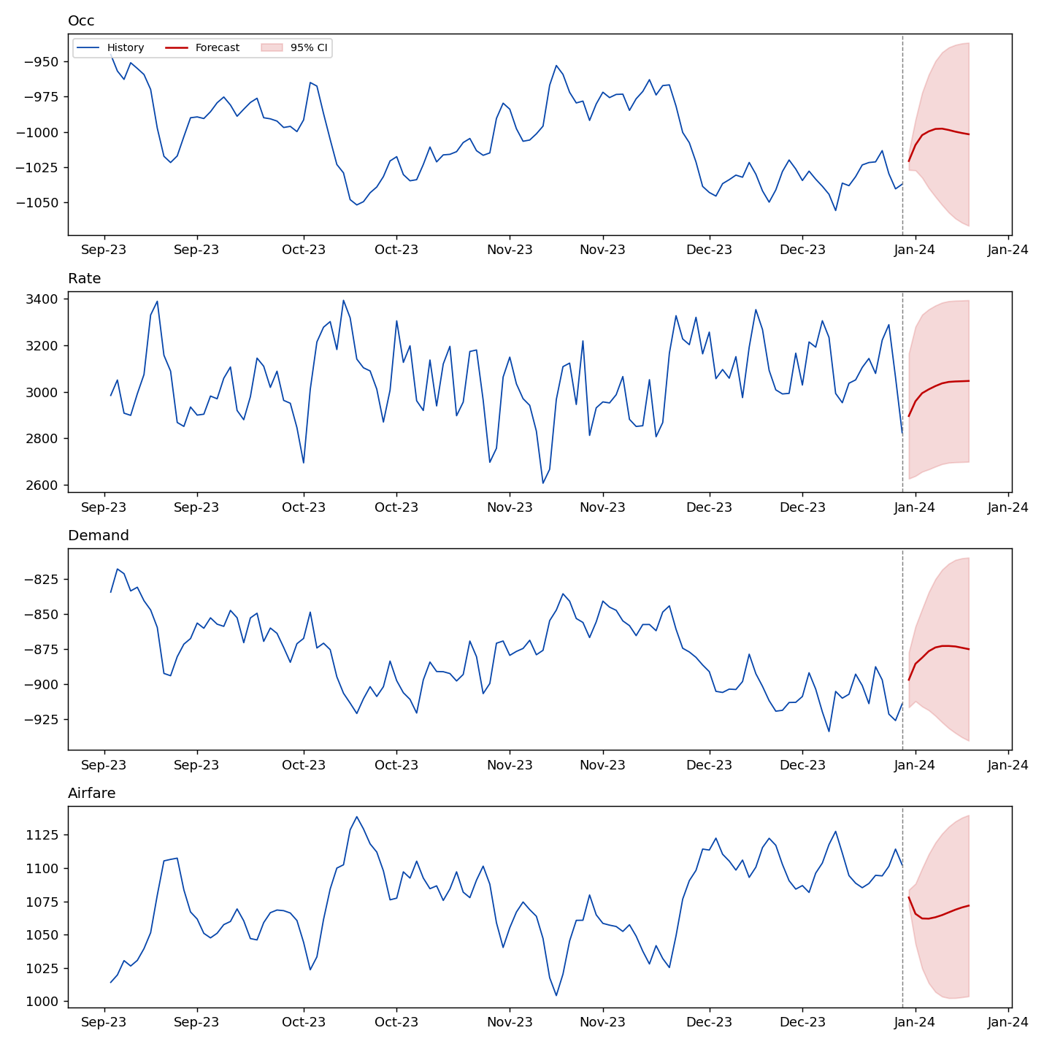
Figure 4. Last 120 days of history plus the 10-day forecast with 95% CI, all four series. Bands widen quickly — normal for a 10-step-ahead daily VAR forecast, not a diagnostic problem — and by day 10 all four series' point forecasts have reverted most of the way back to their post-burn-in means, again consistent with the stationarity result in Section 2.
9. Management Question, Answered
Which indicator should hotel managers monitor as the best early warning of occupancy changes?
Room Rate — not Tourist Demand, and not Airfare. It leads Occupancy with the largest Granger F-statistic in the table by two orders of magnitude, and it explains 96% of Occupancy's forecast-error variance beyond a one-week horizon. Tourist Demand is a real, statistically genuine second-order signal (worth tracking) but is quantitatively minor next to Rate. Airfare is not a reliable early-warning indicator here: it is statistically significant but economically small, and its direction of effect is not stable across the confidence band.

How quickly should room prices respond?

The Rate → Occupancy impulse response peaks in magnitude around day 4-5 and decays to statistical insignificance by roughly day 15 (Fig. 2). That is the effective window: a pricing change shows most of its occupancy impact within the first week and is fully worked through the system within two to three weeks. Reacting to occupancy dips with rate changes on a monthly review cycle is too slow — by the time a monthly cycle reacts, the shock that mattered has already fully propagated and faded. A 5–10 day review cadence matches the data-implied speed of the system.
Practical implication :

- Treat Room Rate as the lead control variable for occupancy management, not the lagging output of a demand forecast — the causal direction in this data runs price-first.
- Use Tourist Demand as a secondary, corroborating signal, not a primary trigger.
- Do not build an early-warning system around Airfare movements alone; the signal is too weak and too short-lived to act on in isolation.
- Re-run this analysis on real occupancy/rate/demand/airfare data before committing capital to a pricing-cadence change — see Section 10.

10. Limitations — Read Before Acting On This

- This is very likely a simulated/synthetic dataset (see Section 2.1: an out-of-range 'occupancy index' running to -1,000+, plus a textbook burn-in transient). The qualitative finding — rate leads occupancy, not the reverse — is real and internally consistent, but the specific magnitudes (96% FEVD share, F-statistics in the thousands) are almost certainly larger than anything you would see in real hotel-market data, where measurement noise and omitted variables are much larger. Treat this as a methodology demonstration with a genuine directional finding, not as a number to put in a business case.
- Granger causality ≡ predictive precedence, not proof of structural mechanism (Section 5). An omitted common driver (cost inputs, a pricing calendar, seasonality) could produce the same statistical pattern without Rate being the true structural cause.
- The Occupancy equation retains mild residual autocorrelation (Table 3) — confidence intervals for Occupancy responses are a lower bound on true uncertainty.
- Only 4 variables are modelled. Any real hotel-revenue system also has seasonality, competitor pricing, and macro travel demand — all omitted here by the scope of the assignment.

11. Out-of-Sample Backtest — Does the Model Actually Forecast?

Section 8 showed a 10-day forecast with confidence bands, but a forecast that only fits history known in advance is not evidence the model works. This section holds out the last 10 days, re-fits VAR(6) on everything before that (lag re-selected on the training data only, not the full sample), forecasts forward, and checks the result against what actually happened — benchmarked against a naive “tomorrow equals today” forecast, so the VAR has to beat a trivial baseline, not just exist.

11.1 Accuracy vs. a naive benchmark
Series | VAR(6) RMSE | Naive RMSE | VAR beats naive?
Occupancy | 16.38 | 27.88 | Yes — 41% lower error
Room Rate | 132.73 | 149.55 | Yes — 11% lower error
Tourist Demand | 23.35 | 11.90 | No — 96% higher error
Airfare | 19.18 | 31.50 | Yes — 39% lower error
Table 7. Root-mean-squared forecast error, VAR(6) vs. a naive random-walk benchmark, 10-day holdout. RMSE in index points; lower is better.
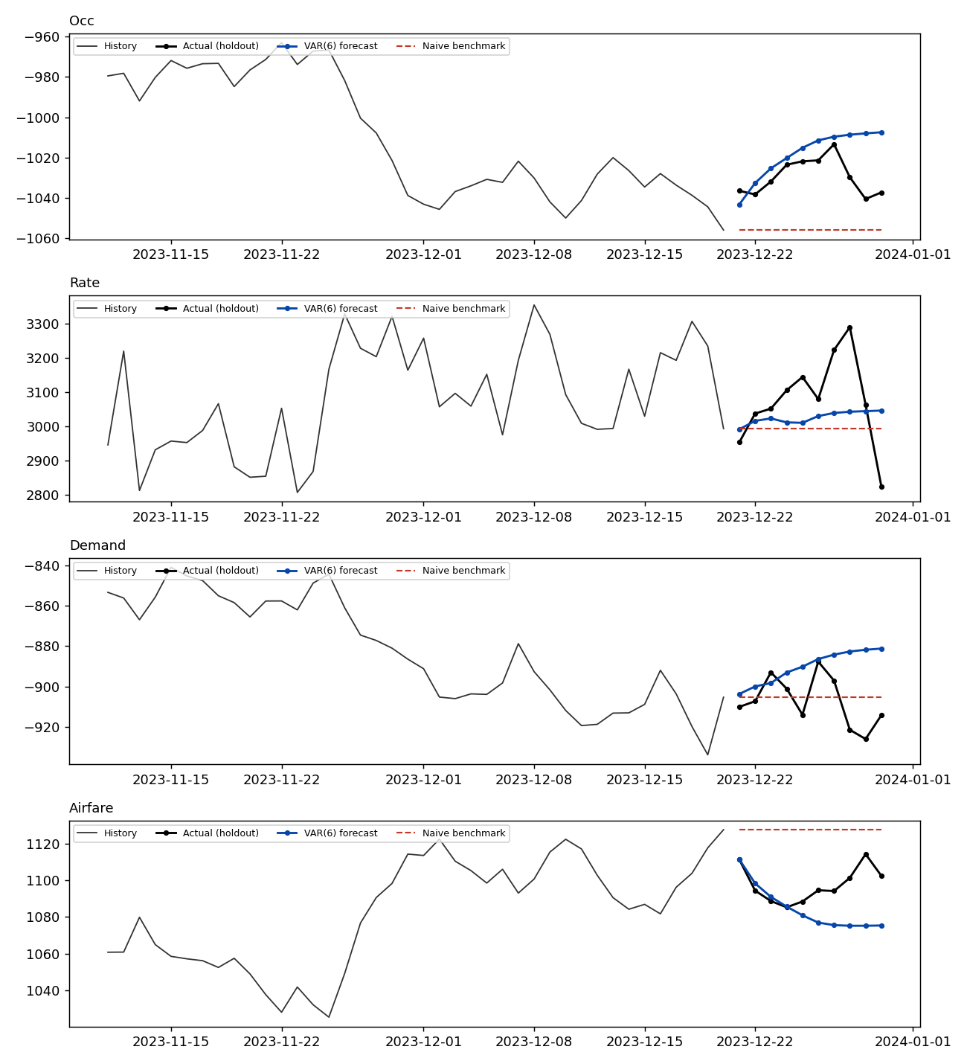
Figure 5. Actual vs. VAR(6) forecast vs. naive benchmark, 10-day holdout (last 40 training days shown for context).

11.2 Reading the result honestly

The model beats the naive benchmark on three of four series — Occupancy, Room Rate and Airfare all forecast measurably better than “tomorrow equals today.” That is a real, checkable result: the VAR is not just fitting noise, it captures dynamics a trivial baseline misses.
On Tourist Demand, it does not. The naive benchmark has 96% lower error over this particular 10-day window. Figure 5 shows why: actual Demand kept oscillating sharply through the holdout period, while the VAR forecast reverted smoothly toward the mean — correct on average, wrong on the specific path. A flat recent trend happened to make the naive forecast look better by luck of this particular window, not because Demand is inherently unforecastable; a different holdout period could reverse this. Either way, the honest statement is: this model should not be trusted for short-horizon Demand forecasts as configured, even though it is usable for Occupancy, Rate and Airfare.
This does not weaken the Section 5 finding that Rate Granger-causes the other three series — that is a claim about lead-lag structure across the full sample, tested with in-sample F-tests. This section is a claim about forecast accuracy on unseen data. The two can and do point in different directions for the same variable, and reporting both is what makes the model's claims checkable rather than asserted.

11.3 What these changes about Section 8

Treat the 10-day point forecast in Section 8 as indicative for Occupancy, Rate and Airfare, where the model has demonstrated skill over a naive baseline.
Do not use this VAR's Demand forecast in isolation for any operational decision — it underperformed a trivial baseline on the one holdout window tested here.
Before any real deployment, repeat this backtest on multiple holdout windows (rolling-origin backtesting), not just the last 10 days — a single window is a sanity check, not proof of generalization.

