React JS– PL2- Social Connect
Case Study

Contents

1.Project Information 3
2.Project Description 3
3. High-Level Requirements 4
Environment Setup 6
4. Getting the Template Source Code 6
5. Requirements 9
5.1 Creating a Header 9
5.2 User Details with Bio 10
5.3 Creating a Cover Page 13
5.4 Add Post 16
5.5 Create a Feed Area 19
5.6 Friends List 21
5.7 Add User (Friends) 24
6. Instructions to zip the completed code 26

1.Project Information

Skill | React JS
Proficiency | Level 2
Duration | 12 Hours
Version | 1

2.Project Description

In the bustling city of Techville, a team of talented developers and designers have come together with a grand vision. Their mission is to create a revolutionary social media platform called "SocialConnect" that will bridge the gap between people and foster meaningful connections in the digital world.

The concept behind SocialConnect is to provide users with a user-friendly and intuitive interface that combines the best aspects of popular social media platforms. It aims to offer a comprehensive solution for users to connect, share, and engage with others in a secure and inclusive environment.

The story of SocialConnect unfolds in the lives of three individuals: Emma, a passionate photographer eager to showcase her work; Ryan, an aspiring musician seeking a platform to share his music; and Lisa, a travel enthusiast eager to connect with like-minded adventurers.

As the project kicks off, the team starts by creating the landing page, the heart of the application, where users can find all the latest updates and engage with a vibrant community. The landing page features a meticulously designed feed area, displaying posts from friends, trending topics, and personalized recommendations. The team emphasizes the importance of componentizing the feed area to ensure seamless scalability and optimize user experience.

Driven by the desire to create a cohesive and user-centric experience, the team delves into the creation of modules and components for each specific functionality. They meticulously design and implement the user profile page, where Emma, Ryan, and Lisa can showcase their unique identities and connect with others who share their passions.

To enhance the user experience, the team integrates Redux with thunk middleware to manage the application's state and handle asynchronous actions seamlessly. The power of Redux allows them to efficiently handle user authentication, manage friends lists, and ensure a smooth data flow across the application.

With an unwavering commitment to performance and efficiency, the team leverages Axios as the API client, encapsulating all the API calls within dedicated components. This approach ensures separation of concerns and promotes clean, maintainable code.

As the project progresses, the team introduces exciting features, such as the ability to add posts with captivating messages and stunning images. They implement features like likes and comments to encourage engagement and interaction within the SocialConnect community. Attention to detail is paramount, with proper input validation, error handling, and seamless navigation between different views.

Throughout the development process, the team focuses on creating a delightful user experience by adhering to the principles of responsive design. They meticulously craft the layout and styling of each component, paying attention to the smallest details, while maintaining consistency and aesthetic appeal.

In the final phase, rigorous testing is conducted to ensure the application's reliability and stability. The team adopts industry-standard testing practices, including unit tests and snapshot testing, to identify and fix any issues early in the development cycle. This guarantees that SocialConnect delivers a seamless and secure user experience.

As the SocialConnect project nears completion, the team reflects on the impact their creation could have on the lives of millions. They eagerly anticipate the moment when Emma can share her breathtaking photographs, Ryan can captivate listeners with his music, and Lisa can embark on thrilling adventures with newfound friends.

SocialConnect: Uniting the Digital World is more than just a social media platform; it's a catalyst for genuine connections, creative expression, and limitless possibilities. The team is excited to unleash SocialConnect into the world, knowing that it has the potential to redefine the way people connect and engage in the digital realm.

3. High-Level Requirements

R# | Business Requirement | Time Required
1 | Creating a Header | 15 Minutes
2 | User Detail with Bio | 2 Hours 30 Minutes
3 | Creating a Cover Page | 1 Hour 30 Minutes
4 | Add Post | 1 Hour 30 Minutes
5 | Create a Feed Area | 3 Hours 30 Minutes
6 | Friends List | 1 Hour 30 Minutes
7 | Add Users (friends) Page | 1 Hour 15 Minutes

Important Information to the associates
- The landing page of the social media application should be divided into separate components, including the feed area, user bio, and user details. These components should be organized within the home component, ensuring a clear and intuitive user interface.
- Implement Redux with thunk middleware to manage the application's state. Create separate reducers for various modules and actions, ensuring a modular and maintainable code structure.
- Set up an Axios client to handle API calls, and create separate components dedicated to handling API interactions. This separation of concerns helps to keep the API calls isolated from the general components of the application.
- Utilize Redux actions to handle API calls and connect all components to the Redux store. This allows for efficient data flow and ensures that the components are synchronized with the application's state values.
- Implement a feature to add feeds for users based on their unique user IDs. Store the feeds separately and map them to the corresponding users, ensuring accurate and personalized content delivery.
- Enable the functionality to add new users and manage the data flow across all components using Redux. This ensures a consistent and centralized approach to data management throughout the application.

Environment Setup

Software Required
- React v18
- Visual Studio Code (latest version)
- Chrome or Edge browser (latest version)

JSON Server Setup
- Using JSON Server, we can quickly start REST API service on our desktop.
- JSON Server is a npm package.
- In the root folder of the provided source code, there is a ‘db.json’ file will be there, which is working as a database.
- Open a new terminal window in Visual Studio Code and start the JSON Server by running the below command in a terminal window:
“ json-server --watch db.json --port 4000”.
This command will start the back-end service.
- After starting the server, we can see the message “Server is running on port 4000” in the terminal.
- There are two API end-points available for you to consume, which are
  - http://localhost:4000/users
  - http://localhost:4000/posts

React app setup
- Open a new terminal window in Visual Studio Code and run npm install command to get the dependencies for the React project.
- Run the React application by entering the command npm start
- The React application will be launched it in the browser using the link http://localhost:3000/
- It should display the below screen layout.

4. Getting the Template Source Code
- The coding should be done based on a template source code provided for this case study.
- This will help to quickly get started with a case study, as some features of coding will be already implemented.
- Find below the code template embedded:

/*** You can also download the skeleton code from portal ***/

- Once the source code is available, open the root folder ‘social-connect in Visual Studio Code.
- When you run the template Source Code, you will see the following screen.



The User Interface after successfully completed the Project.

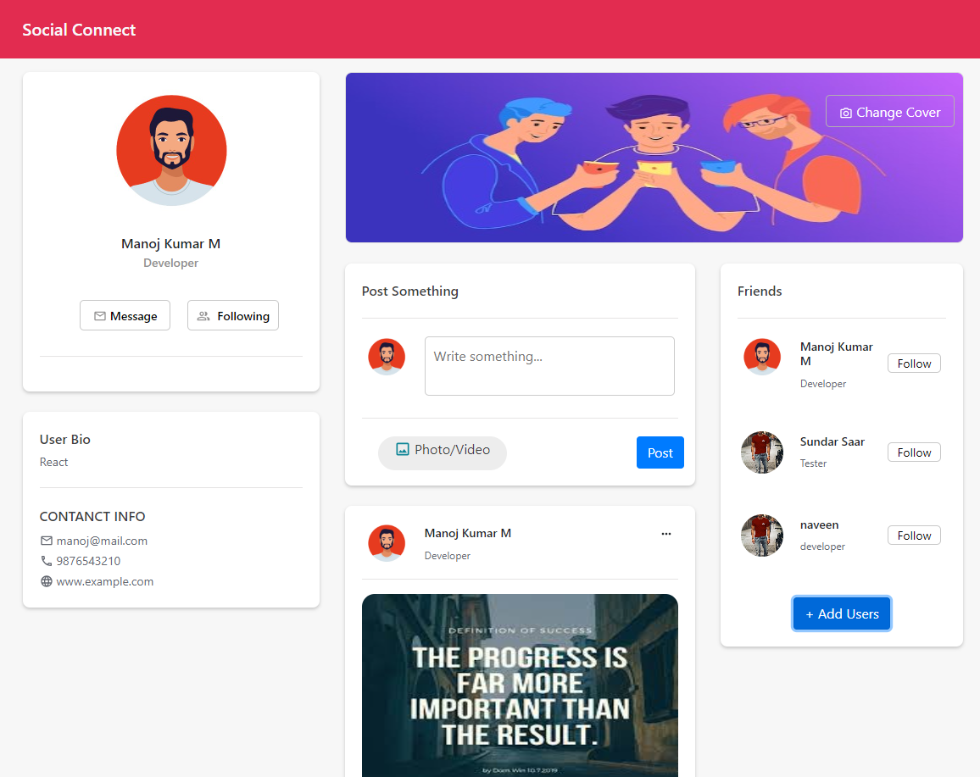
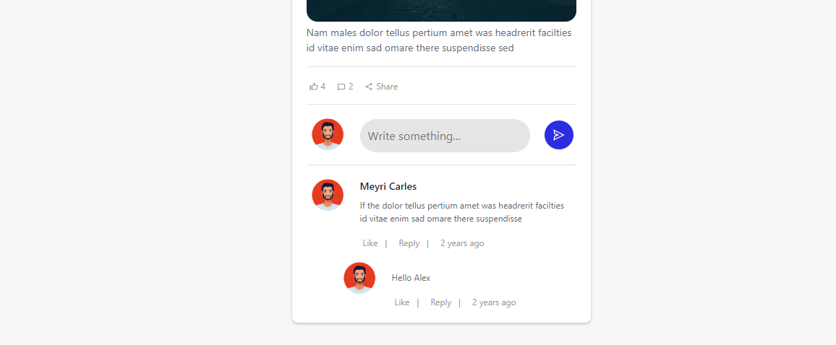

5. Requirements

5.1 Creating a Header

Requirement | The header component plays a crucial role in providing consistent navigation and branding across the Social Connect application. It serves as the primary point of interaction for users to access various sections of the application and should be designed to enhance the overall user experience
Design Consideration | Branding: The header should prominently display the Social Connect logo to reinforce the application's identity and branding.  Responsiveness: The header should be responsive and adapt to different screen sizes and devices, ensuring a seamless experience for users on desktop and mobile devices.
Business Rules and Process | Text Display: The header should display the Social Connect logo prominently, ensuring it is easily identifiable and consistent across all pages.  Active Page Highlight: The header should visually indicate the active page or section to provide users with clear feedback on their current location within the application.
Skills and Features (Technical competencies validated ) | Apply and build the application using the core React concepts.  Apply state management concepts and build the application.  Write the functional react components using hooks  Debug the issues, while developing.  Use essential coding and performance standard  Effectively apply and use any one CSS framework  Apply essential reusable skills while writing the cod  Use the story book for developing reusable components.
Time Required | 15 Minutes

User Interface:

5. 2 User Details with Bio

Requirement | The user detail page and user bio page are essential components in the Social Connect application, providing users with a comprehensive view of a user's details and biography. These pages need to be designed and implemented in a way that effectively presents the user information and bio, while leveraging Redux for data management.
Design Consideration | User Profile Page:  Visual Layout: Design a visually appealing layout that showcases the user's profile picture, name, username, and relevant details.  User Information: Display key user information, such as age, location, interests, and any other pertinent details.  UI Components: Utilize appropriate UI components to present the user details, such as cards, sections, or tabs for organizing different aspects of the user's information.  User Bio Page:  Bio Content: Provide a designated section for the user's biography, allowing them to describe themselves, their interests, or any other relevant information.  Formatting and Styling: Design the bio page with proper formatting and styling, such as paragraph breaks, bullet points, or emphasis on important details.  Readability: Ensure the bio content is presented in a readable format, avoiding clutter and excessive text.
Business Rules and Process | Data Retrieval via Redux:  Connect the userProfile component and aboutUser component to Redux, enabling them to retrieve user-related data from the application state.  Implement Redux actions and reducers to fetch and manage the user details and bio data.  Data Rendering:  Once the user data is retrieved from Redux, dynamically render the user's profile details and bio content on their respective pages.  Ensure that the data rendering is efficient and updates in real-time if any changes occur to the user's details or bio.  User Privacy:  Implement appropriate privacy settings to control the visibility of user details and bio content based on the user's preferences.  Allow users to update their privacy settings and determine who can view their profile information and bio.  Edit and Update:  Provide functionality to edit and update the user's details and bio content, allowing them to make changes and save the modifications to Redux.  Implement proper validation to ensure that the entered data meets the required criteria and maintain data integrity.
Skills and Features (Technical competencies validated) | - Apply and build the application using the core React concepts.  - Apply state management concepts and build the application.  - Debug the issues, while developing.  - Use essential coding and performance standard  - Effectively apply and use any one CSS framework  - Apply essential reusable skills while writing the cod
Time Required | 2 Hours 30 Minutes

Expected User Interface:
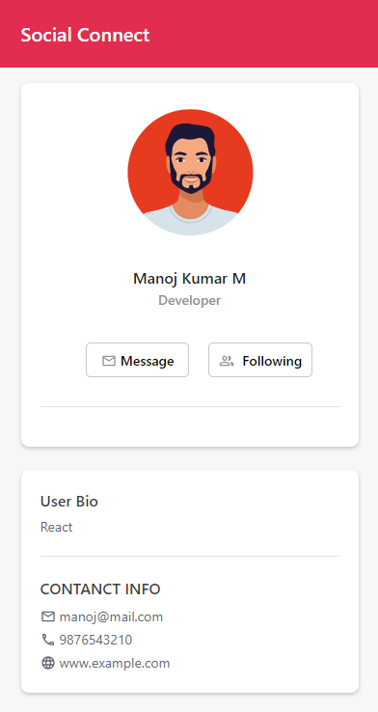

5.3 Creating a Cover Page

Requirement | The cover page is an essential component of the Social Connect application, providing users with the ability to personalize their profiles by setting a cover photo. This requirement involves designing and implementing the cover page, ensuring dynamic functionality to allow users to upload and set their cover photo.
Design Consideration | Cover Page Layout:  Visual Appeal: Design an attractive and visually appealing cover page layout that complements the overall aesthetic of the application.  Integration with User Profile: Ensure that the cover photo seamlessly integrates with the user's profile page, providing a cohesive user experience.  Differentiate Banner and Avatar: Create separate sections or folders to store the cover photo (banner) and user's profile picture (avatar) for easy management.  Dynamic Cover Photo:  User Upload: Allow users to upload their own cover photo from their local device or select from pre-defined options.  File Management: Store the cover photo images in the application's asset folder and create a separate folder to manage and retrieve the cover photos for each user.  Dynamic Rendering: Retrieve and display the user's cover photo dynamically on their profile page, ensuring it reflects the most recent selection or upload.
Business Rules and Process | File Management and Storage:  Implement a server-side component to handle file uploads and manage the storage of cover photos.  Establish a standardized naming convention or unique identifier for each cover photo to ensure easy retrieval and association with the user.  User Interaction:  Provide a user-friendly interface for selecting or uploading a cover photo, allowing users to preview and confirm their selection.  Validate uploaded images to ensure they meet the specified requirements (e.g., file format, size limitations).  Database Integration:  Save the dynamic picture path or unique identifier associated with the user's cover photo in the server's database.  Retrieve the cover photo path from the database when rendering the user's profile page, ensuring the correct cover photo is displayed.  Privacy and Security:  Apply necessary security measures to protect user-uploaded cover photos from unauthorized access or misuse.  Ensure compliance with privacy regulations and guidelines related to user-generated content.
Skills and Features (Technical competencies validated) | - Apply and build the application using the core React concepts.  - Apply state management concepts and build the application.  - Debug the issues, while developing.  - Use essential coding and performance standard  - Effectively apply and use any one CSS framework  - Apply essential reusable skills while writing the cod  - Use the story book for developing reusable components.
Time Required | 1 Hour 30 Minutes

Expected User Interface:

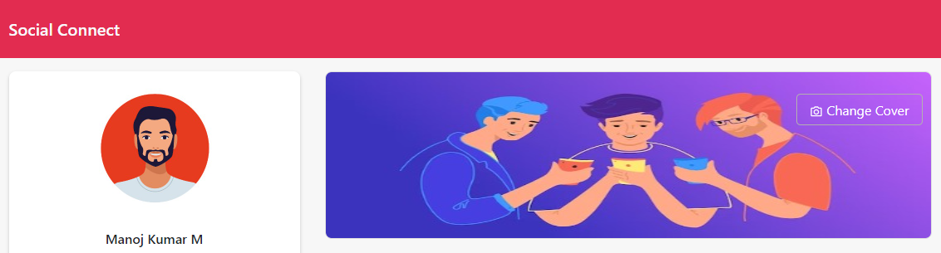



5.4 Add Post

Requirement | The "Add Post" feature is a fundamental aspect of the Social Connect application, enabling users to share their thoughts, experiences, and media content with others. This requirement focuses on designing and implementing a page where users can compose a post by entering a message and optionally attaching an image from the application's assets. The post should be stored and associated with the user who created it.
Design Consideration | Post Composition:  Message Box: Design a user-friendly message box where users can enter their post content, including text, emojis, and other rich media.  Image Attachment: Provide a mechanism for users to select and attach an image from the application's asset folder to their post.  User Interface:  Clear and Intuitive Design: Create a visually appealing and intuitive user interface that guides users through the post creation process.  Responsive Layout: Ensure the page layout is responsive and adaptable to different screen sizes and devices for a consistent user experience.  Image Handling:  Asset Mapping: Establish a mapping between image paths in the application's assets and the corresponding images stored on the server.  Upload and Storage: Implement a mechanism to upload and store the attached images on the server, associating them with the user's post.
Business Rules and Process | Post Creation:  Message Validation: Validate the user's post message to ensure it meets the specified requirements (e.g., character limit, profanity filter).  Image Upload: Allow users to select an image from the application's asset folder and upload it to the server.  Data Association: Associate the created post with the user who authored it, ensuring proper attribution and visibility.  Data Persistence:  Store Post Content: Save the post message, image path, and associated user details in the server's database for future retrieval.  Maintain Data Integrity: Implement appropriate data validation and error handling to ensure the reliability and accuracy of stored post data.  Rendering and Display:  Retrieve Post Data: Retrieve the relevant post information, including the message and associated image path, from the server's database.  Display User Posts: Render the user's posts on the appropriate sections of the application, providing a visually appealing and user-friendly presentation.
Skills and Features (Technical competencies validated) | - Apply and build the application using the core React concepts.  - Apply state management concepts and build the application.  - Debug the issues, while developing.  - Use essential coding and performance standard  - Effectively apply and use any one CSS framework  - Apply essential reusable skills while writing the cod  - Use the story book for developing reusable components.
Time Required | 1 Hour 30 Minutes

Expected User interface:

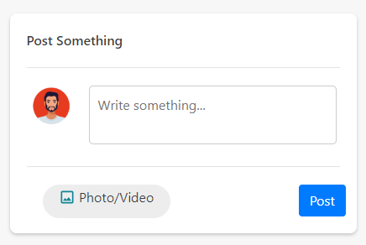

5.5 Create a Feed Area

Requirement | The "Feed" feature is a crucial aspect of the Social Connect application, providing users with a centralized area where they can view and interact with posts from other users. This requirement focuses on designing and implementing a feed area that displays all the posts shared by users. Additionally, users should be able to like posts and reply to comments, fostering engagement and interactivity within the application.
Design Consideration | Feed Display:  User-Friendly Layout: Design a visually appealing and user-friendly layout to present the posts in the feed area.  Post Content: Ensure that the post content, including the message, author, timestamp, and any attached images, is properly displayed and easily readable.  Pagination: Consider implementing pagination or infinite scrolling to manage large volumes of posts efficiently.  Commenting and Replies:  Comment Section: Include a comment section beneath each post where users can leave comments and engage in discussions.  Reply Functionality: Allow users to reply to specific comments within a post, fostering threaded conversations.  Comment Count: Display the total number of comments on a post to provide a sense of engagement and activity.
Business Rules and Process | Feed Population:  Retrieve Post Data: Fetch post data from the server, ensuring that user details and post information are stored and maintained separately.  Display Order: Determine the order in which posts are displayed, such as sorting by the most recent or applying any relevant algorithms for personalized content.  Commenting and Replies:  Comment Creation: Enable users to create comments on posts, associating them with the respective post and user details.  Reply Handling: Implement a threaded comment system that allows users to reply to specific comments, ensuring the replies are nested and organized.  Data Flow:  Redux Integration: Utilize Redux to manage the state of the feed area, ensuring that user details and post data flow through the appropriate Redux actions and reducers.  Data Synchronization: Ensure that any updates or changes made to posts, likes, and comments are synchronized and reflected across all relevant components.  User Engagement:  Real-time Updates: Implement mechanisms for real-time updates, such as WebSocket or push notifications, to notify users of new posts, likes, and comments.  User Notifications: Notify users of any activity related to their posts, likes, or comments, ensuring they stay engaged with the application.
Skills and Features (Technical competencies validated) | - Apply and build the application using the core React concepts.  - Apply state management concepts and build the application.  - Debug the issues, while developing.  - Use essential coding and performance standard  - Effectively apply and use any one CSS framework  - Apply essential reusable skills while writing the cod  - Use the story book for developing reusable components.
Time Required | 3 Hours 30 Minutes

Expected User interface.

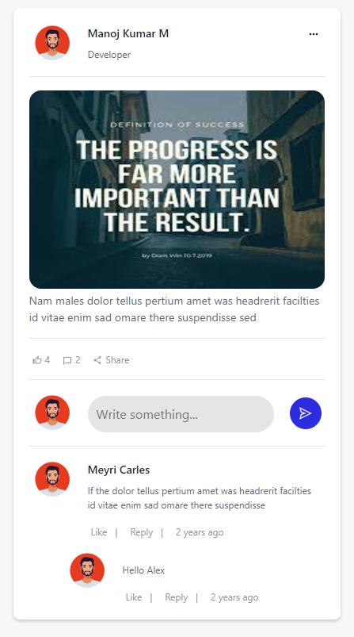

5.6 Friends List

Requirement | In the Social Connect application, users can establish connections and add friends to their network. This requirement focuses on implementing a feature where users can view a list of their friends and seamlessly switch between different user accounts.
Business Rules and Process | Friend List Display:  User-Friendly Layout: Design an intuitive and visually appealing interface to display the user's list of friends.  Friend Details: Include relevant information about each friend, such as their profile picture, name, and any additional details that promote recognition and interaction.
Skills and Features (Technical competencies validated) | - Write the functional react components using hook  - Debug the issues, while developing  - Use essential coding and performance standards.  - Effectively apply and use any one CSS framework  - Use essential rapid prototyping of reusable components for building reusable components (Example: Story Book).
Hours Required | 1 Hour 30 Minutes

Expected User Interface
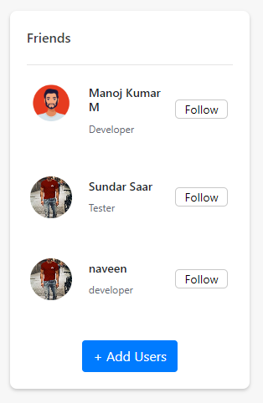

5.7 Add User (Friends)

Requirement | In the Social Connect application, users can add new friends to expand their network. This requirement focuses on providing a feature where users can add a new user with basic information and have them listed in the friends list displayed on the right side of the application. The goal is to facilitate easy user connections and provide a seamless experience for adding new friends.
Design Consideration | Add User Modal Popup:  User-Friendly Interface: Design a modal popup that allows users to enter basic information about the new user they want to add.  Form Fields: Include relevant fields for capturing the basic information, such as name, profile picture, email, and any other necessary details.  Validation: Implement validation for the form fields to ensure the entered information is valid and complete.  Submit Button: Provide a button to submit the user's information and add them to the friends list.  Friends List Update:  Real-Time Update: Ensure that the friends list is updated in real time when a new user is added, providing immediate visibility to the newly added friend.  Append New User: Upon submitting the user's information, append the new user to the existing friends list, displaying their basic information in the appropriate format.
Business Rules and Process | User Input:  Capture User Information: Prompt the user to enter the basic information of the user they want to add, such as name, profile picture, and email.  Validation: Validate the entered information to ensure it meets the required criteria, such as proper email format or specific character limits.  Adding User:  Submit Data: Upon clicking the submit button, send the entered user information to the server or database for processing and storage.  Append to Friends List: Once the server confirms the successful addition of the new user, update the friends list by appending the new user's basic information to the existing list.  User Experience:  Modal Popup: Display the add user functionality within a modal popup to provide a focused and intuitive user experience.  Visual Feedback: Provide visual feedback to indicate the successful addition of the new user, ensuring the user is aware that the process has completed successfully.  Error Handling: Implement error handling mechanisms to handle any issues that may occur during the user addition process, such as network errors or duplicate entries.  Data Management:  Data Security: Implement appropriate security measures to protect user data during the user addition process, ensuring data privacy and compliance with data protection regulations.  Data Persistence: Store the user's basic information securely in the server or database for future reference and retrieval.
Skills and Features (Technical competencies validated) | - Apply and build the application using the core React concepts.  - Apply state management concepts and build the application.  - Debug the issues, while developing.  - Use essential coding and performance standard.  - Effectively apply and use any one CSS framework.  - Apply essential reusable skills while writing the code.  - Use the story book for developing reusable components.
Time Required | 1 Hour 15 Minutes

Expected User Interface:

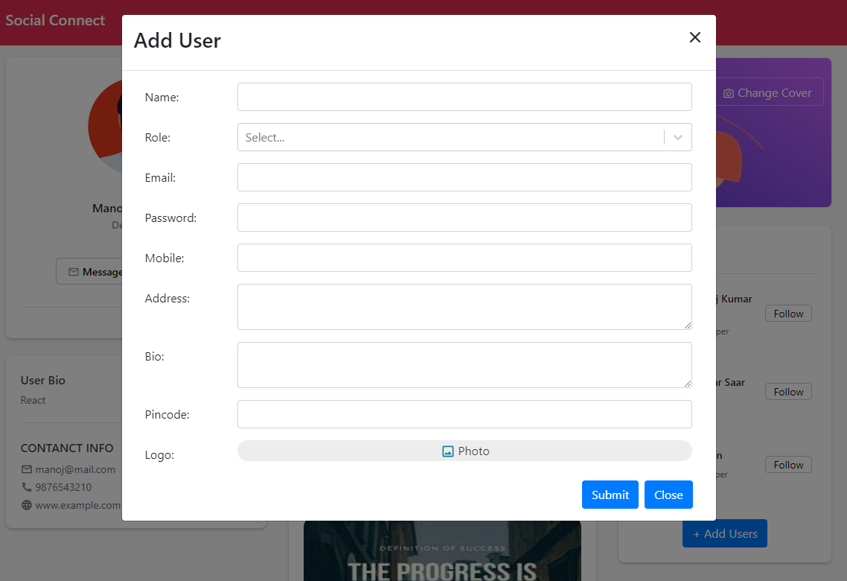

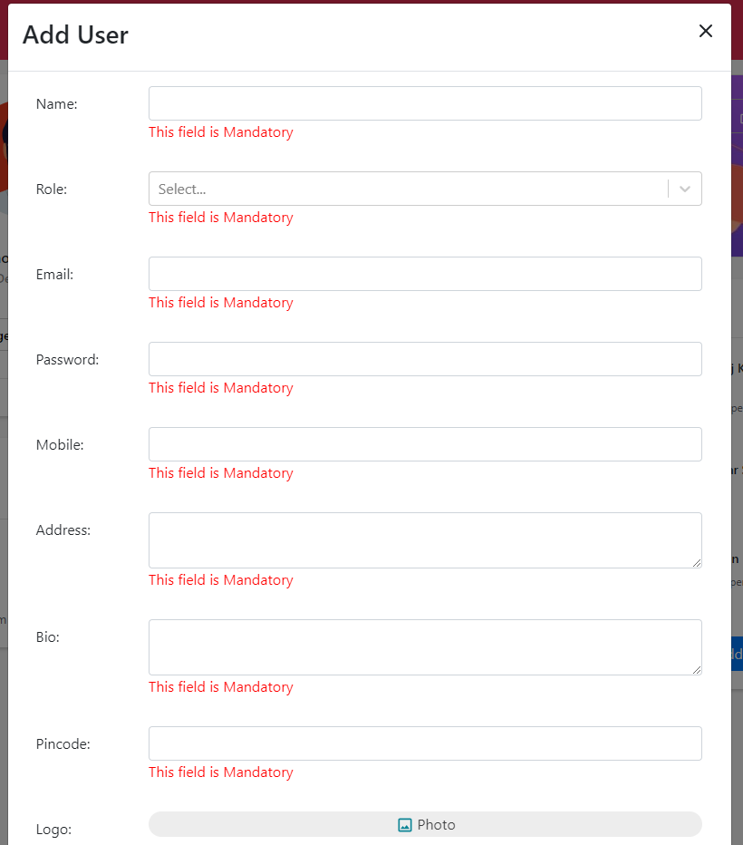

6. Instructions to zip the completed code

- Create a folder named ‘OTJ-React-PL2-Social-Connect-<associate-id>’.
- Go to the ‘Social-Connect’ folder where the completed code is available.
- Select and copy all the files and folders in ‘Social-Connect’ folder except ‘node_modules’.
- Paste the copied files and folders to the folder created in Step 1.
- Zip the ‘OTJ-React-PL2-Social-Connect-<associate-id>’ folder by right-clicking on the folder and selecting ‘Send To’ > ‘Compressed Folder’.
- The zip file name should have the folder name defined in Step 1.

