Junkin= ( I have partialy involved in it but, I have good knowledge of it)

APPLICATION ARCHITECTURE=
- 1 SINGLE TIER ARCHITECTURE =(Monolithic architecture)
- 2 TWO TIER ARCHITECTURE
- 3 THREE TIER ARCHITECTURE
- 4 N – TIER ARCHITECTURE
- 5 MICRO WEB SERVICE ARCHITECTURE

1 SINGLE TIER ARCHITECUTRE=
- IT IS USED TO DEVELOP STANDALONE APPLICATION. LIKE NOTE PAD , EXCEL.
- THE APPLICATION CANNOT BE SHARED ACROSS THE TEAM MEMBERS.
- AT A TIME ONLY 1 USER CAN USE WITHIN A SYSTEM.
NOTE = ALL REMAINING ARCHITECTRE IS USED TO DEVELOP WEB APPLICATION.

2 TWO TIER ARCHITECUTRE= ( INCLUDES BROWSER AND 1 SERVER )
- AXCESS WEB APPLICATION THROW BROWSER .
- DB IS ALSO INSTALLED INSIDE SERVER SO IT IS CALLED AS 2 TIER ARCHITECUTRE.
- 2 TIER ARCH WILL NOT SUPPORT MORE USERS.
database
Server
(app)
browser

3 THREE TIER ARCHITECUTRE=
- CLIENT , 1 SERVER , DATABSE COMPLETELY SEPARATED.
- TO SECURE THE DATA THEY GO FOR 3 TIER ARCHITECTURE.
- ENTIRE APPLICATION INSTALLED IN 1 SERVER.
- WHEN NUMBER OF USER DRASTICALLY INCREASE ( MILLIONS )THE SERVER IS NOT ABLE TO HANDLE THE REQUEST SERVER USED TO SHUTDOWN , SERVER USED TO CRASH MEANS APPLICATION IS USED TO GO DOWN .
- IT IS NOT FIT FOR NUMBER OF LOAD.
Client Browser
Server
Data base
app

4 N – TIER ARCHITECTURE=
- ENTIRE APPLICATION INSTALLED IN ALL THE SERVERS.
- IN N TIER ARCHITECTURE WE CAN HAVE MULTIPLE SERVERS AND LOAD BALANCE SERVER .
- 1 CLIENT , MULTIPLE SERVER AND LB SERVER , 1 DB IS CALLED AS N TIER ARCHITECHTURE.
- IT CAN HANDLE MORE LOAD.
- MILLIONS OF PEOPLE AXCESS THE APPLICATION LB SERVER IT IS GOING TO BALANCE THE LOAD BY SENDING REQUEST MULTIPLE SERVERS.
- INSTALLING ALL THE MODULES IN EVERY SERVER IS DISADVANTAGE.
- PERFORMANCE OF THE APPLICATION WILL BE DECREASED.

Data
base
app
app
Server - 2
Server 1

Load balancer server
Client Browser

Server-3
app

5 MICRO WEB SERVICE ARCHITECTURE=
- ENTIRE APPLICATION IS NOT INSTALLED IN 1 SERVER.
- ENTIRE APPLICATION IS BROKEN INTO SMALL PIECES OF SERVICES ,
- AND IT IS BEING INSTALLED IN MULTIPLE SERVERS.
- ALL THE SERVICES CUMMUNICATING EACH OTHER VIA MICRO WEB SERVICE
- LB SERVER LOAD THE BALANCE BASED ON FUCTIONALITY .
- IF NUMBER OF USERS INCREASE , INCREASE THE SERVERS.
Data
base
Browser

Server 3
Module2
(cart)
Server 2
Module1
(create
Contact)
Server 1
Load balancer

Server 4
Module3
(billing )

-
- JUNKINS IS GOING TO MAINTAIN ALL THIS MACHINES MAINTANED BY DEVOPS.
- WITHOUT CI / CD TOOL WE CANNOT DELIVER THE / GIVE THE APPLICATION SAME TIME
( ENGINEERS WORKING IN OTHER TIME ZONES)
- PARALLALY JUNKINS IS GOING TO DEPLOY THE APPLICATION ON ALL THE COUNTRY REGIONS( USA , EUROPE , ASIA ETC..,)

TOOLS AVAILABLE IN MARKET FOR CI / CD ARE=
- 1 JUNKINS , 2 MICROSOFT AZURE , 3 BAMBO
why junkin is called has ci/cd
- in testing , ci/cd with junkins means automatically building ,testing (execution automation scripts) and deploying code after every commit,
- so testers can quickly validate new features of fixes in each environment.
- after this explain executions and parameters , integrations.

CI / CD [ JUNKINS ]
- IN ORDER TO ACHIVE CI / CD PROCESS WE ARE GOING TO USE JUNKINS TOOL.
- JUNKINS IS A OPEN SOURCE TOOL .
- CI = CONTINUES INTEGRATION CD = CONTINUES DEPLOYEMENT.
- IN AGILE PROCESS ENTIRE CI / CD VERY USEFUL BECOUSE CONTINUES REQUIREMENT.
- DUE TO MONOTOROS JOB OF INSTALLING BUILD INTO ENVIRONMENT WE GO FOR JUNKINS.
USAGE OF JUNKENS=
- DEVELPERS PUSH CODE TO GITHUB REPOSITERY .
- DEVOPS PUSH BUILD INTO GIT HUB REPOSITERY.
- AUTOMATION TEAM PUSH FRAMEWORK INTO GITHUB REPOSITERY.
- IN JUNKEN JOB MEANS PROJECT.
JENKINS STAGES / PROCESS=(1st stage configuration)
- CONTINUES BUILD=
- DEVELOPER TEAM WILL COLLECT THE SOURCE CODE PUSH INTO REPOSITERY USING URL AND GIVE MAVEN COMMAND MVN PACKAGE.
- AFTER EXECUTING COMMAND AUTOMATICALLY IT WILL GO TO SOURCE CODE REPOSITERY DOWNLOAD ENTIRE PROJECT INTO JUNKINS WORKSPACE ( WORKSPACE AVAILABLE IN JUNKEN).
- AND CONVERT ENTIRE SOURCE CODE INTO BUILD FORMATE AND PUSH INTO BUILD REPOSITERY.

CONTINUES DEPLOYEMENT=
- COLLECT URL FROM BUILD REPOSITERY AND GIVE MAVEN COMMAND MVN DEPLOYE.
- IT WILL GO TO BUILD REPOSITERY IN GITHUB.
- TAKE THE LATEST BUILD FROM BUILD REPOSITERY.
- AND DEPLOYE THE APnPLICATION INTO TESTING ENVIRONMENT.

CONTINUES INTIGRATION=
- AUTOMATION ENGINEERS USE JUNKIN MVN TEST AND GOING TO GIVE URL OF THE FRAMEWORK.
- AUTOMATICALLY GO FOR THE FRAMEWORK REPOSITERY.
- DOWNLOAD THE FRAMEWORK INTO JUNKINS WORKSPACE .
- OPEN THE FRAMEWORK FROM JUNKIN WORKSPACE OPEN THE BROWSER .
- GO TO TESTING ENVIRONMENT TEST SCRIPT .
- EXECUTE ALL THE TESE CASES SMOKE AND REGRESSION TEST CASES.

CONTINUES DELIVERY=
- AFTER APPLICATION IS FUNCTIONALLY STABLE
- COLLECT URL OF THE FINAL STABLE BUILD WHICH WILL BE IN BUILD REPOSITERY ,
- AND GIVE IT TO A UAT ENVIRONMENT.
JUNKINS REPORT=
- FOR EVERY EXECUTION JUNKINS GOING TO SEND A REPORT VIA EMAIL.
- SEND TO STAKE HOLDERS , DEVOPS , TE , DEVELOPERS ON DAILY BASIS.
- AUTOMATICALLY CONTINUES BUILD , CONTINUES TEST , CONTINUES DELIVERY ALL PROCESS AUTOMATED BY JUNKINS.

JUNKINS USAGE IN AUTOMATION=
- JUNKINS HELP US FOR EXECUTION.
- JUNKINS PROVIDE EMAIL NOTIFICATION / REPORT.
- JUNKIN PROVIDE REMOTE AXCESS .
- JUNKIN WEB BASED OPEN SOURCE TOOL
( WHEN WE INSTALL THE JUNKIN INTO THE SERVER ANY BODY CAN AXCESS VIA URL ).
- JUNKIN PROVIDE RUN TIME PARAMETER WE CAN PASS URL , UN , PWD.-
- pipeline

JUNKINS PROVIDE 3 TYPES OF EXECUTION=
- 1 ON DEMAND EXECUTION
- 2 ON SCHEDULE EXECUTION.
- 3 ON POLL SCM.

1 ON DEMAND EXECUTION=
- LOGIN TO JUNKIN CLIK ON PLAY BUTTON AUTOMATICALLY CONNECT TO GITHUB REPOSITERY BY TAKIN HELP OF THE URL DOWNLOAD THE FRAMEWORK IS KNOWN AS ON DEMAN EXECUTION.

2 ON SCHEDULE EXECUTION= (triggers)
- BUILD PERIODICALLY FUCTION WILL EXECUTE AUTOMATICALLY BASED ON TIME
- MIN , HRS (23 ) ,DOM, MNT , WOD

3 ON POLL SCM=
- POLL SCM – KEEP ON MONITORING THE GIT REPOSITERY .
- WHEN EVER BUILD COMES AUTOMATICALLY EXECUTE / WHENVER BUILD COMES TO TESTING ENVIRONMENT AUTOMATICALLY EXECUTE .
BUILD = PROJECTNAME/ POM.XML
GOAL = TEST
- AUTOMATICALLY CONNECT TO GIT REPOSITERY BY URL /UN /PWD .
- DOWNLOAD THE FRAMEWORK INTO JUNKINS WORK SPACE .
- CLICK ON PLAY BUTTON CREATE FOLDER IN C DRIVE . JUNKINS FILE
- IT IS GOING TO TRIGER POM.XML FILE IT WILL DOWNLOAD DEPENDENCY JAR 1ST.
- BY TAKING HELP OF GOAL COMMMAND IT IS GOING TO EXECUTE POM.XML
- IF THERE IS COMPILATION ISSUE PROVIDE REPORT IN EMAIL.

BUILD SETTING=
- TAKE THE REPORT AND SEND TO THE PARTICULAR EMAILS.

ADVANTAGES OF JUNKIN=
- JUNKINS CAN AXCESS REMOTELY ( REMOTE AXCESS )
- JUNKINS PROVIDE 3 EXECUTION LEVELS.
- EMAIL NOTIFICATION FOR EVERY ACTION SEND EMAILS.
- JUNKIN PROVIDE RUN TIME PARAMETER.
- PIPELINE.
EXAMPLE=
JOB 1 = BUILD CREATION
JOB 2 = BUILD DEPLOYEMENT
JOB 3= BUILD AUTOMATION JOB
JOB 4 = CONTINUES DELIVERY.
ALL THE JOB CAN BE PIPE LINED

PROJECT BUILD=
- CREATING DEPENDENCY BETWEEN 1 JOB TO ANOTHER JOB .
- IF 1 JOB EXECUTE IT WILL TRIGER 1 BY 1 SO ALL JOB WILL BE EXECUTED.
BEFORE CREATING THE PROJECT THERE ARE SOME PRE CONDITION =
- Plugin# NEED TO INSTALL MAVEN INTIGRATION PLUGIN AND GIT INTIGRATION PLUG IN
- MANAGE JUNIKINS =
- MANAGE PLUGIN =
    - MAVEN INTIGRATION , GIT INTIGRATION ,BUILD PIPELINE PLUGIN. ,
- Tools 2 MANAGE JUNKINS=
- TOOL CONFIG=
- JAVA (PATH) , MAVEN (PATH) , GIT (GIT.EXE)

CREATE A JOB AND FRAMEWORK CONFIG=
- CLICK ON JUNKINS
- CLICK ON NEW ITEM.
- SELECT MAVEN PROJECT AND ENTER THE JOB NAME
- CLICK ON OK BUTTON.

HOW TO LINK SELENIUM FRAMEWORK WHICH IS AVAILABLE IN GIT HUB TO JUNKINS=
- LOGIN TO JUNKINS
- GET INSIDE THE JOB
- CLICK ON CONFIGURE LINK
- CLICK GIT RADIO BUTTON AND ENTER THE GIT INFORMATION.

JUNKINS PROVIDE 3 LEVEL EXECUTION=

1 ON DEMAND=
- BASED ON CUSTOMER DEMAND WE CAN START THE EXECUTION.

2 ON SCEHDULING=
- BASED ON SCHEDULE TIME , START THE EXECUTION AUTOMATICALLY.

3 ON POOL SCM=
- WHERE CONTINUESLY MONITOR THE SCM ( GITHUB ) AND AUTOMATICALLY START THE EXECUTION WHENEVER WE GET NEW BUILD / ONE NEW TEST SCRIPT IS GETTING ADDED TO GIT.

JUNKINS PARAMETER=
- JUNKINS PARAMETER HELP US TO PASS DATA INTO TEST SUITE IN RUNTIME FROM JUNKINS ITSELF .
- LOGIN TO JUNKINS .
- GET INSIDE THE JOB .
- CLICK ON ”CONFIGURE” . general,add prameter
- CLICK ON THE “PROJECT IS PARAMETERIZED”.
- CLICK ON ADD PARAMETER WITH CHOICE PARAMETER OPRIONS
- ENTER THE BELOW DETAILS.

JUNKINS PARAMETER =
- IT WILL GIVE VERY GOOD FLEXIBILITY .
- WHERE WE CAN EXECUTE SUITES FILE IN DIFFERENT DIFFERNET ENVIRONEMENT AND BROWSERS IN VERY HIGH LEVEL .
- HIGH LEVEL= NO NEED TO TEST THE PROGRAMME LOGIN TO JUNKINS SELECT ENVIRONMENT AND EXECUTE .
(ITS LIKE CREATING DROP DOWN )
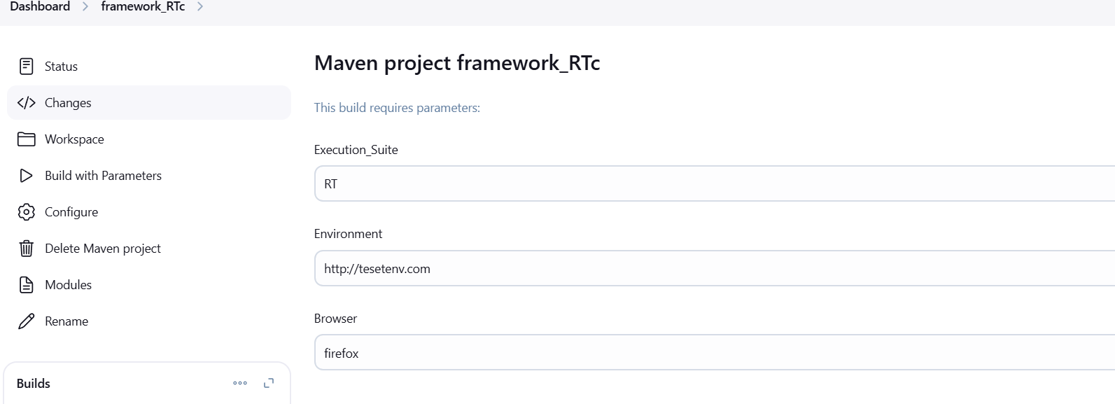

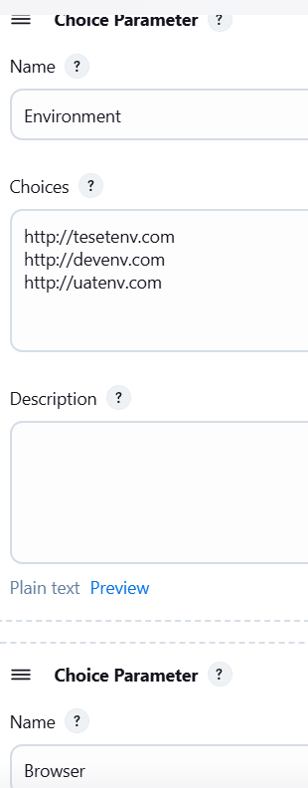
Goal=
test -P $Execution_Suite -Durl=$Environment -Dbrowser=$Browser -Dusername=admin -Dpassword=admin

parameter name =$ to get from dropdown.
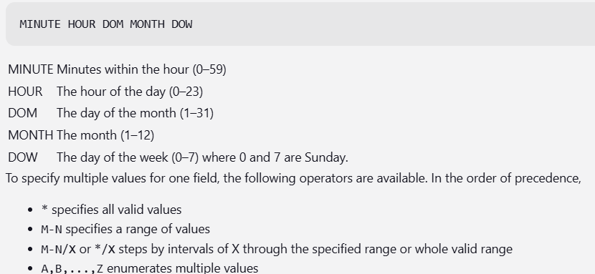

JUNKINS PIPELINE=
- EXECUTE MULTIPEL JOB SEQUENTUALLY ON AFTER THE OTHER IS CALLED JENKINS PIPELINE.
NOTE = MAKE SURE “ BUILD PIPELINE “ PLUG SHOULD BE INSTALLED IN JUNKINS.

STEPS TO CREATE PIPELINE IN JOBS=
- LOGIN TO JUKINS .
- GO TO CONFIGURE FILE OF FIRST JOB .
- SCROLL DOWN IN CONFIGURE FILE.
- CLICK ON “POST BUILD ACTION “ DROP DOWN.
- SELECT BUILD OTHER PROJECT , SHOW IN BELOW IMAGE.
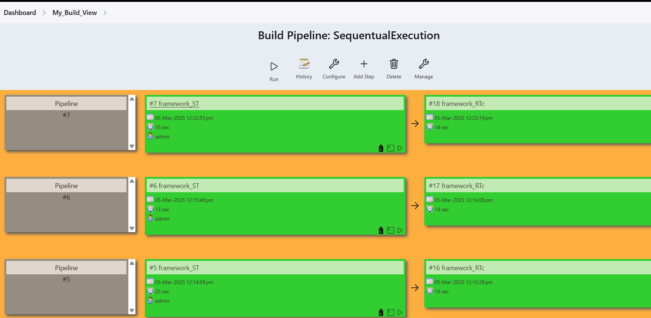
JENKIN ACTIVITY=
SAY ANY ONE ON SCEHDULING OR ON POLL SCM I HAVE DONE TO EXECUTE MY SCRIPT FROM JUNKIN ALL OF THE TESTSCRIPT DONE IN MASTER BRANCH IN TEAM LEAD.
TO EXECUTE MAVEN PROJECT WE NEED PLUGINS
- MAVEN INTEGRATION PLUGIN
- GIT HUB INTEGRATION PLUGIN ,
- BUILD PIPELINE PLUGIN ,
- HTML PUBLISHER PLUGIN ,
- EMAIL EXTENSION PLUGIN.

- PIPELINE NOT MANDETORY
- THEN GLOBAL CONFIGURATION MANAGE JUNKINS SYSTEM CONFIGURATION TOOLS JDK PATH TILL JDK21 FOLDER , GIT HUB TILL GIT.EXE FOLDER(AFTER BIN) MAVEN TILL 3.3(AFTER BIN).
- THEN NEED TO CREATE NEW JOB.

- AFTER BIN BECOUSE EVERY JOB EXECUTES INDIVIDUALLY .
- TO GET EXECUTION REPORT (ALL PLUGINS AT ONCE ADDED) REPORT IN FORM OF HTML.
- BASED ON TESTNG.XML FILE EXECUTION WILL HAPPEN IN JUNKIN , MAVEN USING ID PROFILING.
- CONFIGURE SUITE FILES LIKE PARRALEL , GROUPING , SMOKE , REGRESSIO , CROSS BROWSER BATCH , IT MAY BE SUITE.XML BASED ON SPRING /USER STORIES.
WHAT WILL HAPPEN WHEN WE EXECUTE BOTH AT ONCE=
- BOTH WILL NOT EXECUTE BUT IT WILL TRIGGER EXECUTION WILL BE IN QUE.
- JUNKIN IS THREAD SAFE IN NATURE (EVERY EXECUTION CREATE ITS OWN THREAD).
- JOBS ARE INDEPENDENT , SO IT WILL NOT IMPACT CURRNTLY EXECUTING JOB .
- IN PARRALEL ALSO IT WILL EXECUTE ONLY ONE
JUNKIN STAGES=
• Checkout/Source Code Management (SCM) → Fetching code from GitHub, GitLab, etc.
• Build → Compiling the application, creating artifacts.
• Test → Running unit tests, integration tests, etc.
• Code Analysis → Quality checks with tools like SonarQube.
• Package/Artifact → Preparing deployable files (e.g., JAR/WAR/Docker image).
• Deploy → Deploying to environments like Dev, QA, Staging, Production.
Common Stages in a Pipeline:
- Checkout / SCM: Pull code from version control (Git, SVN, etc.).
- Build: Compile the code and generate artifacts.
- Test: Execute unit tests, integration tests, or other automated tests.
- Code Analysis / Quality: Run tools like SonarQube for code quality checks.
- Package: Prepare deployable artifacts (JAR, WAR, Docker images).
- Deploy: Deploy the application to an environment (Dev, QA, Staging, Prod).
- Post Actions: Steps to execute after stage completion, e.g., notifications.

